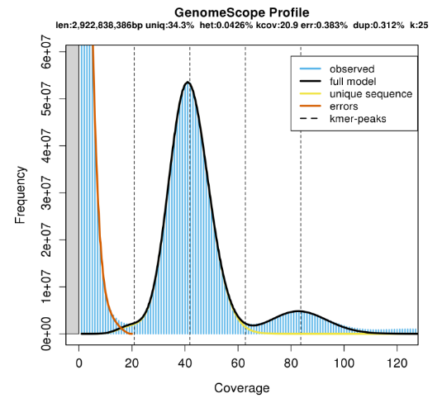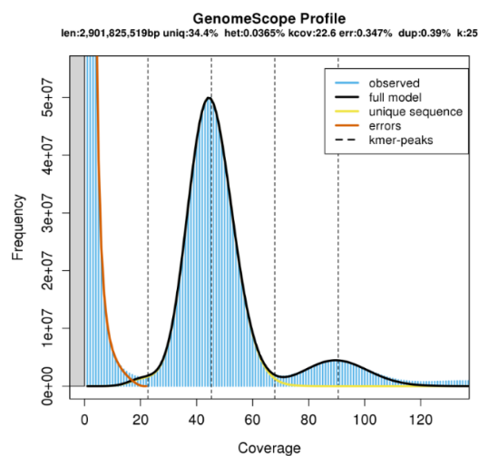
25-kmer distribution curve of SY 25-kmer distribution curve of LT

Fig. S1 k-mer depth distribution analysis of two cultivars. To better estimate the characteristics of the genome, 19-31bp multiple k-mer were analyzed. Subsequently, a 25bp k-mer analysis was performed with small sequencing bias and low error rate. The abscissa is the 25-kmer depth (coverage), while the ordinate is the 25-kmer frequency at this depth.

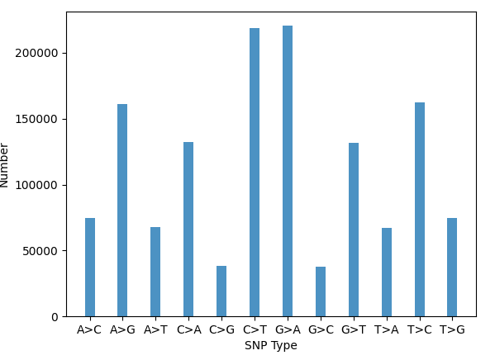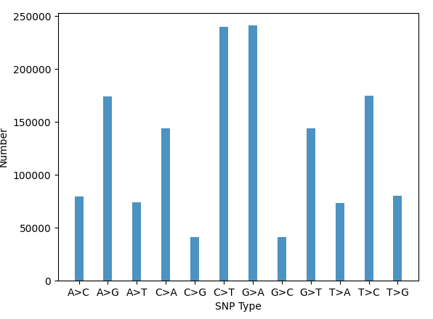
SY SNP type state LT SNP type state

Fig. S2 Result of calling SNP. Distribution of SNP polymorphisms along each opium poppy chromosome. Data were generated by re-mapping the Illumina reads to the opium poppy genome assembly and SNP substitution types in the poppy genome. The y-axis shows the number of SNPs, while the X-axis shows the indel length in nucleotides for the LT and SY species, respectively.

SY vs LT
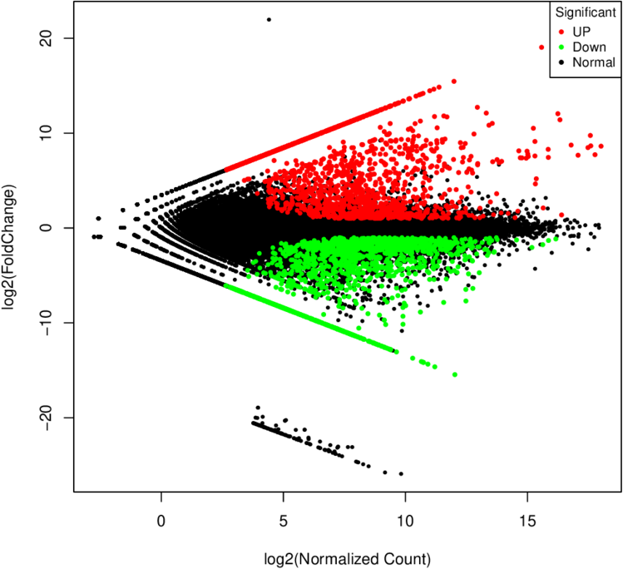
Fig. S3 Distribution of DEGs between single-fruited(LT) and multi-fruited(SY) varieties. The volcano map of DEGs in the two varieties, red spots represent up-regulated DEGs and green spots indicate down-regulated DEG. The detailed information was shown in Table S11. (http://www.biocondutor.org/packages/2.12/biochtml/edgeR.html).

Fig. S4 The heatmap of RT-qPCR results. Taking SY sample as control, LT as sample, the qPCR value of LT/SY indicates that DEGs in LT were up-regulated or down-regulated compared with SY. The detailed information was shown in Table S17, S18.

