Figure S1. Flow of participants through each stage of the study
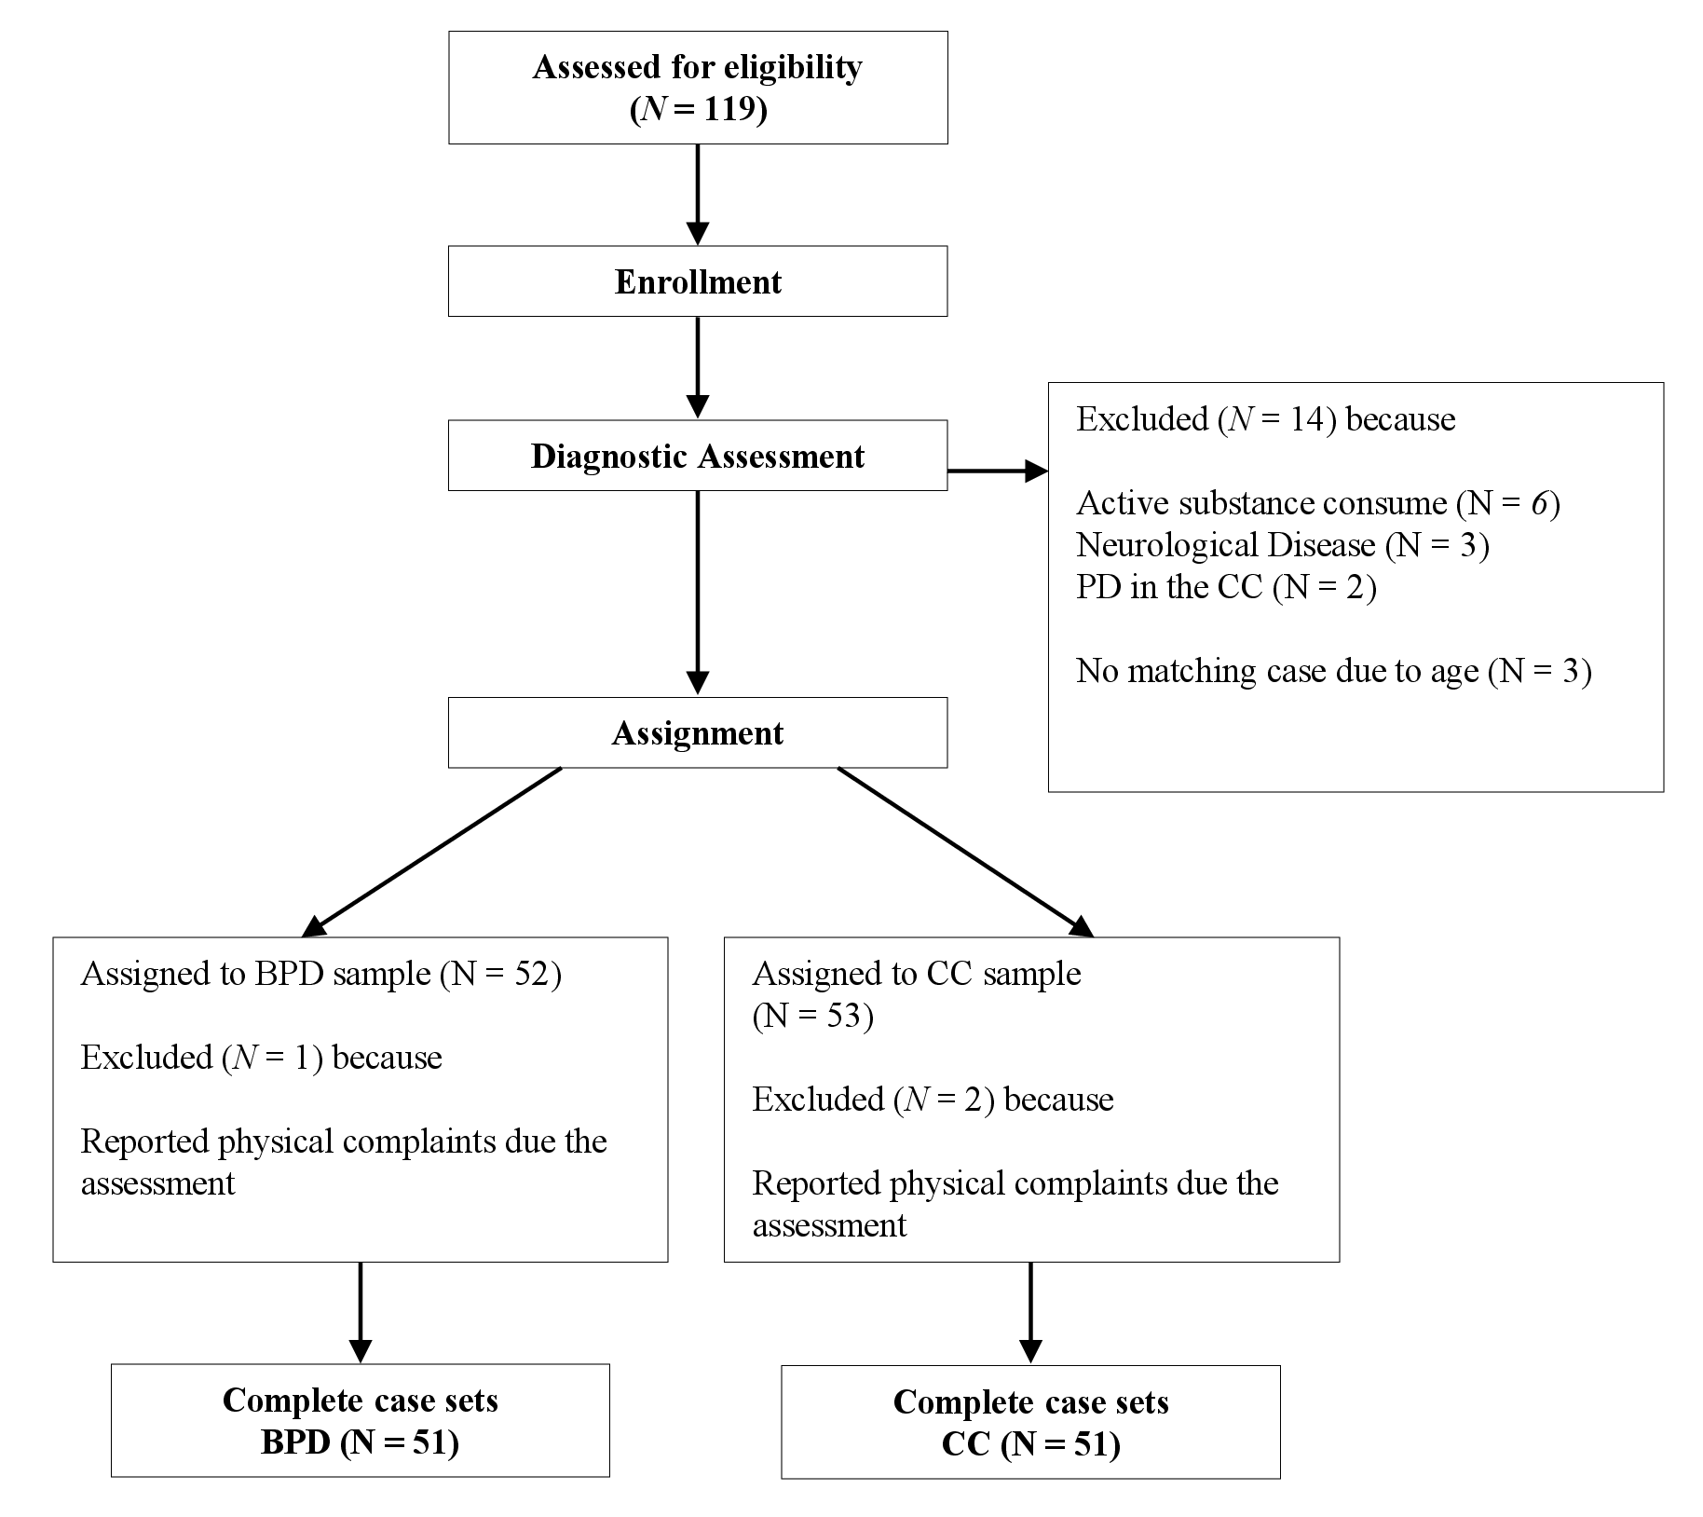

Table S1 Frequency table for the Mini-DIPS diagnoses in the BPD (N = 51) and CC (N = 51) samples.
Diagnoses | BPD (%) | CC (%) | χ² | df | p
Anxiety Disorder | 31 (61%) | 20 (39%) | 3.92 | 1 | .048
Panic Disorder | 19 (37%) | 7 (14%) | 6.25 | 1 | .012
Agoraphobia | 19 (37%) | 10 (20%) | 3.08 | 1 | .079
Social Anxiety Disorder | 10 (20%) | 2 (4%) | 4.63 | 1 | .031
Specific Phobia | 11 (22%) | 7 (14%) | 0.61 | 1 | .436
Generalized Anxiety Disorder | 10 (20%) | 9 (18%) | 0 | 1 | 1
Major Depression | 42 (82%) | 46 (90%) | 0.75 | 1 | .388
Obsessive-Compulsive Disorder | 5 (10%) | 3 (6%) | 0.14 | 1 | .712
PTSD | 18 (35%) | 3 (6%) | 11.75 | 1 | .001
Eating Disorder | 13 (25%) | 5 (10%) | 3.31 | 1 | .069
Somatoform Disorder | 9 (18%) | 5 (10%) | 0.75 | 1 | .388
Note. Mini-DIPS= Short form of the Diagnostic Interview for Mental Disorders Open Access

Figure S2 Intercorrelations between BPD indicators, forgiveness, and all clinical measures in the BPD sample (N=51)
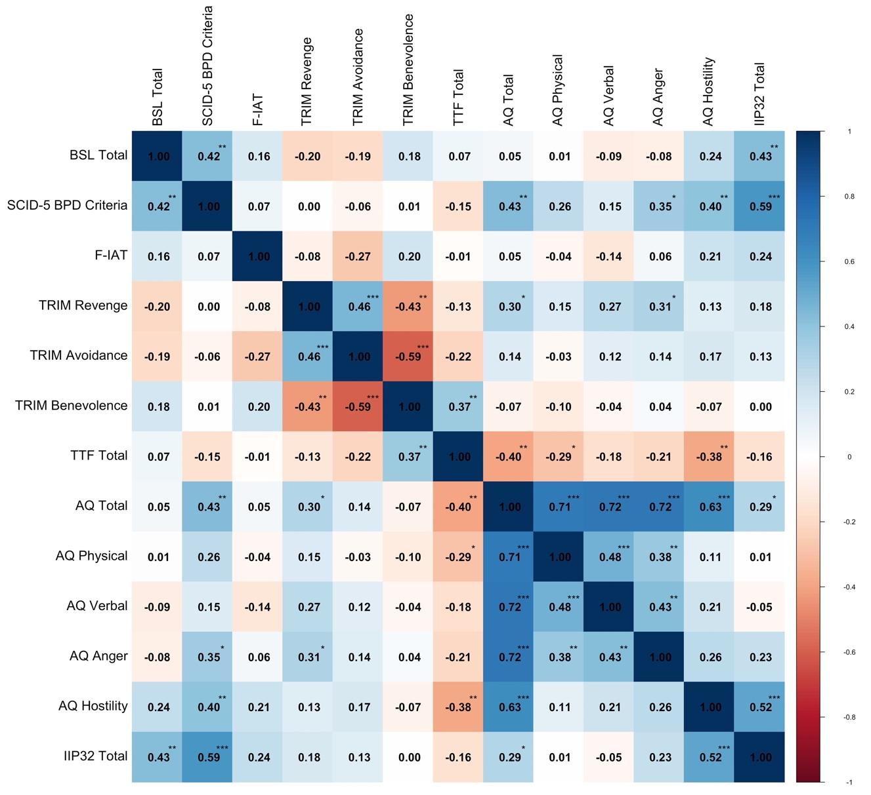

Figure S3 Intercorrelations between BPD indicators, forgiveness, and all clinical measures in the CC sample (N=51)
