Supplemental Materials
Table S1. Pairwise Comparisons of MAP, ICP, and Flow Between Groups
Parameter | Phase | Alternative Hypothesis | p-value | Cohen's d
MAP (mmHg) | Baseline | Control > Rapid | < 0.001 | 0.89 ***
MAP (mmHg) | Baseline | Control > Slow | < 0.001 | 0.88 ***
MAP (mmHg) | Baseline | Rapid > Slow | < 0.001 | 0.10 (ns)
MAP (mmHg) | Fibrillation | Control > Rapid | < 0.001 | 0.74 (ns)
MAP (mmHg) | Fibrillation | Control > Slow | < 0.001 | 1.25 ***
MAP (mmHg) | Fibrillation | Rapid > Slow | < 0.001 | 0.93 ***
MAP (mmHg) | ECMO I | Control > Rapid | < 0.001 | 2.16 ***
MAP (mmHg) | ECMO I | Control > Slow | < 0.001 | 1.72 ***
MAP (mmHg) | ECMO I | Rapid < Slow | < 0.001 | 0.35 (ns)
MAP (mmHg) | ECMO II | Control > Rapid | < 0.001 | 2.60 ***
MAP (mmHg) | ECMO II | Control > Slow | < 0.001 | 3.61 ***
MAP (mmHg) | ECMO II | Rapid > Slow | < 0.001 | 0.51 (ns)
MAP (mmHg) | ECMO III | Control > Rapid | < 0.001 | 2.56 ***
MAP (mmHg) | ECMO III | Control > Slow | < 0.001 | 2.99 ***
MAP (mmHg) | ECMO III | Rapid > Slow | < 0.001 | 0.26 (ns)
ICP (mmHg) | Baseline | Control < Rapid | < 0.001 | 1.95 ***
ICP (mmHg) | Baseline | Control < Slow | < 0.001 | 0.73 (ns)
ICP (mmHg) | Baseline | Rapid > Slow | < 0.001 | 0.82 ***
ICP (mmHg) | Fibrillation | Control > Rapid | < 0.001 | 1.61 ***
ICP (mmHg) | Fibrillation | Control < Slow | < 0.001 | 0.07 (ns)
ICP (mmHg) | Fibrillation | Rapid < Slow | < 0.001 | 1.09 ***
ICP (mmHg) | ECMO I | Control < Rapid | < 0.001 | 0.22 (ns)
ICP (mmHg) | ECMO I | Control < Slow | < 0.001 | 0.65 (ns)
ICP (mmHg) | ECMO I | Rapid < Slow | < 0.001 | 0.63 (ns)
ICP (mmHg) | ECMO II | Control < Rapid | < 0.001 | 0.82 ***
ICP (mmHg) | ECMO II | Control < Slow | < 0.001 | 0.74 (ns)
ICP (mmHg) | ECMO II | Rapid < Slow | < 0.001 | 0.35 (ns)
ICP (mmHg) | ECMO III | Control < Rapid | < 0.001 | 0.53 (ns)
ICP (mmHg) | ECMO III | Control < Slow | < 0.001 | 0.41 (ns)
ICP (mmHg) | ECMO III | Rapid < Slow | < 0.001 | 0.17 (ns)
Flow (L/min) | ECMO I | Control < Rapid | < 0.001 | 0.88 ***
Flow (L/min) | ECMO I | Control < Slow | < 0.001 | 0.52 (ns)
Flow (L/min) | ECMO I | Rapid > Slow | < 0.001 | 0.17 (ns)
Flow (L/min) | ECMO II | Control > Rapid | < 0.001 | 0.75 (ns)
Flow (L/min) | ECMO II | Control < Slow | < 0.001 | 0.19 (ns)
Flow (L/min) | ECMO II | Rapid < Slow | < 0.001 | 0.34 (ns)
Flow (L/min) | ECMO III | Control > Rapid | < 0.001 | 0.38 (ns)
Flow (L/min) | ECMO III | Control > Slow | < 0.001 | 0.48 (ns)
Flow (L/min) | ECMO III | Rapid > Slow | < 0.001 | 0.16 (ns)
Pairwise comparisons were conducted using one-way ANOVA followed by Tukey’s Honestly Significant Difference post hoc test. Cohen’s d was calculated to assess effect size. Values marked with (***) indicate statistically significant and clinically meaningful differences (p < 0.0167 and |d| ≥ 0.8) after Bonferroni correction for multiple comparisons. Abbreviations: MAP: Mean Arterial Pressure; ICP: Intracranial Pressure; ECMO: Extracorporeal Membrane Oxygenation; ANOVA: Analysis of Variance.
Table S2. Phase-wise Group Comparisons of PRx (Tukey HSD + Cohen’s d)
Phase | Alternative Hypothesis | p-value | Cohen's d
Baseline | Control < Rapid | p < 0.001 | 0.05 (ns)
Baseline | Control > Slow | p < 0.001 | 0.55 (ns)
Baseline | Rapid > Slow | p < 0.001 | 0.49 (ns)
Fibrillation | Rapid > Control | p < 0.001 | 0.25 (ns)
Fibrillation | Slow > Control | p < 0.001 | 0.49 (ns)
Fibrillation | Slow > Rapid | p < 0.001 | 0.29 (ns)
ECMO I | Rapid > Control | p = 0.556 | 0.02 (ns)
ECMO I | Slow > Control | p < 0.001 | 0.18 (ns)
ECMO I | Rapid > Slow | p < 0.001 | 0.26 (ns)
ECMO II | Rapid > Control | p < 0.001 | 0.27 (ns)
ECMO II | Control > Slow | p < 0.001 | 0.41 (ns)
ECMO II | Rapid > Slow | p < 0.001 | 0.86 (***)
ECMO III | Rapid > Control | p < 0.001 | 1.79 (***)
ECMO III | Slow > Control | p < 0.001 | 0.27 (ns)
ECMO III | Rapid > Slow | p < 0.001 | 2.40 (***)
Pressure Reactivity Index (PRx) values were compared across experimental groups (Control, Rapid, Slow) and time intervals using Tukey’s HSD test. Cohen’s d was calculated to evaluate effect size. A significance threshold of p < 0.0167 and |d| ≥ 0.8 was applied to denote both statistical and clinical relevance. Significant comparisons are marked (***); non-significant comparisons are marked (ns).
Table S3. K-S Test for PRx Distribution Shifts Across Phases
Group | Comparison | p-value | KS Statistic
Control | Baseline vs Fibrillation | p < 0.001 | 0.355 (ns)
Control | Fibrillation vs ECMO I | p < 0.001 | 0.190 (ns)
Control | ECMO I vs ECMO II | p < 0.001 | 0.165 (ns)
Control | ECMO II vs ECMO III | p < 0.001 | 0.139 (ns)
Rapid | Baseline vs Fibrillation | p < 0.001 | 0.233 (ns)
Rapid | Fibrillation vs ECMO I | p < 0.001 | 0.236 (ns)
Rapid | ECMO I vs ECMO II | p < 0.001 | 0.367 (ns)
Rapid | ECMO II vs ECMO III | p < 0.001 | 0.528 (***)
Slow | Baseline vs Fibrillation | p < 0.001 | 0.220 (ns)
Slow | Fibrillation vs ECMO I | p < 0.001 | 0.069 (ns)
Slow | ECMO I vs ECMO II | p < 0.001 | 0.209 (ns)
Slow | ECMO II vs ECMO III | p < 0.001 | 0.356 (ns)
Phase-to-phase comparisons of PRx distributions were conducted within each experimental group (Control, Rapid, and Slow) using two-sample Kolmogorov–Smirnov tests. To minimize false-positive significance from large sample sizes, only comparisons meeting both a p-value < 0.01 and a KS statistic ≥ 0.4 were considered biologically meaningful.

Figure S1. Group-wise comparisons of mean arterial pressure (MAP), extracorporeal circuit flow, and intracranial pressure (ICP) across experimental phases. Box plots display ECMO flow (top row), MAP (middle row), and ICP (bottom row) at baseline, during ventricular fibrillation, and at three ECMO time intervals (ECMO I: 0–5 min, ECMO II: 5–10 min, ECMO III: 10–15 min). Groups include control (blue), rapid CO₂ correction (red), and slow CO₂ correction (yellow). Boxes indicate interquartile ranges with medians marked; whiskers represent the full data range.
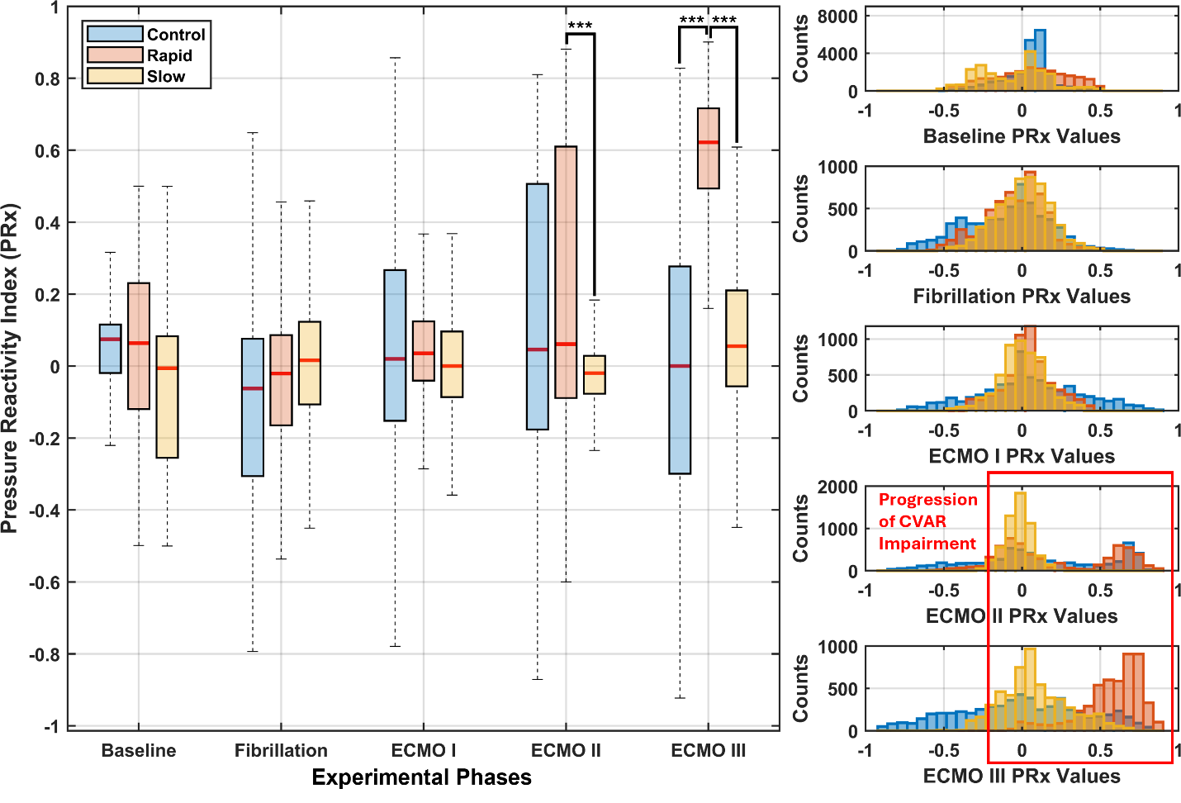
Figure S2. Temporal progression of cerebrovascular autoregulation (CVAR) across groups during ECPR. Left panel: box plots show pressure reactivity index (PRx) values for control (blue), rapid CO₂ correction (red), and slow CO₂ correction (yellow) groups across five experimental phases: baseline, fibrillation, and ECMO phases I–III (0–5, 5–10, and 10–15 min). Right panel: corresponding histograms illustrate the distribution of PRx values at each phase. The rapid group demonstrates a rightward shift in PRx values during ECMO, indicating progressive CVAR impairment. Statistically significant and clinically meaningful differences are marked (***).

Table 1. Pairwise Comparisons of ΔMAP, ΔICP, and Flow Between Groups
Parameter | Phase | Alternative Hypothesis | p-value | Cohen's d
ΔMAP (mmHg) | Fibrillation | Control < Rapid | < 0.001 | 0.34 (ns)
ΔMAP (mmHg) | Fibrillation | Control < Slow | < 0.001 | 0.14 (ns)
ΔMAP (mmHg) | Fibrillation | Rapid > Slow | < 0.001 | 1.31 ***
ΔMAP (mmHg) | ECMO I | Control > Rapid | < 0.001 | 0.48 (ns)
ΔMAP (mmHg) | ECMO I | Control > Slow | < 0.001 | 0.29 (ns)
ΔMAP (mmHg) | ECMO I | Rapid < Slow | < 0.001 | 0.56 (ns)
ΔMAP (mmHg) | ECMO II | Control > Rapid | < 0.001 | 0.32 (ns)
ΔMAP (mmHg) | ECMO II | Control > Slow | < 0.001 | 0.47 (ns)
ΔMAP (mmHg) | ECMO II | Rapid > Slow | < 0.001 | 0.60 (ns)
ΔMAP (mmHg) | ECMO III | Control > Rapid | < 0.001 | 0.47 (ns)
ΔMAP (mmHg) | ECMO III | Control > Slow | < 0.001 | 0.48 (ns)
ΔMAP (mmHg) | ECMO III | Rapid > Slow | < 0.001 | 0.19 (ns)
ΔICP (mmHg) | Fibrillation | Control > Rapid | < 0.001 | 3.09 ***
ΔICP (mmHg) | Fibrillation | Control > Slow | < 0.001 | 0.69 (ns)
ΔICP (mmHg) | Fibrillation | Rapid < Slow | < 0.001 | 2.21 ***
ΔICP (mmHg) | ECMO I | Control > Rapid | < 0.001 | 1.63 ***
ΔICP (mmHg) | ECMO I | Control < Slow | < 0.001 | 0.22 (ns)
ΔICP (mmHg) | ECMO I | Rapid < Slow | < 0.001 | 2.24 ***
ΔICP (mmHg) | ECMO II | Control > Rapid | < 0.001 | 1.08 ***
ΔICP (mmHg) | ECMO II | Control < Slow | < 0.001 | 0.34 (ns)
ΔICP (mmHg) | ECMO II | Rapid < Slow | < 0.001 | 2.02 ***
ΔICP (mmHg) | ECMO III | Control > Rapid | < 0.001 | 1.20 ***
ΔICP (mmHg) | ECMO III | Control > Slow | < 0.001 | 0.10 (ns)
ΔICP (mmHg) | ECMO III | Rapid < Slow | < 0.001 | 0.96 ***
Flow (L/min) | ECMO I | Control < Rapid | < 0.001 | 0.88 ***
Flow (L/min) | ECMO I | Control < Slow | < 0.001 | 0.52 (ns)
Flow (L/min) | ECMO I | Rapid > Slow | < 0.001 | 0.17 (ns)
Flow (L/min) | ECMO II | Control > Rapid | < 0.001 | 0.75 (ns)
Flow (L/min) | ECMO II | Control < Slow | < 0.001 | 0.19 (ns)
Flow (L/min) | ECMO II | Rapid < Slow | < 0.001 | 0.34 (ns)
Flow (L/min) | ECMO III | Control > Rapid | < 0.001 | 0.38 (ns)
Flow (L/min) | ECMO III | Control > Slow | < 0.001 | 0.48 (ns)
Flow (L/min) | ECMO III | Rapid > Slow | < 0.001 | 0.16 (ns)
Pairwise comparisons were conducted using one-way ANOVA followed by Tukey’s Honestly Significant Difference post hoc test. Cohen’s d was calculated to assess effect size. Values marked with (***) indicate statistically significant and clinically meaningful differences (p < 0.0167 and |d| ≥ 0.8) after Bonferroni correction for multiple comparisons. Abbreviations: MAP: Mean Arterial Pressure; ICP: Intracranial Pressure; ECMO: Extracorporeal Membrane Oxygenation; ANOVA: Analysis of Variance.
Table 2. Phase-wise Group Comparisons of ΔPRx (Tukey HSD + Cohen’s d)
Phase | Alternative Hypothesis | p-value | Cohen's d
Fibrillation | Control < Rapid | p < 0.001 | 0.23 (ns)
Fibrillation | Control < Slow | p < 0.001 | 0.81 (***)
Fibrillation | Rapid < Slow | p < 0.001 | 0.68 (ns)
ECMO I | Control > Rapid | p = 0.556 | 0.06 (ns)
ECMO I | Control < Slow | p < 0.001 | 0.18 (ns)
ECMO I | Rapid < Slow | p < 0.001 | 0.34 (ns)
ECMO II | Control < Rapid | p < 0.001 | 0.25 (ns)
ECMO II | Control > Slow | p < 0.001 | 0.11 (ns)
ECMO II | Rapid > Slow | p < 0.001 | 0.44 (ns)
ECMO III | Control < Rapid | p < 0.001 | 1.77 (***)
ECMO III | Control < Slow | p < 0.001 | 0.59 (ns)
ECMO III | Rapid > Slow | p < 0.001 | 1.83 (***)
Variations from baseline in Pressure Reactivity Index (ΔPRx) values were compared across experimental groups (Control, Rapid, Slow) and time intervals using Tukey’s HSD test. Cohen’s d was calculated to evaluate effect size. A significance threshold of p < 0.0167 and |d| ≥ 0.8 was applied to denote both statistical and clinical relevance. Significant comparisons are marked (***); non-significant comparisons are marked (ns).

Table 3. K-S Test for ΔPRx Distribution Shifts Across Phases
Group | Comparison | p-value | KS Statistic
Control | Fibrillation vs ECMO I | p < 0.001 | 0.204 (ns)
Control | ECMO I vs ECMO II | p < 0.001 | 0.162 (ns)
Control | ECMO II vs ECMO III | p < 0.001 | 0.151 (ns)
Rapid | Fibrillation vs ECMO I | p < 0.001 | 0.236 (ns)
Rapid | ECMO I vs ECMO II | p < 0.001 | 0.367 (ns)
Rapid | ECMO II vs ECMO III | p < 0.001 | 0.528 (***)
Slow | Fibrillation vs ECMO I | p < 0.001 | 0.077 (ns)
Slow | ECMO I vs ECMO II | p < 0.001 | 0.118 (ns)
Slow | ECMO II vs ECMO III | p < 0.001 | 0.250 (ns)
Phase-to-phase comparisons of ΔPRx distributions were conducted within each experimental group (Control, Rapid, and Slow) using two-sample Kolmogorov–Smirnov tests. To minimize false-positive significance from large sample sizes, only comparisons meeting both a p-value < 0.01 and a KS statistic ≥ 0.4 were considered biologically meaningful.

Table 4. Tukey Test Summary for Histological Findings and Regional Analysis
Region | Comparison (Slices = N) | Mean 1 | Mean 2 | Mean Diff | SE Diff | 95.00% CI of diff. | p-value
Midbrain | Control (4) vs. Rapid (4) | 23.25 | 7 | 16.25 | 6.183 | -2.726 to 35.23 | 0.087
Midbrain | Control (4) vs. Slow (4) | 23.25 | 17 | 6.25 | 6.183 | -12.73 to 25.23 | 0.597
Midbrain | Rapid (4) vs. Slow (4) | 7 | 17 | -10 | 6.272 | -29.24 to 9.243 | 0.318
Cerebellum (S1) | Control (6) vs. Rapid (6) | 46 | 13.5 | 32.5 | 12.13 | -3.689 to 68.69 | 0.075
Cerebellum (S1) | Control (6) vs. Slow (6) | 46 | 6.833 | 39.17 | 11.73 | 3.051 to 75.28 | 0.037
Cerebellum (S1) | Rapid (6) vs. Slow (6) | 13.5 | 6.833 | 6.667 | 5.757 | -9.336 to 22.67 | 0.505
Cerebellum (S2) | Control (6) vs. Rapid (5) | 12.17 | 27.4 | -15.23 | 8.702 | -42.23 to 11.77 | 0.266
Cerebellum (S2) | Control (6) vs. Slow (6) | 12.17 | 24.5 | -12.33 | 9.31 | -39.90 to 15.23 | 0.428
Cerebellum (S2) | Rapid (5) vs. Slow (6) | 27.4 | 24.5 | 2.9 | 11.6 | -29.48 to 35.28 | 0.966
Hypothalamus (S1) | Control (6) vs. Rapid (6) | 36.67 | 47.83 | -11.17 | 17.9 | -64.17 to 41.83 | 0.812
Hypothalamus (S1) | Control (6) vs. Slow (6) | 36.67 | 33.33 | 3.333 | 13.05 | -33.39 to 40.06 | 0.965
Hypothalamus (S1) | Rapid (6) vs. Slow (6) | 47.83 | 33.33 | 14.5 | 19.69 | -40.84 to 69.84 | 0.749
Hypothalamus (S2) | Control (6) vs. Rapid (6) | 29.17 | 32.67 | -3.5 | 10.65 | -32.70 to 25.70 | 0.943
Hypothalamus (S2) | Control (6) vs. Slow (6) | 29.17 | 31.17 | -2 | 15.55 | -46.76 to 42.76 | 0.991
Hypothalamus (S2) | Rapid (6) vs. Slow (6) | 32.67 | 31.17 | 1.5 | 15.63 | -43.36 to 46.36 | 0.995
Caudate | Control (10) vs. Rapid (10) | 10.6 | 43.1 | -32.5 | 11.27 | -63.64 to -1.361 | 0.041
Caudate | Control (10) vs. Slow (10) | 10.6 | 17.9 | -7.3 | 4.373 | -18.82 to 4.219 | 0.253
Caudate | Rapid (10) vs. Slow (10) | 43.1 | 17.9 | 25.2 | 11.77 | -6.506 to 56.91 | 0.126
Putamen | Control (10) vs. Rapid (5) | 23.9 | 66.6 | -42.7 | 6.65 | -64.50 to -20.90 | 0.003
Putamen | Control (10) vs. Slow (10) | 23.9 | 29.7 | -5.8 | 4.347 | -17.18 to 5.582 | 0.401
Putamen | Rapid (5) vs. Slow (10) | 66.6 | 29.7 | 36.9 | 7.375 | 15.20 to 58.60 | 0.004
Temporal Cortex | Control (8) vs. Rapid (8) | 8.875 | 34.88 | -26 | 7.056 | -45.67 to -6.325 | 0.013
Temporal Cortex | Control (8) vs. Slow (10) | 8.875 | 17.4 | -8.525 | 5.143 | -21.99 to 4.944 | 0.256
Temporal Cortex | Rapid (8) vs. Slow (10) | 34.88 | 17.4 | 17.48 | 7.95 | -3.553 to 38.50 | 0.109
CA-4 | Control (10) vs. Rapid (10) | 5.8 | 10.5 | -4.7 | 2.108 | -10.09 to 0.6893 | 0.094
CA-4 | Control (10) vs. Slow (10) | 5.8 | 10.1 | -4.3 | 2.067 | -9.580 to 0.9795 | 0.123
CA-4 | Rapid (10) vs. Slow (10) | 10.5 | 10.1 | 0.4 | 2.205 | -5.227 to 6.027 | 0.982
CA-3 | Control (6) vs. Rapid (6) | 18 | 4.667 | 13.33 | 3.938 | 1.851 to 24.82 | 0.026
CA-3 | Control (6) vs. Slow (6) | 18 | 9.5 | 8.5 | 4.559 | -4.079 to 21.08 | 0.201
CA-3 | Rapid (6) vs. Slow (6) | 4.667 | 9.5 | -4.833 | 3.371 | -14.41 to 4.742 | 0.369
CA-2 | Control (10) vs. Rapid (10) | 12.5 | 6.4 | 6.1 | 4.273 | -5.088 to 17.29 | 0.354
CA-2 | Control (10) vs. Slow (10) | 12.5 | 2.8 | 9.7 | 3.777 | -0.7880 to 20.19 | 0.070
CA-2 | Rapid (10) vs. Slow (10) | 6.4 | 2.8 | 3.6 | 2.103 | -2.171 to 9.371 | 0.249
CA-1 | Control (10) vs. Rapid (10) | 6.8 | 2.9 | 3.9 | 2.078 | -1.697 to 9.497 | 0.190
CA-1 | Control (10) vs. Slow (10) | 6.8 | 2.8 | 4 | 2.014 | -1.520 to 9.520 | 0.166
CA-1 | Rapid (10) vs. Slow (10) | 2.9 | 2.8 | 0.1 | 0.8333 | -2.053 to 2.253 | 0.992
Tukey’s multiple comparison test was used to compare the percentage of injured neurons across experimental groups and brain regions. The table includes mean injury percentages, mean difference, standard error (SE) of the difference, 95% confidence intervals (CI), and p-values. Statistically significant findings (p < 0.05) are shown in bold. Abbreviations: SE: Standard Error; CI: Confidence Interval; CA: Cornu Ammonis region of the hippocampus; HSD: Honestly Significant Difference; ECMO: Extracorporeal Membrane Oxygenation.

Supplemental Materials
Table S1. Pairwise Comparisons of MAP, ICP, and Flow Between Groups
Parameter | Phase | Alternative Hypothesis | p-value | Cohen's d
MAP (mmHg) | Baseline | Control > Rapid | < 0.001 | 0.89 ***
MAP (mmHg) | Baseline | Control > Slow | < 0.001 | 0.88 ***
MAP (mmHg) | Baseline | Rapid > Slow | < 0.001 | 0.10 (ns)
MAP (mmHg) | Fibrillation | Control > Rapid | < 0.001 | 0.74 (ns)
MAP (mmHg) | Fibrillation | Control > Slow | < 0.001 | 1.25 ***
MAP (mmHg) | Fibrillation | Rapid > Slow | < 0.001 | 0.93 ***
MAP (mmHg) | ECMO I | Control > Rapid | < 0.001 | 2.16 ***
MAP (mmHg) | ECMO I | Control > Slow | < 0.001 | 1.72 ***
MAP (mmHg) | ECMO I | Rapid < Slow | < 0.001 | 0.35 (ns)
MAP (mmHg) | ECMO II | Control > Rapid | < 0.001 | 2.60 ***
MAP (mmHg) | ECMO II | Control > Slow | < 0.001 | 3.61 ***
MAP (mmHg) | ECMO II | Rapid > Slow | < 0.001 | 0.51 (ns)
MAP (mmHg) | ECMO III | Control > Rapid | < 0.001 | 2.56 ***
MAP (mmHg) | ECMO III | Control > Slow | < 0.001 | 2.99 ***
MAP (mmHg) | ECMO III | Rapid > Slow | < 0.001 | 0.26 (ns)
ICP (mmHg) | Baseline | Control < Rapid | < 0.001 | 1.95 ***
ICP (mmHg) | Baseline | Control < Slow | < 0.001 | 0.73 (ns)
ICP (mmHg) | Baseline | Rapid > Slow | < 0.001 | 0.82 ***
ICP (mmHg) | Fibrillation | Control > Rapid | < 0.001 | 1.61 ***
ICP (mmHg) | Fibrillation | Control < Slow | < 0.001 | 0.07 (ns)
ICP (mmHg) | Fibrillation | Rapid < Slow | < 0.001 | 1.09 ***
ICP (mmHg) | ECMO I | Control < Rapid | < 0.001 | 0.22 (ns)
ICP (mmHg) | ECMO I | Control < Slow | < 0.001 | 0.65 (ns)
ICP (mmHg) | ECMO I | Rapid < Slow | < 0.001 | 0.63 (ns)
ICP (mmHg) | ECMO II | Control < Rapid | < 0.001 | 0.82 ***
ICP (mmHg) | ECMO II | Control < Slow | < 0.001 | 0.74 (ns)
ICP (mmHg) | ECMO II | Rapid < Slow | < 0.001 | 0.35 (ns)
ICP (mmHg) | ECMO III | Control < Rapid | < 0.001 | 0.53 (ns)
ICP (mmHg) | ECMO III | Control < Slow | < 0.001 | 0.41 (ns)
ICP (mmHg) | ECMO III | Rapid < Slow | < 0.001 | 0.17 (ns)
Flow (L/min) | ECMO I | Control < Rapid | < 0.001 | 0.88 ***
Flow (L/min) | ECMO I | Control < Slow | < 0.001 | 0.52 (ns)
Flow (L/min) | ECMO I | Rapid > Slow | < 0.001 | 0.17 (ns)
Flow (L/min) | ECMO II | Control > Rapid | < 0.001 | 0.75 (ns)
Flow (L/min) | ECMO II | Control < Slow | < 0.001 | 0.19 (ns)
Flow (L/min) | ECMO II | Rapid < Slow | < 0.001 | 0.34 (ns)
Flow (L/min) | ECMO III | Control > Rapid | < 0.001 | 0.38 (ns)
Flow (L/min) | ECMO III | Control > Slow | < 0.001 | 0.48 (ns)
Flow (L/min) | ECMO III | Rapid > Slow | < 0.001 | 0.16 (ns)
Pairwise comparisons were conducted using one-way ANOVA followed by Tukey’s Honestly Significant Difference post hoc test. Cohen’s d was calculated to assess effect size. Values marked with (***) indicate statistically significant and clinically meaningful differences (p < 0.0167 and |d| ≥ 0.8) after Bonferroni correction for multiple comparisons. Abbreviations: MAP: Mean Arterial Pressure; ICP: Intracranial Pressure; ECMO: Extracorporeal Membrane Oxygenation; ANOVA: Analysis of Variance.
Table S2. Phase-wise Group Comparisons of PRx (Tukey HSD + Cohen’s d)
Phase | Alternative Hypothesis | p-value | Cohen's d
Baseline | Control < Rapid | p < 0.001 | 0.05 (ns)
Baseline | Control > Slow | p < 0.001 | 0.55 (ns)
Baseline | Rapid > Slow | p < 0.001 | 0.49 (ns)
Fibrillation | Rapid > Control | p < 0.001 | 0.25 (ns)
Fibrillation | Slow > Control | p < 0.001 | 0.49 (ns)
Fibrillation | Slow > Rapid | p < 0.001 | 0.29 (ns)
ECMO I | Rapid > Control | p = 0.556 | 0.02 (ns)
ECMO I | Slow > Control | p < 0.001 | 0.18 (ns)
ECMO I | Rapid > Slow | p < 0.001 | 0.26 (ns)
ECMO II | Rapid > Control | p < 0.001 | 0.27 (ns)
ECMO II | Control > Slow | p < 0.001 | 0.41 (ns)
ECMO II | Rapid > Slow | p < 0.001 | 0.86 (***)
ECMO III | Rapid > Control | p < 0.001 | 1.79 (***)
ECMO III | Slow > Control | p < 0.001 | 0.27 (ns)
ECMO III | Rapid > Slow | p < 0.001 | 2.40 (***)
Pressure Reactivity Index (PRx) values were compared across experimental groups (Control, Rapid, Slow) and time intervals using Tukey’s HSD test. Cohen’s d was calculated to evaluate effect size. A significance threshold of p < 0.0167 and |d| ≥ 0.8 was applied to denote both statistical and clinical relevance. Significant comparisons are marked (***); non-significant comparisons are marked (ns).
Table S3. K-S Test for PRx Distribution Shifts Across Phases
Group | Comparison | p-value | KS Statistic
Control | Baseline vs Fibrillation | p < 0.001 | 0.355 (ns)
Control | Fibrillation vs ECMO I | p < 0.001 | 0.190 (ns)
Control | ECMO I vs ECMO II | p < 0.001 | 0.165 (ns)
Control | ECMO II vs ECMO III | p < 0.001 | 0.139 (ns)
Rapid | Baseline vs Fibrillation | p < 0.001 | 0.233 (ns)
Rapid | Fibrillation vs ECMO I | p < 0.001 | 0.236 (ns)
Rapid | ECMO I vs ECMO II | p < 0.001 | 0.367 (ns)
Rapid | ECMO II vs ECMO III | p < 0.001 | 0.528 (***)
Slow | Baseline vs Fibrillation | p < 0.001 | 0.220 (ns)
Slow | Fibrillation vs ECMO I | p < 0.001 | 0.069 (ns)
Slow | ECMO I vs ECMO II | p < 0.001 | 0.209 (ns)
Slow | ECMO II vs ECMO III | p < 0.001 | 0.356 (ns)
Phase-to-phase comparisons of PRx distributions were conducted within each experimental group (Control, Rapid, and Slow) using two-sample Kolmogorov–Smirnov tests. To minimize false-positive significance from large sample sizes, only comparisons meeting both a p-value < 0.01 and a KS statistic ≥ 0.4 were considered biologically meaningful.

Figure S1. Group-wise comparisons of mean arterial pressure (MAP), extracorporeal circuit flow, and intracranial pressure (ICP) across experimental phases. Box plots display MAP (top row), ECMO flow (middle row), and ICP (bottom row) at baseline, during ventricular fibrillation, and at three ECMO time intervals (ECMO I: 0–5 min, ECMO II: 5–10 min, ECMO III: 10–15 min). Groups include control (blue), rapid CO₂ correction (red), and slow CO₂ correction (yellow). Boxes indicate interquartile ranges with medians marked; whiskers represent the full data range.
Figure S2. Temporal progression of cerebrovascular autoregulation (CVAR) across groups during ECPR. Left panel: box plots show pressure reactivity index (PRx) values for control (blue), rapid CO₂ correction (red), and slow CO₂ correction (yellow) groups across five experimental phases: baseline, fibrillation, and ECMO phases I–III (0–5, 5–10, and 10–15 min). Right panel: corresponding histograms illustrate the distribution of PRx values at each phase. The rapid group demonstrates a rightward shift in PRx values during ECMO, indicating progressive CVAR impairment. Statistically significant and clinically meaningful differences are marked (***).

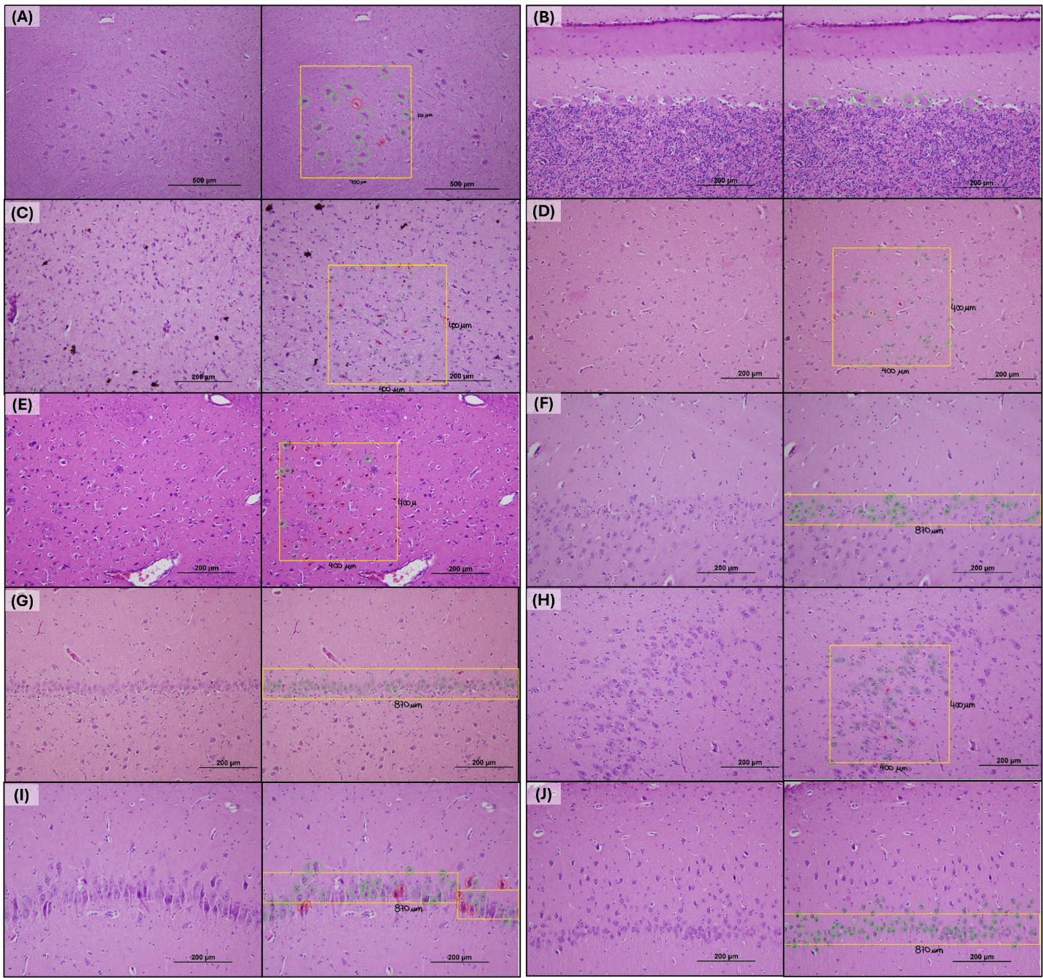
Figure S3: Examples of the counting technique for all regions. High-resolution images of the ischemia-vulnerable regions and their corresponding counting techniques are presented. Outlined in yellow is the specific area for counting to ensure uniformity across all images for the same region without overlap. The image on the left displays the region without the application of counting technique, while the image on the right includes the counting overlay. Healthy neurons were outlined with green, while injured neurons were highlighted in red. The scale bar indicates the magnification level at which the image was acquired. A: One oculomotor nucleus located in the midbrain of one specimen of the control group, designated with a counting area of 0.5625mm² (750µm x 750µm). B: Purkinje cells in the cerebellum of one specimen of the slow CO₂ correction group. This region did not need to be outlined. C: neurons in the hypothalamus of a specimen from the slow CO₂ correction group outlined with a counting area of 0.16mm² (400µm x 400µm). D: neurons from the caudate nucleus of a specimen from the control group in an area of 0.16mm². E: neurons from the putamen nucleus of a specimen from rapid CO₂ correction group (counting area of 0.16mm²). F: neurons from the external pyramidal layer at the cerebral cortex in the temporal region of one specimen from the control group. Outlined area corresponds to 0.087mm². G: neurons from the pyramidal layer at the region CA-4 of the hippocampal formation from a specimen of the control group with a counting area of 870µm x 100µm. H: neurons from the hippocampal region CA-3 of a specimen from the slow CO₂ correction group, designated with a counting area of 0.16 mm² (400µm x 400µm). I: neurons from the pyramidal layer of CA-2 region of the hippocampus from a specimen of the rapid CO₂ correction group. J: neurons from the pyramidal layer of the CA-1 region at the hippocampus from one specimen of the rapid CO₂ correction group.

(A)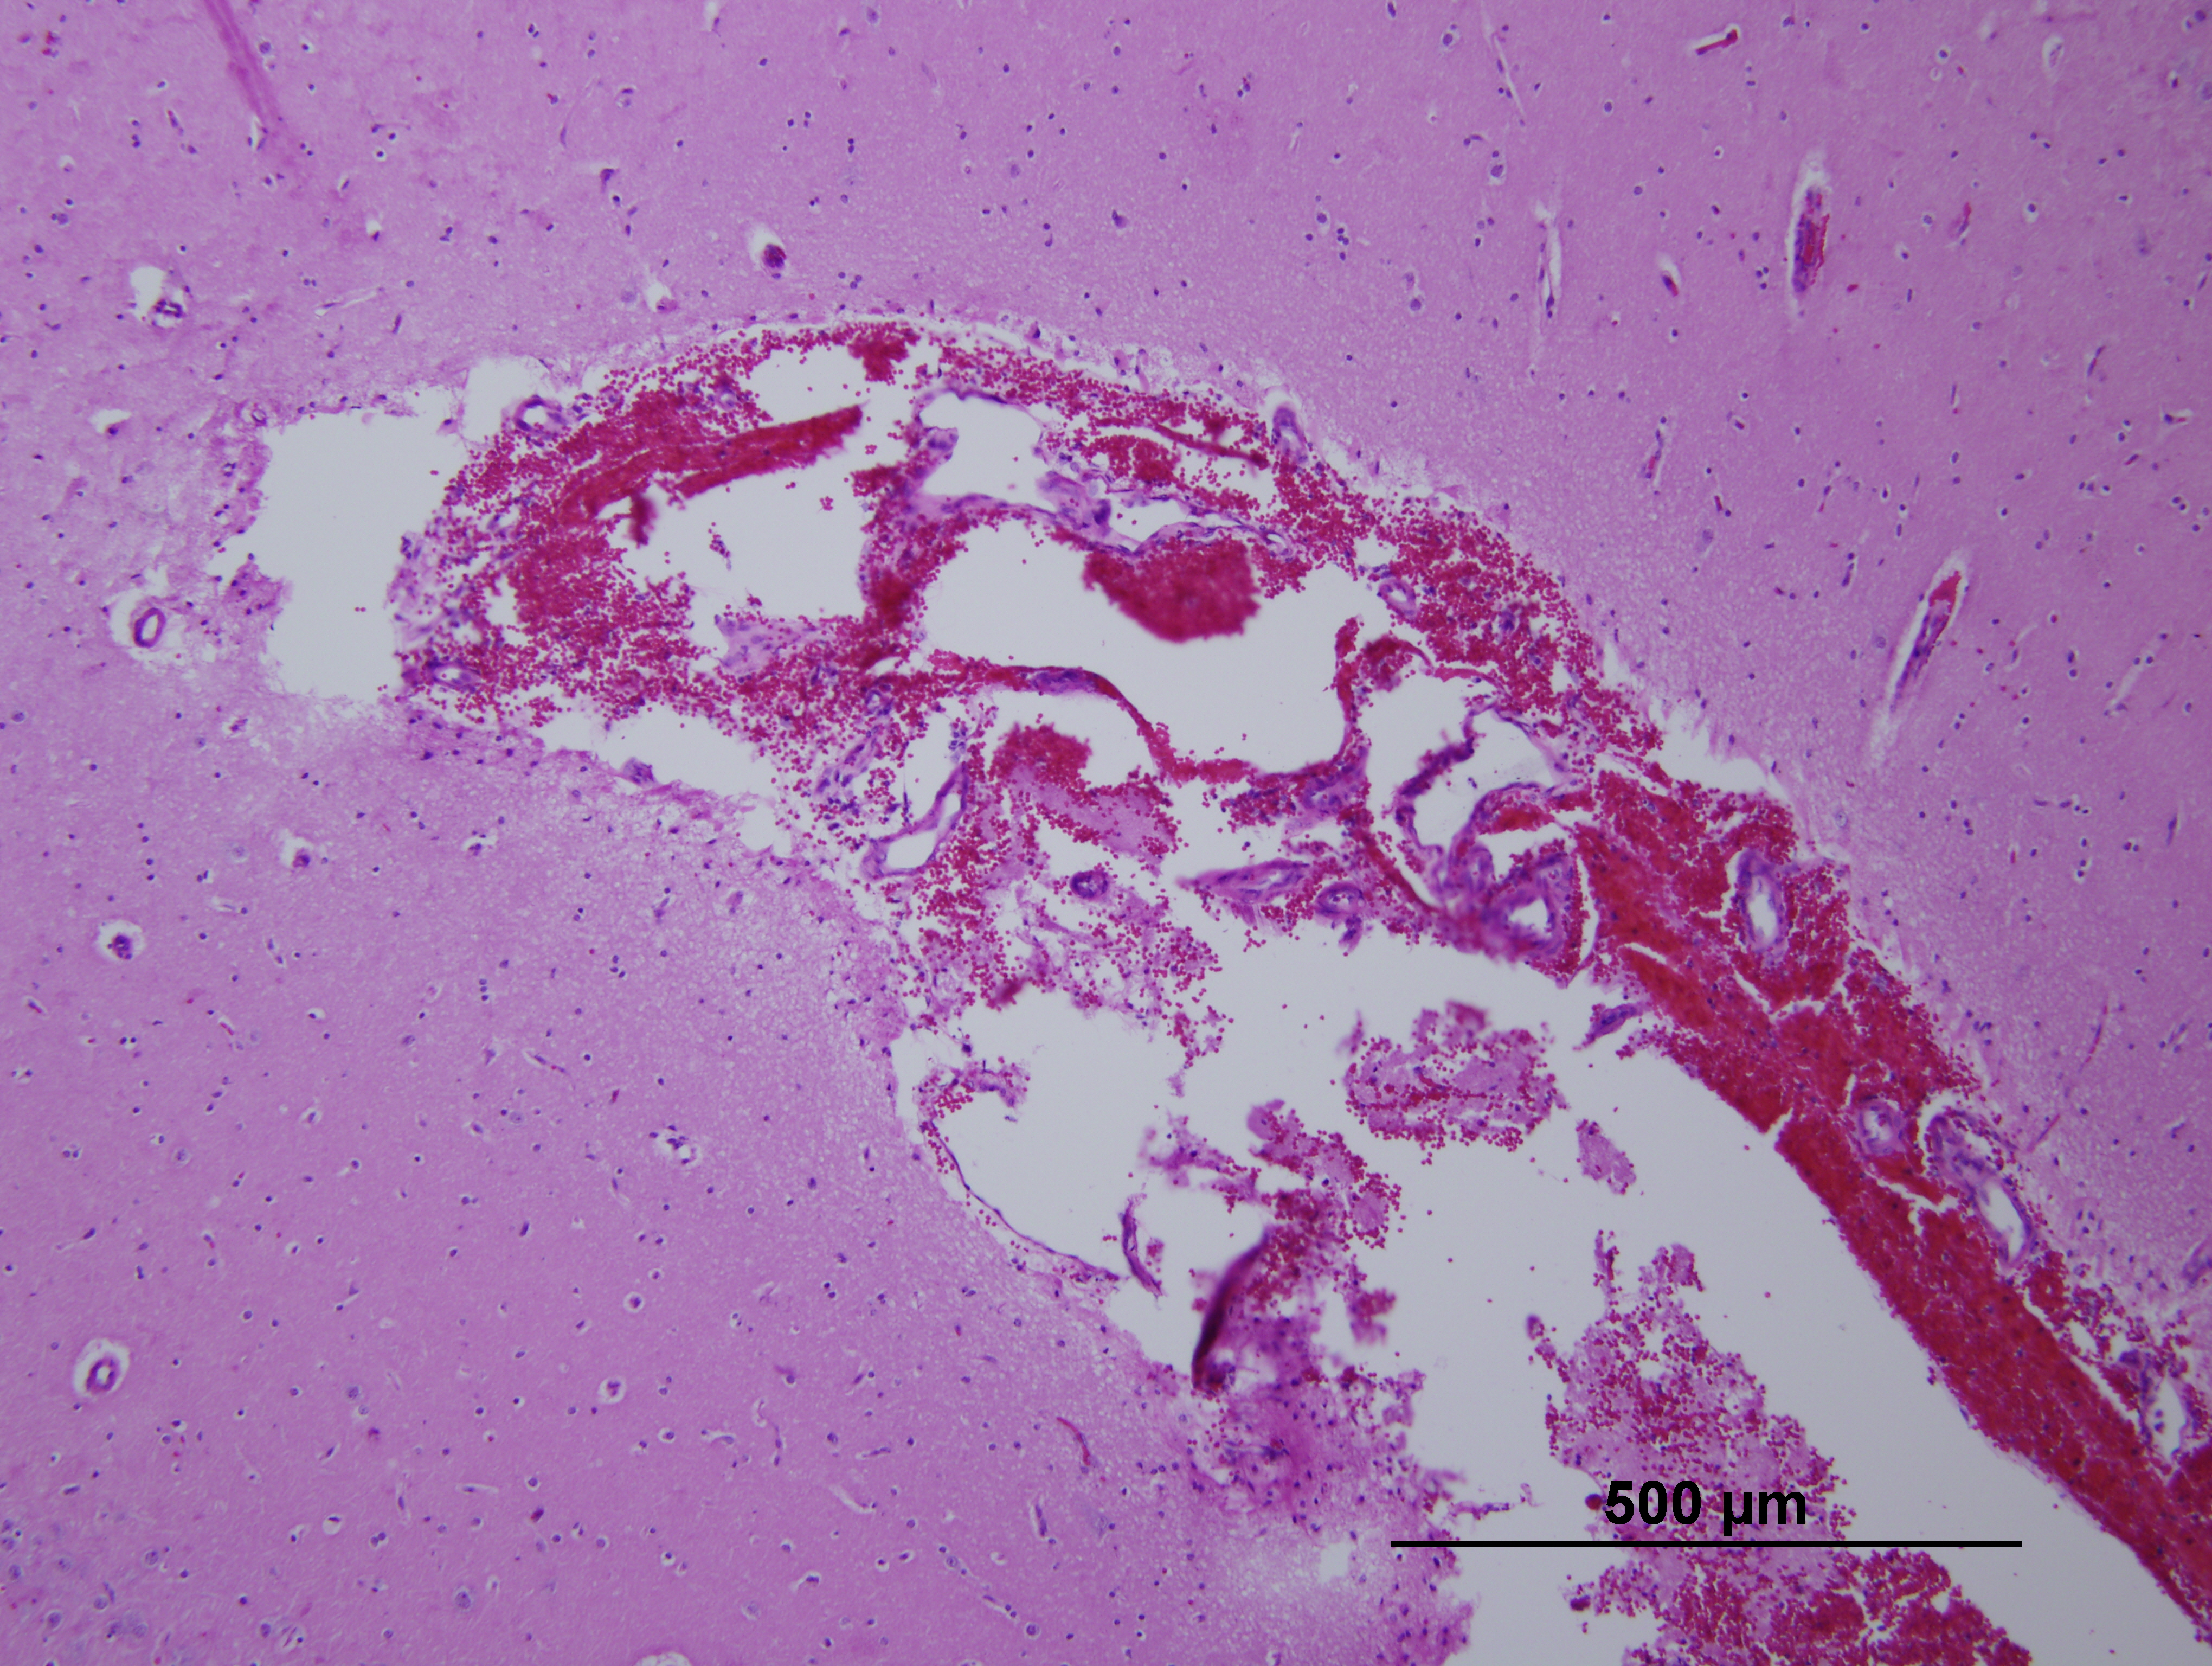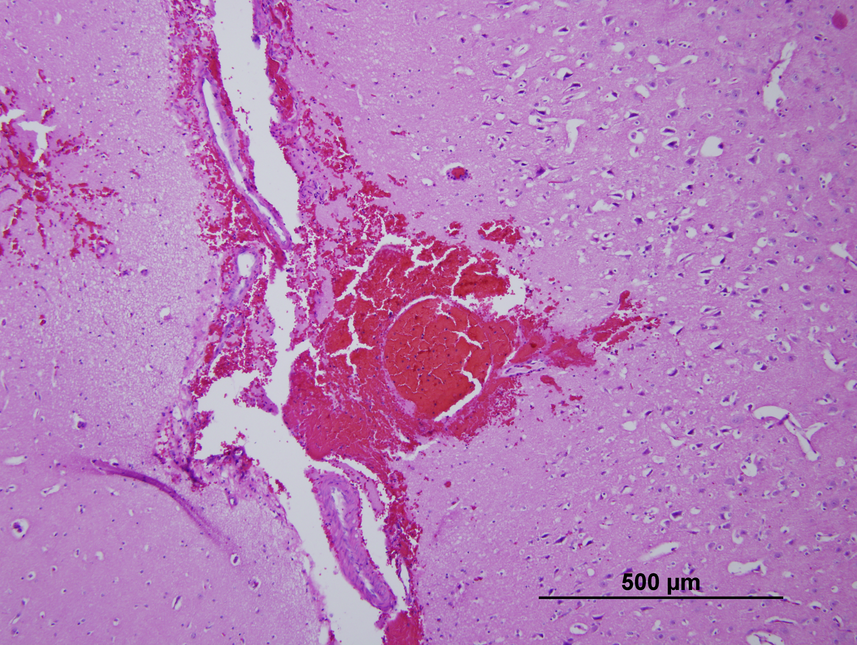
(B)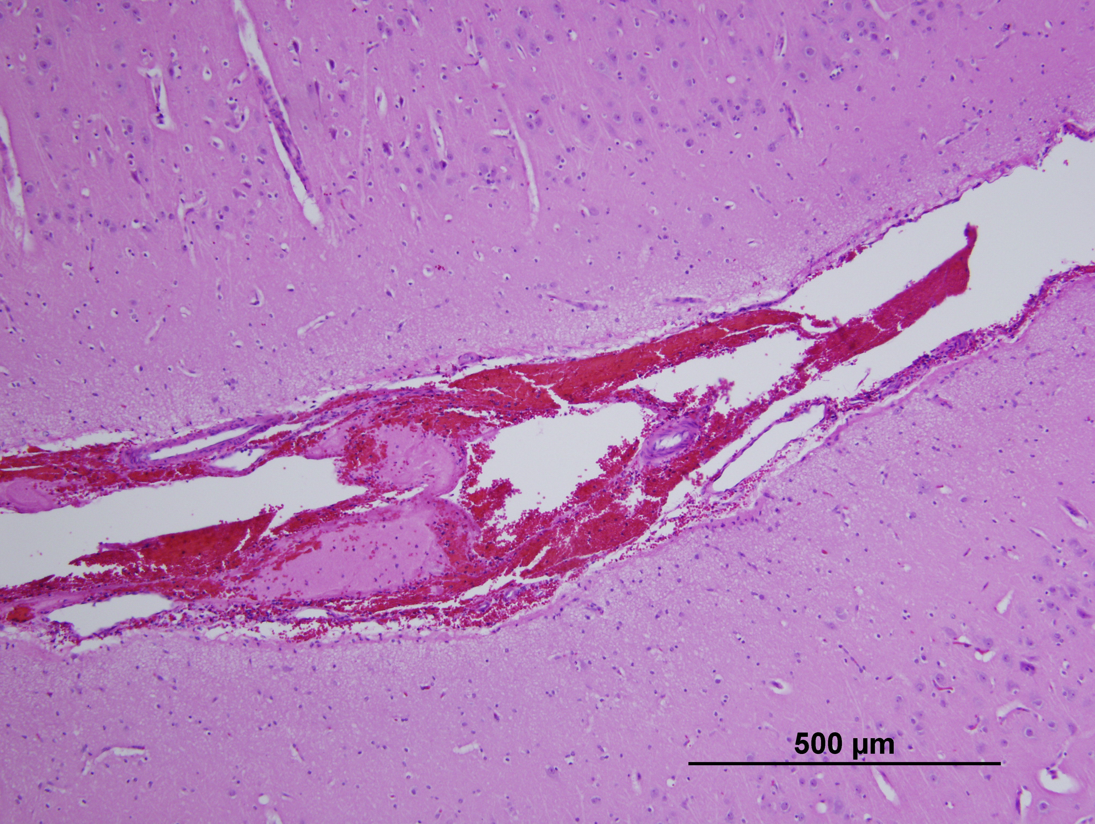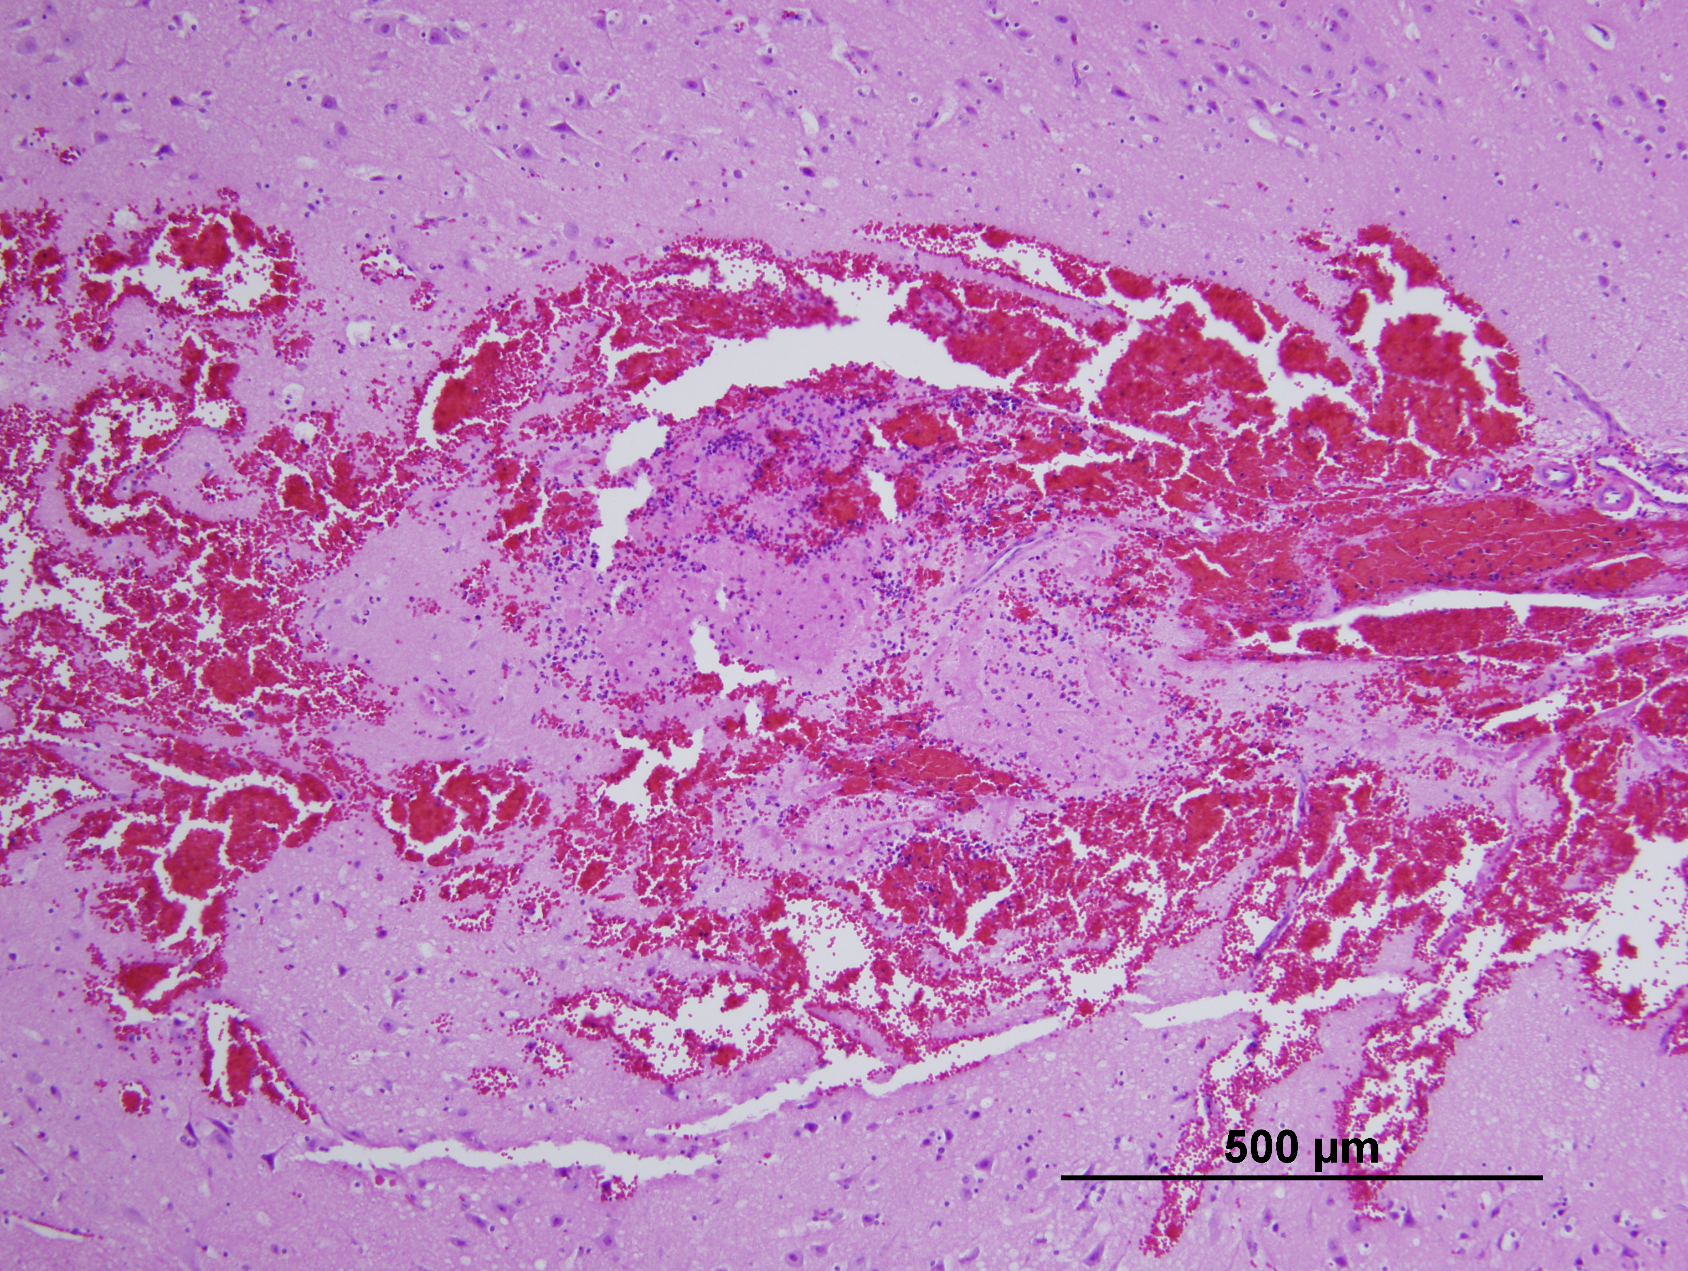
Figure S4: Evidence of non-specific cortical hemorrhages noted during histological assessment from one specimen of the slow CO2 correction group (A) and one specimen from the rapid CO2 correction group (B)

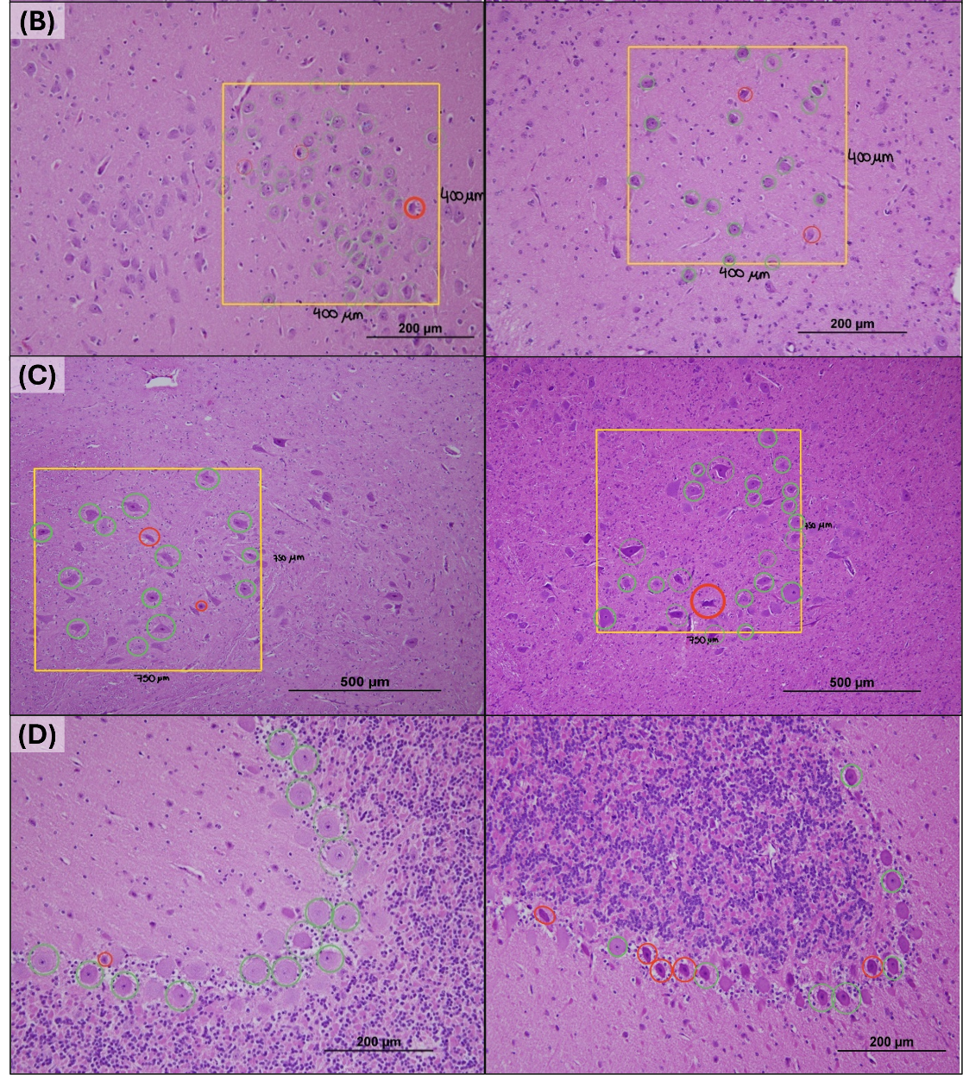
Figure S5. Representative histological evidence of the effects of CO₂ correction across brain regions. (B) Hippocampal CA3 region: control group (left) vs. rapid group (right).
(C) Oculomotor nucleus in the midbrain: control group (left) vs. rapid group (right). (D) Purkinje cells in the cerebellum: control group (left) vs. rapid group (right). Each panel illustrates increased neuronal injury in the rapid correction group compared to the control.
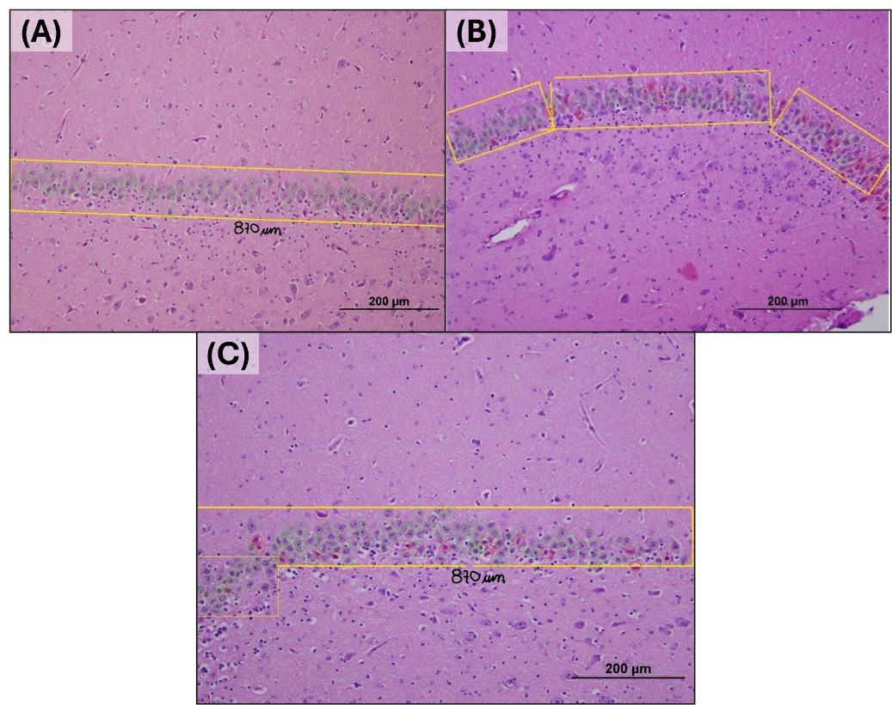
Figure S6. Effects of CO2 correction in the region CA-4 from the hippocampus. A: control group; B: rapid CO2 correction group and C: slow CO2 correction group.

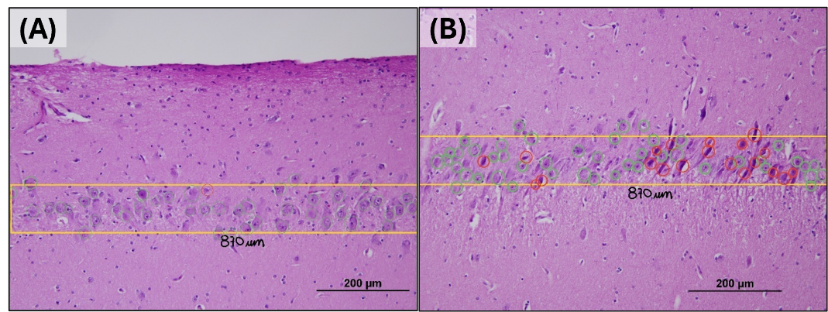
Figure S7 Effects of CO2 correction in the region CA-2 from the hippocampus. A: slow CO2 correction group; B: control group.

