Table S1. Physicochemical properties of both prototypes, PGA-PEG NCs and PGAC14 NAs, with and without AlexaFluor⁴⁸⁸-BVZ
Prototype | Physicochemical properties |  |  | AE (%) | LC (%)
Prototype | Particle size (nm) | PDI | ζ potential (mV) | AE (%) | LC (%)
PGA-PEG NCs (BVZ) | 78 ± 3 | 0.06 | -1 ± 1 | 99 ± 14 | 4.0
PGA-PEG NCs (AlexaFluor⁴⁸⁸-BVZ) | 81 ± 13 | 0.10 | -1 ± 1 | 112 ± 1 | 5
PGAC14-based NAs (BVZ) | 44 ± 4 | 0.24 | -10 ± 2 | 64 ± 18 | 21
PGAC14-based NAs (AlexaFluor⁴⁸⁸-BVZ) | 43 ± 5 | 0.27 | -2 ± 1 | 69 ± 14 | 22

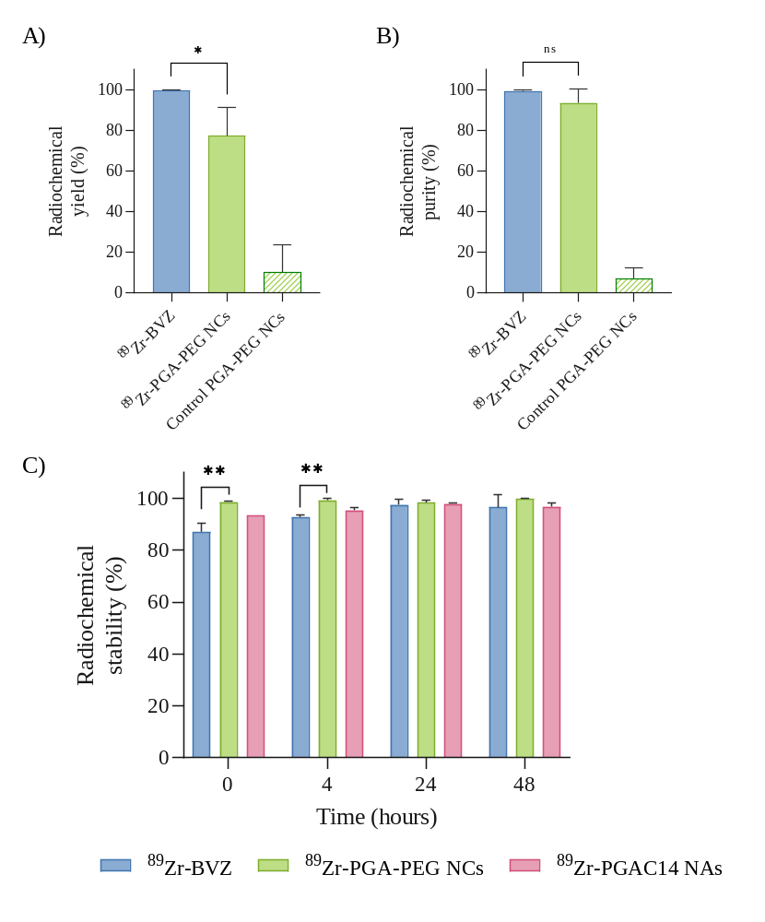
Figure S1. Radiochemical characterization of ⁸⁹Zr-BVZ, ⁸⁹Zr-BVZ-loaded PGA-PEG and ⁸⁹Zr -BVZ-loaded PGAC14 NAs. A) Radiochemical yield; B) Radiochemical purity; C) Radiochemical stability after 0, 4, 24 and 48 hours of incubation in PBS at 37ºC. BVZ-loaded PGA-PEG NCs without DFO were used as control (Control PGA-PEG NCs). Data are represented as mean ± SD, n≥2. Statistical analysis for comparison between free ⁸⁹Zr -BVZ and ⁸⁹Zr -BVZ-loaded PGA-PEG was done using a Mann-Whitney test (A) and unpaired t-test (B). Multiple unpaired t-test was used for comparison between groups (C).

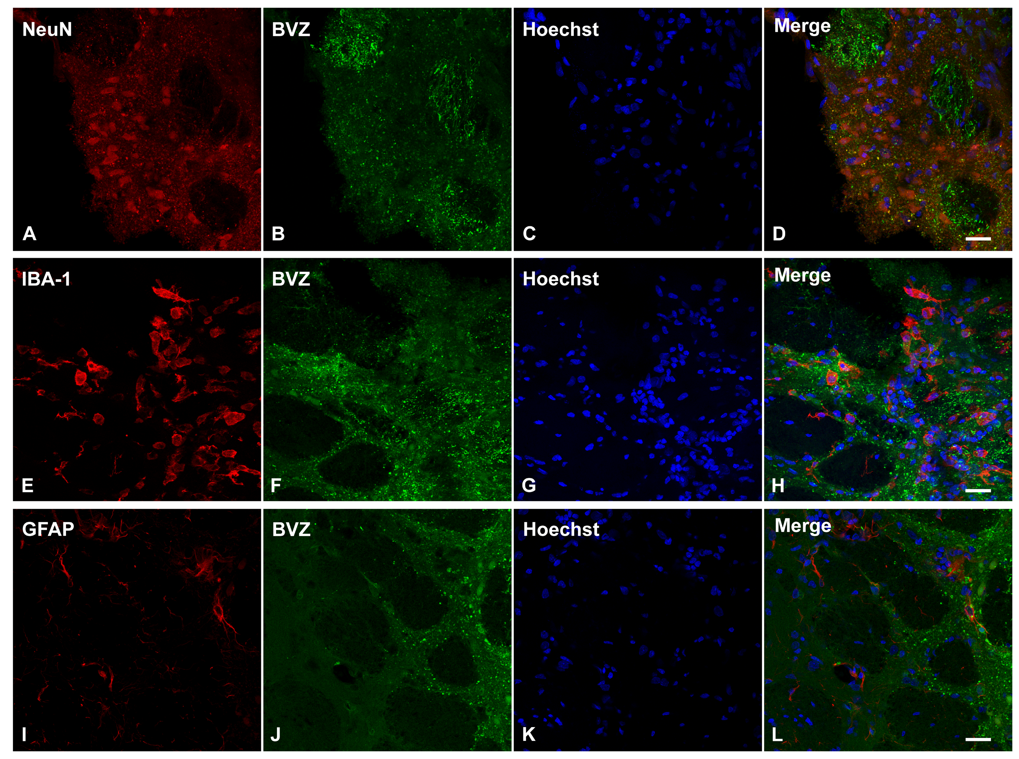
Figure S2. Triple immunofluorescent labeling for different cellular markers in red (NeuN as neuronal marker [A]; IBA-1 as microglial marker [E] and GFAP as astroglial marker [I]), the nuclear counterstaining Hoechst (in blue; [C, G, K]), and AlexaFluor488-labeled free BVZ (in green [B, F, J]) Merged images are shown in D, H, L. Scale bar: 20 µm.

