Supplementary material
Table S1 Geographic distributions of the four Morella species sampled in this study
Species | Population | Location | longitude | latitude | Altitude（m）
M. rubra | GXDC | Dongxing, Guagxi | 108.1869 | 21.652 | 4
M. rubra | FJCL | Change,Fuzhou | 119.6239 | 25.972 | 124
M. rubra | GXSB | Shangsi, Guangxi | 107.9101 | 21.9081 | 249
M. rubra | GZDB | Duyun, Guizhou | 107.6692 | 26.2508 | 855
M. rubra | GDTH | Tianhe, Guangdong | 113.3571 | 23.1574 | 56
M. rubra | GZKY | Kaiyang, Guizhou | 106.9649 | 27.0576 | 1224
M. rubra | JXTH | Taihe, Jiangxi | 114.9304 | 26.8171 | 50
M. rubra | FJXM | Xiamen, Fujian | 118.0339 | 24.4840 | 56
M. rubra | SCNJ | Nanjiang, Sichuan | 106.8335 | 32.3362 | 588
M. rubra | ZJLS | Yunhe, Zhejiang | 119.5734 | 28.1158 | 168
M. rubra | GDMX | Meixiang, Guangdong | 116.3319 | 24.4139 | 197
M. rubra | AHFT | Fengtai, Anhui | 116.5804 | 32.6917 | 15
M. rubra | GZDY | Duyun, Guizhou | 107.4483 | 26.3504 | 873
M. rubra | ZJNL | Linan, Zhejiang | 119.7200 | 30.2400 | 247
M. rubra | AHGC | Guichi, Anhui | 117.4995 | 30.6440 | 45
M. rubra | GXLB | Lingchuan, Guangxi | 110.4624 | 25.2361 | 200
M. rubra | GDGN | Guangning, Guangdong | 112.4824 | 23.8673 | 105
M. rubra | GXLG | Lingui, Guangxi | 110.0696 | 25.3756 | 256
M. rubra | GXJA | Jinchengjiang, Guangxi | 107.7442 | 24.8511 | 510
M. nana | SCRH | Renhe, Guangxi | 102.2333 | 26.8500 | 1099
M. nana | GZQG | Qixingguan, Guizhou | 105.3058 | 27.1826 | 1583
M. nana | YNDL | Dali, Yunnan | 100.3833 | 25.9667 | 1992
M. nana | YNNJ | Nanjian, Yunnan | 100.7500 | 25.1167 | 1401
M. nana | YNQB | Qiubei, Yunnan | 104.4333 | 24.0667 | 2090
M. nana | YNYL | Yiliang, Yunnan | 104.2667 | 28.2000 | 1662
M. nana | YNHZ | Huize, Yunnan | 104.1500 | 27.0500 | 2467
M. nana | GZWN | Weining, Guizhou | 104.2333 | 27.4667 | 2209
M. nana | YNZY | Yiliang, Yunnan | 104.2167 | 27.6333 | 1851
M. nana | YNES | Eshan,Yunnan | 102.6667 | 24.300 | 1542
M. nana | YNLC | Luquan, Yunnan | 103.3333 | 26.2333 | 2015
M. nana | GZSY | Shuicheng, Guizhou | 104.8000 | 26.3833 | 2250
M. nana | GZPZ | Panzhou, Guizhou | 104.4833 | 25.6500 | 2150
M. nana | GZLZ | Liuzhi, Guizhou | 105.2333 | 26.3833 | 1590
M. nana | GZXR | Xingren, Guizhou | 105.9667 | 25.6500 | 1860
M. nana | YNPL | Panlong, Yunnan | 102.7519 | 25.1161 | 2010
M. nana | YNLQ | Luquan, Yyunnan | 102.9667 | 26.0500 | 1753
M. nana | GZQX | Qianxi, Yuizhou | 106.0500 | 27.2500 | 1410
M. nana | GZSC | Shuicheng,Guizhou | 104.9833 | 26.500 | 1720
M. nana | GZZJ | Zhijin, Guizhou | 105.7333 | 26.6167 | 1490
M. nana | SCYB | Yanbian, Sichuan | 102.4333 | 27.1500 | 1143
M. esculenta | GZQL | Qinglong, Guizhou | 105.1956 | 25.7667 | 1487
M. esculenta | YNYB | Yunlong, Yunnan | 99.11903 | 25.6597 | 1786
M. esculenta | SCQB | Jianwei, Sichuan | 103.9360 | 29.2187 | 303
M. esculenta | YNLY | Longyang, Yunnan | 99.19897 | 25.1443 | 1650
M. esculenta | GXTE | Tiane, Guangxi | 106.8647 | 24.6717 | 816
M. esculenta | GXSS | Shangsi, Guangxi | 108.3535 | 21.7692 | 0
M. esculenta | GXSW | Shangsi, Guangxi | 107.9093 | 21.9070 | 248
M. esculenta | GZZF | Zhenfeng, Guizhou | 105.5840 | 25.3819 | 984
M. esculenta | YNXC | Xichou, Yunnan | 104.6726 | 23.4378 | 1628
M. esculenta | YNMG | Maguan, Yunnan | 104.3942 | 23.0129 | 1433
M. esculenta | GXTA | Tiane, Guangxi | 107.1815 | 24.9929 | 382
M. esculenta | GXTB | Tiane, Guangxi | 107.0762 | 25.1578 | 346
M. esculenta | YNYA | Yunlong, Yunnan | 99.12941 | 25.6585 | 1796
M. adenophora | GXHP | Hepu, Yunnan | 109.2100 | 21.6147 | 4.6
M. adenophora | GXFA | Fangcheng, Guangxi | 107.9471 | 21.8133 | 122
M. adenophora | GXFB | Fangcheng, Guangxi | 108.2867 | 21.6555 | 4
M. adenophora | GXXN | Xingning, Guangxi | 108.3532 | 22.9973 | 193
M. adenophora | GXDB | Dongxing, Guangxi | 108.1870 | 21.6519 | 0
M. adenophora | GXHZ | Hengzhou, Guangxi | 109.2643 | 22.5633 | 110
M. adenophora | GXDE | Dongxing, Guangxi | 108.0817 | 21.6463 | 0
M. adenophora | GXQD | Qinbei, Guangxi | 108.3751 | 22.0041 | 0
M. adenophora | GXQA | Qinbei, Guangxi | 108.6201 | 22.1730 | 14
M. adenophora | GXDA | Dongxing, Guangxi | 108.1833 | 21.6762 | 0

Table S2 Sequence of primers for amplification of cpDNA gene fragment.
rimer | Sequence（5'-3'） | Tm（℃） | Reference
psbA-trnH | F: GTTATGCATGAACGTAATGCTC | 55.1 | Liu, 2016
psbA-trnH | R: CGCGCATGGTGGATTCACAATCC | 55.1 | Liu, 2016
trnD-psbM | F: CCACCTTTACACTTATTTAC | 55.1 | Liu, 2016
trnD-psbM | R: AGTACCGATTGATAGGAGAA | 55.1 | Liu, 2016
ycf1₁₂₀₅-ycf1₂₄₀₂ | F: CCTTTACATATCCACCAA | 55.8 | Liu, 2016
ycf1₁₂₀₅-ycf1₂₄₀₂ | R: TCCCAAGTTTCCGCTAAT | 55.8 | Liu, 2016
ycf1₃₁₂₅-ycf1₄₃₈₁ | F: AAATTCCCGAATCGTCTA | 58.2 | Liu, 2016
ycf1₃₁₂₅-ycf1₄₃₈₁ | R: TCCTGTTGGTGACGGTAT | 58.2 | Liu, 2016
trnL-trnF | F: GGTTCAAGTCCCTCTATCCC | 55.7 | Liu, 2016
trnL-trnF | R: ATTTGAACTGGTGACACGAG | 55.7 | Liu, 2016

Table S3 Sequence information of SSR primer pairs.
rimer | Sequence（5'-3'） | Tm（℃） | Primer source
SSR1 | F: CGCGGTGGATACAACAGCTA | 53.6 | Zhang et al. 2009
SSR1 | R: GTTTGCCACCAAGCCAAATATAGT | 53.6 | Zhang et al. 2009
SSR2 | F: GCTTCTATGGCATCACTTCTGA | 54.5 | Zhang et al. 2009
SSR2 | R: AACACAAAGTAGAACTGGGAAC | 54.5 | Zhang et al. 2009
SSR3 | F: CCCAATTGACACAAATTCCC | 53.0 | Liu 2016
SSR3 | R: TTGGCATAGCATTGTTCGTC | 53.0 | Liu 2016
SSR4 | F: GATTGCATGCACCAAATCAC | 54.5 | Chen 2014
SSR4 | R: GAATGTCCACGACGTGAATG | 54.5 | Chen 2014
SSR5 | F: AAGAGCAGGAACCGAACCTT | 56.0 | Liu 2016
SSR5 | R: ACCGAAAGACGAAGAAACGA | 56.0 | Liu 2016

Table S4 Genetic diversity index of the four Morella species populations based on SSR.
Species | Population | Na | Ne | I | Ho | He | PPL
M. nana | SCRH | 2.800 | 2.335 | 0.863 | 0.800 | 0.498 | 80.00%
M. nana | GZQG | 3.800 | 3.406 | 1.255 | 1.000 | 0.694 | 100.00%
M. nana | YNDL | 5.000 | 3.592 | 1.371 | 1.000 | 0.704 | 100.00%
M. nana | YNNJ | 4.000 | 2.776 | 1.120 | 1.000 | 0.625 | 100.00%
M. nana | YNQB | 4.200 | 3.216 | 1.213 | 1.000 | 0.661 | 100.00%
M. nana | YNYL | 4.000 | 2.800 | 1.124 | 1.000 | 0.629 | 100.00%
M. nana | YNHZ | 2.400 | 1.861 | 0.721 | 0.800 | 0.452 | 80.00%
M. nana | GZWN | 1.600 | 1.600 | 0.555 | 0.800 | 0.400 | 80.00%
M. nana | YNZY | 2.000 | 1.840 | 0.682 | 0.800 | 0.446 | 80.00%
M. nana | YNES | 1.600 | 1.569 | 0.550 | 0.600 | 0.348 | 60.00%
M. nana | YNLC | 0.400 | 0.400 | 0.139 | 0.200 | 0.100 | 80.00%
M. nana | GZSY | 3.400 | 2.753 | 1.047 | 1.000 | 0.612 | 100.00%
M. nana | GZPZ | 4.400 | 3.254 | 1.281 | 1.000 | 0.682 | 100.00%
M. nana | GZLZ | 4.800 | 3.874 | 1.425 | 1.000 | 0.729 | 100.00%
M. nana | GZXR | 4.400 | 3.534 | 1.304 | 1.000 | 0.690 | 100.00%
M. nana | YNPL | 3.800 | 2.971 | 1.090 | 0.800 | 0.562 | 80.00%
M. nana | YNLQ | 2.600 | 2.191 | 0.810 | 0.800 | 0.482 | 80.00%
M. nana | GZQX | 3.200 | 2.800 | 1.051 | 1.000 | 0.617 | 100.00%
M. nana | GZSC | 4.600 | 3.598 | 1.310 | 1.000 | 0.683 | 100.00%
M. nana | GZZJ | 3.200 | 2.620 | 1.007 | 1.000 | 0.600 | 100.00%
M. nana | SCYB | 3.000 | 2.543 | 0.969 | 1.000 | 0.592 | 100.00%
M. esculenta | GZQL | 4.400 | 3.221 | 1.267 | 1.000 | 0.675 | 100.00%
M. esculenta | YNYB | 4.000 | 3.493 | 1.196 | 1.000 | 0.655 | 100.00%
M. esculenta | SCQB | 5.000 | 3.586 | 1.370 | 1.000 | 0.702 | 100.00%
M. esculenta | YNLY | 6.600 | 4.917 | 1.671 | 1.000 | 0.775 | 100.00%
M. esculenta | GXTE | 5.400 | 4.542 | 1.504 | 1.000 | 0.735 | 100.00%
M. esculenta | GXSS | 5.200 | 4.034 | 1.434 | 1.000 | 0.716 | 100.00%
M. esculenta | GXSW | 4.000 | 3.470 | 1.248 | 1.000 | 0.677 | 100.00%
M. esculenta | GZZF | 3.800 | 3.157 | 1.129 | 0.800 | 0.579 | 80.00%
M. esculenta | YNXC | 5.000 | 3.983 | 1.455 | 1.000 | 0.738 | 100.00%
M. esculenta | YNMG | 1.600 | 1.407 | 0.536 | 0.600 | 0.341 | 60.00%
M. esculenta | GXTA | 4.800 | 3.715 | 1.362 | 1.000 | 0.701 | 100.00%
M. esculenta | GXTB | 5.600 | 4.556 | 1.538 | 1.000 | 0.749 | 100.00%
M. esculenta | YNYA | 4.600 | 3.884 | 1.424 | 1.000 | 0.740 | 100.00%
M. adenophora | GXHP | 2.800 | 2.526 | 0.947 | 1.000 | 0.589 | 100.00%
M. adenophora | GXFA | 4.000 | 3.546 | 1.285 | 1.000 | 0.697 | 100.00%
M. adenophora | GXFB | 2.800 | 2.667 | 0.970 | 1.000 | 0.600 | 100.00%
M. adenophora | GXDC | 4.600 | 3.400 | 1.294 | 1.000 | 0.679 | 100.00%
M. adenophora | GXXN | 2.400 | 2.088 | 0.758 | 1.000 | 0.518 | 100.00%
M. adenophora | GXDB | 4.000 | 3.581 | 1.271 | 1.000 | 0.689 | 100.00%
M. adenophora | GXHZ | 3.400 | 2.605 | 1.039 | 1.000 | 0.612 | 100.00%
M. adenophora | GXDE | 2.400 | 2.267 | 0.832 | 1.000 | 0.550 | 100.00%
M. adenophora | GXQD | 4.200 | 3.722 | 1.330 | 1.000 | 0.708 | 100.00%
M. adenophora | GXQA | 3.800 | 3.105 | 1.181 | 1.000 | 0.656 | 100.00%
M. rubra | FJCL | 1.200 | 1.200 | 0.416 | 0.600 | 0.300 | 60.00%
M. rubra | GXSB | 2.600 | 2.500 | 0.867 | 1.000 | 0.556 | 100.00%
M. rubra | GZDB | 4.000 | 3.259 | 1.217 | 1.000 | 0.664 | 100.00%
M. rubra | GDTH | 2.800 | 2.667 | 0.970 | 1.000 | 0.600 | 100.00%
M. rubra | GZKY | 3.400 | 2.578 | 1.009 | 0.800 | 0.541 | 80.00%
M. rubra | JXTH | 3.800 | 3.387 | 1.201 | 1.000 | 0.665 | 100.00%
M. rubra | FJXM | 3.000 | 2.524 | 0.938 | 0.800 | 0.523 | 80.00%
M. rubra | SCNJ | 1.800 | 1.653 | 0.613 | 0.600 | 0.369 | 60.00%
M. rubra | ZJLS | 2.000 | 1.829 | 0.682 | 0.800 | 0.444 | 80.00%
M. rubra | GDMX | 1.800 | 1.714 | 0.618 | 0.800 | 0.422 | 80.00%
M. rubra | AHFT | 1.600 | 1.600 | 0.555 | 0.800 | 0.400 | 80.00%
M. rubra | GZDY | 4.800 | 3.336 | 1.347 | 1.000 | 0.695 | 100.00%
M. rubra | GXJA | 4.600 | 3.948 | 1.430 | 1.000 | 0.737 | 100.00%
M. rubra | ZJNL | 4.600 | 3.419 | 1.355 | 1.000 | 0.704 | 100.00%
M. rubra | GXDA | 3.200 | 2.579 | 0.988 | 1.000 | 0.592 | 100.00%
M. rubra | AHGC | 3.800 | 3.328 | 1.253 | 1.000 | 0.693 | 100.00%
M. rubra | GXLB | 4.000 | 3.138 | 1.228 | 1.000 | 0.675 | 100.00%
M. rubra | GDGN | 2.400 | 2.248 | 0.826 | 1.000 | 0.547 | 100.00%
M. rubra | GXLG | 3.400 | 2.563 | 1.001 | 1.000 | 0.592 | 100.00%
Total | Mean | 3.530 | 2.896 | 1.070 | 0.924 | 0.597 | 93.33%
Na, the mean number of alleles; Ne, effective allele number; I, Shannon's information index; Ho, observed heterozygosity; He, expected heterozygosity; PPL, percentage of polymorphic loci.

Table S5 Genetic diversity analysis of five SSR microsatellite loci for the four Morella species.
Locus | Species | Na | Ne | I | Ho | He | F | Fst | Fis | PIC
SSR1 | M. rubra | 3.579 | 2.943 | 1.097 | 0.895 | 0.598 | -0.531 | 0.294 | -0.495 | 0.844
SSR1 | M. nana | 4.048 | 3.092 | 1.184 | 0.952 | 0.639 | -0.518 | 0.233 | -0.490 | 0.772
SSR1 | M.esculenta | 2.769 | 2.434 | 0.908 | 0.846 | 0.532 | -0.628 | 0.393 | -0.591 | 0.782
SSR1 | M.adenophora | 4.100 | 3.789 | 1.284 | 1.000 | 0.688 | -0.515 | 0.199 | -0.453 | 0.861
SSR1 | All | 3.651 | 3.022 | 1.116 | 0.921 | 0.613 | -0.542 | 0.326 | -0.503 | 0.864
SSR2 | M. rubra | 3.316 | 2.850 | 1.057 | 1.000 | 0.618 | -0.665 | 0.286 | -0.618 | 0.865
SSR2 | M. nana | 1.762 | 1.531 | 0.574 | 0.619 | 0.357 | -0.772 | 0.609 | -0.734 | 0.737
SSR2 | M. esculenta | 4.385 | 3.840 | 1.324 | 1.000 | 0.699 | -0.459 | 0.138 | -0.430 | 0.782
SSR2 | M.adenophora | 3.100 | 2.696 | 1.005 | 1.000 | 0.603 | -0.696 | 0.239 | -0.659 | 0.735
SSR2 | All | 2.984 | 2.590 | 0.943 | 0.873 | 0.545 | -0.647 | 0.392 | -0.601 | 0.857
SSR3 | M. rubra | 3.000 | 2.439 | 0.921 | 0.842 | 0.526 | -0.648 | 0.433 | -0.600 | 0.866
SSR3 | M. nana | 4.238 | 3.420 | 1.234 | 0.905 | 0.637 | -0.455 | 0.269 | -0.421 | 0.737
SSR3 | M. esculenta | 3.846 | 3.107 | 1.167 | 0.923 | 0.630 | -0.496 | 0.263 | -0.464 | 0.795
SSR3 | M.adenophora | 3.600 | 2.792 | 1.087 | 1.000 | 0.626 | -0.623 | 0.257 | -0.597 | 0.784
SSR3 | All | 3.683 | 2.960 | 1.102 | 0.905 | 0.600 | -0.547 | 0.346 | -0.507 | 0.881
SSR4 | M. rubra | 3.158 | 2.623 | 1.002 | 1.000 | 0.600 | -0.699 | 0.157 | -0.668 | 0.675
SSR4 | M. nana | 3.143 | 2.443 | 0.951 | 1.000 | 0.581 | -0.742 | 0.169 | -0.721 | 0.648
SSR4 | M. esculenta | 6.462 | 4.913 | 1.654 | 1.000 | 0.768 | -0.329 | 0.090 | -0.301 | 0.835
SSR4 | M.adenophora | 2.900 | 2.431 | 0.943 | 1.000 | 0.582 | -0.737 | 0.200 | -0.720 | 0.715
SSR4 | All | 3.794 | 3.005 | 1.110 | 1.000 | 0.625 | -0.643 | 0.196 | -0.599 | 0.753
SSR5 | M. rubra | 2.421 | 2.163 | 0.796 | 0.789 | 0.479 | -0.693 | 0.429 | -0.649 | 0.700
SSR5 | M. nana | 3.286 | 2.736 | 1.031 | 0.952 | 0.597 | -0.632 | 0.241 | -0.595 | 0.648
SSR5 | M. esculenta | 5.615 | 4.155 | 1.536 | 1.000 | 0.748 | -0.346 | 0.112 | -0.337 | 0.819
SSR5 | M.adenophora | 3.500 | 3.046 | 1.136 | 1.000 | 0.650 | -0.573 | 0.212 | -0.539 | 0.792
SSR5 | All | 3.540 | 2.905 | 1.081 | 0.921 | 0.601 | -0.574 | 0.324 | -0.532 | 0.753
Mean | M. rubra | 3.095 | 2.604 | 0.974 | 0.905 | 0.564 | -0.648 | 0.320 | -0.606 | 0.781
Mean | M. nana | 3.295 | 2.644 | 0.995 | 0.886 | 0.562 | -0.616 | 0.304 | -0.592 | 0.741
Mean | M. esculenta | 4.615 | 3.690 | 1.318 | 0.954 | 0.676 | -0.445 | 0.199 | -0.425 | 0.796
Mean | M.adenophora | 3.440 | 2.951 | 1.091 | 1.000 | 0.630 | -0.629 | 0.221 | -0.593 | 0.778
Mean | All | 3.530 | 2.896 | 1.070 | 0.924 | 0.597 | -0.591 | 0.317 | -0.548 | 0.844
Na, the mean number of alleles; Ne, effective allele number; I, Shannon's information index; Ho, observed heterozygosity; He, expected heterozygosity; F, fixed coefficient; Fst, fixation index; Fis, inbreeding coefficient; PIC, polymorphism information content.
Table S6 Results of cpDNA neutrality tests for the four Morella species.
Species | Tajima's D (P) | Fu and Li's D (P) | Fu and Li's F (P)
M. rubra | -0.52836(P>0.1) | -1.86995(P > 0.10) | -1.63903(P > 0.10)
M. nana | 0.90941(P > 0.10) | -0.98198(P > 0.1) | -0.26669(P > 0.10)
M. esculenta | 0.18604(P > 0.10) | 0.49700(P > 0.10) | 0.45058( P > 0.10)
M. adenophora | -1.43336(P > 0.10) | -1.24754(P > 0.10) | -1.52566(P > 0.10)
All | 0.71428( P > 0.10) | 1.85822(P < 0.02) | 1.57721( 0.10 > P > 0.05)

Table S7 Bottleneck effect analysis of Morella populations based on three models
code | IAM |  |  | SMM |  |  | TPM
code | Sign Test | Standardized Differences Test | Wilcoxon Test | Sign Test | Standardized Differences Test | Wilcoxon Test | Sign Test | Standardized Differences Test | Wilcoxon Test
SCRH | 0.000155* | 0* | 0.0625* | 0.440211* | 0.120446* | 0.125* | 0.089759 | 0.04559* | 0.062500
GZQG | 0.554562 | 0.452741 | 0.812500 | 0.611199 | 0.170325 | 0.812500 | 0.616758 | 0.301058 | 0.812500
YNDL | 0.298939 | 0.079372 | 0.062500 | 0.335355 | 0.494646 | 0.812500 | 0.336507 | 0.216754 | 0.093750
YNNJ | 0.668329 | 0.180701 | 0.812500 | 0.097530 | 0.001492* | 0.062500 | 0.089430 | 0.028334* | 0.093750
YNQB | 0.578743 | 0.156470 | 0.156250 | 0.398639 | 0.429873 | 1.000000 | 0.645440 | 0.316155 | 0.625000
YNYL | 0.407010 | 0.467513 | 1.000000 | 0.010806* | 0.064939 | 0.03125* | 0.128573 | 0.253628 | 0.093750
YNHZ | 0.473812 | 0.373246 | 0.312500 | 0.198946 | 0.215981 | 0.187500 | 0.203562 | 0.407813 | 0.312500
GZWN | 0.068580 | 0.000702* | 0.062500 | 0.061219 | 0.003767* | 0.062500 | 0.043233* | 0.002012* | 0.062500
YNZY | 0.097181 | 0.019469* | 0.062500 | 0.150006 | 0.063255 | 0.062500 | 0.126923 | 0.036442* | 0.062500
YNES | 0.441154 | 0.112020 | 0.250000 | 0.557051 | 0.226756 | 1.000000 | 0.512425 | 0.170359 | 0.250000
YNLC | 0.571000 | 0.072271 | 0.500000 | 0.426000 | 0.112865 | 0.500000 | 0.637000 | 0.098125 | 0.500000
GZSY | 0.037681* | 0.019928* | 0.03125* | 0.267057 | 0.131636 | 0.156250 | 0.298058 | 0.060337 | 0.062500
GZPZ | 0.330398 | 0.198906 | 0.093750 | 0.622781 | 0.263011 | 0.812500 | 0.307169 | 0.447585 | 0.625000
GZLZ | 0.085261 | 0.093048 | 0.03125* | 0.657023 | 0.396925 | 0.812500 | 0.639604 | 0.199492 | 0.156250
GZXR | 0.280529 | 0.110592 | 0.093750 | 0.682179 | 0.457348 | 0.812500 | 0.329491 | 0.254059 | 0.625000
YNPL | 0.127661 | 0.084387 | 0.062500 | 0.525697 | 0.351188 | 0.875000 | 0.466947 | 0.186288 | 0.187500
YNLQ | 0.081018 | 0.017534* | 0.062500 | 0.127145 | 0.077968 | 0.062500 | 0.104593 | 0.038584* | 0.062500
GZQX | 0.648159 | 0.404455 | 1.000000 | 0.530539 | 0.388159 | 1.000000 | 0.571572 | 0.424458 | 1.000000
GZSC | 0.272318 | 0.069404 | 0.093750 | 0.658408 | 0.422308 | 0.812500 | 0.299365 | 0.183533 | 0.625000
GZZJ | 0.254522 | 0.090554 | 0.156250 | 0.287131 | 0.372551 | 0.218750 | 0.327592 | 0.219773 | 0.218750
SCYB | 0.621120 | 0.416148 | 0.812500 | 0.613295 | 0.139463 | 0.812500 | 0.627247 | 0.347162 | 1.000000
GZQL | 0.632986 | 0.400448 | 0.812500 | 0.303963 | 0.022238* | 0.625000 | 0.667725 | 0.118790 | 0.812500
YNYB | 0.315556 | 0.167794 | 0.156250 | 0.622091 | 0.436175 | 0.812500 | 0.652123 | 0.295242 | 0.812500
SCQB | 0.247504 | 0.070668 | 0.062500 | 0.323479 | 0.369563 | 0.812500 | 0.620796 | 0.182716 | 0.218750
YNLY | 0.066496 | 0.032175* | 0.03125* | 0.654691 | 0.202484 | 0.156250 | 0.079032 | 0.083971 | 0.03125*
GXTE | 0.652276 | 0.378926 | 0.625000 | 0.408039 | 0.346370 | 0.625000 | 0.292018 | 0.489940 | 0.625000
GXSS | 0.598437 | 0.258417 | 0.625000 | 0.664980 | 0.292342 | 0.812500 | 0.597102 | 0.466823 | 1.000000
GXSW | 0.339990 | 0.380348 | 0.812500 | 0.127349 | 0.159949 | 0.062500 | 0.185917 | 0.259237 | 0.218750
GZZF | 0.480216 | 0.106801 | 0.125000 | 0.510320 | 0.402455 | 0.875000 | 0.434024 | 0.205144 | 0.875000
YNXC | 0.678866 | 0.141051 | 0.156250 | 0.645363 | 0.324298 | 0.812500 | 0.678926 | 0.334563 | 0.625000
YNMG | 0.153470 | 0.017851* | 0.125000 | 0.284931 | 0.044303* | 0.125000 | 0.209297 | 0.029936* | 0.125000
GXTA | 0.064345 | 0.085014 | 0.03125* | 0.370187 | 0.358274 | 0.812500 | 0.069829 | 0.183075 | 0.03125*
GXTB | 0.316466 | 0.102386 | 0.093750 | 0.633748 | 0.475184 | 0.812500 | 0.657116 | 0.304408 | 0.812500
YNYA | 0.090667 | 0.039387* | 0.03125* | 0.148313 | 0.136820 | 0.062500 | 0.055136 | 0.078731 | 0.03125*
GXHP | 0.058131 | 0.004737* | 0.03125* | 0.099389 | 0.028934* | 0.03125* | 0.066572 | 0.013058* | 0.03125*
GXFA | 0.136574 | 0.017868* | 0.03125* | 0.024315* | 0.051903 | 0.03125* | 0.128544 | 0.033769* | 0.03125*
GXFB | 0.325684 | 0.209839 | 0.812500 | 0.125650 | 0.066020 | 0.062500 | 0.103336 | 0.055916 | 0.062500
GXDC | 0.273061 | 0.087396 | 0.093750 | 0.655768 | 0.441799 | 0.812500 | 0.656476 | 0.239289 | 0.812500
GXXN | 0.437177 | 0.122981 | 0.218750 | 0.123671 | 0.008918* | 0.156250 | 0.449567 | 0.041032* | 0.218750
GXDB | 0.087432 | 0.01369* | 0.03125* | 0.355738 | 0.062139 | 0.093750 | 0.264241 | 0.030253* | 0.062500
GXHZ | 0.295992 | 0.089744 | 0.062500 | 0.636497 | 0.479303 | 1.000000 | 0.341074 | 0.250080 | 0.218750
GXDE | 0.492299 | 0.273047 | 0.625000 | 0* | 0.093943 | 0.03125* | 0* | 0.080426 | 0.03125*
GXQD | 0.253553 | 0.143594 | 0.062500 | 0.650655 | 0.256269 | 0.156250 | 0.672088 | 0.166471 | 0.156250
GXQA | 0.611574 | 0.165950 | 0.625000 | 0.640864 | 0.267484 | 1.000000 | 0.597098 | 0.424966 | 0.812500
FJCL | 0.392880 | 0.065111 | 0.250000 | 0.429680 | 0.073343 | 0.125000 | 0.360877 | 0.059645 | 0.125000
GXSB | 0.228737 | 0.037111* | 0.125000 | 0.147877 | 0.035869* | 0.062500 | 0.113673 | 0.027124* | 0.062500
GZDB | 0.401587 | 0.379461 | 1.000000 | 0.407520 | 0.057937 | 0.156250 | 0.280675 | 0.182050 | 0.218750
GDTH | 0.230286 | 0.076920 | 0.156250 | 0* | 0.024146* | 0.03125* | 0* | 0.01671* | 0.03125*
GZKY | 0.422543 | 0.196683 | 0.625000 | 0.316313 | 0.003735* | 0.156250 | 0.341454 | 0.042517* | 0.156250
JXTH | 0.069329 | 0.001257* | 0.03125* | 0.051889 | 0.0079* | 0.03125* | 0.046406* | 0.003875* | 0.03125*
FJXM | 0.580880 | 0.468171 | 0.812500 | 0.651356 | 0.230507 | 0.812500 | 0.660033 | 0.350154 | 0.812500
SCNJ | 0.070175 | 0.006543* | 0.062500 | 0.101772 | 0.026101* | 0.062500 | 0.090045 | 0.014504* | 0.062500
ZJLS | 0.062166 | 0.007852* | 0.062500 | 0.124902 | 0.030042* | 0.062500 | 0.077762 | 0.017494* | 0.062500
GDMX | 0.051093 | 0.004323* | 0.062500 | 0.115706 | 0.015331* | 0.062500 | 0.096167 | 0.011487* | 0.062500
AHFT | 0.042805* | 0.001541* | 0.062500 | 0.088277 | 0.00456* | 0.062500 | 0.075706 | 0.003811* | 0.062500
GZDY | 0.315970 | 0.263227 | 0.093750 | 0.083912 | 0.155427 | 0.062500 | 0.646813 | 0.449019 | 0.812500
GXJA | 0.490613 | 0.222008 | 0.218750 | 0.622340 | 0.454905 | 1.000000 | 0.615875 | 0.361200 | 0.625000
ZJNL | 0.667451 | 0.298799 | 0.625000 | 0.362414 | 0.155370 | 0.625000 | 0.658288 | 0.399834 | 1.000000
GXDA | 0.064081 | 0.105294 | 0.03125* | 0.651159 | 0.347441 | 0.218750 | 0.376431 | 0.235418 | 0.093750
AHGC | 0.240672 | 0.426286 | 0.812500 | 0.400624 | 0.106631 | 0.156250 | 0.348209 | 0.242476 | 0.218750
GXLB | 0.303665 | 0.389768 | 0.625000 | 0.613078 | 0.119784 | 1.000000 | 0.309669 | 0.369603 | 0.625000
GDGN | 0.323550 | 0.151495 | 0.156250 | 0.643147 | 0.195375 | 0.156250 | 0.573373 | 0.233576 | 0.156250
GXLG | 0.227424 | 0.306387 | 0.218750 | 0.086946 | 0.296680 | 0.218750 | 0.655438 | 0.493585 | 1.000000
Note: IAM: the infinite allelic mutation model; SMM; the stepped-mutation model; TPM the biphasic mutation model. * indicates P < 0.05

Fig. S1. The phylogenetic relationship of Myricaceae. (a)quotes from Herbert (2005). (b) Quotes from Liu et al. (2015), and on the basis of this modification

Fig. S2. Isolation-by-distance test of Morella between the genetic distance and geographical distance
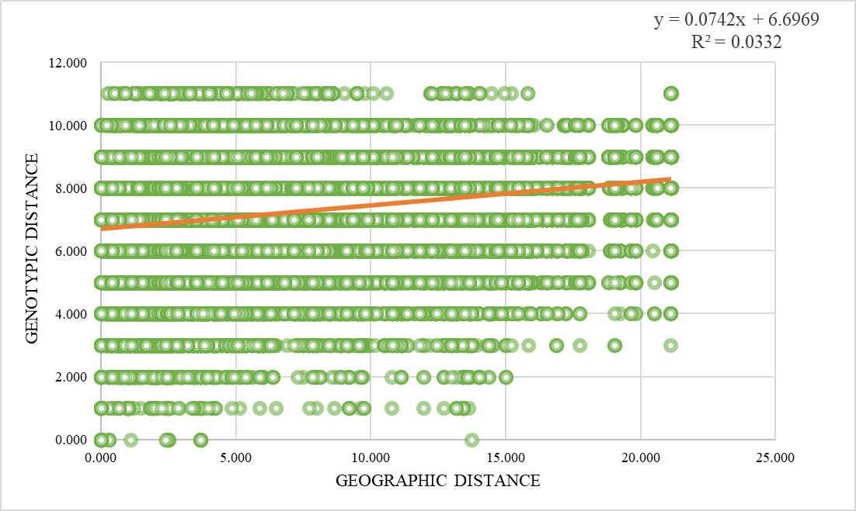

Fig. S3. Isolation-by-distance test of Morella between the genetic distance and population altitude.
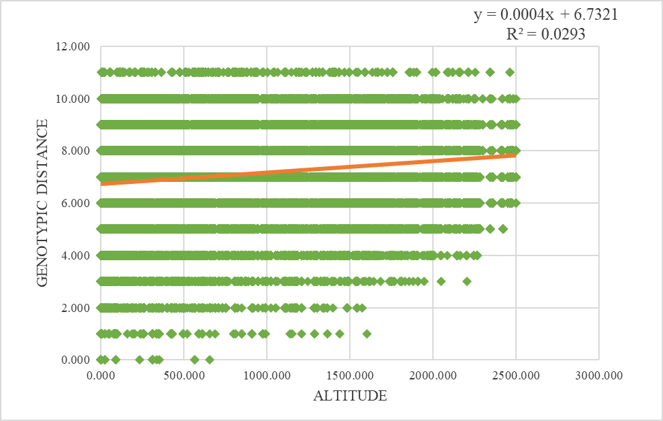

Fig. S4. Mismatch analysis based on chloroplast DNA sequence (a) Mismatched analysis diagram of M. rubra population. (b) Mismatch analysis diagram of M. nana population. (c) Mismatch analysis diagram of M. esculenta population. (d) Mismatch analysis diagram of M. adenophora population. (e) Mismatch analysis chart for all four species.

