Supplementary materials
Supplementary Figure 1. Simple linear regression to predict internalising symptoms scores. Simple linear regressions were run with grit at wave 3 predicting wave 4 depression symptom z-scores (a), and anxiety symptom z-scores (b). All models were significant, with higher grit scores predicting lower depression symptoms, anxiety symptoms and internalising symptoms.
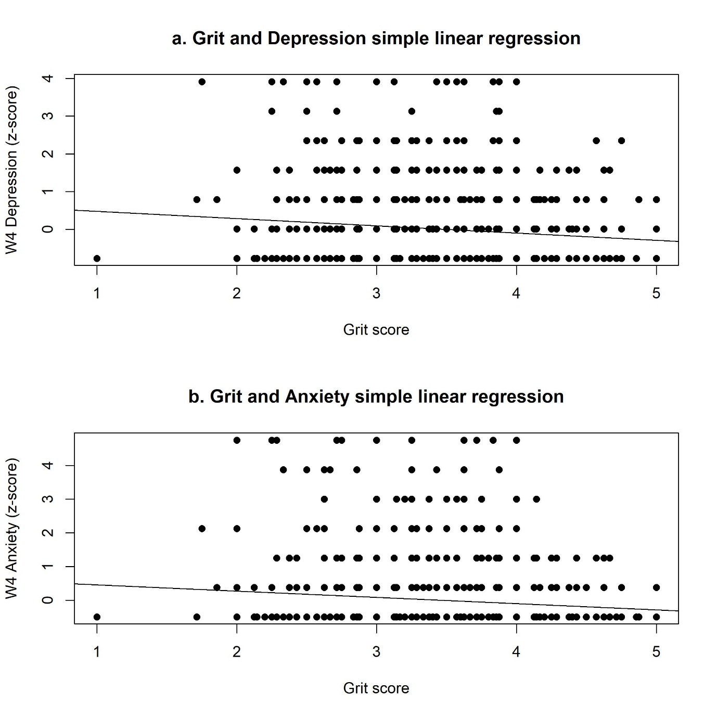
F(1, 1049) = 11.54, p <0,001, R²=0,01
F(1, 1049) = 12.39, p <0,001, R²=0,01

Supplementary Figure 2. Description of internalising symptoms during wave 3 and wave 4. Depression and anxiety symptoms were reported by study participants using standardised measures. The scores were standardised into z-scores and an internalising symptoms score was created by averaging the depression and anxiety z-scores. Higher scores indicate more symptoms present. Overall, no significant changes were seen between wave 3 and wave 4. Although difference gender trends were observed, these were not significant.

Supplementary Figure 3. Difference score in internalising symptoms from wave 3 to wave 4. To calculate a difference score, wave 3 internalising symptoms score was subtracted from wave 4 internalising symptoms scores. Difference scores above 0 mean that they developed more symptoms over time, while scores below 0 means that symptoms reduced over time. The distribution of changes followed a normal bell curve centred around no change.

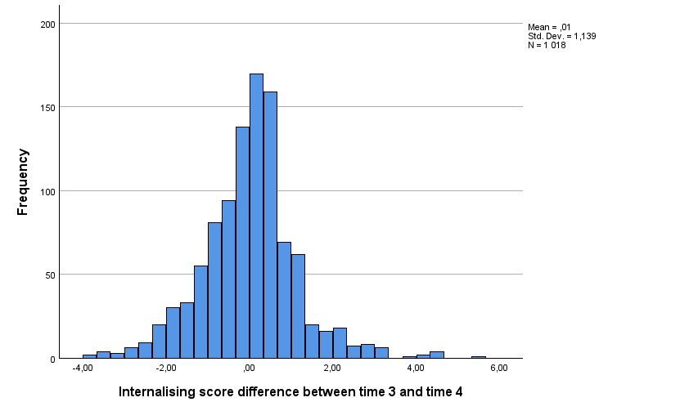
Supplementary Figure 4. Internalising symptoms scores of the top 20% and the remaining 80%. An internalising symptoms score was created by averaging the depression and anxiety z-scores. Those scoring in the top 20% at wave 3 were characterised as presenting with high levels of internalising symptoms as compared to the remaining 80%. The z-scores of the wave 3 top 20% reduced significantly in wave 4 for depressive symptoms (t(190) = 11.38, p<0.001) and anxiety symptoms (t(187) = 10.00, p<0.001). Conversely, the z-scores of the remaining wave 3 80% increased significantly in wave 4 for depressive symptoms (t(814) = -8.41, p<0.001) and anxiety symptoms (t(786) = -7.37, p<0.001).

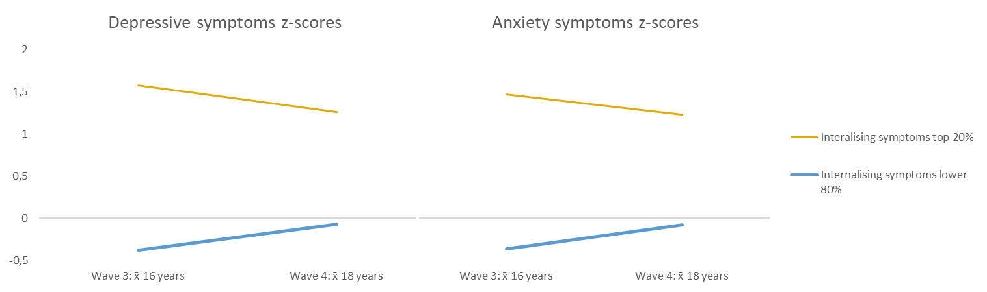
*
*
*

Supplementary Table1. Characterising grit scores by gender. Self-reported grit in the overall sample at Wave 3 was average to high, with a range of 1 – 5. Female adolescents reported significantly higher grit scores as compared to males [t(1092) = -2.55, p = 0.011]. Grit scores were normally distributed in the sample (skewness = -0.001; kurtosis = 0.177}.

 |  | Gender
 | Overall | Male | Female
 | N = 1094¹ | N = 547¹ | N = 547¹ | p-value²
Grit score | 3.42 (0.57) | 3.38 (0.55) | 3.47 (0.59) | 0.011
Missing | 80 | 39 | 41
¹Mean (SD)
²Wilcoxon rank sum test

Supplementary Table 2. Spearman’s rank correlations between grit scores and indicators of socioeconomic adversity. Grit scores were not significantly correlated with any indicators of socioeconomic adversity. Socioeconomic adversity, relative to the sample, was defined as low caregiver education (did not complete primary school), placement within the lowest quartile of household assets and food insecurity.
Variable | Low asset | Food insecurity | Low caregiver education
Low asset | -
Food insecurity | 0.215** | -
Low caregiver education | 0.103** | 0.083** | -
Grit | -0.058 | 0.007 | -0.032
**. Correlation is significant at the 0.01 level (2-tailed).

Supplementary Table 3. Linear regression models predicting depression and anxiety symptoms. This table shows all the linear regressions model run predicting depression and anxiety symptom severity at wave 4, both including and excluding socioeconomic variables. All models were significant, but grit was no longer a significant contributor to the anxiety model when socioeconomic variables were included.
Predictor variable |  | B | SE | t | p | F (p)
Model 1: Internalizing Symptoms
 | Grit | -0.19 | 0.05 | -3.89 | <0.001 | 15.1 (p<0.001)
Model 2: Internalizing Symptoms
 | Grit | -0.12 | 0.05 | -2.45 | 0.015 | 18.01 (p<0.001)
 | Age | 0.12 | 0.04 | 3.08 | 0.002 | 18.01 (p<0.001)
 | Gender | 0.09 | 0.05 | 1.66 | 0.097 | 18.01 (p<0.001)
 | Wave 3 Internalising symptoms | 0.19 | 0.03 | 6.39 | <0.001 | 18.01 (p<0.001)
Model 3: Depressive Symptom
 | Grit | -0.19 | 0.05 | -3.52 | <0.001 | 12.39 (p <0.001)
Model 4: Depressive Symptoms
 | Grit | -0.14 | 0.06 | -2.44 | 0.015 | 19.94 (p <0.001)
 | Age | 0.17 | 0.04 | 4.02 | <0.001 | 19.94 (p <0.001)
 | Gender | 0.11 | 0.06 | 1.81 | 0.071 | 19.94 (p <0.001)
 | Wave 3 depressive symptoms | 0.20 | 0.03 | 6.42 | <0.001 | 19.94 (p <0.001)
Model 5: Depressive Symptoms
 | Grit | -0.14 | 0.06 | -2.37 | 0.018 | 10.25 (p<0.001)
 | Age | 0.18 | 0.04 | 4.06 | <0.001 | 10.25 (p<0.001)
 | Gender | 0.12 | 0.06 | 1.87 | 0.062 | 10.25 (p<0.001)
 | Wave 3 depressive symptoms | 0.20 | 0.03 | 6.14 | <0.001 | 10.25 (p<0.001)
 | Food insecurity | 0.00 | 0.10 | 0.04 | 0.964 | 10.25 (p<0.001)
 | Low caregiver education | -0.02 | 0.07 | -0.34 | 0.731 | 10.25 (p<0.001)
 | Asset index | -0.02 | 0.03 | -0.64 | 0.522 | 10.25 (p<0.001)
Model 6: Anxiety Symptoms
 | Grit | -0.18 | 0.05 | -3.40 | <0.001 | 11.54 (p <0.001)
Model 7: Anxiety Symptoms
 | Grit | -0.11 | 0.06 | -1.91 | 0.05 | 9.08 (p <0.001)
 | Age | 0.05 | 0.05 | 1.08 | 0.279 | 9.08 (p <0.001)
 | Gender | 0.06 | 0.06 | 1.01 | 0.314 | 9.08 (p <0.001)
 | Wave 3 anxiety symptoms | 0.16 | 0.03 | 4.96 | <0.001 | 9.08 (p <0.001)
Model 8: Anxiety Symptoms
 | Grit | -0.10 | 0.06 | -1.61 | 0.107 | 3.28 (p = 0.002)
 | Age | 0.07 | 0.05 | 1.55 | 0.123 | 3.28 (p = 0.002)
 | Gender | 0.06 | 0.07 | 0.96 | 0.336 | 3.28 (p = 0.002)
 | Wave 3 anxiety symptoms | 0.17 | 0.03 | 4.99 | <0.001 | 3.28 (p = 0.002)
 | Food insecurity | -0.01 | 0.02 | -0.324 | 0.746 | 3.28 (p = 0.002)
 | Low caregiver education | 0.00 | 0.02 | 0.136 | 0.892 | 3.28 (p = 0.002)
 | Asset index | 0.02 | 0.03 | 0.53 | 0.595 | 3.28 (p = 0.002)
Notes: B is the unstandardized beta; SE is the standard error for the unstandardised beta; t is the test statistic; p is the significance of each variable; F(p) is the test statistic of the model with the significance of the model

 | Supplementary Table 4. Logistic regression models predicting depression and anxiety symptoms. This table shows all the logistic regressions model run predicting the odds of presenting with depression and anxiety symptoms at wave 4, both including and excluding socioeconomic variables. All depression models were significant, but grit was not a significant contributor to the model when socioeconomic variables were excluded. The anxiety model including socioeconomic was not significant.
 | Predictor variables |  |  | Coefficient (B) | OR (95% CI) |  | p |  | Model statistics
 | Model 1: Depression Symptoms |  |  |  |  |  |  |  | X² (1, N = 1051) = 8.30, p = 0.004
 |  |  | Grit | -0.50 | 0.61 (0.43 – 0.86) |  | 0.004 |  | X² (1, N = 1051) = 8.30, p = 0.004
 | Model 2: Depression Symptoms |  |  |  |  |  |  |  | X² (1, N = 1003) = 47.29, p <0.001
 |  |  | Grit | -0.41 | 0,71 (0.49 – 1.02) |  | 0.064 |  | X² (1, N = 1003) = 47.29, p <0.001
 |  |  | Age | 0.56 | 1,75 (1.32 – 2.31) |  | <0.001
 |  |  | Gender | 0.32 | 1.37 (0.91 – 2.06) |  | 0.126
 |  |  | Wave 3 depression symptoms | 0.96 | 2.60 (1.71 – 3.95) |  | <0.001
Model 3: Depression symptoms |  |  |  |  |  |  |  |  | X² (7, N = 968) = 52.13, p <0.001
 |  | Grit |  | -0,884 |  | 0,41 (0,19 - 0,86) |  | 0,018 | X² (7, N = 968) = 52.13, p <0.001
 |  | Gender |  | 0,148 |  | 1,16 (0,51 - 2,63) |  | 0,723
 |  | Age |  | 0,699 |  | 2,01 (1,10 - 3,67) |  | 0,023
 |  | Wave 3 Depression symptoms |  | 0,877 |  | 2,40 (1,04 - 5,55) |  | 0,04
 |  | Food insecurity |  | -0,501 |  | 0,61 (0,13 - 2,91) |  | 0,531
 |  | Low caregiver education |  | 0,404 |  | 1,50 (0,65 - 3,48) |  | 0,347
 |  | Asset index |  | 0,441 |  | 1,55 (1,01 - 2,39) |  | 0,046
 | Model 4: Anxiety Symptoms |  |  |  |  |  |  |  | X² (1, N = 1051) = 14.50, p <0.001
 |  |  | Grit | -0.84 | 0.43 (0.30 – 0.78) |  | <0.001 |  | X² (1, N = 1051) = 14.50, p <0.001
 | Model 5: Anxiety Symptoms |  |  |  |  |  |  |  | X² (4, N = 971) = 23.049, p <0.001
 |  |  | Grit | -0.56 | 0.57 (0.35 - 0.93) |  | 0.024 |  | X² (4, N = 971) = 23.049, p <0.001
 |  |  | Age | 0.16 | 1.18 (0.82 - 1.69) |  | 0.373
 |  |  | Gender | 0.33 | 1.40 (0.82 – 2.37) |  | 0.218
 |  |  | Wave 3 Anxiety symptoms | 1.03 | 2.81 (1.60 – 4.94) |  | <0.001
Model 6: Anxiety Symptoms |  |  |  |  |  |  |  |  | X² (7, N = 236) = 13.28, p = 0.066
 |  | Grit |  | - |  | - |  | - | X² (7, N = 236) = 13.28, p = 0.066
 |  | Gender |  | - |  | - |  | -
 |  | Age |  | - |  | - |  | -
 |  | Wave 3 Anxiety symptoms |  | - |  | - |  | -
 |  | Food insecurity |  | - |  | - |  | -
 |  | Low caregiver education |  | - |  | - |  | -
 |  | Asset index |  | - |  | - |  | -
 | OR = Odds ratio; CI= Confidence interval

Supplementary Table 5. Sociodemographic characteristics of adolescent participants aged 15-17 years old at wave 3. This table describes the characteristics of a subset of the sample who were between the ages of 15 and 17 at wave 3. P-values refer to the comparison of participant characteristics in wave 3 and wave 4 variables using Chi-square tests. The asset index was calculated using a factor analysis model and standardised (mean [SD], 0 [1]), food insecurity refers to answering “often” to any one of the three questions, and low caregiver education was defined as the third quartile of the distribution.

 |  |  | Wave 3¹ | Wave 4¹
 |  |  | N = 1075 | N = 1029 | p-value
Age | (years)
 | Mean [SD] |  | 15.90 [0.73] | 17.88 [0.68] | -
 | Range |  | 15 - 17 | 16 - 20
Gender
 | Male |  | 538 (50.0%) | 505 (49.0%) | 0.672
 | Female |  | 537 (50.0%) | 525 (51.0%)
 | Missing |  |  | 45
Attending school |  |  |  |  | <0.001
 | Yes |  | 1023 (95.7%) | 817 (79.3%)
 | No |  | 44 (4.1%) | 48 (4.7%)
 | Completed high school |  | 1 (0.1%) | 165 (16.0%)
 | Missing |  | 7 | 45
Grade |  |  |  |  | <0.001
 | Lower than Grade 8 |  | 15 (1.5%) | 2 (0.2%)
 | Grade 8 |  | 75 (7.3 %) | 5 (0.6%)
 | Grade 9 |  | 197 (19.3%) | 31 (3.8%)
 | Grade 10 |  | 369 (36.1%) | 177 (21.6%)
 | Grade 11 |  | 293 (28.6%) | 273 (33.3%)
 | Grade 12 |  | 72 (7.0%) | 331 (40.4%)
 | Missing |  | 52 | 256
HIV Status |  |  |  |  | <0.001
 | Positive |  | 32 (3.0%) | 36 (3.3%)
 | Negative |  | 573 (53.3%) | 929 (86.4%)
 | Unknown |  | 470 (43.7%) | 110 (10.3%)
Grit score |  |  | 3.42 [0.57] | -
 |  | Missing | 65 | -
Patient Health Questionnaire score |  |  |  |  | <0.001
 | Presence of depression symptoms* |  | 201 (22.4%) | 114 (11.1%)
 | Minimal /no depression symptoms |  | 695 (77.6%) | 916 (88.9%)
 | Missing |  | 179 | 45
Generalized Anxiety Disorder Questionnaire Score |  |  |  |  | <0.001
 | Presence of anxiety symptoms* |  | 140 (16.0%) | 67 (6.5%)
 | Minimal /no anxiety symptoms |  | 735 (84.0%) | 963 (93.5%)
 | Missing |  | 200 | 45
Socioeconomic adversity
 | Low asset index |  | 265 (22.5%) | -
 | Food insecurity |  | 65 (6.0%) | -
 | Low caregiver education |  | 349 (32.5%) | -
¹n (%); Mean [SD]
*Scores above the test cut-off

Supplementary Table 6. Linear regression models predicting depression and anxiety symptoms of a sample subset. Linear regressions were run on a subset of participants aged 15-17. This table shows all the models run predicting the odds of presenting with depression and anxiety symptoms at wave 4, both including and excluding socioeconomic variables. All models were significant.

Predictor variable |  | B | SE | T | P | F (p)
Model 1: Internalizing Symptoms
 | Grit | -0.19 | 0.05 | -3.89 | <0.001 | 15.05 (p<0.001)
Model 2: Internalizing Symptoms
 | Grit | -0.13 | 0.05 | -2.47 | 0.014 | 16.79 (p<0.001)
 | Age | 0.12 | 0.04 | 2.93 | 0.003 | 16.79 (p<0.001)
 | Gender | 0.09 | 0.06 | 1.51 | 0.132 | 16.79 (p<0.001)
 | Wave 3 Internalising symptoms | 0.19 | 0.03 | 6.11 | <0.001 | 16.79 (p<0.001)
Model 3: Depressive Symptom
 | Grit | -0.19 | 0.06 | -3.38 | <0.001 | 11.44 (p <0.001)
Model 4: Depressive Symptoms
 | Grit | -0.14 | 0.06 | -2.36 | 0.019 | 18.46 (p <0.001)
 | Age | 0.18 | 0.05 | 3.76 | <0.001 | 18.46 (p <0.001)
 | Gender | 0.11 | 0.06 | 1.63 | 0.104 | 18.46 (p <0.001)
 | Wave 3 depressive symptoms | 0.21 | 0.03 | 6.24 | <0.001 | 18.46 (p <0.001)
Model 5: Depressive Symptoms
 | Grit | -0.14 | 0.06 | -2.40 | 0.017 | 10.77 (p<0.001)
 | Age | 0.18 | 0.05 | 3.71 | <0.001 | 10.77 (p<0.001)
 | Gender | 0.11 | 0.06 | 1.64 | 0.101 | 10.77 (p<0.001)
 | Wave 3 depressive symptoms | 0.21 | 0.03 | 6.24 | <0.001 | 10.77 (p<0.001)
 | Food insecurity | 0.06 | 0.14 | 0.43 | 0.670 | 10.77 (p<0.001)
 | Low caregiver education | -0.04 | 0.07 | -0.65 | 0.518 | 10.77 (p<0.001)
 | Asset index | -0.09 | 0.10 | -0.88 | 0.380 | 10.77 (p<0.001)
Model 6: Anxiety Symptoms
 | Grit | -0.19 | 0.06 | -3.51 | <0.001 | 12.31 (p <0.001)
Model 7: Anxiety Symptoms
 | Grit | -0.12 | 0.06 | -1.95 | 0.052 | 8.56 (p <0.001)
 | Age | 0.05 | 0.05 | 0.97 | 0.333 | 8.56 (p <0.001)
 | Gender | 0.06 | 0.06 | 0.96 | 0.338 | 8.56 (p <0.001)
 | Wave 3 anxiety symptoms | 0.16 | 0.03 | 4.74 | <0.001 | 8.56 (p <0.001)
Model 8: Anxiety Symptoms
 | Grit | -0.12 | 0.06 | -1.97 | 0.050 | 5.52 (p<0.001)
 | Age | 0.04 | 0.05 | 0.90 | 0.367 | 5.52 (p<0.001)
 | Gender | 0.06 | 0.06 | 0.97 | 0.332 | 5.52 (p<0.001)
 | Wave 3 anxiety symptoms | 0.16 | 0.03 | 4.74 | <0.001 | 5.52 (p<0.001)
 | Food insecurity | -0.21 | 0.15 | -1.48 | 0.139 | 5.52 (p<0.001)
 | Low caregiver education | -0.03 | 0.07 | -0.37 | 0.715 | 5.52 (p<0.001)
 | Asset index | -0.19 | 0.10 | -1.89 | 0.059 | 5.52 (p<0.001)
Notes: B is the unstandardized beta; SE is the standard error for the unstandardised beta; t is the test statistic; p is the significance of each variable; F(p) is the test statistic of the model with the significance of the model

 | Supplementary Table 7. Logistic regression models predicting depression and anxiety symptoms at of a sample subset. Logistic regressions were run on a subset of participants aged 15-17. This table shows all the models run predicting the odds of presenting with depression and anxiety symptoms at wave 4, both including and excluding socioeconomic variables. All depression models were significant, but grit was not a significant contributor to the model when socioeconomic variables were excluded. The anxiety model including socioeconomic was not significant.
 | Predictor variables |  |  |  | Coefficient (B) | OR (95% CI) | p |  | Model Statistics
 | Model 1: Depression Symptoms |  |  |  |  |  |  |  | X² (1, N = 1075) = 6.96, p = 0.008
 |  |  | Grit |  | -0.47 | 0.62 (0.44 – 0.89) | 0.009 |  | X² (1, N = 1075) = 6.96, p = 0.008
 | Model 2: Depression Symptoms |  |  |  |  |  |  |  | X² (4, N = 1075) = 42.49, p = <0.001
 |  |  | Grit |  | -0.31 | 0,73 (0.50 – 1.07) | 0.103 |  | X² (4, N = 1075) = 42.49, p = <0.001
 |  |  | Age |  | 0.57 | 1,76 (1.30 – 2.39) | <0.001
 |  |  | Gender |  | 0.26 | 1.30 (0.85 – 1.98) | 0.229
 |  |  | Wave 3 depression symptoms |  | 0.99 | 2.70 (1.74 – 4.17) | <0.001
Model 3: Depression symptoms |  |  |  |  |  |  |  |  | X² (7, N = 1075) = 28.05, p = <0.001
 |  | Grit |  | -0,87 |  | 0,41 (0,19 - 0,86) |  | 0,025 | X² (7, N = 1075) = 28.05, p = <0.001
 |  | Gender |  | 0.12 |  | 1,16 (0,51 - 2,63) |  | 0,788
 |  | Age |  | 0.83 |  | 2,01 (1,10 - 3,67) |  | 0,015
 |  | Wave 3 Depression symptoms |  | 0.96 |  | 2,40 (1,04 - 5,55) |  | 0,031
 |  | Food insecurity |  | -0,51 |  | 0,61 (0,13 - 2,91) |  | 0,530
 |  | Low caregiver education |  | 0.67 |  | 1,50 (0,65 - 3,48) |  | 0,139
 |  | Asset index |  | 0.55 |  | 1,55 (1,01 - 2,39) |  | 0,019
 | Model 4: Anxiety Symptoms |  |  |  |  |  |  |  | X² (1, N = 1075) = 14.98, p <0.001
 |  |  | Grit |  | -0.88 | 0.42 (0.27 – 0.65) | <0.001 |  | X² (1, N = 1075) = 14.98, p <0.001
 | Model 5: Anxiety Symptoms |  |  |  |  |  |  |  | X² (7, N = 1075) = 23.34, p <0.001
 |  |  | Grit |  | -0.56 | 0.57 (0.35 - 0.94) | 0.027 |  | X² (7, N = 1075) = 23.34, p <0.001
 |  |  | Age |  | 0.16 | 1.18 (0.80 - 1.74) | 0.410
 |  |  | Gender |  | 0.31 | 1.37 (0.79 – 2.36) | 0.262
 |  |  | Wave 3 Anxiety symptoms |  | 1.08 | 2.95 (1.64 – 5.31) | <0.001
Model 6: Anxiety Symptoms |  |  |  |  |  |  |  |  | X² (7, N = 1075) = 12.35, p = 0.090
 |  | Grit |  | - |  | - |  | - | X² (7, N = 1075) = 12.35, p = 0.090
 |  | Gender |  | - |  | - |  | -
 |  | Age |  | - |  | - |  | -
 |  | Wave 3 Anxiety symptoms |  | - |  | - |  | -
 |  | Food insecurity |  | - |  | - |  | -
 |  | Low caregiver education |  | - |  | - |  | -
 |  | Asset index |  | - |  | - |  | -
 | OR = Odds ratio; CI= Confidence interval

