Supplement Figure S1
Supplementary Figure 1. Phenotypic characterization of untouched NK cells isolated from B6C3H donor mice. (a) Flow cytometry before NK enrichment to identify CD3-NK1.1⁺ cells from spleen, gated on singlets and CD45⁺ leukocytes, NK cell subsets were determined based on CD11b and CD27 expression. (b) Flow cytometry after enrichment of untouched NK cells prior to adoptive transfer. NK cell subsets based on CD11b and CD27 expression, showing proportions of immature (CD11b⁻CD27⁺), early mature (CD11b⁺CD27⁺), terminally mature (CD11b⁺CD27⁻), and double-negative (CD11b⁻CD27⁻) populations.

a
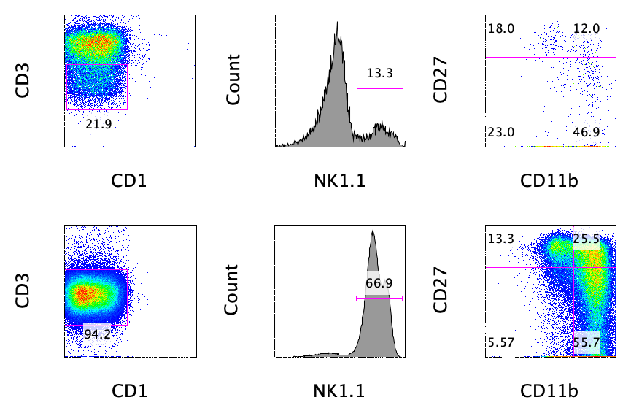

b

Supplementary Figure 2. NK cell infusion at lower dose mitigates pathological α-synuclein burden in specific brain regions. Graphs show the average total area of PK-resistant pS129-aSyn inclusions per region of interest in the cortex, striatum, SN, and brainstem. Quantification was performed on immunohistological images from M83 Tg mice injected with 2 million NK cells or saline in either the monomer or PFF α-syn group at 12 weeks post-injection (p.i.) (n = 4–6 mice per group). Sections were immunostained with anti–pS129-aSyn antibody. Statistical analysis was conducted using two-way ANOVA followed by Fisher’s LSD post hoc test. *p < 0.05, **p < 0.01 comparing saline- vs. NK-treated groups. Error bars represent mean ± SEM.

Supplement Figure S2

Total protein
Supplement Figure S3
a
b
p-aSyn monomer
p-aSyn oligomers
& fibrils

Supplementary Figure 3. NK cell infusion mitigates pathological α-synuclein accumulation in the spinal cord of M83 transgenic mice following PFF injection. M83 mice (8 weeks old) received unilateral stereotaxic injections of either monomeric (Mono) or aSyn PFF into the striatum. Mice were treated with either saline or 4 million NK cells via i.p. injection every two weeks and sacrificed at 7 weeks post-injection. Representative immunoblot images of p-aSyn in the cervical (a) and thoracic (b) spinal cords. Samples were collected from M83 Tg mice in the PFF α-syn and Mono α-syn saline groups (n = 3–5 mice per group).

