Supplement 1.
Gene | Primer Sequence
Gene | Forward | Reverse
Aba1 | 5′-ATCAACAAGCAATTCCTCGATGA-3′ | 5′-CAGCATTCGCTTCAAGGACATA-3′
P2ry12 | 5′-CATTGACCGCTACCTGAAGACC-3′ | 5′-GCCTCCTGTTGGTGAGAATCATG-3′
H2-Eb1 | 5′-TCCAGTGGCTTTGGTCAGAGAC-3′ | 5′-CAGGTTCTCCTCCAGGTTGTAG-3′
CD74 | 5′-GCTGGATGAAGCAGTGGCTCTT-3′ | 5′-GATGTGGCTGACTTCTTCCTGG-3′
GAPDH | 5′-TCCCTGAGCTGAACGGGAAG-3′ | 5′-GGAGGAGTGGGTGTCGCTGT-3′

Supplement 2.
Annotated cell type | Gene markers | Clusters
Endothelial | Pecam1, Cldn5, Flt1, Ctla2a | 0-3, 5, 11
Neuron | Stmn3, Celf4, Bex2, Gap43 | 4, 10, 19, 21, 28, 30
Microglia | Csf1r, C1qb, C1qa | 6, 8, 20
T cell | Cd3e, Cd3g | 7, 23
B cell | Cd79a, Ms4a1, Cd19 | 24
Smooth muscle cell | Myh11, Acta2, Myl9, Tagln, Cnn1, Tpm1 | 9
Choroid plexus epithelial cell | Slc22a17, Krt8 | 12, 27
Astrocyte | Aqp4, Gja1, Epcam | 13
Erythrocyte | Hba-a2, Hba-a1, Hbb-bt | 14
Ependymal | Ccdc153, Enkur, Foxj1 | 25
Oligodendrocyte | Mbp, Opalin, Olig1, Mog | 15
Neutrophil | S100a8, S100a9, Csf3r | 16, 26
DC | Irf8, Clec9a, Itgax | 17
Pericyte | Kcnj8, Rgs5, Mcam | 18
Fibroblasts | Dcn, Col1a1, Col1a2, dgfra | 22
Mast | Ms4a2, Ptprc | 29

Supplement 3.
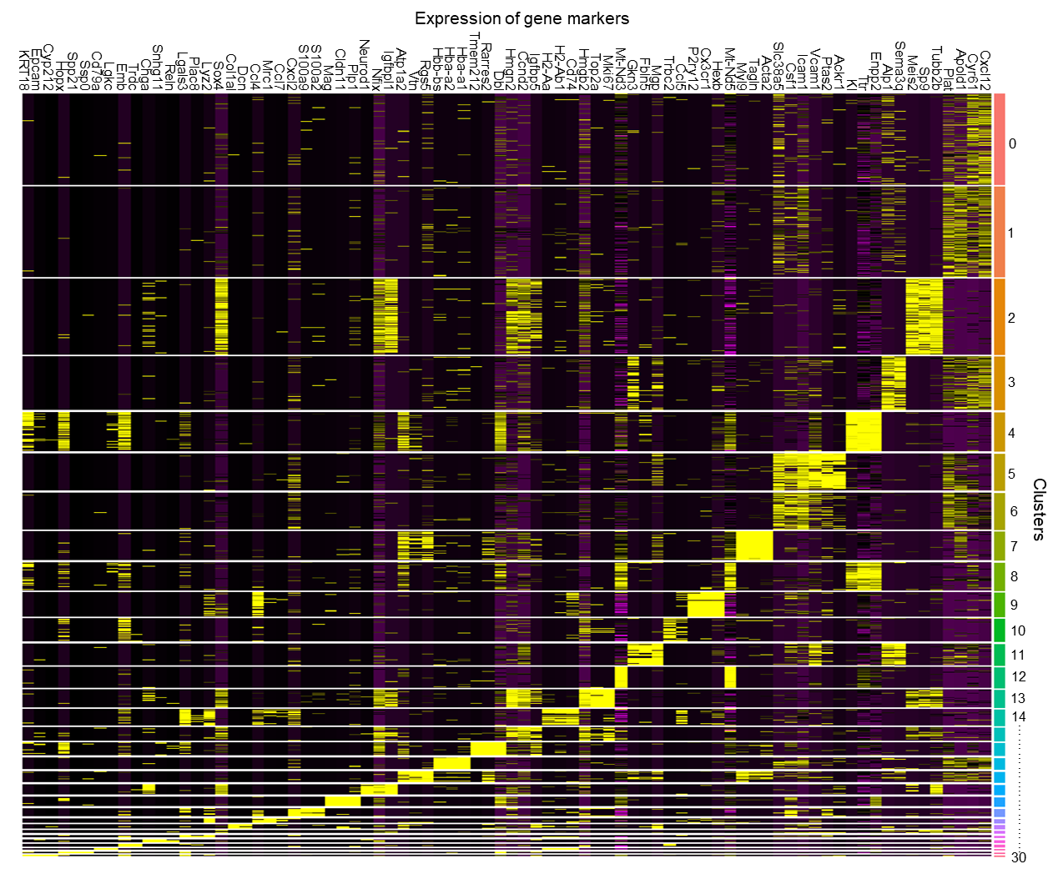

Supplement 4.
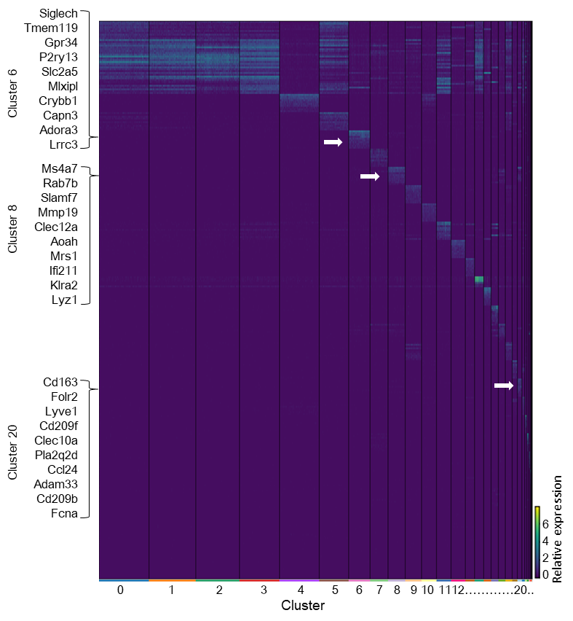

Supplement 5.
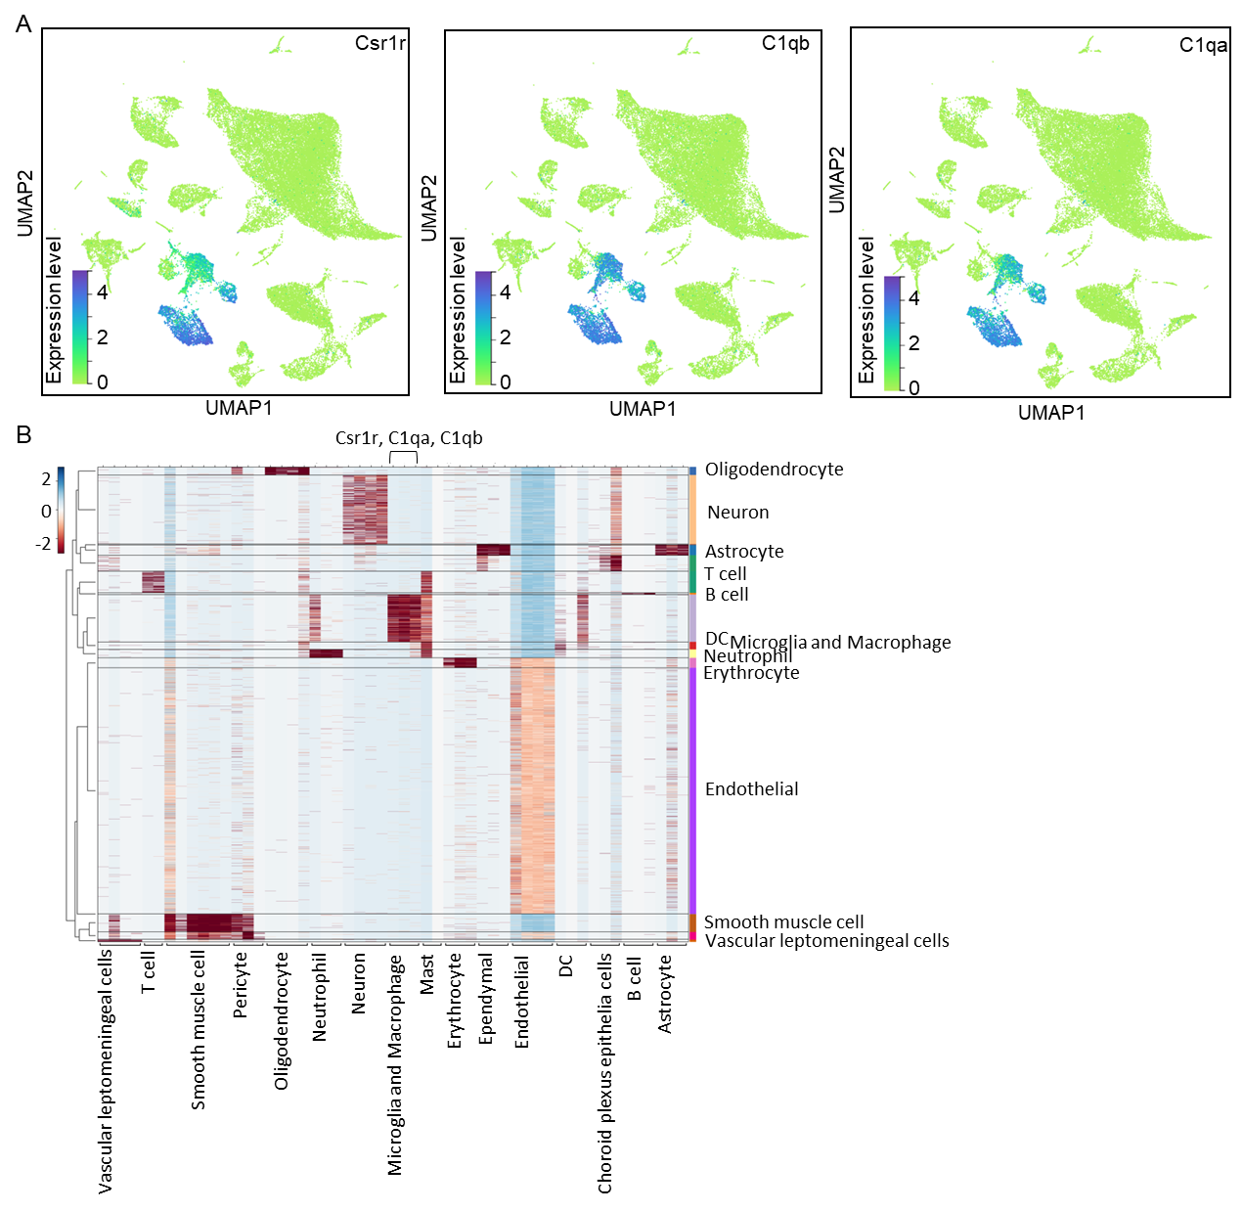

Supplement 6. E
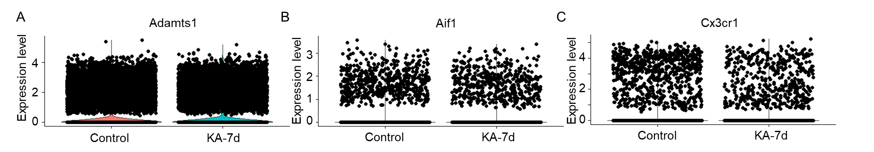

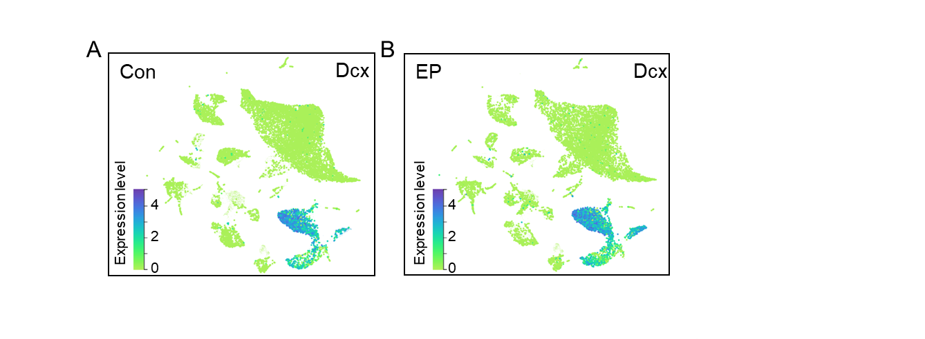
Supplement 7.

Supplement 8.
