Supplementary Figures
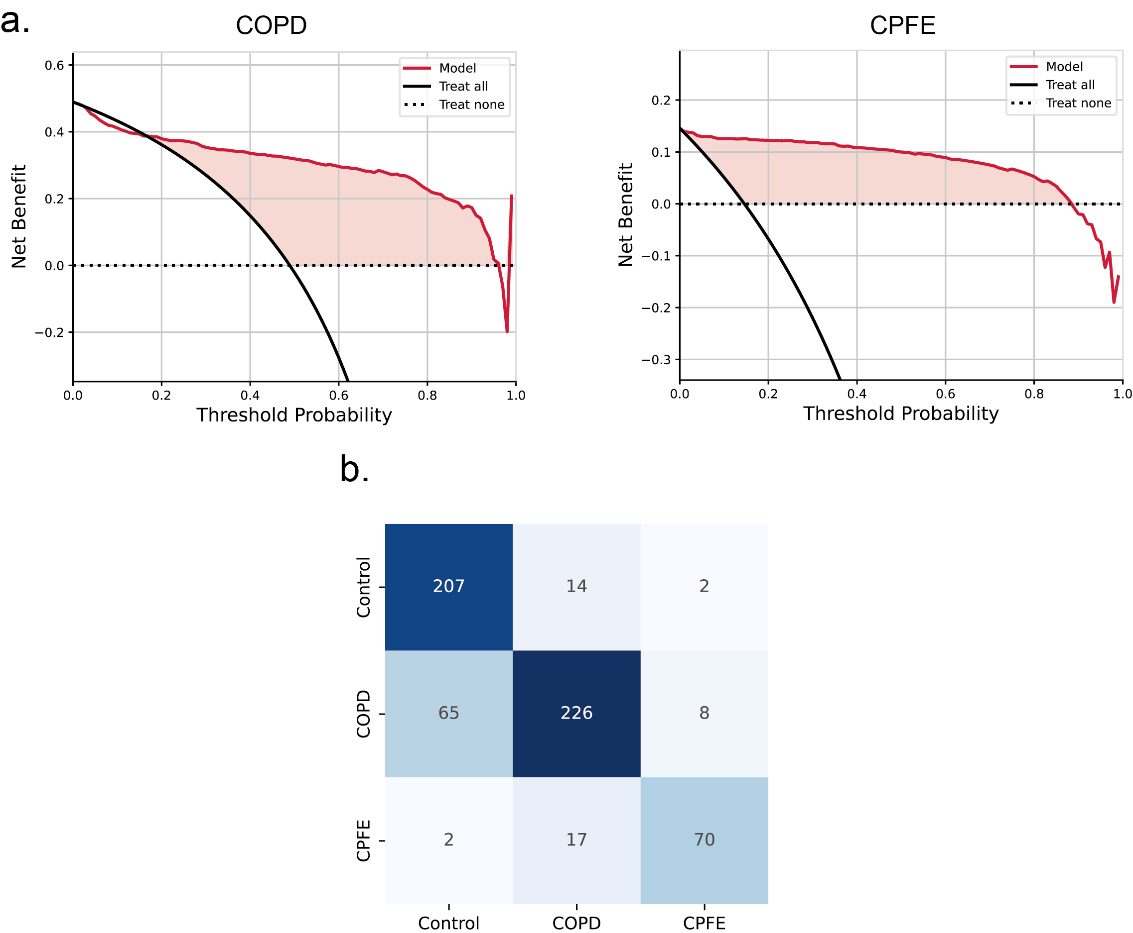
Supplementary figure 1: a: the DCA plot of the CPFENet in COPD and CPFE groups, b: the confusion matrix of the CPFENet for the validation dataset.
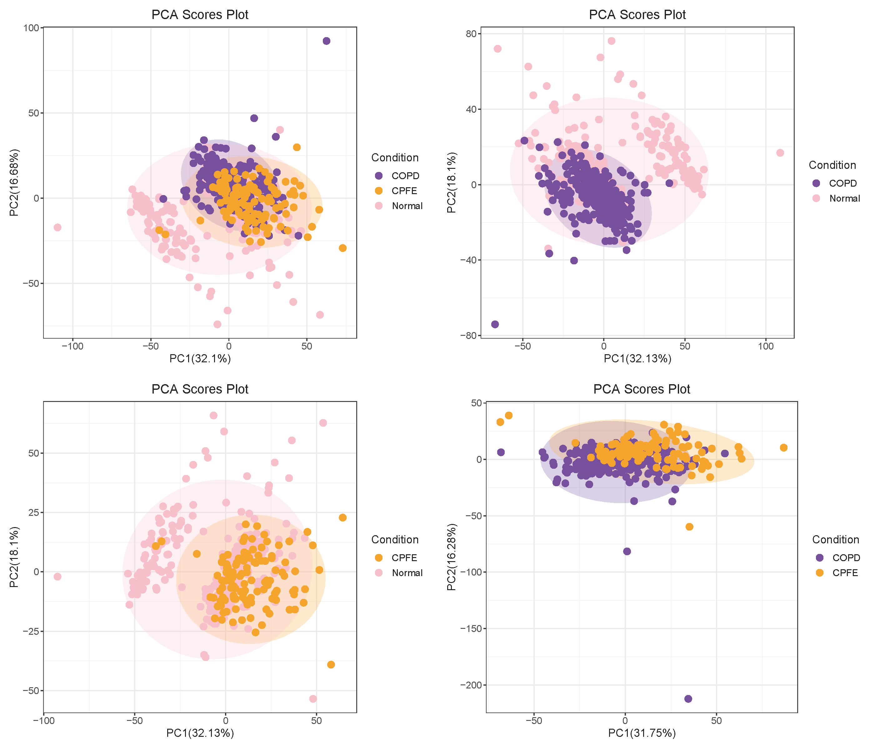
Supplementary figure 2: the PCA plot of different groups with radiomics features.

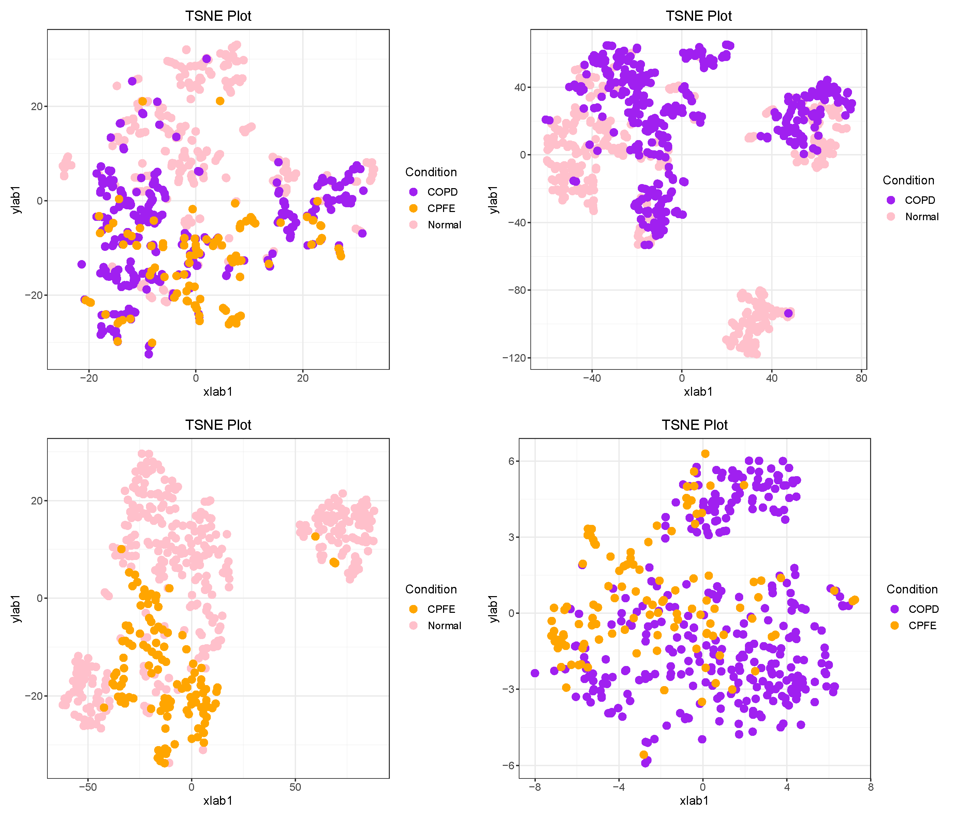
Supplementary figure 3: the TSNE plot of different groups with radiomics features
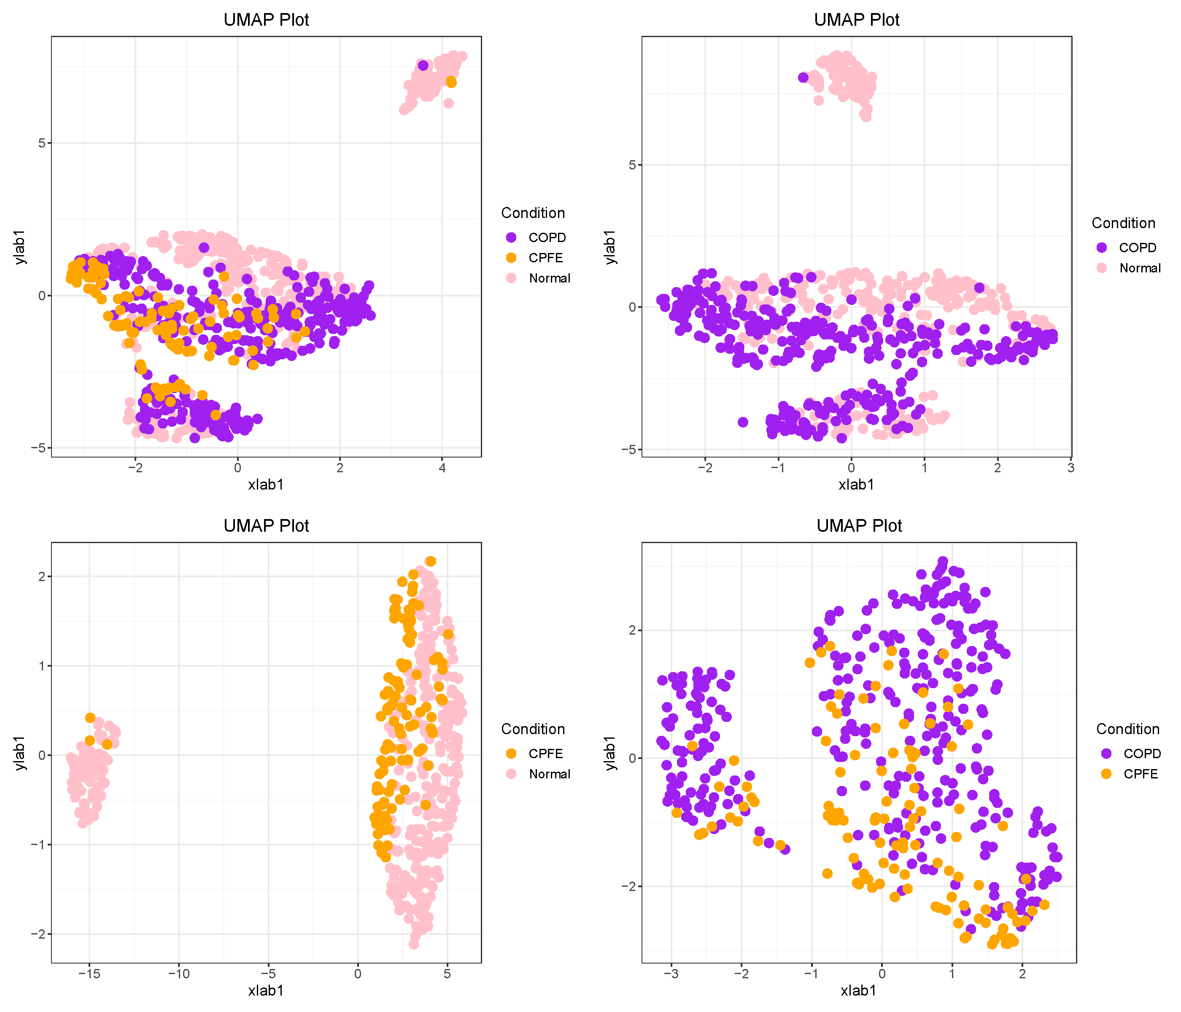
Supplementary figure 4: the UMAP plot of different groups with radiomics features.
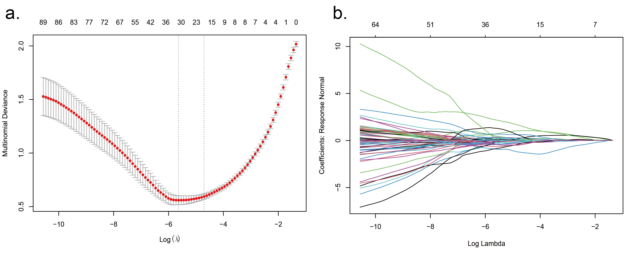
Supplementary figure 5: a: the lasso multinomial deviance-log(λ) plot of the lasso model selection, b: the lasso regularization path plot of the selected lasso model.

