Supplementary Figure 1：Transform continuous variables into categorical variables using cut-off values derived from the ROC curve（A-E）
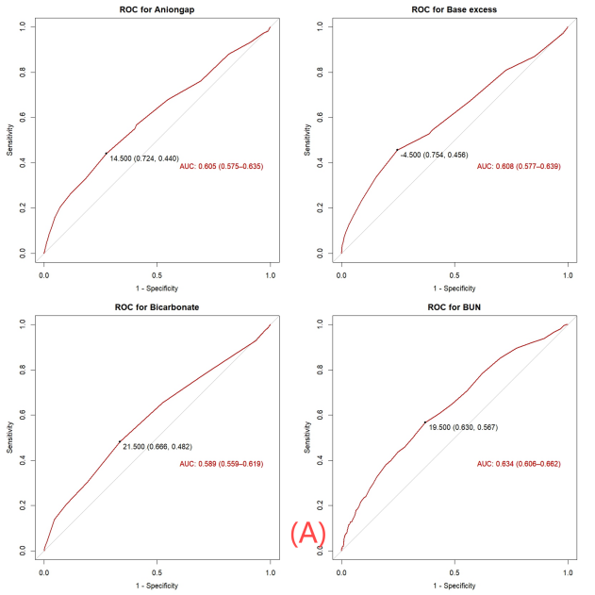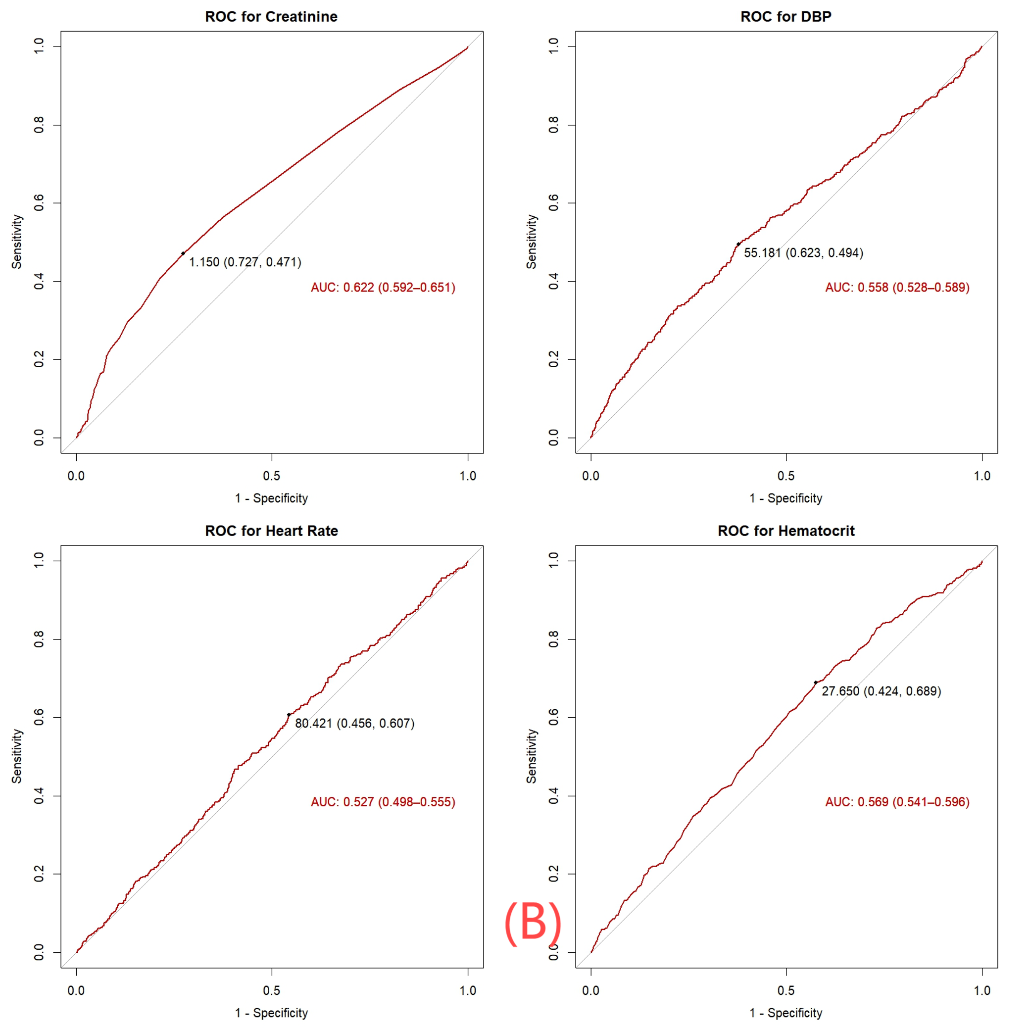
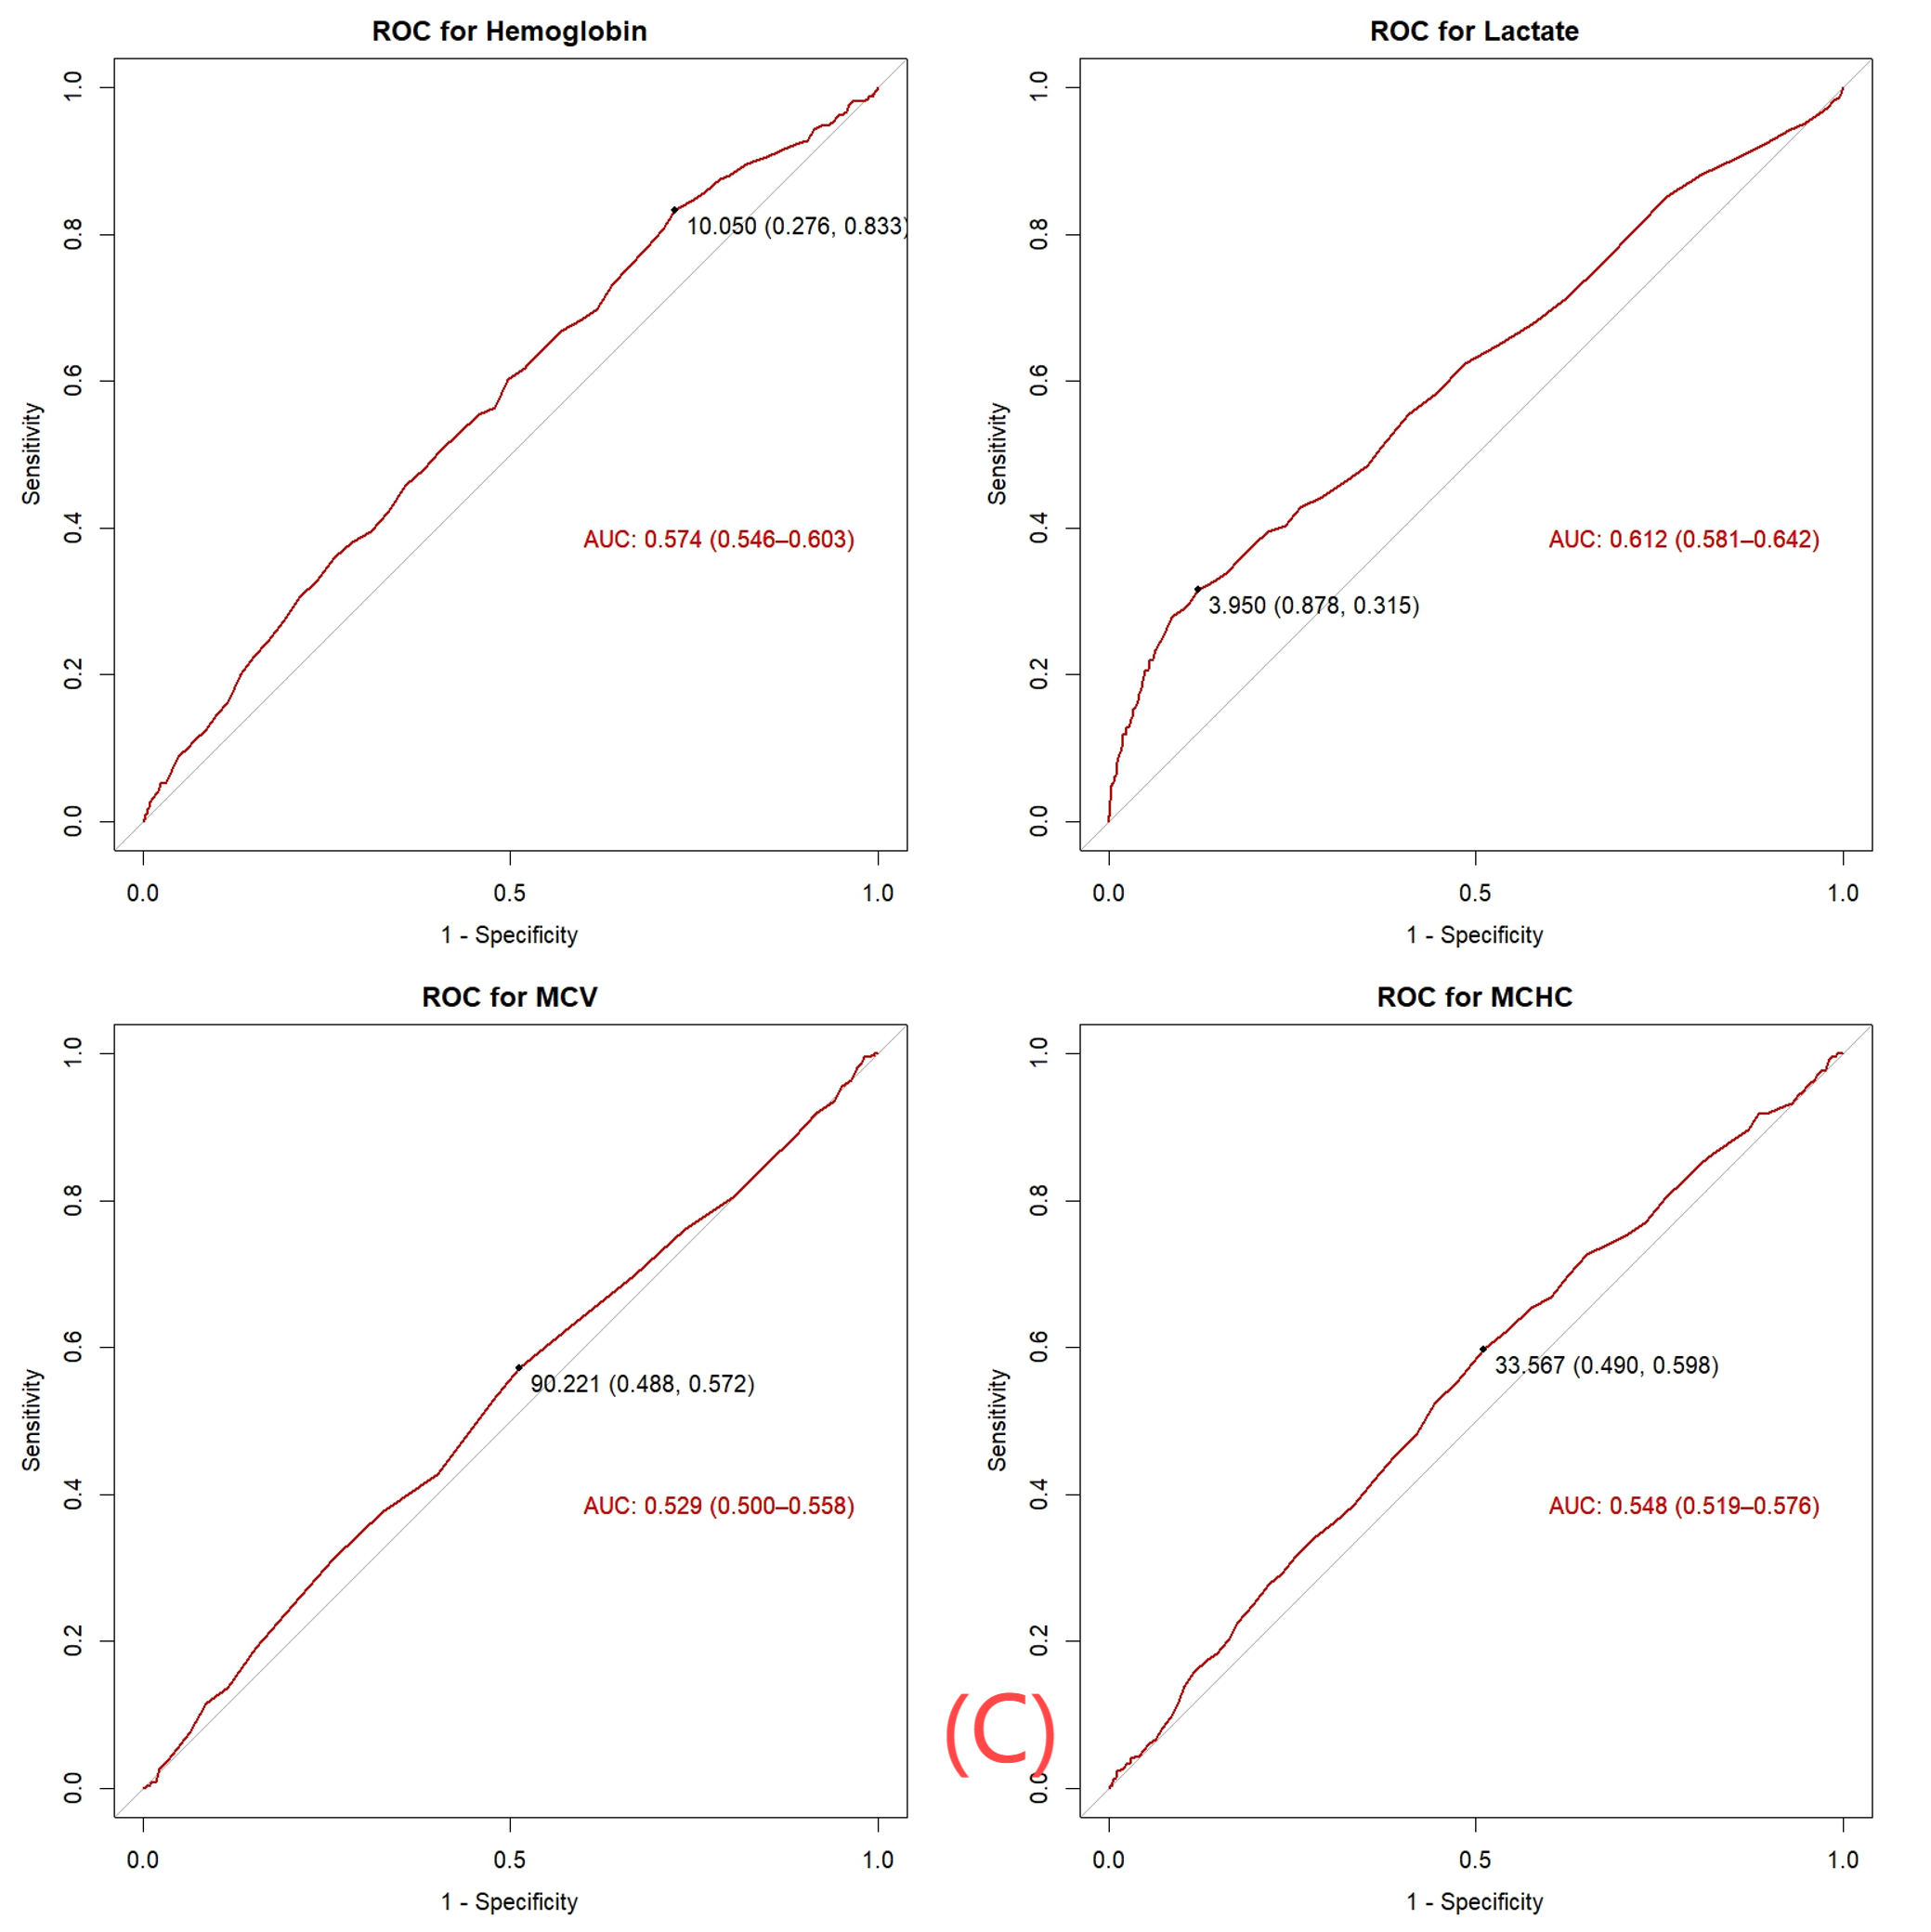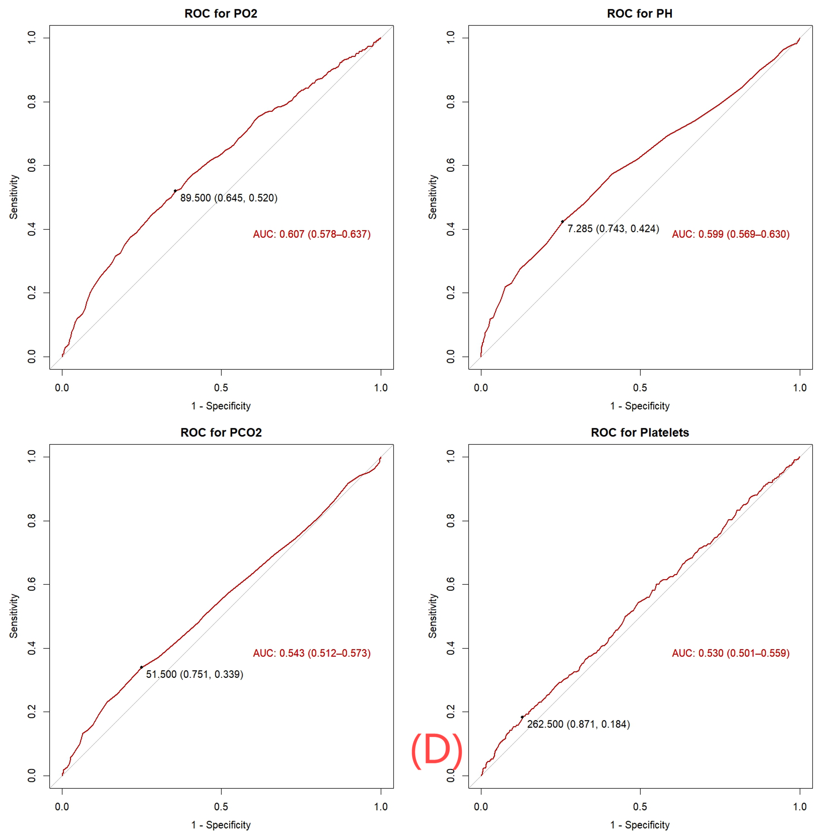
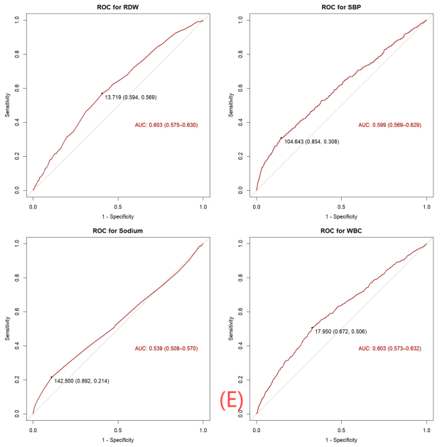
Supplementary Table 1：Approaches for managing missing data in variables
Variables | n | % | Total samples (n) | interpolation
lactate | 99 | 1.88% | 5168 | Mean imputation
PH | 90 | 1.71% | 5177 | Mean imputation
PO2 | 90 | 1.71% | 5177 | Mean imputation
PCO2 | 90 | 1.71% | 5177 | Mean imputation
base excess | 90 | 1.71% | 5177 | Mean imputation
hematocrit | 5 | 0.09% | 5262 | Mean imputation
hemoglobin | 5 | 0.09% | 5262 | Mean imputation
platelets | 76 | 1.44% | 5191 | Mean imputation
WBC | 4 | 0.08% | 5263 | Mean imputation
aniongap | 40 | 0.76% | 5227 | Mean imputation
bicarbonate | 5 | 0.09% | 5262 | Mean imputation
bun | 4 | 0.08% | 5263 | Mean imputation
creatinine | 4 | 0.08% | 5263 | Mean imputation
glucose | 117 | 2.22% | 5150 | Mean imputation
sodium | 10 | 0.19% | 5257 | Mean imputation
potassium | 35 | 0.66% | 5234 | Mean imputation
heart_rate | 4 | 0.08% | 5263 | Mean imputation
SBP | 12 | 0.23% | 5255 | Mean imputation
DBP | 12 | 0.23% | 5255 | Mean imputation
temperature | 591 | 11.22% | 4676 | Multiple imputation
mchc | 192 | 3.65% | 5075 | Mean imputation
mcv | 192 | 3.65% | 5075 | Mean imputation
rdw | 192 | 3.65% | 5075 | Mean imputation
BMI | 423 | 8.03% | 4844 | Multiple imputation
LVEF | 1378 | 26.16% | 3889 | Delete
Variables with > 20% missing data were excluded. Mean imputation was used for outliers and variables with <5% missing values, whereas multiple imputation was employed for variables with 5-20% missing values.

Supplementary File 1: STROBE Statement—checklist of items that should be included in reports of observational studies

 | Item No. | Recommendation | Page  No. | Relevant text from manuscript
Title and abstract | 1 | (a) Indicate the study’s design with a commonly used term in the title or the abstract | 1-2 | LASSO and logistic regression
Title and abstract | 1 | (b) Provide in the abstract an informative and balanced summary of what was done and what was found | 1-2 | Ventricular Arrhythmias
Introduction
Background/rationale | 2 | Explain the scientific background and rationale for the investigation being reported | 3 | Ventricular Arrhythmias, some of the most severe complications post-ABG, are a leading cause of sudden cardiac death.
Objectives | 3 | State specific objectives, including any prespecified hypotheses | 3 | Herein, we aimed to develop a prediction model to assess the risk of VA in patients post-CABG to aid clinicians in implementing proactive preventive and therapeutic measures for reducing in-hospital mortality and improving patient outcomes.
Methods
Study design | 4 | Present key elements of study design early in the paper | 3-4 | Data used herein were extracted from the publicly available Medical Information Mart for Intensive Care (MIMIC-IV version 2.2) database. Notably, since this study involved the analysis of a third-party anonymized public database, Institutional Review Board (IRB) approval was exempted.
Setting | 5 | Describe the setting, locations, and relevant dates, including periods of recruitment, exposure, follow-up, and data collection | 4 | Data used herein were extracted from the publicly available Medical Information Mart for Intensive Care (MIMIC-IV version 2.2) database. This retrospective study involved the analysis of the clinical data of CAD patients who underwent CABG during their hospital stay.
Participants | 6 | (a) Cohort study—Give the eligibility criteria, and the sources and methods of selection of participants. Describe methods of follow-up  Case-control study—Give the eligibility criteria, and the sources and methods of case ascertainment and control selection. Give the rationale for the choice of cases and controls  Cross-sectional study—Give the eligibility criteria, and the sources and methods of selection of participants | 4 | The exclusion criteria were as follows: (1) Patients with missing rhythm records; and (2)Patients with pre-existing VA before CABG. Notably, in the MIMIC-IV database, rhythm descriptions were recorded in the chartevents table.
Participants | 6 | (b) Cohort study—For matched studies, give matching criteria and number of exposed and unexposed  Case-control study—For matched studies, give matching criteria and the number of controls per case
Variables | 7 | Clearly define all outcomes, exposures, predictors, potential confounders, and effect modifiers. Give diagnostic criteria, if applicable | 5-9 | gender, age, race, BMI, complication, heart rate, temperature, systolic/diastolic blood pressure, and laboratory indicators (lactate, PH, PO2, PCO2, base excess, aniongap, white blood cell, hematocrit, hemoglobin, platelets, blood urea nitrogen,creatinine, glucose, sodium,potassium,bicarbonate,mean corpuscular hemoglobin concentration, mean corpuscular volume, red blood cell distribution width),OASIS score, SAPSII score, LODS score,treatment
Data sources/ measurement | 8* | For each variable of interest, give sources of data and details of methods of assessment (measurement). Describe comparability of assessment methods if there is more than one group | 3 | Medical records, laboratory results, demographic information, and International Classification of Diseases (ICD) codes for patients admitted to the Intensive Care Units (ICUs) of Beth Israel Deaconess Medical Center between 2008 and 2019 were extracted.
Bias | 9 | Describe any efforts to address potential sources of bias | 4 | This retrospective study involved the analysis of the clinical data of CAD patients who underwent CABG during their hospital stay. Baseline clinical data for patients upon ICU admission were extracted using SQL queries
Study size | 10 | Explain how the study size was arrived at | 4 | Strictly following the inclusion criteria, the final participants were determined
Quantitative variables | 11 | Explain how quantitative variables were handled in the analyses. If applicable, describe which groupings were chosen and why | 4-5 | For continuous variables, normally and non-normally distributed data were expressed as Mean± Standard Deviation (SD) and Medians [Interquartile Ranges(IQR)], respectively.
Statistical methods | 12 | (a) Describe all statistical methods, including those used to control for confounding | 4-5 | For continuous variables,independent sample t-tests or Mann-Whitney U tests were used for comparisons. Categorical variables were presented as frequencies (percentages) and compared using chi-square tests.
Statistical methods | 12 | (b) Describe any methods used to examine subgroups and interactions |  | No subgroup analysis was conducted
Statistical methods | 12 | (c) Explain how missing data were addressed | 4 | Variables with > 20% missing data were excluded. At the same time, mean imputation was used for outliers and variables with <5% missing values, whereas multiple imputation was employed for variables with 5-20% missing values
Statistical methods | 12 | (d) Cohort study—If applicable, explain how loss to follow-up was addressed  Case-control study—If applicable, explain how matching of cases and controls was addressed  Cross-sectional study—If applicable, describe analytical methods taking account of sampling strategy | 5 | Split the 5,267 CABG patients into two groups: Training (N=3,689) and validation (N=1,578) sets.
Statistical methods | 12 | (e) Describe any sensitivity analyses | 5-6 | The Receiver Operating Characteristic (ROC) curve [Area Under the Curve (AUC)], and calibration curve, Decision Curve Analysis (DCA)
Results
Participants | 13* | (a) Report numbers of individuals at each stage of study—eg numbers potentially eligible, examined for eligibility, confirmed eligible, included in the study, completing follow-up, and analysed | 5 | 5649 patients underwent coronary bypass grafting in MIMIC IV,Venricular arrhythmias before operation(n=48),Missing Heart Rhythm Recording(n=334),5267 patients were enrolled finally
Participants | 13* | (b) Give reasons for non-participation at each stage | 4 | Exclusion criteria
Participants | 13* | (c) Consider use of a flow diagram | 4 | Figure 1
Descriptive data | 14* | (a) Give characteristics of study participants (eg demographic, clinical, social) and information on exposures and potential confounders | 6 | The median age was 69 [61; 76], with 4053 (76.95%) males.
Descriptive data | 14* | (b) Indicate number of participants with missing data for each variable of interest |  | S1 Table. Approaches for managing missing data in variables.
Descriptive data | 14* | (c) Cohort study—Summarise follow-up time (eg, average and total amount) |  | No follow-up was conducted
Outcome data | 15* | Cohort study—Report numbers of outcome events or summary measures over time
Outcome data | 15* | Case-control study—Report numbers in each exposure category, or summary measures of exposure
Main results | 16 | (a) Give unadjusted estimates and, if applicable, confounder-adjusted estimates and their precision (eg, 95% confidence interval). Make clear which confounders were adjusted for and why they were included |  | unadjusted
Main results | 16 | (b) Report category boundaries when continuous variables were categorized |  | S1 Fig. Transform continuous variables into categorical variables using cut-off values derived from the ROC curve.
Main results | 16 | (c) If relevant, consider translating estimates of relative risk into absolute risk for a meaningful time period
Other analyses | 17 | Report other analyses done—eg analyses of subgroups and interactions, and sensitivity analyses
Discussion
Key results | 18 | Summarise key results with reference to study objectives | 10 | The final model included the following eight variables: CHF, AFib, base excess, SBP , WBC count , use of milrinone or dobutamine, CRRT, and LODS score. This model was used to predict the risk of VA (Table 2) and was visualized using a nomogram (Fig 4).
Limitations | 19 | Discuss limitations of the study, taking into account sources of potential bias or imprecision. Discuss both direction and magnitude of any potential bias | 14 | This study had some limitations. First, it involves a retrospective analysis of patients’ clinical data, necessitating additional prospective research to further validate its findings. Second, due to missing data, indicators such as troponin, Brain Natriuretic Peptide (BNP), and Left Ventricular Ejection Fraction (LVEF) were excluded, potentially affecting the model's accuracy.
Interpretation | 20 | Give a cautious overall interpretation of results considering objectives, limitations, multiplicity of analyses, results from similar studies, and other relevant evidence | 15 | This study employed a nomogram to verify eight indicators, Notably, these indicators are very meaningful in identifying VA risk post-CABG and could be leveraged to ensure early VA prediction, thus facilitating risk stratification, enhancing patient monitoring and management post-CABG, and reducing VA incidence in high-risk patients.
Generalisability | 21 | Discuss the generalisability (external validity) of the study results
Other information
Funding | 22 | Give the source of funding and the role of the funders for the present study and, if applicable, for the original study on which the present article is based | 16 | This research was funded by the Tianjin Key Medical Discipline (Specialty) Construction Project (TJYXZDXK-055B).

*Give information separately for cases and controls in case-control studies and, if applicable, for exposed and unexposed groups in cohort and cross-sectional studies.

Note: An Explanation and Elaboration article discusses each checklist item and gives methodological background and published examples of transparent reporting. The STROBE checklist is best used in conjunction with this article (freely available on the Web sites of PLoS Medicine at http://www.plosmedicine.org/, Annals of Internal Medicine at http://www.annals.org/, and Epidemiology at http://www.epidem.com/). Information on the STROBE Initiative is available at www.strobe-statement.org.

