Table 1. A frequency Distribution of the Gender of participants in this study.
 |  | Frequency | Percent
 | Male | 54 | 51.4
 | Female | 51 | 48.6
 | Total | 105 | 100.0

Table 2. A summary of basic data of participants in this study.
 | BMI | age | weight(kg) | height(cm)
Mean | 21.65 | 23.89 | 62.02 | 169.00
Std. Deviation | 2.63 | 2.29 | 9.22 | 6.90
Minimum | 16.04 | 20 | 41.3 | 155
Maximum | 26.95 | 30 | 95.9 | 190

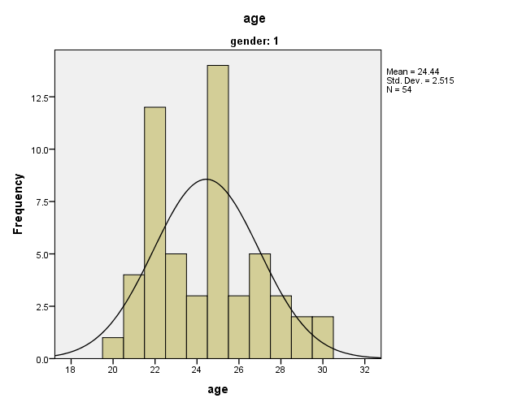 Figure 1. A histogram showing a relatively normal (Gaussian) distribution of the ages of the male participants in this study.
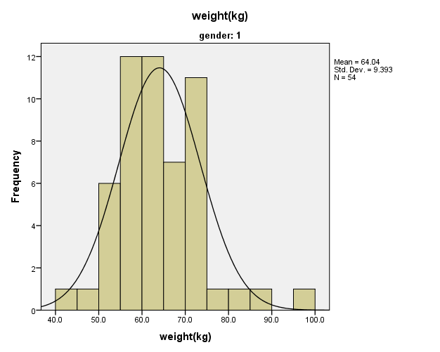
Figure 2. A histogram showing a relatively normal (Gaussian) distribution of the weight of the male participants in this study.

Table 3. Summary of Direct Angular Anthropometric Measurements on participants in this study.
 |  | NFA | NTA | NLA | MLA | ASA | MFA | MCA
Mean (⁰) |  | 129.73 | 73.43 | 81.06 | 113.15 | 106.61 | 19.49 | 80.15
Std. Deviation |  | 9.43 | 5.70 | 9.70 | 15.32 | 14.21 | 3.30 | 9.21
Variance |  | 89.02 | 32.50 | 94.27 | 234.70 | 202.06 | 10.92 | 84.94
Minimum(⁰) |  | 101.50 | 58.50 | 58.50 | 66.00 | 60.00 | 13.50 | 22.50
Maximum(⁰) |  | 149.00 | 88.50 | 116.50 | 139.00 | 137.00 | 30.00 | 100.00

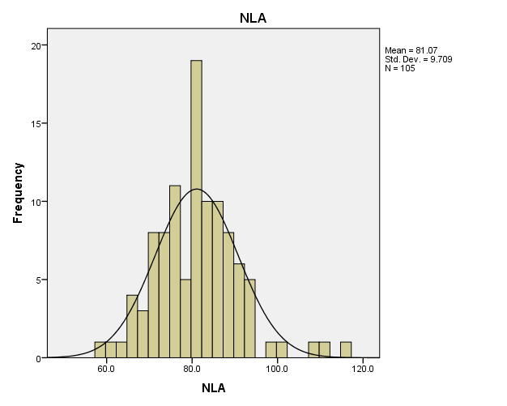

Figure 3. A histogram showing a normal (Gaussian) distribution of the direct NLA measurements from the participants in this study. All the other indirect measurements displayed similar distribution.

