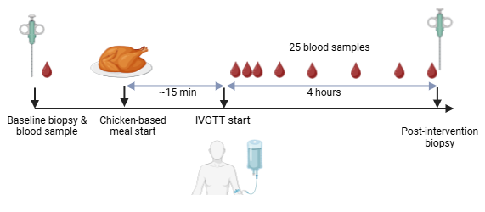
Supplementary Figure 1. Schematic timeline of the acute IVGTT study (not to scale)

