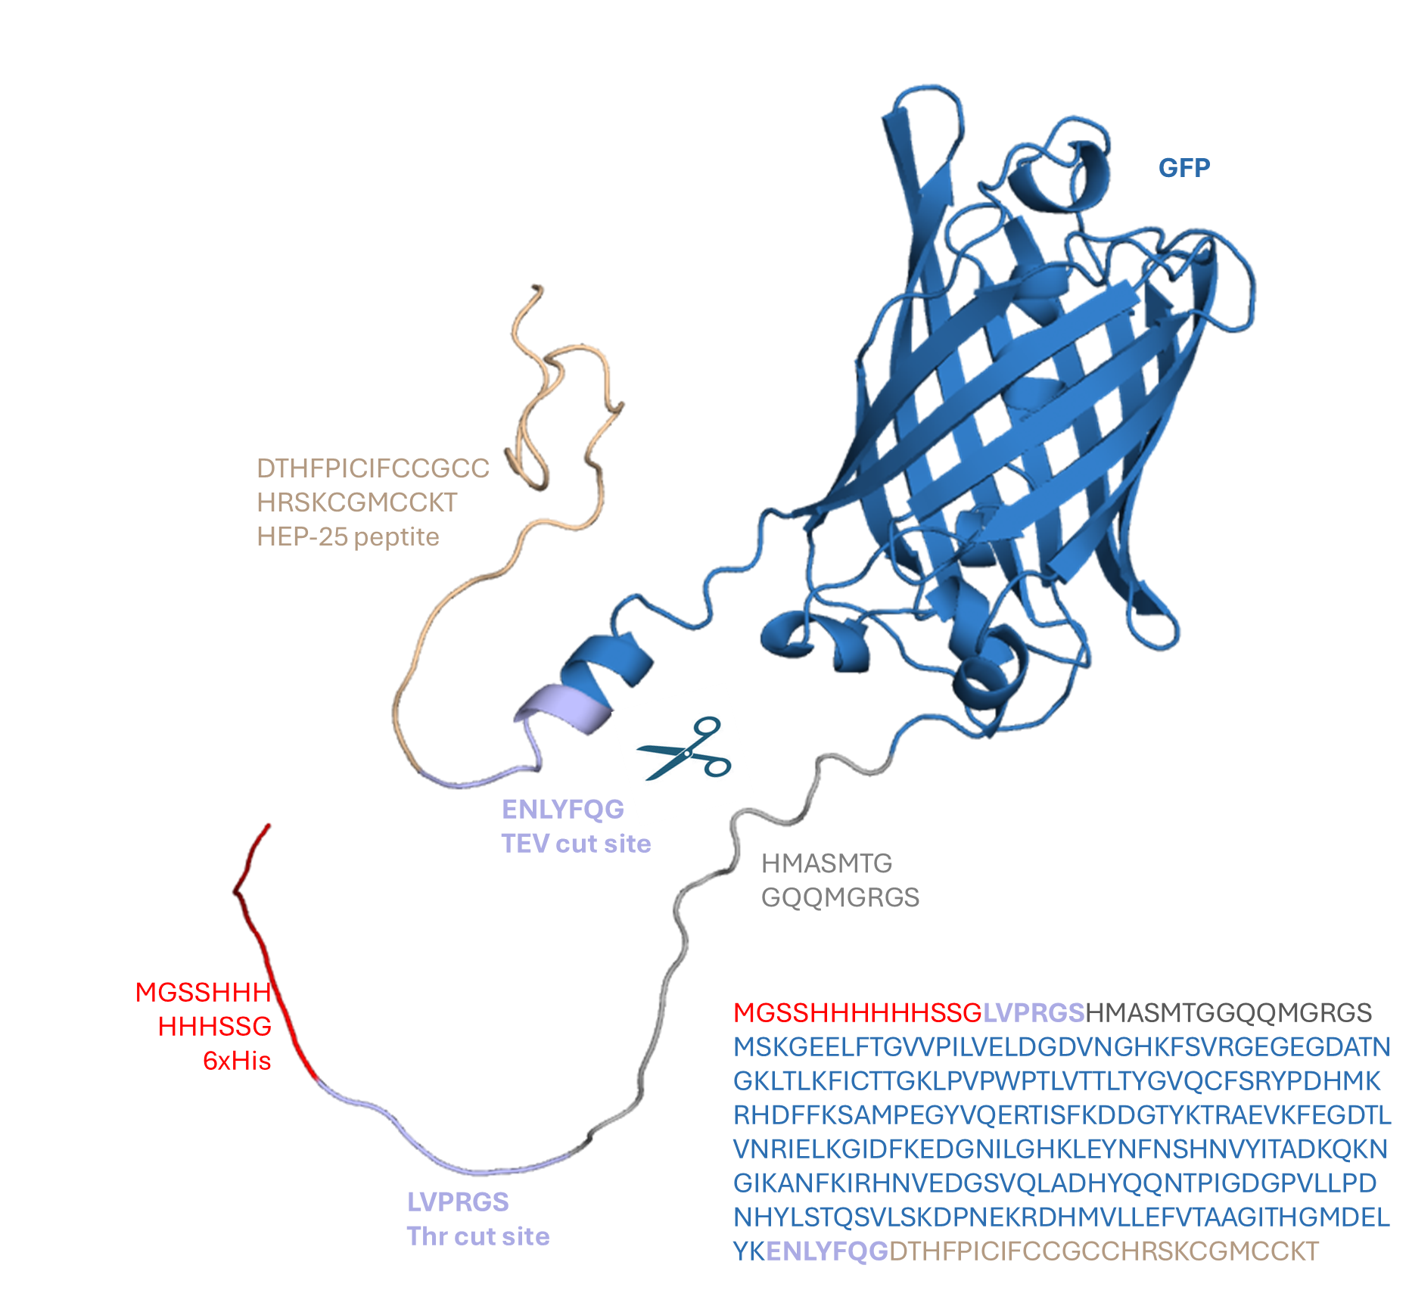
Supplementary Figure 1. AlphaFold prediction of the GFP-HEP25 structure. The GFP-fused HEP structure consists of a 6xHis tag, a thrombin cut site, a GFP, and a TEV cut site, followed by a HEP25 peptide. AF detected the HEP25 as the loop conformation due to the mobility of the HEP25.

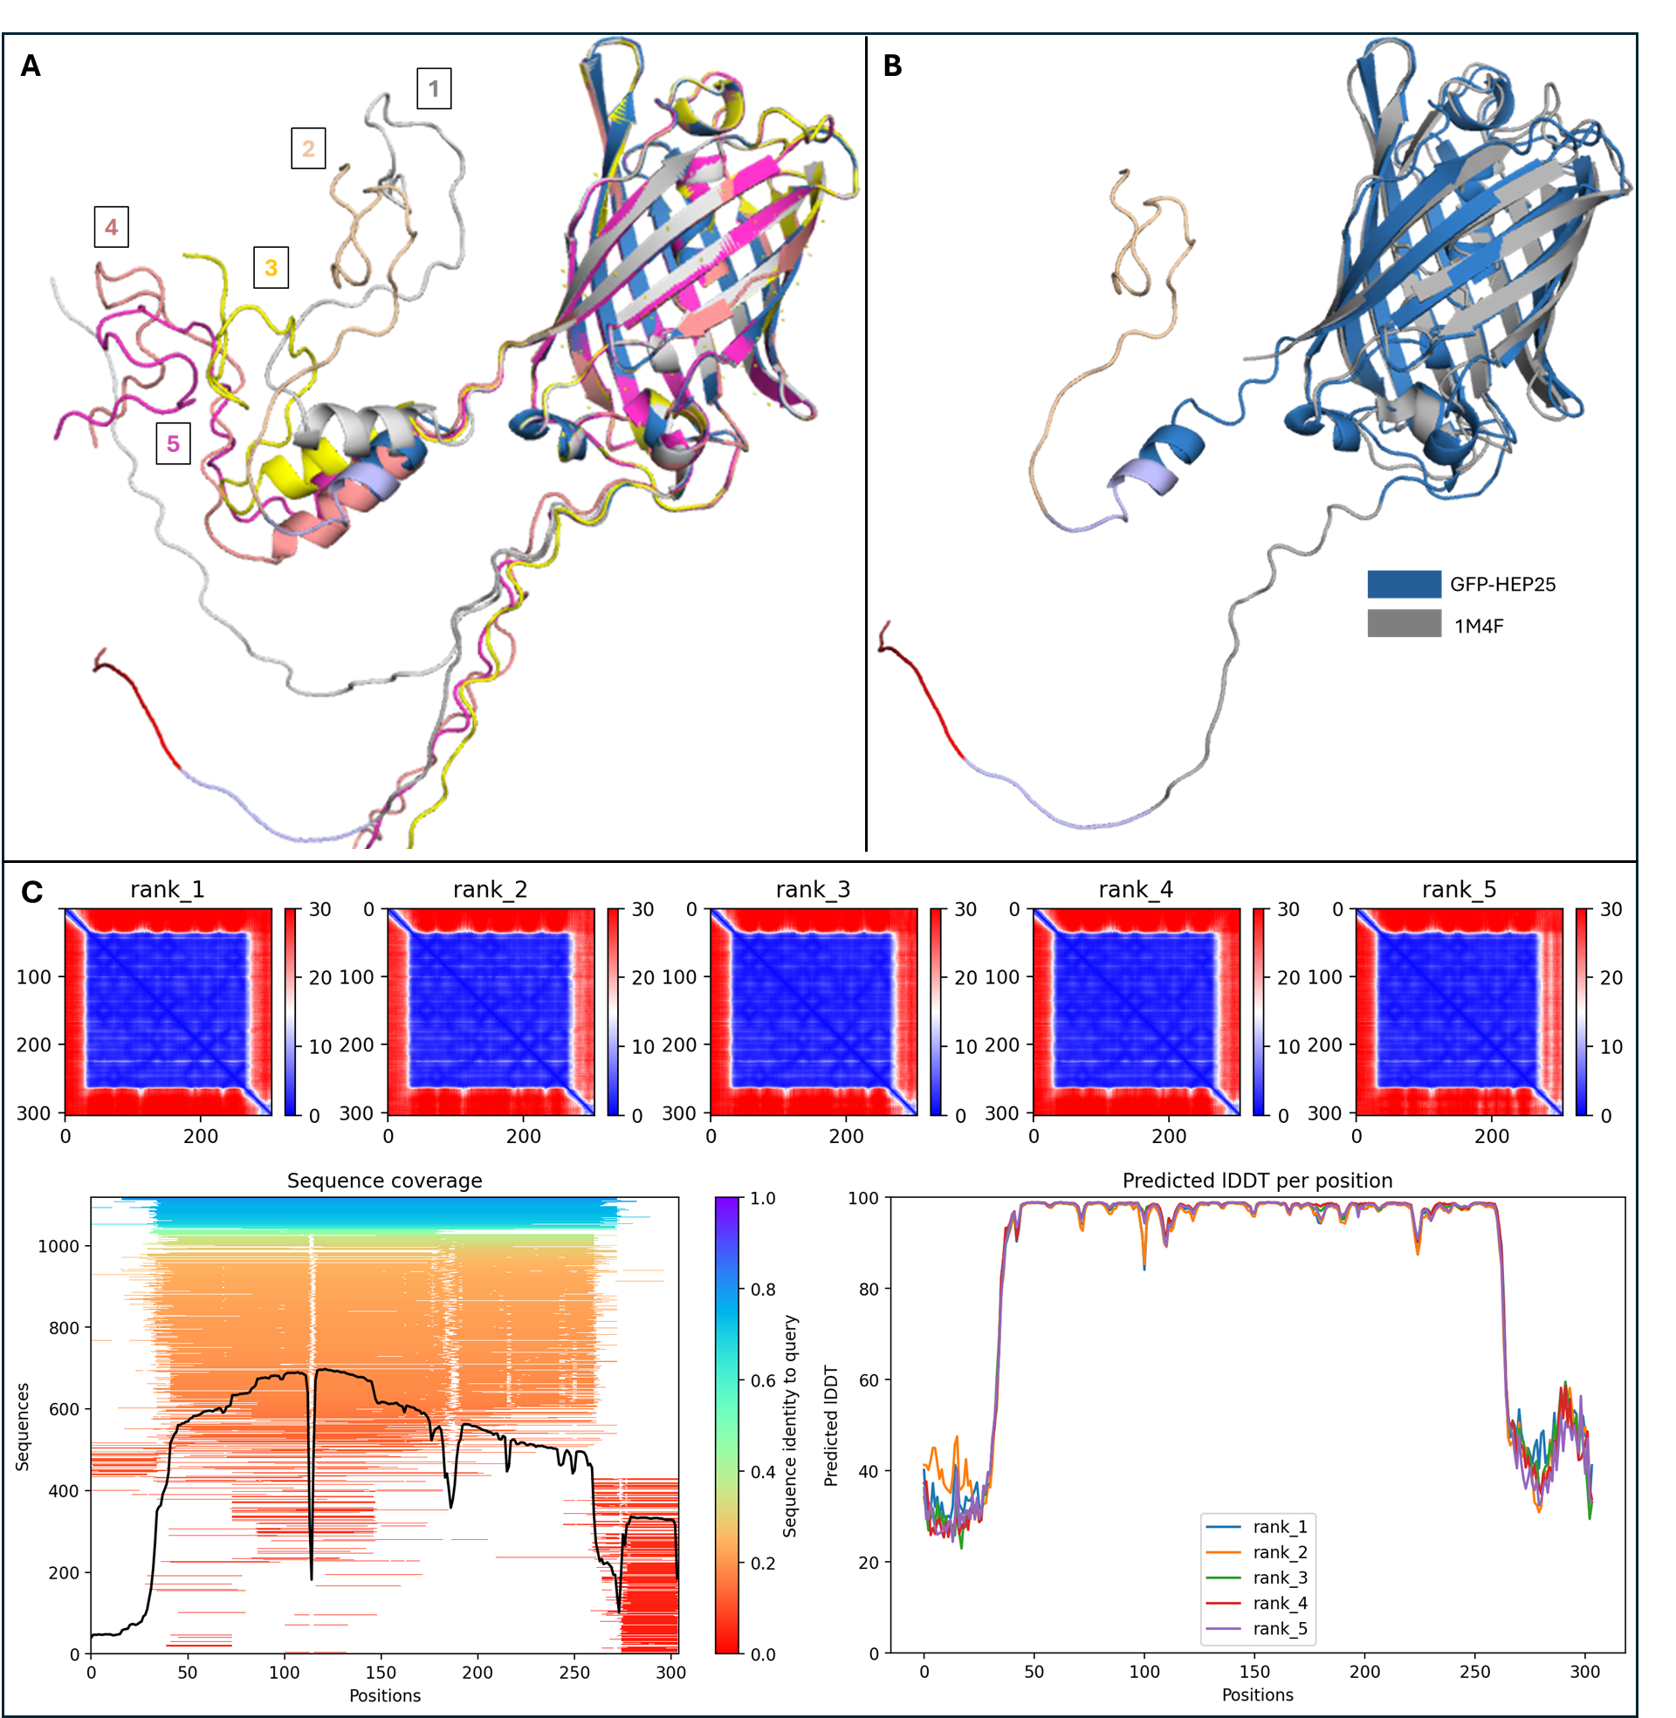

Supplementary Figure 2. AlphaFold models of the GFP-HEP25 structures and overlay of the computational and experimental complexes. (A) Five models, superimposed with a maximum RMSD value of 0.185, demonstrate the mobility of HEP25, showing alternating peptide coordination among them. (B) Overlay of the GFP-HEP25 model and the experimental structure (PDB ID: 1M4F) reveals an RMSD value of 1.124. (C) AF analysis result covers sequence coverage and predicted IDDT per position trends.
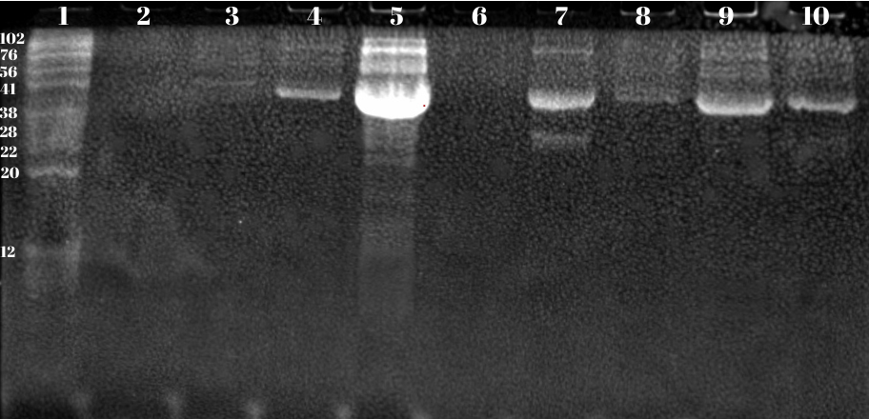
Supplementary Figure 3. Mini scale protein production of GFP-tagged Hepc25 in 15% SDS-PAGE gel. 1, Marker; 2, before induction; 3, after induction; 4, whole cell lysate in solution; 5, harvested cell; 6, supernatant wo cell; 7, GFP-tagged Hepc25; 8, after induction 2h; 9, after induction 24h; 10, similar to well-9. GFP-tagged Hepc25 is ~35 KDa. The gel is uncropped and totally original.

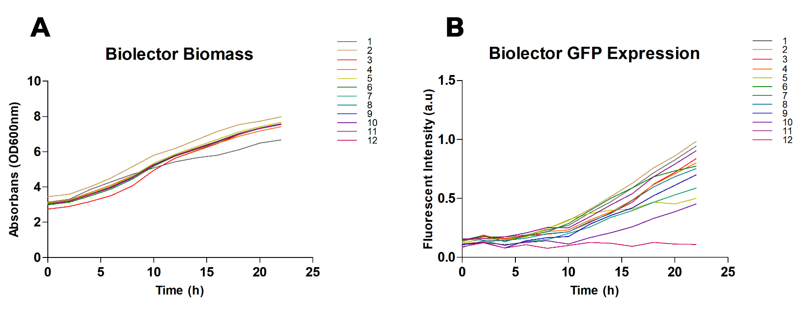
Supplementary Figure 4. Selective twelve media screening to obtain yielded media for Hepc25 production by BioLector microbioreactor. (A) Graph of the time-dependent increase in biomass of the Rosetta DE3 strain in different culture media (nu: 1 to 12). (B) Graph showing the time-dependent GFP-tag expression in the Rosetta DE3 strain, measured by fluorescence intensity 436/540 nm (excitation/emission) wavelengths in different culture media.

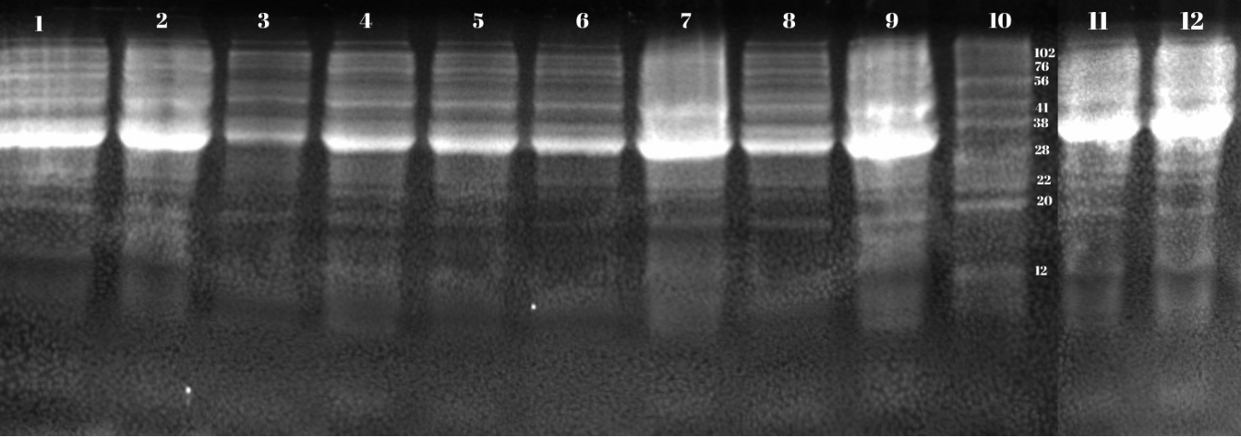
Supplementary Figure 5. Selective twelve media confirmations to obtain yielded media for Hepc25 production by SDS-PAGE (15%). From 1 to 9 wells represent media-3 to media-11, respectively. Well-10 is the marker. Well-11 is media-1, and well-12 is media-2. The gel is uncropped and totally original.

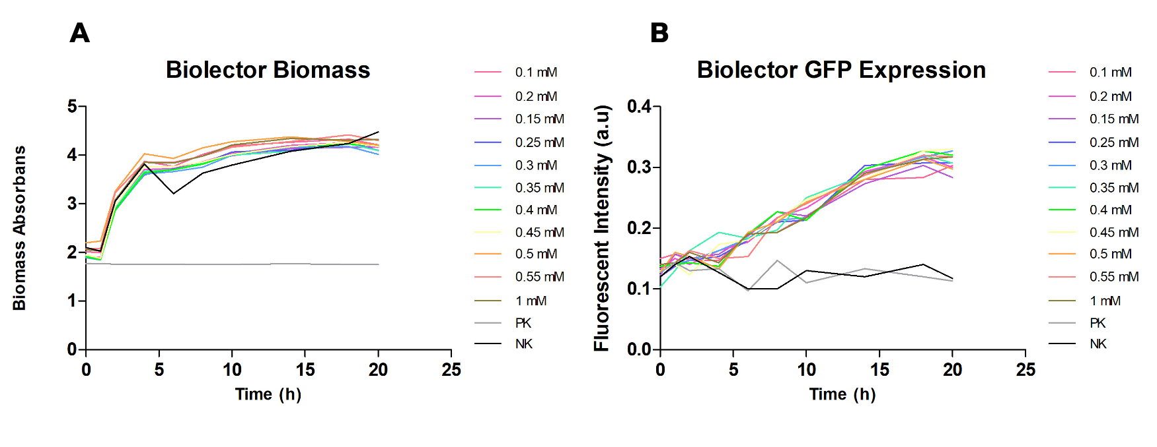
Supplementary Figure 6. Selective eleven IPTG concentration to obtain yielded and cost-efficient amount for Hepc25 production by BioLector microbioreactor. (A) Graph of the time-dependent increase in biomass of the Rosetta DE3 strain induced with different IPTG concentrations (0.1 mM to 1 mM). (B) Graph of the time-dependent increase in GFP expression in the Rosetta DE3 strain induced with different IPTG concentrations, measured by fluorescence intensity 436/540 nm (excitation/emission) wavelengths.

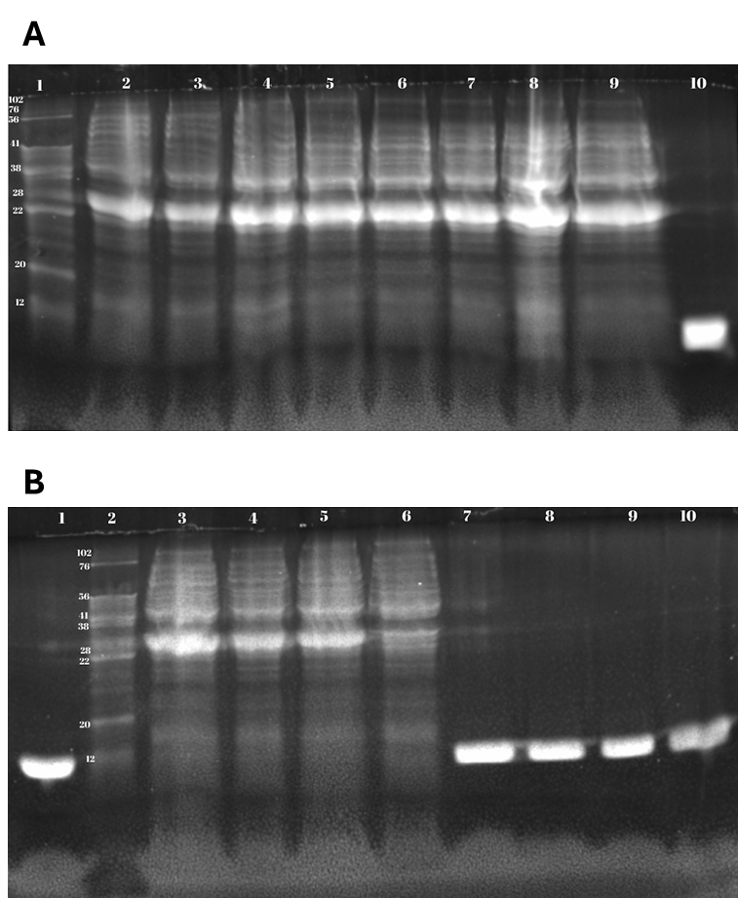
Supplementary Figure 7. Selective eleven distinct IPTG concentrations’ confirmation for Hepc25 production by SDS-PAGE (15%). (A) well 1, marker; wells 2 to 9 are 0.1 mM to 0.45 mM IPTG induced cell lysate, respectively. Well 10 is lysozyme for positive control (~14 KDa). (B) wells 1 and 7 to 10 are lysozyme for positive control. Well 2 is marker, while wells 3 to 5 are 0.55 mM to 1 mM IPTG induced cell lysate. Well 6 is no IPTG negative control. The gel is uncropped and totally original.
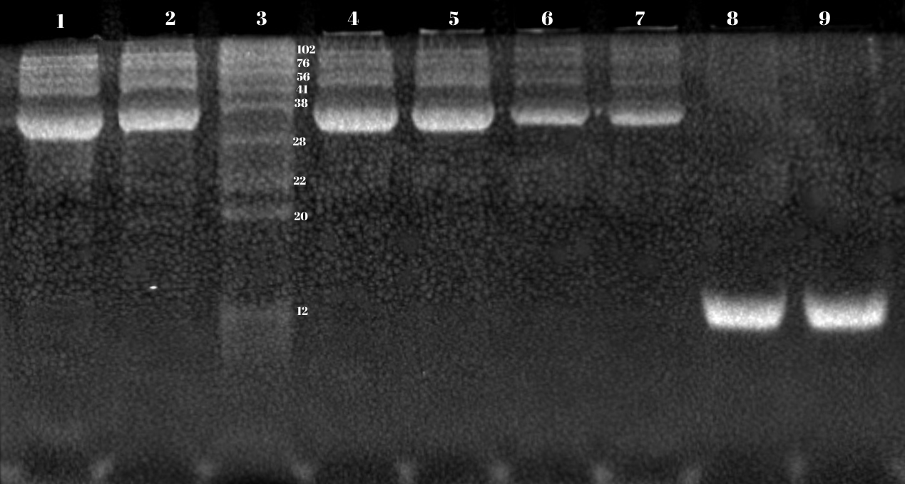
Supplementary Figure 8. Selective three distinct temperature value confirmations for Hepc25 production by SDS-PAGE (15%). Wells 1 to 2 are 18°C incubated samples, well 3 is the marker, wells 4 to 5 are 30°C, and wells 6 to 7 are 37°C incubated samples. Wells 8 to 9 are lysozyme. The gel is uncropped and totally original.

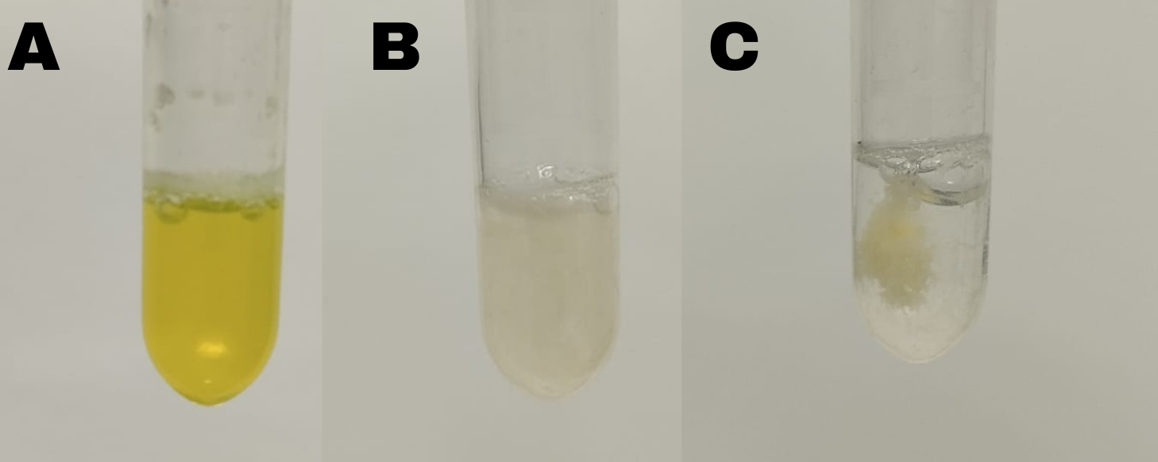
Supplementary Figure 9. Visible precipitates in GFP-Hepc25 samples subjected to 100°C for 10 and 30 minutes. (A) GFP-Hepc25 exposure to 100°C for 5 minutes, no thermal degradation observed. (B) GFP-Hepc25 exposure to 100°C for 10 minutes. (C) GFP-Hepc25 exposure to 100°C for 30 minutes.

