Supplementary information

Section 1: Laboratory Protocols of Morabine grasshoppers’ faeces metabarcoding

Extraction protocol (modified from manufacturer protocol Macherey-Nagel NucleoSpin PlantII April 2023/Rev.14)

1 | Sample homogenization  - In a 2 ml microcentrifuge tube with 3mm metal beads (x2), we homogenized:  - Plant material (20 mg wet weight) + 100 μL Buffer PL1  - Faeces material (20 mg dry weight) + 600 μL Buffer PL1  Tubes were placed in the TissueLyser II (2 min each side of the adaptors). 20 mg wet weight or up to 20 mg dry weight.
2 | - For plant material we completed the 400 μL Buffer PL1 and added 10 μL RNase A solution. and  - For faeces material no additional Buffer PL1 was used, and 15 μL RNase A was added.  Suspensions were vortex for 1 min, and incubated for 60 min at 65 °C.  After incubation the tubes were centrifuged briefly.
3 | Filtration / Clarification of crude lysate  The NucleoSpin® Filter (violet ring) was placed into a new Collection Tube (2 mL) and loaded with the lysate. It was centrifuged for 2 min at 11,000 x g. The clear flowthrough was collected and NucleoSpin® Filter discarded.  The crude lysate can be centrifuge as many times as necessary to only transferred the clear supernatant and remove solid particles completely.
4 | DNA binding conditions adjustment.  - For plant material we added 450 μL Buffer PC and mixed thoroughly by pipetting up and down (5 times).  For faeces material we added 675 μL Buffer PC and mixed thoroughly by pipetting up and down (5 times).
5 | Bind DNA  The NucleoSpin® Plant II Column (green ring) was placed in a new Collection Tube (2 mL) and loaded with a maximum of 700 μL of the sample.  Tubes were centrifuged for 1 min at 11,000 x g and the flowthrough was discarded.
6 | Wash and dry silica membrane  1st wash  We added 400 μL Buffer PW1 to the NucleoSpin® Plant II Column. Centrifuged for 1 min at 11,000 x g and the flowthrough discarded.  2nd wash  We added 700 μL Buffer PW2 to the NucleoSpin® Plant II Column. Centrifuged for 1 min at 11,000 x g and the flowthrough discarded.  3rd wash  We added 200 μL Buffer PW2 to the NucleoSpin® Plant II Column. Centrifuged for 2 min at 11,000 x g to remove wash buffer and dry the silica membrane completely.
7 | DNA elution  The NucleoSpin® Plant II Column was placed into a new 1.5 mL microcentrifuge tube (not provided in the kit).  50 μL Buffer PE (65 °C) was pipetted onto the membrane. Incubate the NucleoSpin® Plant II Column for 5 min at 65 °C. Later they were centrifuged for 1 min at 11,000 x g to elute the DNA.  The step was repeated with another 50 μL Buffer PE (65 °C) and elute into the same tube.

PCR protocol (modified from Carew & Robinson, 2023)

The eluted DNA from faeces obtained from the extraction step weren’t diluted for the PCR steps. On the contrary, DNA obtained from plants, used as positive control, was diluted in a ratio of 1:10.

First PCR (Amplicon PCR):

Equipment, materials, and reagents:
- DNA cabinet (mandatory training).
- Tips and pipettes.
- Micro centrifuge tubes (1.5 ml).
- Semi-skirted PCR plate.
- Self-adhesive foil plate covers.
- Permanent marker pen.
- Ice tray.
- Sterile ddH₂O.
- Small bucket waste.
- Illumina tailed primers.
- KAPA MgCl₂ (25 mM) (KAPA3G Plant PCR Kit)
- KAPA Plant PCR Buffer (2X) (it contains dNTPs and 1.5mM MgCl₂) (KAPA3G Plant PCR Kit)
- KAPA 3G Plant DNA Polymerase (2.5 U/µl) (KAPA3G Plant PCR Kit).
- Centrifuge
- PCR machine
- Agarose gels materials equipment and reagents.
1. | Equipment set up:  - All necessary materials and reagents are placed on the DNA cabinet. Reagents, ice tray in the left, tips, bucket waste and pipettes in the right.
2. | Master mix preparation  - All reagents need to be defrosted before start. This step was done for each amplicon and in triplicate (three amplicons x three replicates = nine PCR’s)  - The master mix was prepared in a 1.5 ml micro centrifuge tube, adding the polymerase last.  - After adding the polymerase the tube was inverted few times to mix it, spined down and placed in ice.
  Reagent | Initial  concentration | Final concentration | Volume per reaction (µl)
  ddH₂O |  |  | 8.3
  KAPA Plant PCR Buffer | 2X | 1X | 12.5
  KAPA MgCl₂ | 25 mM | 2.5 mM | 1
  Forward tailed primer | 10µM | 0.5 µM | 0.5
  Reverse tailed primer | 10µM | 0.5 µM | 0.5
  KAPA 3G Plant DNA Polymerase | 2.5 U/µl | 0.2 units | 0.2
  DNA (faeces no-diluted, plant diluted) |  |  | 2
  Total |  |  | 25
3. | Semi – skirted plate set up:  - A 96 well skirted plate was labelled for each amplicon.  - Using a multi-dispense pipette, 23 µl of the Master Mix was added to each well.  - 2 µl of DNA was then added to each well.  - The PCR plate was firmly roller-sealed with a PCR adhesive foil.
4. | PCR settings.  - Before putting the plates in the PCR machine these were briefly placed in the centrifuge.  nr ITS2  cp rbcL  cp trnL  The amplification was verified on a 2 % agarose gel (2 µl dye + 8 µl DNA).
  Process | Temperature | Time | Replicates
  Initial denaturation | 95 °C | 3 min | 1x
  Denaturation | 95 °C | 30 sec | 35x
  Annealing | 56 °C | 30 sec | 35x
  Extension | 72 °C | 45 sec | 35x
  Final extension | 72 °C | 5 min | 1x
  Process | Temperature | Time | Replicates
  Initial denaturation | 95 °C | 3 min | 1x
  Denaturation | 95 °C | 30 sec | 35x
  Annealing | 54 °C | 30 sec | 35x
  Extension | 72 °C | 30 sec | 35x
  Final extension | 72 °C | 5 min | 1x
  Process | Temperature | Time | Replicates
  Initial denaturation | 95 °C | 3 min | 1x
  Denaturation | 95 °C | 30 sec | 30x
  Annealing | 54 °C | 30 sec | 30x
  Extension | 72 °C | 30 sec | 30x
  Final extension | 72 °C | 5 min | 1x

Cleaning and pooling of amplicons

Equipment, materials, and reagents:
- DNA cabinet (mandatory training).
- Tips and pipettes.
- Micro centrifuge tubes (1.5 ml).
- Semi-skirted PCR plate.
- Self-adhesive foil plate covers.
- Permanent marker pen.
- Ice tray.
- Small bucket waste.
- Exo-SAP-IT
- Centrifuge
- PCR machine
- Agarose gels materials equipment and reagents.
1. | Pooling:  - 15 µl ITS2 and 6 µl rbcL products were pooled in a new 96-well plate, while 10 µl trnL product, given its length, was treated separate (store at -20 °C). Check result of pooling in 3% agarose gel.
2. | Cleaning:  - 2 µl of Exo-SAP-IT was added to each well of a new semi-skirted 96-well plate (performed in DNA cabinet).  - 5 µl of DNA was added to each well (perform on ice in post PCR area).  - Plates were sealed with adhesive foil and spined in the centrifuge.
3. | Incubation:  - Plates were put in a PCR machine for 30 min at 37 °C. (Removed ASAP and stored at -20°C).

Second PCR

Equipment, materials, and reagents:
- DNA cabinet (mandatory training).
- Tips and pipettes.
- Micro centrifuge tubes (1.5 ml).
- Semi-skirted PCR plate.
- Self-adhesive foil plate covers.
- Permanent marker pen.
- Ice tray.
- Small bucket waste.
- MyFi mix
- Centrifuge
- PCR machine
- Agarose gels materials equipment and reagents.
1. | Plate set up:  - In the DNA cabinet we placed a new 96 well plate, the My-Fi mix PCR kit, and Illumina indexing primers. The indexing primers were already in a 96-well plate ready for transfer with the 8-channel pipette to the reaction plate.  - 6.25 µl of My-Fi mix was added to each well of the plate (no ddH₂O was added).  - 1.25 µl of i5 primers was added in each well using the 8-channel pipette (plate placed vertical).  - 1.25 µl of i7 primers was added in each well using the 8-channel pipette (plate placed horizontal).  - The primers were dispensed on the middle front wall of each well, avoiding contact, and checking the presence of it.  - The plate was adhesive foil sealed and spined in the centrifuge.  - Outside the DNA cabinet 3.75 µl of DNA pooled and cleaned was transferred to the PCR plate (one row at a time with an 8-channel pipette).  - The plate was firmly sealed and centrifuged.
2. | PCR  The amplification was confirmed on a 3% Agarose gel.
  Process | Temperature | Time | Replicates
  Initial denaturation | 94 °C | 5 min | 1x
  Denaturation | 94 °C | 30 sec | 12x
  Annealing | 55 °C | 30 sec | 12x
  Extension | 72 °C | 30 sec | 12x
  Final extension | 72 °C | 5 min | 1x

Cleaning and pooling of second PCR products

Equipment, materials, and reagents:
Tips and pipettes.
Micro centrifuge tubes (1.5 ml).
Permanent marker pen.
Ice tray.
Small bucket waste.
Sera-mag beads
Magnetic stand
Centrifuge
Agarose gels materials equipment and reagents.
1. | Pooling:  - 5 µl of each sample was pooled into a 1.5 ml microcentrifuge tube. ITS2 + rbcL in one tube and trnL in a second tube.
2. | Cleaning:  - The ratio for ITS2 + rbcL was 1:1 beads to DNA, for trnL samples was 1:2 beads to DNA. The amount of Sera-mag beads will depend on the number of samples.  - We mix well the beads and the DNA sample by pipetting up and down.  - For 15 minutes the tube was left at room temperature for the beads attached to the DNA. (Protect the sample from the light).  - After the 15 minutes the tube is placed on the magnetic stand for 10 minutes (Protect the sample form the light).  - On the magnetic stand, the supernatant was removed and discarded.  - On the magnetic stand, what was left was washed with 80% ethanol (400 µl) two times (three if needed), all residual ethanol is removed.  - On magnetic stand, 200 µl of TE was added to the tube.  - Outside the stand, the the beads were suspended by pipetting up and down multiple times and left at room temperature.  - The tube was placed again in the magnetic stand for 2 minutes.  - On magnetic stand, the supernatant with the DNA was removed and placed into a single tube. This tube was ready to be send to the lab for MiSeq sequencing.
3. | Final check and quantification:  - In a 3% Agarose gel, the purified and unpurified sample is run.  - The final MiSeq library concentration was also measure using the Qubit.

Section 2: Matchstick grasshopper diet bioinformatic metabarcoding pipeline
Assumptions: QIIME2 installation
Version: 2023.9
All the information displayed in this pipeline is a modification of the QIIME2 tutorials found in its web page: https://docs.qiime2.org/2023.9/

1. Importing data
The data received by the Sequencing Facility falls into Demultiplexed Paired fastq files (data with sequence quality information). Here the fastq manifest format must be forward and reverse reads for each sample ID and assumes the PHRED offset of 33.
conda activate qiime2-amplicon-2023.9
mkdir quiime2-importing-data
cd quiime2-importing-data
qiime tools import \
--type 'SampleData[PairedEndSequencesWithQuality]' \
--input-path doc-manifest.tsv \
--input-format PairedEndFastqManifestPhred33V2 \
--output-path paired-end-demux.qza
doc-manifest.tsv contains as minimal information the ID sample name (sample-id) in the first column, path to the forward file (forward-absolute-filepath) in the second column, and reverse file (reverse-absolute-filepath) in the third column.
Output artifact:
paired-end-demux.qza
*We imported the data separately regarding the primers used. ITS2 and rbcL for one side (they were sequenced together), and trnL on a separate artifact (paired-end-demux-trnL.qza).

2. Trimming using cutadapt
Trimming each primer.
For ITS2
qiime cutadapt trim-paired \
--i-demultiplexed-sequences paired-end-demux.qza \
--p-adapter-f GHGACCYCARRTCARDCGGG$ \
--p-front-f ^TGTGAATTGCARRATYCMG \
--p-adapter-r CKGRATYYTGCAATTCACA$ \
--p-front-r ^CCCGHYTGAYYTGRGGTCDC \
--p-overlap 15 \
--p-minimum-length 187 \
--p-discard-untrimmed \
--o-trimmed-sequences demux-paired-end-trimmed-ITS2.qza
For rbcL
qiime cutadapt trim-paired \
--i-demultiplexed-sequences paired-end-demux.qza \
--p-adapter-f GAAGCAGGGGCTGCAGTGGCTGCGGAATCT$ \
--p-front-f ^ATGTCACCACAAACAGAGACTAAAGCAAGT \
--p-adapter-r ACTTGCTTTAGTCTCTGTTTGTGGTGACAT$ \
--p-front-r ^AGATTCCGCAGCCACTGCAGCCCCTGCTTC \
--p-overlap 15 \
--p-minimum-length 150 \
--p-discard-untrimmed \
--o-trimmed-sequences demux-paired-end-trimmed-rbcL.qza
For trnL
qiime cutadapt trim-paired \
--i-demultiplexed-sequences paired-end-demux-trnL.qza \
--p-adapter-f GATAGGTGCAGAGACTCAATGG \
--p-front-f ^GGGCAATCCTGAGCCAA \
--p-adapter-r TTGGCTCAGGATTGCCC \
--p-front-r ^CCATTGAGTCTCTGCACCTATC \
--p-overlap 15 \
--p-quality-cutoff-3end 30 \
--p-minimum-length 10 \
--p-discard-untrimmed \
--o-trimmed-sequences demux-paired-end-trimmed-trnL.qza
Output artifact:
demux-paired-end-trimmed-ITS2.qza
demux-paired-end-trimmed-rbcL.qza
demux-paired-end-trimmed-trnL.qza
Summarising the trimmed reads using the summarize function.
For ITS2
qiime demux summarize \
--i-data demux-paired-end-trimmed-ITS2.qza \
--o-visualization demux-paired-end-trimmed-ITS2.qzv
For rbcL
qiime demux summarize \
--i-data demux-paired-end-trimmed-rbcL.qza \
--o-visualization demux-paired-end-trimmed-rbcL.qzv
For trnL
qiime demux summarize \
--i-data demux-paired-end-trimmed-trnL.qza \
--o-visualization demux-paired-end-trimmed-trnL.qzv
Output artifact:
demux-paired-end-trimmed-ITS2.qzv
demux-paired-end-trimmed-rbcL.qzv
demux-paired-end-trimmed-trnL.qzv

Visualisation in Qiime2 view interface
https://view.qiime2.org/
Drag the qzv file in the interface for visualisation.
Quality plot for ITS2
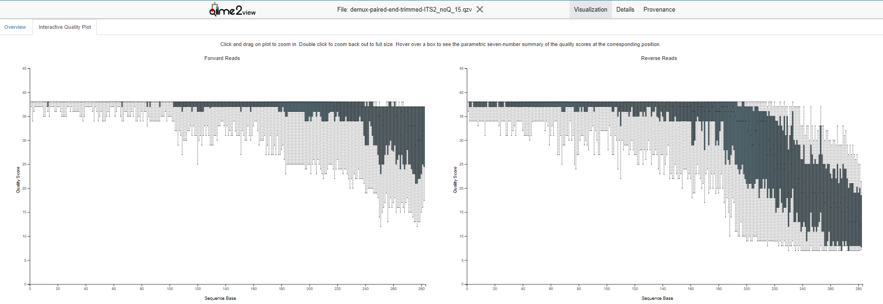
Quality plot for rbcL
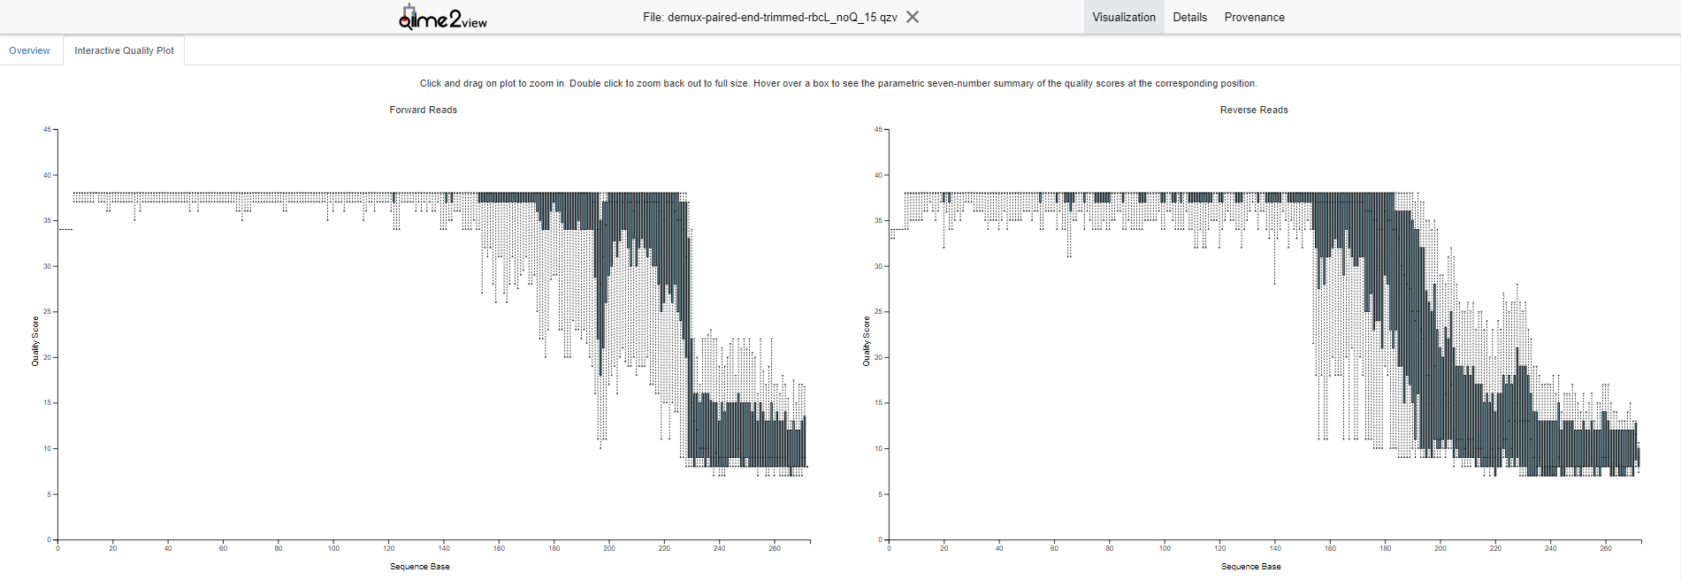
Quality plot for trnL
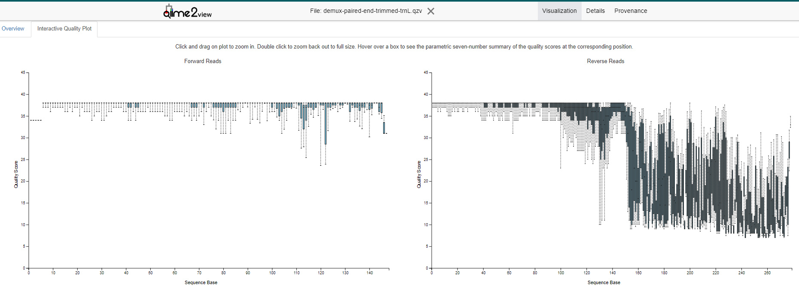Median quality scores of > 30 have been kept; values less than that value have been truncated. In the following step of denoising.

3. Denoising using DADA2
"DADA2 contain internal chimera checking methods and abundance filtering", so no additional chimeric removal was necessary.
For ITS2
qiime dada2 denoise-paired \
--i-demultiplexed-seqs demux-paired-end-trimmed-ITS2.qza \
--p-trunc-len-f 240 \
--p-trunc-len-r 184 \
--p-min-fold-parent-over-abundance 6 \
--output-dir denoise_ITS2/DADA2_denoising_output_ITS2 \
--verbose

For rbcL
qiime dada2 denoise-paired \
--i-demultiplexed-seqs demux-paired-end-trimmed-rbcL.qza \
--p-trunc-len-f 153 \
--p-trunc-len-r 154 \
--output-dir denoise_rbcL/DADA2_denoising_output_rbcL \
--verbose

For trnL
qiime dada2 denoise-paired \
--i-demultiplexed-seqs demux-paired-end-trimmed-trnL.qza \
--p-trunc-len-f 0 \
--p-trunc-len-r 102 \
--output-dir denoise_trnL/DADA2_denoising_output_trnL \
--verbose
Output artifact:
A folder per primer with:
denoising_stats.qza
representative_sequences.qza
table.qza
Visualisation in Qiime2 view interface
example with trnL
qiime metadata tabulate \
--m-input-file denoise_trnL/DADA2_denoising_output_trnL/denoising_stats.qza \
--o-visualization denoise_trnL/DADA2_denoising_output_trnL/denoising_stats_trnL.qzv
After denoising the features produced go by amplicon sequence variant (ASV).

4. Filtering data
Before taxonomic assignation, the sequences will be filtered by samples corresponding to the different species.
Example:
Keyacris scurra, control samples, and trnL
Filtering sample
qiime feature-table filter-samples \
--i-table table_trnL.qza \
--m-metadata-file trnL-manifest.tsv \
--p-where '[species] IN ("Keyacris", "NA")' \
--o-filtered-table filtered-table-KS_trnL.qza
Output artifact:
filtered-table-KS_trnL.qza
Filtering corresponding sequences
qiime feature-table filter-seqs \
--i-data representative_sequences_trnL.qza \
--i-table filtered-table-KS_trnL.qza \
--o-filtered-data filtered-seq-KS_trnL.qza
Output artifact:
filtered-seq-KS_trnL.qza

5. Taxonomy assignation

5.1. Building reference sequences
Two different approaches to build a reference sequence were used: using the package 'refdb' in R for BOLD and NCBI to build a local library (detailed use of the functions are explained in the reference manual of the package) and a second using RESCRIPt with NCBI to built a global library.
- Keck, F., & Altermatt, F. (2023). Management of DNA reference libraries for barcoding and metabarcoding studies with the R package refdb. Molecular Ecology Resources, 23(2), 511-518. doi: 10.1111/1755-0998.13723
- Michael S Robeson II, Devon R O'Rourke, Benjamin D Kaehler, Michal Ziemski, Matthew R Dillon, Jeffrey T Foster, Nicholas A Bokulich. 2021. "RESCRIPt: Reproducible sequence taxonomy reference database management". PLoS Computational Biology 17 (11): e1009581.; doi: 10.1371/journal.pcbi.1009581 5

refdb

Importing reference data sets
The datasets were acquired from BOLD and NCBI using the 'refdb' package in R, with detailed instructions on function usage available in the package's reference manual. To manage the extensive number of species entries, the search was conducted in 100 entries at a time. Later, the outputs were merged to obtain the "merged_KS_trnL_NCBI.fasta" file (sequences) and "merged_KS_trnL_NCBI.txt" (taxonomy) files.
Example:
Keyacris scurra and trnL using NCBI reference data set for the grasshopper species and primer.
qiime tools import \
--type 'FeatureData[Sequence]' \
--input-path merged_KS_trnL_NCBI.fasta \
--output-path merged_KS_trnL_NCBI_seq.qza
qiime tools import \
--type 'FeatureData[Taxonomy]' \
--input-format HeaderlessTSVTaxonomyFormat \
--input-path merged_KS_trnL_NCBI.txt \
--output-path merged_KS_trnL_NCBI_tax.qza
Output artifact:
merged_KS_trnL_NCBI_seq.qza
merged_KS_trnL_NCBI_tax.qza

Merged reference data sets
The datasets acquired from BOLD and NCBI were merged to have only one reference library.
Example:
qiime feature-table merge-taxa \
--i-data merged_data_trnL_NCBI_tax_un.qza merged_data_trnL_BOLD_tax.qza \
--o-merged-data Local_trnL-taxa-merged.qza
qiime feature-table merge-seqs \
--i-data merged_Total_trnL_NCBI_seq.qza merged_Total_trnL_BOLD_seq.qza \
--o-merged-data Local_trnL-seqs-merged.qza
Output artifact:
Local_trnL-taxa-merged.qza
Local_trnL-seqs-merged.qza

RESCRIPt
The classifier was obtained by adapting the tutorial: "Using RESCRIPt's 'extract-seq-segments' to extract reference sequences without PCR primer pairs." from the QIIME2 Forum.
Example with the primer ITS2:
qiime rescript get-ncbi-data \
--p-query "txid35493[ORGN] AND (ITS2[Gene Name] OR internal transcribed spacer 2[Title] OR ITS2[Title]) NOT environmental sample[Filter] NOT environmental samples[Filter] NOT environmental[Title] NOT uncultured[Title] NOT unclassified[Title] NOT unidentified[Title] NOT unverified[Title]" \
--p-ranks kingdom phylum class order family genus species \
--p-rank-propagation \
--p-n-jobs 1 \
--o-sequences ITS2-ref-seqs.qza \
--o-taxonomy ITS2-ref-tax.qza \
--verbose
Output artifacts:
ITS2-ref-seqs.qza
ITS2-ref-tax.qza

5.2. Plugin feature-classifier
This plugin in QIIME 2 facilitates the taxonomic classification of features through diverse methods, such as Naive Bayes, vsearch, and BLAST+. Only Naive Bayes was considered in the study
For more information:
Bokulich, N.A., Kaehler, B.D., Rideout, J.R. et al. Optimizing taxonomic classification of marker-gene amplicon sequences with QIIME 2’s q2-feature-classifier plugin. Microbiome 6, 90 (2018). https://doi.org/10.1186/s40168-018-0470-z

5.2.1. Naive Bayes:

Training the classifier
The classifier is trained using Naive Bayes method. May require training the classifier, which could be computationally intensive.
Example:
qiime feature-classifier fit-classifier-naive-bayes \
--i-reference-reads merged_KS_trnL_NCBI_seq.qza \
--i-reference-taxonomy merged_KS_trnL_NCBI_tax.qza \
--o-classifier class_KS_trnL_NCBI.qza
Output artifact:
class_KS_trnL_NCBI.qza

Pre-fitted sklearn-based taxonomy classifier
Using "classify-sklearn", the sequences are classified by taxon using the trained classifier output from the last step.
Example
qiime feature-classifier classify-sklearn \
--i-classifier class_KS_trnL_NCBI.qza \
--i-reads filtered-seq-KSc_trnL.qza \
--p-read-orientation 'same' \
--o-classification taxonomy_sklearn_KSc_trnL_NCBI.qza
qiime metadata tabulate \
--m-input-file taxonomy_sklearn_KSc_trnL_NCBI.qza \
--o-visualization taxonomy_sklearn_KSc_trnL_NCBI.qzv
Output artifact:
taxonomy_sklearn_KSc_trnL_NCBI.qza

Section 3: Supplementary figures and tables

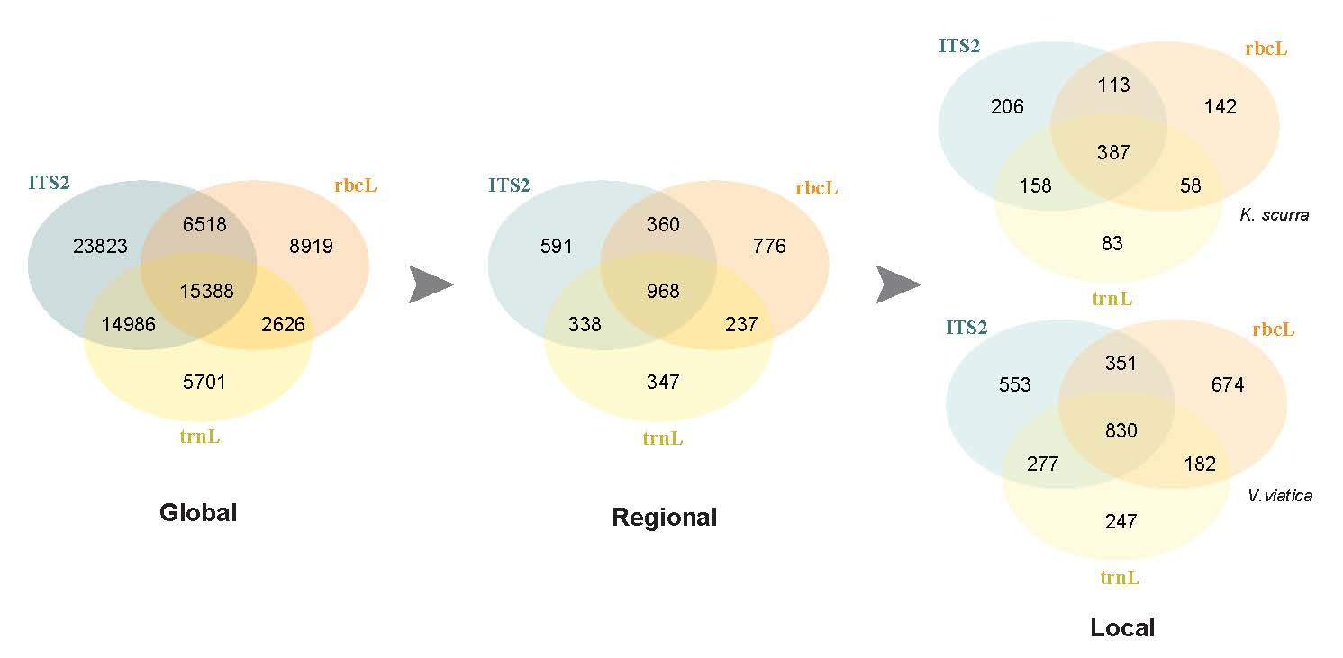
Figure S1 Number of plant species included in each reference library (global, regional and local) and the number of species with DNA sequences for the ITS2, rbcL and trnL markers (The reference library was constructed in August 2023).

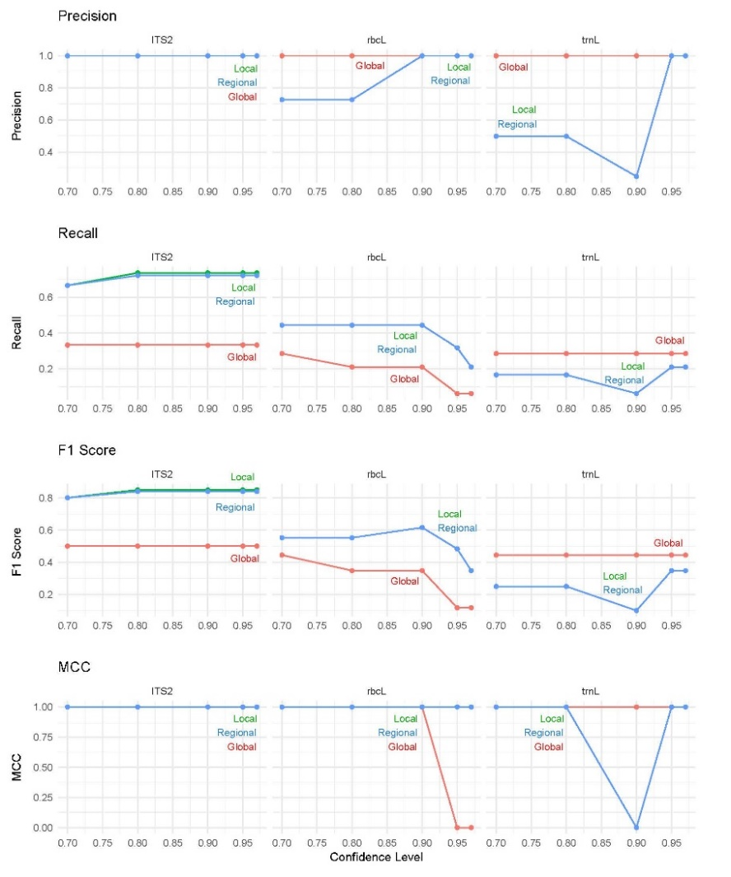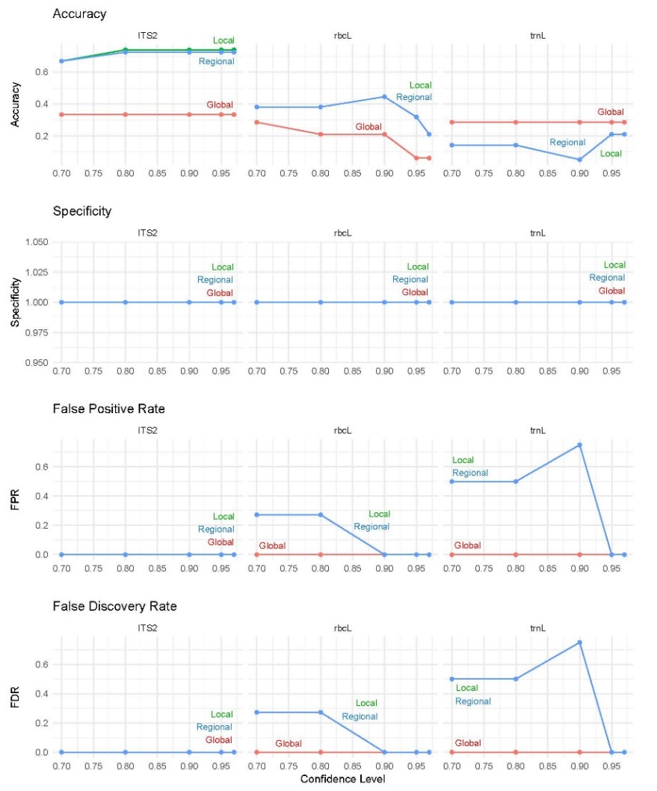
Figure S2 Performance metrics for spike control and ITS2, rbcL and trnL markers using different reference libraries. All metrics accounted for partial classifications. For example, accuracy was calculated as the proportion of true positive and partial true positive classifications out of the total number of classifications (Accuracy=(TP+PTP)/((TP+PTP+FP+PFP+FN)). Where: TP = True positives, PTP = Partial true positives, FP = False positives, PFP = Partial false positives and FN = False negatives.

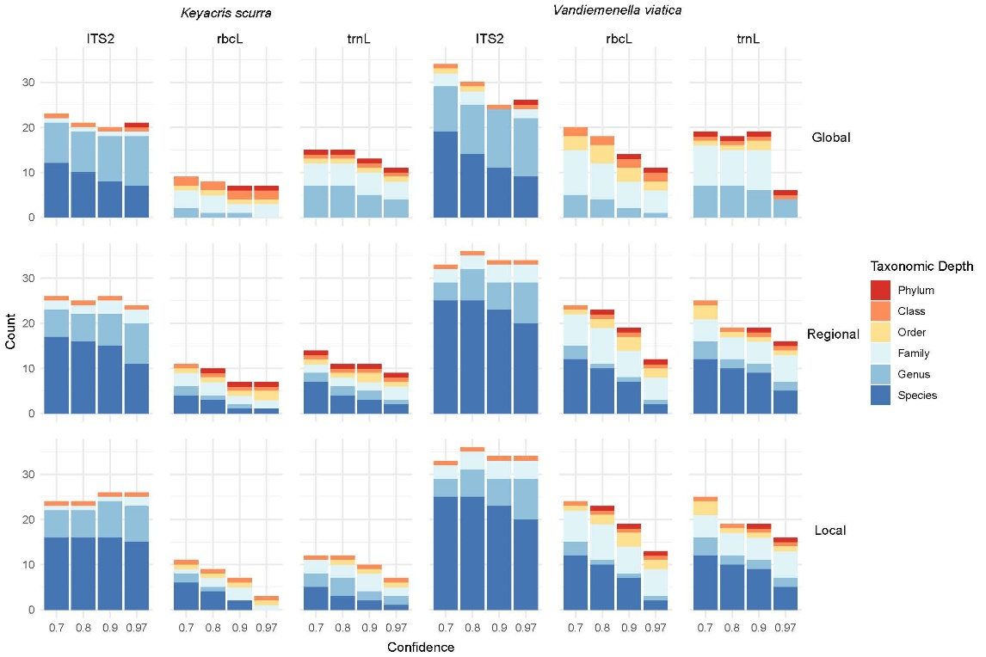
Figure S3 Number of plant phyla, classes, orders, families, genera and species at different confidence thresholds for assigning taxonomy for Keyacris scurra and Vandiemenella viatica, for each DNA marker (ITS2, rbcL and trnL) using the DNA reference libraries.
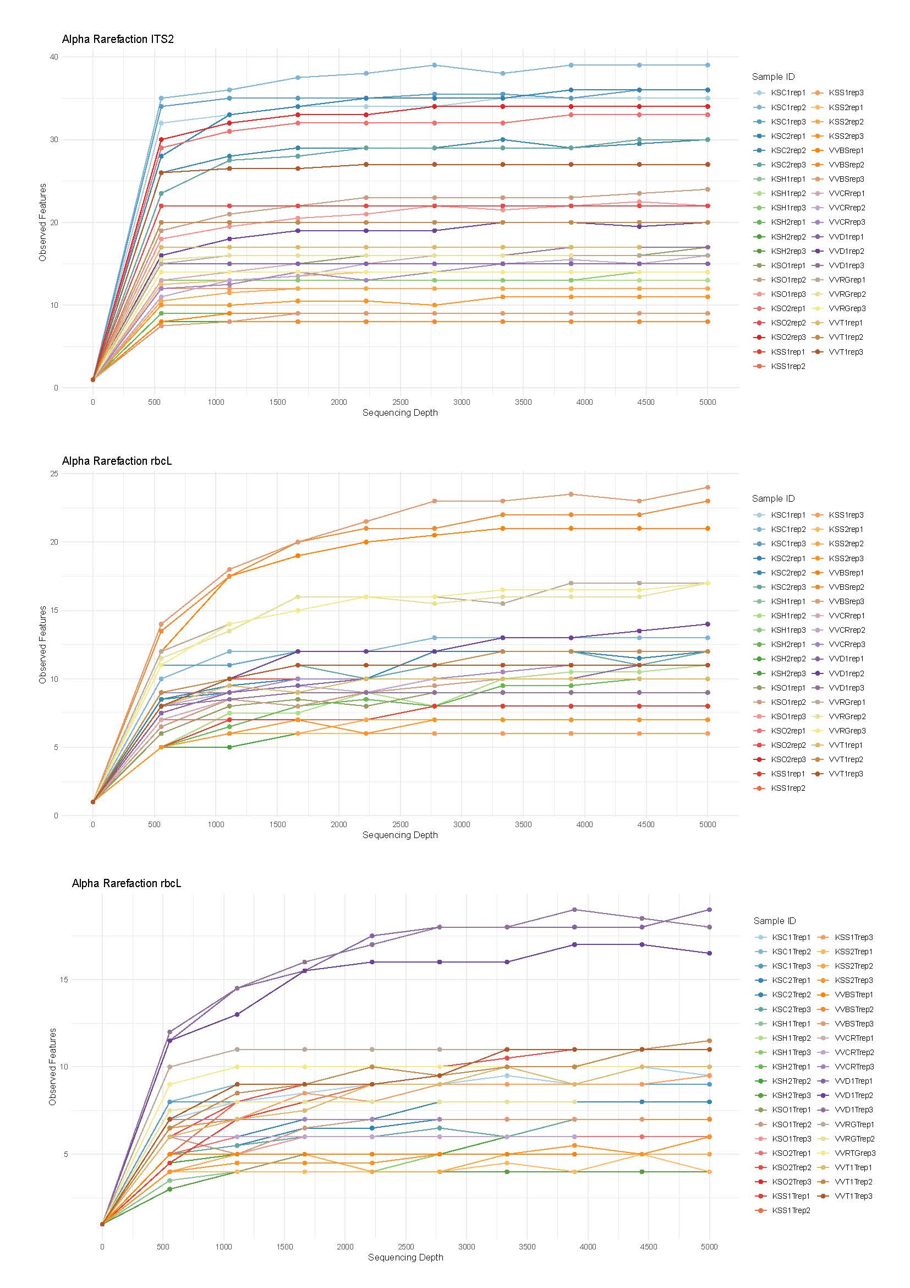
Figure S4 Rarefaction curves for ITS2, rbcL and trnL markers, illustrating the relationship between sequencing depth and the number of observed features across multiple samples. Each curve corresponds to a unique sample, and the asymptotes suggest that the majority of samples have reached a plateau, where additional sequencing does not result in significantly higher species numbers.
Table S1ASV detection consistency across PCR replicates per sample for the trnL marker. The table shows the total number of ASVs detected per sample, the number of ASVs found in at least two out of three PCR replicates (considered reproducible), and the corresponding percentage of reproducible ASVs. These results are derived from the QIIME2 feature table after denoising and filtering. Control samples are not included in this table.
 | ITS2 |  |  | rbcL |  |  | trnL
Sample | Total_ASVs | Rep_ASVs | % | Total_ASVs | Rep_ASVs | % | Total_ASVs | Rep_ASVs | %
KSC1 | 41 | 37 | 90.2 | 16 | 12 | 75 | 12 | 9 | 75
KSC2 | 42 | 31 | 73.8 | 16 | 11 | 68.8 | 10 | 7 | 70
KSH1 | 14 | 13 | 92.9 | 13 | 7 | 53.8 | 5 | 4 | 80
KSH2 | 12 | 9 | 75 | 13 | 7 | 53.8 | 7 | 5 | 71.4
KSO1 | 29 | 20 | 69 | 14 | 8 | 57.1 | 7 | 7 | 100
KSO2 | 37 | 30 | 81.1 | 11 | 8 | 72.7 | 12 | 8 | 66.7
KSS1 | 15 | 15 | 100 | 10 | 7 | 70 | 12 | 10 | 83.3
KSB1 | 20 | 9 | 45 | 8 | 7 | 87.5 | 6 | 6 | 100
VVBS | 12 | 7 | 58.3 | 29 | 22 | 75.9 | 8 | 6 | 75
VVCR | 23 | 16 | 69.6 | 13 | 9 | 69.2 | 8 | 6 | 75
VVD1 | 22 | 16 | 72.7 | 14 | 11 | 78.6 | 27 | 17 | 63
VVRG | 17 | 15 | 88.2 | 22 | 17 | 77.3 | 11 | 10 | 90.9
VVT1 | 27 | 20 | 74.1 | 17 | 10 | 58.8 | 14 | 11 | 78.6

Table S2 Total number of reads per sample and amplicon after quality filtering. Read counts represent the number of high-quality sequences assigned to each replicate sample for each amplicon (ITS2, rbcL, trnL) following denoising and filtering steps in QIIME2. Control samples are not included in this table.
Sample | ITS2 | rbcL | trnL
KSC1rep1 | 20012 | 21399 | 26101
KSC1rep2 | 36030 | 37737 | 27413
KSC1rep3 | 18850 | 20581 | 34018
KSC2rep1 | 25976 | 38845 | 27099
KSC2rep2 | 15396 | 33608 | 61135
KSC2rep3 | 18096 | 36952 | 40580
KSH1rep1 | 15632 | 29259 | 29353
KSH1rep2 | 22767 | 59807 | 32298
KSH1rep3 | 12731 | 20867 | 36607
KSH2rep1 | 6703 | 57229 | 36624
KSH2rep2 | 3685 | 55054 | 72700
KSH2rep3 | 12790 | 31615 | 36293
KSO1rep1 | 14089 | 21273 | 14684
KSO1rep2 | 35717 | 39471 | 18641
KSO1rep3 | 26339 | 15295 | 17061
KSO2rep1 | 17499 | 11328 | 17377
KSO2rep2 | 8079 | 19829 | 45238
KSO2rep3 | 22527 | 16292 | 10062
KSS1rep1 | 14253 | 28346 | 24881
KSS1rep2 | 16935 | 17142 | 31121
KSS1rep3 | 9013 | 12172 | 29711
KSB1rep1 | 12254 | 56106 | 34908
KSB1rep2 | 13143 | 32607 | 52441
KSB1rep3 | 6953 | 26425 | 36948
VVBSrep1 | 12011 | 19230 | 4415
VVBSrep2 | 14525 | 28165 | 5620
VVBSrep3 | 18647 | 30716 | 4950
VVCRrep1 | 8627 | 38515 | 1
VVCRrep2 | 7432 | 42061 | 3927
VVCRrep3 | 11388 | 51446 | 2921
VVD1rep1 | 14147 | 17216 | 29660
VVD1rep2 | 30452 | 34866 | 30564
VVD1rep3 | 17622 | 13213 | 34512
VVRGrep1 | 7781 | 48151 | 4843
VVRGrep2 | 3908 | 39380 | 4054
VVRGrep3 | 5017 | 44021 | 4620
VVT1rep1 | 4583 | 36823 | 30339
VVT1rep2 | 9516 | 42060 | 66412
VVT1rep3 | 16933 | 37893 | 34085

Table S3 Plant species found in metabarcoding analysis of Keyacris scurra faeces for the molecular markers ITS2, rbcL and trnL. (Taxa in only one replicate were not considered)
Order | Family |  | Species | Vernacular name | Life form | Status | Distribution in Australia | Site ID | Previous record as food plant | Reference | Sinclair, S. personal communication, September, 2024
Asterales | Asteraceae |  | Chrysocephalum apiculatum | Common Everlasting | Native perennial herb | LC | All states | Omeo and Cudgewa | Yes | ALA
Asterales |  |  | Chrysocephalum semipapposum | Clustered Everlasting | Native perennial herb | LC | All states | Omeo, Bingo-Munjie and Cudgewa | Yes | ALA
Asterales |  |  | Euchiton japonicus | Creeping cudweed | Native perennial or biennial herb | LC | All states except NT | Shelley | No | Grasslands
Asterales |  |  | Leptorhynchos squamatus | Hairy Buttons | Native perennial herb | LC | All states except WA and NT | Shelley | No | Grasslands
Asterales |  |  | Leucochrysum sp. |  | Native perennial herb |  | All states | Bingo munjie 1 | No | Grasslands | Almost certainly L. albicans.
Asterales |  |  | Hypochaeris sp. |  | Introduced perennial herb |  | All states | Cudgewa 1 | No | ALA
Geraniales | Geraniaceae |  | Geranium sp. |  | Native and introduced species. |  | All states | Beechworth | No | ALA | Taxonomic troubles with the genus.
Lamiales | Plantaginaceae | Plantago debilis |  | Shade Plantain | Native annual or perennial herb | Rare (TZ) | All states | Omeo 2 | Yes | ALA
Lamiales | Plantaginaceae | Plantago lanceolata |  | Common Plantain | Invasive introduced perennial herb | LC | All states | Omeo, Bingo Munjie 1 | Yes | ALA
Poales | Poaceae |  | Bromus hordeaceus | Soft Brome | Invasive introduced annual-biennial grass | LC | All states except NT. | Cudgewa | No | ALA
Poales |  |  | Bromus diandrus | Great Brome | Naturalised tufted annual grass | LC | All states | Cudgewa 2 | No | ALA
Poales |  |  | Vulpia muralis | Wall Fescue | Introduced annual grass | LC | All states except NT | Cudgewa 1 | No | AusGrass2
Rosales | Rosaceae |  | Potentilla recta | Sulphur Cinquefoil | Invasive introduced perennial herb | LC | ACT, NSW, TAS and VIC | Cudgewa. | No | ALA
Rosales |  |  | Rosa rubiginosa | Sweet Briar | Invasive introduced deciduous shrub | LC | All states except NT. | Beechworth | Yes | ALA
Saxifragales | Crassulaceae |  | Crassula sieberiana | Austral Crassula | Native perennial or annua succulent | EN (SA) | All states except NT | Omeo 2 | No | ALA
Source: Atlas of Living Australia website (2024). Available online at http://www.ala.org.au. (last accessed: 15 Jul. 2024). AusGrass2 (2024) Available online at https://ausgrass2.myspecies.info (last accessed: 15 Jul. 2024). VicFlora (2024). Flora of Victoria, Royal Botanic Gardens Victoria. Available online at https://vicflora.rbg.vic.gov.au (last accessed: 15 Jul. 2024
Table S4 Plant species found in metabarcoding analysis of Vandiemenella viatica faeces using the molecular markers ITS2, rbcL and trnL. (Taxa in only one replicate were not considered).
Order | Family | Species | Common name | Life form | Conservation | Distribution | Locality | Previous record as food plant | Reference | Sinclair, S. personal communication, September, 2024
Asterales | Asteraceae | Cassinia longifolia | Cauliflower Bush | Native shrub | LC | ACT, NSW, VIC | Diamond Creek | No | VicFlora /ALA
Asterales | Asteraceae | Olearia ramulosa | Twiggy daisy-bush | Native shrub | LC | All states except NT and WA | Bayside | No | VicFlora /ALA
Asterales | Asteraceae | Olearia teretifolia | Cypress Daisy-Bush | Native shrub | LC | ACT, NSW and VIC | Bayside | No | VicFlora /ALA | Not possible. This species has not been recorded in the Melbourne area, apart from one record from Hawthorn in 1925
Asterales | Asteraceae | Rutidosis leptorhynchoides | Button Wrinklewort | Native perennial herb | EN (AU) | ACT, NSW and VIC | Truganina | No | VicFlora /ALA
Asterales | Asteraceae | Vittadinia cervicularis | Annual New Holland Daisy | Native annual herb | LC | All states except NT and QLD | Royal Golf Club | No | VicFlora /ALA
Caryophyllales | Chenopodiaceae | Atriplex prostrata | Hastate Orache | Introduced annual herb | LC | All states except NT and QLD | Royal Golf Club | No | VicFlora /ALA
Caryophyllales | Polygoniaceae | Rumex pulcher | Fiddle Dock | Introduced perennial herb | LC | All states except NT and QLD | Royal Golf Club | Yes | VicFlora /ALA
Ericales | Ericaceae | Styphelia ericoides (Leucopogon ericoides) | Pink Beard-Heath | Native shrub | LC | ACT, NSW and VIC | Cranbourne | No | VicFlora (2023)/ALA
Ericales | Ericaceae | Monotoca scoparia | Prickly Broom Heath | Native shrub | LC | All states except NT and WA | Royal Golf Club and Cranbourne | No | VicFlora (2023)/ALA
Ericales | Ericaceae | Woollsia pungens | Snow Heath | Native shrub | LC | NSW and QLD | Cranbourne | No | VicFlora /ALA
Fabales | Fabaceae | Bossiaea cinerea | Showy Bossiaea | Native shrub | LC | ACT, NSW, VIC, TAS and SA | Bayside | No | VicFlora /ALA
Fabales | Fabaceae | Trifolium arvense | Haresfoot Clover | Introduced annual or biennial herb | LC | All states | Royal Golf Club | Yes | ALA
Lamiales | Plantaginaceae | Plantago gaudichaudii | Narrow Plantain | Native perennial herb | LC | All states except NT and WA | Truganina | No | AusGrass2
Lamiales | Plantaginaceae | Plantago debilis | Shade Plantain | Native annual or perennial herb | Rare (SA) | All states | Truganina | No | ALA | Impossible in this habitat.
Laurales | Lauraceae | Cassytha pubescens | Downy Dodder-Laurel | Native hemiparasitic vine |  | All states | Royal Golf Club | No | ALA
Myrtales | Myrtaceae | Gaudium laevigatum | Coast Tea-Tree | Native shrub |  | All states except NT | Royal Golf Club | Yes | VicFlora
Myrtales | Myrtaceae | Kunzea ericoides | Burgan | Need taxonomic rev. (shrub endemic to NZ) | LC | All states except NT | Diamond Creek | No | VicFlora /ALA
Pinales | Pinaceae | Pinus radiata | Insignis Pine | Introduced tree |  | All states except NT | Diamond Creek and Truganina | No | VicFlora/ALA | No Pinus radiata anywhere at or near the cemetery.
Poales | Poaceae | Anthoxanthum odoratum | Sweet Vernal grass | Introduced grass |  | All states except NT | Royal Golf Club | No | VicFlora/ALA
Poales | Poaceae | Vulpia muralis | Wall Fescue | Introduced annual grass | LC | All states except NT | Diamond and Royal Golf Club | No | AusGrass2
Sapindales | Rutaceae | Correa sp. |  | Native shrub to small tree | LC | All states except NT | Bayside | No | VicFlora /ALA
Saxifragales | Haloragaceae | Gonocarpus humilis | Shade Raspwort | Native perennial herb | Rare (SA) | All states except NT and WA. | Diamond Creek | No | VicFlora /ALA
Source: Atlas of Living Australia website (2024). Available online at http://www.ala.org.au. (last accessed: 15 Jul. 2024). AusGrass2 (2024) Available online at https://ausgrass2.myspecies.info (last accessed: 15 Jul. 2024). VicFlora (2024). Flora of Victoria, Royal Botanic Gardens Victoria. Available online at https://vicflora.rbg.vic.gov.au (last accessed: 15 Jul. 2024
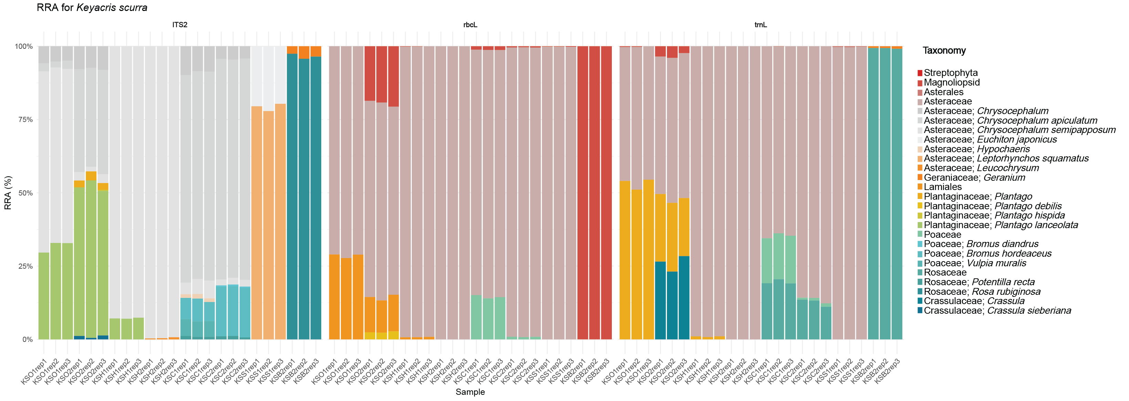
Figure S5 Relative read abundance (RRA) for Keyacris scurra diet using faeces metabarcoding
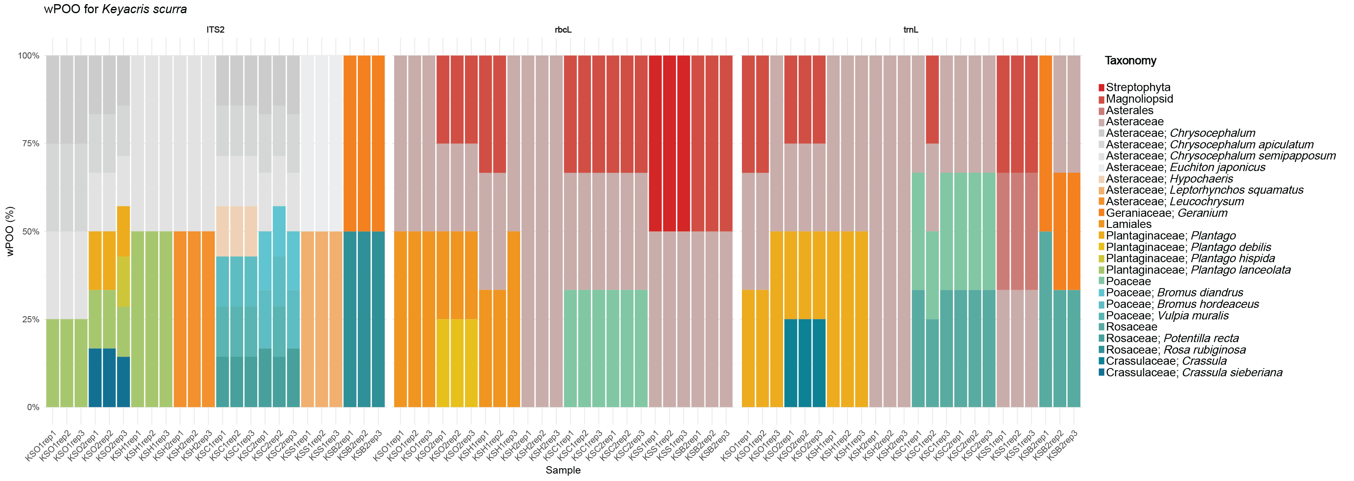
Figure S6 Weighted percent of occurrence (wPOO) for Keyacris scurra diet using faeces metabarcoding
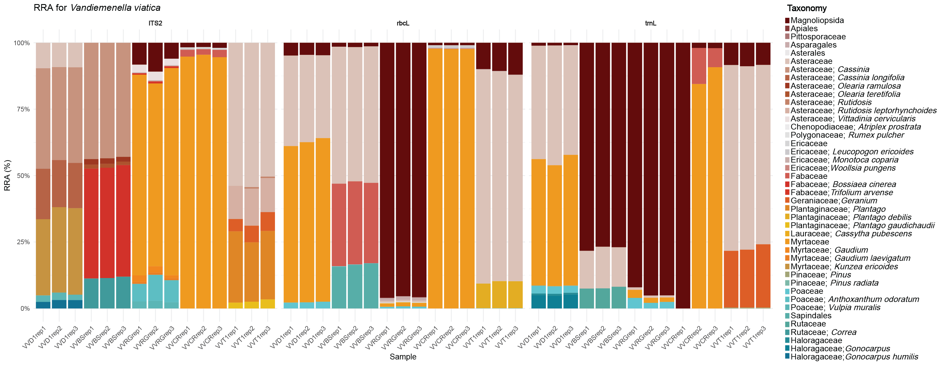
Figure S7 Relative read abundance (RRA) for Vandiemenella viatica diet using faeces metabarcoding
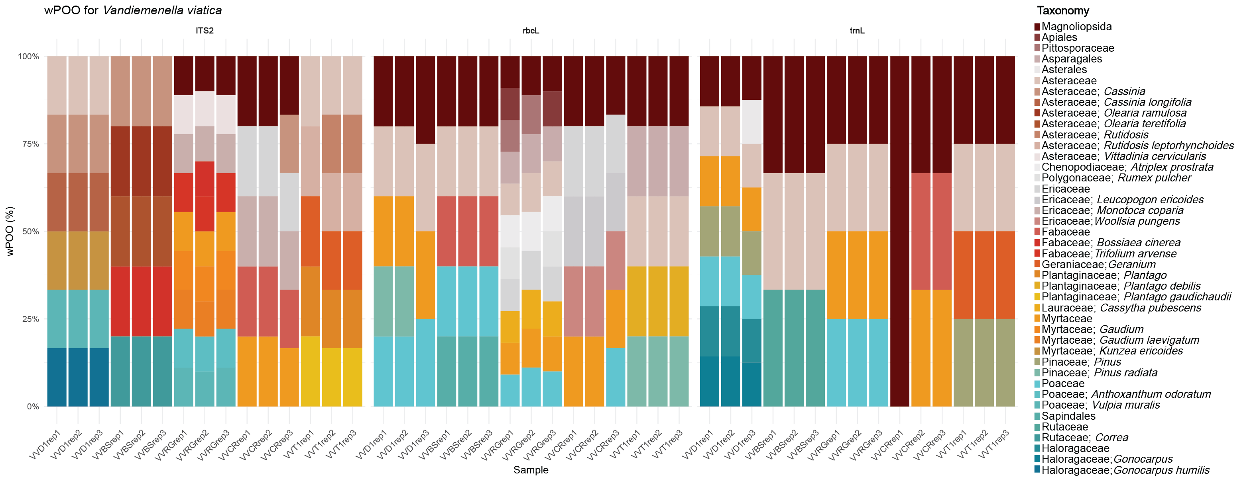
Figure S8 Weighted percent of occurrence (wPOO) for Vandiemenella viatica diet using faeces metabarcoding

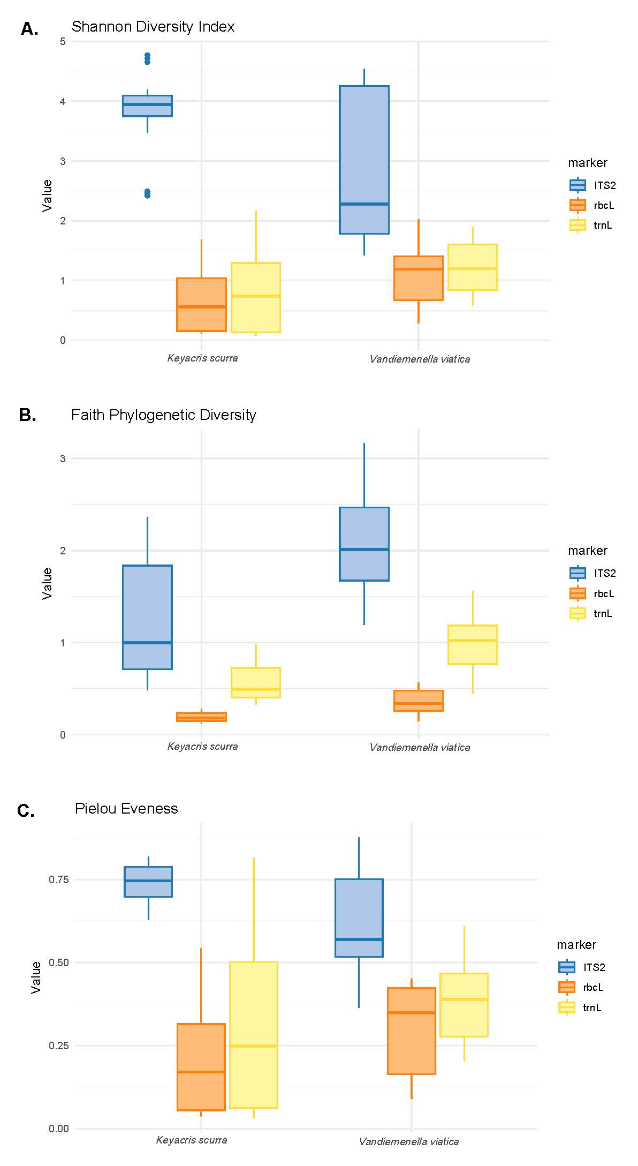
Figure S9 Comparison of alpha diversity metrics for each grasshopper species by molecular marker. A. Boxplots of Shannon diversity index for Keyacris scurra (ITS2 Mdn = 3.95, IQR 3.75–4.09; rbcL Mdn 0.56, IQR 0.16–1.04; trnL Mdn 0.74, IQR 0.16–1.29), Vandiemenella viatica (ITS2 Mdn = 2.28, IQR 1.78-4.25; rbcL Mdn 1.19, IQR 0.67–1.41; trnL Mdn =1.2, IQR 0.84–1.6). Outliers are observed in K. scurra for the ITS2 marker only. B. Boxplots of Faith’s Phylogenetic Diversity in K. scurra (ITS2 Mdn = 1, IQR 0.71–1.84; rbcL = 0.18, IQR 0.15–0.24; trnL Mdn = 0.49, IQR 0.4–0.73), V. viatica (ITS2 Mdn = 2.01, IQR 1.67–2.47; rbcL Mdn 0.34 (IQR 0.26–0.48, TRNL Mdn 1.02 (IQR 0.77–1.18). C. Boxplots of Pielou's Evenness for K. scurra (ITS2 Mdn = 0.75, IQR 0.7–0.79; rbcL Mdn = 0.17, IQR 0.06–0.32; trnL Mdn = 0.25, IQR 0.06–0.5), and V. viatica (ITS2 Mdn = 0.57, IQR 0.52–0.75; rbcL Mdn =0.35, IQR 0.17–0.42; trnL = Mdn 0.39, IQR 0.28–0.47). All Boxplots show that the ITS2 marker had higher values than the other two markers.

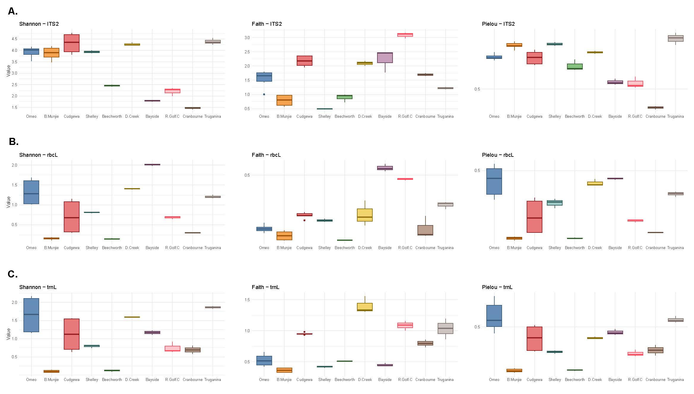
Figure S10 Comparison of alpha diversity metrics for each site by molecular marker. A. Boxplots of Shannon diversity index, Faith’s Phylogenetic Diversity and Pielou's Evenness for ITS2. B. Boxplots of Shannon diversity index, Faith’s Phylogenetic Diversity and Pielou's Evenness for rbcL. C. Boxplots of Shannon diversity index, Faith’s Phylogenetic Diversity and Pielou's Evenness for trnL.
Table S5 Pairwise comparison of diversity metrics and molecular markers across sites using Dunn’s test

Table S6 Pairwise PERMANOVA results for different markers and UniFrac types (Unweighted and Weighted). All tests were conducted using 999 permutations.
Type | marker | Sample size | pseudo-F | p-value
Unweighted | ITS2 | 39 | 7.062 | 0.001
 | rbcL | 39 | 6.994 | 0.001
 | trnL | 38 | 5.611 | 0.002
Weighted | ITS2 | 39 | 16.281 | 0.001
 | rbcL | 39 | 15.311 | 0.001
 | trnL | 38 | 4.916 | 0.003

