Supplementary Information

Mechanistic Multi-Enzyme Engineering for High-Yield Bilirubin Biosynthesis
Zhentao Jiang^{1&}, Jingxin Rao^{2&}, Caokai Zhu¹, Yamiao Li¹, Qiang Zhu¹, Mingyue Zheng²,Wenchi Zhang³, Rongzhen Zhang^{1,*}

¹ School of Biotechnology, Jiangnan University, Wuxi 214122, P. R. China
² Drug Discovery and Design Center, State Key Laboratory of Drug Research, Shanghai Institute of Materia Medica, Chinese Academy of Sciences, Shanghai 201203, China; University of Chinese Academy of Sciences, Beijing 100049, China
³Solomon H. Snyder Department of Neuroscience, Johns Hopkins University School of Medicine, Baltimore, MD 21205, USA

*Corresponding author: Rongzhen Zhang
Tel: +86-510-85916881; Fax: +86-510-85864112
Email address: rzzhang@jiangnan.edu.cn
Present address: School of Biotechnology, Jiangnan University, 1800 Lihu Avenue, Wuxi City, China, 214122

&Zhentao Jiang and &Jingxin Rao contribute equally to this work.

Content
Supplementary methods
Supplementary table 1-3
Supplementary Fig. 1-22
References

Supplementary methods
Determination of kinetic parameters
Prior to kinetic parameter determination, the optimal ratio of RnHO-1 to RnCPR was established by adjusting the concentration of RnCPR required to achieve maximal catalytic activity of RnHO-1. Reaction rates were measured under varying RnCPR concentrations (10‒300 mg/L) at fixed RnHO-1 levels (50, 100, and 150 mg/L). Reaction mixtures contained 1 mM heme, 10 mM NADPH, and 100 mM Tris-HCl buffer (pH 7.5). Reactions were conducted at 35 ℃ with 600 rpm agitation for 10 min, followed by 10-fold dilution with methanol. BV concentrations were quantified via HPLC.
Using heme (0.05‒1.0 mM) as substrate, reactions were performed using 100 mg/L RnHO-1 (or its mutants) and 100 mg/L RnCPR (or its mutants) in 100 mM Tris-HCl buffer (pH 7.5) containing 10 mM NADPH. After 10 min at 35 ℃, reactions were terminated by 10-fold dilution with methanol. BV concentrations were analyzed by HPLC. Michaelis-Menten parameters (K_{m}, k_{cat}, and k_{cat}/K_{m}) for heme were derived via nonlinear regression of reaction curves using Origin 2024 software.
Using BV (0.05–1.0 mM) as substrate, reactions were conducted with 20 mg/L RnBVR in 100 mM Tris-HCl buffer (pH 7.5) containing 2 mM NADPH. After 10 min at 35 ℃, reactions were terminated by 10-fold dilution with DMSO. BR concentrations were determined via HPLC. Michaelis-Menten parameters (K_{m}, k_{cat}, and k_{cat}/K_{m}) for BV were derived via nonlinear regression of reaction curves using Origin 2024 software.
Additionally, the specific activity was calculated based on the obtained experimental data. One unit of enzyme activity (U) was defined as the amount of enzyme required to produce 1 μmol of product per minute under the assay conditions. Specific activity (U/mg) was determined as the ratio of total activity (U) to the mass of enzyme (mg) in the reaction.
Construction of co-expression strains
The co-expression strains were generated through sequential homologous recombination. First, linearized pCDFDuet-1 vector, RnHO-1_{Δ22}, and RnCPR_{Δ54} DNA fragments were amplified via PCR using primers listed in Supplementary Table 3, with pCDFDuet-1, pET28a(+)-RnHO-1_{Δ22}, and pET28a(+)-RnCPR_{Δ54} as templates. A three-fragment homologous recombination (Vazyme Biotech Co., Ltd.) was performed to sequentially integrate RnCPR_{Δ54} and RnHO-1_{Δ22} into the multiple cloning site I (MCS I) and multiple cloning site Ⅱ (MCS Ⅱ) of pCDFDuet-1, generating pCDFDuet-1- RnCPR_{Δ54}/RnHO-1_{Δ22}.
ChCODH was integrated into MCS I of pETDuet-1, PCR fragments from pET28a(+)-ChCODH and pETDuet-1 were recombined, resulting in plasmids pETDuet-1-ChCODH. Then RnBVR and ApFDH (the latter containing a 5’-engineered ribosome binding site, RBS) was amplified from pET28a(+)-ApFDH and pET28a(+)-RnBVR, and linearized vector was amplified from pETDuet-1-ChCODH. A three-fragment homologous recombination (Vazyme Biotech Co., Ltd.) was performed to sequentially integrate RnBVR and ApFDH into multiple cloning site Ⅱ (MCS Ⅱ) of pETDuet-1, generating pETDuet-1-ChCODH/RnBVR/ApFDH. Finally, pCDFDuet-1-RnCPR_{Δ54}/RnHO-1_{Δ22} and pETDuet-1-ChCODH/RnBVR/ApFDH were co-transformed into E. coli BL21 (DE3), to generate the five-enzyme co-expression strain E. coli/pCDFDuet-1-RnCPR_{Δ54}/RnHO-1_{Δ22}/pETDuet-1-ChCODH/RnBVR/ApFDH.
Cell lysate reaction test
Temperature optimization. Cell lysate (each 5 g dry cell/L) from E. coli/pET28a(+)-RnHO-1_{Δ22} and E. coli/pET28a(+)-RnCPR_{Δ54} were added to a 10 mL reaction system containing 1 mM heme, 10 mM NADPH, and 100 mM Tris-HCl buffer (pH 7.5). Reactions were performed at temperatures ranging from 25 to 50 ℃ with 600 rpm agitation for 30 min. Reactions were terminated by 10-fold dilution with DMSO, and product concentrations were quantified via HPLC to calculate relative activity.
FMN and FAD optimization. Cell lysate (each 5 g dry cell weight/L) from E. coli/pET28a(+)-RnHO-1_{Δ22} and E. coli/pET28a(+)-RnCPR_{Δ54} were added to a 10 mL reaction system containing 1 mM heme, 10 mM NADPH, and 100 mM Tris-HCl buffer (pH 7.5), supplemented with varying concentrations of FMN or FAD (0.1‒1 mM) or their combinations. Reactions proceeded at 35 ℃ with 600 rpm agitation for 30 min. Reactions were terminated by 10-fold dilution with DMSO, and product concentrations were quantified via HPLC to calculate relative activity.
Optimal pH for enzyme activity. Cell lysate (each 5 g dry cell/L) from E. coli/pET28a(+)-RnHO-1_{Δ22} and E. coli/pET28a(+)-RnCPR_{Δ54} were added to a 10 mL reaction system containing 1 mM heme, 10 mM NADPH, 0.1 mM FMN, and buffers spanning pH 5.0–9.0: citrate (100 mM, pH 5.0‒6.5); PBS (10 or 100 mM, pH 6.0‒8.0); Tris-HCl (100 mM, pH 7.5‒9.0). Reactions were performed at 35 ℃ with 600 rpm agitation for 30 min. Reactions were terminated by 10-fold dilution with DMSO, and product concentrations were quantified via HPLC to calculate relative activity.
Metal ion supplementation. Cell lysate (each 5 g dry cell/L) from E. coli/pET28a(+)-RnHO-1_{Δ22} and E. coli/pET28a(+)-RnCPR_{Δ54} were added to a 10 mL reaction system containing 1 mM heme, 10 mM NADPH, 0.1 mM FMN, and 100 mM Tris-HCl buffer (pH 7.5), supplemented with 2 mM or 10 mM of the following ions: Mo²⁺, Fe²⁺, Fe³⁺, Ni²⁺, Mg²⁺, Cu²⁺, Co²⁺, Mn²⁺, NH₄⁺, Ca²⁺, Ba²⁺, Zn²⁺, Na⁺, or K⁺. Reactions were conducted at 35 ℃ with 600 rpm agitation for 30 min. Reactions were terminated by 10-fold dilution with DMSO, and product concentrations were quantified via HPLC to calculate relative activity.
Heme to BV conversion. Cell lysate (each 20 g dry cell weight/L) of RnHO-1_{Δ22} / RnCPR_{Δ54} or RnHO-1_{WT}/RnCPR_{WT} were used for heme to BV conversion. 10 mL reaction system containing 1 mM heme, 10 mM NADPH, 0.1 mM FMN, and 100 mM Tris-HCl buffer (pH 7.5), reactions were conducted at 35 ℃ with 600 rpm agitation for 150 min. During the reaction process, samples were taken at intervals and diluted 10-fold with methanol or NaOH (50 mM), and substrate/product concentrations were quantified via HPLC to calculate conversion or yield.
BV to BR conversion. Cell lysate (20 g dry cell/L) of RnBVR was used for BV to BR conversion. 10 mL reaction system containing 1 mM BV, 2 mM NADPH and 100 mM Tris-HCl buffer (pH 7.5), reactions were conducted at 35 ℃ with 600 rpm agitation for 60 min. During the reaction process, samples were taken at intervals and diluted 10-fold with methanol or DMSO, and substrate/product concentrations were quantified via HPLC to calculate conversion or yield.
Heme to BR conversion. Cell lysate (each 20 g dry cell/L) of RnHO-1_{Δ22}, RnCPR_{Δ54} and RnBVR were used for heme to BV conversion. 10 mL reaction system containing 1 mM heme, 10 mM NADPH, 0.1 mM FMN, and 100 mM Tris-HCl buffer (pH 7.5), reactions were conducted at 35 ℃ with 600 rpm agitation for 150 min. During the reaction process, samples were taken at intervals and diluted 10-fold with methanol, NaOH (50 mM) or DMSO, and substrate/intermediate/product concentrations were quantified via HPLC to calculate conversion or yield.
HEDP supplementation. Reactions were conducted using cell lysate (each 20 g dry cell weight/L) of RnHO-1_{Δ22}, RnCPR_{Δ54} and RnBVR, 1 mM heme, 10 mM NADPH, 0.1 mM FMN, and 100 mM Tris-HCl buffer (pH 7.5), supplemented with varying concentrations of HEDP (0‒40 mM). Reactions proceeded at 35 ℃ with 600 rpm agitation for 150 min. During the reaction process, samples were taken at intervals and diluted 10-fold with DMSO, and product concentrations were quantified via HPLC.
Optimal pH for prevent product degradation. Reactions were conducted using cell lysate (each 20 g dry cell/L) of RnHO-1_{Δ22}, RnCPR_{Δ54} and RnBVR, 1 mM heme, 10 mM NADPH, 0.1 mM FMN, supplemented with HEDP (15 mM). Control the pH of the reaction mixture at 6.0‒8.0 by adding HCl (1 M). Reactions proceeded at 35 ℃ with 600 rpm agitation for 150 min. During the reaction process, samples were taken at intervals and diluted 10-fold with DMSO, and product concentrations were quantified via HPLC.
Heme to BR conversion excluding the influence of ferrous ions. Cell lysate (each 20 g dry cell/L) of RnHO-1_{Δ22}, RnCPR_{Δ54} and RnBVR were used for heme to BV conversion. 10 mL reaction system containing 3 mM heme, 30 mM NADPH, 0.1 mM FMN, 15 mM HEDP and 100 mM Tris-HCl buffer (pH 6.5), reactions were conducted at 35 ℃ with 600 rpm agitation for 150 min. During the reaction process, samples were taken at intervals and diluted 10-fold with NaOH (50 mM) or DMSO, and substrate / product concentrations were quantified via HPLC to calculate conversion or yield.
All cell lysates were prepared by ultrasonic disruption with ice bath, the power is 400W, working for 2 seconds, stopping for 4 seconds, and a total working time of 5‒10 minutes.
Preparation of BV/BR degradation product samples
Ferrous chloride (1 mM) was added to 1 mM BV or BR solution and incubate for 150 minutes under enzymatic reaction conditions (35 ℃, pH 7.5) to obtain degradation product samples. When it is necessary to test the effect of HEDP or pH changes on the degree of degradation, add additional HEDP of the corresponding concentration before incubation, or adjust the pH with HCl.
Enzymatic catalysis with pretreated heme
10 mM heme solution (10 mL) was prepared by dissolving in 100 mM NaOH, followed by pH adjustment to 7.5 using HCl. The solution was then saturated with carbon monoxide (CO) by purging CO gas at a flow rate of 4 vvm for 30 minutes, yielding a CO-saturated heme solution. Cell lysate (each 20 g dry cell/L) of RnHO-1_{Δ22} and RnCPR_{Δ54} were used for CO-saturated heme to BV conversion. 10 mL reaction system containing 1 mM CO-saturated heme, 10 mM NADPH, 0.1 mM FMN, 15 mM HEDP and 100 mM Tris-HCl buffer (pH 6.5), reactions were conducted at 35 ℃ with 600 rpm agitation for 30 min. Then terminated by 10-fold dilution with methanol, and product concentrations were quantified via HPLC to calculate relative activity.
Analysis of gas release tunnel
Tunnel analysis was performed on the heme-CO-bound RnHO-1 crystal structure (PDB code: 1IX4) using Caver 3.0 software. Parameters were set as follows: minimum probe radius = 0.9 Å, shell depth = 4 Å, and shell radius = 3 Å, to identify all potential CO release tunnels.
The Metadynamics module within the Maestro software suite was employed to conduct enhanced-sampling molecular dynamics (MD) simulations. A collective variable (CV) was defined between the CO molecule and the mass center of the RnHO-1 active site. A Gaussian bias potential (height = 0.03 kcal/mol, deposition frequency = 0.09 ps) was applied to accelerate sampling. Simulations were performed for 50 ns under isothermal-isobaric conditions (303 K, 1.01 bar) to elucidate CO release pathways and determine the predominant gas tunnel.
Hydrophobicity analysis
Hydrophobicity analysis is performed using the color-h script (https://wiki.pymol.org/index.php/Color_h) in the pymol 3.0.4 program. The corresponding residues are colored from white to red according to the hydrophobicity values of the amino acids, with hydrophobicity ranging from low to high.
Molecular dynamic simulation
The GROMACS software package was employed to perform molecular dynamics (MD) simulations of RnHO-1_{Δ22}. The holo-form protein structures containing heme-CO and heme-O₂ ligands were derived from PDB entries 1ix4 and 4g7l, respectively. To generate input files for the protein-ligand complexes, atomic coordinates of the heme-CO and heme-O₂ ligands were extracted from their respective PDB files. Bonding parameters for the ligands were obtained through vibrational frequency analysis using Gaussian 09 at the B3LYP/6-311G(d, p) level of theory, with the nosymm keyword applied to preserve original coordinate consistency. The Restrained Electrostatic Potential (RESP) charges were calculated using Multiwfn, followed by ligand parameterization with the Generalized Amber Force Field (GAFF) via the Sobtop program¹. Notably, the UFF force field was specifically assigned to the Fe²⁺ center. Concurrently, the Amber03 force field was applied to the protein receptor using the GROMACS pdb2gmx utility to generate topology and coordinate files.
The integrated system was constructed by merging ligand and receptor coordinates and topology files. Solvation was performed using the TIP3P water model, with charge neutralization achieved by adding Na⁺ or Cl⁻ ions. Energy minimization, followed by NVT (constant particle number, volume, and temperature) and NPT (constant particle number, pressure, and temperature) equilibration phases, preceded the production MD simulations. The simulations were conducted with a 1.5-fs time step over 2×10⁷ steps, corresponding to a total trajectory length of 30 ns.
Binding free energy analysis
The binding free energy between heme-CO or heme-O₂ ligands and RnHO-1_{Δ22} was calculated using the gmx_mmpbsa toolkit². Based on the root mean square deviation (RMSD) profile derived from the molecular dynamics (MD) trajectory, a stable simulation phase spanning 20–30 ns was selected for analysis. Binding free energy values and per-residue energy contributions were computed at 0.15-ns intervals across this equilibrated regime. Final thermodynamic parameters, including the mean binding free energy and averaged per-residue contributions, were statistically derived from 67 evenly sampled frames.
Free energy landscape
The free energy landscape (FEL) was reconstructed using the sham utility within GROMACS, employing root mean square deviation (RMSD) and radius of gyration (Rg) as collective variables along the x- and y-axes, respectively. These structural metrics were calculated from the equilibrated trajectory segment (20–30 ns) of the molecular dynamics (MD) simulation. The relative free energy surface was derived by converting the probability distribution of RMSD-Rg configurations into free energy values via the relation ΔG = −k_BT ln(P), where P represents the normalized population density.
HEDP Acid-Base Titration and Coordination Titration
Acid-base titration: 10 mM HEDP solution was titrated with 2 M NaOH under continuous pH monitoring using a Mettler Toledo FE28 pH meter. The pH values corresponding to NaOH-to-HEDP molar ratios of 0.5, 1.5, 2.5, and 3.5 were identified as pKa₁, pKa₂, pKa₃, and pKa₄ of HEDP, respectively.
The species distribution coefficients (δ) for HEDP protonation states were calculated using the following formulae:
$$δ_{H_{4}L}=\frac{{[H^{+}]}^{4}}{{[H^{+}]}^{4}+{[H^{+}]}^{3}K_{a1}+{[H^{+}]}^{2}K_{a1}K_{a2}+\left[H^{+}\right]K_{a1}K_{a2}K_{a3}+K_{a1}K_{a2}K_{a3}K_{a4}}$$
$$δ_{H_{3}L^{-}}=\frac{{[H^{+}]}^{3}K_{a1}}{{[H^{+}]}^{4}+{[H^{+}]}^{3}K_{a1}+{[H^{+}]}^{2}K_{a1}K_{a2}+\left[H^{+}\right]K_{a1}K_{a2}K_{a3}+K_{a1}K_{a2}K_{a3}K_{a4}}$$
$$δ_{H_{2}L^{2-}}=\frac{{[H^{+}]}^{2}K_{a1}K_{a2}}{{[H^{+}]}^{4}+{[H^{+}]}^{3}K_{a1}+{[H^{+}]}^{2}K_{a1}K_{a2}+\left[H^{+}\right]K_{a1}K_{a2}K_{a3}+K_{a1}K_{a2}K_{a3}K_{a4}}$$
$$δ_{HL^{3-}}=\frac{[H^{+}]K_{a1}K_{a2}K_{a3}}{{[H^{+}]}^{4}+{[H^{+}]}^{3}K_{a1}+{[H^{+}]}^{2}K_{a1}K_{a2}+\left[H^{+}\right]K_{a1}K_{a2}K_{a3}+K_{a1}K_{a2}K_{a3}K_{a4}}$$
$$δ_{L^{4-}}=\frac{K_{a1}K_{a2}K_{a3}K_{a4}}{{[H^{+}]}^{4}+{[H^{+}]}^{3}K_{a1}+{[H^{+}]}^{2}K_{a1}K_{a2}+\left[H^{+}\right]K_{a1}K_{a2}K_{a3}+K_{a1}K_{a2}K_{a3}K_{a4}}$$
And the conversion formula between dissociation constant and pKa:
$$pKa=-log{K_{a}}$$
Species distribution profiles were plotted as a function of pH using these equations.
Coordination titration: YoMim UNano-1000 microspectrophotometer was employed to monitor UV-Vis spectral changes during the coordination of HEDP with Fe²⁺. 10 mM HEDP solution was gradually titrated with 1 M FeCl₂ solution to achieve HEDP-to-Fe²⁺ molar ratios ranging from 1 : 0 to 1 : 4. Spectral data were recorded in real-time, with absorbance at 253 nm—the wavelength exhibiting the most pronounced changes—extracted for analysis. The absorbance trend was plotted against the HEDP: Fe²⁺ ratio to determine the coordination stoichiometry.
Analytical methods
Quantitative analysis of heme, BV, and BR by HPLC. Chromatographic analysis was performed using an Agilent-1260 HPLC system (Agilent Technologies Inc., Palo Alto, USA) equipped with a Hypersil ODS-2 reversed-phase column (250 × 4.6 mm, 5 μm). The flow rate was set to 1 mL/min.
Heme analysis. mobile phase: Solvent A: 0.5 % trifluoroacetic acid in water. Solvent B: Acetonitrile : methanol = 9 : 1. Elution program: 0 min, 20 % A; 0‒30 min, 20%‒90% A; 30‒31 min, 90%‒20% A; 31‒35 min, 20% A. Column temperature: 40 ℃. Injection volume: 5 μL. Run time: 35 min. Detection wavelength: 400 nm.
BV analysis. Mobile phase: Solvent A: 25 mM ammonium acetate (pH adjusted to 3.5 with acetic acid). Solvent B: Acetonitrile:methanol:isopropanol = 8 : 1 : 1. A : B = 5 : 95. Column temperature: 35 ℃. Injection volume: 5 μL. Run time: 10 min. Detection wavelength: 370 nm.
BR analysis. Mobile phase: Acetonitrile (0.1% formic acid). Column temperature: 35 °C. Injection volume: 5 μL. Run time: 20 min. Detection wavelength: 450 nm.
Degradation product analysis (BV or BR): Mobile phase: Solvent A: Water with 0.1% formic acid. Solvent B: Acetonitrile with 0.1% formic acid. Gradient program: 0‒10 min, 20% B; 10‒20 min, 20%‒40% B; 20‒30 min, 40 % B; 30‒40 min, 40%‒100% B; 40‒60 min, 100% B; 60‒65 min, 100%‒20% B; 65‒70 min, 20% B. Column temperature: 30 °C. Injection volume: 10 μL. Detection wavelength: 280 nm.
UV-Vis absorption spectra were acquired using a microplate reader (BioTek Co., Vermont, USA). Samples were diluted to 50 mg/L, and 200 μL aliquots were loaded into a 96-well plate. Spectral scans were performed over the range of 300‒700 nm.
NMR analysis
BR obtained from a 1 L reaction mixture was extracted using chloroform. The organic phase was separated, and the solvent was removed via rotary evaporation followed by lyophilization. Aliquot of 10 mg dried sample was dissolved in 0.5 mL of deuterated DMSO (DMSO-d₆) and transferred into an NMR tube, which was stored in the dark to prevent degradation.
NMR spectra data (¹H, ¹³C) were acquired at room temperature using a fully digital nuclear magnetic resonance spectrometer (Bruker AXS, Advance III 400 MHz). Data were processed and visualized using MestReNova software.

Supplementary table 1. Enzyme sequences used to construct phylogenetic tree
Heme oxygenases
Source | NCBI accession number | Source | NCBI accession number
Candida dubliniensis CD36 | XP_002416708.1 | Campylobacter sp. | WP_291950492.1
Spathaspora passalidarum | EGW34641.1 | Campylobacter insulaenigrae | WP_039649786.1
Scheffersomyces stipitis CBS 6054 | EAZ63733.2 | Campylobacter lari | WP_039618098.1
Scheffersomyces stipitis CBS 6054 | XP_001387756.2 | Campylobacter ornithocola | WP_066008361.1
Microbacterium esteraromaticum | SJN27616.1 | Campylobacter sp. LR264d | KAA6231422.1
Planktothrix pseudagardhii | CAD5980227.1 | Campylobacter coli 15-537360 | AGZ20631.1
Homo sapiens | NP_002125.3 | Campylobacter coli | WP_002781409.1
Macaca fascicularis | Q2PG53.1 | Campylobacter estrildidarum | WP_137620255.1
Oryctolagus cuniculus | NP_001076216.1 | Campylobacter aviculae | WP_137621649.1
Oryctolagus cuniculus | P43242.1 | Campylobacter bilis | WP_158334639.1
Rattus norvegicus | NP_077363.1 | Campylobacter vulpis | WP_099461023.1
Mus musculus | NP_001343979.1 | Campylobacter upsaliensis | WP_257457150.1
Mus musculus | NP_001129538.1 | Campylobacter helveticus | WP_082199453.1
Mus musculus | NP_001365928.1 | Campylobacter felis | WP_289233198.1
Gallus gallus | CAA39661.1 | Campylobacter sp. BCW_4332 | WP_070292843.1
Takifugu rubripes | O73688.1 | Campylobacter sp. CH165 | TEX89128.1
Sus scrofa | NP_001004027.1 | Campylobacter jejuni | AZN11653.1
Bos taurus | NP_001014912.1 | Campylobacter jejuni | WP_002858953.1
Ovis aries | QFE32101.1 | Campylobacter jejuni X | QXD09460.1
Homo sapiens | NP_002124.1 | Campylobacter sp. 2014D-0255 | TWO24159.1
Pongo abelii | NP_001126358.1 | Campylobacter avium | WP_094324521.1
Pongo abelii | Q5R7E3.1 | Campylobacter sp. MIT 12-5580 | WP_137633340.1
Rattus norvegicus | NP_036712.1 | Helicobacter pylori | WP_120921203.1
Mus musculus | NP_034572.1 | Helicobacter suis | WP_006564769.1
Mus musculus | P14901.1 | Helicobacter vulpis | WP_121022212.1
Eschenbachia blinii | UDH74131.1 | Helicobacter | WP_115011555.1
Helianthus annuus | KAF5789118.1 | Helicobacter sp. | WP_290948412.1
Nicotiana tabacum | NP_001312953.1 | Helicobacter saguini | WP_034569363.1
Medicago truncatula | RHN74078.1 | Helicobacter sp. 10-6591 | WP_112063610.1
Glycine max | NP_001304379.2 | Helicobacter sp. MIT 05-5293 | WP_034373577.1
Glycine soja | RZC08711.1 | Helicobacter typhlonius | WP_034343676.1
Zea mays | NP_001132297.2 | Helicobacter japonicus | WP_034361242.1
Oryza sativa | NP_001389795.1 | Helicobacter anseris | WP_115578555.1
Oryza sativa | Q69XJ4.1 | Pasteurella caecimuris | TGY48651.1
Rosa chinensis | PRQ46371.1 | Rodentibacter mrazii | WP_077494919.1
Brassica napus | NP_001303087.1 | Rodentibacter pneumotropicus | TGZ99352.1
Arabidopsis thaliana | Q9C9L4.1 | Rodentibacter | WP_256893116.1
Arabidopsis thaliana | Q9LQC0.1 | Haemophilus | WP_005639646.1
Apostasia shenzhenica | PKA64676.1 | Haemophilus influenzae | WP_105878417.1
Supplementary table 1 (continued)
Dioscorea alata | KAH7654623.1 | Haemophilus influenzae | QEQ60422.1
Oryza sativa | NP_001389098.1 | Haemophilus influenzae | AVJ01431.1
Rosa chinensis | PRQ27621.1 | Haemophilus influenzae | WP_005693201.1
Helianthus annuus | KAF5806532.1 | Plasmodium falciparum 3D7 | CZT98369.1
Trifolium repens | KAK2452518.1 | Saccharomyces cerevisiae | GHM92019.1
Sebaldella termitidis | WP_012860056.1 | Synechocystis sp. PCC 6803 | BAA18219.1
Fusobacterium russii | WP_022820146.1 | Clostridium tetani | KIG20952.1
Fusobacterium sp. | WP_303118032.1 | Corynebacterium glutamicum | BAV23840.1
Campylobacter sp. CCUG 57310 | WP_173030755.1 | Rhodella violacea | O19998.1
Campylobacter curvus | WP_011992776.1 | Neopyropia yezoensis | Q1XDL5.1
Campylobacter anatolicus | WP_212139585.1 | Guillardia theta | O78497.1
Cetobacterium ceti | WP_078694881.1 | Porphyra purpurea | P51271.1
Redox partners
Source | NCBI accession number | Source | NCBI accession number
Terasakiella pusilla | WP_028880438.1 | Bos taurus | NP_001030467.1
Rhodoplanes serenus | WP_111383268.1 | Equus caballus | NP_001116127.1
Sphingomonas cavernae | WP_119763241.1 | Rattus norvegicus | NP_113764.1
Pinisolibacter aquiterrae | WP_217927643.1 | Mesocricetus auratus | XP_005080424.1
Pararhodobacter zhoushanensis | WP_264505350.1 | Peromyscus maniculatus bairdii | XP_006971344.1
Paraburkholderia piptadeniae | WP_087736106.1 | Delphinapterus leucas | XP_022443740.1
Collimonas sp. OK607 | WP_092440409.1 | Zalophus californianus | XP_027467136.1
Hydrogenophaga sp. | WP_291085109.1 | Ovis aries | XP_027817445.1
Variovorax guangxiensis | WP_309974066.1 | Mastomys coucha | XP_031194085.1
Pseudomonas putida | 1PDX_A | Camelus dromedarius | XP_031288556.1
Cedecea neteri | AIR06159.1 | Callithrix jacchus | XP_035136169.1
Escherichia coli K-12 | AMH36149.1 | Onychomys torridus | XP_036027987.1
Dickeya zeae | AUQ24444.1 | Sturnira hondurensis | XP_036910685.1
Enterobacter hormaechei | AWQ58964.1 | Artibeus jamaicensis | XP_036995046.2
Citrobacter freundii | KEL79556.1 | Hyaena hyaena | XP_039099418.1
Klebsiella pneumoniae | ODM39688.1 | Ursus maritimus | XP_040490845.1
Leclercia adecarboxylata | OOB86218.1 | Jaculus jaculus | XP_044999771.1
Kluyvera intermedia | ORJ47633.1 | Panthera uncia | XP_049495163.1
Yokenella regensburgei | QIU90263.1 | Acomys russatus | XP_051017268.1
Klebsiella aerogenes | SAI92401.1 | Psammomys obesus | XP_055461736.1
Raoultella ornithinolytica | STR71447.1 | Balaenoptera ricei | XP_059753091.1
Atlantibacter sp. | WP_165462782.1 | Zygosaccharomyces bailii ISA1307 | CDH10415.1
Arabidopsis thaliana | NP_201420.1 | Kazachstania unispora | KAG0660290.1
Eucalyptus grandis | XP_010029673.1 | Nakaseomyces glabratus | KTA97668.1
Pistacia vera | XP_031258505.1 | Saccharomyces cerevisiae S288C | NP_011908.1
Quercus lobata | XP_030950758.1 | Nakaseomyces glabratus | SCV13468.1
Raphanus sativus | XP_018438939.1 | Ogataea parapolymorpha DL-1 | XP_013935420.1
Supplementary table 1 (continued)
Spinacia oleracea | NP_001413399.1 | Candida albicans SC5314 | XP_720425.2
Linum tenue | CAI0375330.1 | Fusarium anthophilum | AMD39138.1
Papaver somniferum | XP_026388415.1 | Daldinia loculata | KAI2779098.1
Lycium ferocissimum | XP_059280711.1 | Fusarium sp. Ph1 | KAI8686995.1
Homo sapiens | BAB18572.1 | Fusarium graminearum PH-1 | XP_011327904.1
Biliverdin reductases
Source | NCBI accession number | Source | NCBI accession number
Homo sapiens | P30043.3 | Ornithorhynchus anatinus | XP_028921161.1
Homo sapiens | P53004.2 | Varanus komodoensis | XP_044281337.1
Rattus norvegicus | P46844.1 | Sceloporus undulatus | XP_042296901.1
Bos taurus | P52556.2 | Zootoca vivipara | XP_034974434.1
Mus musculus | Q923D2.3 | Hemicordylus capensis | XP_053123188.1
Mus musculus | Q9CY64.1 | Eublepharis macularius | XP_054855069.1
Mycobacterium tuberculosis H37Rv | P9WLL7.1 | Hemiscyllium ocellatum | XP_060711979.1
Mycobacterium tuberculosis CDC1551 | P9WLL6.1 | Girardinichthys multiradiatus | XP_047246805.1
Mytilus edulis | CAG2219175.1 | Oreochromis niloticus | XP_003456428.1
Sepia pharaonis | CAE1266289.1 | Anarrhichthys ocellatus | XP_031719470.1
Mytilus coruscus | CAC5386919.1 | Latimeria chalumnae | XP_005991674.1
Synechocystis sp. PCC 6803 | 5B3V_A | Macaca mulatta | NP_001245073.1
Synechocystis salina | WP_194016239.1 | Piliocolobus tephrosceles | XP_023082181.1
Woronichinia naegeliana WA131 | UXE59516.1 | Cebus imitator | XP_017370858.1
Hydrococcus rivularis | WP_073597835.1 | Chlorocebus sabaeus | XP_007979690.1
Spirulina subsalsa | WP_265262750.1 | Symphalangus syndactylus | XP_055149291.1
Microcoleus vaginatus HSN003 | UNU26907.1 | Propithecus coquereli | XP_012502400.1
Phormidium ambiguum | WP_073597391.1 | Manis javanica | KAI5936316.1
Nodularia spumigena | WP_272075355.1 | Lipotes vexillifer | XP_007447050.1
Planktothrix mougeotii | WP_193868076.1 | Miniopterus natalensis | XP_016068003.1
Microcystis sp. M061S2 | WP_287728570.1 | Mirounga leonina | XP_034882389.1
Halotia branconii | WP_281480524.1 | Balaenoptera musculus | XP_036719038.1
Cyanobacterium aponinum | WP_015219984.1 | Odocoileus virginianus texanus | XP_020769236.1
Geminocystis sp. NIES-3708 | WP_066343891.1 | Sus scrofa | XP_003134937.1
Leptolyngbya sp. FACHB-671 | WP_190679623.1 | Dipodomys spectabilis | XP_042550893.1
Anabaenopsis arnoldii | WP_271731552.1 | Cricetulus griseus | XP_003497860.1
Pan paniscus | XP_003812530.1 | Mastomys coucha | XP_031227656.1
Trachypithecus francoisi | XP_033080859.1 | Antechinus flavipes | XP_051839958.1
Molossus molossus | XP_036131551.1 | Sarcophilus harrisii | XP_031812883.1
Rhinolophus sinicus | XP_019607065.1 | Monodelphis domestica | XP_056660796.1
Onychomys torridus | XP_036049882.1 | Trichosurus vulpecula | XP_036595383.1
Marmota marmota | XP_015352329.1 | Microcaecilia unicolor | XP_030045860.1
Acinonyx jubatus | XP_026900706.2 | Myotis daubentonii | XP_059567555.1
Supplementary table 1 (continued)
Cavia porcellus | XP_003462050.1 | Felis catus | XP_023105956.1
Myotis myotis | XP_036202397.1 | Caretta caretta | XP_048695055.1
Hyaena hyaena | XP_039101745.1 | Myotis brandtii | XP_014391932.1
Balaenoptera acutorostrata | XP_007166870.1 | Pelodiscus sinensis | XP_006124170.1
Orcinus orca | XP_004271319.1 | Zonotrichia albicollis | XP_005487039
Octodon degus | XP_023564062.1 | Corapipo altera | XP_027511697.1
Bos indicus | XP_019835239.1 | Lepidothrix coronata | XP_017677605.1
Elephantulus edwardii | XP_006900959.1 | Phalacrocorax carbo | XP_009510697.1
Echinops telfairi | XP_004710393.1 | Onychostruthus taczanowskii | XP_041281154.1
Tupaia chinensis | XP_027627738.1 | Oenanthe melanoleuca | XP_056340283.1
Equus quagga | XP_046536144.1 | Bos taurus | NP_001091040.1
Trichosurus vulpecula | XP_036603779.1 | Cavia porcellus | XP_003470146.1
Bison bison | XP_010847540.1 | Rhinopithecus bieti | XP_017750420.1
Puma yagouaroundi | XP_040301764.1
Notes: Enzymes with different functional characteristics may exist in the same species, therefore some species in the table appear repeatedly.

Supplementary table 2. PCR primers for constructing truncated mutants
Primer name | Sequence (5’→3’)
General primer of RnHO-1-F | CGCGGATCCATGGAACGTCCCCAA
RnHO-1_{Δ5}-R | GTGGTGGTGCTCGAGTTACACCGCCACGGT
RnHO-1_{Δ11}-R | GTGGTGGTGCTCGAGTTACAGAAAGCTCAG
RnHO-1_{Δ17}-R | GTGGTGGTGCTCGAGTTACACCCAACGCAG
RnHO-1_{Δ22}-R | GTGGTGGTGCTCGAGTTACGGAGTTTGCGA
General RnHO-1 Vector-F | CTCGAGCACCACCACCACCACCACTGAGA
General RnHO-1 Vector-R | TTCCATGGATCCGCGACCCATTTGCTG
RnCPR_{Δ10}-F | ATGGGTCGCGGATCCATGATGCCGGAAGCG
RnCPR_{Δ19}-F | ATGGGTCGCGGATCCATGAGCCTGTTTAGC
RnCPR_{Δ32}-F | ATGGGTCGCGGATCCATGATCGTTGGTGTG
RnCPR_{Δ44}-F | ATGGGTCGCGGATCCATGAAAAAGAAAGAA
RnCPR_{Δ54}-F | ATGGGTCGCGGATCCATGAAAATCCAGACC
General primer of RnCPR-R | GTGGTGCTCGAGttaGGACCAAACGTCCAG
General RnCPR Vector-F | TAACTCGAGCACCACCACCACCACCACTGAGA
General RnCPR Vector-R | GGATCCGCGACCCATTTGCTGTCCA

Supplementary table 3. PCR primers for constructing five enzymes co-expression strain
Primer name | Sequence (5’→3’)
RnCPR_{Δ54}-F | AGGATCCCATGAGCAAAATCCAGAC
RnCPR_{Δ54}-R | TTGTCGACGGACCAAACGTCCAGA
pCDFDuet-1 MCS Ⅰ-F | GTTTGGTCCGTCGACAAGCTTGCGGCC
pCDFDuet-1 MCS Ⅰ-R | TTGCTCATGGGATCCTGGCTGTGGTG
RnHO-1_{Δ22}-F | GATATACATATGGAACGTCCCCAATTAGAT
RnHO-1_{Δ22}-R | AGACTCGATTACGGAGTTTGCGAA
pCDFDuet-1 MCS Ⅱ-F | TCCGTAATCGAGTCTGGTAAAGAAA
pCDFDuet-1 MCS Ⅱ-R | CGTTCCATATGTATATCTCCTTCTTAT
ChCODH-F | GAAGGAGATATACCATGGCGAAACAGAACCT
ChCODH-R | CAAGCTTGTCGATTACCACGGCAGACCCAG
pETDuet-1 MCS Ⅰ-F | TAATCGACAAGCTTGCGGCC
pETFDuet-1 MCS Ⅰ-R | GGTATATCTCCTTCTTAAAGTTAAACAAAATTATTTCTAGAGG
RnBVR-F | GAGATATACATATGGATGCGGAACCGAAAC
RnBVR-R | GGTATATCTCCTTCTTATTTTTTCTGGTGGC
ApFDH-F | GAAGGAGATATACCATGGCGAAAATCGTTTG
ApFDH-R | AGACTCGAGTTATGCCGGAACCGCCG
pCETDuet-1 MCS Ⅱ-F | GCATAACTCGAGTCTGGTAAAGAAACCGCTGC
pCETDuet-1 MCS Ⅱ-R | CCGCATCCATATGTATATCTCCTTCTTATACTTA

Supplementary Fig. 1. Mechanism of heme oxygenase catalyzing the conversion of heme to biliverdin

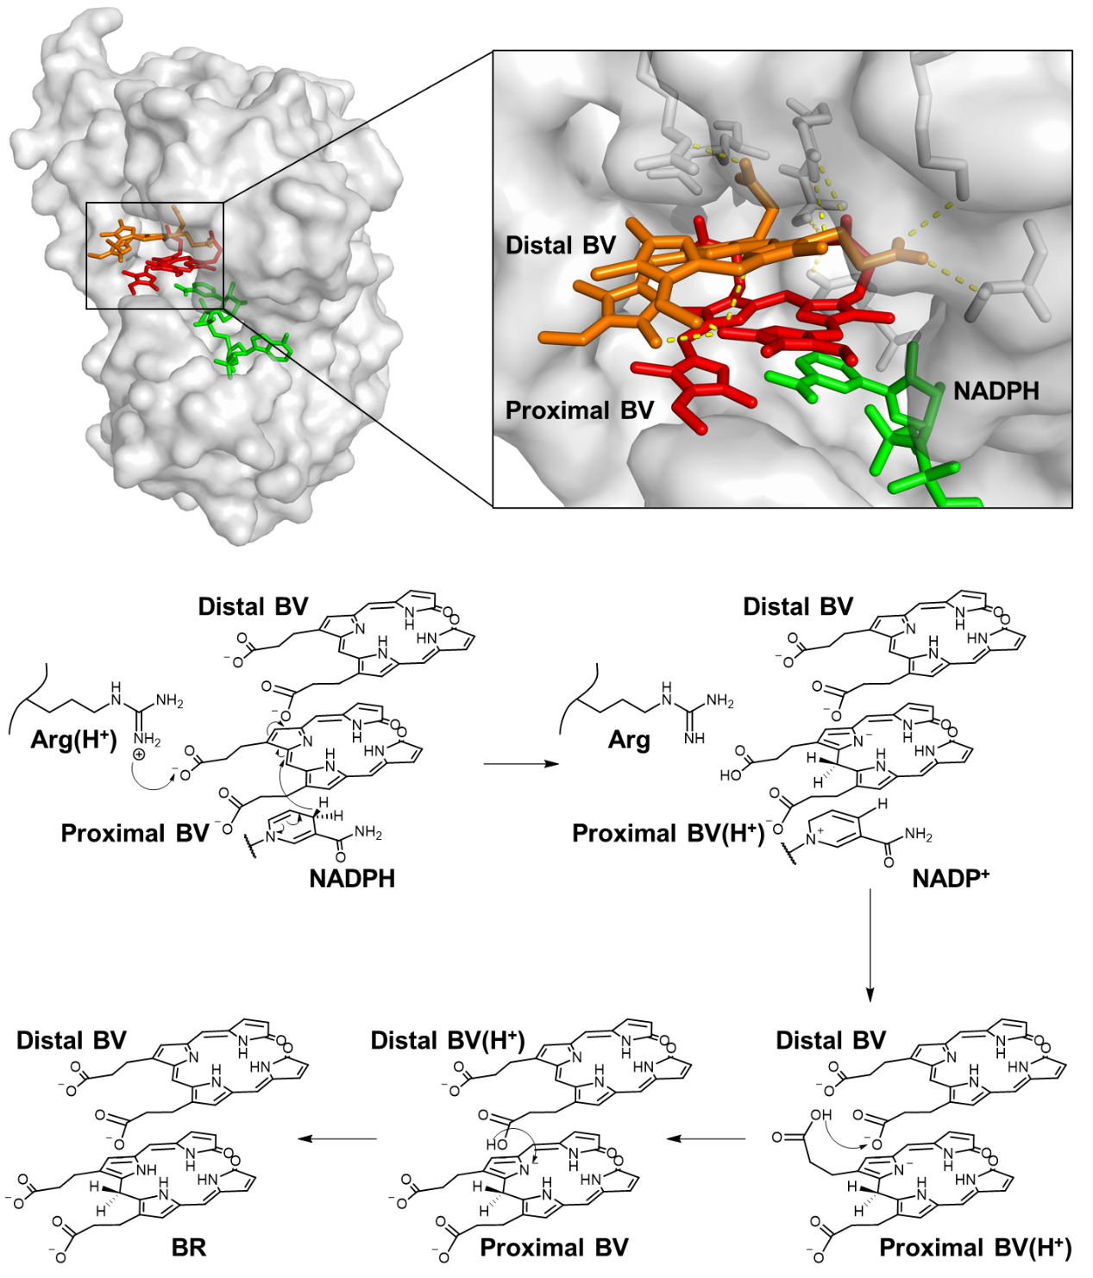
Supplementary Fig. 2. The proposed mechanism of biliverdin reductase catalyzing the conversion of biliverdin to bilirubin

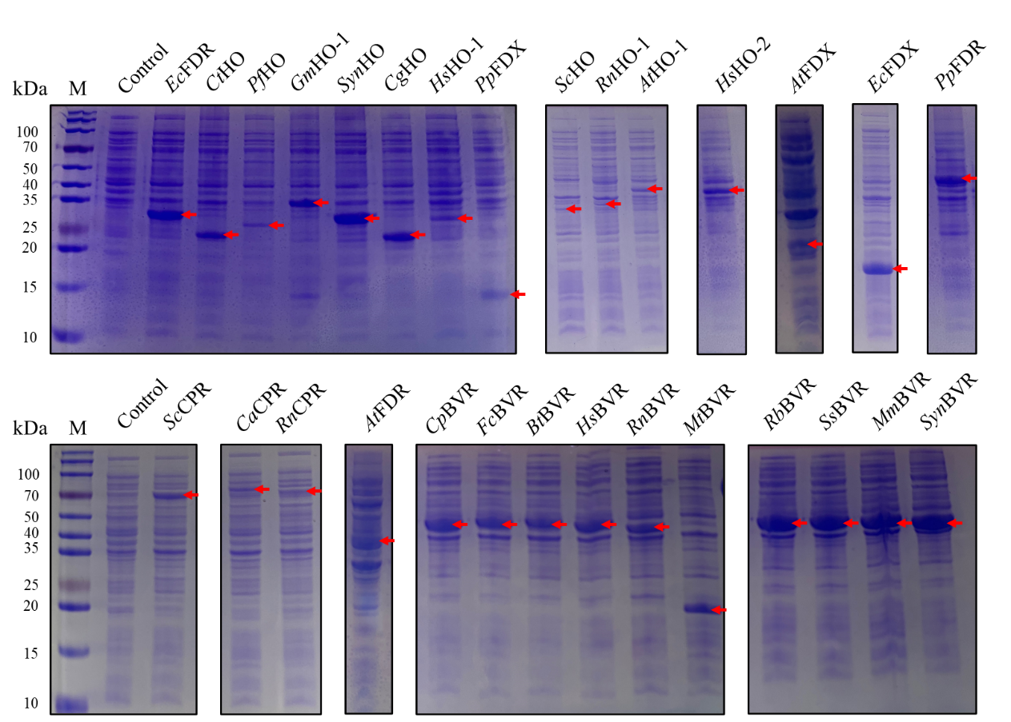
Supplementary Fig. 3. Expression profiles of protein sequences from the screened library in E. coli

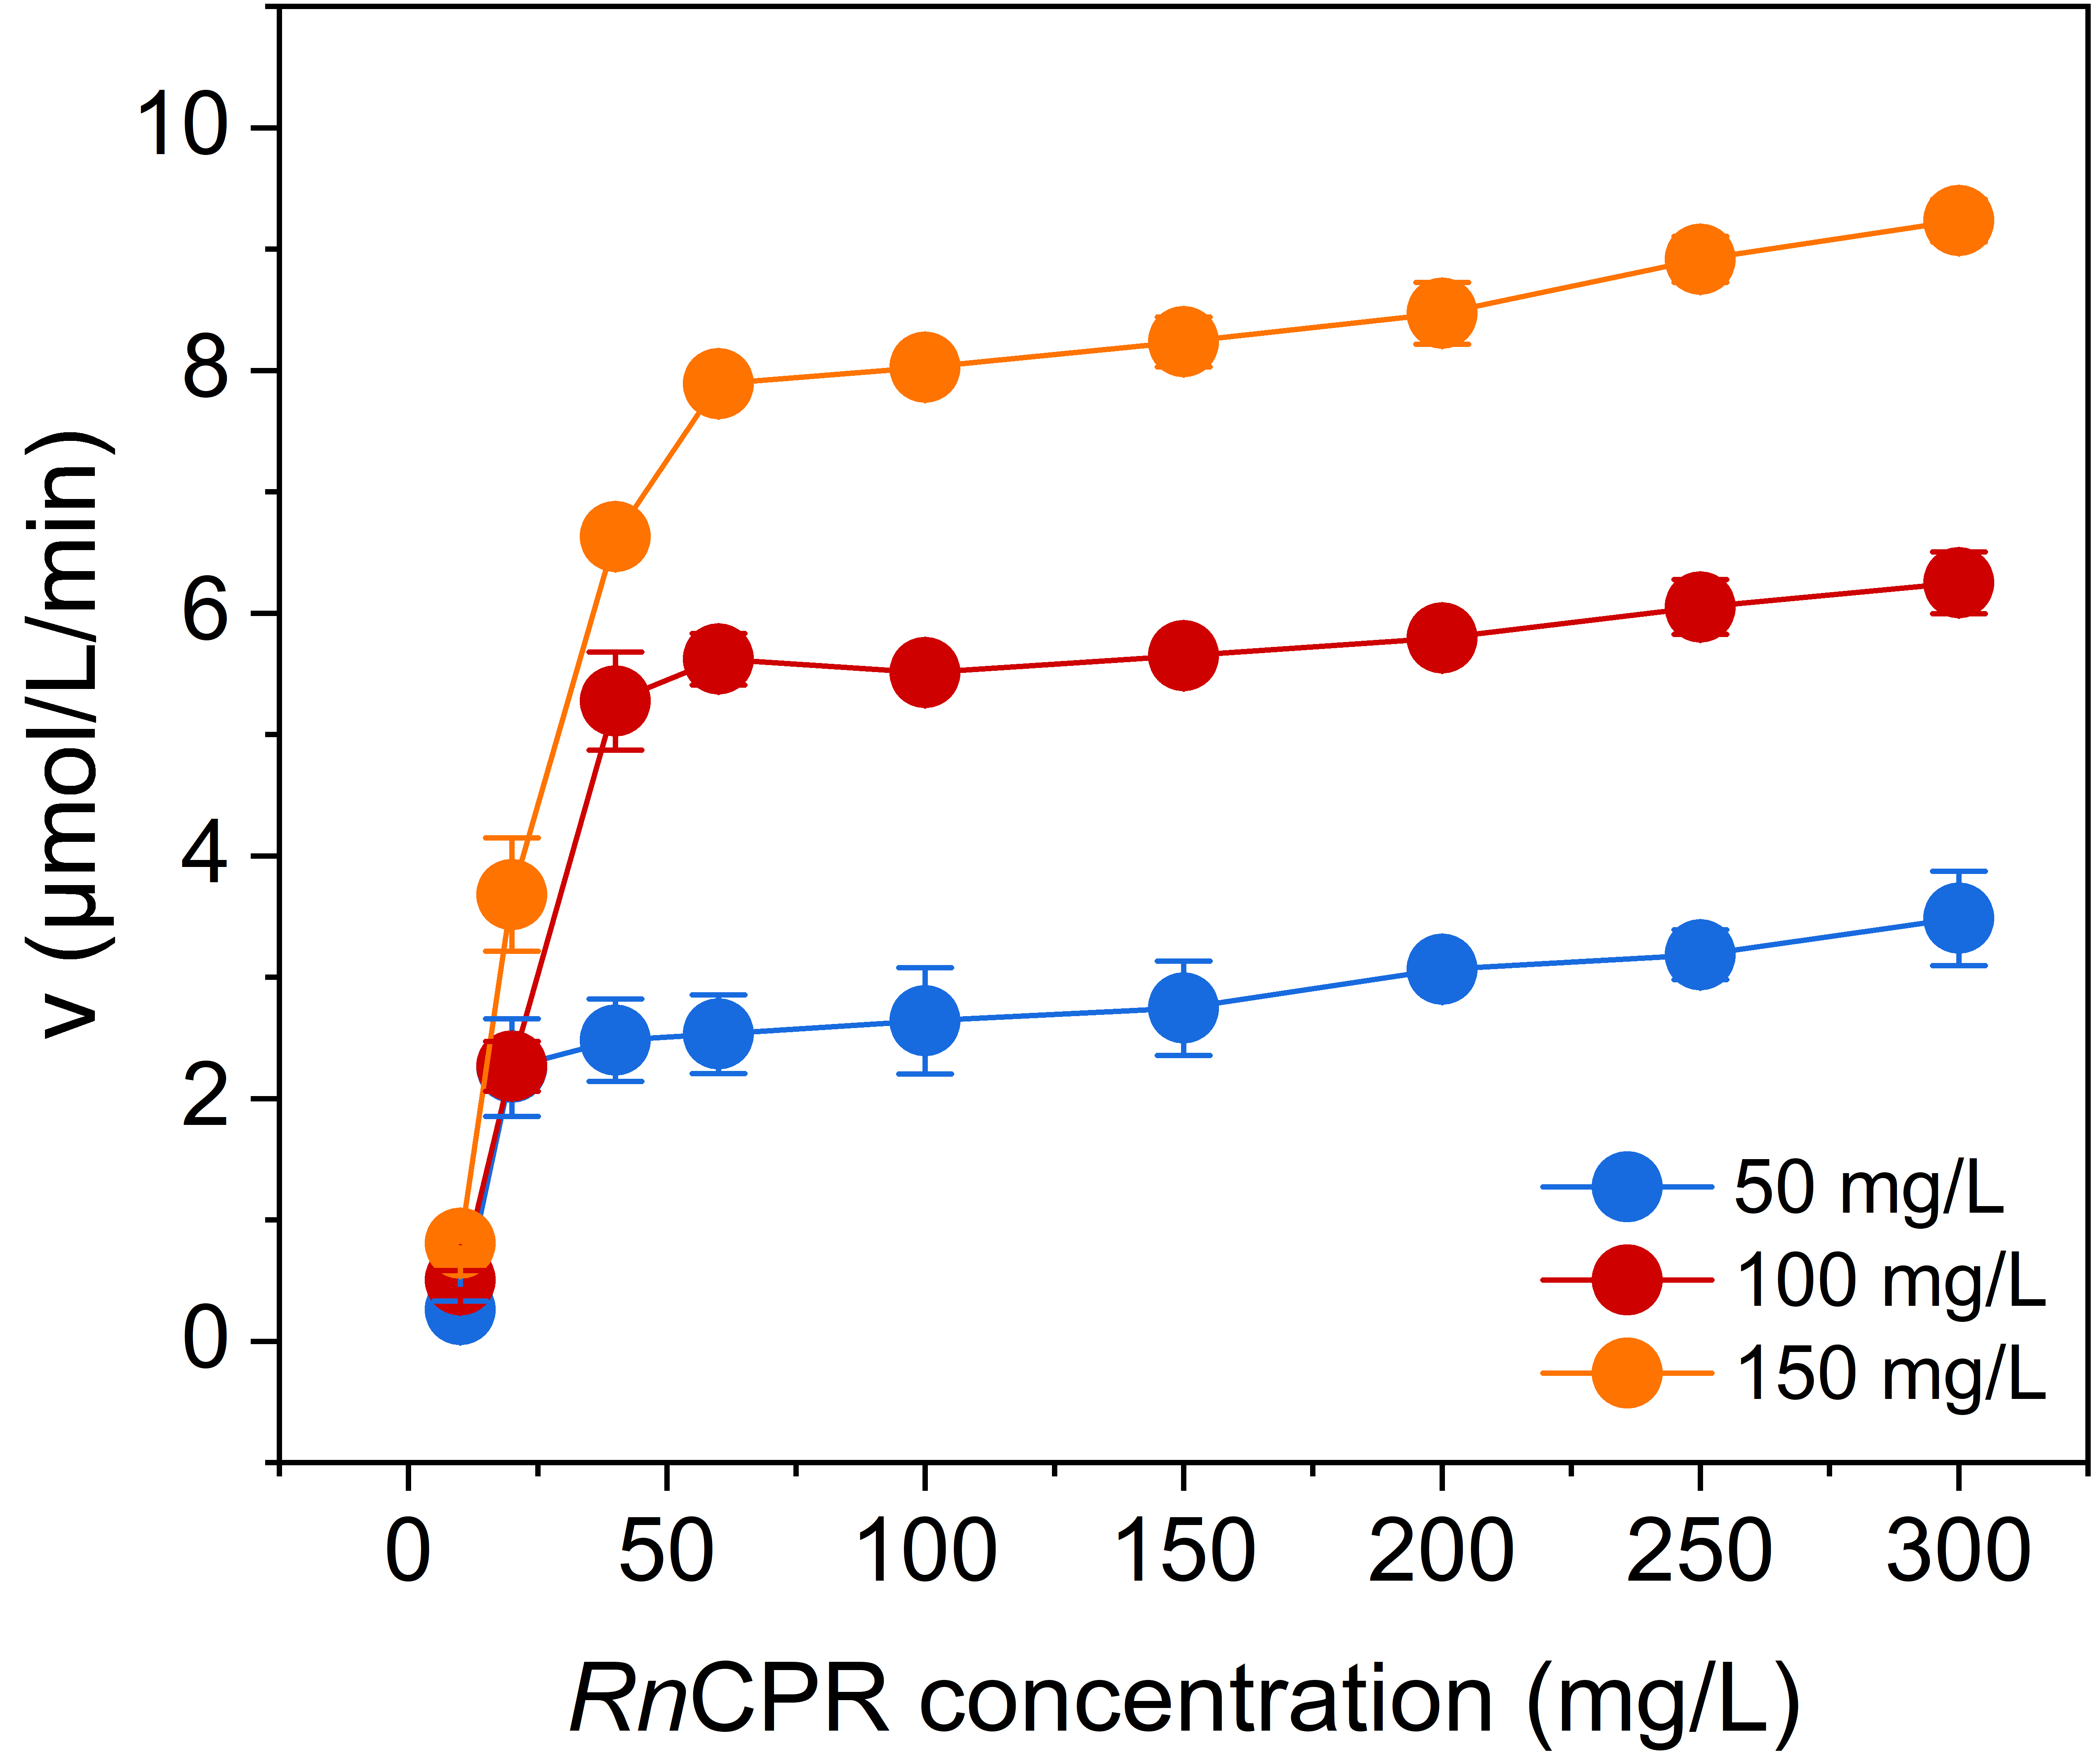
Supplementary Fig. 4. Dependence of catalytic rate on increasing RnCPR concentration under varying RnHO-1 levels.

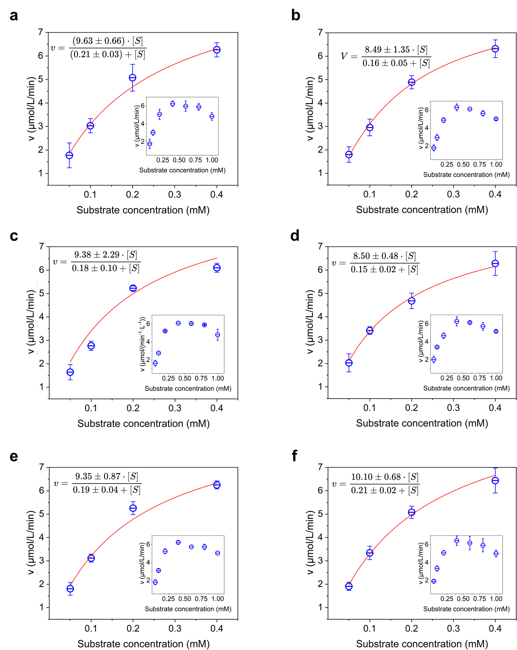
Supplementary Fig. 5. Michaelis-Menten kinetics for combinations of a series of truncated mutants of RnHO-1 with either RnCPR_{WT} or RnCPR_{Δ54}. a, RnHO-1_{WT} + RnCPR_{WT}; b, RnHO-1_{Δ5} + RnCPR_{WT}; c, RnHO-1_{Δ11} + RnCPR_{WT}; d, RnHO-1_{Δ17} + RnCPR_{WT}; e, RnHO-1_{Δ22} + RnCPR_{WT}; f, RnHO-1_{Δ22} + RnCPR_{Δ54}. Due to substrate inhibition at high heme concentrations, only the first four substrate concentrations were used for curve fitting.
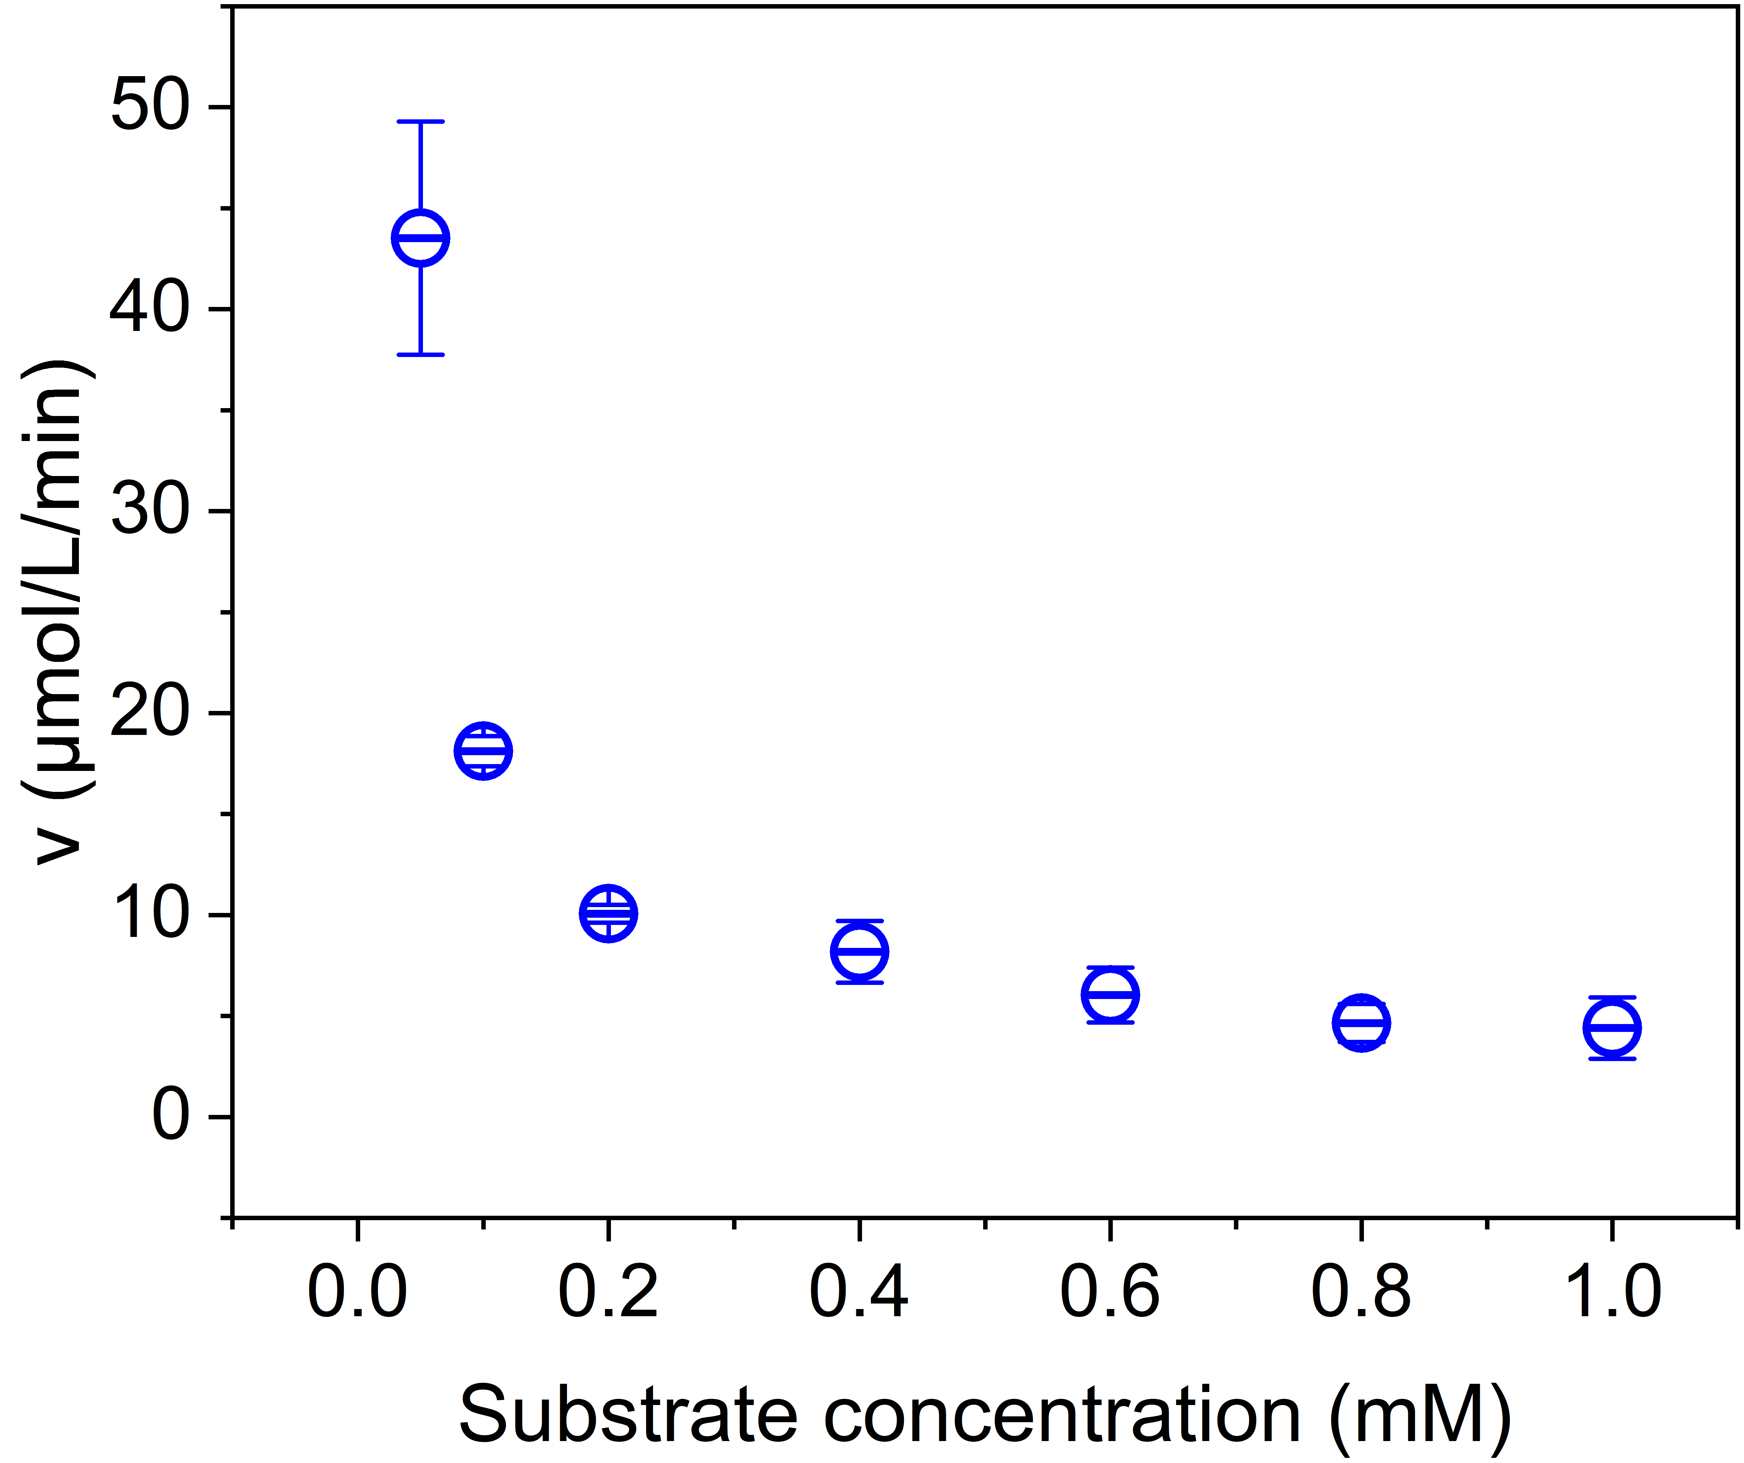
Supplementary Fig. 6. Reaction rates of RnBVR were measured at varying biliverdin concentrations. Pronounced substrate inhibition prevented the experimental data from conforming to Michaelis-Menten kinetics, while attempts to use lower substrate concentrations were severely compromised by instrumental noise. Consequently, kinetic parameters of RnBVR could not be reliably determined, and enzymatic activity was only calculated at the lowest detectable substrate concentration permitted by the instrument.

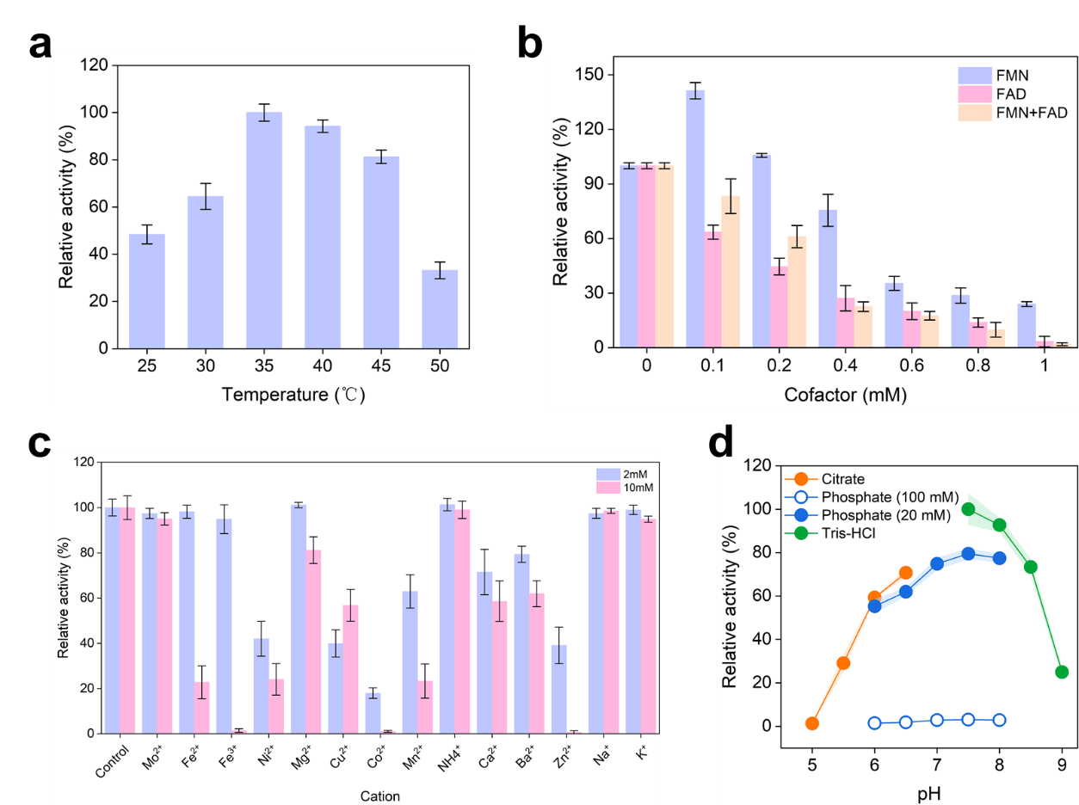
Supplementary Fig. 7. Optimization of catalytic conditions for heme-to-biliverdin conversion using RnHO-1_{Δ22} and RnCPR_{Δ54} as catalysts (5 gdcw/L each). (a) Reaction temperature optimization; (b) Flavin cofactor supplementation optimization; (c) Exploration of metal ion types and concentrations; (d) Reaction pH optimization, with high phosphate concentrations causing significant enzyme inhibition.

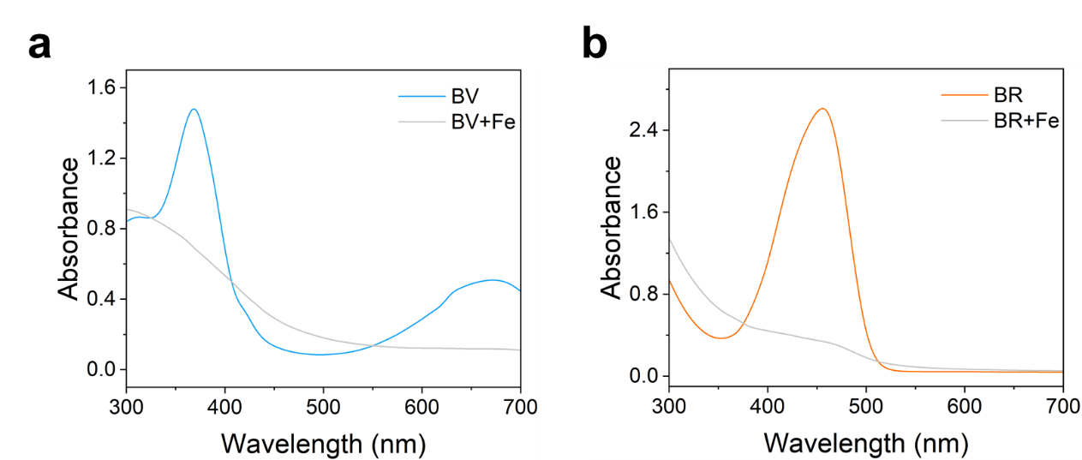
Supplementary Fig. 8. UV-Vis absorption spectra of biliverdin (a) and bilirubin (b) standard solutions after incubation with Fe²⁺.

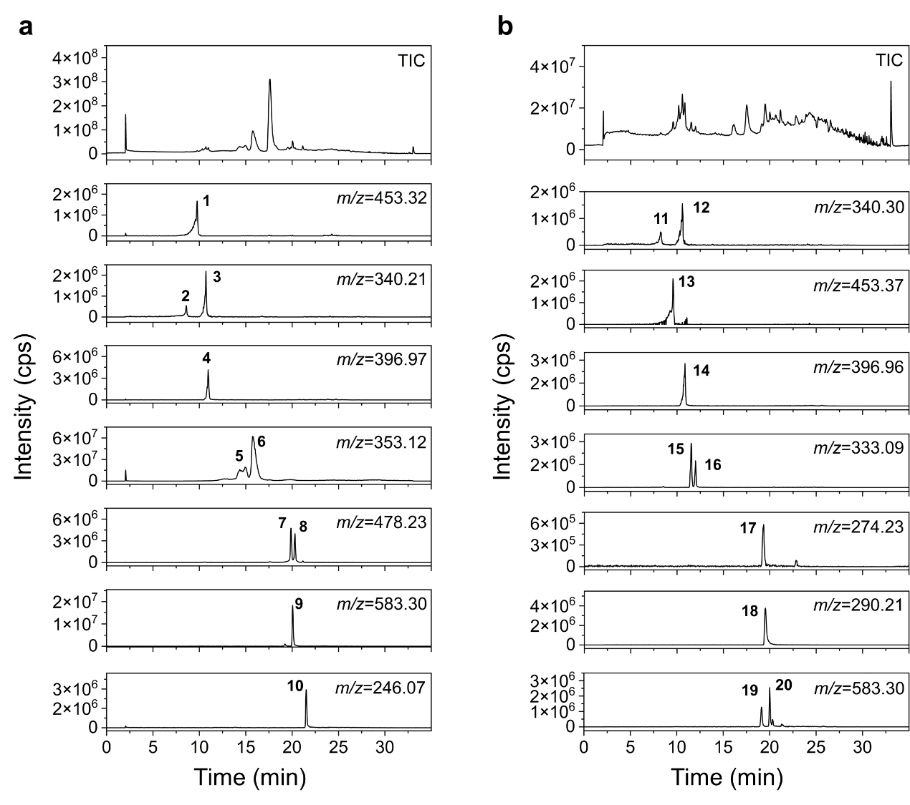
Supplementary Fig. 9. LC-MS total ion chromatograms (TICs) and extracted ion chromatograms (EICs) at specific mass-to-charge ratios (m/z) for biliverdin (a) and bilirubin (b) following treatment with Fe²⁺. Numbers 1-20 denote the 20 compounds identified. Mass spectrometry conditions: electrospray ionization (ESI) source, positive ion mode.

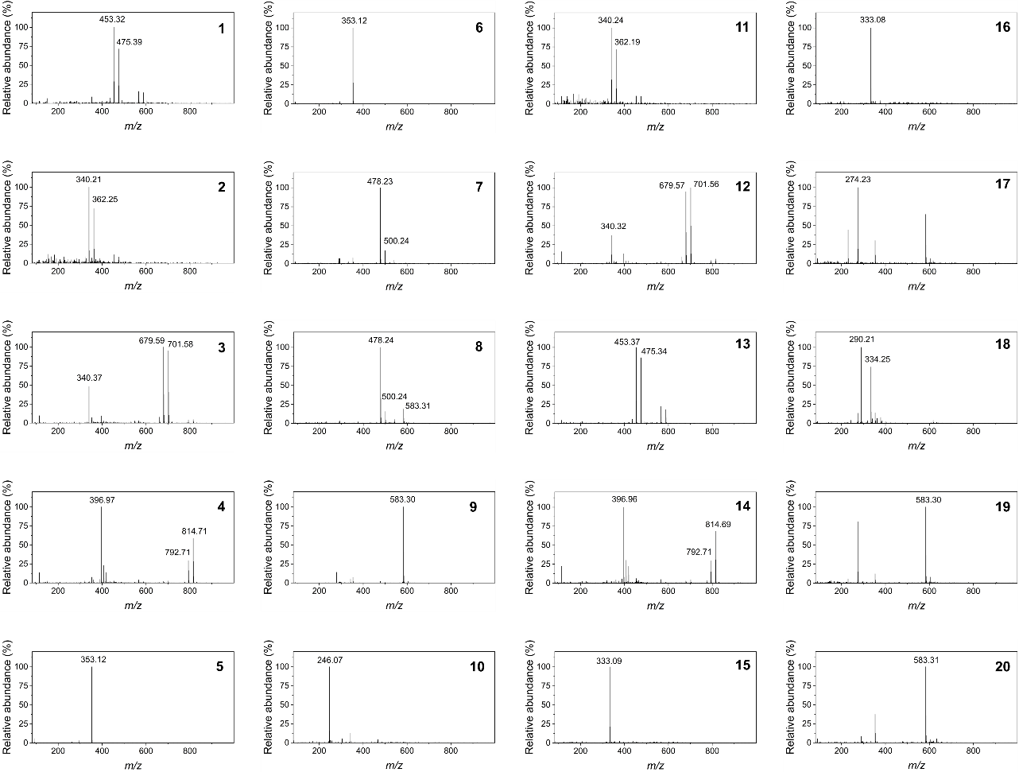
Supplementary Fig. 10. Mass spectrometric analysis of the 20 compounds extracted from ion chromatograms.

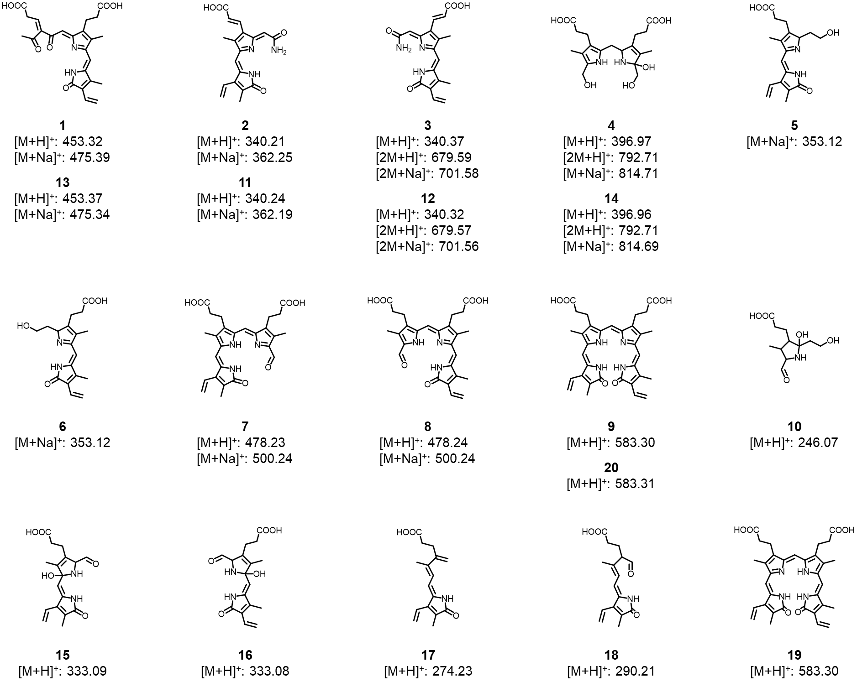
Supplementary Fig. 11. Proposed chemical structures of the 20 compounds inferred from mass spectrometric analysis.

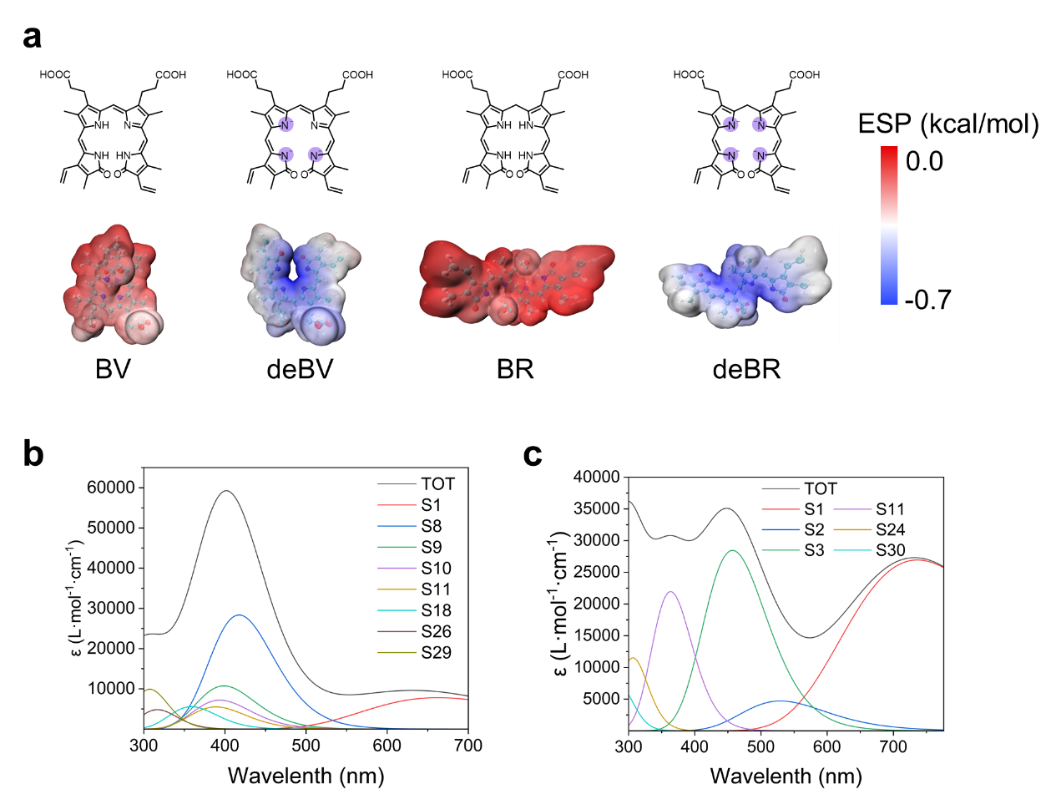
Supplementary Fig. 12. Electrostatic potential surfaces of BV and BR. (a) Calculation by density functional theory (DFT); (b) Theoretical UV-Vis absorption spectra of BV; (c) Theoretical UV-Vis absorption spectra of deBV.

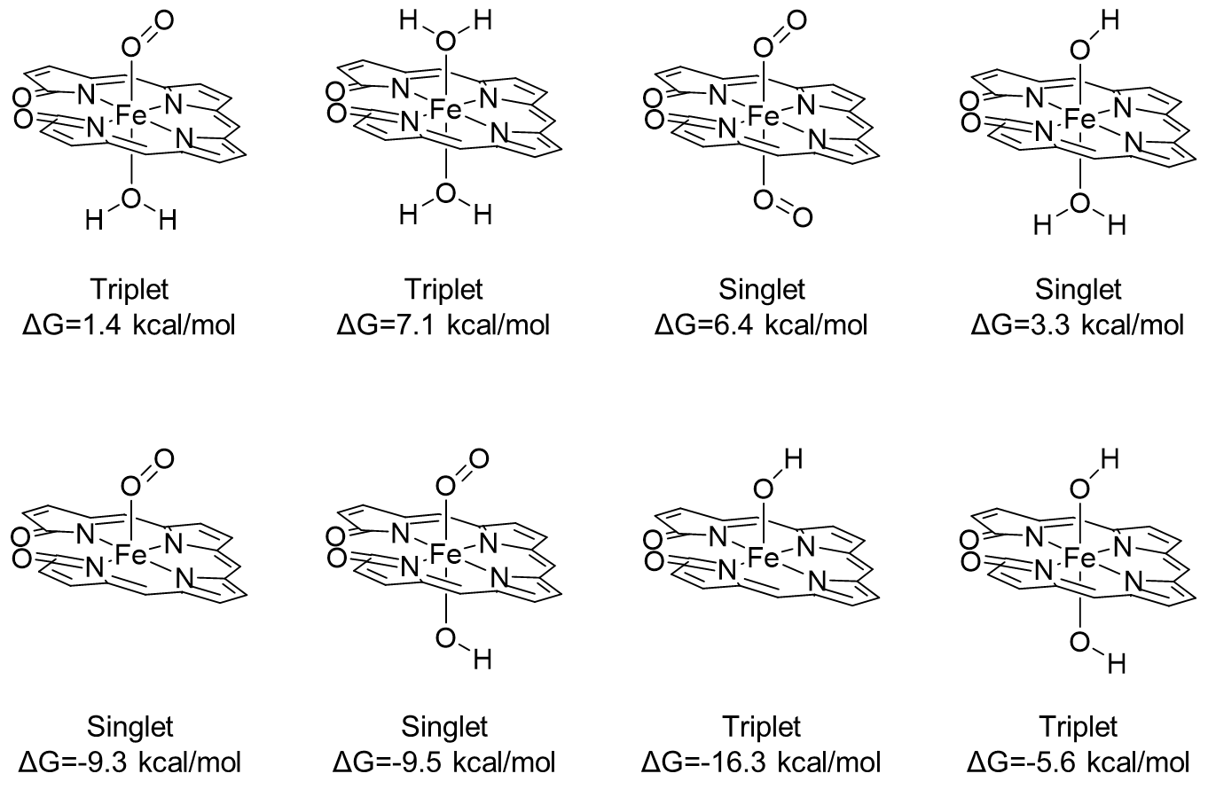
Supplementary Fig. 13. Possible coordination modes of deBV-Fe with ligands (O₂, H₂O, and OH⁻) in the solvent environment and their calculated coordination free energies.

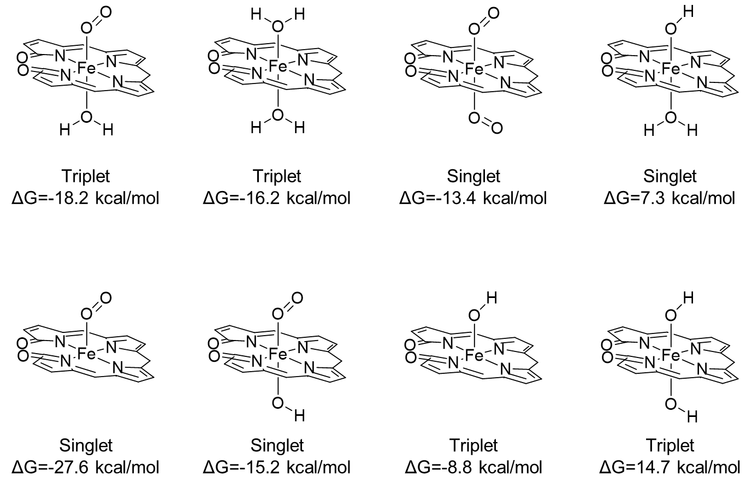
Supplementary Fig. 14. Possible coordination modes of deBR-Fe with ligands (O₂, H₂O, and OH⁻) in the solvent environment and their calculated coordination free energies.

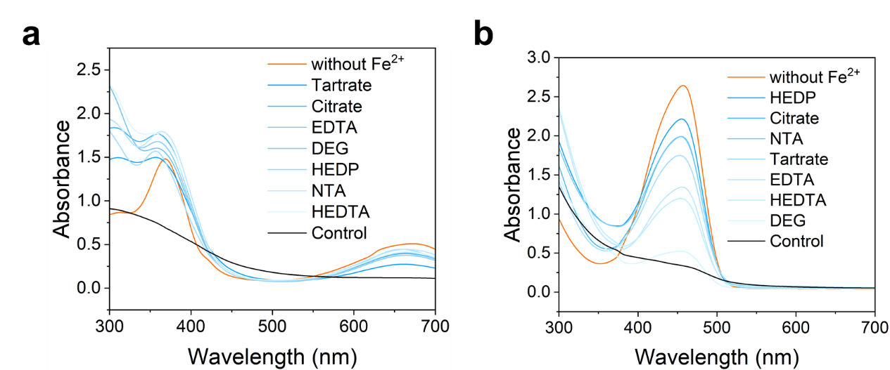
Supplementary Fig. 15. Changes in UV-Vis absorption spectra of BV (a) and BR (b) following the addition of various chelating agents.

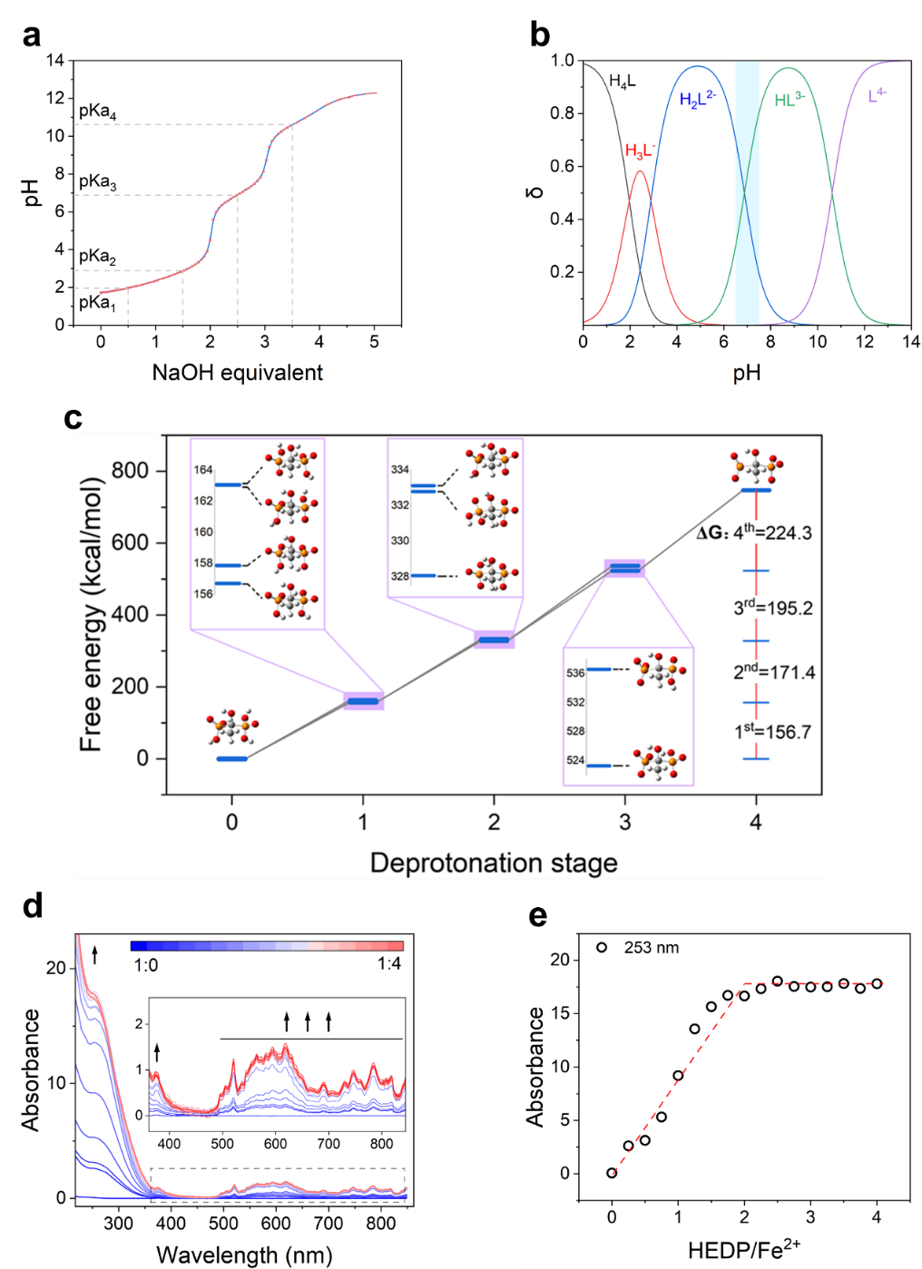
Supplementary Fig. 16. Determination of the coordination chemistry properties of the chelating agent HEDP. (a) Acid-base titration curve of HEDP; (b) Species distribution diagram of HEDP at different pH values calculated using its four acid dissociation constants (pKa); (c) DFT-calculated deprotonation sequence of HEDP, used to determine the structures of its species; (d) Coordination titration spectra of HEDP with Fe²⁺; (e) Absorbance change curve of HEDP at 253 nm with increasing Fe²⁺ concentration.

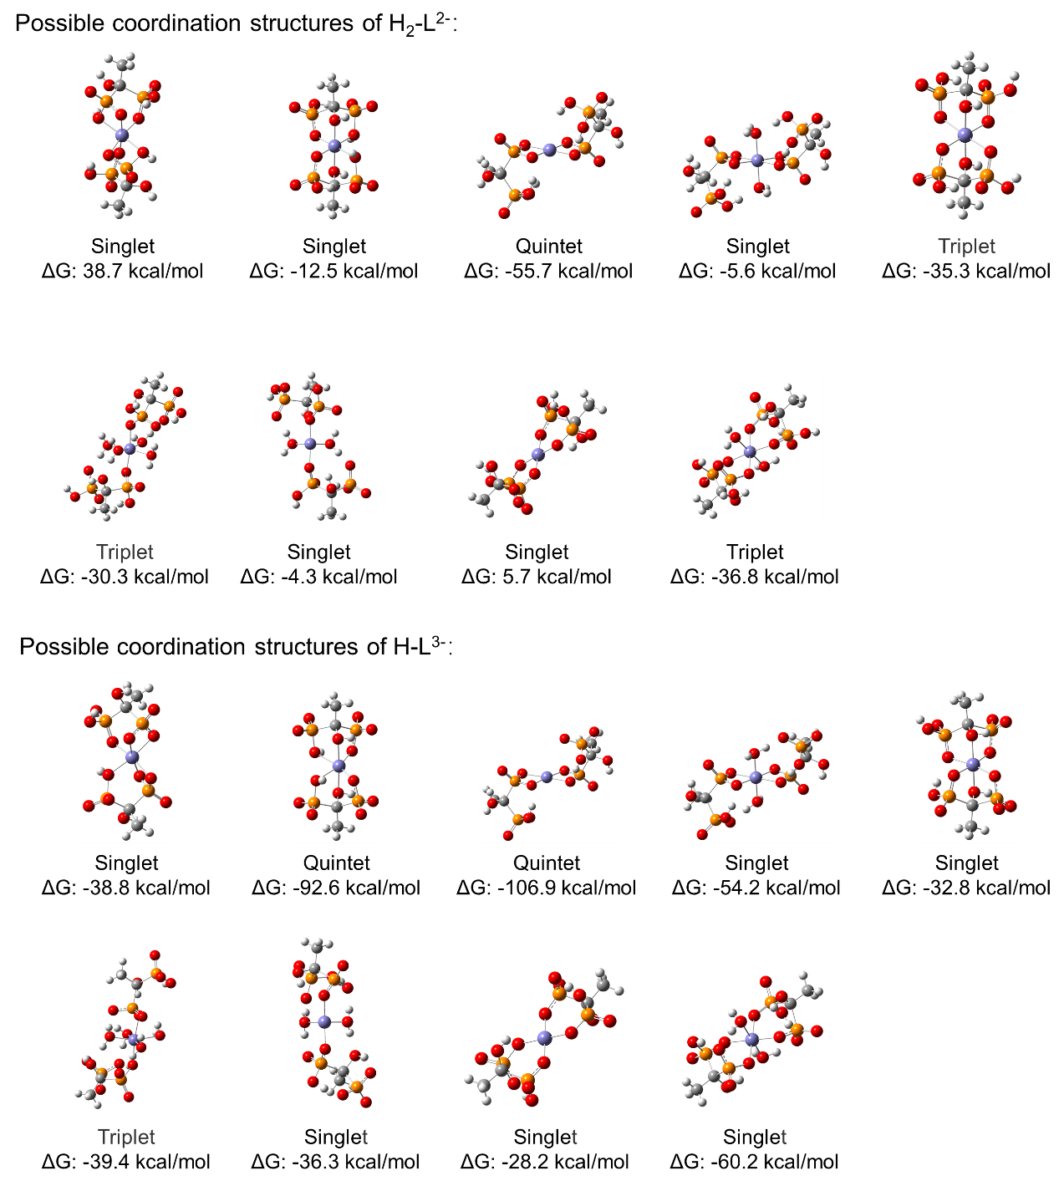
Supplementary Fig. 17. Possible coordination structures and their corresponding binding free energies were calculated for the two deprotonated forms of HEDP-the doubly deprotonated species (H₂-L²⁻) and the triply deprotonated species (H-L³⁻)-under enzymatic reaction pH conditions.

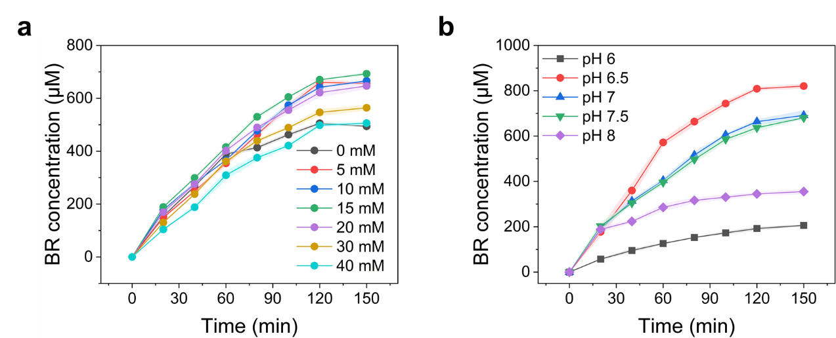
Supplementary Fig. 18. Optimization of HEDP dosage (a) and pH (b) during the conversion of heme to BR.
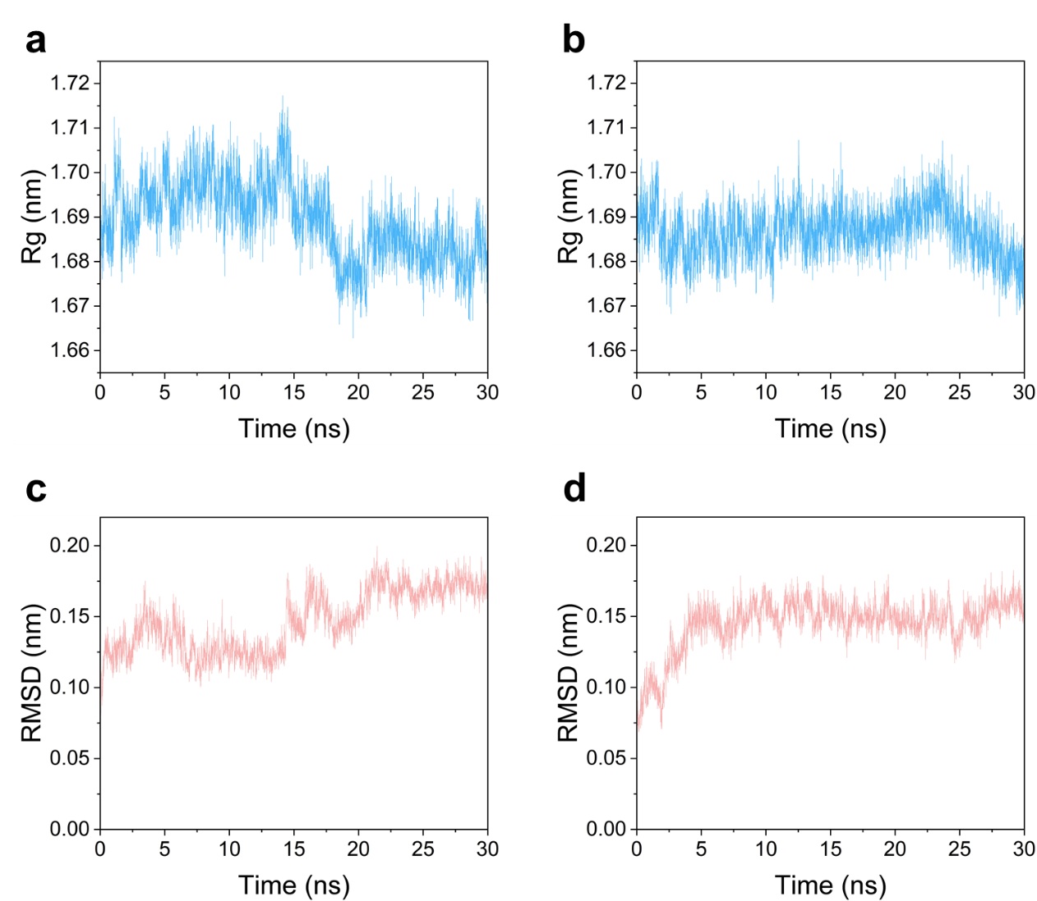
Supplementary Fig. 19. The analysis of the 30-ns molecular dynamics simulation results. Radius of gyration (a) and RMSD (c) for the protein complex with the Heme-O₂ ligand; radius of gyration (b) and RMSD (d) for the protein complex with the Heme-CO ligand.

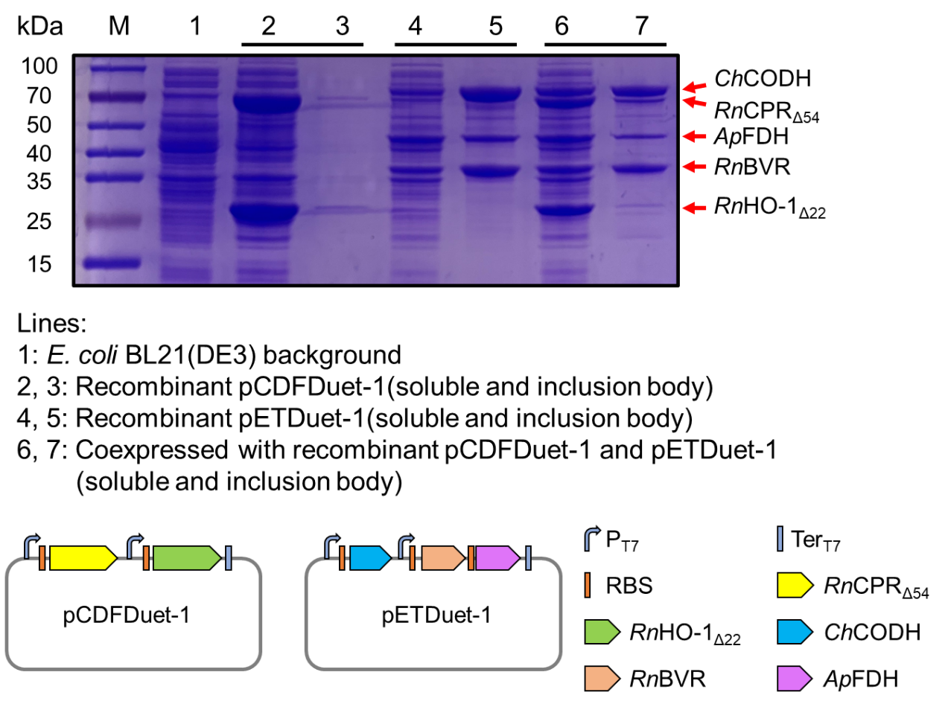
Supplementary Fig. 20. Five-enzyme co-expression strategy and protein expression profiles following the incorporation of carbon monoxide dehydrogenase.

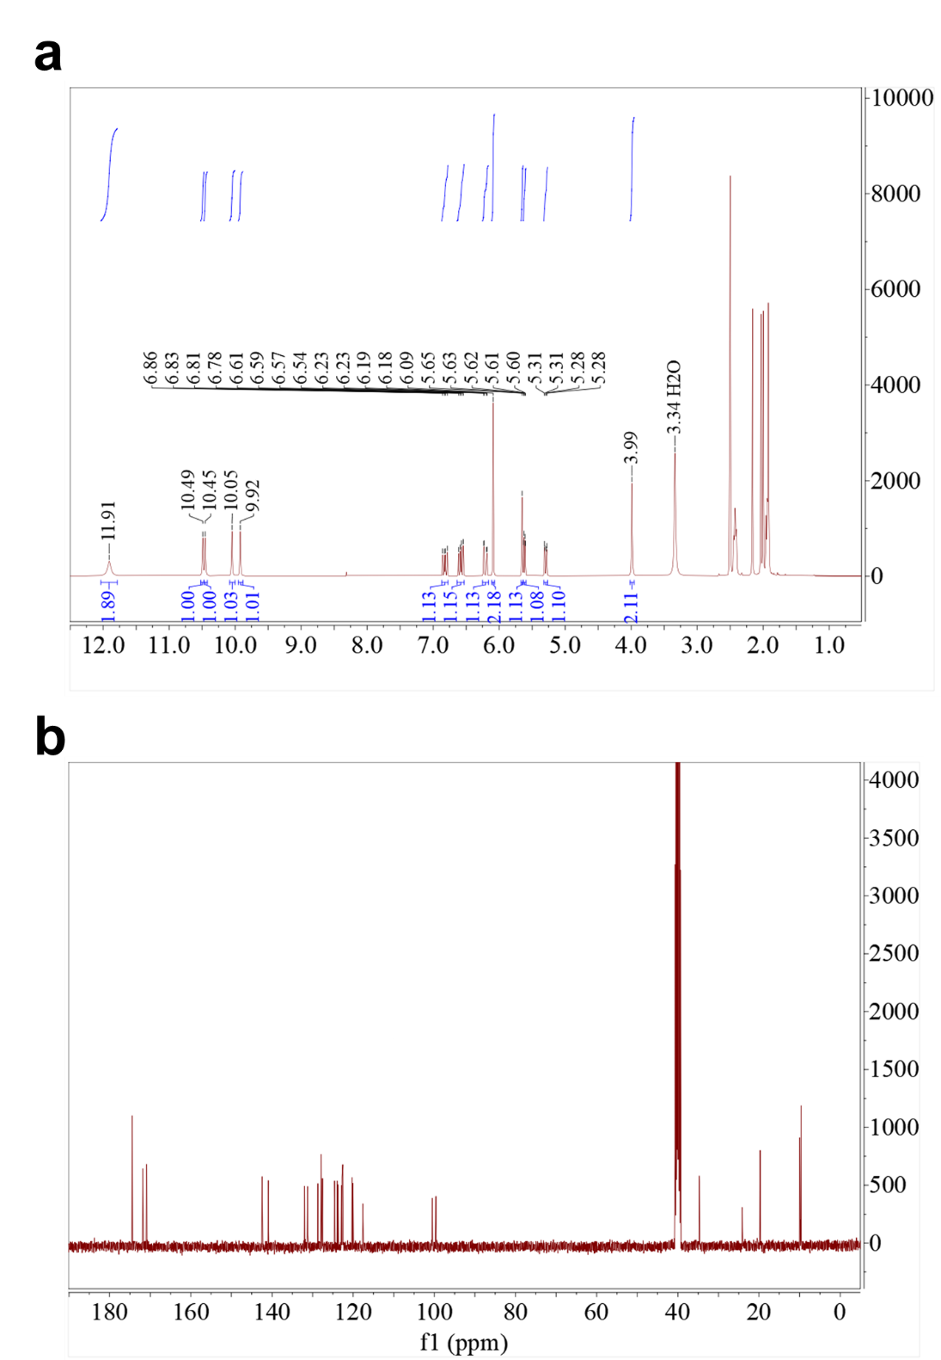
Supplementary Fig. 21. NMR analysis of BR standard. a, ¹H NMR (400 MHz, DMSO-d6) δ 11.91 (s, 2H), 10.49 (s, 1H), 10.45 (s, 1H), 10.05 (s, 1H), 9.92 (s, 1H), 6.82 (dd, J = 17.4, 11.9 Hz, 1H), 6.58 (dd, J = 17.5, 11.5 Hz, 1H), 6.21 (dd, J = 17.5, 2.8 Hz, 1H), 6.09 (s, 2H), 5.65 (s, 1H), 5.63-5.59 (m, 1H), 5.30 (dd, J = 11.6, 2.8 Hz, 1H), 3.99 (s, 2H); b, ¹³C NMR.

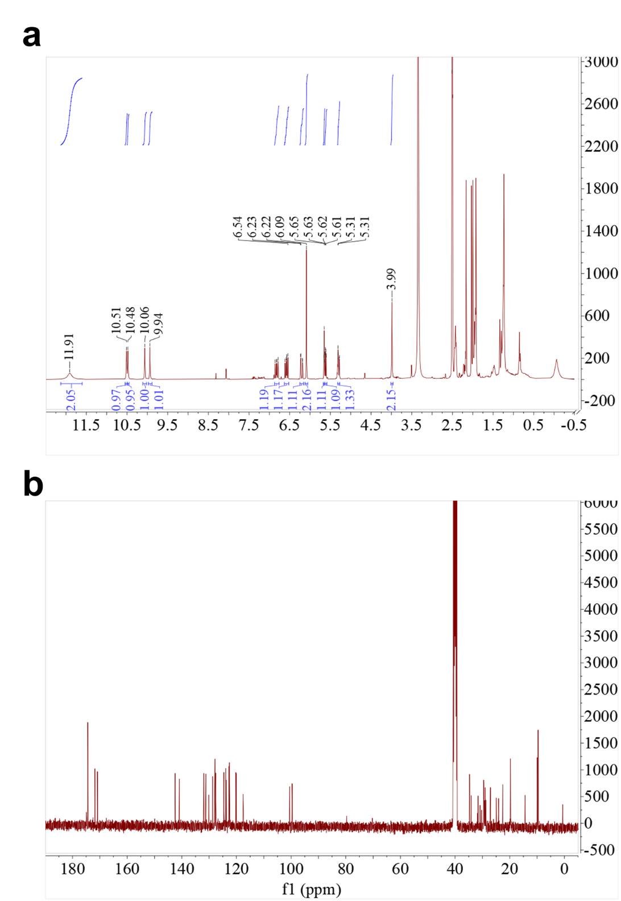
Supplementary Fig. 22. NMR analysis of synthesized BR sample. a, ¹H NMR (400 MHz, DMSO-d6) δ 11.91 (s, 2H), 10.51 (s, 1H), 10.48 (s, 1H), 10.06 (s, 1H), 9.94 (s, 1H), 6.82 (dd, J = 17.5, 11.8 Hz, 1H), 6.58 (dd, J = 17.5, 11.5 Hz, 1H), 6.21 (dd, J = 17.5, 2.9 Hz, 1H), 6.09 (s, 2H), 5.65 (d, J = 2.4 Hz, 1H), 5.62 (dd, J = 8.7, 1.8 Hz, 1H), 5.29 (dd, J = 11.5, 2.7 Hz, 1H), 3.99 (s, 2H); b, ¹³C NMR.
References
1 Tian Lu, Sobtop, Version 1.0, http://sobereva.com/soft/Sobtop (accessed on 02/04/2025)
2 Valdes-Tresanco, M. S., Valdes-Tresanco, M. E., Valiente, P. A. & Moreno, E. gmx_MMPBSA: a new tool to perform end-state free energy calculations with GROMACS. J. Chem. Theory Comput. 17, 6281-6291 (2021). https://doi.org:10.1021/acs.jctc.1c00645

