SUpplemeNtary Information
Supplementary Figure 1. Malaria transmission by species in Ann Township from 2013–2023

Supplementary Figure 2. Annual Parasite Incidence (API) by Townships, Rakhine State, 2015–2019 [Source: Vector Borne Disease Control Annual Review Meeting (2019-2020), Rakhine State Public Health Department]
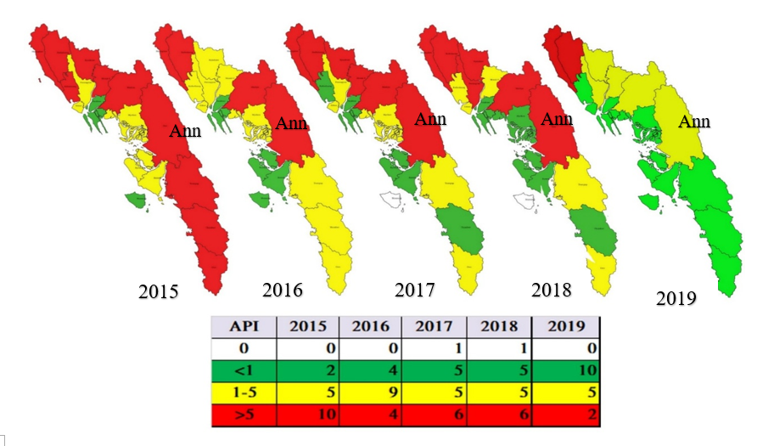

2019
Supplementary Table 1. Two by two table of the number of positive samples by conventional rapid diagnostic test (cRDT) (A) and highly sensitive rapid diagnostic test (hsRDT) (B) compared to the ultrasensitive polymerase chain reaction (usPCR) as the gold standard amongst contacts.
A. cRDT -vs- usPCR |  |  |  |  | B. hsRDT -vs- usPCR
 | usPCR + | usPCR - | Total |  |  | usPCR+ | usPCR - | Total
cRDT + | 28 | 0 | 28 |  | hsRDT + | 57 | 21 | 78
cRDT - | 176 | 1,786 | 1,962 |  | hsRDT - | 147 | 1,765 | 1,912
Total | 204 | 1,786 | 1,990 |  | Total | 204 | 1,786 | 1,990

Supplementary Table 2. Previous history of malaria and treatment-seeking behaviors among cases and contacts in Sakhamaw village tract, Ann Township, Rakhine, 2017–2018
 | Index Cases (N=51) | Contacts (N=1,990)
Reported symptoms suggestive of malaria in the past month
Fever with chills/rigor | 18 (35.3%) | 385 (19.4%)
Headache | 30 (58.8%) | 935 (47.0%)
Body ache | 27 (52.9%) | 785 (39.4%)
Nausea | 10 (19.6%) | 122 (6.1%)
Vomiting | 11 (21.6%) | 123 (6.2%)
Abdominal discomfort | 15 (29.4%) | 517 (26.0%)
Decreased appetite | 12 (23.5%) | 330 (16.6%)
Fatigue | 11 (21.6%) | 318 (16.0%)
Previous malaria diagnosis and treatment within one month prior to study enrollment
Received malaria RDT | 13 (25.5%) | 348 (17.5%)
Known malaria RDT positive | 1 (7.7%) | 21 (6.0%)
Type of malaria among those with known RDT positive result
Plasmodium falciparum | 1 (100.0%) | 14 (66.7%)
Plasmodium vivax | N/A | 5 (23.8%)
Unknown | N/A | 2 (9.5%)
Received antimalarial drug treatment | 1 (100.0%) | 20 (95.2%)

