Supporting Information
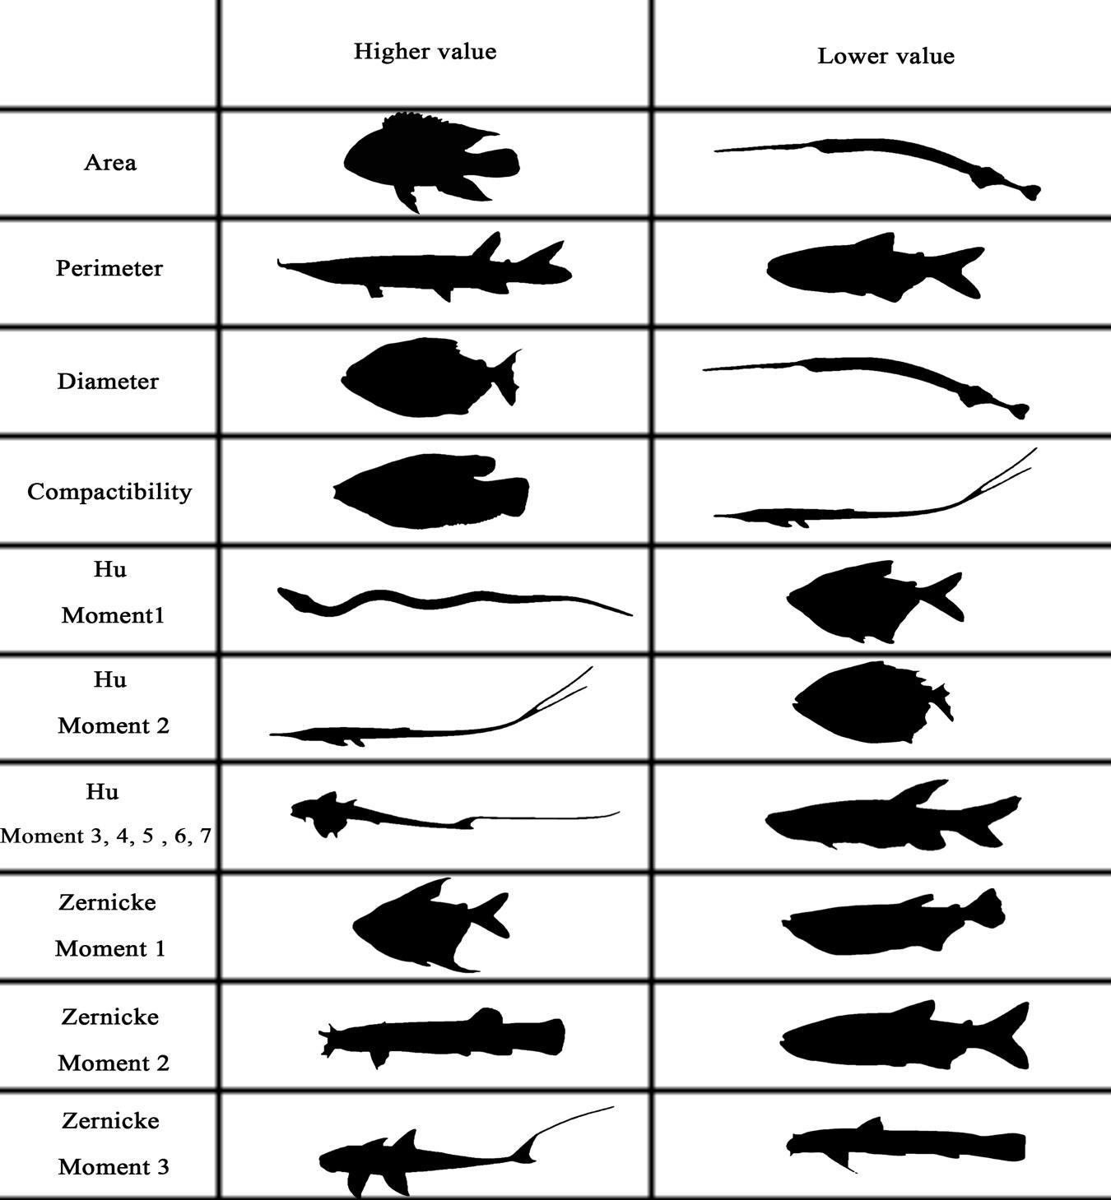
Fig. S1 Correlation Matrix of Morphological Descriptors

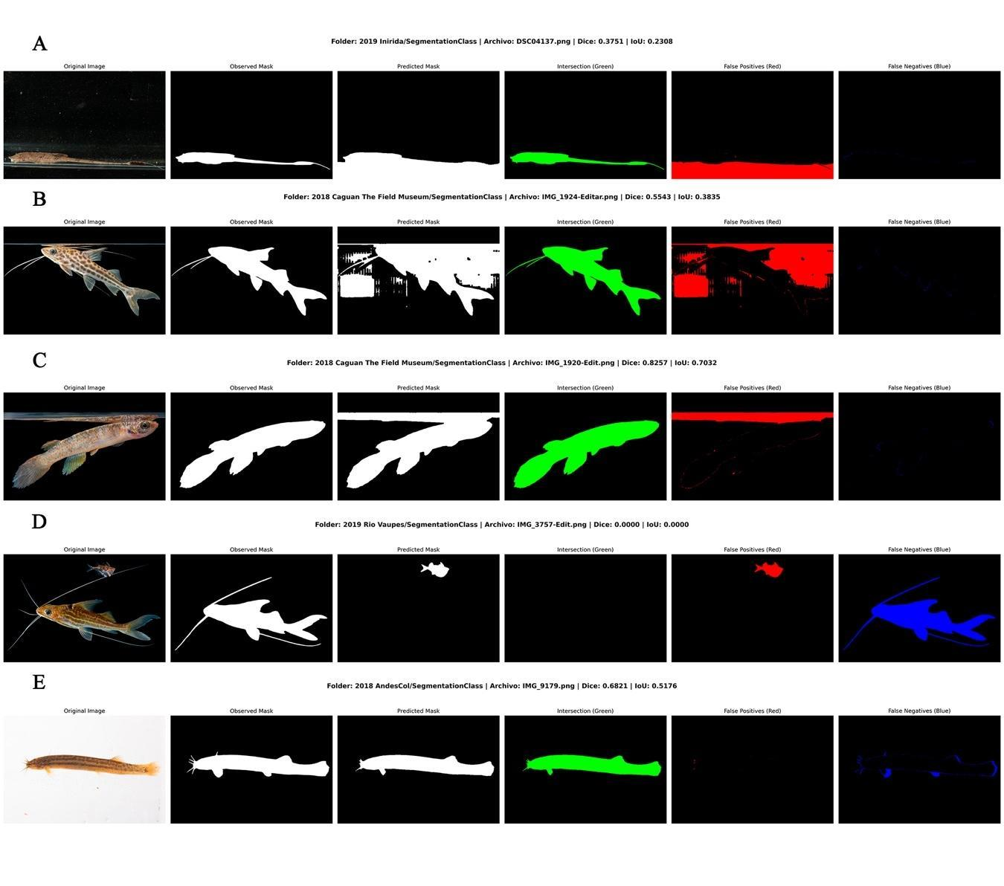Fig. S2 The five most error-prone fish segmentation cases, identified by the lowest Dice and IoU. Each row (A–E) shows the original image, ground-truth mask, predicted mask, and an error map (green = intersection, red = false positives, blue = false negatives).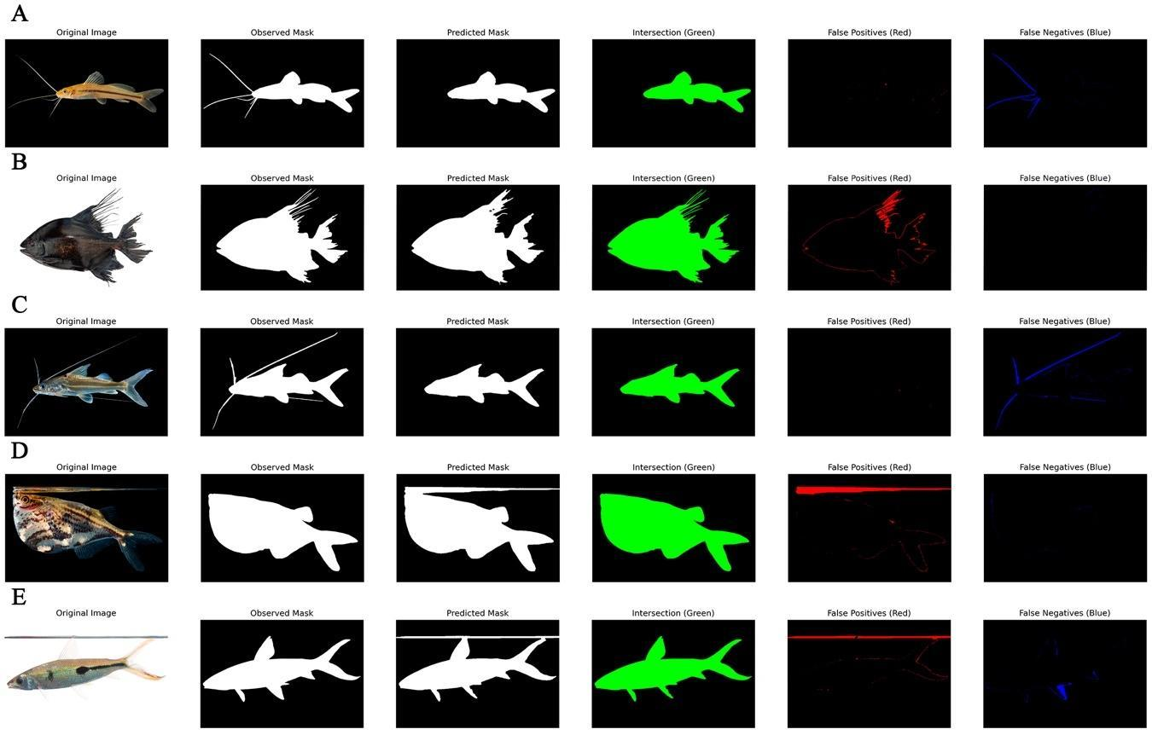
Fig. S3 The five largest perimeter segmentation errors, identified by R² and RMSE in observed vs. predicted perimeter analysis. Each row (A–E) shows the original image, ground truth mask, predicted mask, and error map (green = intersection, red = false positives, blue = false negatives).

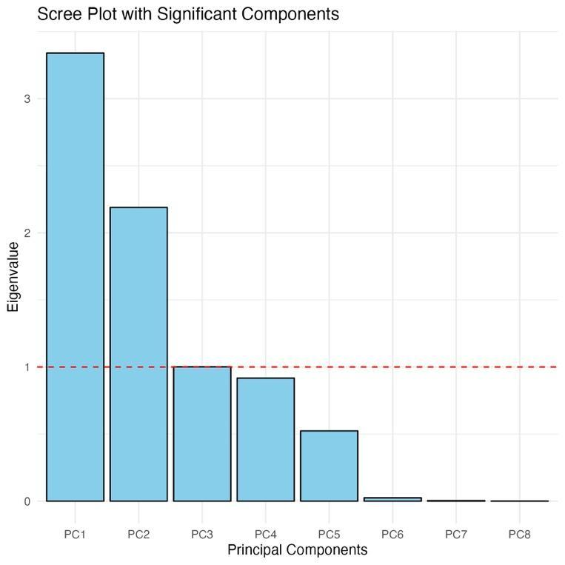
Fig. S4 Scree plot showing significant Principal Components based on Eigenvalues of morphological characterization of Colombian freshwater fish

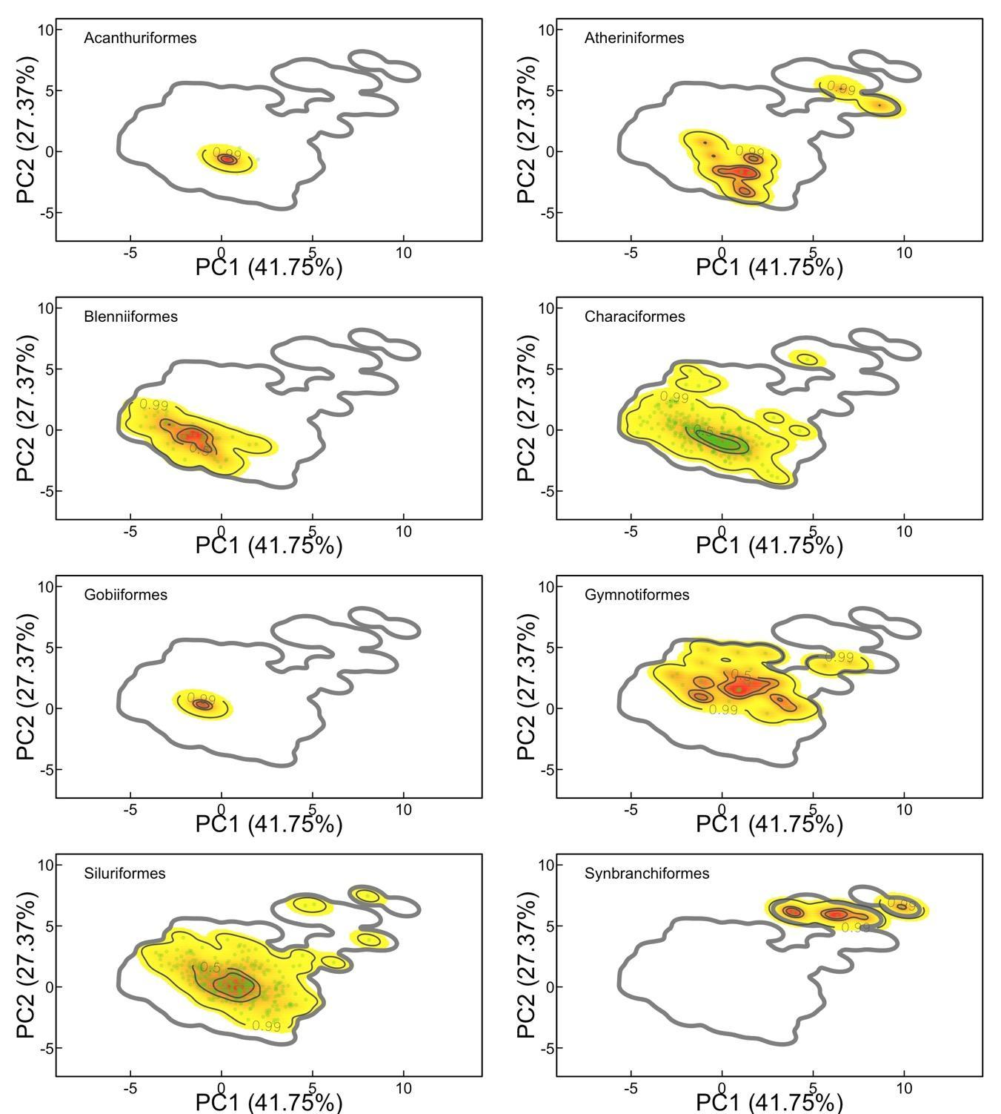
Fig. S5 Morphological space distribution across taxonomic Orders of Colombian Freshwater Fish based on Principal Components

Table S1 Principal component analysis (PCAs) of global spectrum of morphological characterization of Colombian freshwater fish
Importance of components | Comp.1 | Comp.2 | Comp.3 | Comp.4 | Comp.5 | Comp.6 | Comp.7 | Comp.8
Standard deviation | 1,827 | 1,480 | 1,001 | 0,957 | 0,724 | 0,158 | 0,065 | 0,003
Proportion of Variance | 0,417 | 0,274 | 0,125 | 0,115 | 0,065 | 0,003 | 0,001 | 0,000
Cumulative Proportion | 0,417 | 0,691 | 0,816 | 0,931 | 0,996 | 0,999 | 1,000 | 1,000
Loadings
Hu.Moment.1 | 0,412 | 0,405 |  | 0,133 | 0,294 | 0,735 | 0,148
Hu.Moment.2 | 0,379 | 0,405 |  | 0,153 | 0,496 | -0,629 | -0,163
Zernike.Moment.1 |  |  | 0,993 | -0,116
Zernike.Moment.3 |  | 0,237 | -0,113 | -0,962
Area | -0,488 | 0,295 |  |  | 0,146 | 0,119 | -0,371 | 0,707
Perimeter | -0,336 | 0,521 |  |  | -0,192 | -0,186 | 0,732
Diameter | -0,488 | 0,295 |  |  | 0,147 | 0,118 | -0,370 | -0,708
Compatibility | -0,305 | -0,413 |  |  | 0,765 |  | 0,370
Principal components (PCs) display variance (via standard deviations), and their proportion and cumulative proportion indicate explained variance. Trait loadings show each morphological variable’s impact on the PCs; higher absolute values imply stronger influence. Blank cells represent minimal contributions.

