Supplemental Materials

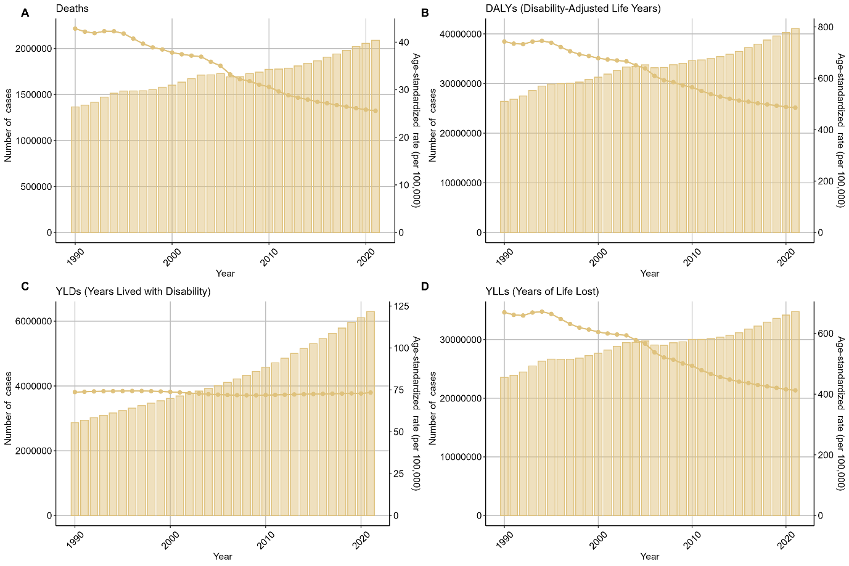
Figure S1. The numbers and age-standardized rates of mortality, DALYs ,YLDs, and YLLs of ischemic stroke attributable to hypertension in G20 countries from 1990 to 2021.
A, Mortality. B, DALYs. C, YLDs. D, YLLs. Bars and broken lines indicate numbers and age-standardized rates, respectively. DALYs, disability-adjusted life years. YLDs, years lived with disability. YLLs, years of life lost.

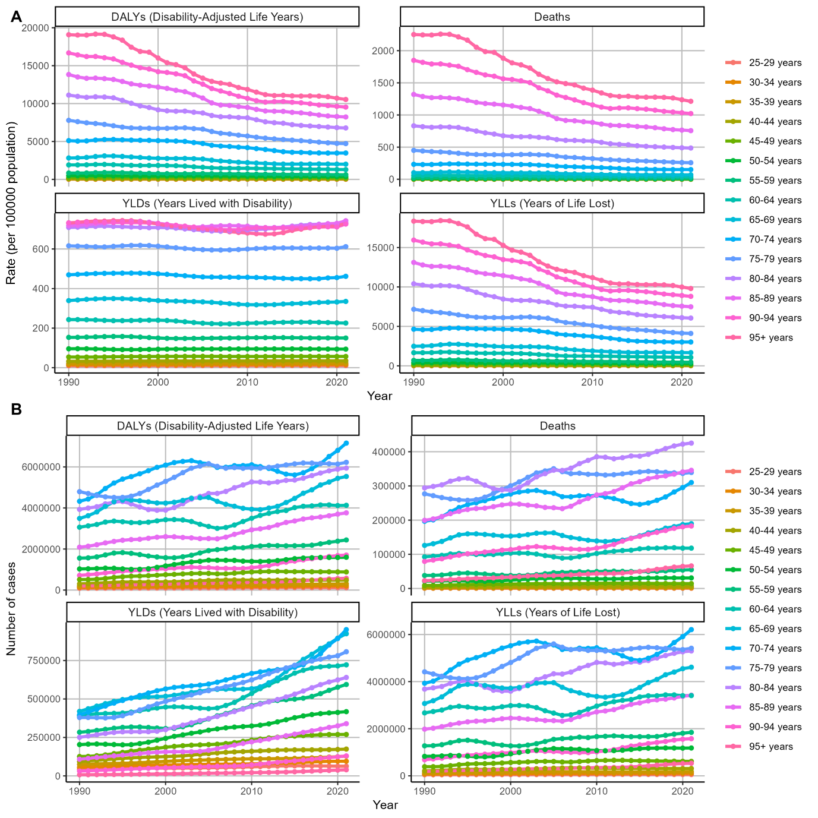
Figure S2. Bueden of ischemic stroke attributable to hypertension in G20 countries from 1990 to 2021, by age.
A, Age-standardized rates of DALYs, mortality, YLDs, and YLLs. B, Numbers of DALYs, mortality, YLDs, and YLLs. DALYs, disability-adjusted life years. YLDs, years lived with disability. YLLs, years of life lost.

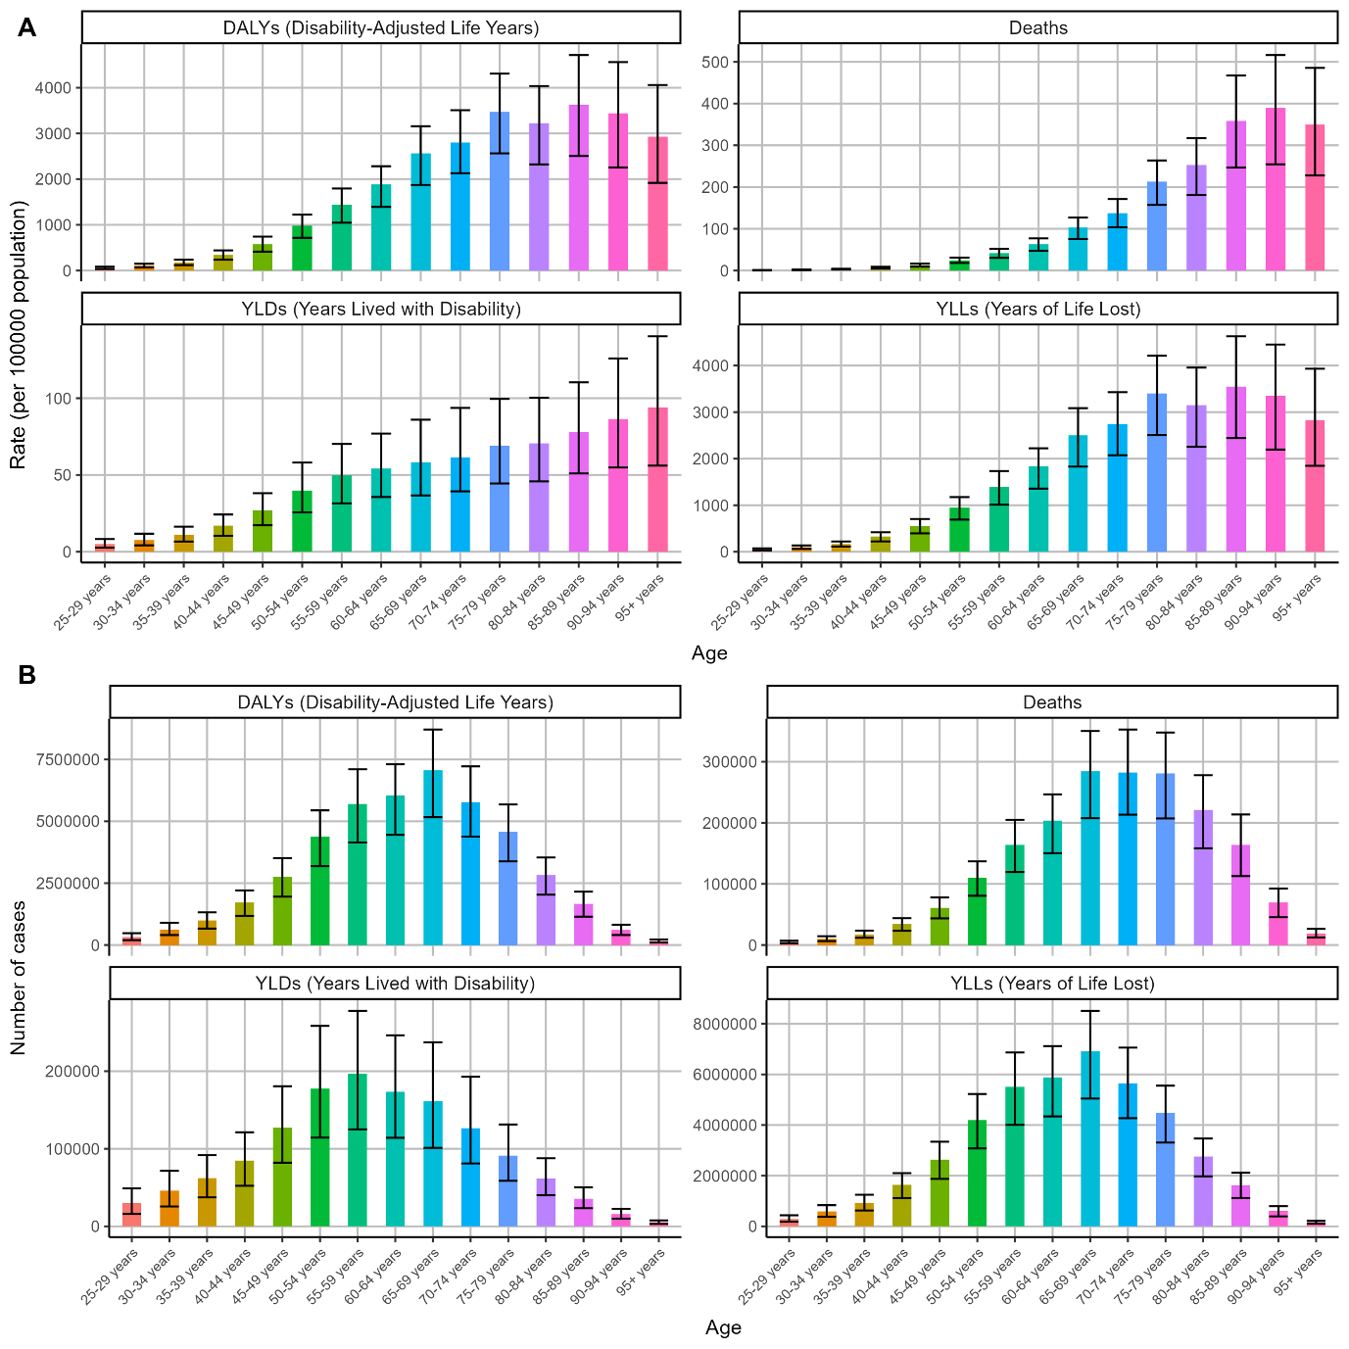
Figure S3. Bueden of ischemic stroke attributable to hypertension in G20 countries in 2021, by age.
A, Rates of DALYs, mortality, YLDs, and YLLs. B, Numbers of DALYs, mortality, YLDs, and YLLs. DALYs, disability-adjusted life years. YLDs, years lived with disability. YLLs, years of life lost.

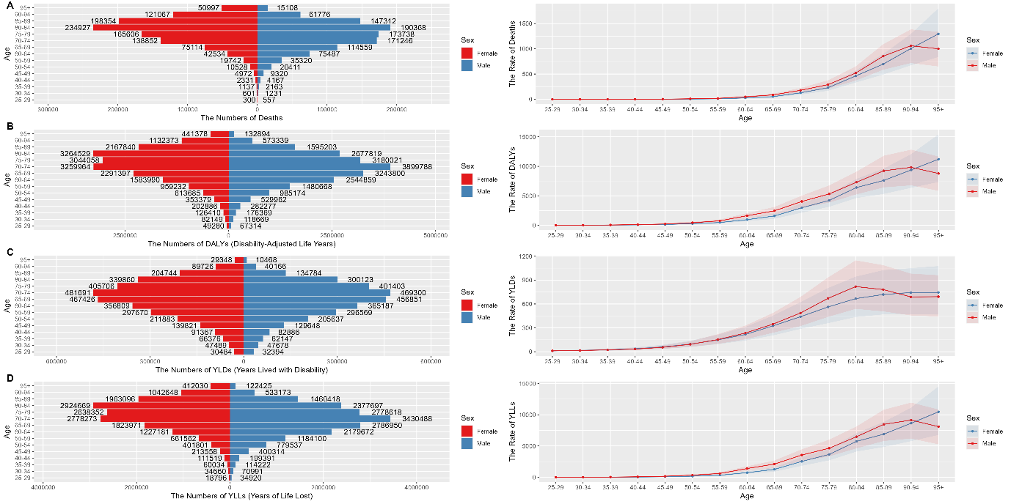
Figure S4. Burden of ischemic stroke attributable to hypertension in G20 countries in 2021, by sex and age.
A, Mortality. B, DALYs. C, YLDs. D, YLLs. DALYs, disability-adjusted life years. YLDs, years lived with disability. YLLs, years of life lost.

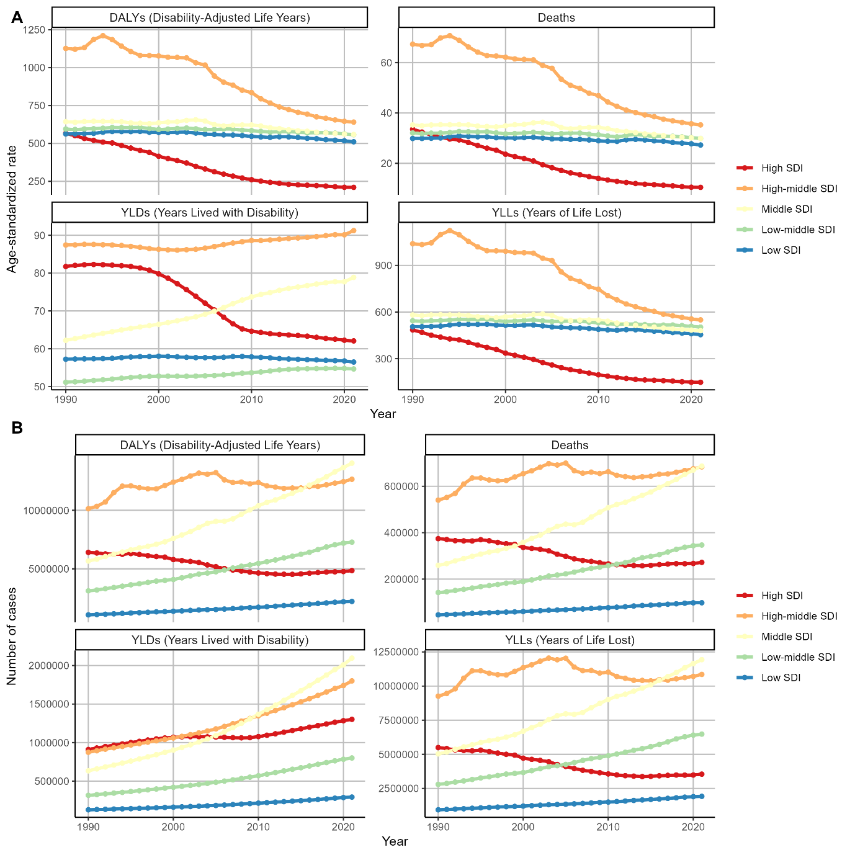
Figure S5. Bueden of ischemic stroke attributable to hypertension in G20 countries from 1990 to 2021, by SDI.
A, Age-standardized rates of DALYs, mortality, YLDs, and YLLs. B, Numbers of DALYs, mortality, YLDs, and YLLs. DALYs, disability-adjusted life years. YLDs, years lived with disability. YLLs, years of life lost.

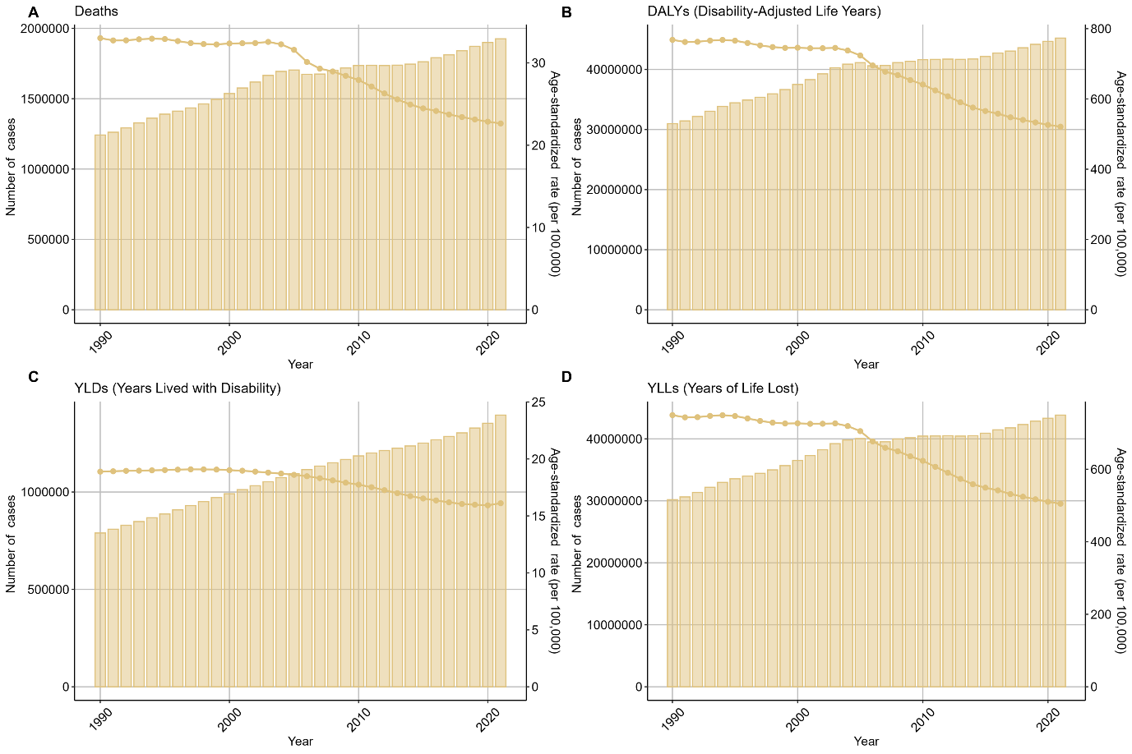
Figure S6. The numbers and age-standardized rates of mortality, DALYs ,YLDs, and YLLs of intracerebral hemorrhage attributable to hypertension in G20 countries from 1990 to 2021.
A, Mortality. B, DALYs. C, YLDs. D, YLLs. Bars and broken lines indicate numbers and age-standardized rates, respectively. DALYs, disability-adjusted life years. YLDs, years lived with disability. YLLs, years of life lost.

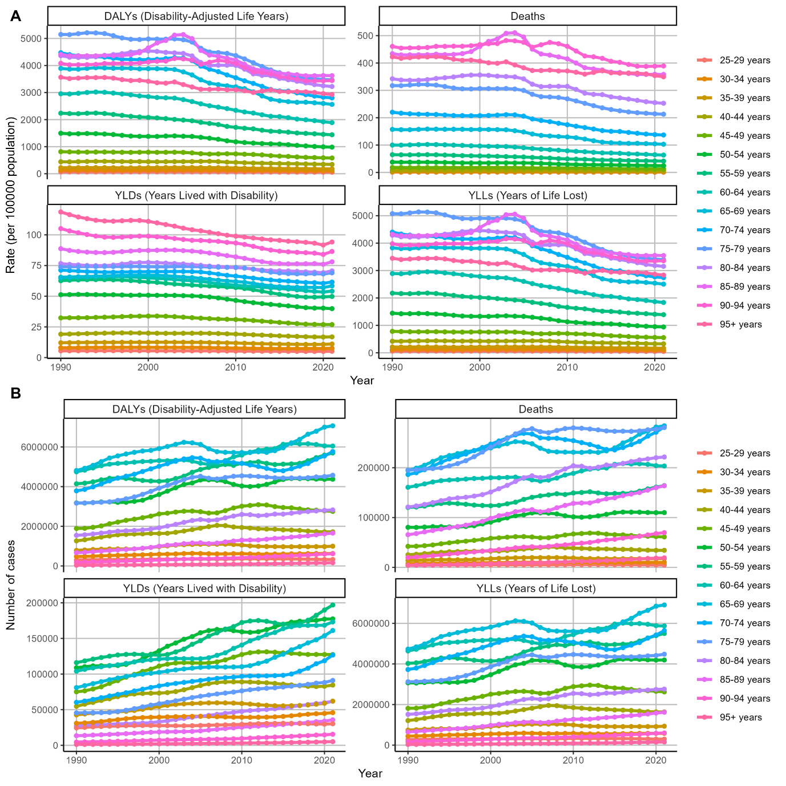
Figure S7. Burden of intracerebral hemorrhage attributable to hypertension in G20 countries from 1990 to 2021, by age.
A, Age-standardized rates of DALYs, mortality, YLDs, and YLLs. B, Numbers of DALYs, mortality, YLDs, and YLLs. DALYs, disability-adjusted life years. YLDs, years lived with disability. YLLs, years of life lost.

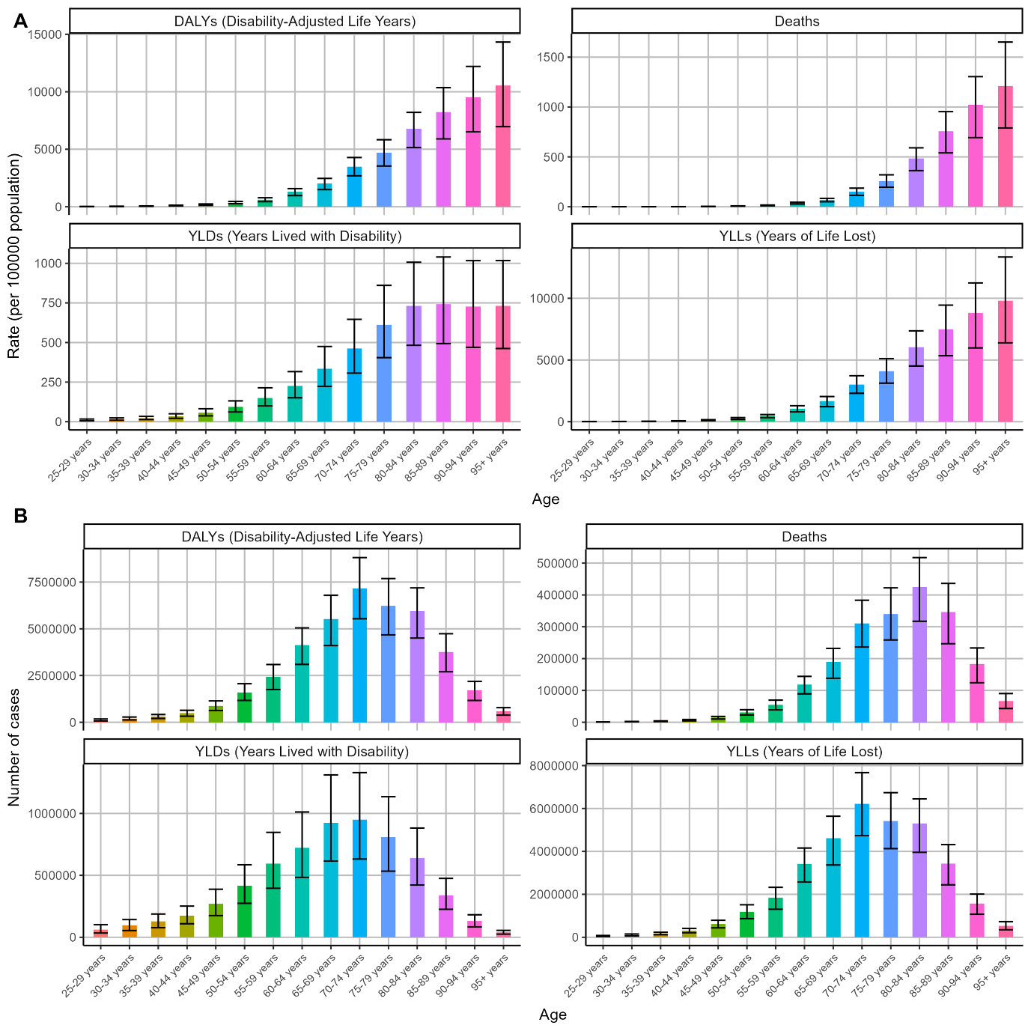
Figure S8. Bueden of intracerebral hemorrhage attributable to hypertension in G20 countries in 2021, by age.
A, Rates of DALYs, mortality, YLDs, and YLLs. B, Numbers of DALYs, mortality, YLDs, and YLLs. DALYs, disability-adjusted life years. YLDs, years lived with disability. YLLs, years of life lost.

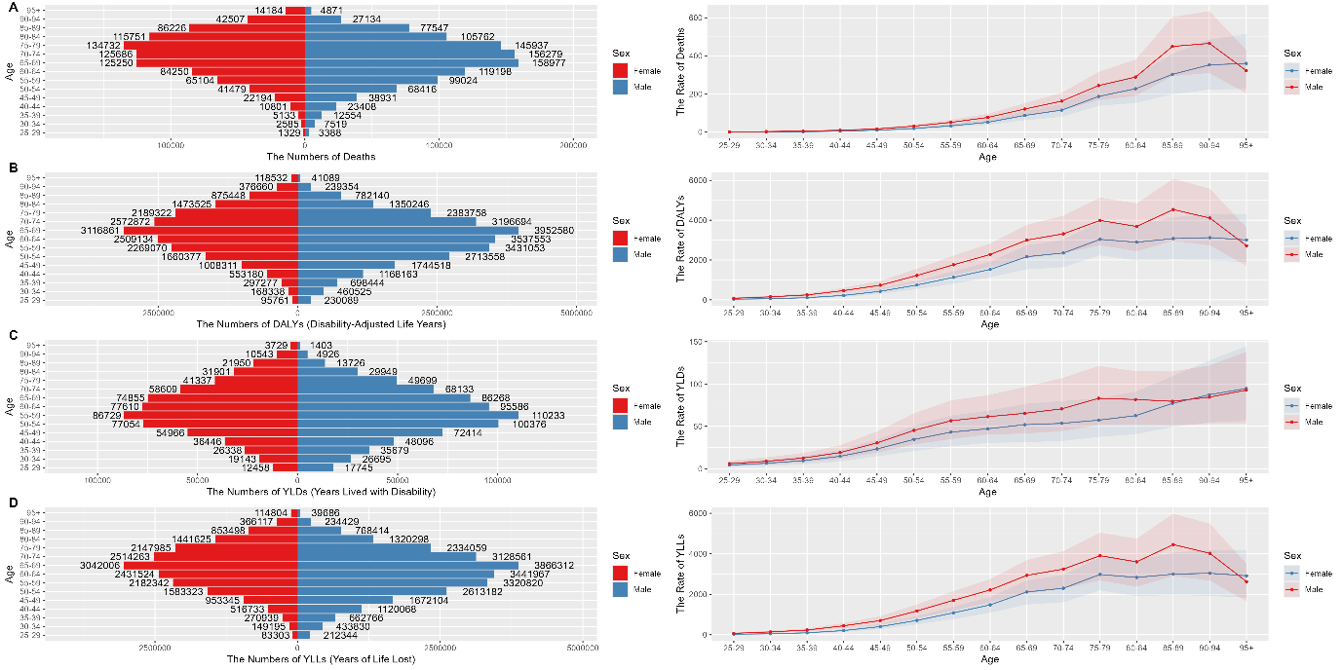
Figure S9. Burden of intracerebral hemorrhage attributable to hypertension in G20 countries in 2021, by sex and age.
A, Mortality. B, DALYs. C, YLDs. D, YLLs. DALYs, disability-adjusted life years. YLDs, years lived with disability. YLLs, years of life lost.

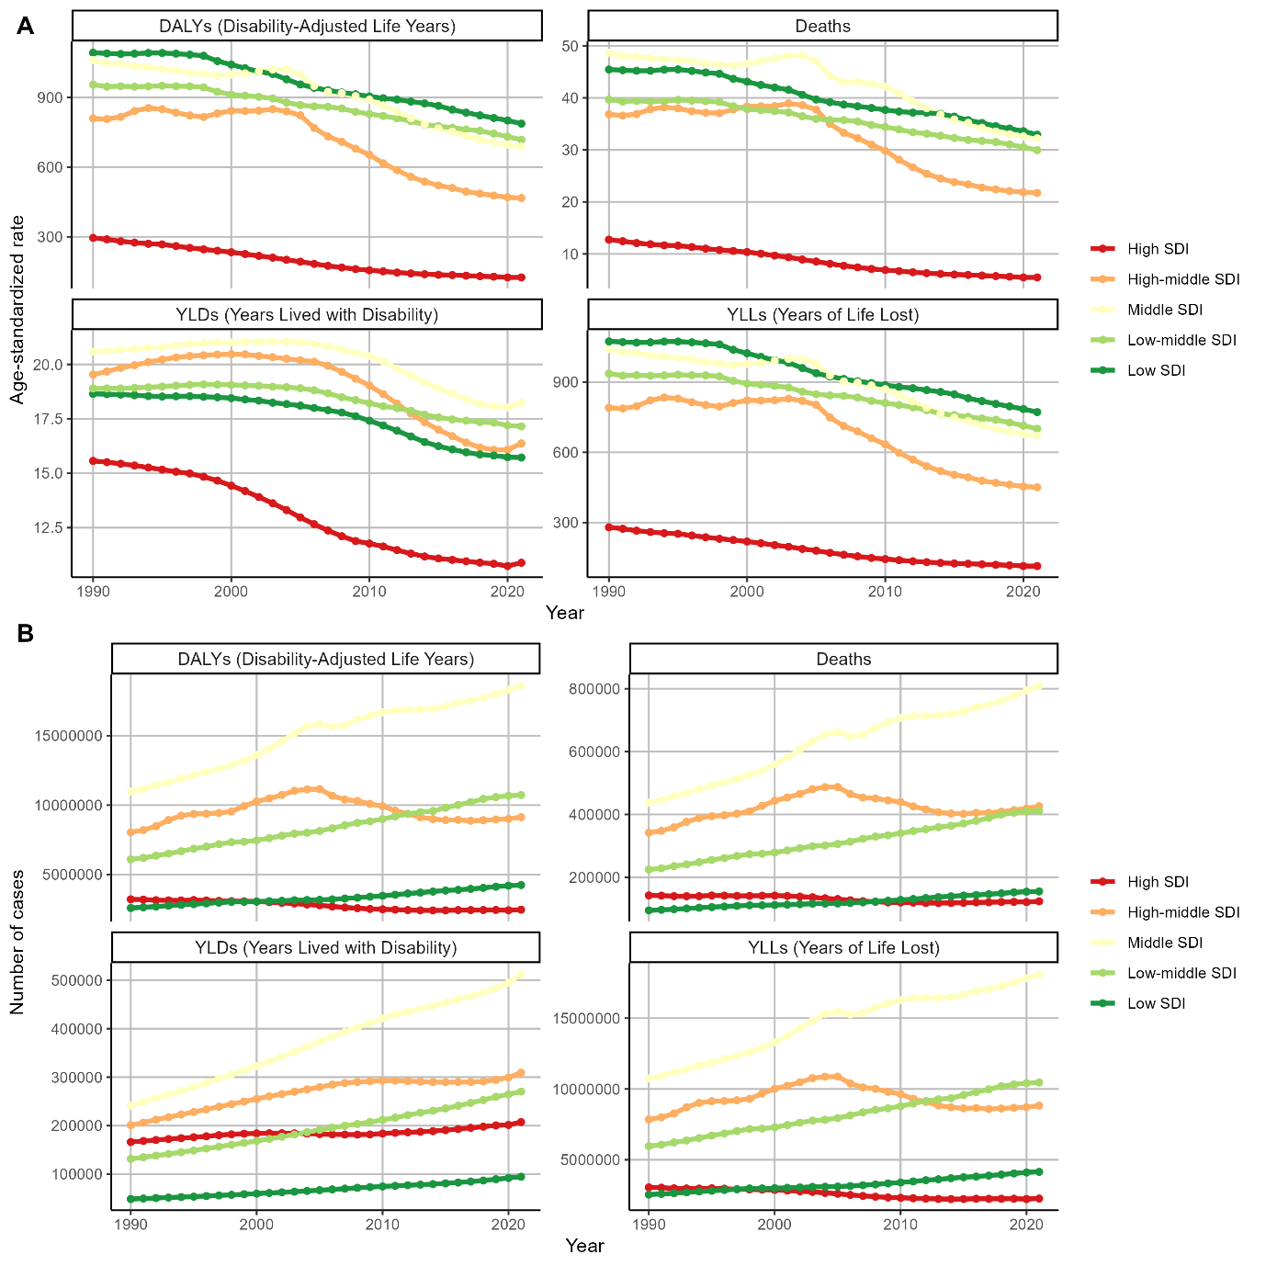
Figure S10. Burden of intracerebral hemorrhage attributable to hypertension in G20 countries from 1990 to 2021, by SDI.
A, Age-standardized rates of DALYs, mortality, YLDs, and YLLs. B, Numbers of DALYs, mortality, YLDs, and YLLs. DALYs, disability-adjusted life years. YLDs, years lived with disability. YLLs, years of life lost.

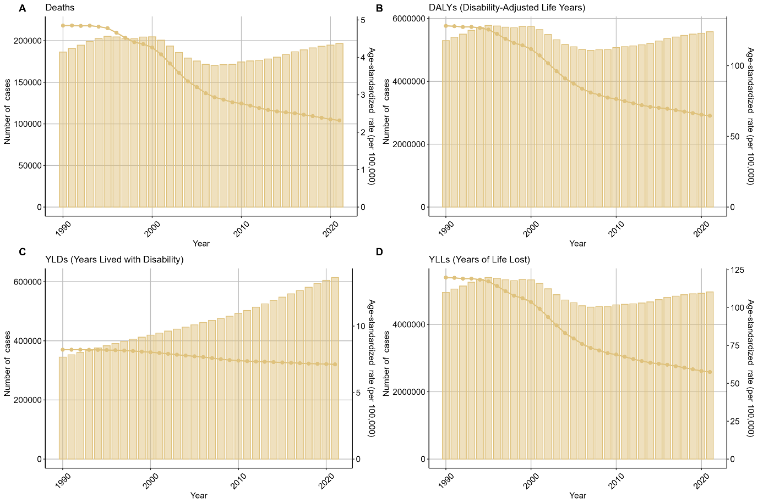
Figure S11. The numbers and age-standardized rates of mortality, DALYs ,YLDs, and YLLs of subarachnoid hemorrhage attributable to hypertension in G20 countries from 1990 to 2021.
A, Mortality. B, DALYs. C, YLDs. D, YLLs. Bars and broken lines indicate numbers and age-standardized rates, respectively. DALYs, disability-adjusted life years. YLDs, years lived with disability. YLLs, years of life lost.

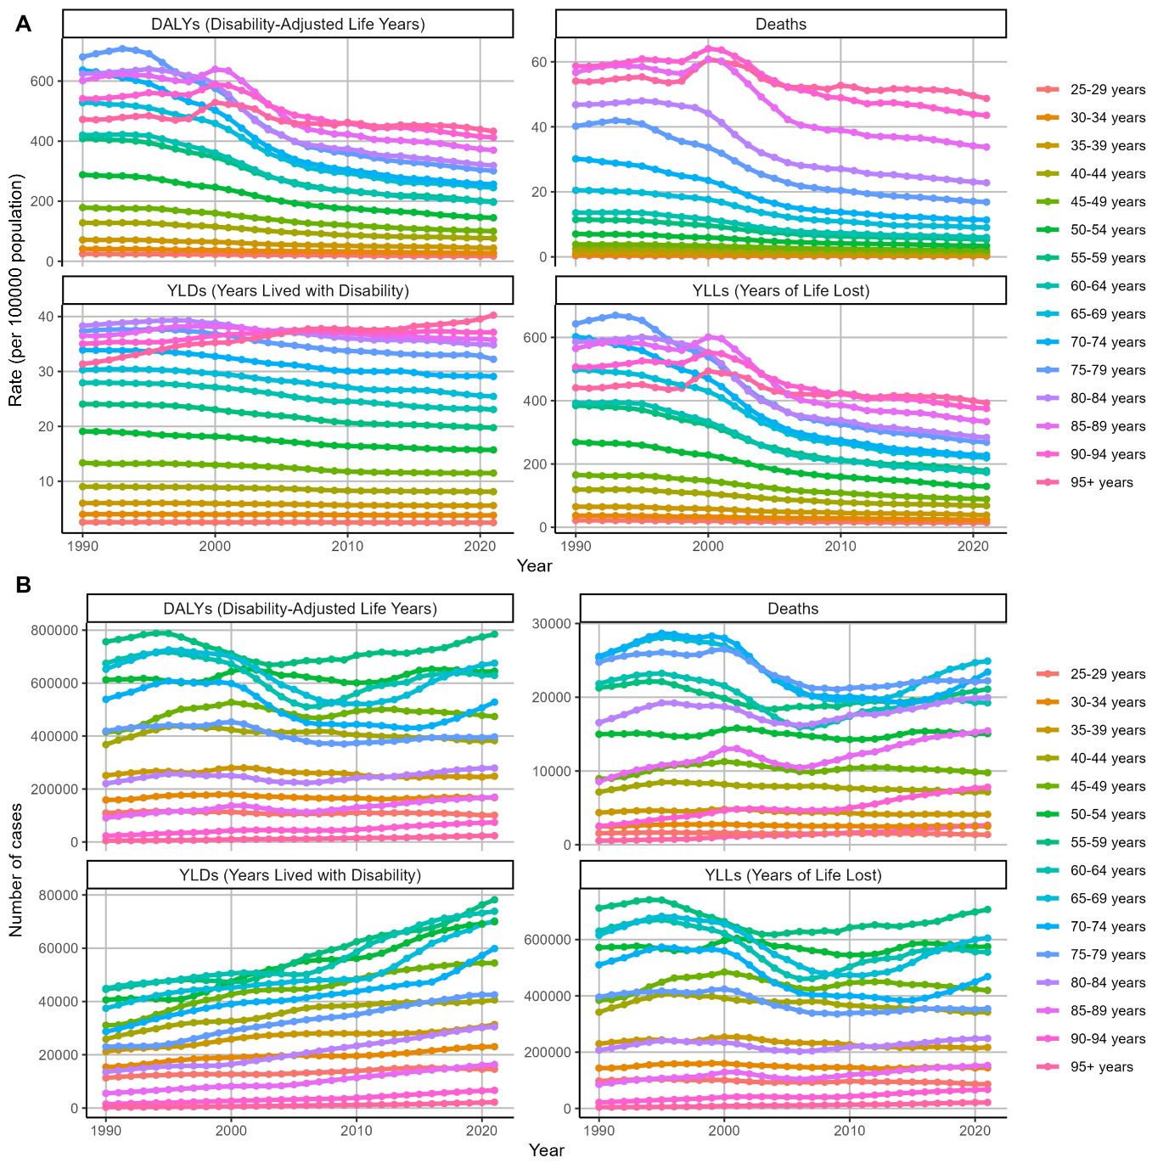
Figure S12. Burden of subarachnoid hemorrhage attributable to hypertension in G20 countries in 2021, by age.
A, Age-standardized rates of DALYs, mortality, YLDs, and YLLs. B, Numbers of DALYs, mortality, YLDs, and YLLs. DALYs, disability-adjusted life years. YLDs, years lived with disability. YLLs, years of life lost.

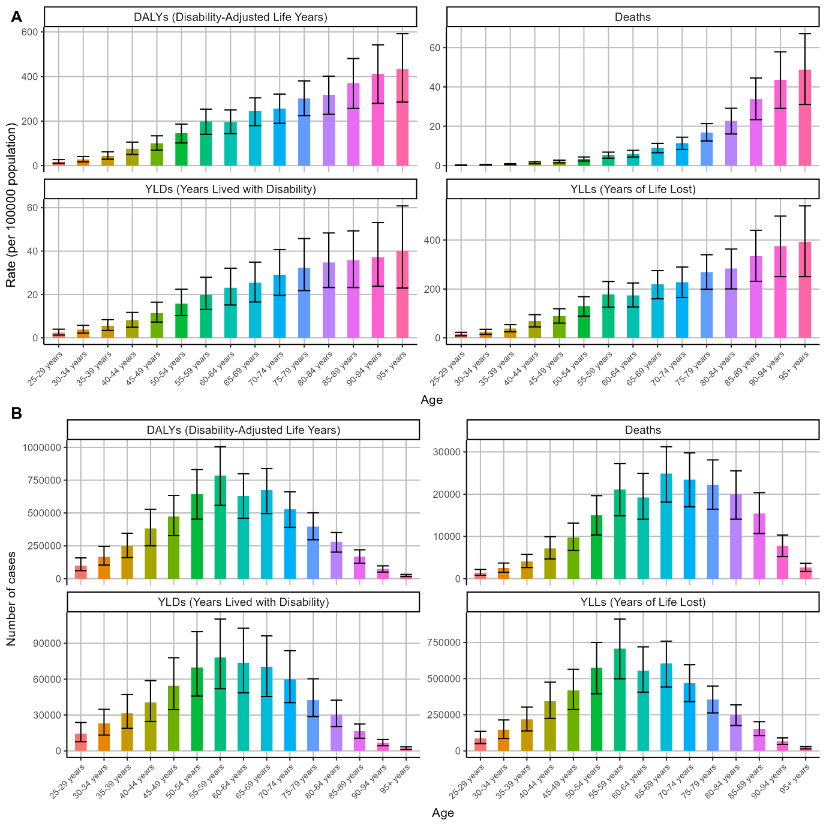
Figure S13. Bueden of subarachnoid hemorrhage attributable to hypertension in G20 countries in 2021, by age.
A, Rates of DALYs, mortality, YLDs, and YLLs. B, Numbers of DALYs, mortality, YLDs, and YLLs. DALYs, disability-adjusted life years. YLDs, years lived with disability. YLLs, years of life lost.

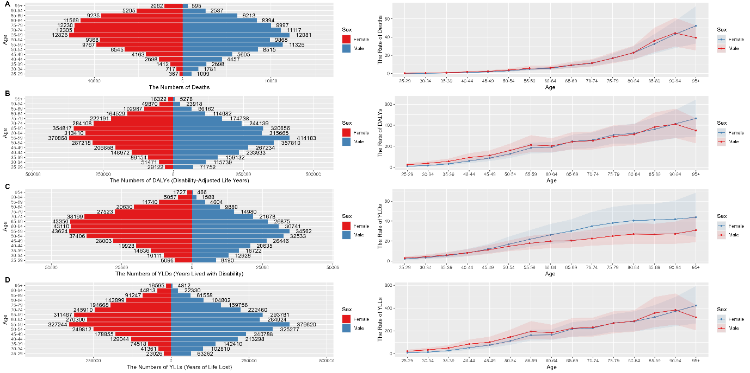
Figure S14. Burden of subarachnoid hemorrhage attributable to hypertension in G20 countries in 2021, by sex and age.
A, Mortality. B, DALYs. C, YLDs. D, YLLs. DALYs, disability-adjusted life years. YLDs, years lived with disability. YLLs, years of life lost.

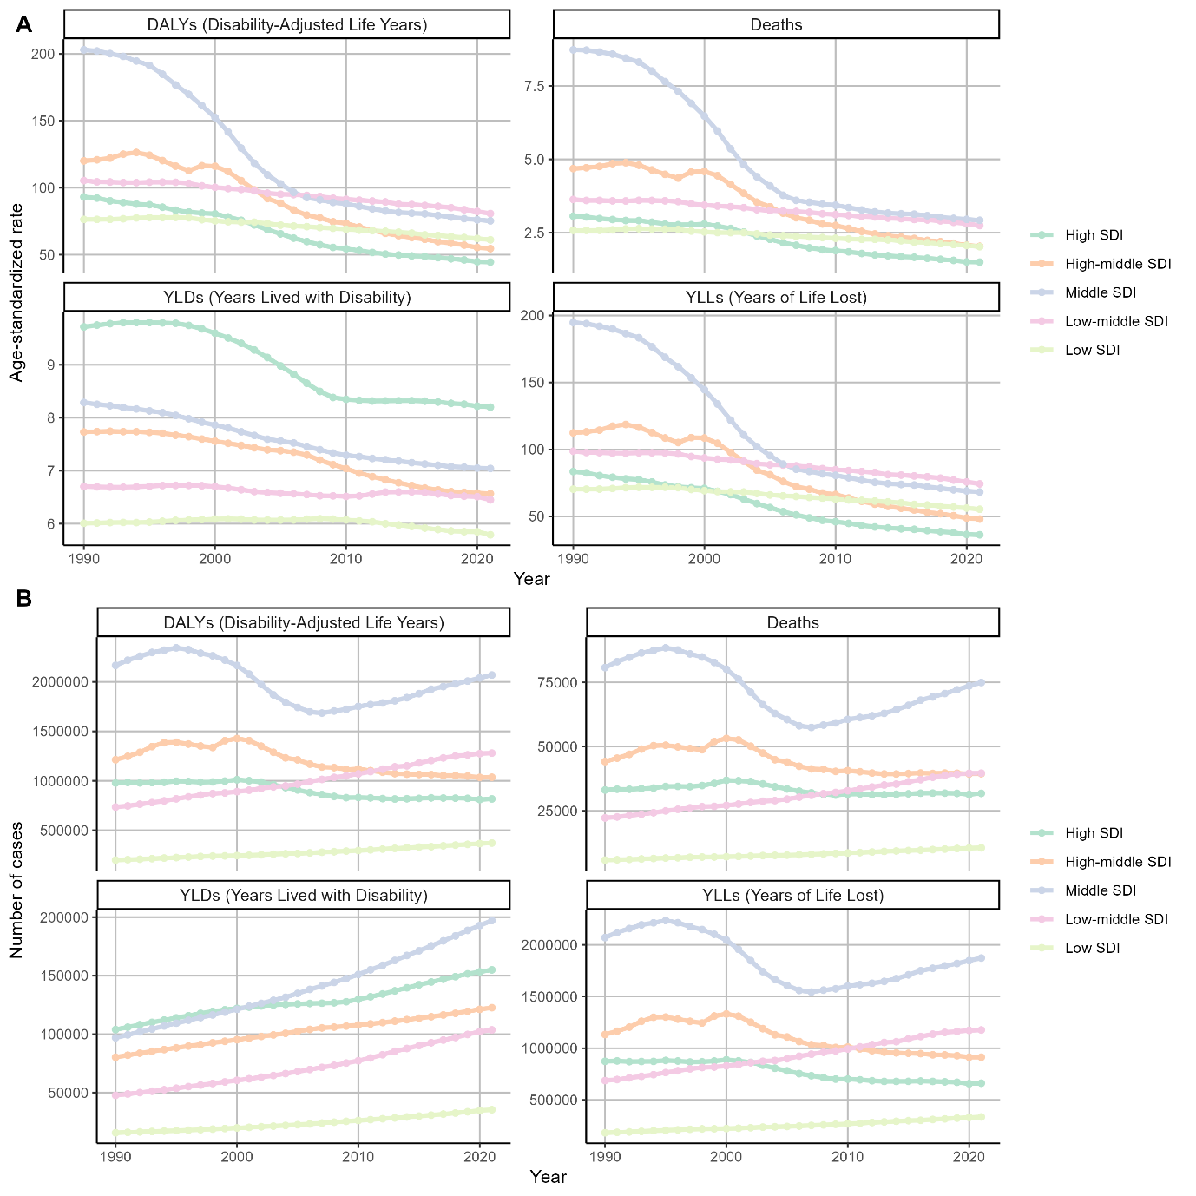
Figure S15. Burden of subarachnoid hemorrhage attributable to hypertension in G20 countries from 1990 to 2021, by SDI.
A, Age-standardized rates of DALYs, mortality, YLDs, and YLLs. B, Numbers of DALYs, mortality, YLDs, and YLLs. DALYs, disability-adjusted life years. YLDs, years lived with disability. YLLs, years of life lost.

Table S1. Burden of stroke attributable to hypertension in G20 countries, by nations, 1990–2021
 |  |  | DALYs |  |  |  |  |  | Mortality
 | 1990 cases  (×100000, 95% UI) | 1990 ASDALYR  (per 100000, 95% UI) | 2021 cases  (×100000, 95% UI) | 2021 ASDALYR  (per 100000, 95% UI) | 1990–2021 EAPC  (95% CI) |  | 1990 cases  (×100000, 95% UI) | 1990 ASMR  (per 100000, 95% UI) | 2021 cases  (×100000, 95% UI) | 2021 ASMR  (per 100000, 95% UI) | 1990–2021 EAPC  (95% CI)
Overall | 264.23 (198.37–317.92) | 743.20 (558.75–893.21) | 410.61 (311.46–502.01) | 485.90 (368.95–593.66) | −0.83 (−1.15 to −0.51) |  | 13.66 (10.23–16.45) | 42.84 (31.84–51.58) | 20.90 (15.71–25.74) | 25.57 (19.16–31.56) | −0.99 (−1.4 to −0.57)
Country
Argentina | 1.35 (0.92–1.76) | 447.25 (304.87–577.60) | 1.25 (0.93–1.54) | 215.23 (160.04–265.7) | −1.4 (−1.61 to −1.20) |  | 0.08 (0.05–0.10) | 27.51 (19.7–35.80) | 0.07 (0.05–0.08) | 11.25 (8.29–13.86) | −1.68 (−1.92 to −1.44)
Australia | 0.84 (0.63–1.01) | 438.89 (328.50–528.16) | 0.63 (0.45–0.80) | 124.07 (88.80–157.63) | −3.58 (−4.19 to −2.97) |  | 0.05 (0.04–0.06) | 28.08 (20.7–34.34) | 0.04 (0.03–0.05) | 6.66 (4.60–8.67) | −3.88 (−4.55 to −3.21)
Brazil | 6.11 (4.52–7.36) | 781.33 (581.76–941.70) | 7.24 (5.35–8.83) | 296.8 (218.92–362.27) | −1.89 (−2.38 to −1.39) |  | 0.31 (0.23–0.37) | 45.18 (33.6–54.86) | 0.39 (0.29–0.49) | 16.63 (12.15–20.47) | −1.69 (−2.28 to −1.10)
Canada | 1.09 (0.82–1.33) | 335.07 (252.35–410.02) | 1.04 (0.75–1.34) | 131.73 (93.84–168.76) | −2.44 (−3.11 to −1.77) |  | 0.06 (0.05–0.08) | 19.60 (14.20–24.20) | 0.06 (0.04–0.07) | 6.36 (4.31–8.17) | −2.89 (−3.63 to −2.15)
China | 47.26 (33.25–62.71) | 669.00 (475.20–876.40) | 134.94 (95.99–176.69) | 669.45 (475.53–878.06) | 1.47 (1.06 to 1.88) |  | 2.13 (1.49–2.82) | 36.78 (25.98–48.26) | 6.72 (4.67–9.02) | 36.26 (25.27–48.78) | 1.62 (1.05 to 2.20)
France | 3.54 (2.66–4.26) | 391.70 (292.38–469.53) | 2.43 (1.74–3.04) | 140.22 (103.36–176.13) | −2.5 (−3.42 to −1.58) |  | 0.24 (0.18–0.30) | 26.16 (19.25–32.00) | 0.16 (0.11–0.21) | 7.52 (5.26–9.60) | −2.95 (−3.99 to −1.90)
Germany | 10.16 (7.83–12.00) | 745.63 (573.91–881.73) | 4.98 (3.66–6.19) | 222.13 (166.39–275.43) | −3.25 (−4.24 to −2.24) |  | 0.63 (0.48–0.75) | 45.75 (34.57–54.97) | 0.27 (0.19–0.35) | 10.76 (7.60–13.44) | −3.78 (−4.85 to −2.70)
India | 15.60 (10.76–21.15) | 396.59 (273.99–530.66) | 37.74 (26.48–50.57) | 344.23 (242.19–456.89) | 0.20 (−0.54 to 0.96) |  | 0.67 (0.45–0.91) | 20.50 (13.98–27.64) | 1.79 (1.26–2.33) | 18.31 (12.94–24.02) | 0.48 (−0.47 to 1.44)
Indonesia | 7.34 (5.55–9.29) | 915.81 (684.64–1152.24) | 22.98 (16.21–30.66) | 1202.56 (858.41–1573.74) | 1.66 (0.80 to 2.53) |  | 0.31 (0.23–0.40) | 48.52 (35.29–62.06) | 1.04 (0.73–1.39) | 68.50 (49.06–90.40) | 1.88 (0.74 to 3.03)
Italy | 5.80 (4.51–6.85) | 633.92 (494.09–752.70) | 2.63 (1.82–3.36) | 140.23 (98.26–177.54) | −4.33 (−5.44 to −3.22) |  | 0.38 (0.30–0.46) | 43.05 (32.98–51.92) | 0.20 (0.13–0.26) | 9.16 (6.00–11.93) | −4.21 (−5.39 to −3.02)
Japan | 9.29 (7.06–11.03) | 578.43 (436.06–689.74) | 7.59 (5.44–9.65) | 169.38 (122.97–213.41) | −2.72 (−3.84 to −1.60) |  | 0.53 (0.40–0.64) | 35.35 (26.33–42.75) | 0.45 (0.31–0.60) | 7.56 (5.26–9.81) | −3.16 (−4.44 to −1.87)
Mexico | 1.21 (0.87–1.53) | 330.30 (238.06–416.68) | 2.11 (1.53–2.62) | 177.31 (129.37–221.41) | −0.74 (−1.46 to −0.01) |  | 0.06 (0.05–0.08) | 19.91 (14.49–25.40) | 0.11 (0.08–0.14) | 9.67 (6.93–12.18) | −0.82 (−1.67 to 0.04)
Republic of Korea | 2.66 (1.90–3.30) | 1140.29 (819.29–1401.24) | 1.97 (1.30–2.59) | 210.62 (138.93–277.61) | −4.60 (−5.15 to −4.05) |  | 0.12 (0.09–0.15) | 65.37 (47.63–81.01) | 0.10 (0.07–0.14) | 11.32 (7.19–15.51) | −4.59 (−5.25 to −3.93)
Russian Federation | 33.26 (25.33–39.08) | 1963.05 (1494.24–2312.20) | 25.83 (19.55–30.81) | 1066.26 (806.03–1272.52) | −2.22 (−2.78 to −1.65) |  | 1.78 (1.35–2.09) | 115.30 (87.28–136.26) | 1.48 (1.11–1.79) | 61.07 (45.79–73.82) | −2.10 (−2.63 to −1.58)
Saudi Arabia | 0.50 (0.33–0.68) | 978.32 (644.65–1330.62) | 1.14 (0.78–1.49) | 695.57 (493.63–905.17) | −0.96 (−2.34 to 0.44) |  | 0.02 (0.02–0.03) | 54.03 (35.79–73.95) | 0.04 (0.03–0.05) | 38.42 (27.34–50.19) | −1.35 (−3.11 to 0.44)
South Africa | 1.04 (0.75–1.28) | 550.15 (394.21–680.37) | 2.60 (1.99–3.16) | 650.06 (493.14–788.21) | 1.13 (0.32 to 1.94) |  | 0.05 (0.03–0.06) | 27.34 (18.66–34.63) | 0.13 (0.09–0.15) | 36.24 (27.04–44.00) | 1.51 (0.54 to 2.50)
Turkey | 2.53 (1.79–3.24) | 838.72 (595.08–1067.35) | 3.76 (2.63–4.86) | 435.37 (304.72–561.53) | −1.09 (−1.58 to −0.60) |  | 0.13 (0.09–0.16) | 47.13 (33.63–60.71) | 0.21 (0.14–0.28) | 25.97 (17.86–34.45) | −0.53 (−1.14 to 0.09)
United Kingdom | 6.41 (5.01–7.43) | 654.47 (509.12–761.20) | 2.04 (1.48–2.54) | 137.64 (99.5–172.65) | −5.16 (−6.02 to −4.29) |  | 0.41 (0.32–0.48) | 41.76 (32.48–48.94) | 0.13 (0.09–0.16) | 7.69 (5.46–9.65) | −5.40 (−6.34 to −4.45)
United States of America | 10.87 (8.13–13.16) | 322.59 (240.9–391.42) | 11.20 (7.97–14.39) | 181.59 (129.21–233.07) | −2.04 (−2.68 to −1.40) |  | 0.61 (0.46–0.74) | 17.85 (13.35–21.68) | 0.62 (0.43–0.79) | 9.28 (6.46–11.91) | −2.24 (−2.96 to −1.51)
DALYs, disability-adjusted life years. ASDALYR, age-standardized disability adjusted of life years rate. ASMR, age-standardized mortality rate. EAPC, estimated annual percentage change.

Table S2. Burden of intracerebral hemorrhage attributable to hypertension in G20 countries, by nations, 1990–2021
 |  |  | DALYs |  |  |  |  |  | Mortality
 | 1990 cases  (×100000, 95% UI) | 1990 ASDALYR  (per 100000, 95% UI) | 2021 cases  (×100000, 95% UI) | 2021 ASDALYR  (per 100000, 95% UI) | 1990–2021 EAPC  (95% CI) |  | 1990 cases  (×100000, 95% UI) | 1990 ASMR  (per 100000, 95% UI) | 2021 cases  (×100000, 95% UI) | 2021 ASMR  (per 100000, 95% UI) | 1990–2021 EAPC  (95% CI)
Overall | 309.75 (226.73–383.68) | 768.15 (563.15–949.55) | 452.14 (337.14–553.88) | 521.09 (388.7–638.08) | −0.79 (−1.03 to −0.55) |  | 12.42 (9.17–15.29) | 33.01 (24.32–40.66) | 19.26 (14.49–23.62) | 22.64 (17–27.76) | −0.68 (−0.98 to −0.38)
Country
Argentina | 1.62 (1.08–2.12) | 502.29 (335.77–658.71) | 1.27 (0.92–1.54) | 230.96 (167.58–280.88) | −1.99 (−2.13 to −1.86) |  | 0.07 (0.04–0.08) | 20.67 (13.93–26.76) | 0.05 (0.04–0.07) | 9.59 (6.98–11.57) | −1.79 (−1.96 to −1.62)
Australia | 0.35 (0.26–0.42) | 177.50 (133.39–212.99) | 0.30 (0.22–0.38) | 66.50 (48.79–83.79) | −2.7 (−3.22 to −2.18) |  | 0.02 (0.01–0.02) | 8.62 (6.46–10.34) | 0.02 (0.01–0.02) | 3.45 (2.45–4.39) | −2.29 (−2.88 to −1.69)
Brazil | 7.11 (5.19–8.71) | 725.26 (529.80–882.97) | 6.44 (4.76–7.85) | 251.06 (185.72–306.42) | −2.69 (−2.99 to −2.38) |  | 0.24 (0.18–0.30) | 27.35 (19.98–33.14) | 0.25 (0.18–0.30) | 9.75 (7.20–11.88) | −2.42 (−2.80 to −2.04)
Canada | 0.41 (0.31–0.50) | 125.95 (94.31–154.27) | 0.44 (0.31–0.57) | 61.87 (42.86–79.47) | −1.74 (−2.33 to −1.15) |  | 0.02 (0.01–0.02) | 5.68 (4.25–6.92) | 0.02 (0.02–0.03) | 2.95 (2.07–3.72) | −1.43 (−2.10 to −0.77)
China | 102.34 (70.55–137.94) | 1309.63 (910.34–1757.36) | 156.27 (108.33–205.49) | 753.99 (528.24–992.08) | −0.57 (−0.97 to −0.17) |  | 4.39 (3.07–5.91) | 67.38 (47.33–89.44) | 7.57 (5.30–9.95) | 38.83 (27.35–51.19) | −0.39 (−0.89 to 0.11)
France | 1.77 (1.33–2.12) | 220.80 (165.90–264.89) | 1.09 (0.80–1.35) | 76.16 (56.8–94.27) | −2.88 (−3.60 to −2.15) |  | 0.09 (0.07–1.06) | 10.18 (7.61–12.21) | 0.07 (0.05–0.08) | 3.84 (2.75–4.79) | −2.40 (−3.28 to −1.50)
Germany | 3.08 (2.41–3.69) | 248.89 (193.75–296.90) | 1.65 (1.23–2.03) | 85.77 (64.92–105.13) | −3.04 (−3.89 to −2.18) |  | 0.15 (0.11–0.18) | 11.01 (8.53–13.29) | 0.09 (0.07–0.12) | 4.15 (3.05–5.13) | −2.49 (−3.46 to −1.51)
India | 33.33 (23.64–43.55) | 674.06 (477.30–877.31) | 60.89 (43.68–77.84) | 490.11 (352.99–626.34) | −0.41 (−0.93 to 0.11) |  | 1.18 (0.83–1.54) | 27.01 (19.16–35.31) | 2.31 (1.66–2.97) | 19.90 (14.25–25.43) | −0.25 (−0.89 to 0.39)
Indonesia | 20.56 (14.98–25.48) | 1972.83 (1438.52–2459.17) | 44.67 (32.39–57.57) | 1769.79 (1300.21–2303.03) | 0.50 (−0.03 to 1.04) |  | 0.73 (0.53–0.91) | 82.26 (58.80–103.47) | 1.66 (1.21–2.15) | 77.73 (55.66–101.36) | 0.63 (−0.10 to 1.37)
Italy | 2.42 (1.85–2.83) | 276.39 (210.50–324.03) | 1.38 (0.96–1.71) | 93.46 (64.85–116.00) | −2.94 (−3.83 to −2.05) |  | 0.11 (0.09–0.13) | 12.57 (9.71–14.78) | 0.09 (0.06–0.11) | 4.86 (3.38–6.06) | −2.26 (−3.31 to −1.20)
Japan | 5.44 (4.14–6.43) | 322.56 (245.21–382.51) | 4.35 (3.20–5.41) | 139.26 (102.57–171.21) | −1.85 (−2.72 to −0.98) |  | 0.23 (0.18–0.27) | 14.04 (10.78–16.76) | 0.24 (0.17–0.30) | 5.62 (4.13–7.01) | −1.52 (−2.59 to −0.45)
Mexico | 1.06 (0.75–1.33) | 238.50 (169.38–297.26) | 1.88 (1.34–2.36) | 144.71 (103.41–181.60) | −0.87 (−1.42 to −0.32) |  | 0.04 (0.03–0.05) | 10.42 (7.47–13.08) | 0.07 (0.05–0.09) | 6.11 (4.43–7.66) | −0.81 (−1.47 to −0.14)
Republic of Korea | 3.51 (2.45–4.48) | 1206.78 (856.34–1532.81) | 1.10 (0.72–1.44) | 119.16 (77.4–156.28) | −6.82 (−7.29 to −6.35) |  | 0.14 (0.10–0.18) | 57.59 (41.08–73.08) | 0.05 (0.03–0.07) | 5.41 (3.51–7.29) | −6.65 (−7.18 to −6.12)
Russian Federation | 11.26 (8.65–13.15) | 621.00 (475.55–727.61) | 8.71 (6.54–10.44) | 386.35 (289.02–464.76) | −2.12 (−2.75 to −1.49) |  | 0.45 (0.35–0.53) | 26.17 (20.00–30.67) | 0.36 (0.27–0.43) | 15.39 (11.60–18.44) | −2.13 (−2.73 to −1.53)
Saudi Arabia | 0.49 (0.32–0.71) | 760.73 (487.37–1069.63) | 1.01 (0.65–1.40) | 392.30 (273.39–524.07) | −1.58 (−2.51 to −0.64) |  | 0.02 (0.01–0.02) | 32.85 (21.17–45.95) | 0.03 (0.02–0.04) | 16.77 (12.06–22.00) | −1.93 (−3.21 to −0.63)
South Africa | 1.66 (1.20–2.05) | 718.99 (527.08–889.35) | 3.25 (2.44–3.95) | 668.44 (499.52–810.49) | 0.28 (−0.31 to 0.88) |  | 0.06 (0.04–0.07) | 26.99 (19.34–33.58) | 0.12 (0.09–0.15) | 28.15 (21.26–34.34) | 0.64 (−0.09 to 1.38)
Turkey | 2.33 (1.62–3.05) | 654.30 (455.70–849.89) | 2.29 (1.56–2.96) | 245.11 (166.33–316.38) | −2.56 (−2.94 to −2.18) |  | 0.09 (0.06–0.12) | 28.88 (19.96–37.32) | 0.10 (0.07–0.13) | 11.78 (8.11–15.34) | −1.96 (−2.44 to −1.48)
United Kingdom | 1.76 (1.37–2.04) | 200.52 (155.93–232.88) | 1.05 (0.76–1.29) | 81.33 (58.91–99.24) | −2.83 (−3.53 to −2.12) |  | 0.09 (0.07–0.10) | 9.15 (7.11–10.61) | 0.06 (0.04–0.08) | 4.17 (3.00–5.14) | −2.24 (−3.07 to −1.40)
United States of America | 4.73 (3.54–5.71) | 152.22 (113.73–183.69) | 6.17 (4.34–7.77) | 110.59 (76.88–138.97) | −0.81 (−1.30 to −0.31) |  | 0.21 (0.16–0.26) | 6.53 (4.94–7.88) | 0.30 (0.21–0.38) | 4.92 (3.50–6.19) | −0.68 (−1.26 to −0.10)
DALYs, disability-adjusted life years. ASDALYR, age-standardized disability adjusted of life years rate. ASMR, age-standardized mortality rate. EAPC, estimated annual percentage change.

Table S3. Burden of subarachnoid hemorrhage attributable to hypertension in G20 countries, by nations, 1990–2021
 |  |  | DALYs |  |  |  |  |  | Mortality
 | 1990 cases  (×100000, 95% UI) | 1990 ASDALYR  (per 100000, 95% UI) | 2021 cases  (×100000, 95% UI) | 2021 ASDALYR  (per 100000, 95% UI) | 1990–2021 EAPC  (95% CI) |  | 1990 cases  (×1000, 95% UI) | 1990 ASMR  (per 100000, 95% UI) | 2021 cases  (×1000, 95% UI) | 2021 ASMR  (per 100000, 95% UI) | 1990–2021 EAPC  (95% CI)
Overall | 52.96 (36.47–71.22) | 128.12 (88.16–172.13) | 55.79 (40.49–70.62) | 64.58 (46.84–81.79) | −2.03 (−2.26 to −1.81) |  | 186.35 (125.76–250.02) | 4.85 (3.25–6.52) | 196.71 (143.36–249.92) | 2.32 (1.69–2.94) | −2.19 (−2.49 to −1.89)
Country
Argentina | 0.44 (0.28–0.59) | 137.18 (87.24–184.87) | 0.37 (0.26–0.45) | 68.84 (49.23–85.30) | −1.66 (−1.85 to −1.46) |  | 1.48 (0.96–1.96) | 4.69 (3.06–6.22) | 1.24 (0.90–1.52) | 2.25 (1.64–2.75) | −1.67 (−1.93 to −1.41)
Australia | 0.14 (0.10–0.17) | 73.14 (53.54–88.93) | 0.14 (0.10–0.18) | 34.93 (24.91–44.37) | −1.99 (−2.40 to −1.57) |  | 0.49 (0.36–0.59) | 2.56 (1.89–3.07) | 0.57 (0.40–0.73) | 1.25 (0.87–1.58) | −1.70 (−2.22 to −1.18)
Brazil | 1.49 (1.04–1.86) | 135.39 (95.48–168.02) | 2.36 (1.72–2.89) | 91.58 (66.59–112.42) | −0.64 (−0.90 to −0.37) |  | 3.89 (2.76–4.81) | 3.84 (2.77–4.73) | 7.58 (5.59–9.30) | 2.99 (2.20–3.67) | 0.03 (−0.31 to 0.36)
Canada | 0.20 (0.15–0.26) | 64.68 (47.02–81.55) | 0.20 (0.14–0.26) | 31.44 (21.39–41.24) | −1.91 (−2.43 to −1.39) |  | 0.68 (0.50–0.83) | 2.12 (1.58–2.63) | 0.82 (0.57–1.04) | 1.11 (0.77–1.43) | −1.36 (−1.97 to −0.75)
China | 21.71 (10.91–32.18) | 267.24 (130.02–393.3) | 12.68 (8.24–17.20) | 60.95 (39.50–82.88) | −4.48 (−4.98 to −3.98) |  | 87.86 (40.16–129.88) | 12.85 (5.72–18.75) | 52.31 (33.75–72.23) | 2.63 (1.70–3.62) | −4.75 (−5.34 to −4.15)
France | 0.37 (0.28–0.45) | 49.54 (36.55–60.77) | 0.40 (0.29–0.50) | 35.11 (25.66–44.43) | −0.42 (−1.00 to 0.16) |  | 1.38 (1.04–1.68) | 1.69 (1.27–2.07) | 1.71 (1.19–2.16) | 1.17 (0.84–1.46) | −0.15 (−0.95 to 0.66)
Germany | 0.91 (0.69–1.09) | 80.86 (61.23–97.65) | 0.61 (0.46–0.75) | 38.06 (28.03–47.23) | −2.13 (−2.81 to −1.44) |  | 3.09 (2.33–3.76) | 2.55 (1.92–3.09) | 2.52 (1.87–3.10) | 1.29 (0.96–1.58) | −1.65 (−2.50 to −0.79)
India | 5.06 (2.93–8.31) | 92.19 (52.85–153.57) | 8.40 (5.45–12.39) | 64.58 (42.02–95.23) | −0.63 (−1.05 to −0.22) |  | 14.91 (8.11–25.64) | 3.10 (1.64–5.49) | 26.09 (16.68–39.16) | 2.15 (1.37–3.24) | −0.56 (−1.11 to −0.01)
Indonesia | 1.76 (1.20–2.58) | 153.15 (103.6–238.31) | 3.25 (2.24–4.75) | 120.33 (82.91–180.09) | 0.05 (−0.37−0.46) |  | 5.10 (3.36–8.43) | 5.33 (3.40–9.44) | 9.74 (6.45–15.30) | 4.33 (2.82–7.19) | 0.13 (−0.50 to 0.77)
Italy | 0.42 (0.32–0.50) | 53.57 (40.14–63.61) | 0.31 (0.21–0.38) | 24.38 (16.98–30.41) | −1.81 (−2.55 to −1.07) |  | 1.44 (1.11–1.69) | 1.72 (1.30–2.02) | 1.47 (1.01–1.85) | 0.92 (0.63–1.15) | −0.84 (−1.80 to 0.14)
Japan | 2.64 (2.03–3.13) | 155.74 (119.53–185.46) | 2.14 (1.56–2.68) | 79.37 (58.08–98.76) | −1.86 (−2.61 to −1.10) |  | 8.56 (6.60–10.11) | 5.05 (3.89–5.98) | 7.95 (5.61–10.07) | 2.30 (1.67–2.84) | −1.91 (−2.84 to −0.97)
Mexico | 0.24 (0.16–0.31) | 46.33 (32.35–59.52) | 0.83 (0.59–1.05) | 62.13 (44.74–78.65) | 2.06 (1.62 to 2.51) |  | 0.64 (0.44–0.81) | 1.42 (1.01–1.78) | 2.68 (1.93–3.38) | 2.12 (1.53–2.67) | 2.65 (2.07 to 3.24)
Republic of Korea | 0.73 (0.47–1.04) | 220.49 (144.24–311.31) | 0.39 (0.26–0.52) | 43.56 (28.36–58.47) | −4.44 (−4.84 to −4.03) |  | 2.37 (1.53–3.38) | 8.45 (5.48–12.50) | 1.37 (0.91–1.85) | 1.49 (0.99–2.02) | −4.44 (−4.87 to −4.00)
Russian Federation | 1.79 (1.37–2.13) | 101.14 (76.86–120.29) | 2.24 (1.66–2.69) | 103.98 (76.05–125.44) | −0.40 (−1.16 to 0.36) |  | 5.55 (4.23–6.49) | 3.20 (2.44–3.76) | 8.32 (6.22–10.00) | 3.64 (2.72–4.39) | 0.04 (−0.89 to 0.97)
Saudi Arabia | 0.03 (0.02–0.04) | 34.61 (21.91–55.76) | 0.07 (0.04–0.11) | 21.93 (14.06–31.46) | −0.60 (−1.28 to 0.07) |  | 0.07 (0.04–0.12) | 1.14 (0.69–1.92) | 0.16 (0.09–0.25) | 0.70 (0.44–1.00) | −0.89 (−1.91 to 0.15)
South Africa | 0.07 (0.05–0.10) | 30.65 (22.42–38.99) | 0.15 (0.11–0.20) | 29.84 (21.88–37.82) | 0.53 (0.08 to 0.98) |  | 0.18 (0.13–0.23) | 0.82 (0.60–1.06) | 0.43 (0.30–0.54) | 0.92 (0.65–1.16) | 0.99 (0.39 to 1.60)
Turkey | 0.55 (0.34–0.92) | 140.74 (88.58–241.12) | 0.52 (0.34–0.69) | 54.62 (35.78–72.72) | −2.50 (−2.80 to −2.20) |  | 1.74 (1.06–3.12) | 5.09 (3.11–9.38) | 1.89 (1.22–2.57) | 2.10 (1.35–2.85) | −2.05 (−2.46 to −1.64)
United Kingdom | 0.86 (0.66–1.01) | 112.37 (85.94–132.78) | 0.46 (0.34–0.57) | 41.50 (30.23–51.10) | −3.22 (−3.75 to −2.69) |  | 3.08 (2.39–3.59) | 3.69 (2.85–4.31) | 2.02 (1.45–2.50) | 1.53 (1.10–1.89) | −2.58 (−3.27 to −1.88)
United States of America | 1.80 (1.33–2.23) | 61.77 (45.42–76.83) | 2.24 (1.55–2.82) | 43.77 (30.10–55.14) | −0.86 (−1.29 to −0.42) |  | 6.12 (4.61–7.41) | 2.00 (1.51–2.43) | 9.04 (6.40–11.40) | 1.57 (1.11–1.98) | −0.35 (−0.87 to 0.18)
DALYs, disability-adjusted life years. ASDALYR, age-standardized disability adjusted of life years rate. ASMR, age-standardized mortality rate. EAPC, estimated annual percentage change.

