Supplemental Material

Figure S1 Workflow for sequencing data analysis of 190 participants.
Yellow color represented QIIME2 (16S rRNA) analysis pipeline²⁰. Light blue color represented HUMAnN2 (metagenomics) analysis²⁴. Pink color represented metabolome analysis¹⁷⁻¹⁹. Red color represented multi-omics integrated analysis^{25, 26}.
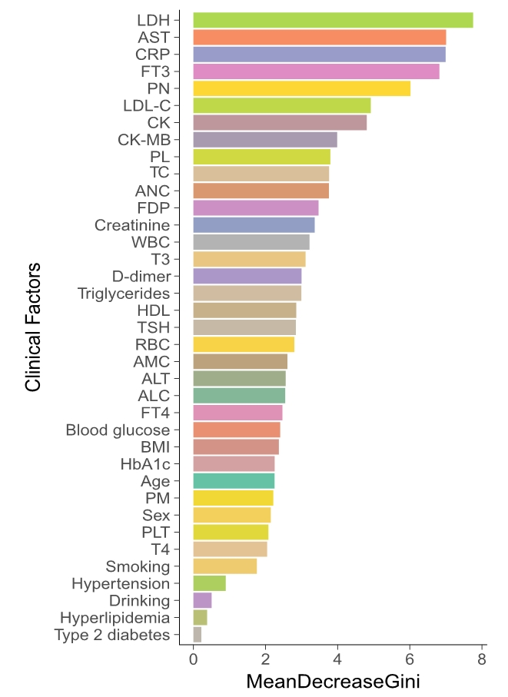
Figure S2 Gini coefficients of clinical indexes
Bar plot illustrating the top clinical indexes that were found to be significantly associated with 190 samples. The variations were derived from Gini coefficients.

Figure S3 Alpha diversity plot of 190 participants.
The X axis represented sequencing depth, the Y axis represented the number of observed otus. Different color represented different participants.

Figure S4 Beta diversity plot of CAD subgroups.
Different color represented different group. PCoA analysis has performed by QIIME2 plugin²⁰.

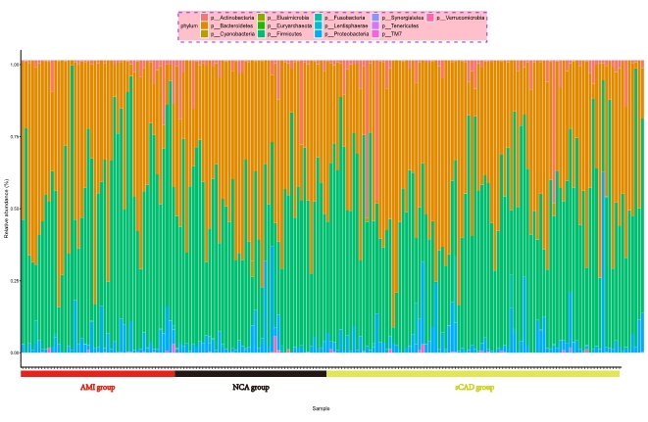
Figure S5 Taxonomy relative abundance of 190 samples in phylum level
Stacked bar chart of the phylum-level classification of gut microbiota by relative abundance. Vertical bars represent individual samples.

