Supplementary Materials for
Enhanced Antibacterial Properties of Lyotropic Liquid Crystalline Nanoparticles via Curvature Modulation
Xiangfeng Lai¹, Anton P. Le Brun², Chenguang Ding³, Hsien-Yi Hsu⁴, Yajun Wang⁵, Anton Y. Peleg⁶*， and Hsin-Hui Shen^{1,7}*
¹Department of Materials Science and Engineering, Faculty of Engineering, Monash University, Melbourne, Victoria 3800, Australia
²Australian Centre for Neutron Scattering, Australian Nuclear Science and Technology Organisation, Locked Bag 2001, Kirrawee DC, New South Wales 2232, Australia
³Department of Kidney Transplantation, Nephropathy Hospital, The First Affiliated Hospital of Xi'an Jiaotong University, Xi'an, Shaanxi, 710061, PR China; Institute of Organ Transplantation, Xi'an Jiaotong University, Xi'an, 710061, China
⁴School of Energy and Environment & Department of Materials Science and Engineering & Centre for Functional Photonics (CFP), City University of Hong Kong, Kowloon Tong, Hong Kong, China.; Shenzhen Research Institute of City University of Hong Kong, Shenzhen 518057, China.
⁵College of Chemistry & Materials Engineering, Wenzhou University, Wenzhou 325027, Zhejiang, China
⁶Department of Microbiology, Monash University, Melbourne, Victoria 3800, Australia
⁷Biomedicine Discovery Institute and Department of Biochemistry and Molecular Biology, Monash University, Melbourne, Victoria 3800, Australia
*E-mail: Anton.Peleg@monash.edu, Hsin-Hui.Shen@monash.edu
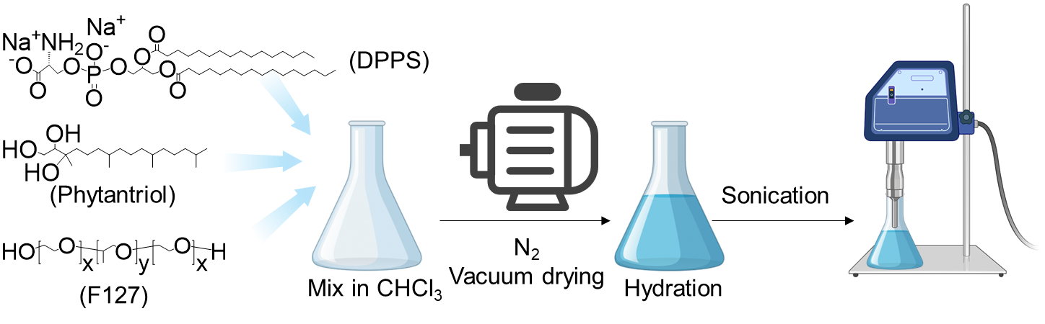
Fig. 1. Formulation process. LCNPs were formulated by a top-down process involving lipid mixing, N₂/vacuum drying, water hydration and tip sonication.

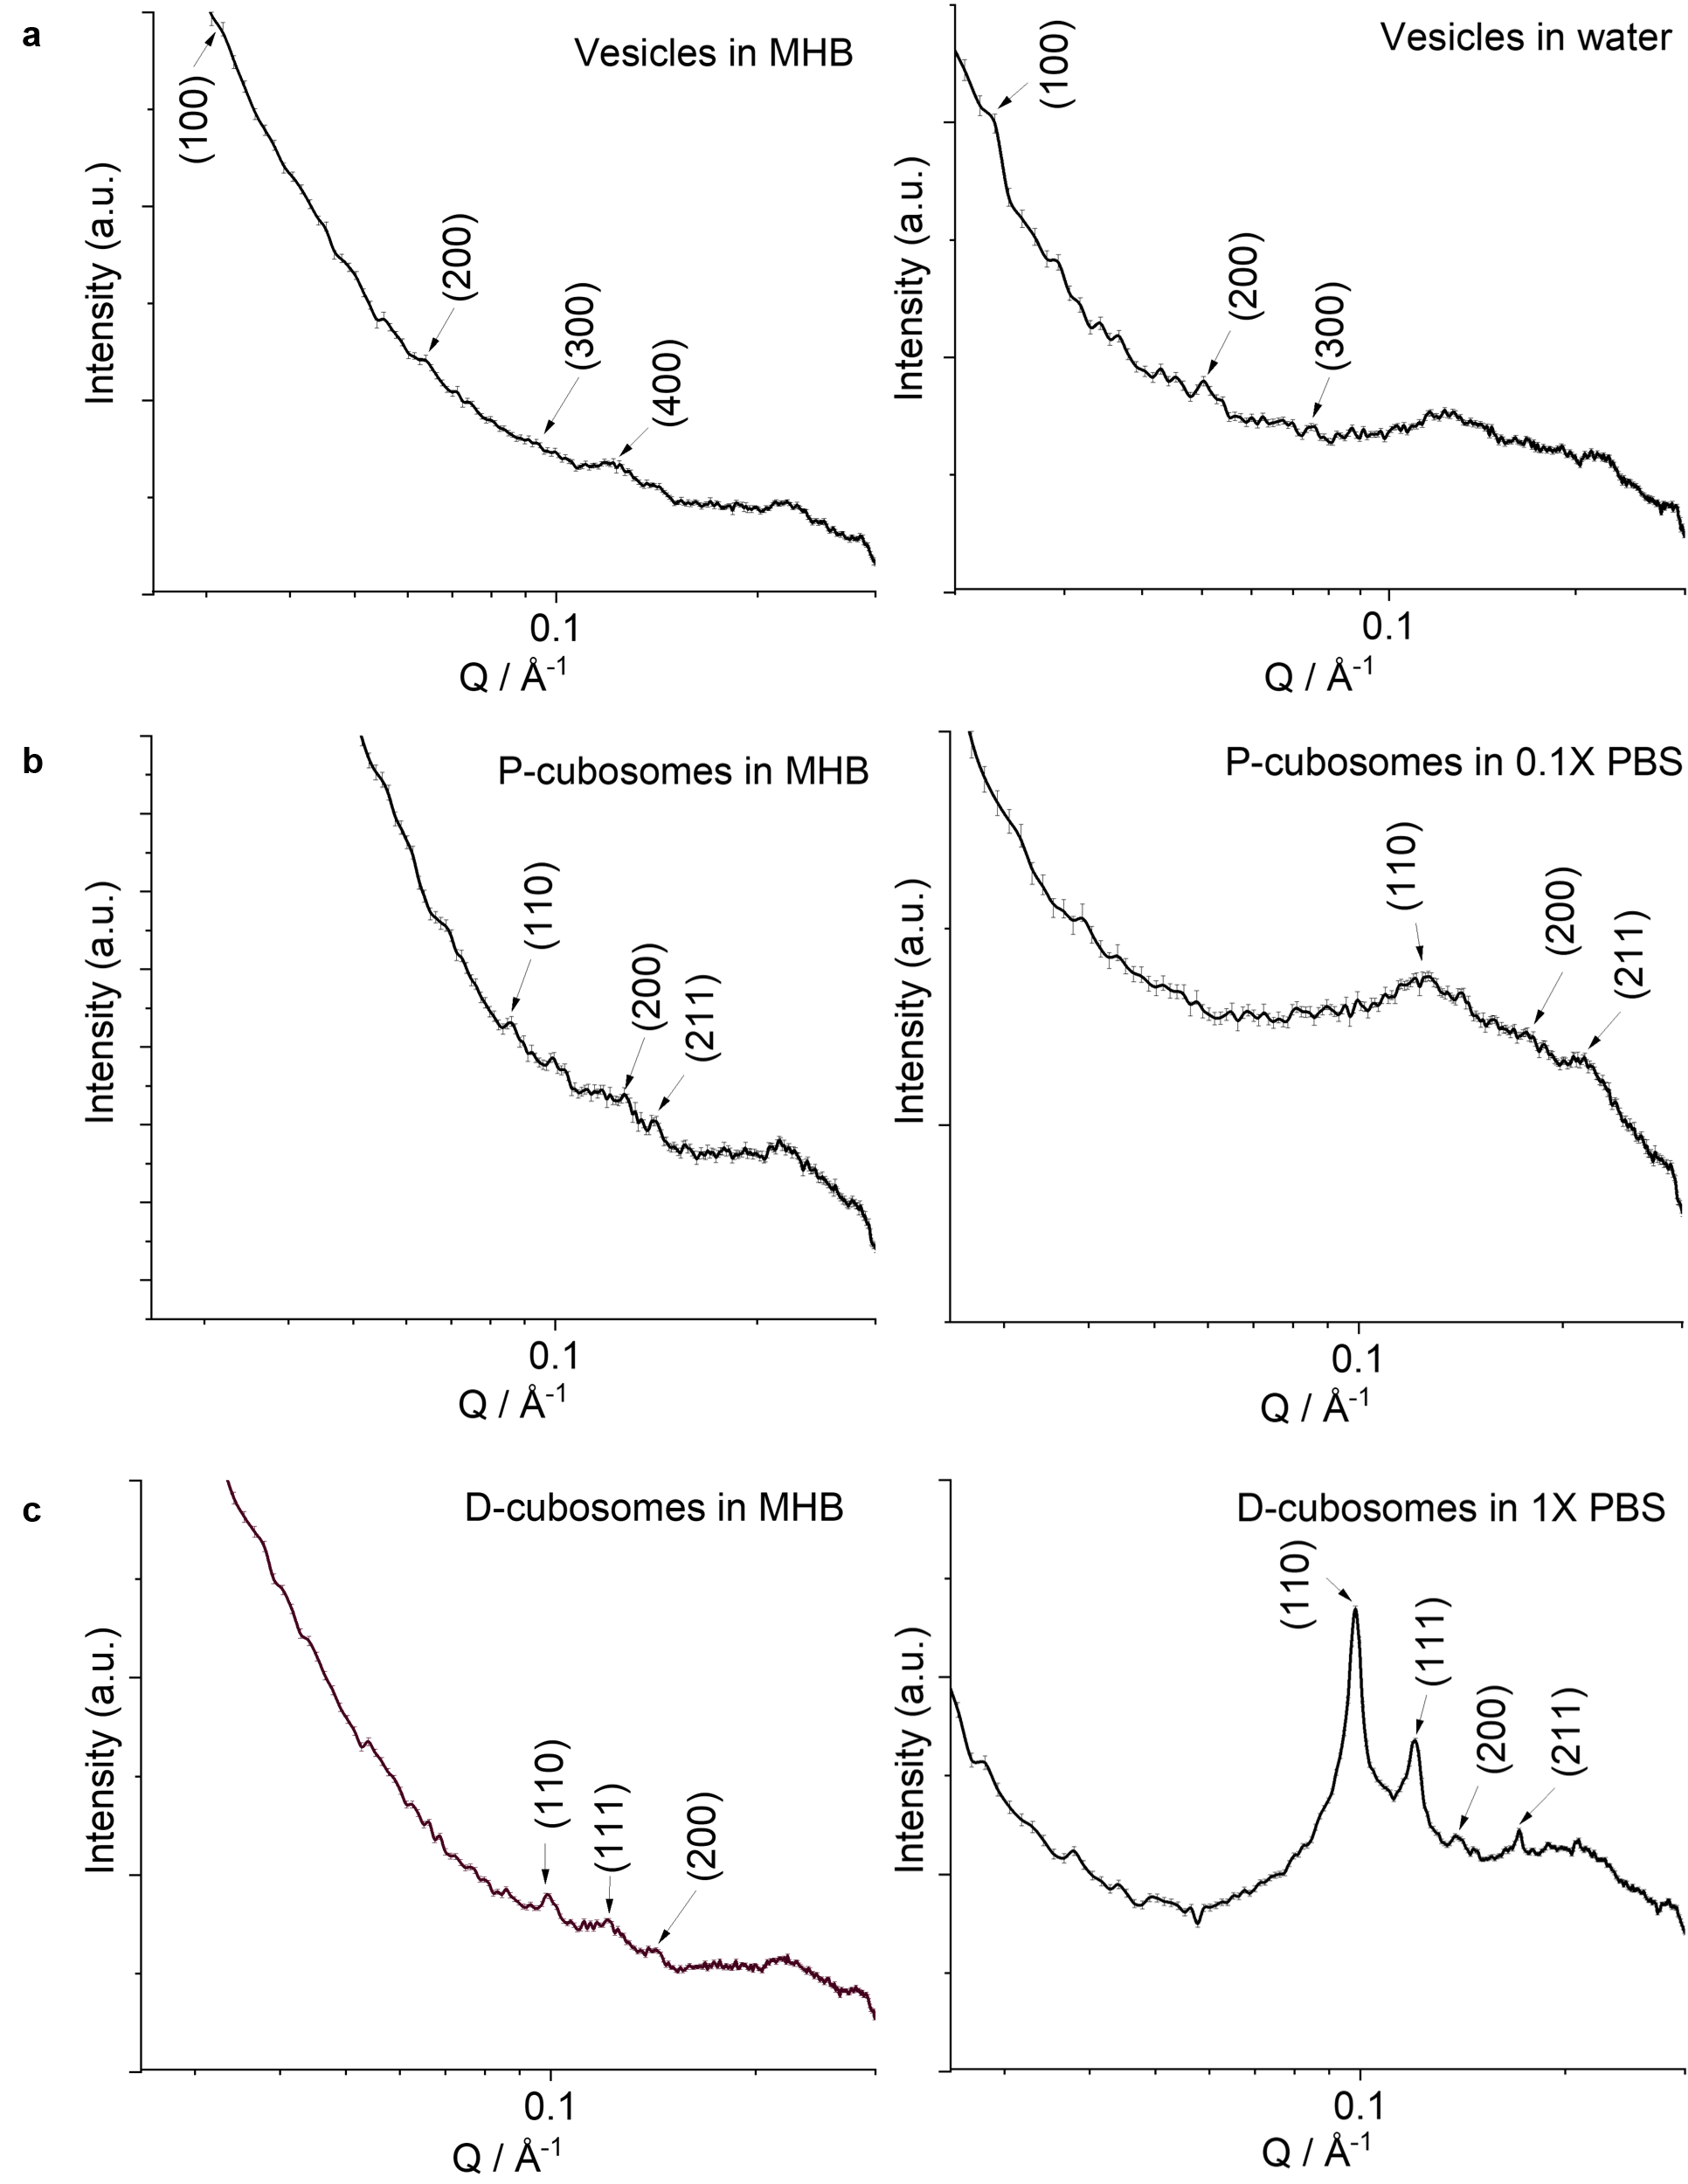
Fig. 2. 1D BioSAXS diffraction patterns. a Vesicles in Mueller Hinton Broth (MHB) media and water, b P-cubosomes in MHB and 0.1X PBS, and c D-cubosomes in MHB and 1X PBS, after incubation at 37 ºC for 72h, measured at room temperature 25 ºC, n = 10.
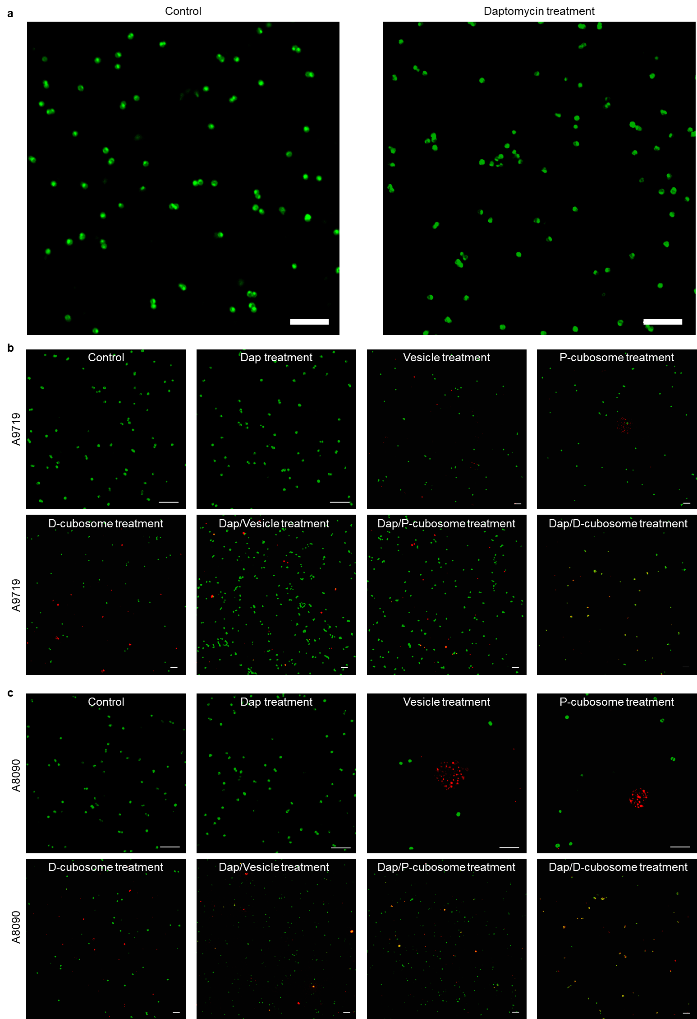
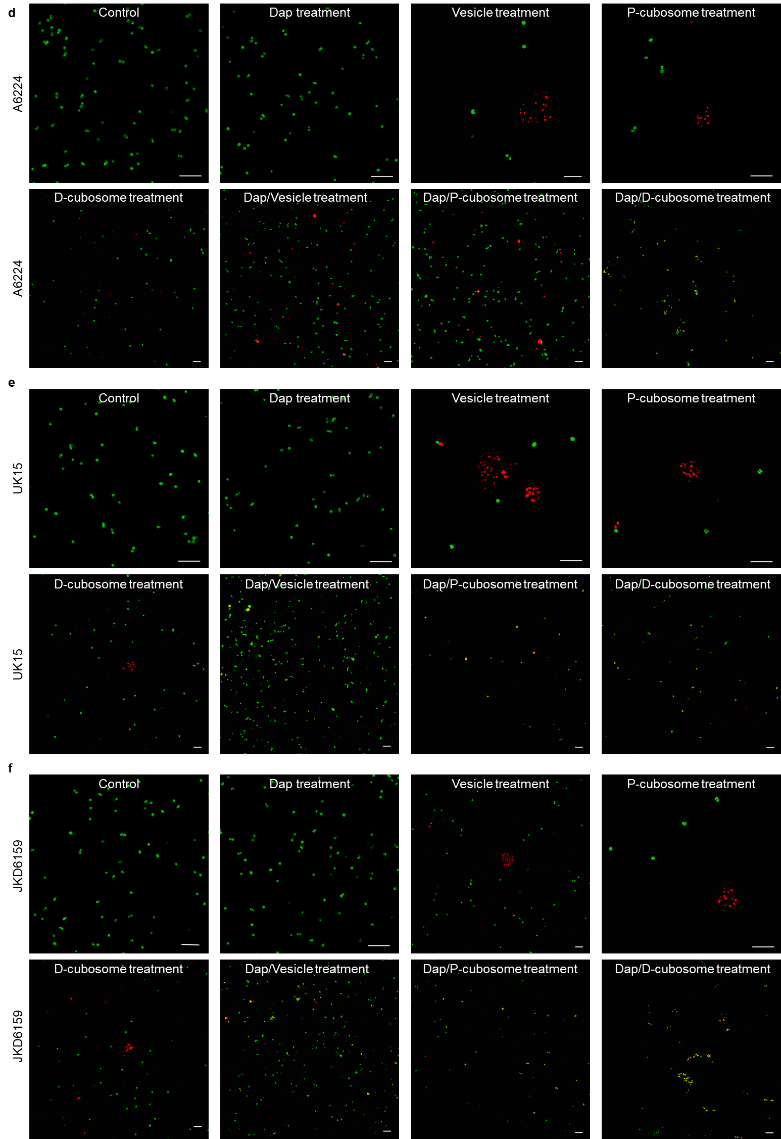
Fig. 3. LCNP – membrane interaction study. Fluorescence microscopy images of six MRSA strains (control) under different treatments. a A8819. b A9719. c A8090. d A6224. e UK15. f JKD6159. Scale bar: 5 µm. All images are representative of three independent experiments.

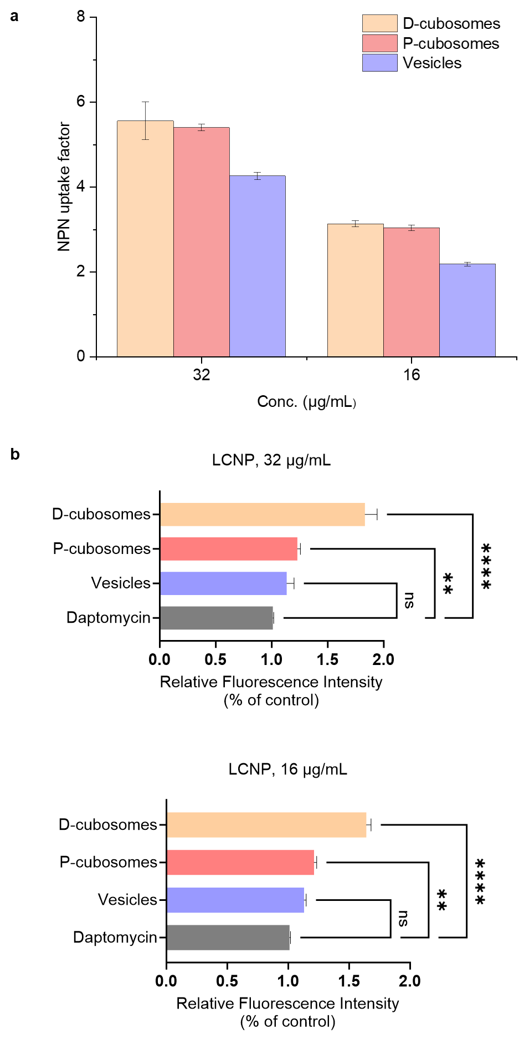
Fig.4. Interaction of LCNPs alone with MRSA A8819 membrane. a MRSA A8819 membrane permeabilization as measured with 1-N-phenylnaphthylamine (NPN) fluorescence emission (Ex/Em: 340 nm/ 405 nm). Data points represent mean ± SD (n = 3). b The relative fluorescence intensity (n = 3) generated at 24h under different treatments in 2',7'-dichlorofluorescin diacetate-stained MRSA A8819. Daptomycin (Dap, 0.25 ug/mL), LCNPs: 16-32 ug/mL. Error bars represent the mean ± sd. ****p < 0.0001 compared with daptomycin, one-way ANOVA.

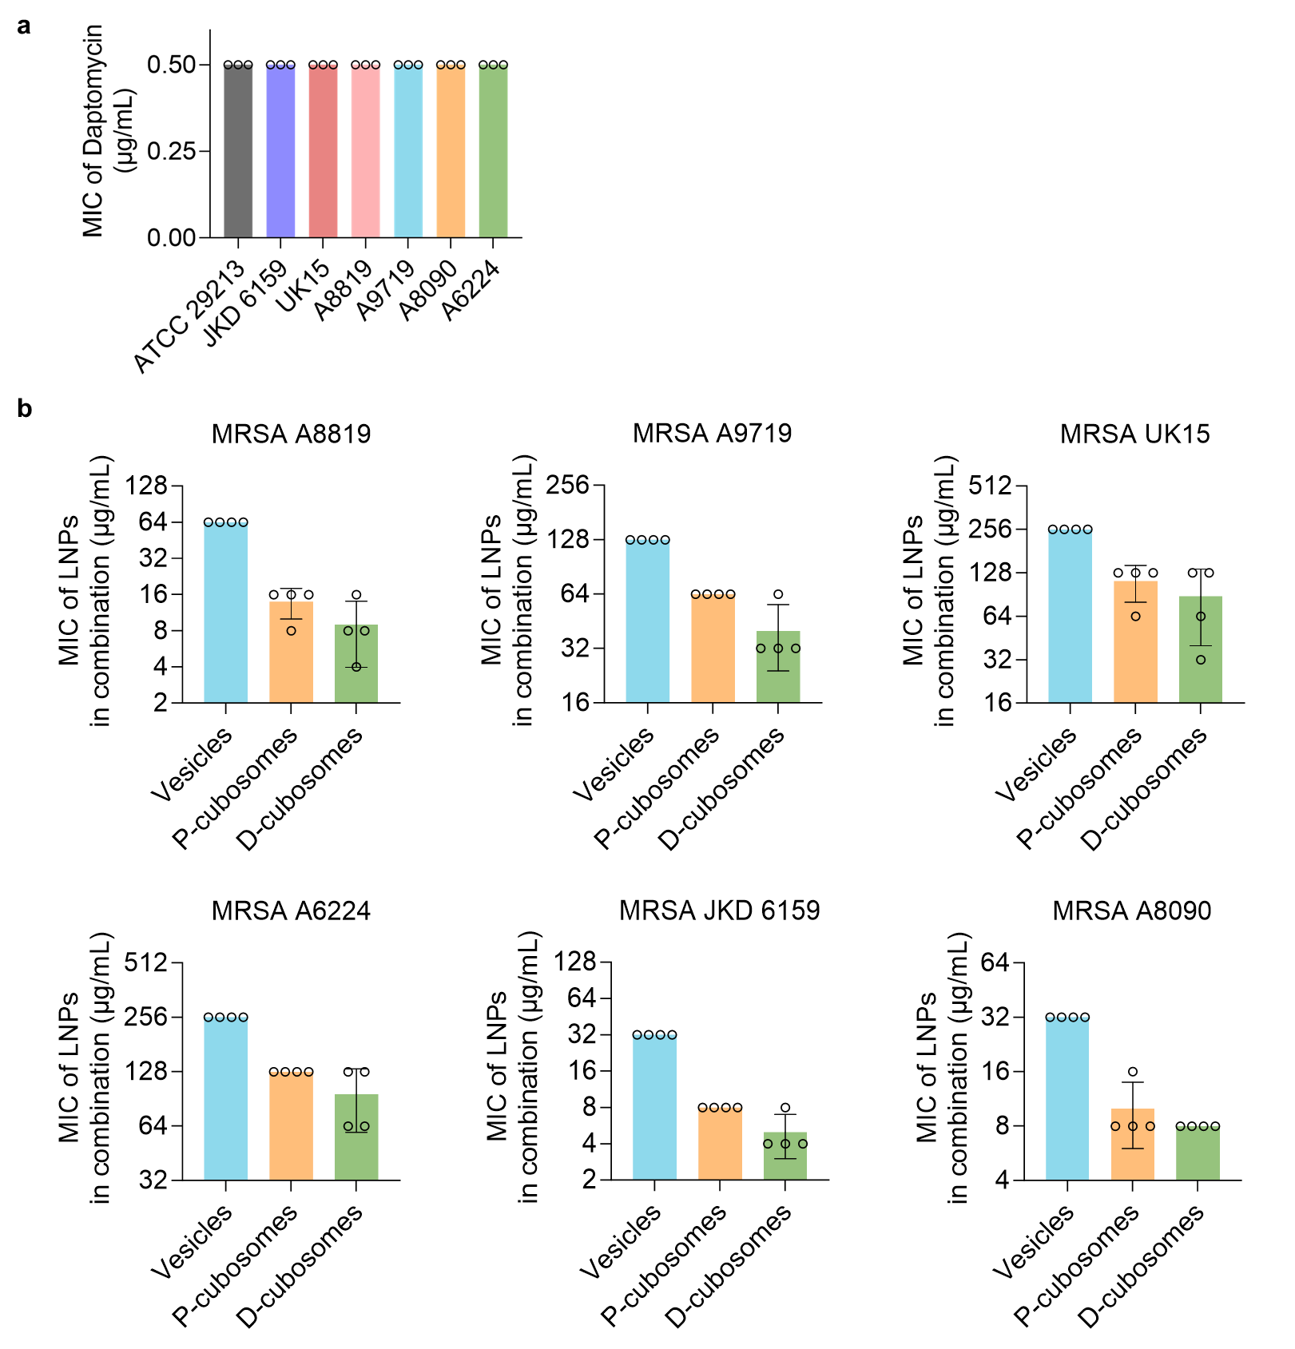
Fig. 5. Antimicrobial activity assay. a The minimum inhibitory concentration (MIC) of daptomycin alone against six MRSA strains (n=3). b MIC of diverse LCNPs against MRSA strains with daptomycin fixed at 0.25 µg/mL (n = 4). The control experiment revealed that 0.1X PBS 1X PBS did not affect the bacterial growth. All values are presented as mean ± s.d.
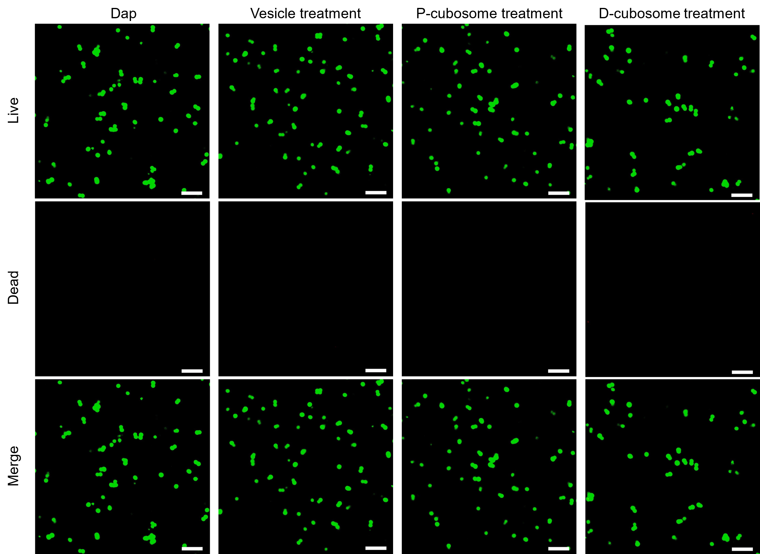
Fig. 6. Representative fluorescent microscopy images. Live/dead staining of MRSA A8819 with treatments of Daptomycin (Dap), vesicles, P-cubosomes and D-cubosomes. Scale bars, 5 μm.

Fig. 7. Analysis of relative viability of S. aureus suspensions in a fluorescence microplate reader. The integrated intensities of the green (530 ± 30 nm) and red (640 ± 30 nm) emission of suspensions excited at 480 ± 30 nm were acquired, and the green/red fluorescence ratios were calculated for each proportion of live/dead S. aureus. Each point represents the mean of three measurements. The line is a least-squares fit of the relationship between % live bacteria (x) and green/red ratio (y).
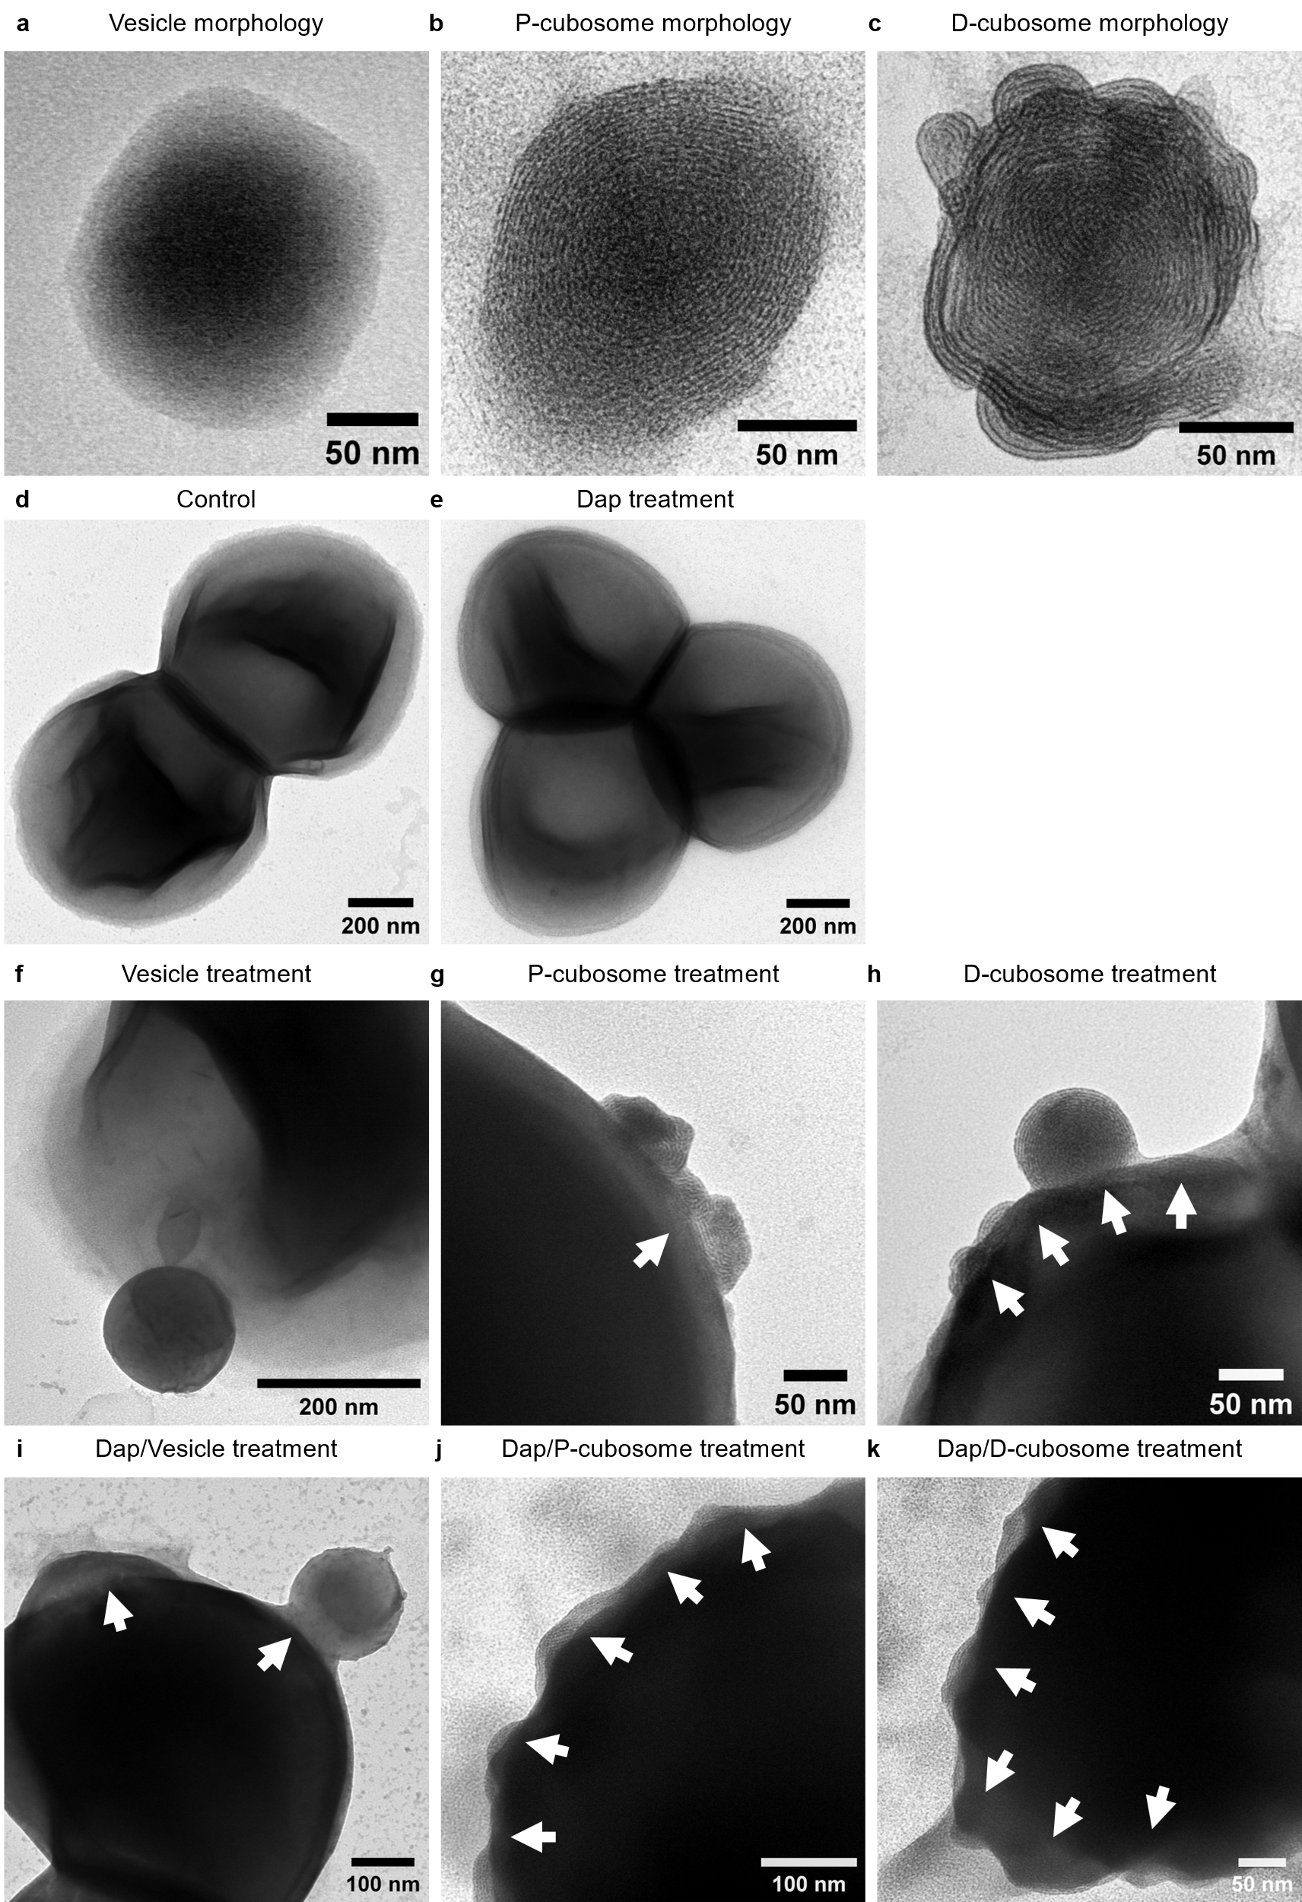
Fig. 8. TEM images of a Vesicles, b P-cubosomes, c D-cubosomes, d MRSA A8819 control and e MRSA A8819 treated with daptomycin (Dap). The enlarged TEM images for monotherapies of f vesicles, g P-cubosomes and h D-cubosomes. The enlarged TEM images for polytherapy of daptomycin with i vesicles, j P-cubosomes and k D-cubosomes. Regions of interest are indicated by white arrows. All images are representative of three independent experiments.

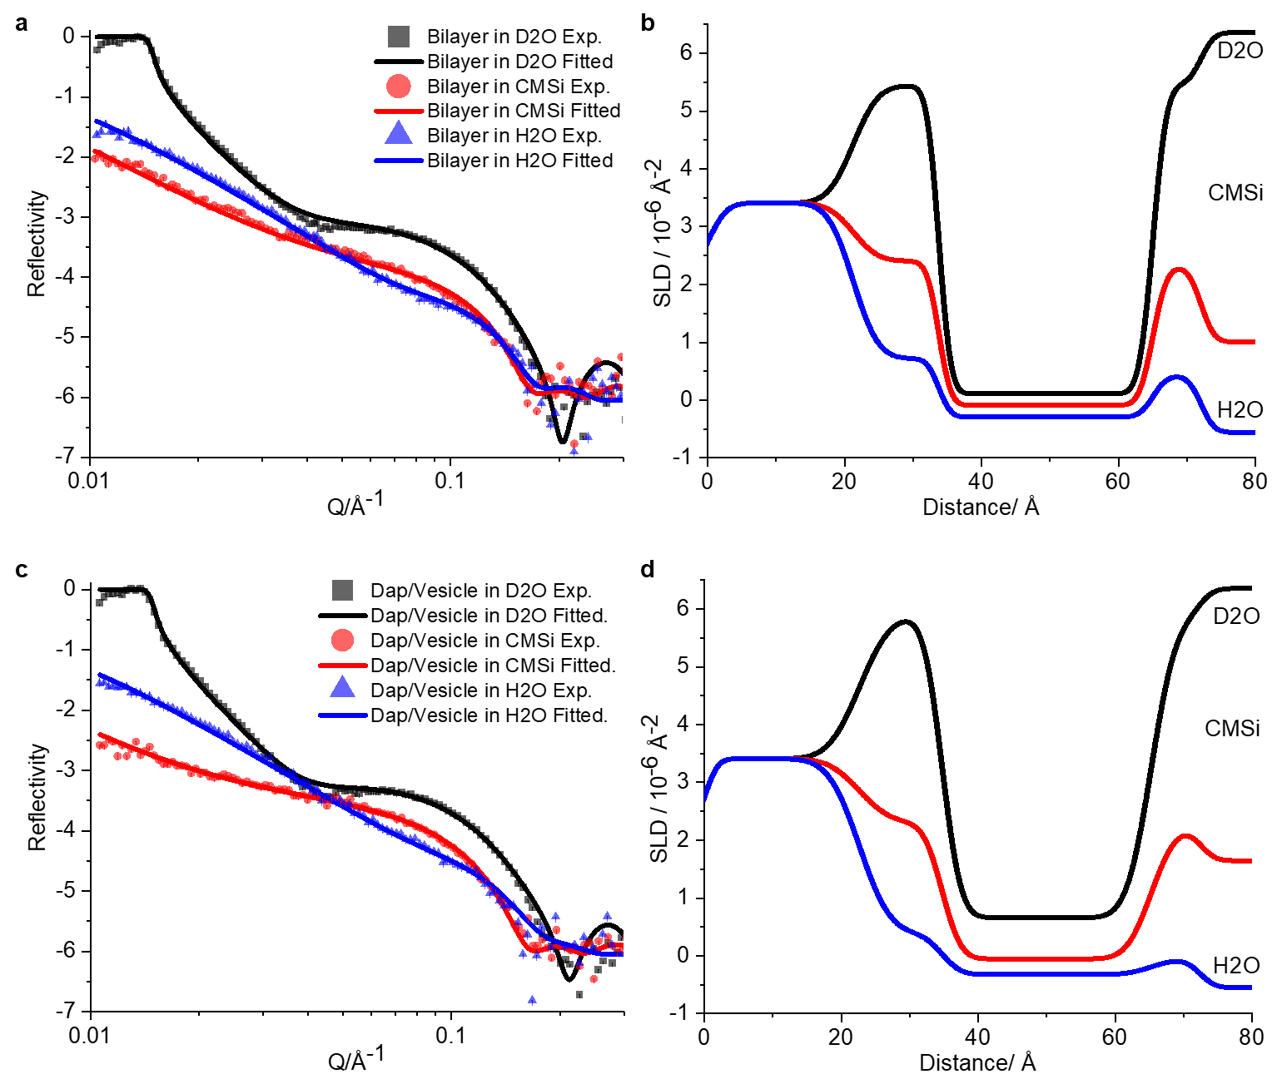
Fig. 9. Neutron reflectometry profiles for model Gram-positive bacterial membrane treated with daptomycin (Dap)/Vesicles. a Experimental (symbols) and fitted (lines) profiles of the model Gram-positive bacterial membrane bilayer. b Corresponding scattering length density (SLD) profiles of (a). c Reflectivity profiles after introducing daptomycin/Vesicles (2/ 64 µg/mL). d Corresponding scattering length density (SLD) profiles of (c). Error bars for experimental data points are the standard deviation of the number of counts. All data are expressed as median ± s.d. (indicated by error bars), based on values obtained from three isotopic contrasts, i.e., D₂O, CMSi (contrast-matched silicon) and H₂O.

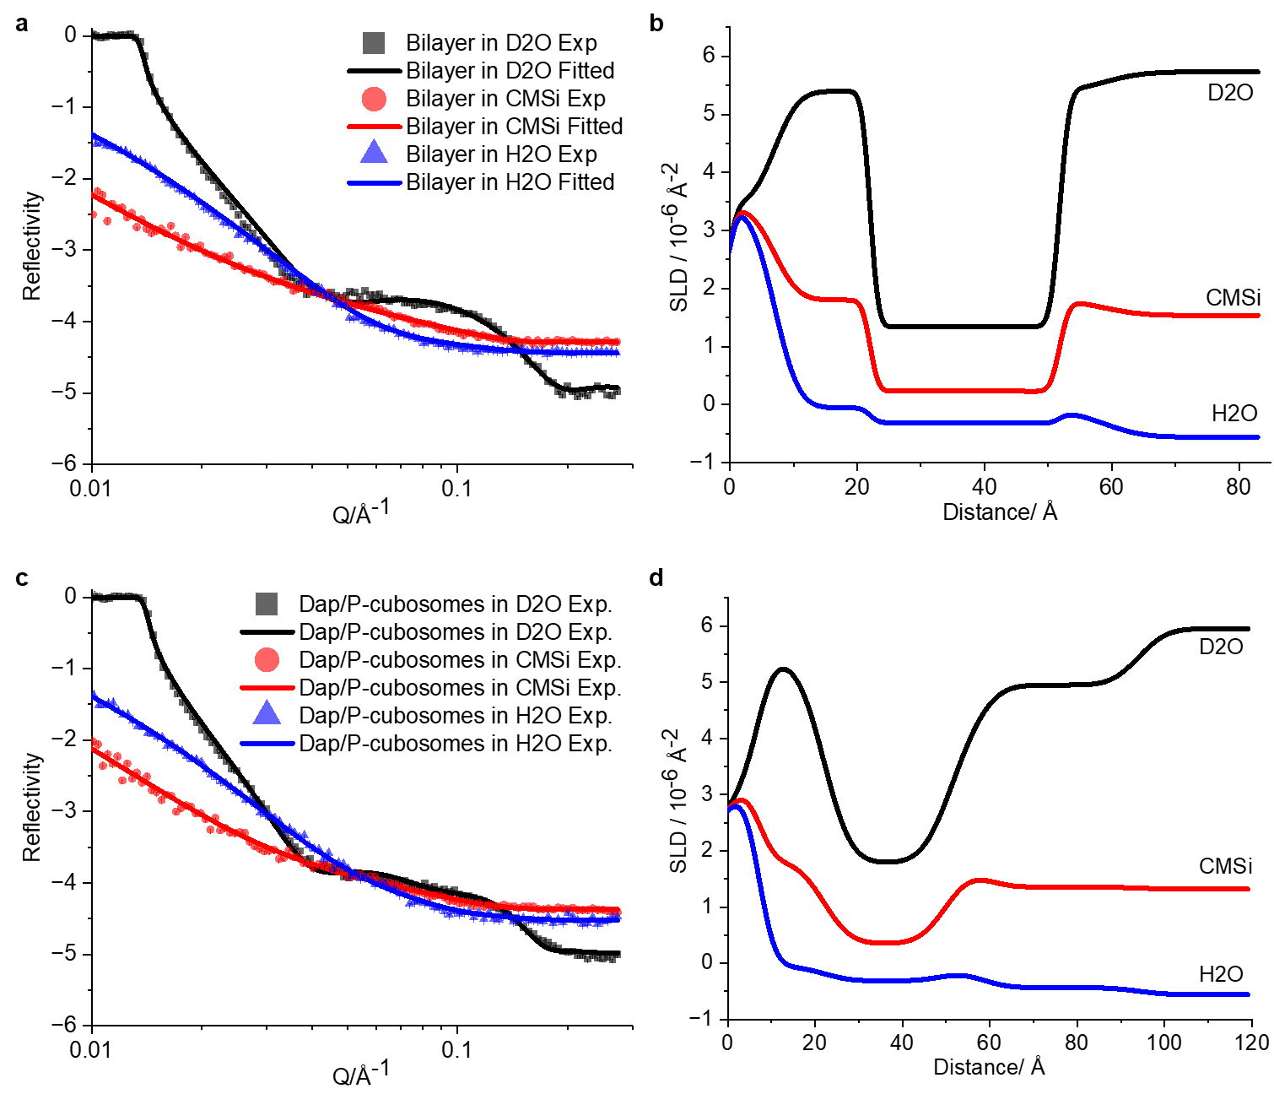
Fig. 10. Neutron reflectometry profiles for model Gram-positive bacterial membrane treated with daptomycin (Dap)/P-cubosomes. a Experimental (symbols) and fitted (lines) profiles of the model Gram-positive bacterial membrane bilayer. b Corresponding scattering length density (SLD) profiles of (a). c Reflectivity profiles after introducing daptomycin/P-cubosomes (2/ 64 µg/mL). d Corresponding scattering length density (SLD) profiles of (c). Error bars for experimental data points are the standard deviation of the number of counts. All data are expressed as median ± s.d. (indicated by error bars), based on values obtained from three isotopic contrasts, i.e., D₂O, CMSi (contrast-matched silicon) and H₂O.

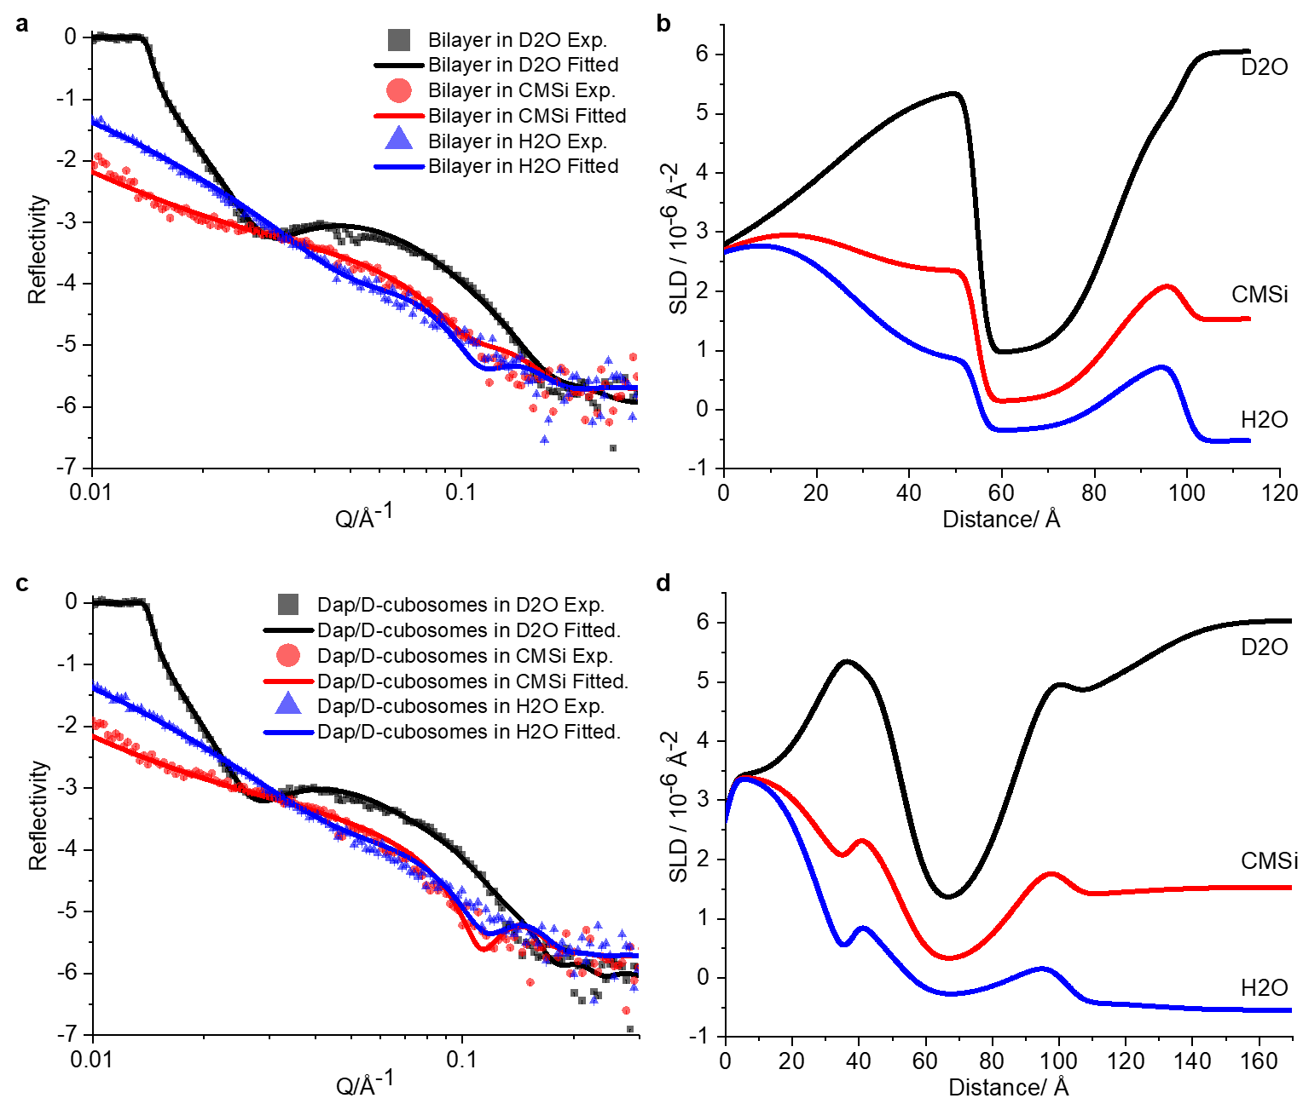
Fig. 11. Neutron reflectometry profiles for model Gram-positive bacterial membrane treated with daptomycin (Dap)/D-cubosomes. a Experimental (symbols) and fitted (lines) profiles of the model Gram-positive bacterial membrane bilayer. b Corresponding scattering length density (SLD) profiles of (a). c Reflectivity profiles after introducing daptomycin/D-cubosomes (2/ 64 µg/mL). d Corresponding scattering length density (SLD) profiles of (c). Error bars for experimental data points are the standard deviation of the number of counts. All data are expressed as median ± s.d. (indicated by error bars), based on values obtained from three isotopic contrasts, i.e., D₂O, CMSi (contrast-matched silicon) and H₂O.

Table 1. Small angle X-ray scattering (SAXS). Phase properties of 15 wt% DPPS LCNP dispersed in 0.1 X PBS and 1 X PBS buffer.
Nanoparticles | 15 wt% DPPS | 15 wt% in 0.1X PBS | 15 wt% in 1X PBS
Space group | L_{α} | Q_{Ⅱ}^{P} (Im3m) | Q_{Ⅱ}^{D} (Pn3m)
Unit cell parameter (a, nm) | 24.22 ± 0.14 | 12.71 ± 0.04 | 8.03 ± 0.02
Surface-averaged Gaussian curvature (K, nm⁻²) | 0¹ | -0.0663 ± 0.0004 | -0.1016 ± 0.0004
The unit cell parameter 'a' was calculated using the formula: $a=d_{hkl}\sqrt{(h^{2}+k^{2}+l^{2})}$, where the lattice spacing d_{hkl} = 2π/Q, h, k, and l are miller indices. The Gauss-Bonnet theorem establishes a relationship between the surfaced-averaged value of the Gaussian curvature (K) at the center of the bilayer and the lattice parameter via $K=\frac{2πχ}{σ_{0}a^{2}}$, where σ₀ is the normalized surface to volume ratio and χ represents the interfacial topology (σ₀ = 1.919 and χ =−2 for Pn3m structure; σ₀ = 2.345 and χ = −4 for Im3m structure)²⁻⁴. The surface-average Gaussian curvature (K) can be linked to the packing properties of lipid aggregates and the transformations between particles can be quantitatively described⁵: K = [3/(2l_{c}²)] * (1 - P), where P = ν / (a₀ · l_{c}) serves as a dimensionless metric for predicting lipid aggregate morphology⁶, v represents the molecular volume of the fluid hydrocarbon chain(s), a₀ denotes the interfacial area per molecule at the polar–non-polar interface, and l_{c} indicates the critical tail length.

Table 2. Neutron scattering length densities (SLD). Summary of the theoretical SLD of the substrate, lipid components, daptomycin and solution subphases used to fit neutron reflectometry data.
Materials | SLD (× 10⁻⁶ Å⁻²)
Materials | D₂Oª | CMSi^{b} | H₂O^{c}
Si | 2.07 | 2.07 | 2.07
SiO₂ | 3.41 | 3.41 | 3.41
H₂O | - | - | -0.56
CMSi | - | 2.07 | -
D₂O | 6.35 | - | -
PG head | 3.59 | 3.09 | 2.78
CL head | 3.11 | 2.99 | 2.91
L-PG head | 3.78 | 2.69 | 2.02
PG, CL and L-PG tails | -0.28 | -0.28 | -0.28
Phytantriol | 0.37 | -0.10 | -0.39
DPPS head | 3.47 | 3.47 | 3.47
DPPS tail | -0.36 | -0.36 | -0.36
Daptomycin | 3.96 | 3.00 | 2.41
ªD₂O 100%; ^{b}D₂O/H₂O (38/62, v/v), contrast matched the silicon substrate (CMSi); ^{c}H₂O 100%. PG, 1-palmitoyl-2-oleoyl-sn-glycero-3-phospho-(1'-rac-glycerol) (sodium salt). CL, 1',3'-bis[1,2-dioleoyl-sn-glycero-3-phospho]-glycerol (sodium salt). L-PG, 1,2-dioleoyl-sn-glycero-3-[phospho-rac-(3-lysyl(1-glycerol))] (chloride salt). DPPS, 1,2-dipalmitoyl-sn-glycero-3-phospho-L-serine (sodium salt).

Table 3. Fitted parameters for model Gram-positive bacterial membrane bilayer treated with daptomycin (Dap)/Vesicles.
Sublayer | Thickness/Å | V_{lipid}ª /% | V_{Dap/Vesicles}ª /% | V_{hydration}ª /%
Inner head | 12.5±0.2 | 36.2±3.8 | - | 63.8±3.8
Tail | 31.3±0.1 | 93.2±0.9 | - | 6.8±0.9
Outer head | 7.0±0.1 | 29.0±3.6 | - | 71.0±3.6
Daptomycin/Vesicles, 2/ 64 µg/mL
Inner head | 12.1±0.1 | 23.6±6.5 | - | 76.4±6.5
Tail | 30.6±0.2 | 86.8±2.0^{b} |  | 13.3±4.1
Outer head | 7.1±0.2 | 17.1±1.2 | - | 82.9±1.2
ªVolume fraction, to represent membrane integrity. All data are expressed as median ± s.d., based on values obtained from three isotopic contrasts fitted simultaneously using Monte Carlo analysis. ^{b}The relative volume fractions of the lipids and Dap/Vesicles in the headgroup and tail structures were not able to be determined owing to the minimal isotopic contrast (Supplementary Table 2).

Table 4. Fitted parameters for model Gram-positive bacterial membrane bilayer treated with daptomycin (Dap)/P-cubosomes.
Sublayer | Thickness/Å | V_{lipid}ª /% | V_{Dap/P-cubosomes} ª /% | V_{hydration}ª /%
Inner head | 14.9±0.1 | 15.7±1.1 | - | 84.3±1.1
Tail | 29.6±0.2 | 76.8±2.8 | - | 23.2±2.8
Outer head | 7.1±0.2 | 14.8±0.2 | - | 85.2±0.2
Daptomycin/P-cubosomes, 2/ 64 µg/mL
Inner head | 14.9±0.1 | 15.7±1.1 | - | 84.3±1.1
Tail | 28.4±0.4 | 67.3±1.2 | - | 32.7±1.2
Outer head | 7.5±0.6 | 27.5±9.3^{b} |  | 72.5±9.5
P-cubosomes | 35.7±0.9 | - | 18.7±4.5 | 81.3±4.5
ªVolume fraction, to represent membrane integrity. All data are expressed as median ± s.d., based on values obtained from three isotopic contrasts fitted simultaneously using Monte Carlo analysis. ^{b}The relative volume fractions of the lipids and Dap/P-cubosomes in the headgroup and tail structures were not able to be determined owing to the minimal isotopic contrast (Supplementary Table 2).

Table 5. Fitted parameters for model Gram-positive bacterial membrane bilayer treated with daptomycin (Dap)/D-cubosomes.
Sublayer | Thickness/Å | V_{lipid}ª /% | V_{Dap/D-cubosomes} ª /% | V_{hydration}ª /%
Inner head | 14.7±0.3 | 46.9±6.1 | - | 53.1±6.1
Tail | 29.8±0.4 | 78.7±6.5 | - | 21.3±6.5
Outer head | 14.8±0.2 | 54.3±6.7 | - | 45.7±6.7
Daptomycin/D-cubosomes, 2/ 64 µg/mL
Inner head | 14.7±0.3 | 54.1±5.0^{b} |  | 45.9±0.9
Tail | 34.7±0.3 | 70.8±5.8^{b} |  | 29.2±4.9
Outer head | 14.7±0.4 | 65.7±4.1^{b} |  | 34.3±1.2
D-cubosomes | 24.7±0.5 | - | 17.0±1.4 | 83.0±1.4
ªVolume fraction, to represent membrane integrity. All data are expressed as median ± s.d., based on values obtained from three isotopic contrasts fitted simultaneously using Monte Carlo analysis. ^{b}The relative volume fractions of the lipids and Dap/D-cubosomes in the headgroup and tail structures were not able to be determined owing to the minimal isotopic contrast (Supplementary Table 2).

References
1 Gruner, S. M. Stability of lyotropic phases with curved interfaces. The Journal of Physical Chemistry 93, 7562-7570 (1989).
2 Salim, M., Wan Iskandar, W. F. N., Patrick, M., Zahid, N. I. & Hashim, R. Swelling of Bicontinuous Cubic Phases in Guerbet Glycolipid: Effects of Additives. Langmuir 32, 5552-5561, doi:10.1021/acs.langmuir.6b01007 (2016).
3 Templer, R. et al. Inverse bicontinuous cubic phases in 2: 1 fatty acid/phosphatidylcholine mixtures. The effects of chain length, hydration, and temperature. The Journal of Physical Chemistry B 102, 7251-7261 (1998).
4 Barois, P., Eidam, D. & Hyde, S. X-ray study of cubic phases in ternary systems of surfactant DDAB, water and oil. Le Journal de Physique Colloques 51, C7-25-C27-34 (1990).
5 Tyler, A. I. et al. Electrostatic swelling of bicontinuous cubic lipid phases. Soft Matter 11, 3279-3286, doi:10.1039/c5sm00311c (2015).
6 Khalil, R. A. & Zarari, A.-h. A. Theoretical estimation of the critical packing parameter of amphiphilic self-assembled aggregates. Applied Surface Science 318, 85-89, doi:10.1016/j.apsusc.2014.01.046 (2014).

