Supplementary Figure 1
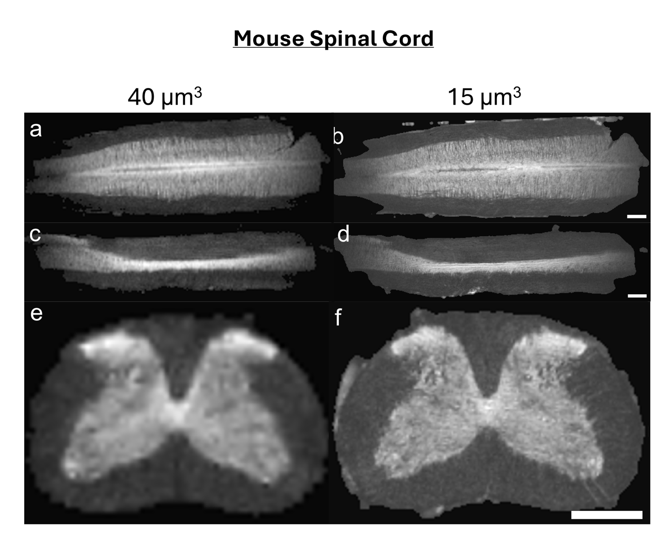
Supplementary Figure 1 | Comparison of mouse spinal cord at 40 μm³ and 15 μm³ resolutions. (a,b) Comparison of coronal slices. (c,d) Comparison of sagittal slices. (e,f) Comparison of transverse slices. The spinal cord microstructures, as discussed in Section 1.2.1 of Results, are more clearly resolved at a resolution of 15 μm³ compared to 40 μm³. The scale bars represent 500 μm.

Supplementary Figure 2
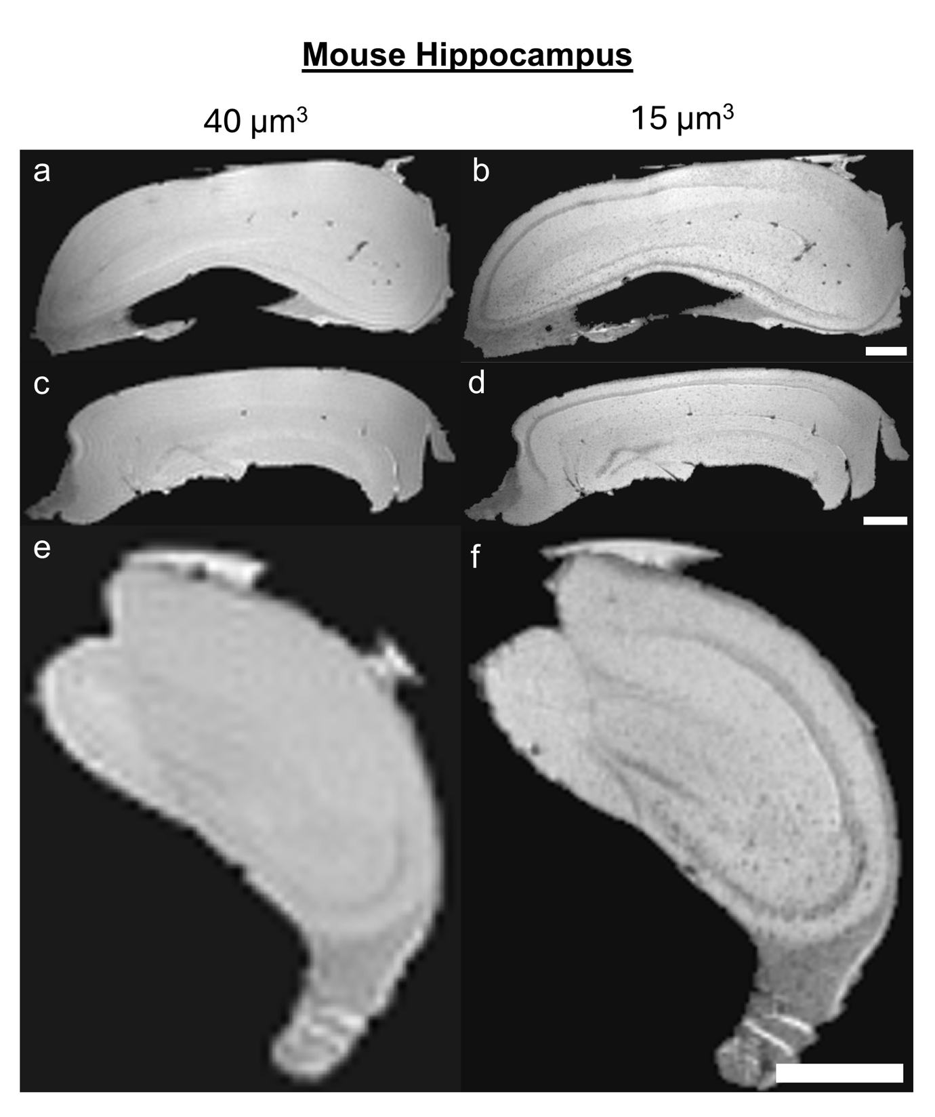
Supplementary Figure 2 | Comparison of mouse hippocampus at 40 μm³ and 15 μm³ resolutions. (a,b) Comparison of coronal slices, respectively. (c,d) Comparison of sagittal slices. (e,f) Comparison of transverse slices. The hippocampal microstructures, as discussed in Section 1.2.2 of Results, are more clearly resolved at a resolution of 15 μm³ compared to 40 μm³. The scale bars represent 500 μm.

Supplementary Figure 3
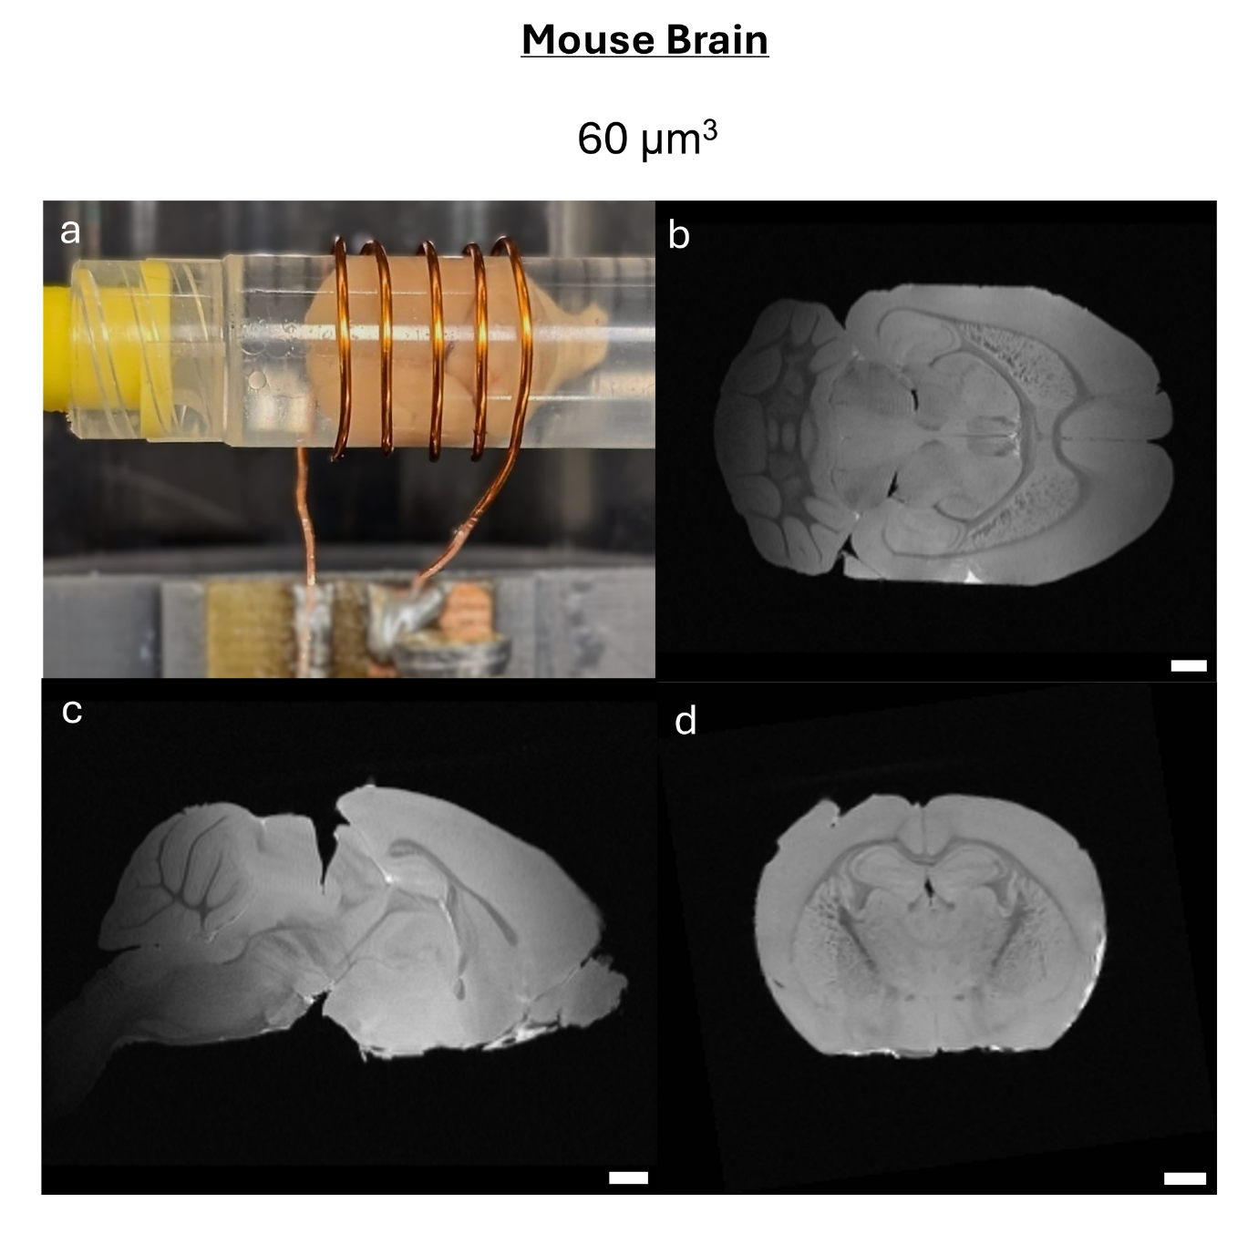
Supplementary Figure 3 | MR microscopy of an excised mouse brain using the micro-imaging probe using 10 mm diameter solenoid. (a) A 5-turn 10 mm diameter solenoid soldered to the probe. (b) Coronal slice of the brain. (c) Sagittal slice of the brain. (d) Axial slice of the brain. A 3D FLASH sequence was used to acquire images at a spatial resolution of 60 μm³ with an SNR of 68. Imaging parameters were as follows: flip angle = 47.9°, repetition time (TR) = 100 ms, echo time (TE) = 3.56 ms, number of repetitions = 6, image matrix = 268×200×200, field of view (FOV) = 16×12×12 mm³, resolution = 60×60×60 μm³, receiver bandwidth = 65,789 Hz, and scan time = 6 hours and 40 minutes. The scale bars represent 1000 μm.

Supplementary Figure 4
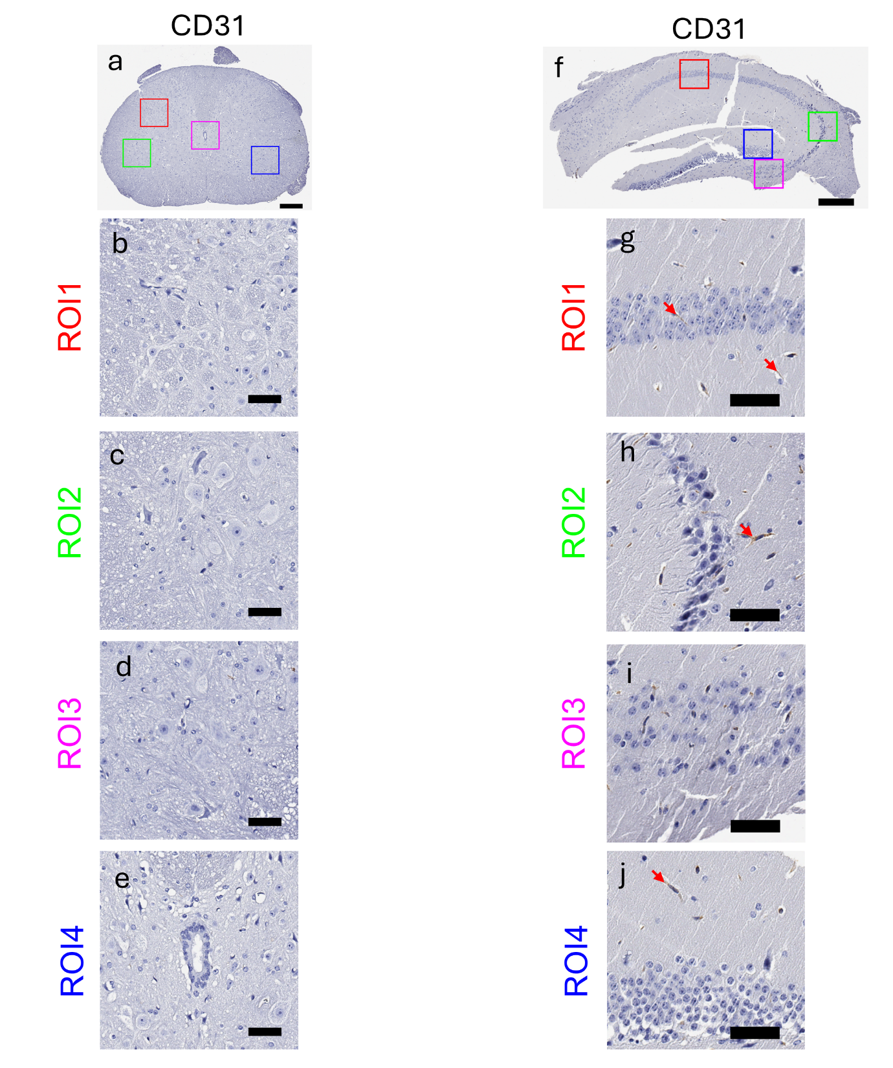
Supplementary Figure 4 | CD31 stain of the spinal cord and hippocampus tissue. (a) CD31 stain of a transverse section of the spinal cord with four regions of interest (ROIs) highlighted in different colors. (b) ROI 1 (red) covers the intermediate zone and dorsal horn of the spinal cord. (c) ROI 2 (green) corresponds to the left ventral horn region. (d) ROI 3 (blue) corresponds to the right ventral horn region. (e) ROI 4 (magenta) represents the central canal region of the spinal cord. (f) CD31 stain of a transverse section of the hippocampus with four regions of interest (ROIs) highlighted in different colors. (b) ROI 1 (red) covers the CA1 cellular layer. (c) ROI 2 (green) corresponds to the CA2 cellular layer. (d) ROI 3 (blue) corresponds to the CA3 cellular layer. (e) ROI 4 (magenta) represents the granule cellular layer of the dentate gyrus. The red arrows in Fig. (f-j) represent the possible blood vessel. The scale bar in (a) and (f) represents 250 µm and the scale bar for stained ROI Fig. (b-e) and (g-j) represents 50 µm.

Supplementary table1
List of items used to build the Micro-imaging probe.

Supplementary video 1
The video file is attached separately.

Supplementary video 2
The video file is attached separately.

