6. Supplementary material
We modelled the drivers of burn severity within five Labor Day 2020 wildfire perimeters along a latitudinal gradient in the Western Cascades of Oregon state; from north to south, these included the Riverside (55,901 ha, 45.10 N), Beachie Creek (78,364 ha, 44.84 N), Lionshead (82,802 ha, 44.76, N), Holiday Farm (70,171 ha, 44.15 N), and Archie Creek (53,241 ha, 43.36 N) fires. During this period, an extreme pressure gradient fueled strong easterly winds, atypical for this time of the year, which descended over the Cascade crest as adiabatic effects warmed and dried the air and maintained fuel moisture at extreme lows with no nighttime recovery. Onshore air flow returned on Sept 10 and while fuel moisture remained low, winds subsided, and relative humidity recovered at night. Combined with an inverted temperature column that formed at low elevation, fire activity in the post-wind period was constrained to higher elevations. The first of the fall rains began on September 17th. The fires burned 334,500 hectares in total, with the vast majority (80%) of fire growth occurring during the ca. 72 hr. period between September 7th and 9th. Likewise, the proportion of the fire area that burned at high severity during the wind event was approximately three times that which occurred in the period that followed (65% vs 26%).
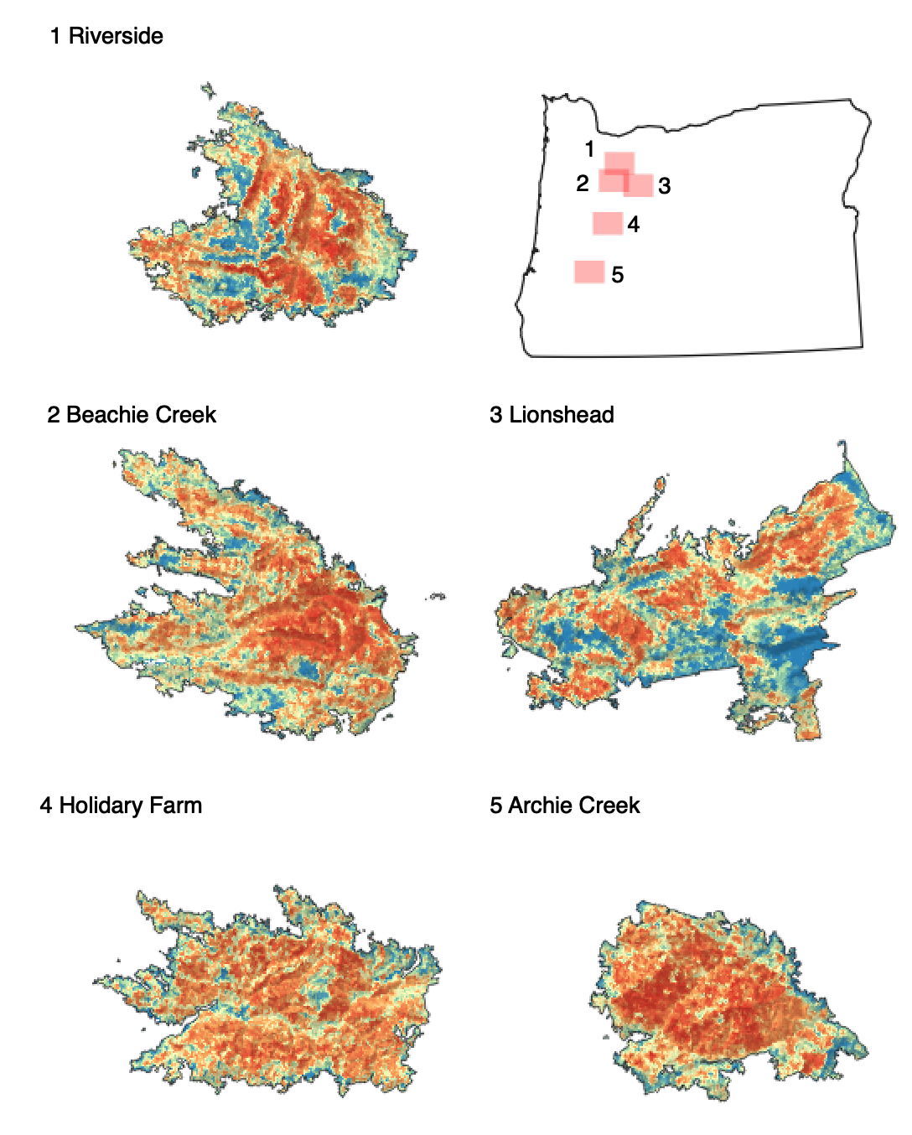
Figure S1. Geographic locations, perimeters, and continous burn severity estimates (dNBR; following histogram distribution from Fig. S2) of the five wildfires analyzed in this study within the western Cascades of Oregon state.

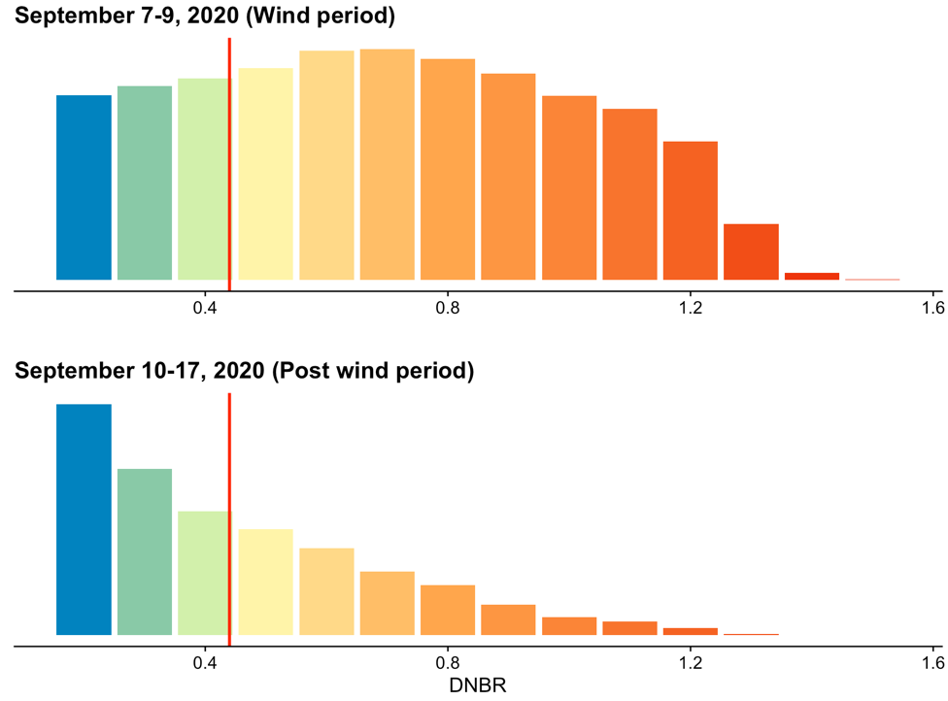
Figure S2. Histogram of DNBR values during the windstorm (top) and afterward (bottom). The threshold for classifying high severity (DNBR > 0.44) is shown as a vertical red line.

Figure S3. Observed vs expected differences in the proportion of forested area (hectares) burned at high severity between “short” and “tall” forest stands and the two burn weather periods. A 10m canopy height (CH) threshold was identified from previous analyses and used to separate the two height classes. Note the difference in the scale of the y-axis.

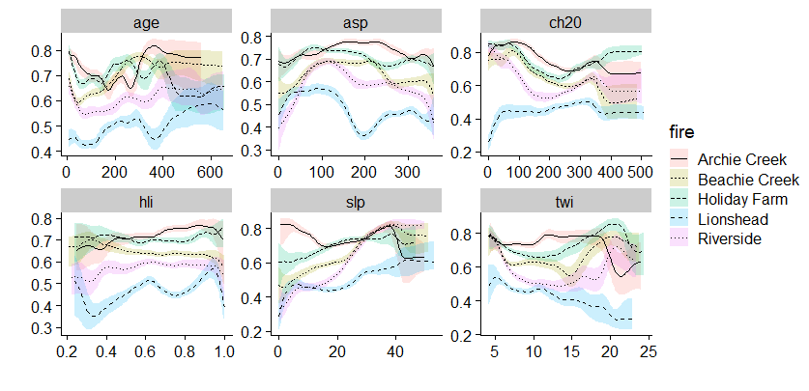
Figure S4. Partial dependence plots of most important variables by individual event (both periods combined).

Table S1. Percent of fire excluded from the analysis. Fires are listed latitudinally from S to N.
Row Labels | Hectares | Included | Excluded
Archie Creek | 53,125 | 97.8% | 2.2%
Holiday Farm | 69,594 | 96.9% | 3.1%
Beachie Creek | 77,474 | 95.6% | 4.4%
Lionshead | 79,591 | 51.6% | 48.4%
Riverside | 54,645 | 94.9% | 5.1%
Combined | 334,429 | 87.0% | 13.0%

Table S2. Area burned (ha) by fire (w/o excluded area). The totals presented here do not include areas burned during the Sept fires that did not meet the criteria detailed in the methods. Fires are listed latitudinally from S to N.
Row Labels | Hectares | Wind | Post Wind
Archie Creek | 52,104 | 87.3% | 12.7%
Holiday Farm | 68,002 | 89.3% | 10.7%
Beachie Creek | 74,908 | 97.6% | 2.4%
Lionshead | 42,767 | 84.5% | 15.5%
Riverside | 53,066 | 88.2% | 11.8%
Combined | 290,847 | 90.2% | 9.8%

Table S3. Percent high severity by burn period (w/o excluded area). The totals presented here do not include areas burned during the Sept fires that did not meet the criteria detailed in the methods. Fires are listed latitudinally from S to N.
Row Labels | Combined | Wind | Post Wind
Archie Creek | 72.1% | 79.5% | 21.0%
Holiday Farm | 68.5% | 72.9% | 32.0%
Beachie Creek | 62.0% | 63.2% | 16.5%
Lionshead | 47.5% | 49.4% | 36.9%
Riverside | 56.4% | 60.7% | 24.3%
Combined | 62.2% | 65.9% | 27.9%

Table S4. Area burned (ha) by ownership (w/o excluded area; 1 = BLM, 2 = ST) ). The totals presented here do not include areas burned during the Sept fires that did not meet the criteria detailed in the methods. Fires are listed latitudinally from S to N.
Row Labels | USFS | Private | BLM | State
Archie Creek | 19.9% | 48.6% | 31.5% | 0%
Holiday Farm | 18.5% | 70.1% | 10.9% | 0.5%
Beachie Creek | 27.0% | 39.7% | 20.8% | 12.4%
Lionshead | 93.3% | 6.3% | 0.0% ² | 0.5%
Riverside | 61.5% | 30.1% | 8.4% ¹ | 0%
Combined | 39.8% | 41.7% | 18.5% | 100%

Table S5. Percent high severity (i.e., >75% tree mortality) by ownership. Fires are listed latitudinally from S to N.
Row Labels | USFS | Private | Other
Archie Creek | 47% | 55% | 47%
Holiday Farm | 42% | 55% | 45%
Beachie Creek | 60% | 38% | 27%
Lionshead | 43% | 21% | 43%
Riverside | 38% | 43% | 35%
Grand Total | 46% | 42% | 39%

