Supplementary Table S1. Comparison of Clinical and Laboratory Characteristics by 10-Year Survival Status in the Derivation Cohort
Variable | Alive (n=59) | Deceased (n=77) | P-value
Demographics
Age (years) | 61.0 ± 7.4 | 69.4 ± 8.3 | <0.001 *
Male, n (%) | 47 (79.7%) | 64 (83.1%) | 0.606
BMI | 28.6 ± 4.6 | 28.3 ± 5.6 | 0.781
BMI ≤21, n (%) | 2 (3.4%) | 7 (9.1%) | 0.185
Smoking status (Never/Former/Current), n (%) | See notes | See notes | 0.685
Pack years | 31.0 ± 28.3 | 41.3 ± 39.0 | 0.078
Comorbidities
Hypertension, n (%) | 19 (32.2%) | 38 (49.4%) | 0.045 *
Diabetes mellitus, n (%) | 9 (15.3%) | 18 (23.4%) | 0.239
Coronary artery disease, n (%) | 11 (18.6%) | 20 (26.0%) | 0.313
Congestive heart failure, n (%) | 3 (5.1%) | 11 (14.3%) | 0.080
Pulmonary Function Tests
FEV1/FVC ratio | 60.1 ± 8.0 | 55.2 ± 10.7 | 0.011 *
FEV1 (L) | 1.64 ± 0.52 | 1.17 ± 0.48 | <0.001 *
FEV1 (% predicted) | 58.4 ± 15.7 | 46.5 ± 17.6 | <0.001 *
FVC (L) | 2.67 ± 0.80 | 2.10 ± 0.73 | <0.001 *
FVC (% predicted) | 76.3 ± 17.7 | 64.4 ± 18.7 | <0.001 *
Symptoms and Exacerbations
MMRC dyspnea scale, n (%) | See notes | See notes | <0.001 *
Annual exacerbations | 1.20 ± 2.18 | 2.66 ± 3.30 | 0.002 *
Annual hospitalizations | 0.39 ± 0.79 | 0.96 ± 1.50 | 0.029 *
Laboratory Parameters
CRP (mg/L) | 6.86 ± 5.67 | 7.29 ± 5.71 | 0.332
WBC (10³/µL) | 8.73 ± 1.89 | 8.45 ± 2.23 | 0.350
Lymphocyte count (10³/µL) | 2.30 ± 0.76 | 2.00 ± 0.64 | 0.011 *
Eosinophil count (10³/µL) | 0.26 ± 0.31 | 0.20 ± 0.14 | 0.991
Hemoglobin (g/dL) | 15.3 ± 1.6 | 14.7 ± 2.4 | 0.117
RDW (%) | 12.3 ± 1.2 | 13.6 ± 1.7 | <0.001 *
NLR | 2.92 ± 2.97 | 2.99 ± 1.25 | 0.025 *
MLR | 0.30 ± 0.17 | 0.35 ± 0.15 | 0.045 *
PLR | 112.8 ± 40.4 | 138.5 ± 65.6 | 0.018 *
Notes: Data are presented as mean ± standard deviation or number (percentage). Statistically significant values are indicated with an asterisk (p < 0.05).
Smoking status distribution:
Alive group: Never: 13 (22.0%), Former: 30 (50.9%), Current: 16 (27.1%)
Deceased group: Never: 19 (24.7%), Former: 42 (54.5%), Current: 16 (20.8%)
MMRC dyspnea scale distribution:
Alive group: 0: 7 (11.9%), 1: 31 (52.5%), 2: 10 (17.0%), 3: 9 (15.3%), 4: 2 (3.4%)
Deceased group: 0: 3 (3.9%), 1: 21 (27.3%), 2: 18 (23.4%), 3: 14 (18.2%), 4: 21 (27.3%)

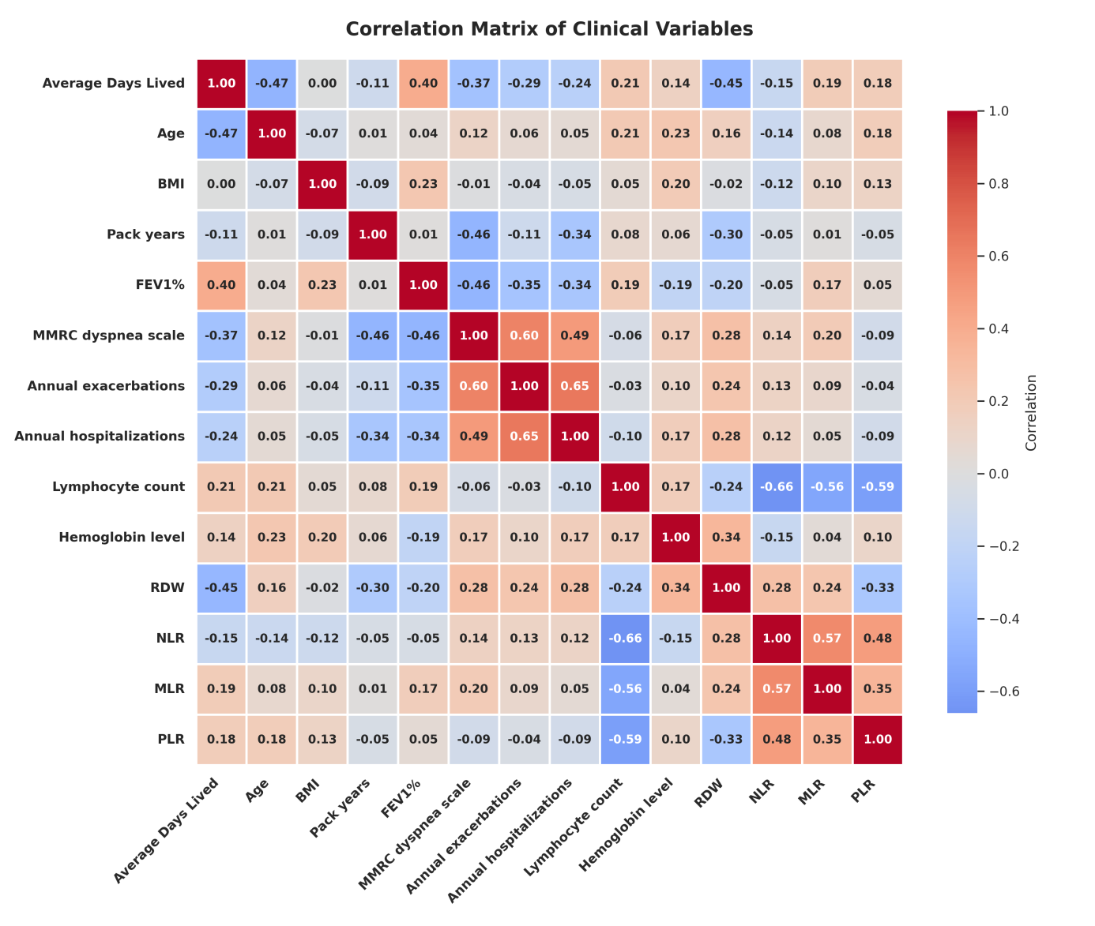
Supplementary Figure S1. Correlation matrix of clinical variables in the Derivation Cohort
The figure illustrates the relationships between “Average Days Lived” and various clinical parameters. Positive and negative correlations are shown in red and blue tones, respectively. Correlation coefficients are based on Pearson correlation analysis.

Supplementary Table S2. Performance Metrics of the 4-Variable and 7-Variable Prognostic Models
Dataset | C-index | IBS | AIC | C-index | IBS | AIC | LLR  p- value
 | 4-Variable Model |  |  | 7-Variable Model
Derivation | 0.798 | 0.115 | 634.4 | 0.802 | 0.114 | 626.9 | 0.004
Cross Validation | 0.785 ± 0.017 | 0.076 ± 0.037 | 479.9 ± 10.7 | 0.8 ±  0.028 | 0.077 ± 0.038 | 475.5 ±  9.6 | 0.053 ± 0.08
Validation | 0.744  ± 0.01 | 0.075  ± 0.03 | 1003.5  ± 1.4 | 0.745  ± 0.01 | 0.076  ± 0.04 | 1008.3  ± 1.5 | 0.668  ± 0.1
Notes: C-index: Harrell’s concordance index. IBS: Integrated Brier Score. AIC: Akaike Information Criterion. LLR: Likelihood ratio test comparing the 7-variable model with the 4-variable model.
- ADO Score  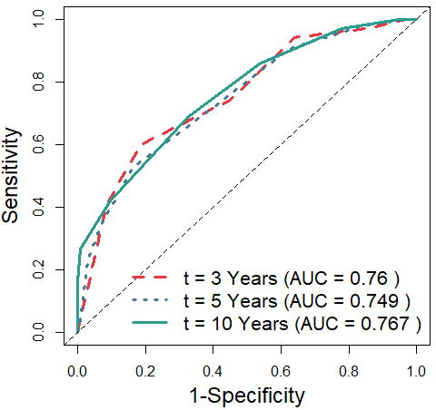 | - ADO + RDW Score  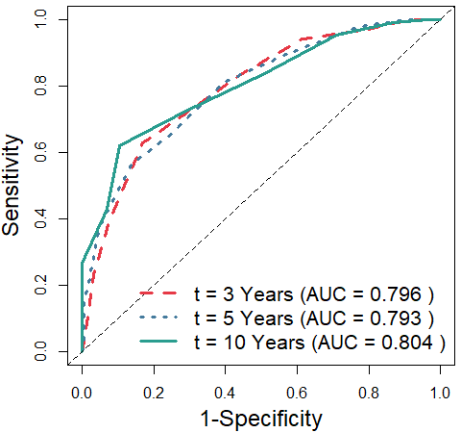
- DOSE Score  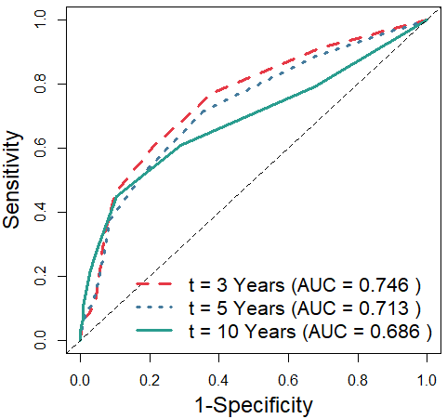 | - DOSE + RDW Score  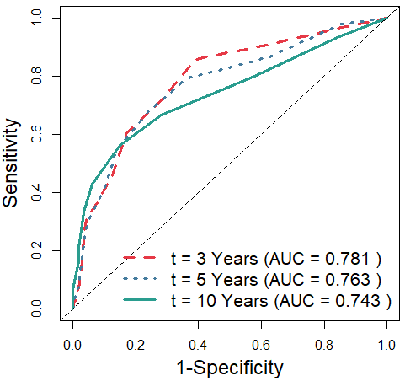
- BODEX Score  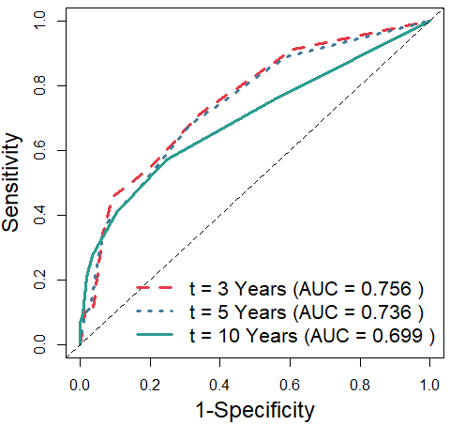 | - BODEX + RDW Score  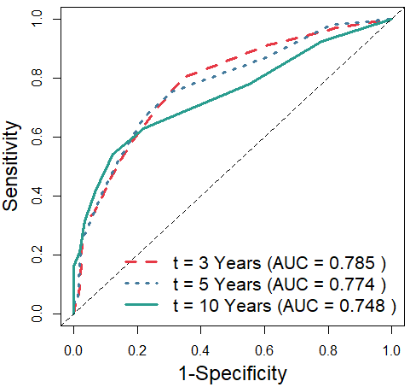
Supplementary Figure S2. Time-Dependent ROC Curves: The Effect of Adding RDW on the Prognostic Performance of Existing Scoring Systems (ADO, DOSE, BODEx) in Predicting 3-, 5-, and 10-Year Mortality (Validation Cohort)
The left panels display the time-dependent ROC curves of the original ADO, DOSE, and BODEx scores for predicting 3-, 5-, and 10-year mortality, while the right panels illustrate the performance of the same scores with RDW added.
Supplementary Table and Figure S3. Comparison of ADO, DOSE, and BODEX scores with and without RDW Using C-index, Brier Score, LLR p-value, and Calibration Plots in the Derivation Dataset
 | Without RDW |  | With RDW
Scoring System | C-index | IBS | C-index | IBS | LLR p-value
ADO | 0.797 | 0.0781 | 0.823 | 0.0704 | < 0.001
DOSE | 0.690 | 0.0837 | 0.741 | 0.0766 | < 0.001
BODEX | 0.707 | 0.0802 | 0.750 | 0.0741 | < 0.001

Notes: Table S3 summarizes model performance metrics for 10-year mortality prediction, while Figure S3 illustrates the calibration of predicted versus observed mortality. Green, blue, and red lines correspond to 3-year, 5-year, and 10-year mortality, respectively.

Supplementary Table and Figure S4. Comparison of ADO, DOSE, and BODEX Scores With and Without RDW Using C-index, Brier Score, LLR p-value, and Calibration Plots in the Cross-Validation Dataset
 | Without RDW |  | With RDW
Scoring System | C-index | IBS | C-index | IBS | LLR p-value
ADO | 0.803 ± 0.018 | 0.078 ± 0.039 | 0.837 ± 0.022 | 0.070 ± 0.034 | < 0.001
DOSE | 0.692 ± 0.077 | 0.084 ± 0.043 | 0.743 ± 0.047 | 0.077 ± 0.038 | < 0.001
BODEX | 0.707 ± 0.094 | 0.080 ± 0.041 | 0.756 ± 0.082 | 0.074 ± 0.037 | < 0.001

Notes: Table S4 summarizes model performance metrics for 10-year mortality prediction, while Figure S4 illustrates the calibration of predicted versus observed mortality. Green, blue, and red lines correspond to 3-year, 5-year, and 10-year mortality, respectively.

Supplementary Table and Figure S5. Comparison of ADO, DOSE, and BODEX Scores With and Without RDW Using C-index, Brier Score, LLR p-value, and Calibration Plots in the Validation Dataset
 | Without RDW |  | With RDW
Scoring System | C-index | IBS | C-index | IBS | LLR p-value
ADO | 0.736 ± 0.0023 | 0.0807 ± 0.0414 | 0.759 ± 0.0011 | 0.0762 ± 0.0382 | < 0.001
DOSE | 0.678 ± 0.0036 | 0.0845 ± 0.0443 | 0.714 ± 0.0012 | 0.0804 ± 0.0414 | < 0.001
BODEX | 0.688 ± 0.0040 | 0.0838 ± 0.0438 | 0.715 ± 0.0022 | 0.0800 ± 0.0411 | < 0.001

Notes: Table S5 summarizes model performance metrics for 10-year mortality prediction, while Figure S5 illustrates the calibration of predicted versus observed mortality. Green, blue, and red lines correspond to 3-year, 5-year, and 10-year mortality, respectively.

Supplementary Table S6. Comparison of RDW Levels According to Clinical Characteristics in the Derivation and Validation Cohorts
 | Derivation Cohort  n=136 |  |  | Validation Cohort  n=219
Variables | RDW Level (Mean ± SD)  Yes | RDW Level (Mean ± SD)  No | p-value | RDW Level (Mean ± SD)  Yes | RDW Level (Mean ± SD)  No | p-value
Dead after 10 years | 13.6 ± 1.7 (n=77) | 12.3 ± 1.2 (n=59) | <0.001 * | 13.6 ± 1.9 (n=106) | 12.4 ± 1.3 (n=113) | <0.001 *
Male sex | 13 ±1.7 (n=111) | 13.2 ±1,3 (n=25) | 0.19 | 12,8 ±1.5 (n=176) | 13.9 ±2.3 (n=43) | 0,003 *
BMI <21 | 14.1 ± 1.8 (n=9) | 13 ± 1.6 (n=127) | 0.043 * | 14.9 ± 2 (n=10) | 12,9 ± 1.7 (n=209) | 0,002 *
Active smoking | 12.9 ± 1.6 (n=32) | 13,1 ± 1.6 (n=104) | 0.613 | 13 ± 1.7 (n=49) | 13 ± 1.8 (n=170) | 0.492
Hypertension | 13.1 ± 1.5 (n=57) | 13 ± 1.7 (n=79) | 0.357 | 13 ± 1.6 (n=108) | 13 ± 1.9 (n=111) | 0.94
Diabetes mellitus | 12.7±1.5 (n=27) | 13.1 ± 1.7 (n=109) | 0.194 | 13±1.8 (n=47) | 13 ± 1.7 (n=172) | 0.722
Coronary artery disease | 14.1 ± 2.1 (n=31) | 12.7 ± 1.3 (n=105) | <0.001 * | 13,5 ± 2 (n=50) | 12.9± 1.7 (n=169) | 0.043 *
Congestive heart failure | 14 ± 1.9 (n=14) | 12.9 ±1.6 (n=122) | 0.035 * | 13.4 ± 1.9 (n=28) | 12.9 ±1.7 (n=191) | 0.127
Notes: This table shows mean RDW values (± standard deviation) across different clinical subgroups within the derivation (n=136) and validation (n=219) cohorts. Statistically significant values are indicated with an asterisk (p < 0.05).

Supplementary Table S7. Correlation of RDW with Clinical, Laboratory, and Scoring Parameters in the Derivation and Validation Cohorts
 | Derivation Cohort  n=136 |  | Validation Cohort  n=219
Variables | Correlation coefficient | p-value | Correlation coefficient | p-value
Average Days Lived | -0.453 | <0.001 * | -0.401 | <0.001 *
Age | 0.161 | 0.061 | 0.204 | 0,02 *
FEV1 (% predicted) | -0.295 | <0.001 * | -0.305 | <0.001 *
MMRC dyspnea scale | 0.197 | 0.022 * | 0.225 | 0,004 *
Annual exacerbations | 0.2 | 0.018 * | 0.245 | 0.001 *
Hemoglobin | -0.331 | <0.001 * | -0.368 | <0.001 *
Lymphocyte count | -0.236 | <0.001 * | -0.143 | 0,034 *
NLR | 0.28 | <0.001 * | 0.178 | 0,008*
MLR | 0.239 | 0.005 * | 0.179 | 0,008*
PLR | 0.34 | <0.001 * | 0.087 | 0.2
ADO score ** | 0.31 | <0.001 * | 0.323 | <0.001 *
DOSE score ** | 0.224 | 0.008 * | 0.312 | <0.001 *
BODEX score ** | 0.261 | 0.002 * | 0.337 | <0.001 *
Notes: This table presents the Pearson correlation coefficients between RDW and various clinical, laboratory, and composite scoring parameters (e.g., ADO, DOSE, BODEx). The results are shown separately for the derivation (n=136) and validation (n=219) cohorts. * denotes a statistically significant correlation. ** The ADO, updated ADO, DOSE, and BODEX scores were calculated according to the methods recommended by their developers. Detailed information and calculation methods can be found in the original publications by the developers.

(a)  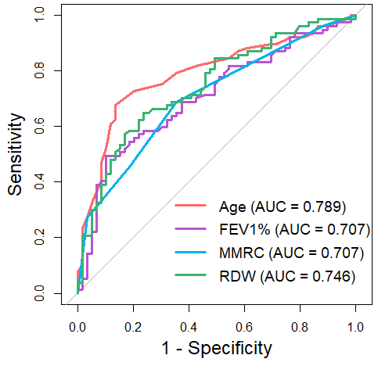 | (b)  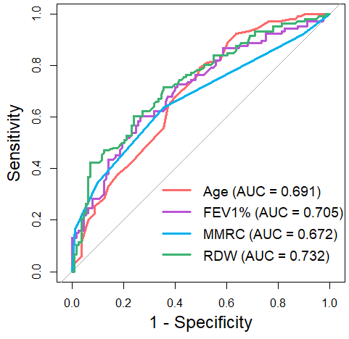
Supplementary Figure S6. ROC Curves for Age, FEV1%, mMRC, and RDW in Predicting 10-Year Mortality (A) In the derivation cohort, RDW demonstrated an AUC of 0.746, showing strong discriminatory capacity, outperforming FEV1% and mMRC, with Age achieving the highest AUC. (B) In the validation cohort, RDW maintained its robust predictive performance with an AUC of 0.732, surpassing FEV1%, mMRC, and Age.
These findings underscore RDW's consistent and superior predictive capacity across both cohorts, solidifying its reliability as a biomarker for long-term mortality prediction.

