Supplementary Materials

Photo-Initiated Depolymerization of Consumer Poly(methyl methacrylate): Chlorine Not Required
Authors: Jonathan T. Husband,*¹ Gavin Irvine,¹ Callum R. Morris,² Andrea Folli,² Matthew G. Davidson,*¹ Simon J.Freakley.*¹
Affiliations:
¹ Bath Institute of Sustainability and Climate Change, Room 3.02, East Building, Claverton Down, Bath, BA2 7AY and Department of Chemistry, University of Bath, South Building, Soldier Down Ln, Claverton Down, Bath BA2 7AY, U.K.
² Net Zero Innovation Institute, Cardiff Catalysis Institute, School of Chemistry, Cardiff University, Translational Research Hub, Maindy Road, Cardiff, CF24 4HQ, United Kingdom
*Corresponding authors. Jonathan T. Husband: jth67@bath.ac.uk; Matthew G. Davidson: M.G.Davidson@bath.ac.uk; Simon J. Freakley: sf756@bath.ac.uk.

Materials and Methods
All chemicals were purchased from either Sigma Aldrich or Fischer Scientific. PMMA controls were purchased from Sigma Aldrich as 15 kDa and 350 kDa molecular weights.
Samples of Perspex® were obtained from Perspex Distribution Ltd: Perspex® frost Aurora Violet S2 7T58 3mm, Perspex® XT clear 0X00 3 mm, and Perspex® spectrum LED blue 7TL1 3 mm. Samples were broken into pieces sub 5 mm in diameter before dissolution in solvent and depolymerization.
All NMR spectra were acquired using a 500 MHz (¹H) Bruker Avance III spectrometer, unless otherwise stated. CDCl₃ and acetone-d₆ was purchased from Sigma Aldrich and used as received as the NMR solvent.
Polymer molecular weight data was acquired using and Agilent 1260 Infinity system in THF eluent, fitted with 2 x PLgel 5 um Mixed D (300 x 7.5 mm) columns and a PLgel Mixed Guard (50 x 7.5 mm) guard column operating at 35 degrees C. Analysis was followed with a fitted differential refractometer (dRI) operating at 35°C. The system was calibrated by linear narrow molecular weight PMMA standards ranging from 260,900 g /mol to 885 g mol. Data was processed using Agilent’s GPC/SEC Software, Revision A.02.01. Unless otherwise stated, polymer samples were not purified prior to GPC analysis, but were filtered through a 0.5 μM filter to remove any potential particulate matter.

Depolymerizations
PMMA depolymerization general set-up
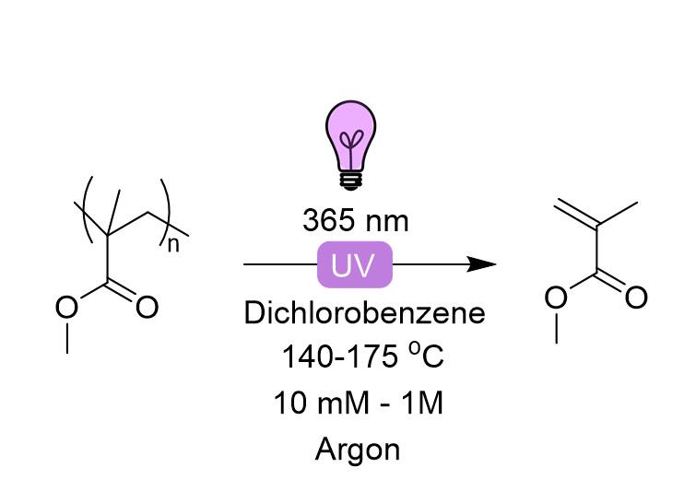
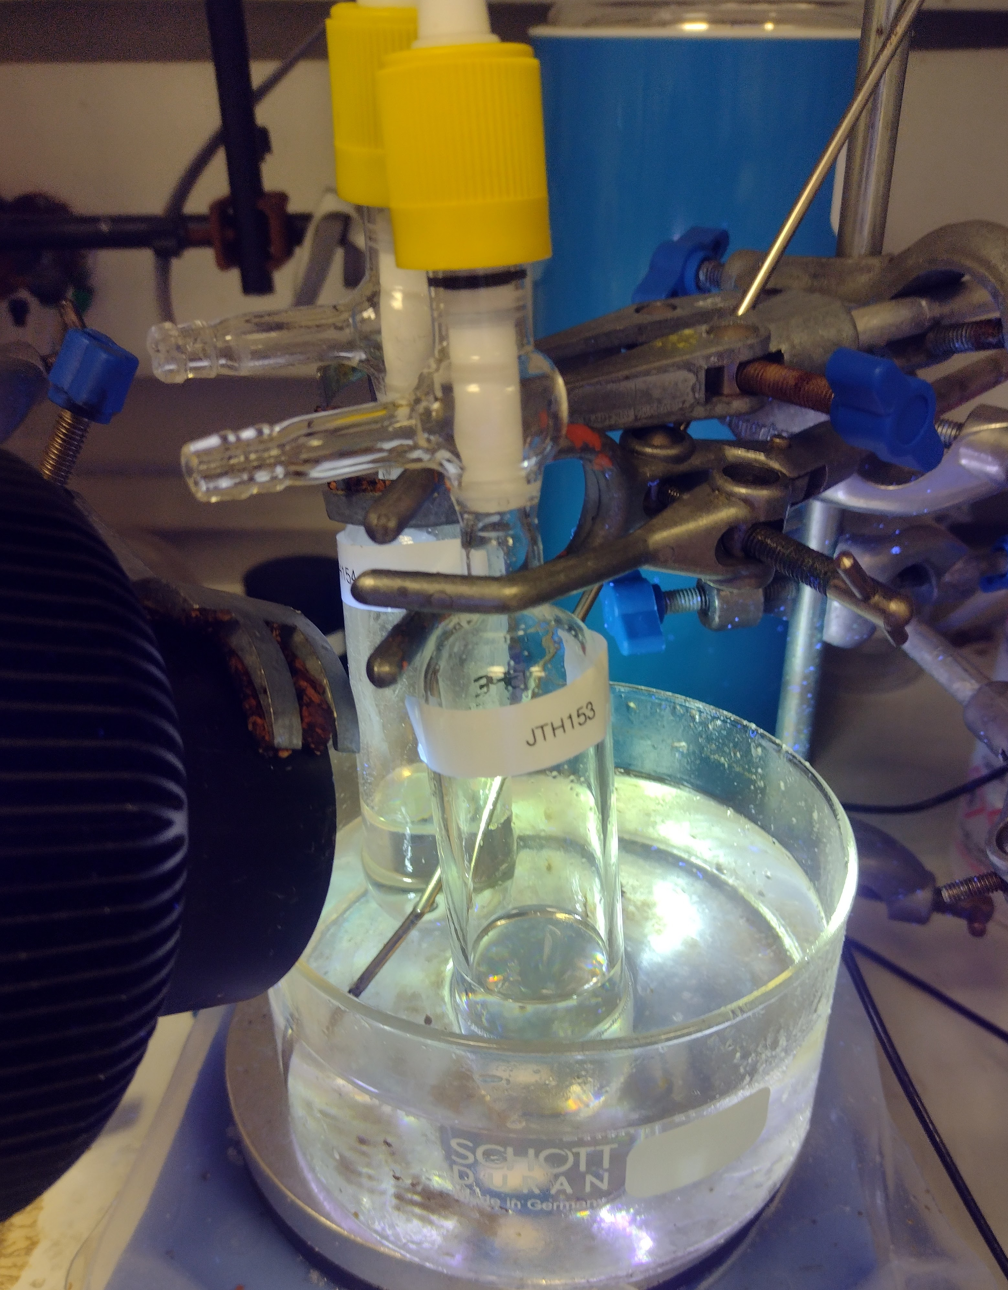

Figure S1: Photograph of the general depolymerization set-up (left) and general scheme (right).
Lamp power
To study the effect of lamp distance on conversion the depolymerizations was undertaken at 140 ºC, with the lamp at 2 cm and 6 cm. To estimate lamp output the emission of the lamp was measured by UV-A meter at various lamp distances (Figure S2). The detector had a limit of 40 mW/cm², so the relationship was extrapolated to distances < 10 cm. At a lamp distance of 2 cm (≈ 100 mW/cm²), conversion was measured at 16 %, whereas at a lamp distance of 6 cm (≈ 60 mWcm²), conversion was measured at 12 %.
Detector limit
Figure S2: UV-A absorbance measured at distances from the UV lamp.

Analysis of depolymerization conversion
For monitoring, samples were run with approximately 50:50 NMR solvent to crude reaction solution. Acetone-d₆ was found to help resolve the PMMA methyl from monomer methyl compared to CDCl₃. For low conversion samples the vinyl protons on the monomer could be integrated against total OMe integration/3: $Method 1: Conv\left(\%\right)= \int{H_{Vinyl}/(\int{H_{OMe}/3)*100}}$. For samples that reach higher conversion, the OMe for Monomer and OMe for Polymer can be differentiated and the following calculation can also be used: $Method 2: Conv\left(\%\right)= \int{H_{OMe monomer}/(\int{H_{OMe polymer})*100}}$. Both methods gave relative errors within ± 5% even with a slight overlap of peaks, therefore all reported values are with method 1. In addition, polymer OMe protons (~3.4 ppm) can be compared to polymer CH₂-CH₃ regions at 0.7 – 1.2 ppm, and all samples maintained the ratio 1:1 indicating the integrity of PMMA architecture.
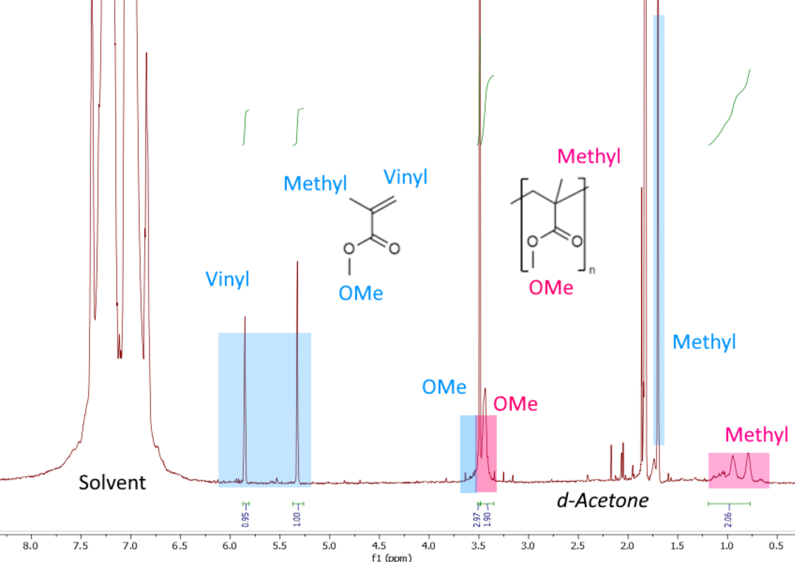
Method 1: $\frac{0.975}{4.87/3}= 60\%$

Method 2: $\frac{2.97}{4.87}= 61\%$

Figure S3: Example ¹H NMR regions used for integration in a reaction that reached high conversion, showing good agreement between methods 1 and 2 of integration.

Distillation of rMMA
To recycle MMA, the crude reaction solution in dichlorobenzene was heated to around 180°C in a short path distillation set-up (Figure S4) for about 4 hours. MMA was collected in a round bottom flask, 84% of MMA was recovered from the crude NMR conversion; while some monomer remained in the distillation set-up. The distilled MMA solution (2.7 mL) was 73 mol% MMA (1.84 g) with the remainder being co-evaporated dichlorobenzene (0.96 g).
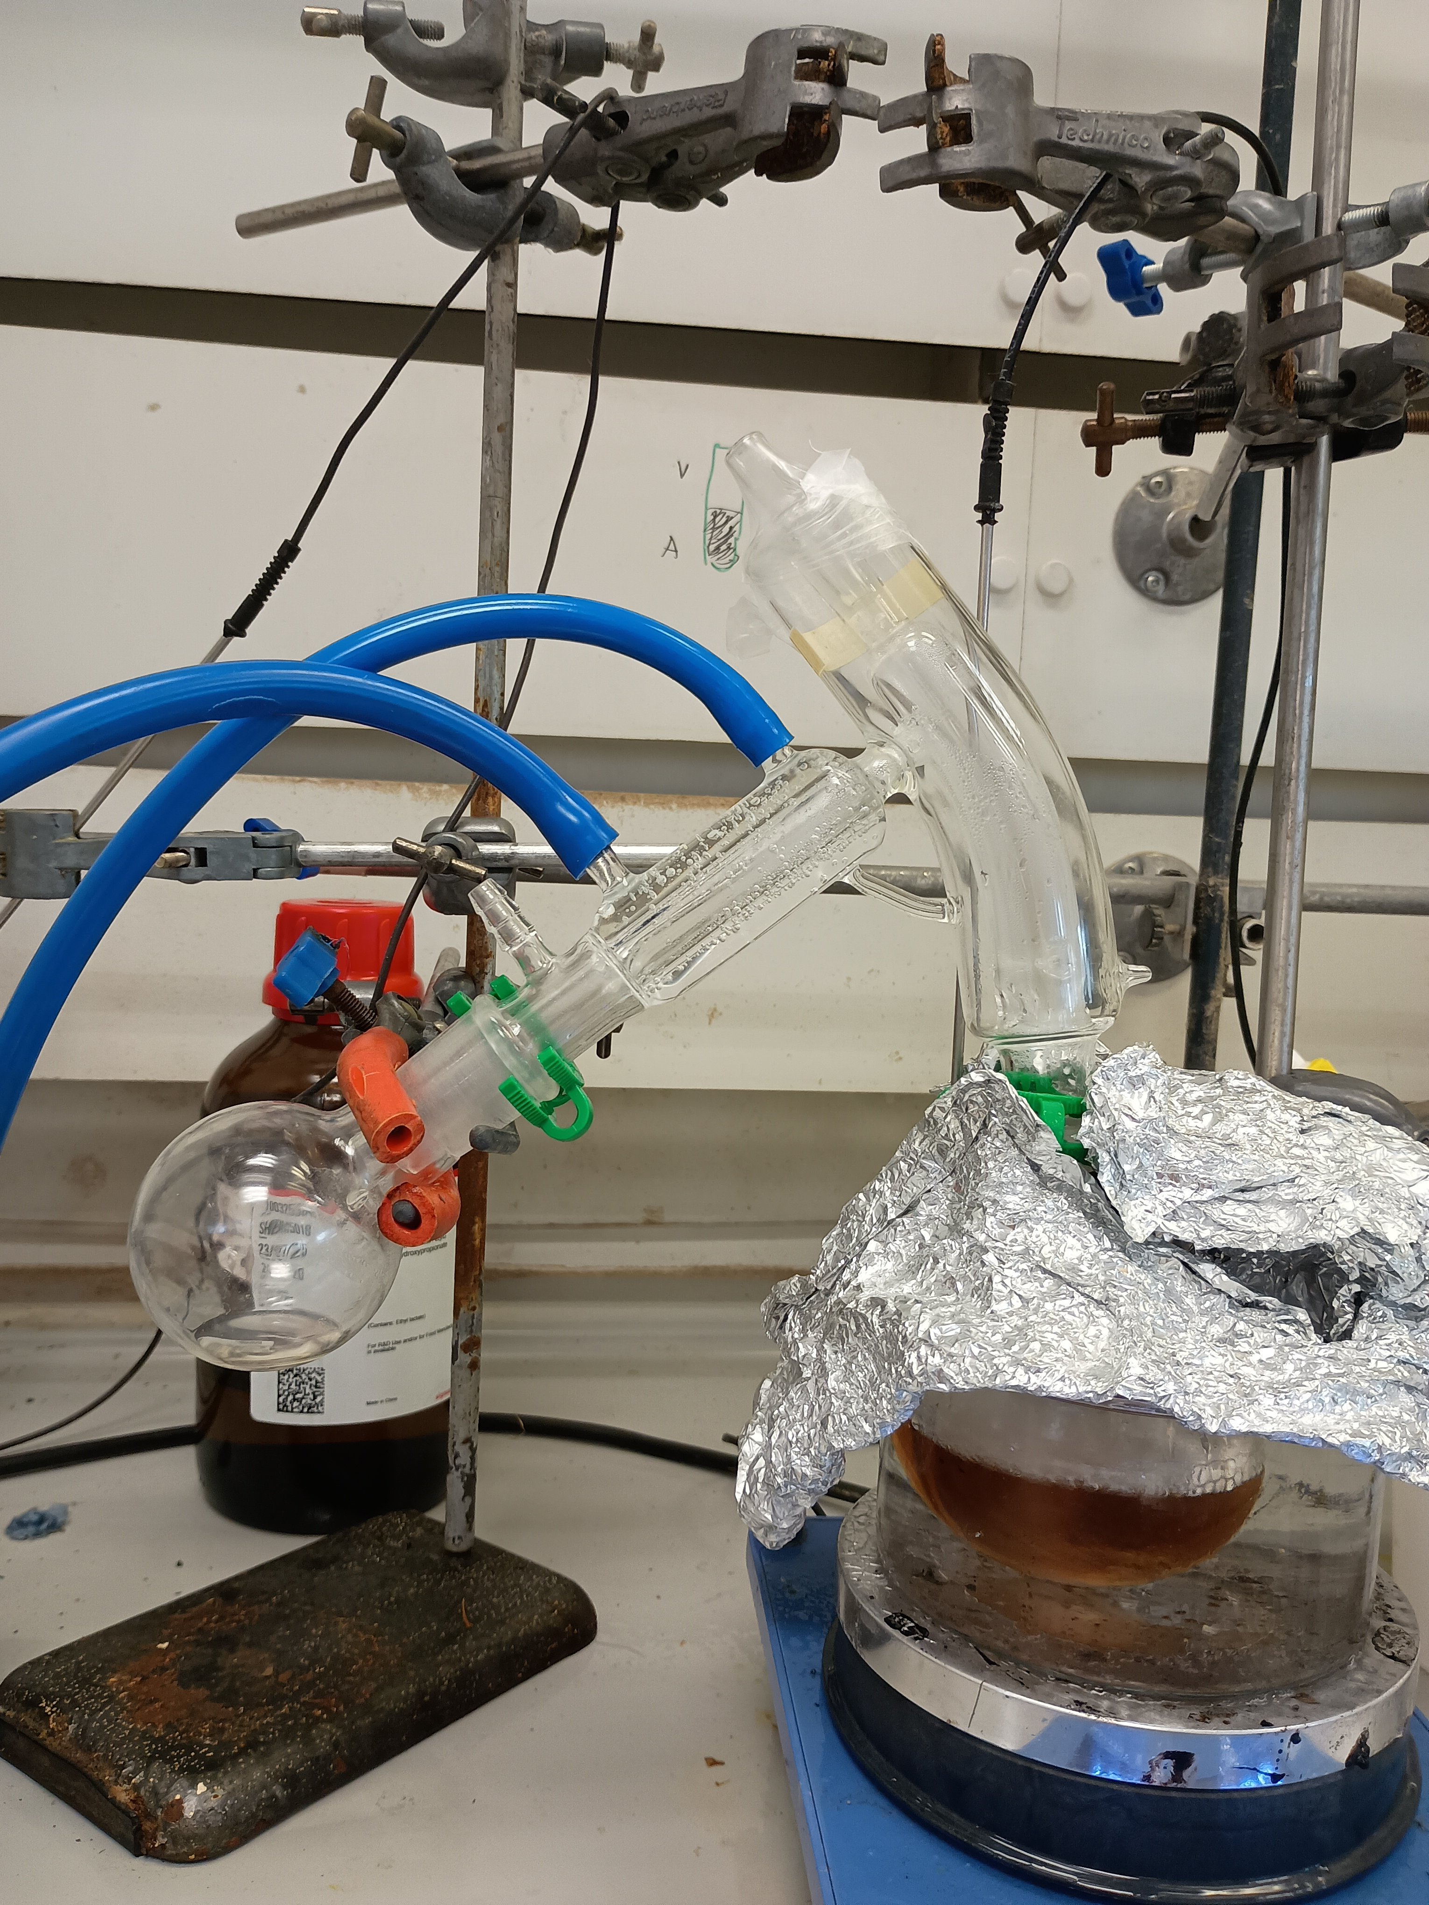
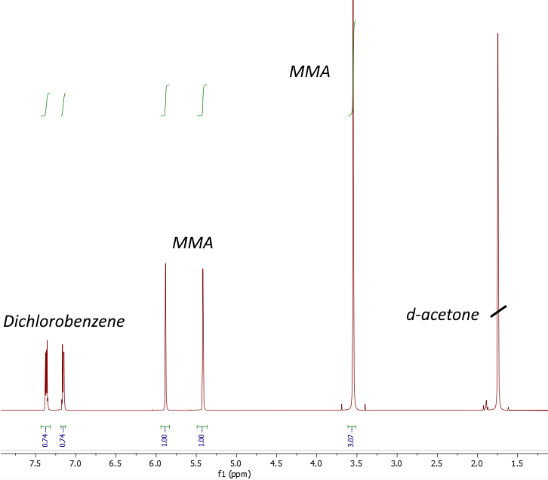

Figure S4: Left: Photo of rMMA distillation set-up. Right: ¹H NMR of rMMA distillate.
Original HAT experiment with xanthyl N-functionalized amide hydrogen atom transfer (HAT) catalyst

Scheme S1: Overview of PMMA depolymerization with xanthylation catalyst.
Consumer PMMA was weighed into a Schlenk flask with a stirrer bar, followed by 1 – 10 equivalents of xanthylation catalyst with respect to polymer chains. Dichlorobenzene was then added. Dibromoanisole was occasionally added as in internal NMR standard. The solution was bubbled with argon flow for around 5 minutes and then sealed under a strong flow of argon. Once fully dissolved and sealed the Schlenk was placed in a preheated oil bath at the temperature for the study and a 30W 365 nm LED array lamp was used to irradiate the samples, placed 3-4 cm from the Schenk flasks. After an elapsed time period, the Schenk was removed and placed into a beaker of water to cool before either taking aliquots for analysis under argon, or being opening to air.

Figure S5: Conversion of PMMA to monomer at varying xanthylation catalyst loadings, and catalyst to MMA ratio (black), showing no effect of catalyst.
Reaction of DCB depolymerized PMMA with acridine orange

Scheme S2: Two-step method for acridine functionalization with initial PMMA depolymerization in dichlorobenzene.
Step 1. 400 mg of 200 kDa PMMA was dissolved in 20 mL dichlorobenzene in a Schelnk and degassed with argon bubbling for 10 mins. The Schlenk was sealed and placed in a preheated oil bath at 175ºC, and a 30W 365 nm LED lamp was used to irradiate the samples, placed ~3 cm from the Schenk. After 5 minutes, the Schenk was placed into a beaker of water to cool. Once cool the DCB solution was precipitated into a 1:1 MeOH:H₂O solution and the precipitate dried for use in step 2.
Step 2. 50 mg of precipitated PMMA from step 1, was dissolved into dichloromethane (5 mL). To this 5 mg of acridine orange was added. Finally, 100 uL of a 0.5 M KOH in methanol, solution was added. The solution was heated to 60ºC and left overnight.
As a control step 2 was repeated with untreated 200 kDa PMMA.

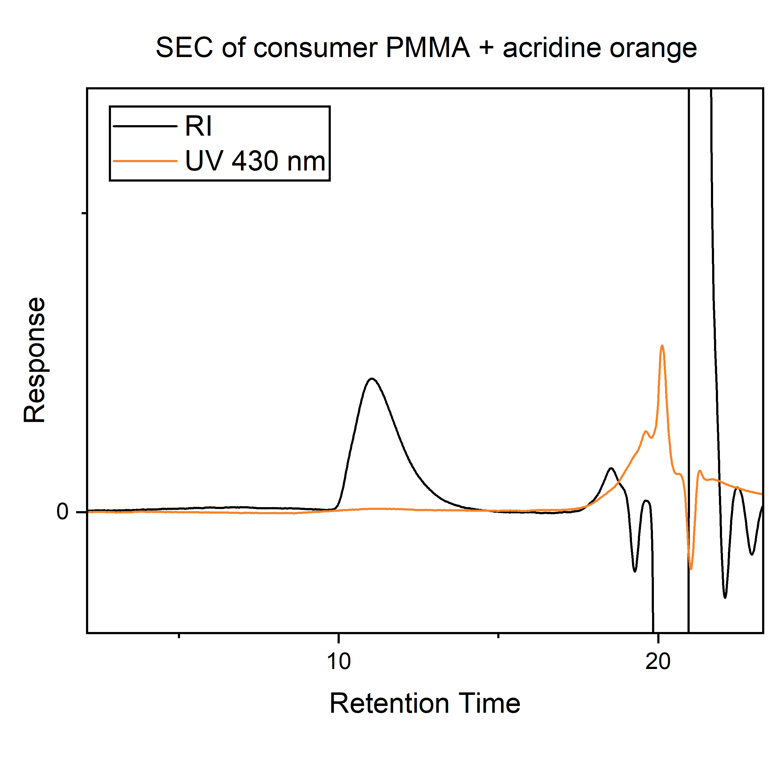
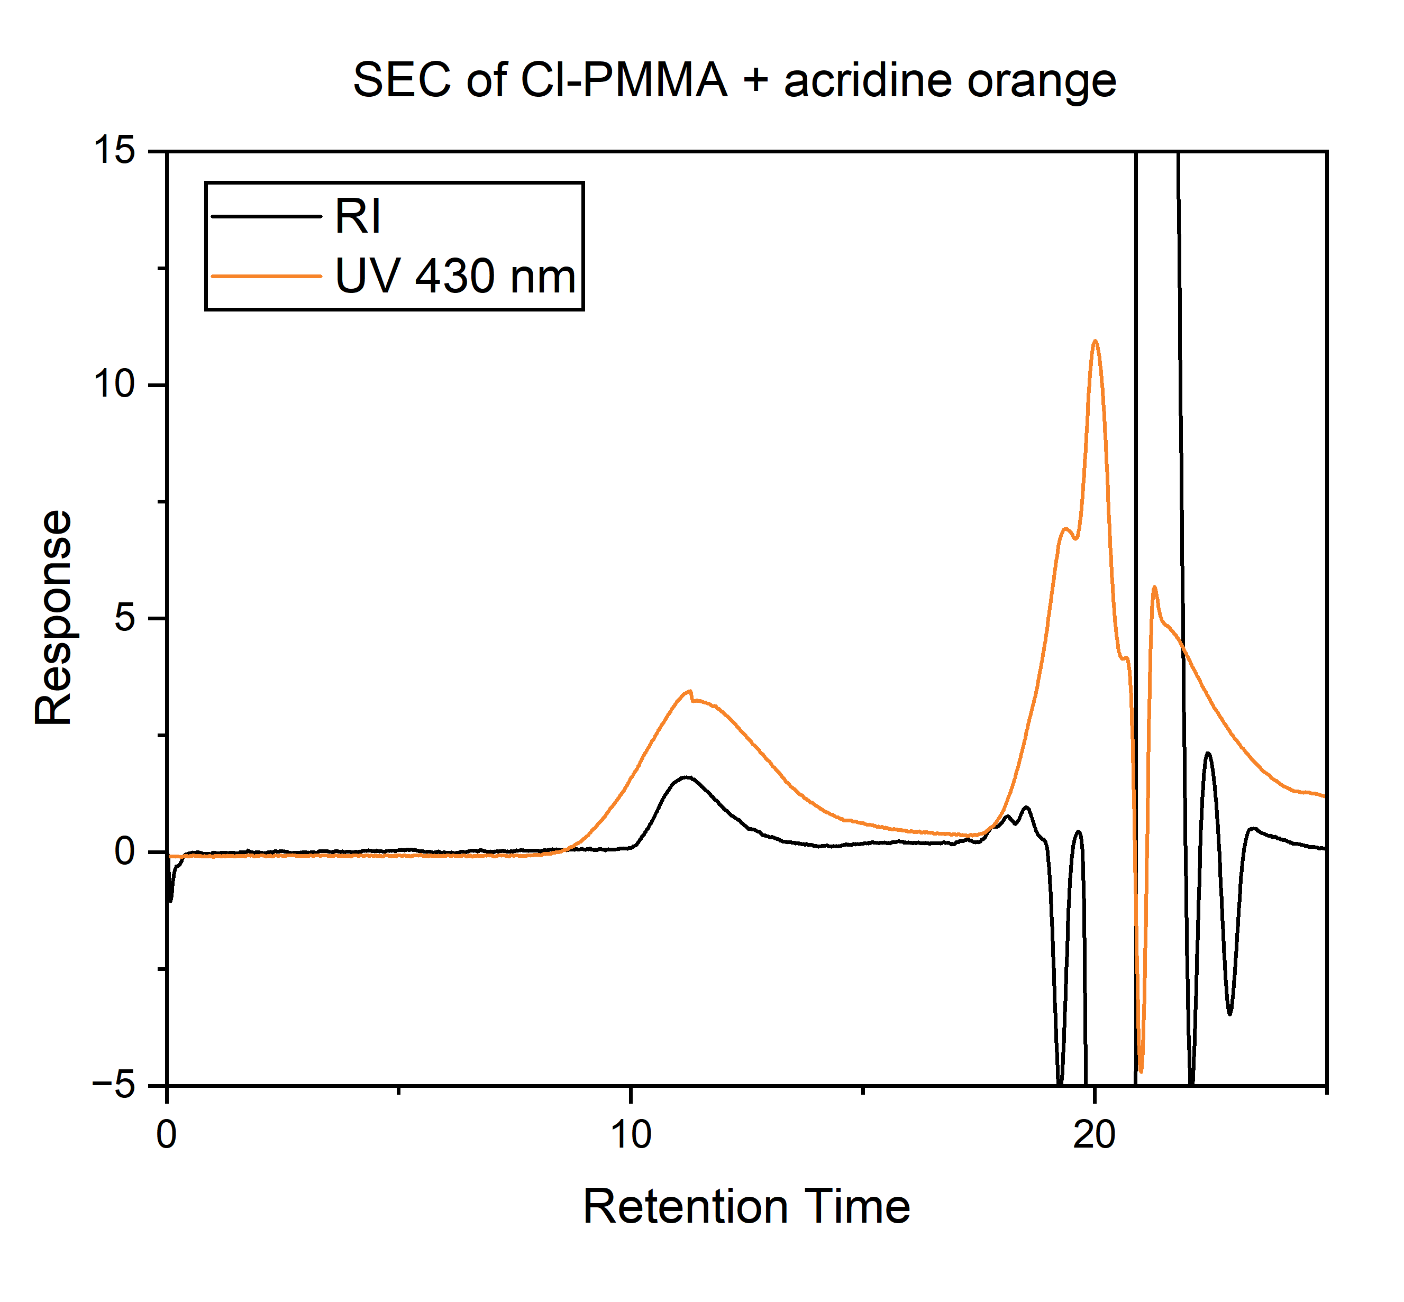
Figure S6 and 7. SEC chromatograms for Cl-PMMA reacted with acridine orange (left) and consumer PMMA reacted with acridine orange (right), showing dramatic increase in 430 nm absorption corresponding to polymer RI response in the Cl-PMMA polymer versus the consumer PMMA (right).
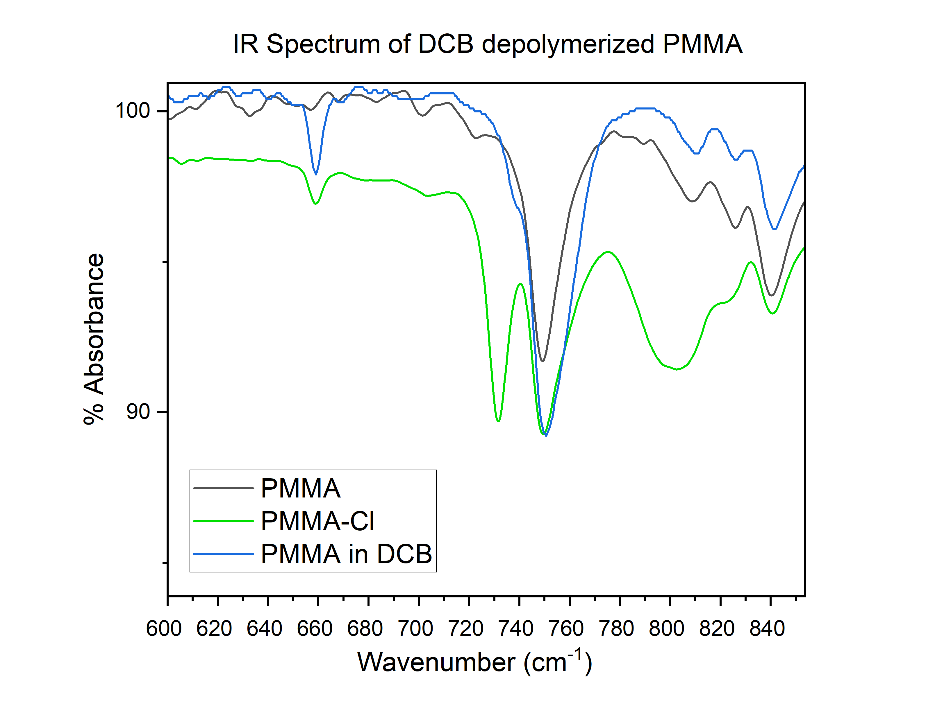
Figure S8. FT-IR spectrum of 200 kDa PMMa left for 1 hour under DCB depolymerization conditions versus 200 kDa PMMA and PMMA in DCB controls, illustrating the new potential C-Cl absorbance at 725 nm.

Depolymerization conversion versus titration of sulfolane with dichlorobenzene

Fig S9. Measured monomer produced by ¹H NMR at different sulfolane DCB mixtures, showing reduction in conversion at increasing sulfolane concentrations. Reaction conducted with UV at 140 ºC, 15 kDa PMMA, 4 hours. Results indicate that small additions of sulfolane to DCB decrease conversion more than a linear relationship, suggesting sulfonate-induced quenching of the depropagation is occurring.

Rate of depolymerization of DCB vs Benzonitrile
Fig S10. Measured monomer produced by ¹H NMR spectroscopy for DCB and benzonitrile with time at 175ºC, 200 kDa PMMA.

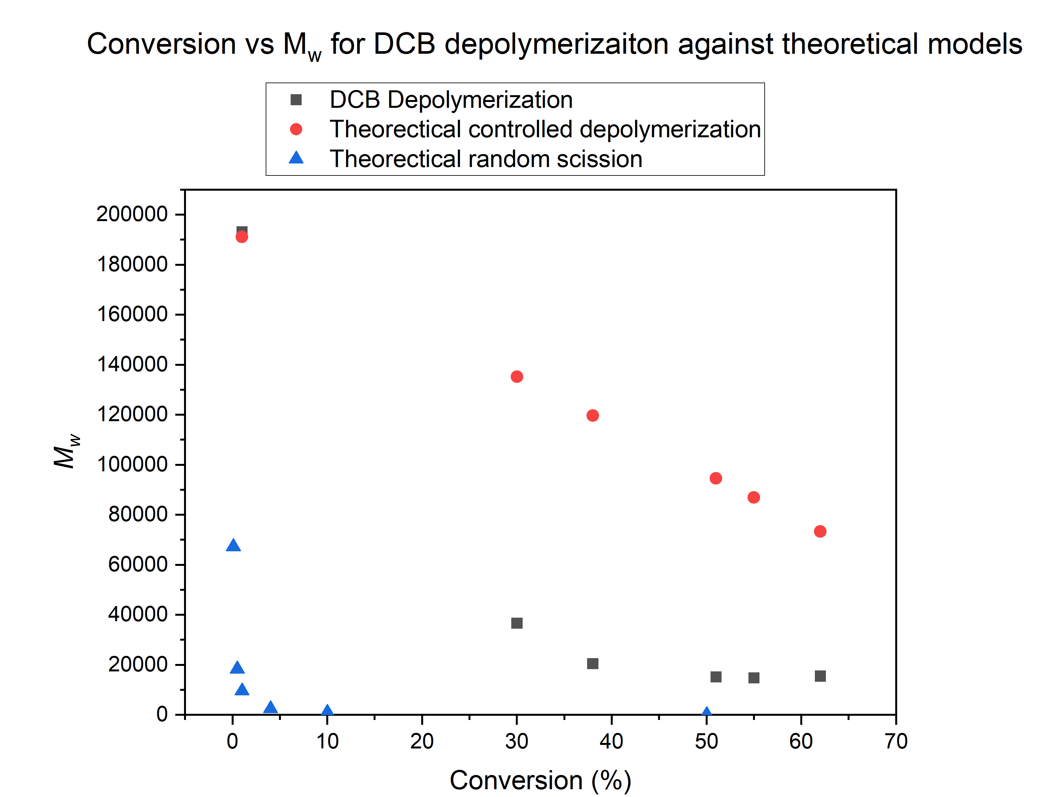

Fig S11. Measured monomer produced by ¹H NMR spectroscopy for DCB at 175ºC, 200 kDa PMMA (black squares), versus theoretical conversions for random scission (blue riangles) and an end chain controlled radical depolymerization (red circles).

Attempt to depolymerize polystyrene:
Scheme S3: Scheme for attempted depolymerization of polystyrene
Polystyrene (M_{n}^{SEC} of 102 kgmol⁻¹ , Đ = 2.19) was weighed into a Schlenk flask with a stirrer bar and solvent was then added. The solution was bubbled with argon flow for around 5 minutes and then sealed under a strong flow of argon. The Schlenk was then placed in a preheated oil bath at 160° and a 30W 365 nm LED array lamp was used to irradiate the sample. After 4 hours the Schenk was removed and placed into a beaker of water to cool before opening to air. The solution was analyzed by THF-SEC and ¹H NMR spectroscopy, and despite a large M_{w} decrease observed by SEC (Figure S9), minimal production of monomer could be observed by ¹H NMR spectroscopy. It is postulated that through optimization unzipping to monomer can be achieved.
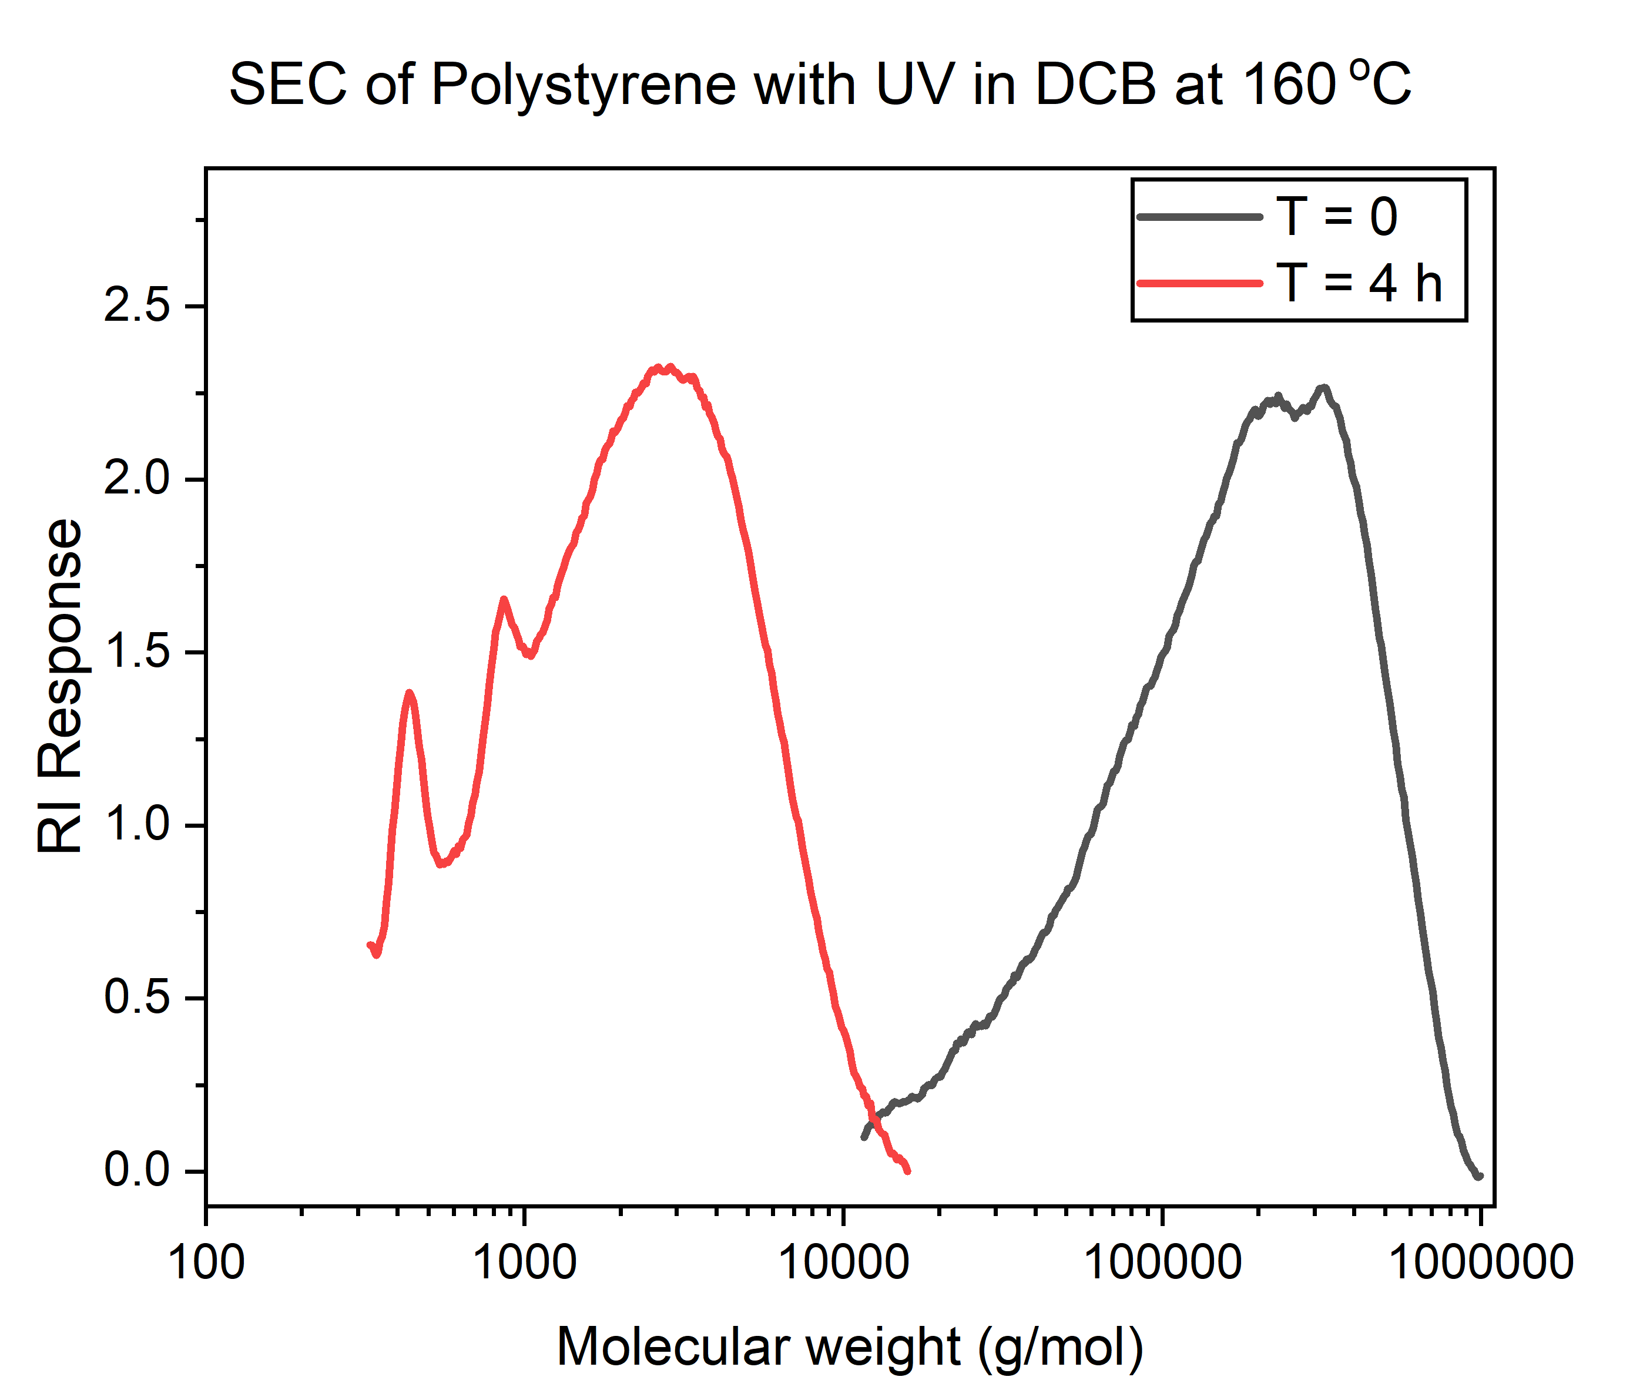

Figure S12: SEC chromatogram, showing reduced M_{w} in polystyrene subjected to depolymerization conditions (160 °C, 4 hours, dichlorobenzene).

Polymerizations
15 kDa RAFT MMA polymer:

Scheme S4: Overview of MMA RAFT polymerization targeting 15 kDa.
Methyl methacrylate was first filtered through a plug of alumina to remove the inhibitor. 3 g of this was added to 5 mL ml DCB in a Schlenk tube. To this, 51 mg of 4-Cyano-4-[(dodecylsulfanylthiocarbonyl)sulfanyl]pentanoic acid was added, followed by 100 μL of a 78 mg/mL stock solution of AIBN in DCB. The solution was bubbled with argon and the tube was purged and sealed. The Schlenk was immersed in an oil bath at 70°C and left for 48 hours. The resultant thick oil was sampled for conversion by ¹H NMR, determined to be 99%, and was then precipitated into diethyl ether, filtered and dried in vacuo, to yield 2.45 g of pure PMMA (SEC: M_{n}^{SEC} of 16.9 kgmol⁻¹, Đ = 1.07, ¹H NMR (d₆-acetone, 500 MHz): M_{n}^{NMR} of 19 kgmol⁻¹, DP^{NMR} 185).
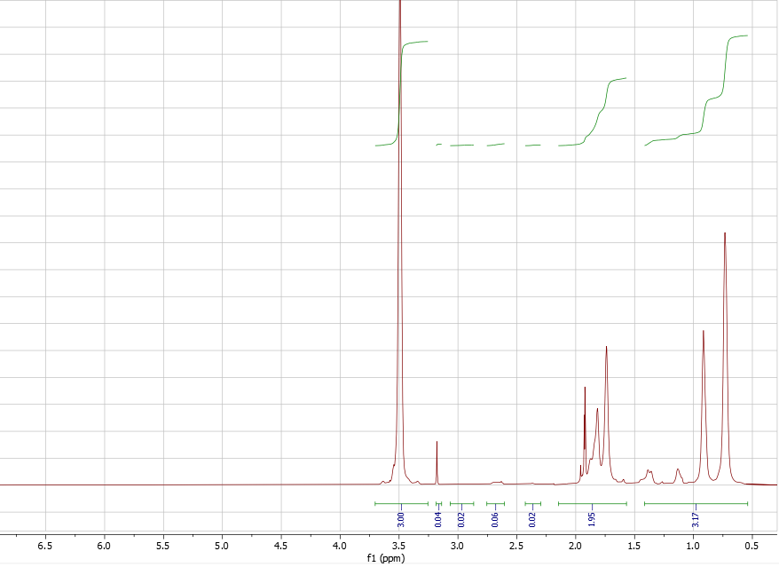

Figure S13. ¹H NMR of RAFT 15 kDa PMMA post-precipitation

15 kDa RAFT rMMA polymer:

Scheme S5: Overview of recycled MMA (rMMA) RAFT polymerization targeting 15 kDa.
1 mL of recovered rMMA distillate was added to a Schlenk tube as is. To this, 17 mg of 4-Cyano-4-[(dodecylsulfanylthiocarbonyl)sulfanyl]pentanoic acid was added, followed by 100 μL of a 15 mg/mL stock solution of AIBN in DCB. The solution was bubbled with argon and the tube was purged and sealed. The Schlenk was immersed in an oil bath at 70°C and left for 48 hours. The resultant thick oil was sampled for conversion by ¹H NMR, determined to be 96%, and was then precipitated into diethyl ether, filtered and dried in vacuo, to yield 1720 mg of PMMA (SEC: M_{n}^{SEC} of 20 gmol⁻¹, Đ = 1.11, M_{n}^{NMR} of 13 kgmol⁻¹, DP^{NMR} 125).

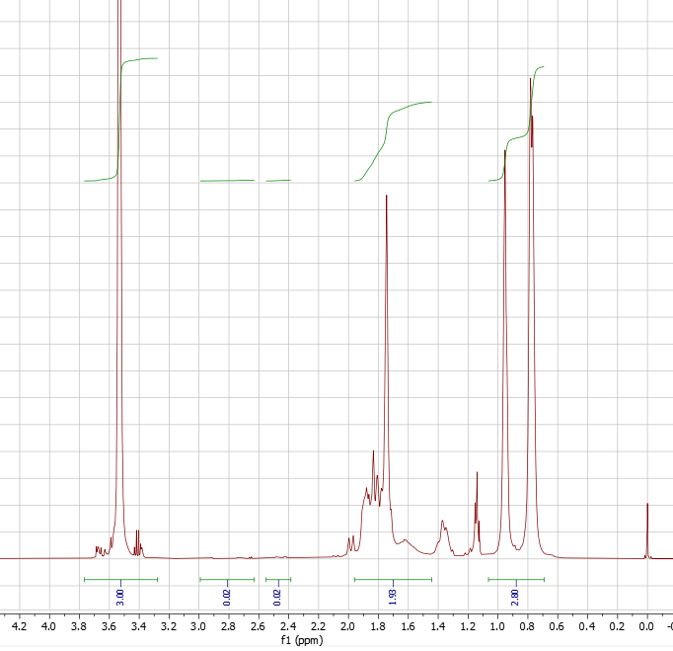

Figure S14. ¹H NMR of RAFT 15 kDa rPMMA post-precipitation

200 kDa RAFT MMA polymer:

Scheme S6: Overview of MMA RAFT polymerization targeting 200 kDa.
Methyl methacrylate was first filtered through a plug of alumina to remove the inhibitor. 3 g of this was added to 10 mL ml DCB in a Schlenk tube. To this, 3.5 mg of 4-Cyano-4-[(dodecylsulfanylthiocarbonyl)sulfanyl]pentanoic acid was added, followed by 30 μL of a 15 mg/mL stock solution of AIBN in DCB. The solution was bubbled with argon and the tube was purged and sealed. The Schlenk was immersed in an oil bath at 70°C and left for 48 hours. The resultant solid was sampled for conversion by ¹H NMR, and determined to be 91%. The solid was heating and dissolved in a few mL of hot DCB and was precipitated into diethyl ether, filtered and dried in vacuo, to yield 2.20 g of PMMA (SEC: M_{n}^{SEC} of 190 kgmol⁻¹, Đ = 1.26).
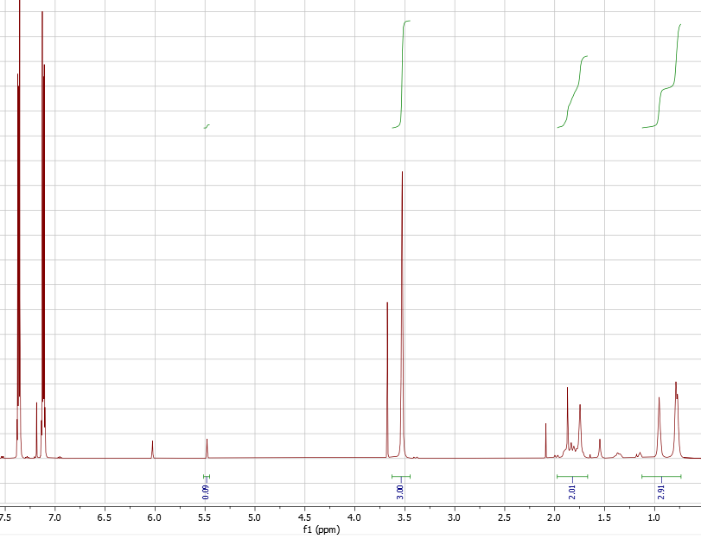
Figure S15. ¹H NMR of RAFT 200 kDa PMMA pre-precipitation

Uncontrolled FRP of rMMA:

Scheme S7: Uncontrolled rMMA polymerization.
0.5 mL of recovered rMMA distillate was added to a Schlenk tube as is. AIBN was added to the solution by adding 100 μL 10 mg/mL stock solution in DCB. The solution was bubbled with argon and the tube was purged and sealed. The Schlenk was immersed in an oil bath at 70°C and left for 24 hours. The resultant thick oil was sampled for conversion by ¹H NMR, determined to be 96%, and was then precipitated into diethyl ether, filtered and dried in vacuo, to yield 458 mg of pure PMMA (SEC: M_{n}^{SEC} of 38.8 kgmol⁻¹, Đ = 1.65).

ATRP PMMA polymer:

Scheme S8: ATRP polymerization of MMA
Methyl methacrylate was first filtered through a plug of alumina to remove inhibitor. 2 mL (1.88 g, 18.7 mmol) of this monomer was added to a 30 mL glass vial along with tosyl chloride (0.018 g, 0.094 mmol), AIBN (0.002 g, 0.009 mmol), 30 μL of a 1 mL stock solution of tris(2-pyridylmethyl)amine (TPMA, 0.032 g, 0.112 mmol) and copper (II) chloride (0.005 g, 0.037 mmol) in DMF and 2 mL of anisole. The solution was purged with nitrogen for 10 minutes and sealed before being immersed in an oil bath at 65 °C for 24 hours. The resulting solution was sampled for monomer conversion by 1H NMR (CDCl3) and determined to be 85%. The polymer was then precipitated into methanol, filtered and dried in vacuo to yield 0.46 g of PMMA-Cl (SEC: M_{n}^{SEC} of 5800 gmol-1, Đ = 1.43).

Chain extension of ATRP PMMA polymer:
Scheme S9: ATRP chain extension of ATRP macroinitiator with MMA.

Methyl methacrylate was first filtered through a plug of alumina to remove inhibitor. 0.08 mL (0.075 g, 0.75 mmol) of this monomer was added to a 30 mL glass vial along with the PMMA-ATRP macroinitiator (0.075 g), AIBN (0.002 g, 0.009 mmol), 30 μL of a 1 mL stock solution of tris(2-pyridylmethyl)amine (TPMA, 0.032 g, 0.112 mmol) and copper (II) chloride (0.005 g, 0.037 mmol) in DMF and 2 mL of anisole. The solution was purged with nitrogen for 10 minutes and sealed before being immersed in an oil bath at 65 °C for 24 hours. The resulting solution was sampled for monomer conversion by 1H NMR (CDCl3) and determined to be 85%. The polymer was then precipitated into methanol, filtered and dried in vacuo to yield 0.097 g of polymer (SEC: M_{n}^{SEC} of 148,200 gmol-1, Đ = 1.57).
Chain extension of Cl-PMMA polymer:

Scheme S10: Attempted ATRP chain extension of depolymerized PMMA, with MMA.
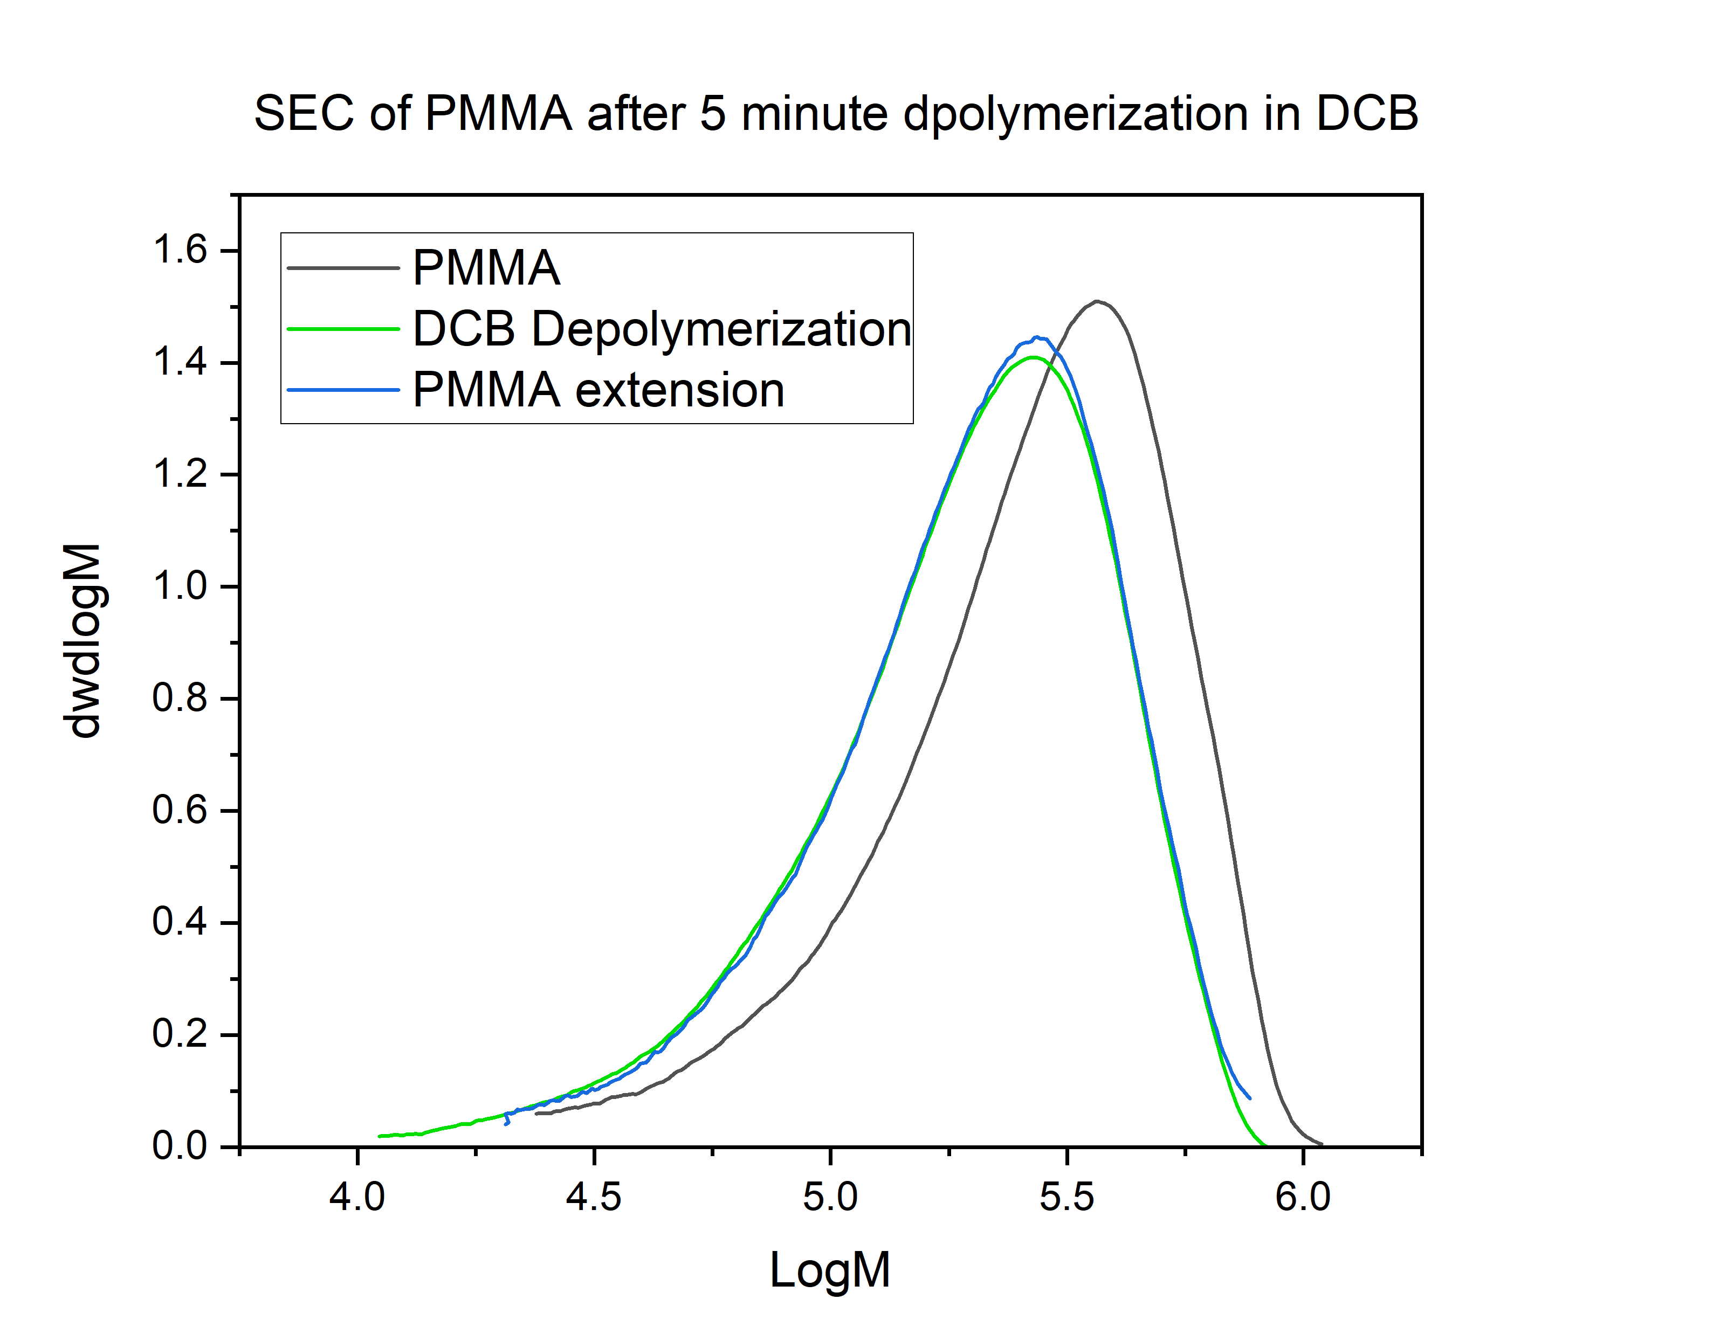
PMMA-Cl from Step 1 of the 10-minute DCB PMMA depolymerization was subjected to the same chain extension procedure as for ATRP-PMMA above. However negligible change in Mn was observed by SEC for this, suggesting the chlorine is not at the alpha-position relative to the carbonyl as seen in the ATRP PMMA.
Figure S16: THF-SEC of PMMA before and after 5 minutes of UV irradiation in DCB and subsequent failed attempt at ATRP chain extension.

Figures of SEC analyses of PMMA polymers

Figure S17: SEC (THF) traces for polymers in this study with an M_{n} below 50 kDa.

Figure S18: SEC (THF) traces for polymers in this study with an M_{n} above 50 kDa.

Measurement of Critical Temperature (Tc) in different solvents

Figure S19. Measured monomer remaining by ¹H NMR at equilibrium conversion at different temperatures. Initial monomer concentration: [M]₀ = 0.2 M . Catalyst (AIBN) concentration: 1 mol %. Reaction time > 24 hours.

Figure S20. Plot of Theoretical equilibrium behavior Ln([M]_{eq}/[M]₀) as a function of temperature in selected solvents.

Solvent | dH | dS | T_{C} (K) | T_{C} (ºC) | R²
Dichlorobenzene | -51368 | -136 | 377.7059 | 104.7059 | 0.93
Xylenes | -29298 | -76.7 | 381.9817 | 108.9817 | 0.96
Benzonitrile | -43732 | -116 | 377 | 104 | 0.79
Sulfolane | -83026 | -219 | 379.1142 | 106.1142 | 0.92
Table S1. Thermodynamic parameters derived from Ln([M]_{eq}/[M]₀) as a function of temperature plot, including T_{c}, using equations 1 and 2.

Equation 1 : $Rln(\frac{\left[M\right]eq}{{\left[M\right]}_{0}}=\frac{1}{T}* ∆H_{p}- ∆S_{p}$) Equation 2 : $T_{C}= \frac{∆H_{p}}{∆S_{p}}$

Proposed mechanism

Figure S21. Early-stage mechanistic theory for observations of the depolymerization. UV light causes homolysis and radical formation on the aromatic solvent. The dashed line represents PMMA homolysis which has not been ruled out. The solvent homolysis process produces a species capable of hydrogen atom transfer from the polymer backbone. The radical polymer species then undergoes either termination through reaction when high concentrations of solvent radicals are present (e.g. by Cl in DCB) or uncontrolled depolymerization releasing monomer (e.g. in benzonitrile). The Cl-capped polymer can then undergo re-initiation with UV or HAT.

UV-Vis spectrometry of PMMA polymers
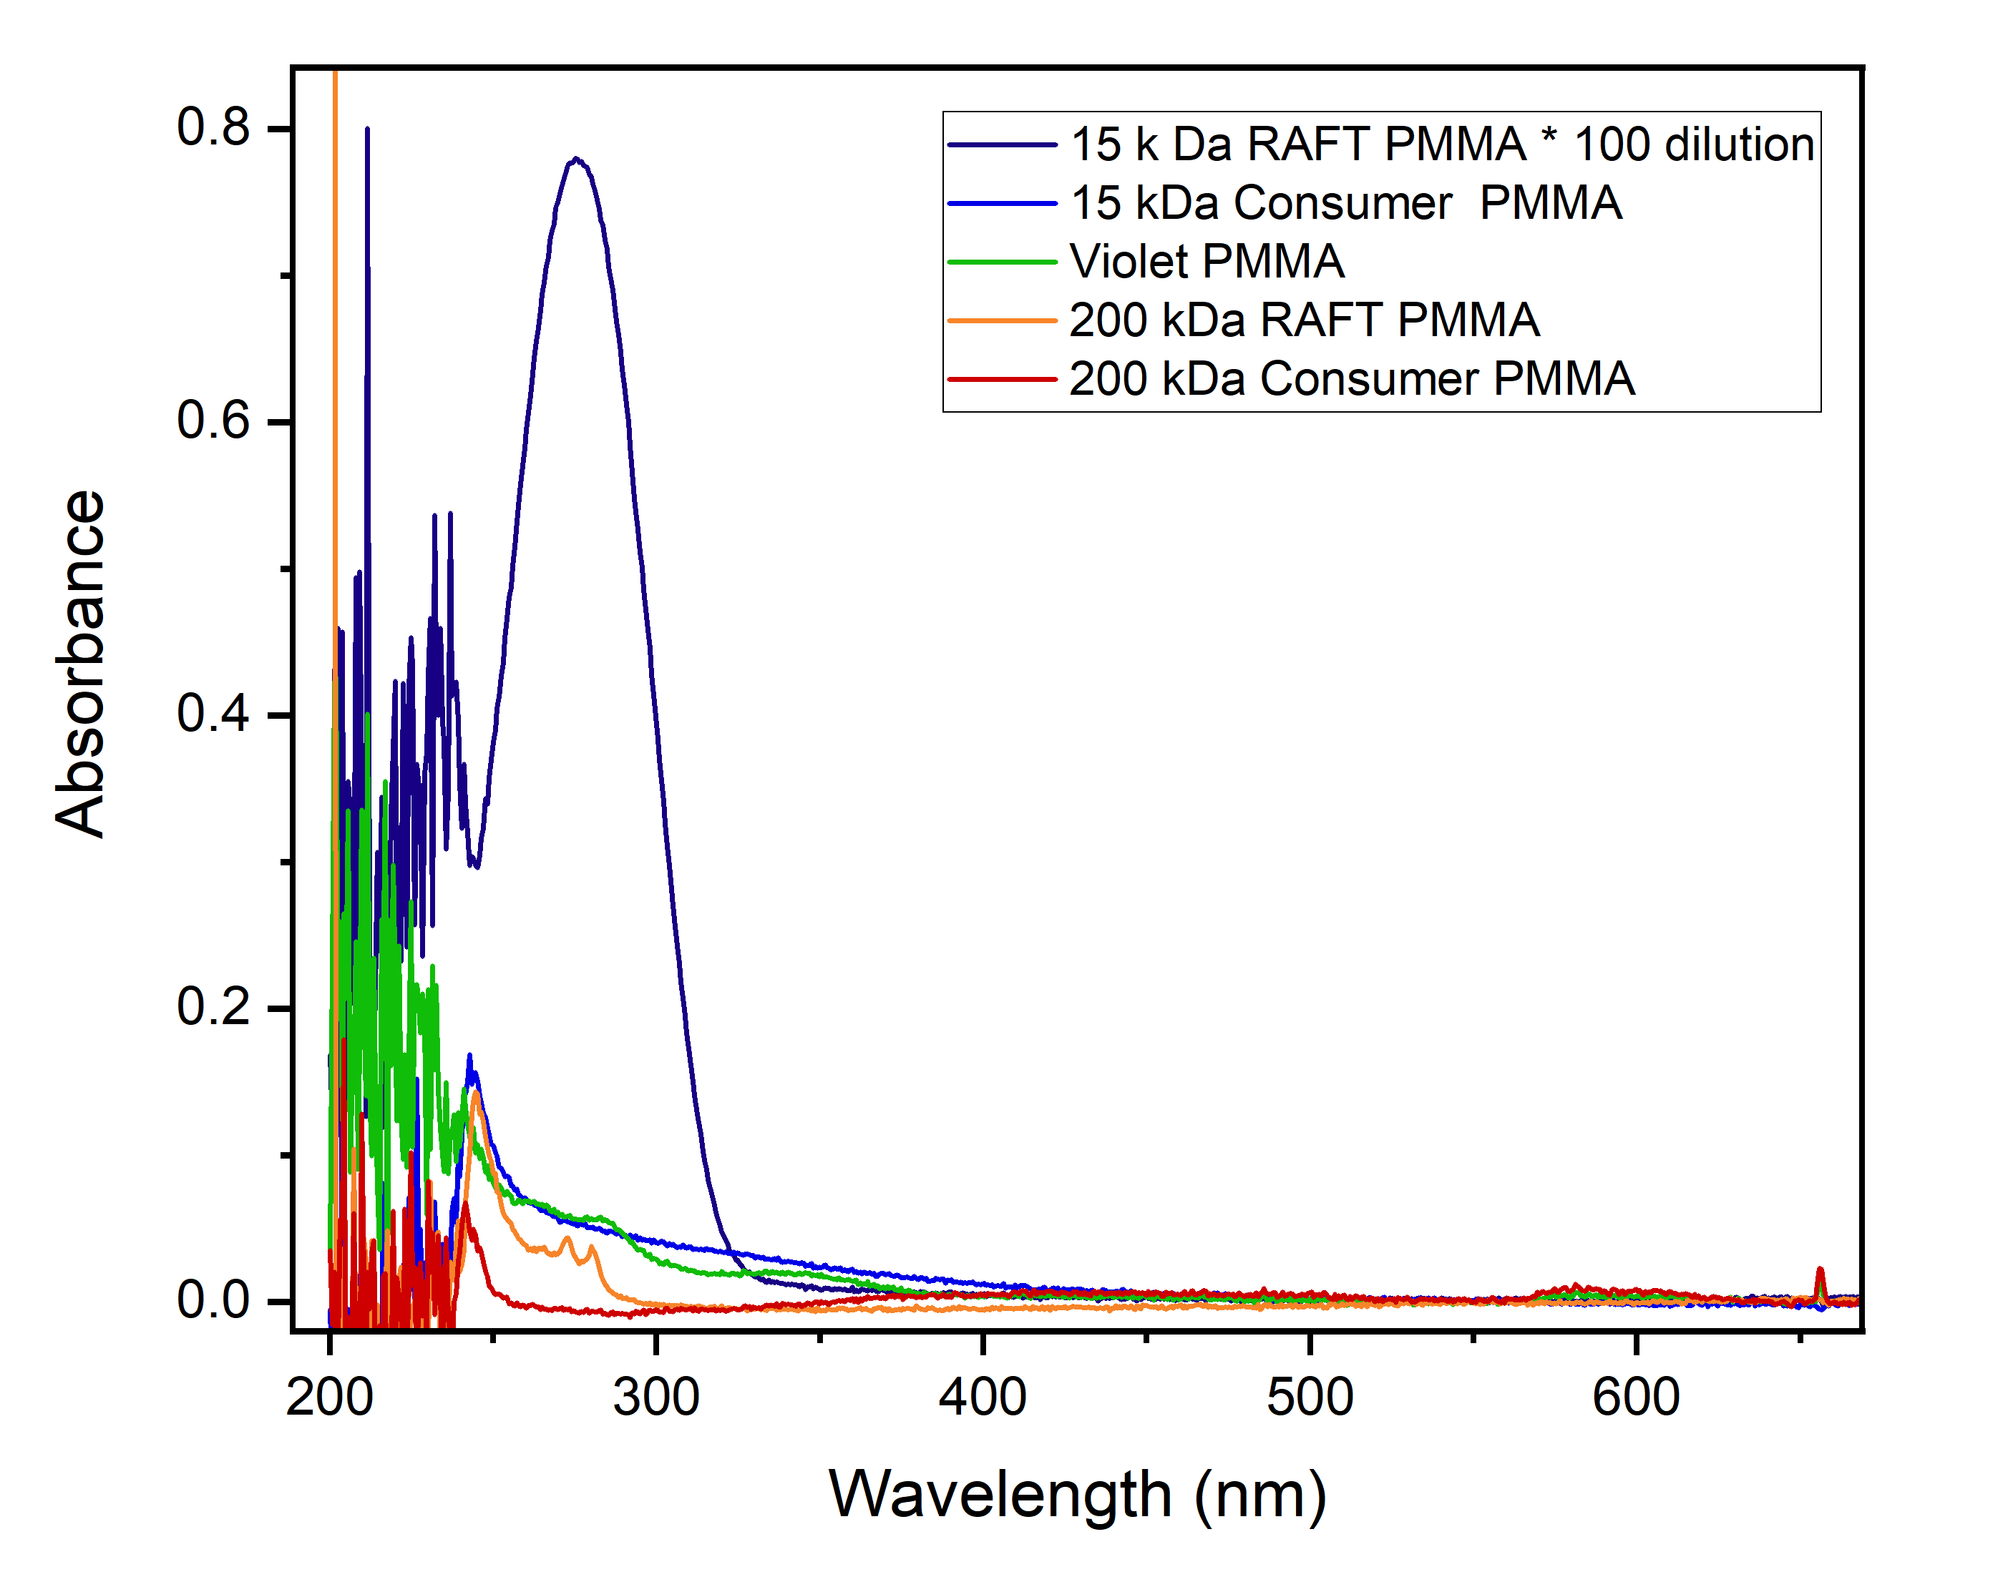

Figure S22: UV-Vis spectrometry of PMMA polymers in chloroform at 5mg/ml (excluding 15 kDa RAFT PMMA). No CTA absorbance is observed for the 15 kDa or 200 kDa consumer PMMA. The absorbance in violet Perspex® is attributed to dyes and additives in the plastic.
Tables of conversions measured by ¹H NMR spectroscopy (Method 1)
Table S2: Investigating temperature and concentration relationships
Solvent | DCB | DCB | DCB | DCB | DCB | DCB | DCB | DCB | DCB | DCB | DCB | DCB | DCB | DCB | DCB | DCB | DCB | DCB | DCB | DCB | DCB
Monomer mg/mL | 1.01 | 1.01 | 1.717 | 1.717 | 2.525 | 2.525 | 2.525 | 2.525 | 2.525 | 5.05 | 10.1 | 10.1 | 15.15 | 15.15 | 30.3 | 40.4 | 40.4 | 101 | 101 | 202 | 202
PMMA | 300 kDa | 15 kDa | 15 kDa | 15 kDa | 300 kDa | 15 kDa | 15 kDa | 15 kDa | 300 kDa | 15 kDa | 15 kDa | 15 kDa | 15 kDa | 300 kDa | 15 kDa | 15 kDa | 300 kDa | 300 kDa | 15 kDa | 15 kDa | 300 kDa
Molarity (mM) | 10 | 10 | 17 | 17 | 25 | 25 | 25 | 25 | 25 | 50 | 100 | 100 | 150 | 150 | 300 | 400 | 400 | 1000 | 1000 | 2000 | 2000
Temp | 175 | 175 | 140 | 150 | 140 | 175 | 175 | 175 | 175 | 175 | 175 | 175 | 175 | 175 | 175 | 175 | 175 | 175 | 175 | 175 | 175
Time (min) | 300 | 300 | 300 | 300 | 300 | 300 | 300 | 300 | 300 | 300 | 300 | 300 | 300 | 300 | 300 | 300 | 300 | 300 | 300 | 300 | 300
ʃ Monomer_{Vinyl} | 1 | 1 | 1 | 0.26 | 1 | 1 | 1 | 1 | 1 | 1 | 1 | 1 | 1 | 1 | 1 | 1 | 1 | 1 | 1 | 1 | 1
ʃ Polymer_{OMe} + Monomer_{OMe} | 4.22 | 7.2 | 17.8 | 2.64 | 5.79 | 5.6 | 6.4 | 5.3 | 4.19 | 5.7 | 10.8 | 7.3 | 9.5 | 4.68 | 13.3 | 13.8 | 5.05 | 5.09 | 17.4 | 28.8 | 16.3
% Monomer | 71.1 | 41.7 | 16.9 | 29.5 | 51.8 | 53.6 | 46.9 | 56.6 | 71.6 | 52.6 | 27.8 | 41.1 | 31.6 | 64.1 | 22.6 | 21.7 | 59.4 | 58.9 | 17.2 | 10.4 | 18.4

Table S3: Investigating Solvent -pt 1
Solvent | Cyrene | Sulfolane | Xylenes | Cyrene | Sulfolane | DCB | Xylenes | Diphenyether | Diphenyether | Mesitlyene | Ditertbuyl-phenol | Trichloro-benzene | Trichloro-benzene | Benzonitrile | Benzonitrile
PMMA | 15 kDa | 15 kDa | 15 kDa | 15 kDa | 15 kDa | 15 kDa | 15 kDa | 15 kDa | 15 kDa | 15 kDa | 15 kDa | 15 kDa | 15 kDa | 15 kDa | 15 kDa
Molarity (mM) | 25 | 25 | 25 | 25 | 25 | 25 | 25 | 35 | 35 | 25 | 25 | 25 | 25 | 25 | 25
Temp | 175 | 175 | 140 | 175 | 175 | 175 | 140 | 175 | 140 | 175 | 175 | 140 | 175 | 140 | 175
Time (min) | 300 | 300 | 300 | 300 | 300 | 300 | 300 | 300 | 300 | 300 | 300 | 300 | 300 | 300 | 300
ʃ Monomer_{Vinyl} | 1 | 1 | 1 | 1 | 1 | 1 | 1 | 1 | 1 | 1 | 1 | 1 | 1 | 1 | 1
ʃ Polymer_{OMe} + Monomer_{OMe} | 45.6 | Neg. | 32.1 | 45.6 | Neg. | 5.3 | 32.1 | 6.4 | 47 | Neg. | 56 | 19.1 | 7.6 | 63 | 10.7
% Monomer | 6.6 | Neg. | 9.3 | 6.6 | Neg. | 56.6 | 9.3 | 46.9 | 6.4 | Neg. | 1.8 | 15.7 | 39.5 | 4.8 | 28.0

Table S3: Investigating Solvent -pt 2
Solvent | NMP | Diphenylether | Dibromo-benzene | Sulfolane | NMP | Dibromo-benzene | NMP | Sulfolane | Methyl levullinate | p-Cymene | Vanilylalcohol | 10% Sulfolane in DCB | 50% Sulfolane in DCB
PMMA | 15 kDa | 15 kDa | 15 kDa | 15 kDa | 15 kDa | 15 kDa | 15 kDa | 15 kDa | 15 kDa | 15 kDa | 15 kDa | 15 kDa | 15 kDa
Molarity (mM) | 25 | 1000 | 25 | 25 | 25 | 25 | 25 | 25 | 25 | 25 | 25 | 25 | 25
Temp | 175 | 175 | 175 | 175 | 175 | 140 | 140 | 140 | 140 | 160 | 160 | 140 | 140
Time (min) | 300 | 1080 | 300 | 300 |  | 300 | 300 | 300 | 300 | 300 | 300 | 300 | 300
ʃ Monomer_{Vinyl} | 1 | 1 | 1 | 1 | 1 | Neg | Neg | Neg | Neg | 1 | Neg | 1 | 1
ʃ Polymer_{OMe} + Monomer_{OMe} | 47 | 33 | 9.4 | 69 | 291 | Neg | Neg | Neg | Neg | 46 | Neg | 24.1 | 64.4
% Monomer | 6.4 | 9.1 | 31.9 | 4.3 | 1.0 | Neg | Neg | Neg | Neg | 6.5 | Neg | 12.4 | 4.7

Investigating PMMA type
Solvent | DCB | DCB | DCB | DCB | DCB | DCB | DCB | DCB | DCB | DCB | DCB | DCB | DCB | DCB
Additional Variable | None | No UV | No UV | None | No UV | None | None | None | None | None | None | None | None | None
Monomer mg/mL | 2.525 | 2.525 | 2.525 | 202 | 2.525 | 202 | 2.525 | 2.525 | 2.525 | 101 | 101 | 101 | 50.5 | 50.5
PMMA | 300 kDa | RAFT PMMA 15 kDa | 300 kDa | 15 kDa | 15 kDa | 300 kDa | Clear Perspex | Blue Perspex | Violet Perspex | Violet Perspex | Blue Perspex | Clear Perspex | Violet Perspex | Violet Perspex
Molarity (mM) | 25 | 25 | 25 | 2000 | 25 | 2000 | 25 | 25 | 25 | 1000 | 1000 | 1000 | 500 | 500
Temp | 175 | 175 | 175 | 175 | 175 | 175 | 175 | 175 | 175 | 175 | 175 | 175 | 175 | 175
Time (min) | 300 | 300 | 300 | 300 | 300 | 300 | 300 | 300 | 300 | 300 | 300 | 300 | 1080 | 1080
ʃ Monomer_{Vinyl} | 1 | 1 | 1 | 1 | 1 | 1 | 1 | 1 | 1 | 1 | 1 | 1 | 1 | 1
ʃ Polymer_{OMe} + Monomer_{OMe} | 4.19 | 4.89 | Neg | 28.8 | Neg | 16.3 | 5.65 | 7.26 | 4.4 | 4.38 | 13.55 | 6.57 | 4.65 | 5.44
% Monomer | 71.6 | 61.4 | Neg | 10.4 | Neg | 18.4 | 53.1 | 41.3 | 68.2 | 68.5 | 22.1 | 45.7 | 64.5 | 55.2

