Preparation and Multimodal Applications of Biomass-Based Fluorescent Carbon Dots Ink with Multifunctional Anti-Counterfeiting Effects
Supplementary Information
CaiTingTing¹, ZhaoYiFan¹, Zhang Tingyu¹, Yang Yun²
1 Department of Chemistry and Material Engineering, Lyuliang University, Lyuliang 033000, P. R. China
2 Department of Resource and Mechanical Engineering, Lyuliang University, Lvliang, China

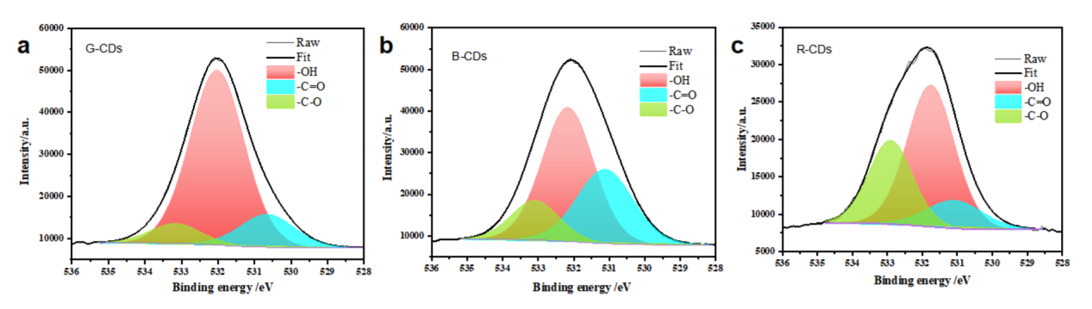
Figure S1 High-resolution O 1s spectrum of (b) B-CDs and (c) G-CDs.


Figure S2 The sealing of the R-CDs solution without purification treatment under sunlight and 365 nm UV illumination.
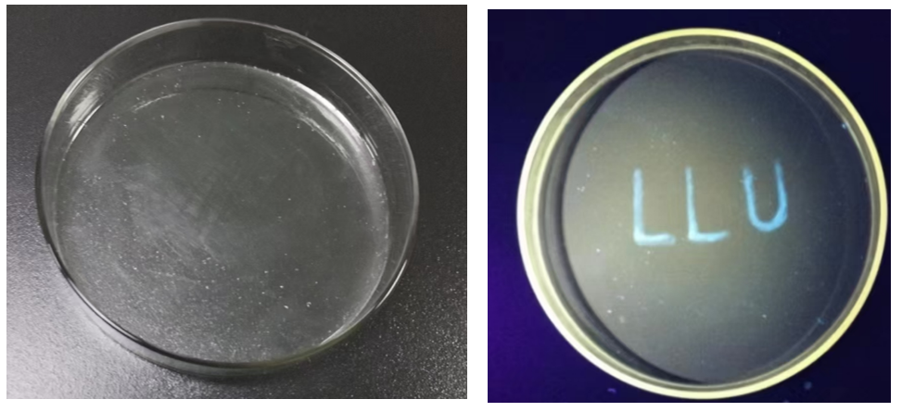
Figure S3 The writing of B-CDs ink pen on the PVA film under sunlight and 365 nm UV illumination.
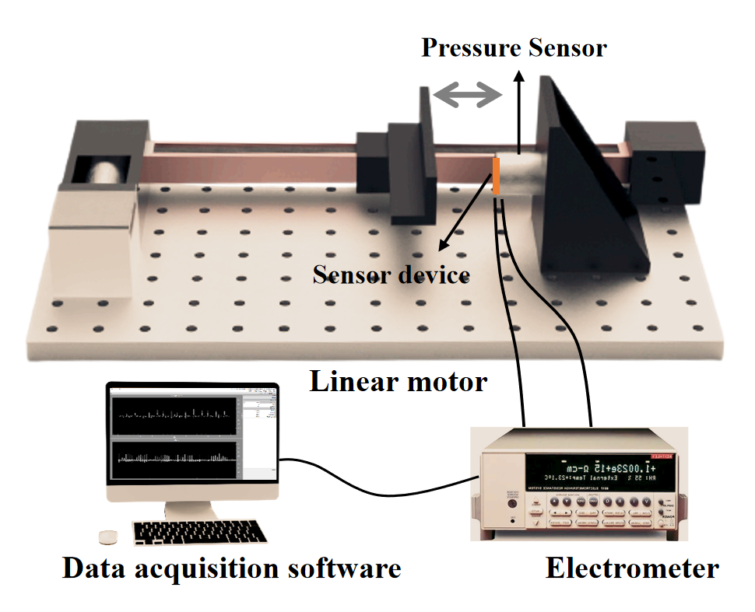
Figure S4 The schematic illustration of triboelectric sensor testing system

