Supplementary files

Supplementary table 1.

 |  | Total | OMPU Hospital | YTG Hospital | p-value
Subject number |  | 69 | 52 | 17
Demographics | Age, Years old | 73 (70, 78) | 72 (70, 77) | 75 (72, 80) | 0.149
 | BMI, kg/m² | 22.0 (20.0, 24.3) | 22.3 (20.2, 25.0) | 20.8 (19.0, 23.7) | 0.124
Laboratory index | Alb, g/dL | 4.1 (3.6, 4.3) | 4.1 (3.7, 4.3) | 3.9 (3.6, 4.2) | 0.096
 | CRP, mg/dL | 0.20 (0.10, 1.18) | 0.20 (0.05, 0.97) | 0.28 (0.12, 1.48) | 0.342
 | Hb, g/dL | 13.5 (12.1, 14.5) | 13.6 (12.3, 14.4) | 13.5 (11.3, 14.8) | 0.983
 | PLT, 10⁴/μL | 22.5 (18.2, 27.1) | 22.7 (18.8, 28.1) | 20.1 (17.1, 24.7) | 0.166
 | TLC, counts/μL | 1667 (1268, 2049) | 1606 (1289, 2100) | 1825 (1111, 2006) | 0.759
 | Neutrophile, counts/μL | 4108 (2888, 4966) | 4217 (2880, 5183) | 3784 (2867, 4829) | 0.646
 | Mono, counts/μL | 388 (302, 494) | 389 (294, 507) | 372 (312, 470) | 0.749
 | ALI | 36.02 (26.01, 46.34) | 35.65 (26.99, 46.91) | 38.30 (24.75, 46.20) | 0.759
 | HALP | 37.87 (27.01, 50.71) | 36.63 (26.77, 51.63) | 38.97 (27.78, 47.17) | 0.989
 | NLR | 2.30 (1.78, 3.38) | 2.30 (1.79, 3.42) | 2.35 (1.64, 3.35) | 0.754
 | SII, 10⁴/μL | 55.4 (37.4, 76.1) | 56.5 (38.0, 80.4) | 44.4 (31.5, 68.3) | 0.392

All data are expressed in medium (25% tile, 75% tile). Mann-Whitney's U test and the chi-square or Fisher's exact test for categorical variables.

Supplementary table 2. The list of references of ALI-related articles shown in table 4 in the text.

References and their numbers of ALI-related articles and classifications as follows: lung cancer (#1: non-small cell lung cancer (NSCLC), small cell lung cancer (SCLC), lung cancer, adenocarcinoma), non-lung cancer (#2), lifestyle-related diseases (#3), and other references (#4) and the reference numbers are shown below: reference 1 to 96 belonging to any of one category, #1,2,3, and #4.

Ref.  No | Reference | Lung  cancer | Non-Lung cancer | Life-related diseases | Others
1 | Chen Y, Guan M, Wang R, Wang X. Relationship between advanced lung cancer inflammation index and long-term all-cause, cardiovascular, and cancer mortality among type 2 diabetes mellitus patients: NHANES, 1999-2018. Front Endocrinol (Lausanne). 2023;14:1298345. doi: 10.3389/fendo.2023.1298345. |  |  | ●
2 | Song M, Zhang Q, Song C, Liu T, Zhang X, Ruan G, Tang M, Xie H, Zhang H, Ge Y, Li X, Zhang K, Yang M, Li Q, Liu X, Lin S, Xu Y, Xu H, Wang K, Li W, Shi H. The advanced lung cancer inflammation index is the optimal inflammatory biomarker of overall survival in patients with lung cancer. J Cachexia Sarcopenia Muscle. 2022;13(5):2504-2514. doi: 10.1002/jcsm.13032. | ●
3 | Liu XR, Wang LL, Zhang B, Liu XY, Li ZW, Kang B, Yuan C, Wei ZQ, Peng D. The advanced lung cancer inflammation index is a prognostic factor for gastrointestinal cancer patients undergoing surgery: a systematic review and meta-analysis. World J Surg Oncol. 2023;21(1):81. doi: 10.1186/s12957-023-02972- |  | ●
4 | Chen X, Hong C, Guo Z, Huang H, Ye L. Association between advanced lung cancer inflammation index and all-cause and cardiovascular mortality among stroke patients: NHANES, 1999-2018. Front Public Health. 2024;12:1370322. doi: 10.3389/fpubh.2024.1370322. |  |  |  | ●
5 | Tu J, Wu B, Xiu J, Deng J, Lin S, Lu J, Yan Y, Yu P, Zhu J, Chen K, Ding S, Chen L. Advanced lung cancer inflammation index is associated with long-term cardiovascular death in hypertensive patients: national health and nutrition examination study, 1999-2018. Front Physiol. 2023;14:1074672. doi: 10.3389/fphys.2023.1074672. |  |  | ●
6 | Mandaliya H, Jones M, Oldmeadow C, Nordman II. Prognostic biomarkers in stage IV non-small cell lung cancer (NSCLC): neutrophil to lymphocyte ratio (NLR), lymphocyte to monocyte ratio (LMR), platelet to lymphocyte ratio (PLR) and advanced lung cancer inflammation index (ALI). Transl Lung Cancer Res. 2019;8(6):886-894. doi: 10.21037/tlcr.2019.11.16. | ●
7 | Pang HY, Chen XF, Yan MH, Chen LH, Chen ZX, Zhang SR, Sun H. Clinical significance of the advanced lung cancer inflammation index in gastrointestinal cancer patients: a systematic review and meta-analysis. Front Oncol. 2023;13:1021672. doi: 10.3389/fonc.2023.1021672. |  | ●
8 | Horino T, Tokunaga R, Miyamoto Y, Baba H. Advanced Lung Cancer Inflammation Index: A Novel Comprehensive Biomarker of Host Status for Patients with Metastatic Colorectal Cancer. J Anus Rectum Colon. 2024;8(3):137-149. doi: 10.23922/jarc.2023-077. |  | ●
9 | Li Q, Ma F, Wang JF. Advanced lung cancer inflammation index predicts survivaloutcomes of hepatocellular carcinoma patients receiving immunotherapy. Front Oncol. 2023;13:997314. doi: 10.3389/fonc.2023.997314. |  | ●
10 | L i X, Wang Q, Wu F, Ye Z, Li Y. Association between advanced lung cancer inflammation index and chronic kidney disease: a cross-sectional study. Front Nutr. 2024;11:1430471. doi: 10.3389/fnut.2024.1430471. |  |  | ●
11 | Zhang Y, Pan Y, Tu J, Liao L, Lin S, Chen K, Ding S, Xiao G. The advanced lung cancer inflammation index predicts long-term outcomes in patients with hypertension: National  health and nutrition examination study, 1999-2014. Front Nutr. 2022;9:989914. doi: 10.3389/fnut.2022.989914. |  |  | ●
12 | Yuan X, Huang B, Wang R, Tie H, Luo S. The prognostic value of advanced lung cancer inflammation index (ALI) in elderly patients with heart failure. Front Cardiovasc Med. 2022;9:934551. doi: 10.3389/fcvm.2022.934551. |  |  |  | ●
13 | Sun X, Zhang X, Tang R, Tian J, Li Y, Hu X, Sun Z, Wu A, Xiao J, Dong M, Yao G, Lu H. Advanced lung cancer inflammation index is associated with mortality in critically ill patients with heart failure. ESC Heart Fail. 2025;12(1):508-516. doi: 10.1002/ehf2.15098. |  |  |  | ●
14 | Chen H, Zhang F, Luo D, Guo J, Lin Y, Chen S, Yin S, Chen X, Peng J, Lian L. Advanced lung cancer inflammation index predicts the outcomes of patients with non-metastatic gastric cancer after radical surgical resection. J Gastrointest Oncol. 2023;14(1):85-96. doi: 10.21037/jgo-22-657. |  | ●
15 | Alifano M. Systemic immune-inflammation index and prognosis of advanced non-small cell lung cancer. Ann Transl Med. 2020;8(11):667. doi: 10.21037/atm.2020.03.174. | ●
16 | Horino T, Tokunaga R, Miyamoto Y, Hiyoshi Y, Akiyama T, Daitoku N, Sakamoto Y, Yoshida N, Baba H. The advanced lung cancer inflammation index is a novel independent prognosticator in colorectal cancer patients after curative resection. Ann Gastroenterol Surg. 20214;6(1):83-91. doi: 10.1002/ags3.12499. |  | ●
17 | Ma Z, Wu S, Guo Y, Ouyang S, Wang N. Association of advanced lung cancer inflammation index with all-cause and cardiovascular mortality in US patients with rheumatoid arthritis. Front Nutr. 2024;11:1397326. doi: 10.3389/fnut.2024.1397326. |  |  |  | ●
18 | Chen W, Zhang G, Lei Q, Lu H. Prognostic value of advanced lung cancer inflammation index in heart failure patients: A comprehensive analysis. ESC Heart Fail. 2024 Dec 3. doi: 10.1002/ehf2.15178. Online ahead of print. |  |  |  | ●
19 | Shi T, Wang Y, Peng Y, Wang M, Zhou Y, Gu W, Li Y, Zou J, Zhu N, Chen L. Advanced lung cancer inflammation index combined with geriatric nutritional risk index predict all-cause mortality in  heart failure patients. BMC Cardiovasc Disord. 2023;23(1):565. doi: 10.1186/s12872-023-03608-x |  |  |  | ●
20 | Wang X, Wei C, Fan W, Sun L, Zhang Y, Sun Q, Liu Y, Liu J. Advanced Lung Cancer Inflammation Index for Predicting Prognostic Risk for Patients with Acute Coronary Syndrome Undergoing Percutaneous Coronary Intervention. J Inflamm Res. 2023;16:3631-3641. doi: 10.2147/JIR.S421021. |  |  |  | ●
21 | Liu J, Li S, Zhang S, Liu Y, Ma L, Zhu J, Xin Y, Wang Y, Yang C, Cheng Y. Systemic immune-inflammation index, neutrophil-to-lymphocyte ratio, platelet-to-lymphocyte ratio can predict clinical outcomes in patients with metastatic non-small-cell lung cancer treated with nivolumab. J Clin Lab Anal. 2019;33(8):e22964. doi: 10.1002/jcla.22964. | ●
22 | Zhang X, Wang D, Sun T, Li W, Dang C. Advanced lung cancer inflammation index (ALI) predicts prognosis of patients with gastric cancer after surgical resection. BMC Cancer. 20221;22(1):684. doi: 10.1186/s12885-022-09774-z. |  | ●
23 | Amin AM, Ghaly R, Elbenawi H, Ewis A, Khan U, Elshaer KSM, Abuelazm M, Abdelazeem B, Patel B, Timimi FK, Elgendy IY. Impact of advanced lung cancer inflammation index on all-cause mortality among patients with heart failure: a systematic review and meta-analysis with reconstructed time-to-event data. Cardiooncology. 2025;11(1):9. doi: 10.1186/s40959-024-00295-1. |  |  |  | ●
24 | Qiu X, Shen S, Lu D, Jiang N, Feng Y, Li J, Yang C, Xiang B. Predictive Efficacy of the Advanced Lung Cancer Inflammation Index in Hepatocellular Carcinoma After Hepatectomy. J Inflamm Res. 2024;17:5197-5210. doi: 10.2147/JIR.S468215. |  | ●
25 | Qi C, Zhou Y, Hu Z, Niu H, Yue F, An H, Chen Z, Wang P, Wang L, Duan G. The prognostic value of the advanced lung cancer inflammation index (ALI) for patients with neuroblastoma. J Int Med Res. 2022;50(6):3000605221109382. doi: 10.1177/03000605221109382 |  | ●
26 | Lan W, Zhuang W, Wang R, Wang X, Lin Z, Fu L, Zhang Y, Wen Y. Advanced lung cancer inflammation index is associated with prognosis in skin cancer patients: a retrospective cohort  study. Front Oncol. 2024;14:1365702. doi: 10.3389/fonc.2024.1365702. |  | ●
27 | Wu H, Ding F, Lin M, Shi Z, Mei Z, Chen S, Jiang C, Qiu H, Zheng Z, Chen Y, Zhao P. Use of the Advanced Lung Cancer Inflammation Index as a Prognostic Indicator for Patients With Cholangiocarcinoma. Front Surg. 2022;9:801767. doi: 10.3389/fsurg.2022.801767. |  | ●
28 | Peng L, Wang Y, Liu F, Qiu X, Zhang X, Fang C, Qian X, Li Y. Peripheral blood markers predictive of outcome and immune-related adverse events in advanced non-small cell lung cancer treated with PD-1 inhibitors. Cancer Immunol Immunother. 2020;69(9):1813-1822. doi: 10.1007/s00262-020-02585-w. | ●
29 | Kobayashi S, Karube Y, Inoue T, Araki O, Maeda S, Matsumura Y, Chida M. Advanced Lung Cancer Inflammation Index Predicts Outcomes of Patients with Pathological Stage IA Lung Adenocarcinoma Following Surgical Resection. Ann Thorac Cardiovasc Surg. 2019;25(2):87-94. doi: 10.5761/atcs.oa.18-00158. | ●
30 | Gaudioso P, Borsetto D, Tirelli G, Tofanelli M, Cragnolini F, Menegaldo A, Fabbris C, Molteni G, Marchioni D, Nicolai P, Bossi P, Ciorba A, Pelucchi S, Bianchini C, Mauramati S, Benazzo M, Giacomarra V, Di Carlo R, Sethi M, Polesel J, Fussey J, Boscolo-Rizzo P. Advanced lung cancer inflammation index and its prognostic value in HPV-negative head and neck squamous cell carcinoma: a multicentre study. Support Care Cancer. 2021;29(8):4683-4691. doi: 10.1007/s00520-020-05979-9. |  | ●
31 | Jin Z, Sun W, Huang J, Wang G. Association between advanced lung cancer inflammation index and unstable asthma: a population-based study from the NHANES 2007-2018. Front Nutr. 2024;11:1482328. doi: 10.3389/fnut.2024.1482328. |  |  |  | ●
32 | Hu Z, Wu W, Zhang X, Li P, Zhang H, Wang H, Xue W, Chen Z, Zhao Q, Duan G. Advanced Lung Cancer Inflammation Index is a Prognostic Factor of Patients with Small-Cell Lung Cancer Following Surgical Resection. Cancer Manag Res. 2021;13:2047-2055. doi: 10.2147/CMAR.S295952. | ●
33 | Pang H, Dai L, Chen L, Chen X, Chen Z, Zhang S, Sun H. Prognostic value of the advanced lung cancer inflammation index in patients with gastric cancer after radical gastrectomy: a propensity-score matching cohort study and meta-analysis. BMC Cancer. 2024;24(1):583. doi: 10.1186/s12885-024-12349-9. |  | ●
34 | Andersen BL, Myers J, Blevins T, Park KR, Smith RM, Reisinger S, Carbone DP, Presley CJ, Shields PG, Carson WE. Depression in association with neutrophil-to-lymphocyte, platelet-to-lymphocyte, and advanced lung cancer inflammation index biomarkers predicting lung cancer survival. PLoS One. 2023;18(2):e0282206. doi: 10.1371/journal.pone.0282206. | ●
35 | Tsai YT, Hsu CM, Chang GH, Tsai MS, Lee YC, Huang EI, Lai CH, Fang KH. Advanced Lung Cancer Inflammation Index Predicts Survival Outcomes of Patients With Oral Cavity Cancer Following Curative Surgery. Front Oncol. 2021;11:609314. doi: 10.3389/fonc.2021.609314. |  | ●
36 | Xu Y, Yan Z, Liu L. Association between advanced lung cancer inflammation index and osteoporosis in patients with type 2 diabetes mellitus: evidence from NHANES. Front Endocrinol (Lausanne). 2024;15:1421696. doi: 10.3389/fendo.2024.1421696. |  |  | ●
37 | Ma S, Li Z, Wang L. The advanced lung cancer inflammation index (ALI) predicted the postoperative survival rate of patients with non-small cell lung cancer and the construction of a nomogram model. World J Surg Oncol. 2024;22(1):158. doi: 10.1186/s12957-024-03432-3. | ●
38 | Fu J, Zou Y, Luo L, Zhang J, Wang X, Zhang D. Associations of advanced lung cancer inflammation index with all-cause and respiratory disease mortality in adults with asthma: NHANES, 1999-2018. Sci Rep. 2024;14(1):29693. doi: 10.1038/s41598-024-80983-1. |  |  |  | ●
39 | Li Q, Ma F, Tsilimigras DI, Åberg F, Wang JF. The value of the Advanced Lung Cancer Inflammation Index (ALI) in assessing the prognosis of patients with hepatocellular carcinoma treated with camrelizumab: a retrospective cohort study. Ann Transl Med. 2022;10(22):1233. doi: 10.21037/atm-22-5099. |  | ●
40 | Ren Z, Wu J, Wu S, Zhang M, Shen S. The advanced lung cancer inflammation index is associated with mortality in peritoneal dialysis patients. BMC Nephrol. 2024;25(1):208. doi: 10.1186/s12882-024-03645-4. |  |  |  | ●
41 | Lu P, Ma Y, Kai J, Wang J, Yin Z, Xu H, Li X, Liang X, Wei S, Liang X. A Low Advanced Lung Cancer Inflammation Index Predicts a Poor Prognosis in Patients With Metastatic Non-Small Cell  Lung Cancer. Front Mol Biosci. 2022;8:784667. doi: 10.3389/fmolb.2021.784667. | ●
42 | Huo C, Liu Y, Xie F, Zhao L, Huang H, Feng Q. Advanced lung cancer inflammation index predicts the outcomes of patients with non-metastatic gastric cancer after radical surgical resection.  J Gastrointest Oncol. 2023;14(3):1653-1654. doi: 10.21037/jgo-23-315. |  | ●
43 | Cheng J, Li Q, Xiao S, Nie L, Liao J, Jiang Q, Xiang B, Zhang H, Jiang Y, Yao C.The advanced lung cancer inflammation index predicts chemotherapy response and infection risk in multiple myeloma patients receiving induction chemotherapy. Front Genet. 2022;13:1047326. doi: 10.3389/fgene.2022.1047326. |  | ●
44 | Zhang L, Zhao K, Kuang T, Wang K, Chai D, Qiu Z, Liu R, Deng W, Wang W. The prognostic value of the advanced lung cancer inflammation index in patients with gastrointestinal malignancy.  BMC Cancer. 2023;23(1):101. doi: 10.1186/s12885-023-10570-6. |  | ●
45 | Mao W, Wang K, Wu Y, Ni J, Zhang H, Wang Y, Wu Z, Liu R, Geng J, Chen S, Chen M. Prognostic Significance of Modified Advanced Lung Cancer Inflammation Index in Patients With Renal Cell Carcinoma Undergoing Laparoscopic Nephrectomy: A Multi-Institutional, Propensity Score Matching Cohort Study. Front Nutr. 2022;8:781647. doi: 10.3389/fnut.2021.781647. |  | ●
46 | Mountzios G, Samantas E, Senghas K, Zervas E, Krisam J, Samitas K, Bozorgmehr F, Kuon J, Agelaki S, Baka S, Athanasiadis I, Gaissmaier L, Elshiaty M, Daniello L, Christopoulou A, Pentheroudakis G, Lianos E, Linardou H, Kriegsmann K, Kosmidis P, El Shafie R, Kriegsmann M, Psyrri A, Andreadis C, Fountzilas E, Heussel CP, Herth FJ, Winter H, Emmanouilides C, Oikonomopoulos G, Meister M, Muley T, Bischoff H, Saridaki Z, Razis E, Perdikouri EI, Stenzinger A, Boukovinas I, Reck M, Syrigos K, Thomas M, Christopoulos P. Association of the advanced lung cancer inflammation index (ALI) with immune checkpoint inhibitor efficacy in patients with advanced non-small-cell lung cancer. ESMO Open. 2021;6(5):100254. doi: 10.1016/j.esmoop.2021.100254. | ●
47 | Hua X, Chen J, Wu Y, Sha J, Han S, Zhu X. Prognostic role of the advanced lung cancer inflammation index in cancer patients: a meta-analysis. World J Surg Oncol. 2019;17(1):177. doi: 10.1186/s12957-019-1725-2. |  | ●
48 | Tian X, Qu Z, Sun Y, Zhang B. Association between the advanced lung cancer inflammation index and all-cause and cardiovascular mortality in patients with RA: Insights from NHANES data analysis. Heliyon. 2024;10(13):e33673. doi: 10.1016/j.heliyon.2024.e33673. |  |  |  | ●
49 | Wang H, Shi Y, Shi Y, Cao M, Zhang L, Wu Y, Xu Y, Wang K, Weng X. The Prognostic Value and Potential Mechanism of Tumor-Nutrition-Inflammation Index and Genes in Patients with  Advanced Lung Cancer. Int J Clin Pract. 2023;2023:8893670. doi: 10.1155/2023/8893670. | ●
50 | Wen YZ, Liu GM, Liao JP, Xu JW. Advanced lung cancer inflammation index predicts overall survival of hepatocellular carcinoma after hepatectomy. Front Oncol. 2024;14:1294253. doi: 10.3389/fonc.2024.1294253. |  | ●
51 | Li T, Wang Q, Li Y, Zhang W, Chen M, Deng B, Liang L, Lin W, Lin Y, Meng Y. Predictive effects of advanced lung cancer inflammation index and serum vitamin D on mortality in patients with  asthma. Nutr J. 2025;24(1):26. doi: 10.1186/s12937-024-01065-6. |  |  |  | ●
52 | Jafri SH, Previgliano C, Khandelwal K, Shi R. Cachexia Index in Advanced Non-Small-Cell Lung Cancer Patients. Clin Med Insights Oncol. 2015;9:87-93. doi: 10.4137/CMO.S30891. | ●
53 | Bozkuş F, Keskin O. The Prognostic Role of Advanced Lung Cancer Inflammation Index in Patients with Idiopathic Pulmonary Fibrosis. J Clin Med. 2024;13(19):5874. doi: 10.3390/jcm13195874. |  |  |  | ●
54 | Topkan E, Mertsoylu H, Ozdemir Y, Sezer A, Kucuk A, Besen AA, Ozyilkan O, Selek U. Prognostic Usefulness Of Advanced Lung Cancer Inflammation Index In Locally-Advanced Pancreatic Carcinoma Patients Treated With Radical Chemoradiotherapy. Cancer Manag Res. 201;11:8807-8815. doi: 10.2147/CMAR.S222297. |  | ●
55 | Mahajan A, Goyal D, Agarwal U, Patil V, Shukla S, Noronha V, Joshi A, Menon N, Prabhash K. Exploring the implications of modified advanced lung cancer inflammation index on outcomes in patients with advanced non-small cell lung cancer. Explor Target Antitumor Ther. 2023;4(5):896-911. doi: 10.37349/etat.2023.00172. | ●
56 | Deng Y, Sun Y, Lin Y, Huang Y, Chi P. Clinical implication of the advanced lung cancer inflammation index in patients with right-sided colon cancer after complete mesocolic excision: a propensity score-matched analysis. World J Surg Oncol. 2022;20(1):246. doi: 10.1186/s12957-022-02712-0 |  | ●
57 | Cheng X, Dong Y, Lou F. The Predictive Significance of the Advanced Lung Cancer Inflammation Index (ALI) in Patients with Melanoma Treated with Immunotherapy as Second-Line Therapy.  Cancer Manag Res. 2021;13:173-180. doi: 10.2147/CMAR.S286453. |  | ●
58 | Huang Y, Wang X, Li Z, Yin X. A novel nutritional inflammation index for predicting mortality in acute ischemic stroke patients: insights into advanced lung cancer inflammation index from the Medical Information Mart for Intensive Care-IV database. Front Nutr. 2024;11:1408372. doi: 10.3389/fnut.2024.1408372. |  |  |  | ●
59 | Topkan E, Ozdemir Y, Kucuk A, Guler OC, Sezer A, Besen AA, Mertsoylu H, Senyurek S, Kilic Durankus N, Bolukbasi Y, Selek U, Pehlivan B. Low Advanced Lung Cancer Inflammation Index Predicts Poor Prognosis in Locally Advanced Nasopharyngeal Carcinoma Patients Treated with Definitive Concurrent Chemoradiotherapy. J Oncol. 2020;2020:3127275. doi: 10.1155/2020/3127275. |  | ●
60 | Konuş AH, Özderya A, Çırakoğlu ÖF, Sayın MR, Yerlikaya MG. The relationship between advanced lung cancer inflammation index and high SYNTAX score in patients with non-STelevation myocardial infarction. Postepy Kardiol Interwencyjnej. 2024;20(3):277-284. doi: 10.5114/aic.2024.142239. |  |  |  | ●
61 | Seo BM, Choi J, Chang B, Kim BG, Park TS, Lee H, Moon JY, Kim SH, Kim TH, Yoo SJ, Park HJ, Yoon HJ, Sohn JW, Lee SH, Park DW. Clinical significance of the advanced lung cancer inflammation index in patients with limited-stage small cell lung cancer treated with chemoradiotherapy. Sci Rep. 2024;14(1):10347. doi: 10.1038/s41598-024-61145-9. | ●
62 | Han Z, Hu Z, Zhao Q, Xue W, Duan G.The advanced lung cancer inflammation index predicts outcomes of patients with non-small cell lung cancer following video-assisted thoracic surgery. J Int Med Res. 2021;49(12):3000605211062442. doi: 10.1177/03000605211062442. | ●
63 | Xie H, Huang S, Yuan G, Kuang J, Yan L, Wei L, Tang S, Gan J. The advanced lung cancer inflammation index predicts short and long-term outcomes in patients with colorectal cancer following surgical resection: a retrospective study. PeerJ. 2020;8:e10100. doi: 10.7717/peerj.10100. |  | ●
64 | Zhou J, Liu W, Liu X, Wu J, Chen Y. Independent and joint influence of depression and advanced lung cancer inflammation index on mortality among individuals with chronic kidney disease. Front Nutr. 2024;11:1453062. doi: 10.3389/fnut.2024.1453062. |  |  | ●
65 | Tan X, Peng H, Gu P, Chen M, Wang Y. Prognostic Significance of the L3 Skeletal Muscle Index and Advanced Lung Cancer Inflammation Index in Elderly Patients with Esophageal Cancer. Cancer Manag Res. 2021;13:3133-3143. doi: 10.2147/CMAR.S304996. |  | ●
66 | Trimarchi G, Pizzino F, Lilli A, De Caterina AR, Esposito A, Dalmiani S, Mazzone A, Di Bella G, Berti S, Paradossi U. Advanced Lung Cancer Inflammation Index as Predictor of All-Cause Mortality in ST-Elevation Myocardial Infarction Patients Undergoing Primary Percutaneous Coronary Intervention. J Clin Med. 2024;13(20):6059. doi: 10.3390/jcm13206059. |  |  |  | ●
67 | Fan W, Zhang Y, Liu Y, Ding Z, Si Y, Shi F, Liu J, Sun L. Nomograms Based on the Advanced Lung Cancer Inflammation Index for the Prediction of Coronary Artery Disease and Calcification. Clin Appl Thromb Hemost. 2021:10760296211060455. doi: 10.1177/10760296211060455. |  |  |  | ●
68 | Ürün M, Güner G, Sezgin Y, Uysal E, Sakin A, Kilickap S. Prognostic Significance of the Advanced Lung Cancer Inflammation Index in Metastatic Small Cell Lung Cancer: A Retrospective Analysis of 96 Patients. Med Sci Monit. 2024;30:e945752. doi: 10.12659/MSM.945752. | ●
69 | Sun W, Zhang P, Ye B, Situ MY, Wang W, Yu Y. Systemic immune-inflammation index predicts survival in patients with resected lung invasive mucinous adenocarcinoma. Transl Oncol. 2024;40:101865. doi: 10.1016/j.tranon.2023.101865. | ●
70 | Yang F, Gao L, Xu C, Wang Q, Gao W. Association between advanced lung cancer inflammation index and in-hospital mortality in ICU patients with community-acquired pneumonia: A retrospective analysis of the MIMIC-IV database. Aging Med (Milton). 202;7(3):350-359. doi: 10.1002/agm2.12334. |  |  |  | ●
71 | Barth DA, Brenner C, Riedl JM, Prinz F, Klocker EV, Schlick K, Kornprat P, Lackner K, Stöger H, Stotz M, Gerger A, Pichler M. External validation of the prognostic relevance of the advanced lung cancer inflammation index (ALI) in pancreatic cancer patients. Cancer Med. 2020;9(15):5473-5479. doi: 10.1002/cam4.3233. |  | ●
72 | Hosoda K, Shimizu A, Kubota K, Notake T, Kitagawa N, Yoshizawa T, Sakai H, Hayashi H, Yasukawa K, Soejima Y. Combination of advanced lung cancer inflammation index and nonalcoholic fatty liver disease fibrosis score as a promising marker for surgical procedure selection for hepatocellular carcinoma. Ann Gastroenterol Surg. 2024;8(6):1096-1106. doi: 10.1002/ags3.12815 |  |  | ●
73 | Chantharakhit C, Sujaritvanichpong N.Prognostic Impact of the Advanced Lung Cancer Inflammation Index (ALI) in Metastatic Non-Small Cell Lung Cancer Treated with First Line Chemotherapy. Asian Pac J Cancer Prev. 202;22(4):1149-1156. doi: 10.31557/APJCP.2021.22.4.1149. | ●
74 | Shibutani M, Maeda K, Nagahara H, Fukuoka T, Matsutani S, Kimura K, Amano R, Hirakawa K, Ohira M. The prognostic significance of the advanced lung cancer inflammation index in patients with unresectable metastatic colorectal cancer: a retrospective study. BMC Cancer. 2019;19(1):241. doi: 10.1186/s12885-019-5468-9. |  | ●
75 | Bacha S, Sghaier A, Habibech S, Cheikhrouhou S, Racil H, Chaouch N, Chabbou A, Megdiche ML. Advanced Lung Cancer Inflammation index: a prognostic score in patients with metastatic non-small cell lung cancer. Tunis Med. 2017e;95(11):976-981. | ●
76 | Li Q, Ma F, Wang JF. Corrigendum: Advanced lung cancer inflammation index predicts survival outcomes of hepatocellular carcinoma patients receiving immunotherapy. Front Oncol. 2024;14:1431058. doi: 10.3389/fonc.2024.1431058. |  | ●
77 | Inoue A, Takahashi H, Ibe T, Ishii H, Kurata Y, Ishizuka Y, Batsaikhan B, Hamamoto Y. Application of the advanced lung cancer inflammation index for patients with coronavirus disease 2019 pneumonia: Combined risk prediction model with advanced lung cancer inflammation index, computed tomography and chest radiograph. Exp Ther Med. 2022;23(6):388. doi: 10.3892/etm.2022.11315. |  |  |  | ●
78 | Wang Y, Lin L, Ji Y, Mei X, Zhao C, Chen Y, Che G. Prognostic value of the advanced lung cancer inflammation index in early-stage non-small cell lung cancer patients undergoing video-assisted thoracoscopic pulmonary resection. Ann Palliat Med. 2020;9(3):721-729. doi: 10.21037/apm.2020.03.18. | ●
79 | Hashimoto I, Tanabe M, Onuma S, Morita J, Nagasawa S, Maezawa Y, Kanematsu K, Aoyama T, Yamada T, Ogata T, Yukawa N, Rino Y, Saito A, Oshima T. A propensity-matched analysis of the prognostic value of advanced lung cancer inflammation index in patients with gastric cancer after curative resection. Oncol Lett. 2024;27(6):285. doi: 10.3892/ol.2024.14418. |  | ●
80 | Huang Q, Lin L, Li J, Lin J, Zeng Z, Fu Y, Qiu J, Zheng J. Associations Between Advanced Lung Cancer Inflammation Index and Chronic Pain: Insights From National Health and Nutrition Examination Survey (NHANES) 1999-2004. Immun Inflamm Dis. 2024;12(11):e70053. doi: 10.1002/iid3.70053. |  |  |  | ●
81 | Liu B, Jin L, Nan B, Sun Z, Chen F, Zhou Y, Sa Q, Feng Y, Men A, Wang W, Feng X, Zhang W. Positive association between advanced lung cancer inflammation index and gallstones, with greater impact on women: a cross-sectional study of the NHANES database. Front Nutr. 2024;11:1506477. doi: 10.3389/fnut.2024.1506477. |  |  |  | ●
82 | Ozturk AE, Komurcuoglu B, Karakurt GK, Ozturk O. Prognostic value of diffuse cancer inflammation index (ALI), serum neutrophil/lymphocyte (NLR) and platelet/lymphocyte (PLR) in advanced-stage lung cancer. J Cancer Res Ther. 2024;20(3):893-897. doi: 10.4103/jcrt.JCRT_1762_20. | ●
83 | Zhang Y, Chen B. Prognostic Value of the Advanced Lung Cancer Inflammation Index in Patients with Lung Cancer: A Meta-Analysis. Dis Markers. 2019;2019:2513026. doi: 10.1155/2019/2513026. | ●
84 | Jafri SH, Shi R, Mills G. Advance lung cancer inflammation index (ALI) at diagnosis is a prognostic marker in patients with metastatic non-small cell lung cancer (NSCLC): a retrospective review. BMC Cancer. 2013;13:158. doi: 10.1186/1471-2407-13-158. | ●
85 | Tian TL, Qu XK, Zhang HB, Wang CC, Yuan QQ, Xia J, Cao LF, Liu K. Association between advanced lung cancer inflammation index and all-cause and cause-specific mortality among  asthma patients: a cohort study. Front Nutr. 2025;12:1519271. doi: 10.3389/fnut.2025.1519271. |  |  |  | ●
86 | Liu T, Ye F, Li Y, Liu A. Comparison and exploration of the prognostic value of the advanced lung cancer inflammation index, prognostic nutritional index, and systemic immune-inflammation index in newly diagnosed diffuse large B-cell lymphoma. Ann Palliat Med. 2021;10(9):9650-9659. doi: 10.21037/apm-21-2067. |  | ●
87 | Shiroyama T, Suzuki H, Tamiya M, Tamiya A, Tanaka A, Okamoto N, Nakahama K, Taniguchi Y, Isa SI, Inoue T, Imamura F, Atagi S, Hirashima T. Pretreatment advanced lung cancer inflammation index (ALI) for predicting early progression in nivolumab-treated patients with advanced non-small cell lung cancer. Cancer Med. 2018;7(1):13-20. doi: 10.1002/cam4.1234. | ●
88 | Gong M, Sasmita BR, Zhu Y, Chen S, Wang Y, Xiang Z, Jiang Y, Luo S, Huang B. Prognostic Value of the Advanced Lung Cancer Inflammation Index Ratio in Patients with Acute Myocardial Infarction Complicated by Cardiogenic Shock: A Cohort Study. Rev Cardiovasc Med. 2024;25(7):267. doi: 10.31083/j.rcm2507267. |  |  |  | ●
89 | Zhao G, Tang W, Yang C, Liu X, Huang J. The Prognostic Value of Advanced Lung Cancer Inflammation Index in Elderly Patients with Acute Coronary Syndrome Undergoing Percutaneous Coronary Intervention. Int Heart J. 202;65(4):621-629. doi: 10.1536/ihj.24-046. |  |  |  | ●
90 | Jiang H, Li B, Wu M, Wang Q, Li Y. Association of the Advanced Lung Cancer Inflammation Index (ALI) and Gustave Roussy Immune (GRIm) score with immune checkpoint inhibitor efficacy in patients with gastrointestinal and lung cancer. BMC Cancer. 202;24(1):428. doi: 10.1186/s12885-024-12149-1. | ●
91 | Liu Y, Wang R. Advanced lung cancer inflammation index: a key predictor of hepatic steatosis and fibrosis severity. BMC Gastroenterol. 2025;25(1):106. doi: 10.1186/s12876-024-03544-w. |  |  | ●
92 | Hatayama T, Goto K, Kohada Y, Nishida K, Ueno T, Furutani T, Hashimoto K, Takemoto K, Naito M, Miyamoto S, Kobatake K, Sekino Y, Kitano H, Goriki A, Hieda K, Hinata N. The advanced lung cancer inflammation index as a useful prognostic indicator for patients who underwent radical nephroureterectomy for upper tract urothelial carcinoma. World J Urol. 2025;43(1):132. doi: 10.1007/s00345-025-05505-8. |  | ●
93 | Kim EY, Kim N, Kim YS, Seo JY, Park I, Ahn HK, Jeong YM, Kim JH. Prognostic Significance of Modified Advanced Lung Cancer Inflammation Index (ALI) in Patients with Small Cell Lung  Cancer_ Comparison with Original ALI. PLoS One. 2016;11(10):e0164056. doi: 10.1371/journal.pone.0164056. | ●
94 | Tomita M, Ayabe T, Maeda R, Nakamura K. Combination of Advanced Lung Cancer Inflammation Index and C-Reactive Protein Is a Prognostic Factor in Patients With Operable Non-Small Cell Lung Cancer. World J Oncol. 2017;8(6):175-179. doi: 10.14740/wjon1076w. | ●
95 | He K, Si L, Pan X, Sun L, Wang Y, Lu J, Wang X. Preoperative Systemic Immune-Inflammation Index (SII) as a Superior Predictor of Long-Term Survival Outcome in Patients With Stage I-II Gastric Cancer After Radical Surgery. Front Oncol. 2022;12:829689. doi: 10.3389/fonc.2022.829689. |  | ●
96 | Hu BL, Chen LH, Xu JQ, Wang ZZ, Yu YW, Han YX, Huang J, Shen WY. [The prognostic value of lower pretreatment advanced lung cancer inflammation index (ALI) in B cell lymphoma]. Zhonghua Xue Ye Xue Za Zhi. 20184;39(1):53-55. doi: 10.3760/cma.j.issn.0253-2727.2018.01.012 |  | ●

Ref.No | Reference | Lung  cancer | Non-Lung cancer | Life-related diseases | Others
1 | Chen Y, Guan M, Wang R, Wang X. Relationship between advanced lung cancer inflammation index and long-term all-cause, cardiovascular, and cancer mortality among type 2 diabetes mellitus patients: NHANES, 1999-2018. Front Endocrinol (Lausanne). 2023;14:1298345. doi: 10.3389/fendo.2023.1298345. |  |  | ●
2 | Song M, Zhang Q, Song C, Liu T, Zhang X, Ruan G, Tang M, Xie H, Zhang H, Ge Y, Li X, Zhang K, Yang M, Li Q, Liu X, Lin S, Xu Y, Xu H, Wang K, Li W, Shi H. The advanced lung cancer inflammation index is the optimal inflammatory biomarker of overall survival in patients with  lung cancer. J Cachexia Sarcopenia Muscle. 2022;13(5):2504-2514. doi: 10.1002/jcsm.13032. | ●
3 | Liu XR, Wang LL, Zhang B, Liu XY, Li ZW, Kang B, Yuan C, Wei ZQ, Peng D. The advanced lung cancer inflammation index is a prognostic factor for gastrointestinal cancer patients undergoing  surgery: a systematic review and meta-analysis. World J Surg Oncol. 2023;21(1):81. doi: 10.1186/s12957-023-02972- |  | ●
4 | Chen X, Hong C, Guo Z, Huang H, Ye L. Association between advanced lung cancer inflammation index and all-cause and cardiovascular mortality among stroke patients: NHANES, 1999-2018. Front Public Health. 2024;12:1370322. doi: 10.3389/fpubh.2024.1370322. |  |  |  | ●
5 | Tu J, Wu B, Xiu J, Deng J, Lin S, Lu J, Yan Y, Yu P, Zhu J, Chen K, Ding S, Chen L. Advanced lung cancer inflammation index is associated with long-term cardiovascular death in hypertensive patients: national health and nutrition examination study, 1999-2018. Front Physiol. 2023;14:1074672. doi: 10.3389/fphys.2023.1074672. |  |  | ●
6 | Mandaliya H, Jones M, Oldmeadow C, Nordman II. Prognostic biomarkers in stage IV non-small cell lung cancer (NSCLC): neutrophil to lymphocyte ratio (NLR), lymphocyte to monocyte ratio (LMR), platelet to lymphocyte ratio (PLR) and advanced lung cancer inflammation index (ALI). Transl Lung Cancer Res. 2019;8(6):886-894. doi: 10.21037/tlcr.2019.11.16. | ●
7 | Pang HY, Chen XF, Yan MH, Chen LH, Chen ZX, Zhang SR, Sun H. Clinical significance of the advanced lung cancer inflammation index in gastrointestinal cancer patients: a systematic review and meta-analysis. Front Oncol. 2023;13:1021672. doi: 10.3389/fonc.2023.1021672. |  | ●
8 | Horino T, Tokunaga R, Miyamoto Y, Baba H. Advanced Lung Cancer Inflammation Index: A Novel Comprehensive Biomarker of Host Status for Patients with Metastatic Colorectal Cancer. J Anus Rectum Colon. 2024;8(3):137-149. doi: 10.23922/jarc.2023-077. |  | ●
9 | Li Q, Ma F, Wang JF. Advanced lung cancer inflammation index predicts survivaloutcomes of hepatocellular carcinoma patients receiving immunotherapy. Front Oncol. 2023;13:997314. doi: 10.3389/fonc.2023.997314. |  | ●
10 | L i X, Wang Q, Wu F, Ye Z, Li Y. Association between advanced lung cancer inflammation index and chronic kidney disease: a cross-sectional study. Front Nutr. 2024;11:1430471. doi: 10.3389/fnut.2024.1430471. |  |  | ●
11 | Zhang Y, Pan Y, Tu J, Liao L, Lin S, Chen K, Ding S, Xiao G. The advanced lung cancer inflammation index predicts long-term outcomes in patients with hypertension: National  health and nutrition examination study, 1999-2014. Front Nutr. 2022;9:989914. doi: 10.3389/fnut.2022.989914. |  |  | ●
12 | Yuan X, Huang B, Wang R, Tie H, Luo S. The prognostic value of advanced lung cancer inflammation index (ALI) in elderly patients with heart failure. Front Cardiovasc Med. 2022;9:934551. doi: 10.3389/fcvm.2022.934551. |  |  |  | ●
13 | Sun X, Zhang X, Tang R, Tian J, Li Y, Hu X, Sun Z, Wu A, Xiao J, Dong M, Yao G, Lu H. Advanced lung cancer inflammation index is associated with mortality in critically ill patients with heart failure. ESC Heart Fail. 2025;12(1):508-516. doi: 10.1002/ehf2.15098. |  |  |  | ●
14 | Chen H, Zhang F, Luo D, Guo J, Lin Y, Chen S, Yin S, Chen X, Peng J, Lian L. Advanced lung cancer inflammation index predicts the outcomes of patients with non-metastatic gastric cancer after radical surgical resection. J Gastrointest Oncol. 2023;14(1):85-96. doi: 10.21037/jgo-22-657. |  | ●
15 | Alifano M. Systemic immune-inflammation index and prognosis of advanced non-small cell lung cancer. Ann Transl Med. 2020;8(11):667. doi: 10.21037/atm.2020.03.174. | ●
16 | Horino T, Tokunaga R, Miyamoto Y, Hiyoshi Y, Akiyama T, Daitoku N, Sakamoto Y, Yoshida N, Baba H. The advanced lung cancer inflammation index is a novel independent prognosticator in colorectal cancer patients after curative resection. Ann Gastroenterol Surg. 20214;6(1):83-91. doi: 10.1002/ags3.12499. |  | ●
17 | Ma Z, Wu S, Guo Y, Ouyang S, Wang N. Association of advanced lung cancer inflammation index with all-cause and cardiovascular mortality in US patients with rheumatoid arthritis. Front Nutr. 2024;11:1397326. doi: 10.3389/fnut.2024.1397326. |  |  |  | ●
18 | Chen W, Zhang G, Lei Q, Lu H. Prognostic value of advanced lung cancer inflammation index in heart failure patients: A comprehensive analysis. ESC Heart Fail. 2024 Dec 3. doi: 10.1002/ehf2.15178. Online ahead of print. |  |  |  | ●
19 | Shi T, Wang Y, Peng Y, Wang M, Zhou Y, Gu W, Li Y, Zou J, Zhu N, Chen L. Advanced lung cancer inflammation index combined with geriatric nutritional risk index predict all-cause mortality in  heart failure patients. BMC Cardiovasc Disord. 2023;23(1):565. doi: 10.1186/s12872-023-03608-x |  |  |  | ●
20 | Wang X, Wei C, Fan W, Sun L, Zhang Y, Sun Q, Liu Y, Liu J. Advanced Lung Cancer Inflammation Index for Predicting Prognostic Risk for Patients with Acute Coronary Syndrome Undergoing Percutaneous Coronary Intervention. J Inflamm Res. 2023;16:3631-3641. doi: 10.2147/JIR.S421021. |  |  |  | ●
21 | Liu J, Li S, Zhang S, Liu Y, Ma L, Zhu J, Xin Y, Wang Y, Yang C, Cheng Y. Systemic immune-inflammation index, neutrophil-to-lymphocyte ratio, platelet-to-lymphocyte ratio can predict clinical outcomes in patients with metastatic non-small-cell lung cancer treated with nivolumab. J Clin Lab Anal. 2019;33(8):e22964. doi: 10.1002/jcla.22964. | ●
22 | Zhang X, Wang D, Sun T, Li W, Dang C. Advanced lung cancer inflammation index (ALI) predicts prognosis of patients with gastric cancer after surgical resection. BMC Cancer. 20221;22(1):684. doi: 10.1186/s12885-022-09774-z. |  | ●
23 | Amin AM, Ghaly R, Elbenawi H, Ewis A, Khan U, Elshaer KSM, Abuelazm M, Abdelazeem B, Patel B, Timimi FK, Elgendy IY. Impact of advanced lung cancer inflammation index on all-cause mortality among patients with heart failure: a systematic review and meta-analysis with reconstructed time-to-event data. Cardiooncology. 2025;11(1):9. doi: 10.1186/s40959-024-00295-1. |  |  |  | ●
24 | Qiu X, Shen S, Lu D, Jiang N, Feng Y, Li J, Yang C, Xiang B. Predictive Efficacy of the Advanced Lung Cancer Inflammation Index in Hepatocellular Carcinoma After Hepatectomy. J Inflamm Res. 2024;17:5197-5210. doi: 10.2147/JIR.S468215. |  | ●
25 | Qi C, Zhou Y, Hu Z, Niu H, Yue F, An H, Chen Z, Wang P, Wang L, Duan G. The prognostic value of the advanced lung cancer inflammation index (ALI) for patients with neuroblastoma. J Int Med Res. 2022;50(6):3000605221109382. doi: 10.1177/03000605221109382 |  | ●
26 | Lan W, Zhuang W, Wang R, Wang X, Lin Z, Fu L, Zhang Y, Wen Y. Advanced lung cancer inflammation index is associated with prognosis in skin cancer patients: a retrospective cohort  study. Front Oncol. 2024;14:1365702. doi: 10.3389/fonc.2024.1365702. |  | ●
27 | Wu H, Ding F, Lin M, Shi Z, Mei Z, Chen S, Jiang C, Qiu H, Zheng Z, Chen Y, Zhao P. Use of the Advanced Lung Cancer Inflammation Index as a Prognostic Indicator for Patients With Cholangiocarcinoma. Front Surg. 2022;9:801767. doi: 10.3389/fsurg.2022.801767. |  | ●
28 | Peng L, Wang Y, Liu F, Qiu X, Zhang X, Fang C, Qian X, Li Y. Peripheral blood markers predictive of outcome and immune-related adverse events in advanced non-small cell lung cancer treated with PD-1 inhibitors. Cancer Immunol Immunother. 2020;69(9):1813-1822. doi: 10.1007/s00262-020-02585-w. | ●
29 | Kobayashi S, Karube Y, Inoue T, Araki O, Maeda S, Matsumura Y, Chida M. Advanced Lung Cancer Inflammation Index Predicts Outcomes of Patients with Pathological Stage IA Lung Adenocarcinoma Following Surgical Resection. Ann Thorac Cardiovasc Surg. 2019;25(2):87-94. doi: 10.5761/atcs.oa.18-00158. | ●
30 | Gaudioso P, Borsetto D, Tirelli G, Tofanelli M, Cragnolini F, Menegaldo A, Fabbris C, Molteni G, Marchioni D, Nicolai P, Bossi P, Ciorba A, Pelucchi S, Bianchini C, Mauramati S, Benazzo M, Giacomarra V, Di Carlo R, Sethi M, Polesel J, Fussey J, Boscolo-Rizzo P. Advanced lung cancer inflammation index and its prognostic value in HPV-negative head and neck squamous cell carcinoma: a multicentre study. Support Care Cancer. 2021;29(8):4683-4691. doi: 10.1007/s00520-020-05979-9. |  | ●
31 | Jin Z, Sun W, Huang J, Wang G. Association between advanced lung cancer inflammation index and unstable asthma: a population-based study from the NHANES 2007-2018. Front Nutr. 2024;11:1482328. doi: 10.3389/fnut.2024.1482328. |  |  |  | ●
32 | Hu Z, Wu W, Zhang X, Li P, Zhang H, Wang H, Xue W, Chen Z, Zhao Q, Duan G. Advanced Lung Cancer Inflammation Index is a Prognostic Factor of Patients with Small-Cell Lung Cancer Following Surgical Resection. Cancer Manag Res. 2021;13:2047-2055. doi: 10.2147/CMAR.S295952. | ●
33 | Pang H, Dai L, Chen L, Chen X, Chen Z, Zhang S, Sun H. Prognostic value of the advanced lung cancer inflammation index in patients with gastric cancer after radical gastrectomy: a propensity-score matching cohort study and meta-analysis. BMC Cancer. 2024;24(1):583. doi: 10.1186/s12885-024-12349-9. |  | ●
34 | Andersen BL, Myers J, Blevins T, Park KR, Smith RM, Reisinger S, Carbone DP, Presley CJ, Shields PG, Carson WE. Depression in association with neutrophil-to-lymphocyte, platelet-to-lymphocyte, and advanced lung cancer inflammation index biomarkers predicting lung cancer survival. PLoS One. 2023;18(2):e0282206. doi: 10.1371/journal.pone.0282206. | ●
35 | Tsai YT, Hsu CM, Chang GH, Tsai MS, Lee YC, Huang EI, Lai CH, Fang KH. Advanced Lung Cancer Inflammation Index Predicts Survival Outcomes of Patients With Oral Cavity Cancer Following Curative Surgery. Front Oncol. 2021;11:609314. doi: 10.3389/fonc.2021.609314. |  | ●
36 | Xu Y, Yan Z, Liu L. Association between advanced lung cancer inflammation index and osteoporosis in patients with type 2 diabetes mellitus: evidence from NHANES. Front Endocrinol (Lausanne). 2024;15:1421696. doi: 10.3389/fendo.2024.1421696. |  |  | ●
37 | Ma S, Li Z, Wang L. The advanced lung cancer inflammation index (ALI) predicted the postoperative survival rate of patients with non-small cell lung cancer and the construction of a nomogram model. World J Surg Oncol. 2024;22(1):158. doi: 10.1186/s12957-024-03432-3. | ●
38 | Fu J, Zou Y, Luo L, Zhang J, Wang X, Zhang D. Associations of advanced lung cancer inflammation index with all-cause and respiratory disease mortality in adults with asthma: NHANES, 1999-2018. Sci Rep. 2024;14(1):29693. doi: 10.1038/s41598-024-80983-1. |  |  |  | ●
39 | Li Q, Ma F, Tsilimigras DI, Åberg F, Wang JF. The value of the Advanced Lung Cancer Inflammation Index (ALI) in assessing the prognosis of patients with hepatocellular carcinoma treated with camrelizumab: a retrospective cohort study. Ann Transl Med. 2022;10(22):1233. doi: 10.21037/atm-22-5099. |  | ●
40 | Ren Z, Wu J, Wu S, Zhang M, Shen S. The advanced lung cancer inflammation index is associated with mortality in peritoneal dialysis patients. BMC Nephrol. 2024;25(1):208. doi: 10.1186/s12882-024-03645-4. |  |  |  | ●
41 | Lu P, Ma Y, Kai J, Wang J, Yin Z, Xu H, Li X, Liang X, Wei S, Liang X. A Low Advanced Lung Cancer Inflammation Index Predicts a Poor Prognosis in Patients With Metastatic Non-Small Cell  Lung Cancer. Front Mol Biosci. 2022;8:784667. doi: 10.3389/fmolb.2021.784667. | ●
42 | Huo C, Liu Y, Xie F, Zhao L, Huang H, Feng Q. Advanced lung cancer inflammation index predicts the outcomes of patients with non-metastatic gastric cancer after radical surgical resection.  J Gastrointest Oncol. 2023;14(3):1653-1654. doi: 10.21037/jgo-23-315. |  | ●
43 | Cheng J, Li Q, Xiao S, Nie L, Liao J, Jiang Q, Xiang B, Zhang H, Jiang Y, Yao C.The advanced lung cancer inflammation index predicts chemotherapy response and infection risk in multiple myeloma patients receiving induction chemotherapy. Front Genet. 2022;13:1047326. doi: 10.3389/fgene.2022.1047326. |  | ●
44 | Zhang L, Zhao K, Kuang T, Wang K, Chai D, Qiu Z, Liu R, Deng W, Wang W. The prognostic value of the advanced lung cancer inflammation index in patients with gastrointestinal malignancy.  BMC Cancer. 2023;23(1):101. doi: 10.1186/s12885-023-10570-6. |  | ●
45 | Mao W, Wang K, Wu Y, Ni J, Zhang H, Wang Y, Wu Z, Liu R, Geng J, Chen S, Chen M. Prognostic Significance of Modified Advanced Lung Cancer Inflammation Index in Patients With Renal Cell Carcinoma Undergoing Laparoscopic Nephrectomy: A Multi-Institutional, Propensity Score Matching Cohort Study. Front Nutr. 2022;8:781647. doi: 10.3389/fnut.2021.781647. |  | ●
46 | Mountzios G, Samantas E, Senghas K, Zervas E, Krisam J, Samitas K, Bozorgmehr F, Kuon J, Agelaki S, Baka S, Athanasiadis I, Gaissmaier L, Elshiaty M, Daniello L, Christopoulou A, Pentheroudakis G, Lianos E, Linardou H, Kriegsmann K, Kosmidis P, El Shafie R, Kriegsmann M, Psyrri A, Andreadis C, Fountzilas E, Heussel CP, Herth FJ, Winter H, Emmanouilides C, Oikonomopoulos G, Meister M, Muley T, Bischoff H, Saridaki Z, Razis E, Perdikouri EI, Stenzinger A, Boukovinas I, Reck M, Syrigos K, Thomas M, Christopoulos P. Association of the advanced lung cancer inflammation index (ALI) with immune checkpoint inhibitor efficacy in patients with advanced non-small-cell lung cancer. ESMO Open. 2021;6(5):100254. doi: 10.1016/j.esmoop.2021.100254. | ●
47 | Hua X, Chen J, Wu Y, Sha J, Han S, Zhu X. Prognostic role of the advanced lung cancer inflammation index in cancer patients: a meta-analysis. World J Surg Oncol. 2019;17(1):177. doi: 10.1186/s12957-019-1725-2. |  | ●
48 | Tian X, Qu Z, Sun Y, Zhang B. Association between the advanced lung cancer inflammation index and all-cause and cardiovascular mortality in patients with RA: Insights from NHANES data analysis. Heliyon. 2024;10(13):e33673. doi: 10.1016/j.heliyon.2024.e33673. |  |  |  | ●
49 | Wang H, Shi Y, Shi Y, Cao M, Zhang L, Wu Y, Xu Y, Wang K, Weng X. The Prognostic Value and Potential Mechanism of Tumor-Nutrition-Inflammation Index and Genes in Patients with  Advanced Lung Cancer. Int J Clin Pract. 2023;2023:8893670. doi: 10.1155/2023/8893670. | ●
50 | Wen YZ, Liu GM, Liao JP, Xu JW. Advanced lung cancer inflammation index predicts overall survival of hepatocellular carcinoma after hepatectomy. Front Oncol. 2024;14:1294253. doi: 10.3389/fonc.2024.1294253. |  | ●
51 | Li T, Wang Q, Li Y, Zhang W, Chen M, Deng B, Liang L, Lin W, Lin Y, Meng Y. Predictive effects of advanced lung cancer inflammation index and serum vitamin D on mortality in patients with  asthma. Nutr J. 2025;24(1):26. doi: 10.1186/s12937-024-01065-6. |  |  |  | ●
52 | Jafri SH, Previgliano C, Khandelwal K, Shi R. Cachexia Index in Advanced Non-Small-Cell Lung Cancer Patients. Clin Med Insights Oncol. 2015;9:87-93. doi: 10.4137/CMO.S30891. | ●
53 | Bozkuş F, Keskin O. The Prognostic Role of Advanced Lung Cancer Inflammation Index in Patients with Idiopathic Pulmonary Fibrosis. J Clin Med. 2024;13(19):5874. doi: 10.3390/jcm13195874. |  |  |  | ●
54 | Topkan E, Mertsoylu H, Ozdemir Y, Sezer A, Kucuk A, Besen AA, Ozyilkan O, Selek U. Prognostic Usefulness Of Advanced Lung Cancer Inflammation Index In Locally-Advanced Pancreatic Carcinoma Patients Treated With Radical Chemoradiotherapy. Cancer Manag Res. 201;11:8807-8815. doi: 10.2147/CMAR.S222297. |  | ●
55 | Mahajan A, Goyal D, Agarwal U, Patil V, Shukla S, Noronha V, Joshi A, Menon N, Prabhash K. Exploring the implications of modified advanced lung cancer inflammation index on outcomes in patients with advanced non-small cell lung cancer. Explor Target Antitumor Ther. 2023;4(5):896-911. doi: 10.37349/etat.2023.00172. | ●
56 | Deng Y, Sun Y, Lin Y, Huang Y, Chi P. Clinical implication of the advanced lung cancer inflammation index in patients with right-sided colon cancer after complete mesocolic excision: a propensity score-matched analysis. World J Surg Oncol. 2022;20(1):246. doi: 10.1186/s12957-022-02712-0 |  | ●
57 | Cheng X, Dong Y, Lou F. The Predictive Significance of the Advanced Lung Cancer Inflammation Index (ALI) in Patients with Melanoma Treated with Immunotherapy as Second-Line Therapy.  Cancer Manag Res. 2021;13:173-180. doi: 10.2147/CMAR.S286453. |  | ●
58 | Huang Y, Wang X, Li Z, Yin X. A novel nutritional inflammation index for predicting mortality in acute ischemic stroke patients: insights into advanced lung cancer inflammation index from the Medical Information Mart for Intensive Care-IV database. Front Nutr. 2024;11:1408372. doi: 10.3389/fnut.2024.1408372. |  |  |  | ●
59 | Topkan E, Ozdemir Y, Kucuk A, Guler OC, Sezer A, Besen AA, Mertsoylu H, Senyurek S, Kilic Durankus N, Bolukbasi Y, Selek U, Pehlivan B. Low Advanced Lung Cancer Inflammation Index Predicts Poor Prognosis in Locally Advanced Nasopharyngeal Carcinoma Patients Treated with Definitive Concurrent Chemoradiotherapy. J Oncol. 2020;2020:3127275. doi: 10.1155/2020/3127275. |  | ●
60 | Konuş AH, Özderya A, Çırakoğlu ÖF, Sayın MR, Yerlikaya MG. The relationship between advanced lung cancer inflammation index and high SYNTAX score in patients with non-STelevation myocardial infarction. Postepy Kardiol Interwencyjnej. 2024;20(3):277-284. doi: 10.5114/aic.2024.142239. |  |  |  | ●
61 | Seo BM, Choi J, Chang B, Kim BG, Park TS, Lee H, Moon JY, Kim SH, Kim TH, Yoo SJ, Park HJ, Yoon HJ, Sohn JW, Lee SH, Park DW. Clinical significance of the advanced lung cancer inflammation index in patients with limited-stage small cell lung cancer treated with chemoradiotherapy. Sci Rep. 2024;14(1):10347. doi: 10.1038/s41598-024-61145-9. | ●
62 | Han Z, Hu Z, Zhao Q, Xue W, Duan G.The advanced lung cancer inflammation index predicts outcomes of patients with non-small cell lung cancer following video-assisted thoracic surgery. J Int Med Res. 2021;49(12):3000605211062442. doi: 10.1177/03000605211062442. | ●
63 | Xie H, Huang S, Yuan G, Kuang J, Yan L, Wei L, Tang S, Gan J. The advanced lung cancer inflammation index predicts short and long-term outcomes in patients with colorectal cancer following surgical resection: a retrospective study. PeerJ. 2020;8:e10100. doi: 10.7717/peerj.10100. |  | ●
64 | Zhou J, Liu W, Liu X, Wu J, Chen Y. Independent and joint influence of depression and advanced lung cancer inflammation index on mortality among individuals with chronic kidney disease. Front Nutr. 2024;11:1453062. doi: 10.3389/fnut.2024.1453062. |  |  | ●
65 | Tan X, Peng H, Gu P, Chen M, Wang Y. Prognostic Significance of the L3 Skeletal Muscle Index and Advanced Lung Cancer Inflammation Index in Elderly Patients with Esophageal Cancer. Cancer Manag Res. 2021;13:3133-3143. doi: 10.2147/CMAR.S304996. |  | ●
66 | Trimarchi G, Pizzino F, Lilli A, De Caterina AR, Esposito A, Dalmiani S, Mazzone A, Di Bella G, Berti S, Paradossi U. Advanced Lung Cancer Inflammation Index as Predictor of All-Cause Mortality in ST-Elevation Myocardial Infarction Patients Undergoing Primary Percutaneous Coronary Intervention. J Clin Med. 2024;13(20):6059. doi: 10.3390/jcm13206059. |  |  |  | ●
67 | Fan W, Zhang Y, Liu Y, Ding Z, Si Y, Shi F, Liu J, Sun L. Nomograms Based on the Advanced Lung Cancer Inflammation Index for the Prediction of Coronary Artery Disease and Calcification. Clin Appl Thromb Hemost. 2021:10760296211060455. doi: 10.1177/10760296211060455. |  |  |  | ●
68 | Ürün M, Güner G, Sezgin Y, Uysal E, Sakin A, Kilickap S. Prognostic Significance of the Advanced Lung Cancer Inflammation Index in Metastatic Small Cell Lung Cancer: A Retrospective Analysis of 96 Patients. Med Sci Monit. 2024;30:e945752. doi: 10.12659/MSM.945752. | ●
69 | Sun W, Zhang P, Ye B, Situ MY, Wang W, Yu Y. Systemic immune-inflammation index predicts survival in patients with resected lung invasive mucinous adenocarcinoma. Transl Oncol. 2024;40:101865. doi: 10.1016/j.tranon.2023.101865. | ●
70 | Yang F, Gao L, Xu C, Wang Q, Gao W. Association between advanced lung cancer inflammation index and in-hospital mortality in ICU patients with community-acquired pneumonia: A retrospective analysis of the MIMIC-IV database. Aging Med (Milton). 202;7(3):350-359. doi: 10.1002/agm2.12334. |  |  |  | ●
71 | Barth DA, Brenner C, Riedl JM, Prinz F, Klocker EV, Schlick K, Kornprat P, Lackner K, Stöger H, Stotz M, Gerger A, Pichler M. External validation of the prognostic relevance of the advanced lung cancer inflammation index (ALI) in pancreatic cancer patients. Cancer Med. 2020;9(15):5473-5479. doi: 10.1002/cam4.3233. |  | ●
72 | Hosoda K, Shimizu A, Kubota K, Notake T, Kitagawa N, Yoshizawa T, Sakai H, Hayashi H, Yasukawa K, Soejima Y. Combination of advanced lung cancer inflammation index and nonalcoholic fatty liver disease fibrosis score as a promising marker for surgical procedure selection for hepatocellular carcinoma. Ann Gastroenterol Surg. 2024;8(6):1096-1106. doi: 10.1002/ags3.12815 |  |  | ●
73 | Chantharakhit C, Sujaritvanichpong N.Prognostic Impact of the Advanced Lung Cancer Inflammation Index (ALI) in Metastatic Non-Small Cell Lung Cancer Treated with First Line Chemotherapy. Asian Pac J Cancer Prev. 202;22(4):1149-1156. doi: 10.31557/APJCP.2021.22.4.1149. | ●
74 | Shibutani M, Maeda K, Nagahara H, Fukuoka T, Matsutani S, Kimura K, Amano R, Hirakawa K, Ohira M. The prognostic significance of the advanced lung cancer inflammation index in patients with unresectable metastatic colorectal cancer: a retrospective study. BMC Cancer. 2019;19(1):241. doi: 10.1186/s12885-019-5468-9. |  | ●
75 | Bacha S, Sghaier A, Habibech S, Cheikhrouhou S, Racil H, Chaouch N, Chabbou A, Megdiche ML. Advanced Lung Cancer Inflammation index: a prognostic score in patients with metastatic non-small cell lung cancer. Tunis Med. 2017e;95(11):976-981. | ●
76 | Li Q, Ma F, Wang JF. Corrigendum: Advanced lung cancer inflammation index predicts survival outcomes of hepatocellular carcinoma patients receiving immunotherapy. Front Oncol. 2024;14:1431058. doi: 10.3389/fonc.2024.1431058. |  | ●
77 | Inoue A, Takahashi H, Ibe T, Ishii H, Kurata Y, Ishizuka Y, Batsaikhan B, Hamamoto Y. Application of the advanced lung cancer inflammation index for patients with coronavirus disease 2019 pneumonia: Combined risk prediction model with advanced lung cancer inflammation index, computed tomography and chest radiograph. Exp Ther Med. 2022;23(6):388. doi: 10.3892/etm.2022.11315. |  |  |  | ●
78 | Wang Y, Lin L, Ji Y, Mei X, Zhao C, Chen Y, Che G. Prognostic value of the advanced lung cancer inflammation index in early-stage non-small cell lung cancer patients undergoing video-assisted thoracoscopic pulmonary resection. Ann Palliat Med. 2020;9(3):721-729. doi: 10.21037/apm.2020.03.18. | ●
79 | Hashimoto I, Tanabe M, Onuma S, Morita J, Nagasawa S, Maezawa Y, Kanematsu K, Aoyama T, Yamada T, Ogata T, Yukawa N, Rino Y, Saito A, Oshima T. A propensity-matched analysis of the prognostic value of advanced lung cancer inflammation index in patients with gastric cancer after curative resection. Oncol Lett. 2024;27(6):285. doi: 10.3892/ol.2024.14418. |  | ●
80 | Huang Q, Lin L, Li J, Lin J, Zeng Z, Fu Y, Qiu J, Zheng J. Associations Between Advanced Lung Cancer Inflammation Index and Chronic Pain: Insights From National Health and Nutrition Examination Survey (NHANES) 1999-2004. Immun Inflamm Dis. 2024;12(11):e70053. doi: 10.1002/iid3.70053. |  |  |  | ●
81 | Liu B, Jin L, Nan B, Sun Z, Chen F, Zhou Y, Sa Q, Feng Y, Men A, Wang W, Feng X, Zhang W. Positive association between advanced lung cancer inflammation index and gallstones, with greater impact on women: a cross-sectional study of the NHANES database. Front Nutr. 2024;11:1506477. doi: 10.3389/fnut.2024.1506477. |  |  |  | ●
82 | Ozturk AE, Komurcuoglu B, Karakurt GK, Ozturk O. Prognostic value of diffuse cancer inflammation index (ALI), serum neutrophil/lymphocyte (NLR) and platelet/lymphocyte (PLR) in advanced-stage lung cancer. J Cancer Res Ther. 2024;20(3):893-897. doi: 10.4103/jcrt.JCRT_1762_20. | ●
83 | Zhang Y, Chen B. Prognostic Value of the Advanced Lung Cancer Inflammation Index in Patients with Lung Cancer: A Meta-Analysis. Dis Markers. 2019;2019:2513026. doi: 10.1155/2019/2513026. | ●
84 | Jafri SH, Shi R, Mills G. Advance lung cancer inflammation index (ALI) at diagnosis is a prognostic marker in patients with metastatic non-small cell lung cancer (NSCLC): a retrospective review. BMC Cancer. 2013;13:158. doi: 10.1186/1471-2407-13-158. | ●
85 | Tian TL, Qu XK, Zhang HB, Wang CC, Yuan QQ, Xia J, Cao LF, Liu K. Association between advanced lung cancer inflammation index and all-cause and cause-specific mortality among  asthma patients: a cohort study. Front Nutr. 2025;12:1519271. doi: 10.3389/fnut.2025.1519271. |  |  |  | ●
86 | Liu T, Ye F, Li Y, Liu A. Comparison and exploration of the prognostic value of the advanced lung cancer inflammation index, prognostic nutritional index, and systemic immune-inflammation index in newly diagnosed diffuse large B-cell lymphoma. Ann Palliat Med. 2021;10(9):9650-9659. doi: 10.21037/apm-21-2067. |  | ●
87 | Shiroyama T, Suzuki H, Tamiya M, Tamiya A, Tanaka A, Okamoto N, Nakahama K, Taniguchi Y, Isa SI, Inoue T, Imamura F, Atagi S, Hirashima T. Pretreatment advanced lung cancer inflammation index (ALI) for predicting early progression in nivolumab-treated patients with advanced non-small cell lung cancer. Cancer Med. 2018;7(1):13-20. doi: 10.1002/cam4.1234. | ●
88 | Gong M, Sasmita BR, Zhu Y, Chen S, Wang Y, Xiang Z, Jiang Y, Luo S, Huang B. Prognostic Value of the Advanced Lung Cancer Inflammation Index Ratio in Patients with Acute Myocardial Infarction Complicated by Cardiogenic Shock: A Cohort Study. Rev Cardiovasc Med. 2024;25(7):267. doi: 10.31083/j.rcm2507267. |  |  |  | ●
89 | Zhao G, Tang W, Yang C, Liu X, Huang J. The Prognostic Value of Advanced Lung Cancer Inflammation Index in Elderly Patients with Acute Coronary Syndrome Undergoing Percutaneous Coronary Intervention. Int Heart J. 202;65(4):621-629. doi: 10.1536/ihj.24-046. |  |  |  | ●
90 | Jiang H, Li B, Wu M, Wang Q, Li Y. Association of the Advanced Lung Cancer Inflammation Index (ALI) and Gustave Roussy Immune (GRIm) score with immune checkpoint inhibitor efficacy in patients with gastrointestinal and lung cancer. BMC Cancer. 202;24(1):428. doi: 10.1186/s12885-024-12149-1. | ●
91 | Liu Y, Wang R. Advanced lung cancer inflammation index: a key predictor of hepatic steatosis and fibrosis severity. BMC Gastroenterol. 2025;25(1):106. doi: 10.1186/s12876-024-03544-w. |  |  | ●
92 | Hatayama T, Goto K, Kohada Y, Nishida K, Ueno T, Furutani T, Hashimoto K, Takemoto K, Naito M, Miyamoto S, Kobatake K, Sekino Y, Kitano H, Goriki A, Hieda K, Hinata N. The advanced lung cancer inflammation index as a useful prognostic indicator for patients who underwent radical nephroureterectomy for upper tract urothelial carcinoma. World J Urol. 2025;43(1):132. doi: 10.1007/s00345-025-05505-8. |  | ●
93 | Kim EY, Kim N, Kim YS, Seo JY, Park I, Ahn HK, Jeong YM, Kim JH. Prognostic Significance of Modified Advanced Lung Cancer Inflammation Index (ALI) in Patients with Small Cell Lung  Cancer_ Comparison with Original ALI. PLoS One. 2016;11(10):e0164056. doi: 10.1371/journal.pone.0164056. | ●
94 | Tomita M, Ayabe T, Maeda R, Nakamura K. Combination of Advanced Lung Cancer Inflammation Index and C-Reactive Protein Is a Prognostic Factor in Patients With Operable Non-Small Cell Lung Cancer. World J Oncol. 2017;8(6):175-179. doi: 10.14740/wjon1076w. | ●
95 | He K, Si L, Pan X, Sun L, Wang Y, Lu J, Wang X. Preoperative Systemic Immune-Inflammation Index (SII) as a Superior Predictor of Long-Term Survival Outcome in Patients With Stage I-II Gastric Cancer After Radical Surgery. Front Oncol. 2022;12:829689. doi: 10.3389/fonc.2022.829689. |  | ●
96 | Hu BL, Chen LH, Xu JQ, Wang ZZ, Yu YW, Han YX, Huang J, Shen WY. [The prognostic value of lower pretreatment advanced lung cancer inflammation index (ALI) in B cell lymphoma]. Zhonghua Xue Ye Xue Za Zhi. 20184;39(1):53-55. doi: 10.3760/cma.j.issn.0253-2727.2018.01.012 |  | ●

Supplementary figures

Supplementary figure 1. A strong positive Podoplanin (PDPN) staining picture.

In this image, brown stained areas are PDPN positive and more than 50% of the stained tissue is PDPN positive, corresponding to a strong positive PDPN stain. This photograph was taken under a light microscope at 100x magnification.

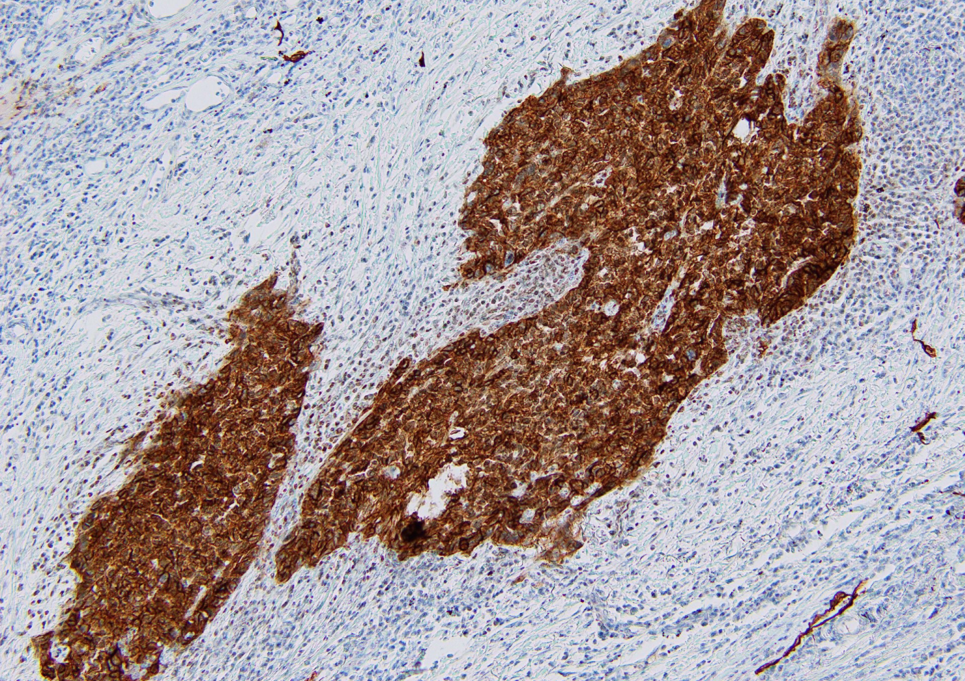

Supplementary figure 2. A weak positive Podoplanin (PDPN) staining picture.

In this image, brown stained areas are PDPN positive and less than 50% of the stained tissue is PDPN positive, corresponding to a weak positive PDPN stain. This photograph was taken under a light microscope at 100x magnification.

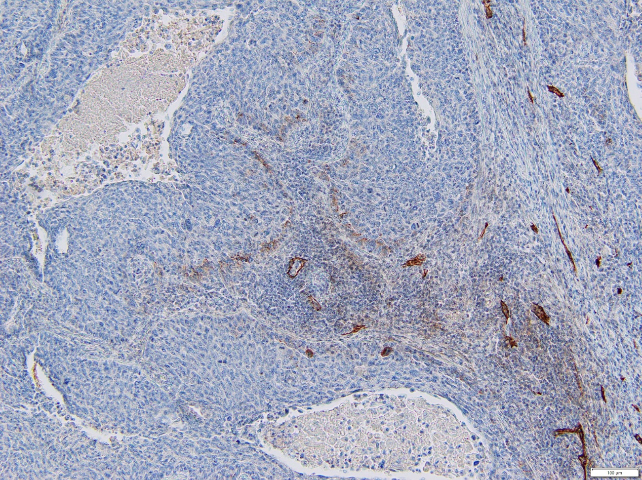

Supplementary figure 3. A negative Podoplanin (PDPN) staining picture.

In this image, brown stained areas are PDPN positive and only lymphatic endothelial cells are PDPN positive, corresponding to a weak positive PDPN stain. The result is negative if no brown is observed in any area. This photograph was taken under a light microscope at 100x magnification.

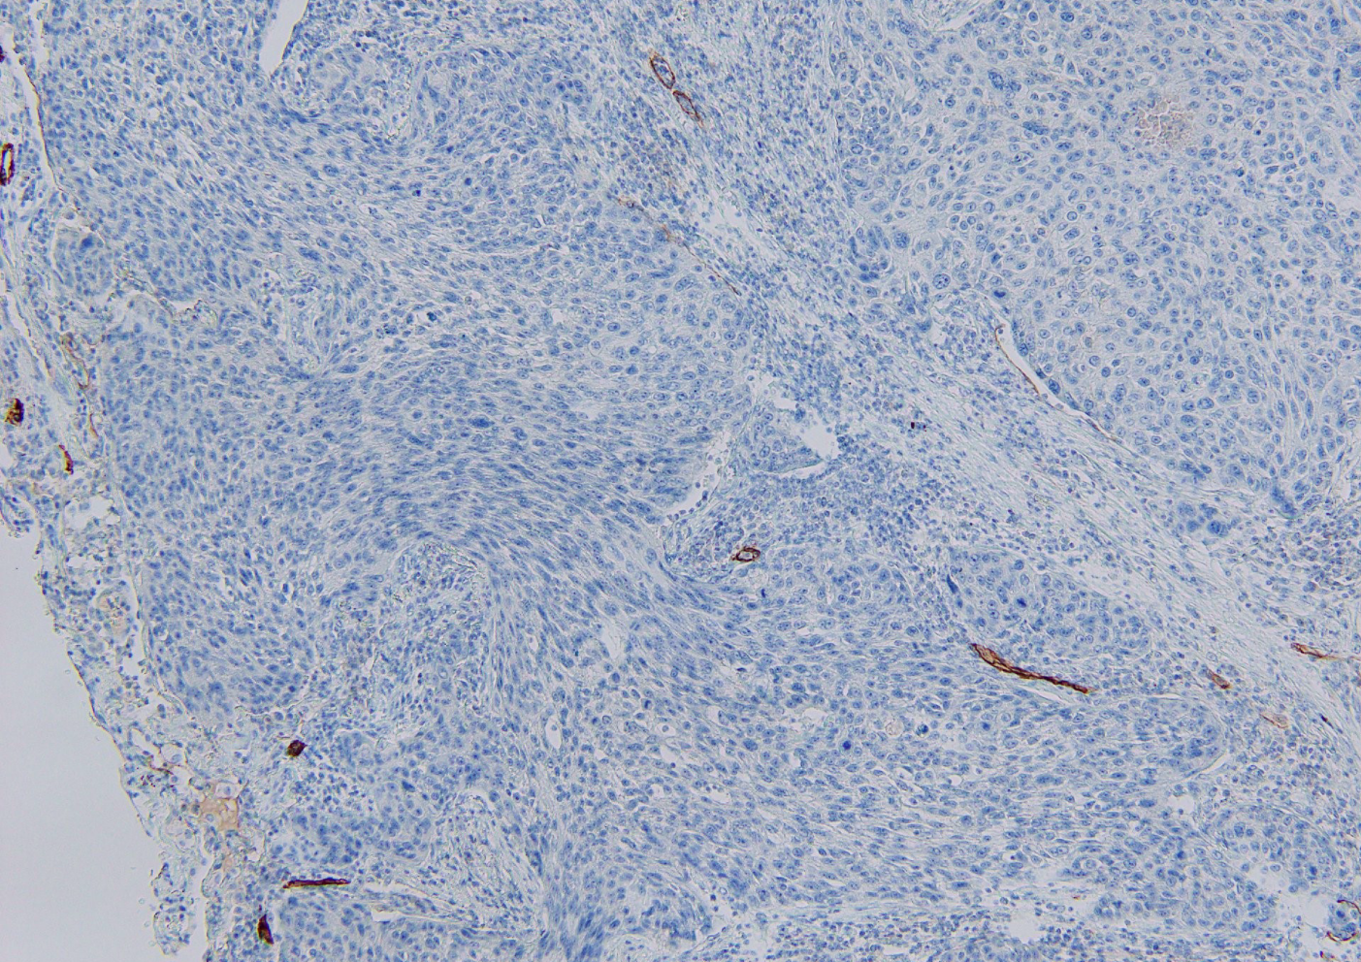

Supplementary figure 4. ROC curve analysis to determine the cutoff value of ALI.

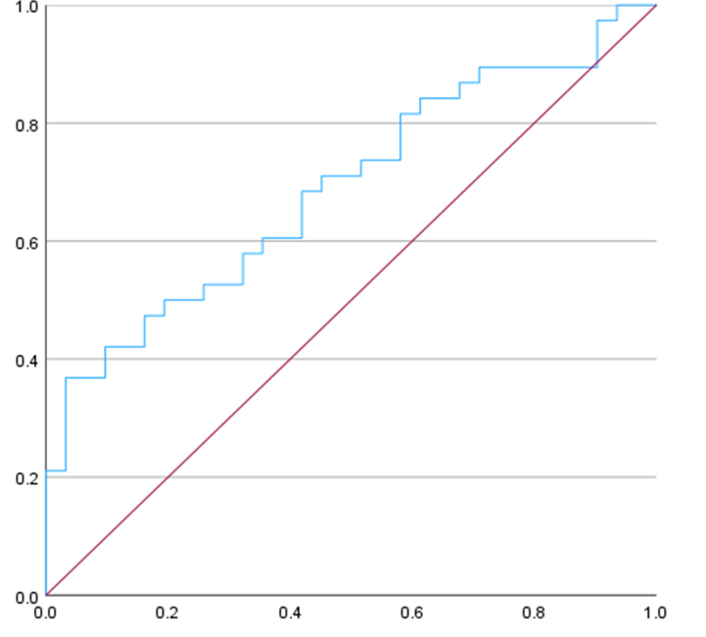

Supplementary figure 5. Survival curves during 5 years for two groups of patients with squamous cell carcinoma of the lung.

PDPN strong positive group and the others, using Kaplan-Meier Survival Analysis.

