Supplementary materials
Abbreviations:
AAPC: Average annual percentage change
APC: Annual percentage change
APCMA: Age-period-cohort Model Analysis
ASDR: Age-standardized DALY rate
ASMR: Age-standardized mortality rate
BAPC: Bayesian Age-Period Cohort
EAPC: Estimated annual percentage change
DALYs: Disability adjusted life years
LDI: Lagged distribution of per capita income
SDI: Socio-demographic index

Socio-demographic index (SDI)
The socio-demographic Index is utilized to assess the comprehensive level of development within a given region, incorporating metrics such as the lagged distribution of per capita income (LDI), the mean educational attainment of individuals aged 15 and above (EDU15+), and the total fertility rate (TFR) among people aged under 25 (2016). The globe is divided into five SDI regions based on quintiles of SDI. For access to SDI information, please visit the public webpage at http://ghdx.healthdata.org/record/ihme-data/gbd-2019-socio-demographic-index-sdi-1950-2019.

Joinpoint model
The fundamental principle underlying the joinpoint regression model involves partitioning a long-term trend line into several segments through model-fitting, wherein each segment is characterized by continuous linearity, and the points where different trend segments meet are referred to as turning points. Finally, we used the Monte Carlo permutation method for significance testing. The joinpoint regression model can be expressed as a segmentation function:
$${E[y|x]=e}^{β_{0}+β_{1}x+δ_{1}(x-τ_{1})^{+}+...+δ_{k}(x-τ_{k})^{+}}$$
Where $y$ is mortality rate. $x$ indicates year. $β_{0}$ is the constant parameter. $β_{1}$ is regression coefficient, $k$ is the number of joinpoints. $δ_{k}$ denotes the regression coefficient of the k^{th} segment function.

The BAPC model is expressed as
nij = log(λij) = μ + αi + βj + γk
where λij denotes the count of cases, μ denotes the intercept, and αi, βj, and γk signify the effect of age, period, and cohort, respectively.

Socio-demographic index (SDI)
SDI was originally constructed for GBD 2015 by using the Human Development Index (HDI) methodology, wherein a 0 to 1 index value was determined for each of the original three covariate inputs (TFR in ages 15 to 49 years, EDU15+, and LDI per capita) by using the observed minima and maxima over the estimation period to set the scales. In response to feedback from collaborators and the evolution of the GBD, we have refined the indicator with each GBD cycle. Beginning in GBD 2017, along with our expanded estimation of age‐specific fertility, we replaced TFR with TFU25 as one of the three component indices. The TFU25 provides a better measure of women’s status in society because it focuses on ages at which childbearing disrupts the pursuit of education and entrance into the workforce. In addition, we observed that in highly developed countries, the TFU25 has tended to decline consistently over time despite rebounds in TFR driven by increasing fertility at older ages. Thus, for each covariate input, an index score of 0 represents the minimum level of each covariate input past which selected health outcomes can get no worse, and an indexscore of 1 represents the maximum level of each covariate input past which selected health outcomes cease to improve. As a composite, a ocation with an SDI of 0 would have a theoretical minimum level of sociodemographic development relevant to these health outcomes, and a location with an SDI of 1 (before multiplying by 100 for reporting) would have a theoretical maximum level of sociodemographic development relevant to these health outcomes.
We computed the index scores underlying SDI as follows:
$$I_{cly}=\max\left(\frac{C_{ly}-C_{low}}{C_{high}-C_{low}}, 0.05\right)$$
Where: $I_{cly}$ is the index for covariate C, location l and year y and is equal to the difference between the value of this covariate in this location year and the lower limit of the covariate divided by the difference between the upper and lower limits for this covariate. For access to SDI information, please visit the public webpage at http://ghdx.healthdata.org/record/ihme-data/gbd-2019-socio-demographic-index-sdi-1950-2019

Data processing and heterogeneity control
In GBD 2021, adjustments were made to epidemiological data known to have biases, such as those using alternative case definitions or measurement methods. These adjustments were made using correction factors estimated by MR-BRT (Meta-regression—Bayesian, regularized, trimmed), a collection of statistical models including linear and nonlinear mixed-effects models. The input data included paired estimates of two case definitions or measurement methods for the same age, sex, region, and year. MR-BRT also controlled for heterogeneity through network meta-regression and performed sex-splitting for inputs not reported by sex, and age-sex splitting for data not reported by either. These processes ensured data standardization and consistency, reducing heterogeneity issues caused by varying data sources and definitions. Additionally, input data spanning more than 25 years were disaggregated into finer age-specific estimates using alternative age patterns estimated from other available data sources.

YLLs and DALYs estimation process
In GBD 2021, YLLs were calculated by multiplying the estimated number of deaths by the standard life expectancy at the age of death, stratified by age, sex, region, and year. To ensure accurate attribution of causes of death, GBD 2021 employed the principles of the 11th edition of the International Classification of Diseases (ICD-11), assigning each death to the underlying cause that initiated the chain of events leading to death. For deaths recorded with non-specific, unreliable, or intermediate cause codes, reallocation algorithms were applied to reassign these "garbage codes" to the most probable causes of death. These algorithms were derived from published studies, expert consultations, or regression-based adjustments using data from sources reporting multiple causes of death. The cause of death for most diseases and injuries is estimated using the Cause of Death Ensemble model (CODEm). CODEm employs a set of statistical models, systematically testing the predictive validity of different covariate combinations, then combining the results to estimate the number of deaths for specific causes by location, age, sex, and year. For a small number of causes with sparse data or significant changes in reporting practices, GBD 2021 adopted customized modeling strategies, including the use of prevalence, incidence, case fatality data, or data related to sub-causes to infer causes of death. Through this process, GBD 2021 achieved progress in controlling data heterogeneity and reducing uncertainty. To estimate DALYs in GBD 2021, specific cause mortality rates and YLDs were first estimated. DALYs for each year were then calculated by adding YLLs to YLDs. The uncertainty of YLLs was assumed to be independent of the uncertainty of YLDs. By summing the first set of YLLs and YLDs across 500 simulations, and repeating the process for subsequent simulations, the 95% uncertainty interval for DALYs was ultimately calculated. The estimation of DALYs covered every cause, location, age group, sex, and year, providing a comprehensive assessment of the global health burden.

Definition of Smoking exposure
Smoking is classified as a tobacco subcategory under behavioral risk, defined as current or previous active use of any tobacco product (excluding chewing tobacco and passive second-hand smoke). Exposure was measured by the number of cigarettes smoked per day and cumulative years of smoking PMID: 359885567. Smoking exposure in the social and human sciences was measured by self-reported data from major representative survey series containing modules on household composition, including Demographic Health Surveys (DHS), Multiple Indicator Cluster Surveys (MICS) and living standards Measurement Surveys (LSMS), as well as national and local censuses. Included are censuses from the IPUMS project, all determined using the Global Health Data Exchange Directory (GHDx).

The GBD study utilized a conceptual framework of comparative risk Assessment (CRA) to quantify the burden of asthma caused by smoking.
Cras are valuable tools because they integrate evidence from a variety of sources that focuses on a specific factor affecting health, assess the relationship between that factor and expected health outcomes, and employ attribution strategies to determine the extent to which one cause contributes to outcomes influenced by multiple causes. To calculate the Asthma burden due to Smoking, GBD compared the risk of this distribution with the expected risk of the theoretical minimum risk exposure level, based on a continuous risk-outcome curve derived using a non-parametric Bayesian spline method, based on the Smoking exposure values provided, The group attribution score (PAF) for these outcomes was estimated. We calculated the number of cause-specific deaths attributable to each risk factor by multiplying the estimated PAF by the total number of deaths from the disease in each layer.

When forecasting the prevalence of different smoking groups, it is important to consider that current smokers have a higher relative risk of mortality than former smokers, who in turn have a higher risk than never smokers. While the reference scenario incorporates these differing mortality rates across smoking statuses by forecasting smoking prevalence in period space, differential mortality must be explicitly added to the alternative scenario prevalence forecasts. To account for the effects of different mortality rates between current, former, and never smokers, we estimated the asthma relative risks of mortality by smoking status. We computed exposure weighted relative risks by location, age, sex, and cause in 2022 and aggregated these cause specific relative risks across all causes to generate an asthma relative risk of mortality. Finally, we computed the mortality rate among never smokers and used each of the mortality rates to adjust our prevalence estimates in every future year.

Using these inputs, we calculated smoking PAFs for every location, sex, 5-year age group, and cause at 5-year intervals between 2022 and 2040, using the formula below, adapted from the GBD study

PAF=$\frac{p\left(n\right)+p\left(f\right)∫exp\left(x\right)*rr\left(x\right)+p\left(f^{'}\right)∫exp\left(z\right)*rr\left(x\right)+p\left(c\right)∫exp\left(y\right)*rr\left(y\right)-1}{p\left(n\right)+p\left(f\right)∫exp\left(z\right)*rr\left(x\right)+p\left(f^{'}\right)∫exp\left(z\right)*rr\left(x\right)+p\left(c\right)∫exp\left(y\right)*rr\left(y\right)}$

Where $p\left(n\right)$ is the prevalence of never smokers, $p\left(f\right)$ is the prevalence of former smokers who quit in 2022 or earlier, $p\left(f^{'}\right)$ is the prevalence of former smokers who quit in 2023 or later, $\exp\left(x\right)$is a distribution of years since quitting among former smokers who quit in 2022 or earlier, $\exp\left(z\right)$ is a uniform distribution of years since quitting among former smokers who quit in 2023 or later, $rr\left(x\right)$ is the relative risk for years since quitting, $rr\left(y\right)$ is the prevalence of current smokers, $\exp\left(y\right)$is a distribution of cigarettes per smoker per day or pack-years, and $rr\left(y\right)$ is the relative risk for cigarettes per smoker per day or pack-years.

The Cause-of-death Integrated Model (CODEm) is an analytical tool developed from GBD data to estimate mortality and DALY for asthma. This analysis focused on data collected in 1990 and 2021 to investigate trends in asthma burden over this period. The selection of these years allows comprehensive comparisons to highlight changes in mortality and the overall impact of asthma on global health over a nearly three-decade interval.

The fixed effects allow us to capture broad trends in both age patterns and the impacts of key biological and environmental covariates. The random effects allow for improved estimation by adding intercept shifts by GBD super-region, region, and country (the 187 countries are grouped into 21 regions based on both geographical proximity and epidemiologic similarity; the 21 regions are further grouped into seven more general super-regions), and changes in age patterns across regions and countries. The models of this family follow this form:
$$\ln\left({rate}_{s,r,c,y,a}\right)=β_{i}X_{i_{s,r,c,y,a}}+β_{a}d+π_{s}+π_{s,r}+π_{s,r,c}+π_{s,r,c,a}+ε_{s,r,c,y,a}$$
$$logit\left(cause fraction_{s,r,c,y,a}\right)=β_{i}X_{i_{s,r,c,y,a}}+β_{a}d+π_{s}+π_{s,r}+π_{s,r,c}+π_{s,r,c,a}+ε_{s,r,c,y,a}$$
s = super-region index; r = region index; c = country index; y = year index; a = age index
[countries are nested within regions, which are nested within super-regions]
$β_{i}$ = coefficient on covariate i
$X_{i_{s,r,c,y,a}}$ = covariate i for observation s, r, c, y, a
$β_{a}$ = coefficient on age offsets
$d$ = age dummy variables
π_{s} = random intercept on super-region
π_{s, r} = random intercept on region (nested within super-region)
π_{s, r, a} = random intercept on age (nested within region)
π_{s, r, a, c} = random intercept on country (nested within region-age)

Because of the small numbers that are often encountered for certain age groups, countries, or causes of death, covariate models may occasionally predict numbers that are negative in natural log or logit space. To avoid creating very large residuals that can negatively affect subsequent prediction steps, we have introduced a floor such that the predictions never go below a rate of .01 deaths per 100,000 people. In addition, log rate models, unlike logit cause-fraction models, are not constrained from predicting more deaths than the all-cause mortality rate. We have greater confidence in all-cause mortality predictions, because there are typically more data available for predicting all-cause mortality rates in the form of censuses, demographic and health surveys, vital registration systems that do not capture cause of death, etc. We have therefore placed a ceiling on log rate models such that they can never exceed the log all-cause mortality rate.

Forecasting framework
We obtained estimates of independent drivers of asthma, including pooled exposure values for more than 70 risk factors from the Global Study of Diseases, Injuries and Risk Factors (GBD), interventions such as vaccine and antiretroviral treatment coverage, And covariates such as the Sociodemographic Index (a combined measure of income, education, and fertility under the age of 25) in GBD 2021, for each location, age, and sex from 1990 to 2019. These independent variables are then projected to 2040, primarily using a generalized integration model that includes past annual rates of change and relationship to sociodemographic indices, to predict future trends
Once we have a complete time series for each independent variable from 1990 to 2040, we can use them to predict cause-specific mortality through 2040.

The BAPC model is a Bayesian model added to the age-period-cohort analysis model that can solve the difficulty of parameter estimation due to the linear relationship between the 3 factors in the age-period-cohort model. Age, period, and/or cohort effects can be optimized with second-order random walk (RW2) construction models to more accurately predict future ASMR and ASDR.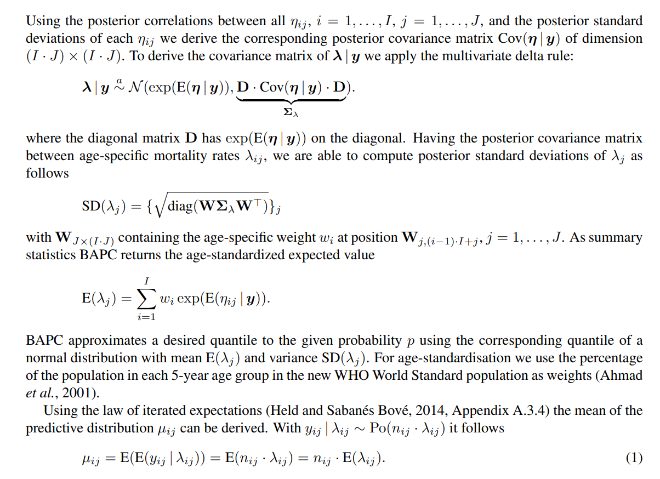
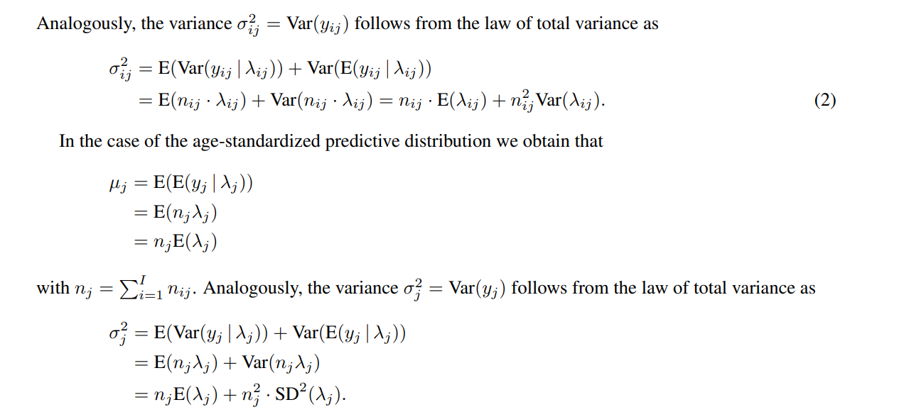

Data visualization
Name | Cite
bamp | Schmid V, Geressen F, Held L, Rainer E (2022). _ bamp: Bayesian Age-Period-Cohort Modeling and Prediction_. R package version 2.1.3, https://cran.r-project.org/web/packages/bamp/index.html.
data.table | Dowle M, Srinivasan A (2023). _data.table: Extension of `data.frame`_. R package version 1.14.8, https://CRAN.R-project.org/package=data.table.
digest | Lucas DEwcbA, Tuszynski J, Bengtsson H, Urbanek S, Frasca M, Lewis B, Stokely M, Muehleisen H, Murdoch D, Hester J, Wu W, Kou Q, Onkelinx T, Lang M, Simko V, Hornik K, Neal R, Bell K, de Queljoe M, Suruceanu I, Denney B, Schumacher D, Chang. aW (2022). _digest: Create Compact Hash Digests of R Objects_. R package version 0.6.31, https://CRAN.R-project.org/package=digest.
gglot2 | H. Wickham. ggplot2: Elegant Graphics for Data Analysis. Springer-Verlag New York, 2016.
dplyr | Wickham H, François R, Henry L, Müller K, Vaughan D (2023). _dplyr: A Grammar of Data Manipulation_. R package version 1.1.0, https://CRAN.R-project.org/package=dplyr.
forcats | Wickham H (2023). _forcats: Tools for Working with Categorical Variables (Factors)_. R package version 1.0.0, https://CRAN.R-project.org/package=forcats.
ggnewscale | Campitelli E (2022). _ggnewscale: Multiple Fill and Colour Scales in 'ggplot2'_. R package version 0.4.8, https://CRAN.R-project.org/package=ggnewscale.
ggrepel | Slowikowski K (2023). _ggrepel: Automatically Position Non-Overlapping Text Labels with 'ggplot2'_. R package version 0.9.3, https://CRAN.R-project.org/package=ggrepel.
ggsci | Xiao N (2023). _ggsci: Scientific Journal and Sci-Fi Themed Color Palettes for 'ggplot2'_. R package version 3.0.0, https://CRAN.R-project.org/package=ggsci.
inla | Krainski E T, Lindgren F, Rue H (2024). _INLAspacetime: Spatial and Spatio-Temporal Models using 'INLA'_. R package version 0.1.10, https://cran.r-project.org/web/packages/INLAspacetime/index.html
lubridate | Garrett Grolemund, Hadley Wickham (2011). _ Dates and Times Made Easy with lubridate. Journal of Statistical Software, 40(3), 1-25. URL https://www.jstatsoft.org/v40/i03/.
nordpred | Moller B, Weedon-Fekjaer H (2019) ._ nordpred: Fit power5 and poisson Age-Period-Cohort models to calculate prediction of cancer incidence and mortality_. R package version 1.1, URL http://www.kreftregisteret.no/software/nordpred/.
patchwork | Pedersen T (2022). _patchwork: The Composer of Plots_. R package version 1.1.2, https://CRAN.R-project.org/package=patchwork.
purrr | Wickham H, Henry L (2023). _purrr: Functional Programming Tools_. R package version 1.0.1, https://CRAN.R-project.org/package=purrr.
RColorBrewer | Neuwirth E (2022). _RColorBrewer: ColorBrewer Palettes_. R package version 1.1-3, https://CRAN.R-project.org/package=RColorBrewer.
readr | Wickham H, Hester J, Bryan J (2023). _readr: Read Rectangular Text Data_. R package version 2.1.4, https://CRAN.R-project.org/package=readr.
readxl | Wickham H, Bryan J (2023). _readxl: Read Excel Files_. R package version 1.4.2, https://CRAN.R-project.org/package=readxl.
sf | Pebesma, E., 2018. Simple Features for R: Standardized Support for Spatial Vector Data. The R Journal 10 (1), 439-446, https://doi.org/10.32614/RJ-2018-009 Pebesma, E., & Bivand, R. (2023). Spatial Data Science: With Applications in R (1st ed.). Chapman and Hall/CRC. https://doi.org/10.1201/9780429459016
snow | Tierney L, Rossini AJ, Li N, Sevcikova H (2021). _snow: Simple Network of Workstations_. R package version 0.4-4, https://CRAN.R-project.org/package=snow.
snowfall | Knaus J (2022). _snowfall: Easier Cluster Computing (Based on 'snow')_. R package version 1.84-6.2, https://CRAN.R-project.org/package=snowfall.
stringr | Wickham H (2022). _stringr: Simple, Consistent Wrappers for Common String Operations_. R package version 1.5.0, https://CRAN.R-project.org/package=stringr.
tibble | Müller K, Wickham H (2022). _tibble: Simple Data Frames_. R package version 3.1.8, https://CRAN.R-project.org/package=tibble.
tidyr | Wickham H, Vaughan D, Girlich M (2023). _tidyr: Tidy Messy Data_. R package version 1.3.0, https://CRAN.R-project.org/package=tidyr.
tidyverse | Wickham H, Averick M, Bryan J, Chang W, McGowan LD, François R, Grolemund G, Hayes A, Henry L, Hester J, Kuhn M, Pedersen TL, Miller E, Bache SM, Müller K, Ooms J, Robinson D, Seidel DP, Spinu V, Takahashi K, Vaughan D, Wilke C, Woo K, Yutani H (2019). “Welcome to the tidyverse.” _Journal of Open Source Software_, *4*(43), 1686. doi:10.21105/joss.01686 https://doi.org/10.21105/joss.01686.
viridis | Simon Garnier, Noam Ross, Robert Rudis, Antônio P. Camargo, Marco Sciaini, and Cédric Scherer (2021). Rvision - Colorblind-Friendly Color Maps for R. R package version 0.6.2
viridisLite | Simon Garnier, Noam Ross, Robert Rudis, Antônio P. Camargo, Marco Sciaini, and Cédric Scherer (2022). Rvision - Colorblind-Friendly Color Maps for R. R package version 0.4.1

SDI quintiles for countries estimated in GBD 2021
SDI quintile | Locations included based on SDI values in 2021 from GBD 2021 results
Low SDI（0.00-0.47） | Afghanistan, Benin, Burkina Faso, Burundi, Central African Republic, Chad, Cote d'lvoire, Democratic Republic of the Congo, Eritrea, Ethiopia, Gambia, Guinea, Guinea-Bissau, Haiti, Liberia, Madagascar, Malawi, Mali, Mozambique, Nepal, Niger, Pakistan, Papua New Guinea, Rwanda, Senegal, Sierra Leone, Solomon Islands, Somalia, South Sudan, Togo, Uganda, United Republic of Tanzania, Yemen
Low-middle SDI（0.47-0.62） | Angola, Bangladesh, Belize, Bhutan, Bolivia (Plurinational State of), Cabo Verde, Cambodia, Cameroon, Comoros, Congo, Democratic People's Republic of Korea, Djibouti, Dominican Republic, El Salvador, Eswatini, Ghana, Guatemala, Honduras, India, Kenya, Kiribati, Kyrgyzstan, Lao People's Democratic Republic, Lesotho, Maldives, Marshall Islands, Mauritania, Micronesia (Federated States of), Mongolia, Morocco, Myanmar, Nicaragua, Nigeria, Palestine, Sao Tome and Principe, Sudan, Tajikistan, Timor-Leste, Tuvalu, Vanuatu, Venezuela (Bolivarian Republic of), Zambia, Zimbabwe
Middle SDI（0.62-0.71） | Albania, Algeria, Armenia, Azerbaijan, Botswana, Brazil, China, Colombia, Costa Rica, Cuba, Ecuador, Egypt, Equatorial Guinea, Fiji, Gabon, Grenada, Guyana, Indonesia, Iran (Islamic Republic of), Iraq, Jamaica, Mexico, Namibia, Nauru, Panama, Paraguay, Peru, Philippines, Saint Lucia, Saint Vincent and the Grenadines, Samoa, South Africa, Suriname, Syrian Arab Republic, Thailand, Tokelau, Tonga, Tunisia, Turkmenistan, Uzbekistan, Viet Nam
High-middle SDI（0.71-0.81） | American Samoa, Antigua and Barbuda, Argentina, Bahamas, Bahrain, Barbados, Belarus, Bosnia and Herzegovina, Bulgaria, Chile, Cook Islands, Croatia, Dominica, Georgia, Greece, Greenland, Hungary, Israel, Italy, Jordan, Kazakhstan, Lebanon, Libya, Malaysia, Malta, Mauritius, Montenegro, Niue, North Macedonia, Northern Mariana Islands, Oman, Palau, Poland, Portugal, Republic of Moldova, Romania, Russian Federation, Saint Kitts and Nevis, Saudi Arabia, Serbia, Seychelles, Spain, Sri Lanka, Trinidad and Tobago, Turkey, Ukraine, United States Virgin Islands, Uruguay
High SDI（0.81-1.00） | Andorra, Australia, Austria, Belgium, Bermuda, Brunei Darussalam, Canada, Cyprus, Czechia, Denmark, Estonia, Finland, France, Germany, Guam, Iceland, Ireland, Japan, Kuwait, Latvia, Lithuania, uxembourg, Monaco, Netherlands, New Zealand, Norway, Puerto Rico, Qatar, Republic of Korea, San Marino, Singapore, Slovakia, Slovenia, Sweden, Switzerland, Taiwan (Province of China), United Arab Emirates, United Kingdom, United States of America
Abbreviation: SDI, socio-demographic index.

