Supplementary information of Climate change drives increasing and spatially variable global rain-on-snow events

Supplementary Notes 2
Supplementary Note 1: ROS events experiment. 2
Supplementary Note 2: Validation of ERA5-Land Data. 4
Supplementary Note 3: Calculation and analysis of the relationship between different factors and ROS events. 5
Supplementary Note 4: Construction and Use of the Copula Model. 7
Supplementary Note 5: Mathematical Statistical Analysis Methods. 9
Supplementary Figures 11
Supplementary Fig. 1 | Research process framework diagram. 11
Supplementary Fig. 2 | The spatial distribution trend of global ROS events in different time periods from 1950 to 2023. 12
Supplementary Fig. 3 | Spatial distribution of ROS events of different levels in 1950 and 2023. 13
Supplementary Fig. 4 | Changes between ROS events of different intensities and main influencing factors. 14
Supplementary Fig. 5 | Multi-year (1950–2023) average monthly spatial distribution of ROS events. 15
Supplementary Fig. 6 | Monthly ROS event trends from 1950 to 2023. 16
Supplementary Fig. 7 | Seasonal Distribution of ROS Events. 17
Supplementary Fig. 8 | Field experiment locations and distribution of observation stations. 18
Supplementary Fig. 9 | Trends in the spatial distribution of rainfall, snow depth, temperature, and ROS event days. 19
Supplementary Fig. 10 | Validation of results from the Copula. 20
Supplementary Tables 21
Supplementary Table. 3 | Countries with ROS events mainly occur. 23
Supplementary Table. 4 | Distribution of ROS events across different elevation ranges. 24
Supplementary Table. 5 | Seasonal characteristics of ROS events. 25
Supplementary Table. 6 | Distribution of ROS events across different latitudinal ranges. 26
Supplementary Table. 7 | Field measured stations. 27
Supplementary Table. 8 | Introduction and sources of main datasets. 28
Supplementary Table. 9 | The key factors influencing ROS events. 29
Supplementary Table. 10 | The current experiments on ROS events around the world. 30

Supplementary Notes

Supplementary Note 1: ROS events experiment.
Although some scholars have begun to pay attention to ROS events, almost no one has conducted experiments on the occurrence mechanism. Only a few American scholars have conducted simple experiments on ROS events outdoors¹⁻³ (Supplementary Table. 10), but this cannot reveal the occurrence mechanism of ROS events. Therefore, in order to clarify the internal mechanism of ROS events, we conducted experiments on ROS events. The specific contents are as follows:
Indoor ROS events control experiment. First, the NLJY-10 series artificial rainfall simulation system (with a rainfall area of 400 cm × 300 cm and a height of 400 cm) was installed in an indoor laboratory (Extended Data Fig. 10a). An indoor experimental support structure was set up with a movable test chamber. The base consisted of a tempered glass plate with dimensions of 150 cm × 100 cm, serving as the effective rainfall area. Glass panels with a height of 20 cm were installed on the left and right sides, while adjustable glass baffles measuring 100 cm × 20 cm and 100 cm × 19 cm were placed on the upper and lower edges, respectively (Extended Data Fig. 10b). The bottom of the lower baffle featured a 100 cm × 1 cm drainage slit, with its lower edge connected to a triangular water collection tank. The end of the tank was linked via a hose to a graduated water collection bucket placed on the ground (Extended Data Fig. 10c). The bucket was marked with water level scales to measure the volume of meltwater, with readings recorded every minute. The conduit from the drainage outlet to the bucket was sealed to prevent interference from direct rainfall (Extended Data Fig. 10d).
(1) Controlled experiment of rainfall intensity
During the experiment, only rainfall intensity was varied, while other snowmelt-related factors (such as air temperature and snow depth) were kept constant. This approach enabled the quantification of snowmelt generated solely by rainfall on the snow surface. Rainfall intensity was controlled across five gradients: drizzle (0–10 mm/day), light rain (10–25 mm/day), moderate rain (25–50 mm/day), heavy rain (50–100 mm/day), and extreme rain (>100 mm/day), with the no-rain condition serving as a control. During snow sampling, a tempered glass sampling plate measuring 150 cm × 100 cm was inserted horizontally into the outdoor snowpack at the sampling site, ensuring that the original snow structure remained intact. The collected snow sample, enclosed within the experimental chamber, was then transported indoors and placed onto the fixed support frame. The snow depth was adjusted according to experimental requirements.
(2) Controlled experiment of temperature
Extreme warming refers to the sudden rise of air temperature above 0 °C during late winter or early spring, rather than high temperatures in the conventional sense. When air temperatures exceed 0 °C during the snow-covered season, it indicates the potential onset of snowmelt-induced flash floods. If rainfall occurs on the snow surface under these conditions, it can lead to the formation of ROS events. However, it is not practical to control extreme warming conditions in the field. Therefore, a pre-fabricated temperature and humidity controller in the laboratory was used to simulate these conditions. The indoor temperature was adjusted to 0°C, 4°C, and 8°C, while other snowmelt factors (rainfall and snow depth) were kept constant. Simulated temperature-controlled snowmelt experiments were conducted to calculate the amount of snowmelt generated solely by temperature variations and to assess the differences.
(3) Controlled experiment of snow depth
Snow samples of different depths (100 mm, 200 mm, and 400 mm) were collected from the outdoor site, while other snowmelt factors (such as rainfall and temperature) were kept constant. Snowmelt control experiments were conducted for each snow depth, allowing for the calculation of the contribution rate of snow depth to the overall snowmelt.
Field- semi-controlled ROS event experiment. Based on the feasibility of the experiment and the spatial observability of ROS events, the study selected the Gongnaisi River Basin on the northern slope of the Tianshan Mountains (42°10'N - 43°50'N, 81°50'E - 84°20'E) and the Hutubi River Basin (41°12'N - 44°30'N, 84°15'E - 87°30'E) for the field-based semi-controlled ROS events experiment. Seven main snow observation stations were established along elevation gradients of 500 meters (1000 m, 1500 m, 2000 m, 2500 m, 3000 m, 3500 m, and 4000 m), covering the alpine meadow, coniferous forest, and glacier foreland zones. To capture small-scale topographic effects (such as correcting snow depth, rainfall intensity, temperature, and other remote sensing data), 20 auxiliary observation points were added near the main observation stations. All sensors were connected to the CR1000X data logger, with continuous data storage at 1-minute intervals. The main stations were equipped with dual power sources (solar energy and lithium batteries), ensuring a battery life of $≥$ 90 days under low-temperature conditions (-30°C). Data collection was performed once a month at each observation station. Bayesian change point analysis was used to identify the abrupt changes in the snow layer temperature gradient (∆T) during rainfall events^{4,5}, and to locate the depth of the active phase change layer. The basin was further refined into a grid system (500 m × 500 m) for hydrological unit processing (Supplementary Fig. 8). Subsequently, each hydrological unit’s ROS events were encoded and assigned corresponding values, constructing a set of ROS events driving factors. Combined with the results from indoor experiments, the intrinsic mechanisms of ROS events were comprehensively determined, and the temperature, precipitation, and snow depth thresholds were clarified.

Supplementary Note 2: Validation of ERA5-Land Data.
While the ERA5-Land dataset serves as the main data source in this study, additional relevant datasets and in-situ observations were employed to validate its accuracy and ensure the reliability of the analytical results.
First, a preliminary validation was conducted using gridded station data: the Global Historical Climatology Network daily (GHCNd), a meteorological station dataset provided by the National Centers for Environmental Information (NCEI) of the National Oceanic and Atmospheric Administration (NOAA), was selected (https://www.ncei.noaa.gov/products/land-based-station/global-historical-climatology-network-daily). The GHCNd dataset provides daily observations of temperature, precipitation, snow depth, snow water equivalent, and other variables from more than 100,000 meteorological stations globally⁶⁻⁸. For this study, temperature, precipitation, and snow depth were selected as key variables for comparison. The GHCNd gridded station data, known for its high accuracy, was used to perform a preliminary validation of temperature, precipitation, and snow depth data provided by ERA5-Land. First, the spatial and temporal domains of the GHCNd and ERA5-Land datasets were aligned. Station locations were projected onto the grid points of the reanalysis data, after which values from both the observational (GHCNd) and ERA5-Land datasets were extracted for the same time periods. Statistical metrics such as correlation and RMSE were then calculated to analyze and summarize the results, providing an initial validation of the accuracy of the ERA5-Land dataset.
Subsequently, cross-validation was conducted using remote sensing imagery: the daily snow cover data from MODIS, derived from observations by the MODIS sensor and provided by NASA, was employed. The MOD10A1 snow product was specifically used in this study (https://nsidc.org/data/mod10a1/versions/61). The MODIS sensor, mounted on both the Terra and Aqua satellites, has been providing daily continuous snow cover data since 2000. The data has a typical spatial resolution of 1 kilometer and covers the global extent⁹⁻¹¹. Cross-validation was performed on the snow cover data from ERA5-Land using the daily snow cover products provided by MOD10A1 (Terra) and MYD10A1 (Aqua). The MODIS and ERA5-Land datasets were resampled to match both temporal and spatial resolutions. Correlation coefficients (R), RMSE, and other statistical metrics (KGE) were computed to quantify the differences between MODIS and ERA5-Land snow depth data, thereby assessing and refining the accuracy and reliability of the snow depth data.
Lastly, field validation was performed using observed precipitation, temperature, and snow data. This study leveraged long-term hydrometeorological data from national baseline meteorological stations, as well as observed snow, temperature, and precipitation data from six snow measurement stations established at various elevations on the northern slope of the Tianshan Mountains. R, RMSE and KGE were computed to determine the reliability of the ERA5-Land dataset. The validation through station gridded data, remote sensing imagery, and field observation data demonstrates that the ERA5-Land dataset employed in this study is suitable for the calculation and analysis of ROS events.

Supplementary Note 3: Calculation and analysis of the relationship between different factors and ROS events.
Calculation and analysis of the relationship between elevation and ROS events. We first divide the global land elevation range from 0 to 8900 meters into 18 elevation intervals, with a 500-meter gap for each, specifically classified as: (0, 500), (500, 1000), (1000, 1500), (1500, 2000), (2000, 2500), (2500, 3000), (3000, 3500), (3500, 4000), (4000, 4500), (4500, 5000), (5000, 5500), (5500, 6000), (6000, 6500), (6500, 7000), (7000, 7500), (7500, 8000), (8000, 8500), and (8500, 9000). First, calculate the precipitation events, snow depth variations, and ROS events for each elevation range from 1950 to 2023, and create time series plots. This means there will be 18 statistics for precipitation, snow depth, and ROS events for each year. Then, calculate the multi-year variation values of precipitation events, snow depth, and ROS events for each elevation interval and output the CSV statistics. The analysis in Python will then be conducted, with only the ROS events displayed in the manuscript. The precipitation and snow depth event variation plots can be found in Supplementary Fig. 9. For ease of reading and analysis, we further divide the global land elevation into low to mid-elevation zones, high-elevation zones, and ultra-high-elevation zones.
Calculation and analysis of the relationship between temperature and ROS events. We select the 2 m temperature data from ERA5-Land, first converting the temperature units to °C. Then, we calculate the global land annual average temperature for each year from 1950 to 2023, and output the annual average temperature images for each year. Based on the annual average temperature images, we calculate the temperature change trend globally from 1950 to 2023 and add significance to analyze the temperature change characteristics of the global climate over the past 74 years. Next, we calculated the correlation between the annual average temperature and ROS events for each year from 1950 to 2023. Output the correlation images and add significance simultaneously. Similarly, we calculated the monthly temperature for each year and output the monthly temperature images from 1950 to 2023. Based on this, we calculated the multi-year average monthly temperature trend over the past 74 years and added significance. Then, we calculated the correlation between the monthly temperature and monthly ROS events, output the correlation images, and added significance simultaneously. Finally, the above annual temperature, monthly temperature, and annual ROS events as well as monthly ROS events are converted into CSV format for output. Linear analysis and correlation matrix calculations are then performed to further explore the relationship between ROS events and temperature.
Calculation and analysis of the relationship between temperature and ROS events. First, we use global SST Anomaly imagery data to calculate the anomalies and convert the units to °C. Then, we perform resampling using bicubic interpolation and restrict the values of the interpolated data within the range of (-2, 2)¹². When the temperature anomaly (Anomaly) > 0.5°C, it indicates an El Niño state. When Anomaly < -0.5°C, it indicates a La Niña state. When -0.5 < Anomaly < 0.5, it indicates a neutral state^{13,14}. Subsequently, we computed the annual SST anomalies from 1981 to 2023 and generated imagery for each year. Based on these, we assessed the multi-year trend to characterize the global ENSO variability. In addition, we calculated the correlation between Niño 3.4 SST statistics and ROS events. By computing the annual SST anomalies and the multi-year mean monthly SST anomalies from daily Niño 3.4 SST data, we performed a comparative analysis with the corresponding ROS events to assess the relationship between intra-annual and inter-annual ENSO and ROS events. Finally, considering the influence of elevation on the distribution of ROS events, we performed a correlation analysis between ROS events in different elevation ranges and ENSO, using the previously computed ROS event statistics for each elevation range. This analysis yielded the correlation coefficients between ROS events and ENSO across different elevation ranges.

Supplementary Note 4: Construction and Use of the Copula Model.
(1) Data Preparation and Preprocessing.
Prepare global temperature (T), precipitation (P), and ROS events (ROS) data with a unified temporal and spatial resolution. Remove outliers and handle missing values, followed by data normalization. This process primarily involves estimating the marginal distributions and calculating the marginal probabilities¹⁵. The estimation of the marginal distribution can be achieved by calculating the empirical cumulative distribution function of each variable¹⁶. The expression for the marginal probability is as follows:
$$U=F_{T}\left(T\right), V=F_{P}\left(P\right), W=F_{ROS}(ROS)$$
Through the above processing, the data can be transformed into dimensionless variables U, V, and W within the [0, 1] interval, facilitating the subsequent computational analysis.
(2) Determine the model type and estimate the parameters.
This study adopts the Gaussian three-dimensional Copula probability framework^{17,18}, and compute the correlation coefficients between T, P, and ROS ($ρ_{(T,P)}, ρ_{(T,ROS)}, ρ_{(P,ROS)}$). The Copula correlation matrix is estimated under the assumption, and the parameters are solved using Maximum Likelihood Estimation (MLE).
The expression for the three-dimensional Gaussian Copula is as follows:
$$C_{\sum{(u,v,w)}}=Φ_{\sum{\left(Φ^{-1}\left(u\right),Φ^{-1}(v){, Φ}^{-1}(w)\right)}}$$
Where ΦΣ is the Cumulative Distribution Function (CDF) of a ternary normal distribution with mean 0 and covariance matrix Σ. $Φ^{-1}$ is the inverse CDF (i.e., Probit transform) of the standard normal distribution. u, v, w are the cumulative distribution values ​​of the marginal distribution.
The estimated Copula correlation matrix is as follows:
$$\sum{=\left[\begin{matrix}1 & ρ_{(T,P)} & ρ_{(T,ROS)} \\ ρ_{(T,P)} & 1 & ρ_{(P,ROS)} \\ ρ_{(T,ROS)} & ρ_{(P,ROS)} & 1\end{matrix}\right]}$$
The Σ of the Copula are estimated using the MLE method：
$$\hat{Σ}=arg\max_{Σ}{\sum_{i=1}^{n}{\log{c_{\sum{(u_{i},v_{i},w_{i})}}}}}$$
Where $c_{\sum{(u_{i},v_{i},w_{i})}}$ is the density function of the Copula.
(3) Establish the joint distribution.
By combining the estimated parameters, construct the trivariate joint distribution, generate the joint probability, obtain the joint probability density function, and then calculate the joint probability density.
By combining the estimated $\hat{Σ}$, the trivariate joint distribution is constructed as follows:
$$F\left(T,P,ROS\right)=C_{\hat{Σ}}(F_{T}\left(T\right),F_{P}\left(P\right),)F_{ROS}(ROS))$$
The final joint probability density function is:
$$f\left(T,P,ROS\right)=c_{\hat{Σ}}(F_{T}\left(T\right),F_{P}\left(P\right),)F_{ROS}(ROS))∙f_{T}(T)∙f_{P}(P)∙f_{ROS}(ROS)$$
(4) Calculate the joint conditional probability of the ROS events.
Determine the probability of ROS events occurring under different thresholds, i.e., at quantiles (0.1, 0.2, 0.3, 0.4), that satisfy the given conditions, and output the conditional probability distribution results.
Calculate the probability of ROS occurrence under the given conditions:
$$P\left(ROS | T,P\right)=P(T>T_{0},{P>P}_{0})$$
Where $T_{0}$ and $P_{0}$ are the corresponding thresholds of temperature and precipitation, such as the 0.1 quantile.
Through the above steps, the conditional probability estimation of the three-dimensional Copula can be completed, and the conditional probability of the ROS events can be obtained, so as to draw its spatial distribution map and obtain the conditional probability distribution characteristics of the global ROS events. However, since previous studies mostly employed a bivariate Copula model for joint distribution¹⁹⁻²¹, this study innovatively uses a three-dimensional Copula. Therefore, it is necessary to conduct proper result validation to enhance the reliability of the model. Specifically, we can plot the correlation matrix of T, P, and ROS to view the correlation pattern between the variables, and verify the Copula distribution fitting results through the QQ plot (Supplementary Fig. 10).

Supplementary Note 5: Mathematical Statistical Analysis Methods.
Trend analysis. This study selected the modified Mann-Kendall (MMK) nonparametric rank test method to analyse the changing trend of ROS events²², considering it mainly used for trend testing of rainfall days, snow days and ROS days. The MMK test considers the effect of serial autocorrelation on the statistic Z tested by the original MK method and uses a correction factor n² to obtain a modified statistic Z_{m}, which is given by:
$$Z_{m}=\frac{Z}{\sqrt{n^{s}}}，n^{s}=\left\{\begin{aligned}1+\frac{2}{n}\sum_{gh=1}^{n-1}{\left(n-1\right)r_{gh}} gh>1 \\ 1+2\frac{{r_{1}}^{n+1}-{nr_{1}}^{2}+\left(n-1\right)r_{1}}{n{\left(r_{1}-1\right)}^{2}} gh=1\end{aligned}\right.$$
Where: r_{gh} is the serial autocorrelation coefficient for a given lag gh, and n is the serial length. Under the assumption of no trend, both Z and Z_{m} follow a standard normal distribution. If it is greater than 1.96 at a 0.05 confidence level, the null hypothesis is rejected. If, Z_{m} is positive (negative), the tested sequence has an upward (downward) trend.
Correlation analysis. This study employs the commonly used Pearson correlation coefficient to quantify the relationships between ROS events and variables such as elevation, temperature, precipitation, snow depth, and ENSO²³. The formula is as follows:
$$r=\frac{\sum{(X_{i}-\overline{X})(Y_{i}-\overline{Y})}}{\sqrt{\sum{{(X_{i}-\overline{X})}^{2}∙}}\sqrt{{(Y_{i}-\overline{Y})}^{2}}}$$
Where $X_{i}$ and $Y_{i}$ are the sample values ​​of two variables, and $\overline{X}$ and$\overline{Y}$ are the means of variables X and Y.
Regression analysis. This study assumes that there is a linear regression relationship between elevation, temperature, precipitation, snow depth, ENSO, etc. and ROS events, so the common linear regression is selected to fit the linear relationship between them²⁴. The formula is as follows:
$$Y=β_{0}+β_{1}X_{1}+β_{2}X_{2}+…+β_{n}X_{n}+ε$$
Where Y is the dependent variable (ROS event), X is the independent variable (elevation, temperature, precipitation, snow depth or ENSO influencing factors), β is the regression coefficient, and ε is the error term.
Accuracy Evaluation. The indicators used in this article to evaluate the site measured data and remote sensing inversion accuracy results include Pearson correlation coefficient (R), correlation coefficient significance ratio at the significance level P < 0.05, root mean square error (RMSE) and (Kling -Gupta efficiency) KGE. KGE has a high degree of recognition in hydrological model calibration because it balances the correlation, bias, and variance ratios. The closer the KGE value is to 1, the better the model performance^{25,26}.
$$R=\frac{\sum_{i=1}^{n}{\left(p_{i}-p_{u}\right)}\left(o_{i}-μ_{o}\right)}{\sqrt{\sum_{i=1}^{n}{{\left(p_{i}-p_{u}\right)}^{2}}}\sqrt{\sum_{i=1}^{n}{{\left(o_{i}-μ_{o}\right)}^{2}}}}$$
$$RMSE=\sqrt{\frac{\sum_{i=1}^{n}{{\left(o_{i}-μ_{o}\right)}^{2}}}{n}}$$
$$KGE=1-\sqrt{{\left(R-1\right)}^{2}-{\left(\frac{μ_{p}}{μ_{o}}-1\right)}^{2}-{\left(\frac{σ_{p}}{σ_{o}}-1\right)}^{2}}$$
Where p_{i} and o_{i} represent the predicted value and observed value of the i-th year respectively; μ_{p} and μ_{o} are the means of the predicted value and observed value in n years respectively, and the total number of years is n. σ_{p} and σ_{o} are their standard deviations respectively.

Supplementary Figures
Supplementary Fig. 1 | Research process framework diagram. This study first collected and verified data, experimented, and referenced existing research to define ROS events. Then, it conducted a spatiotemporal analysis of these events. Based on precipitation levels, ROS events were classified into five intensity categories, allowing for the exploration of the main and potential factors that influenced the occurrence and changes of ROS events. Furthermore, we evaluated the conditional probability of ROS event occurrence and its trend of change. Finally, the spatiotemporal distribution and changing trends of global ROS events driven by climate change were comprehensively concluded.
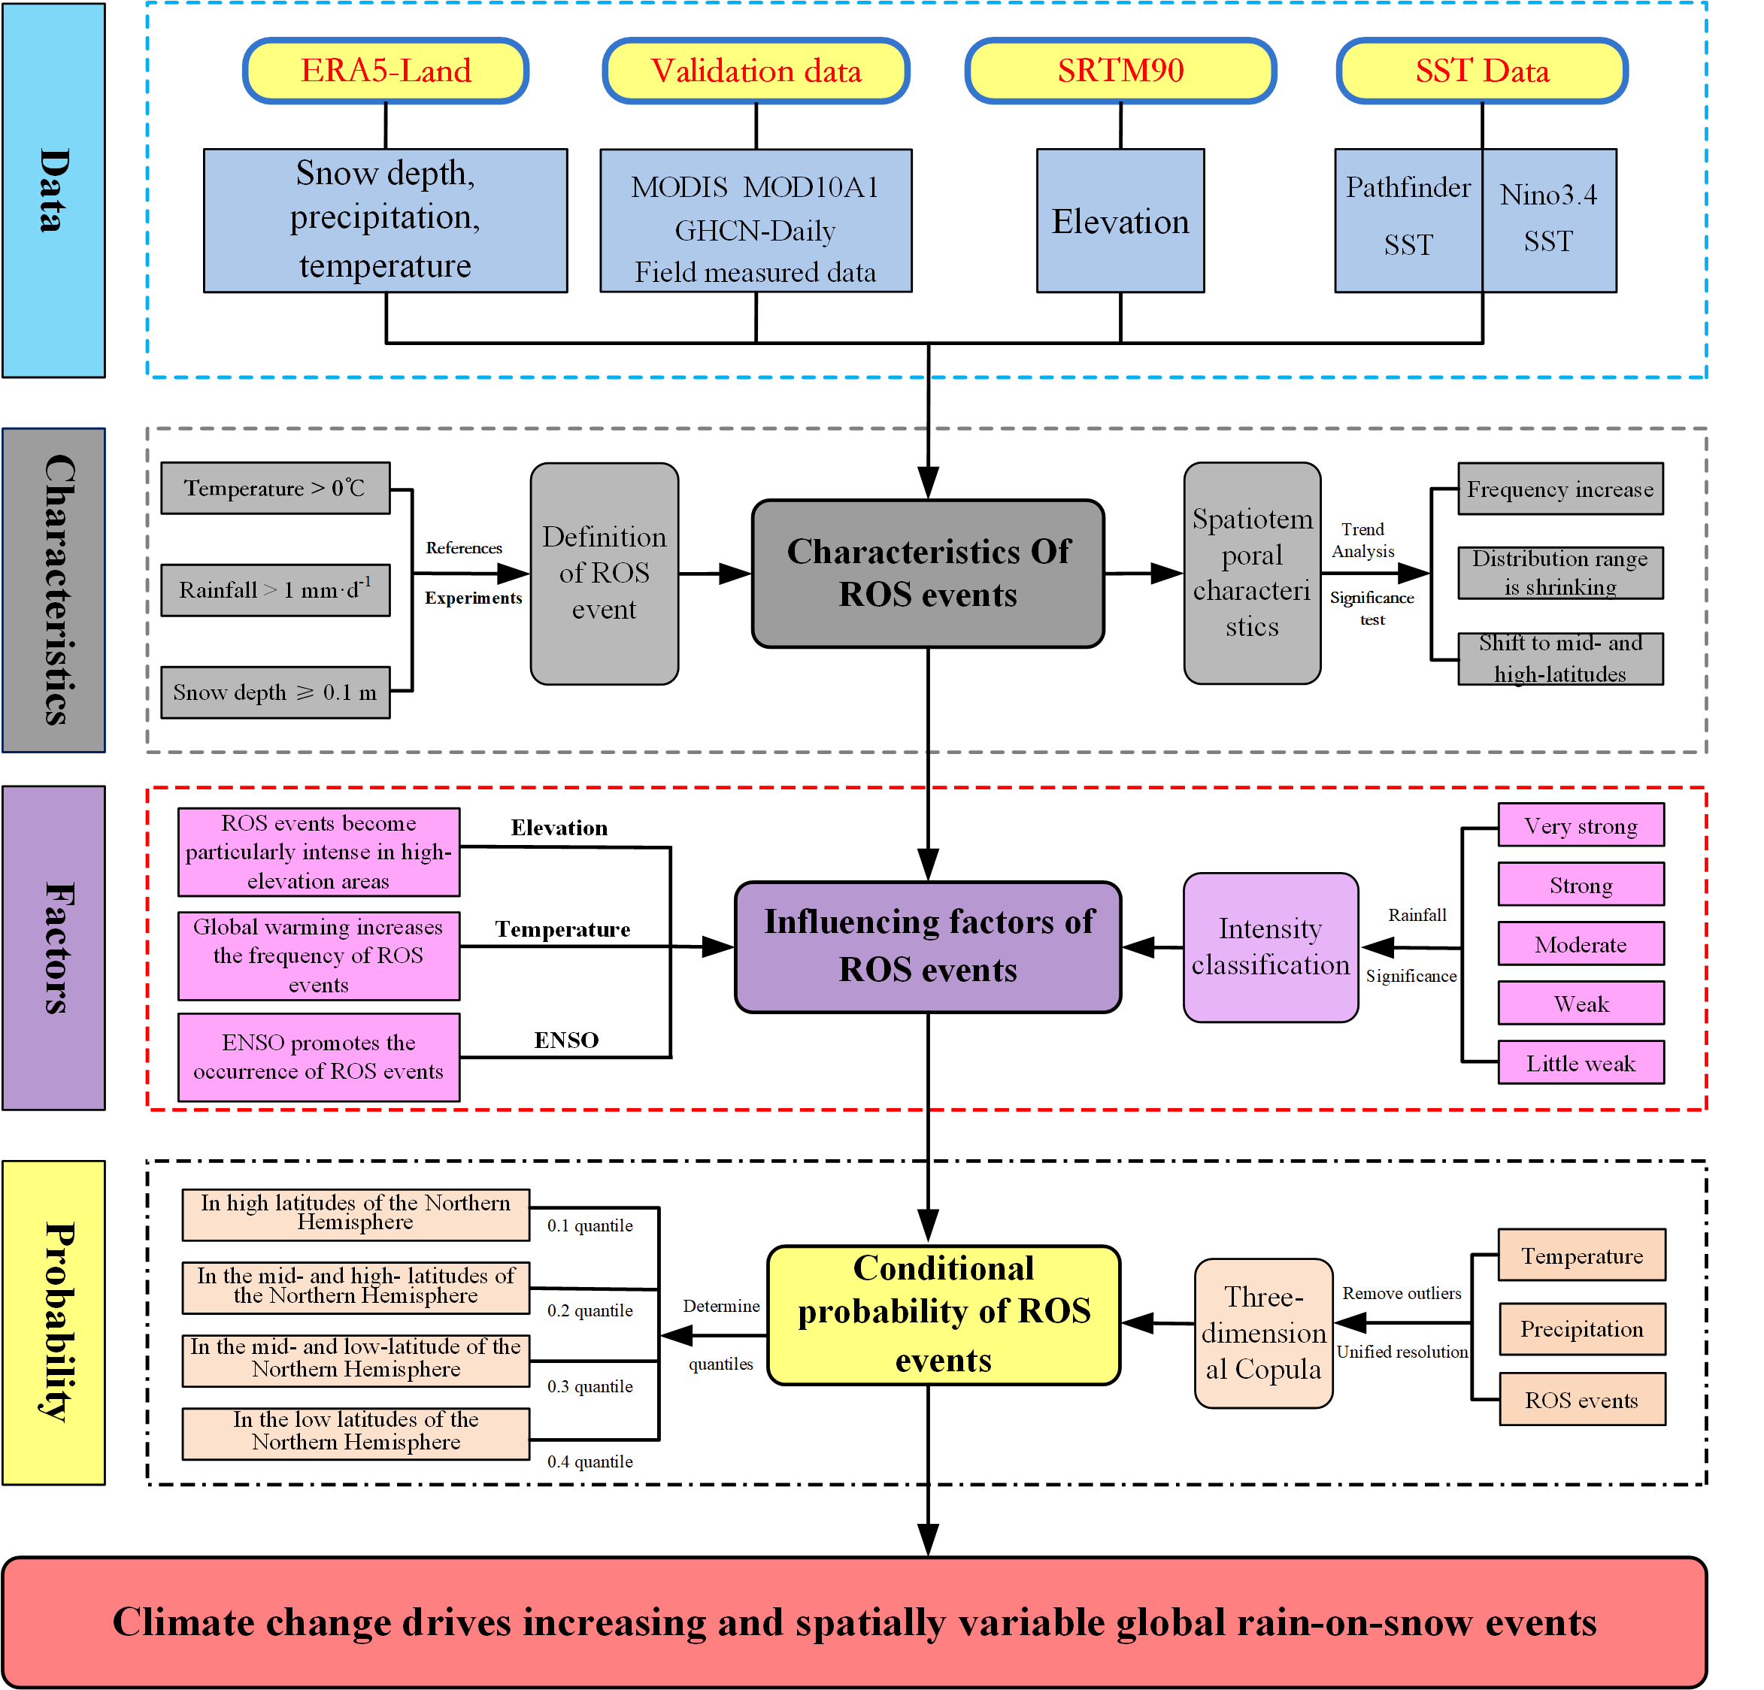

Supplementary Fig. 2 | The spatial distribution trend of global ROS events in different time periods from 1950 to 2023. a. is the trend change of ROS events from 1950 to 1959. b. is the trend change of ROS events from 1960 to 1969. c. is the trend change of ROS events from 1970 to 1979. d. is the trend change of ROS events from 1980 to 1989, e. is the trend change of ROS events from 1990 to 1999. f. is the trend change of ROS events from 2000 to 2009. g. is the trend change of ROS events from 2010 to 2019. h. is the trend change of ROS events from 2020 to 2023.
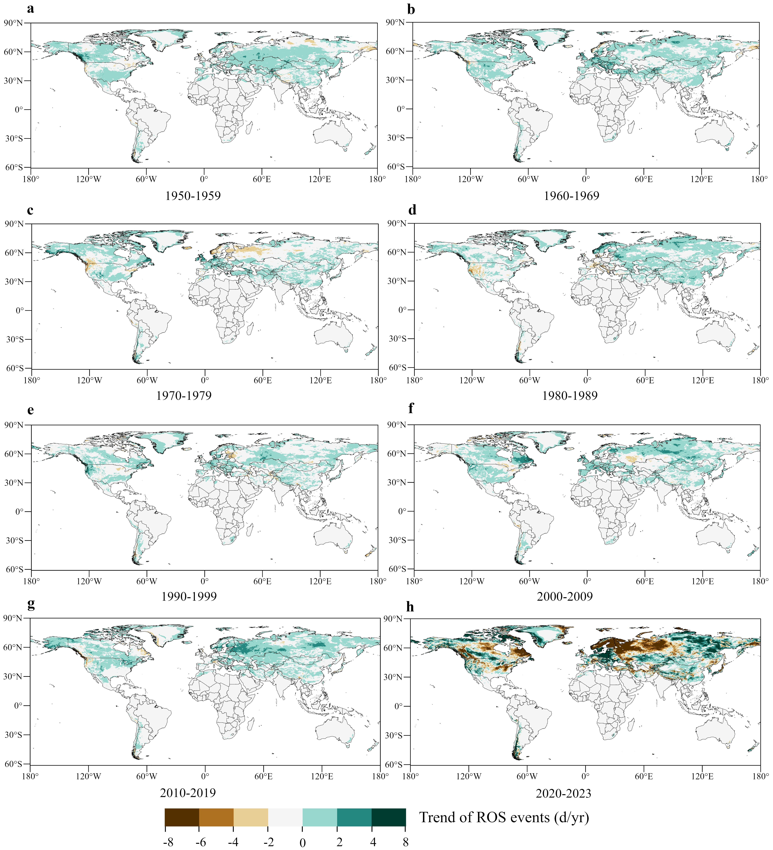

Supplementary Fig. 3 | Spatial distribution of ROS events of different levels in 1950 and 2023. a, c, e, g, i. are the little weak, weak, moderate, strong, and super strong ROS events in 1950, respectively. b, d, f, h, j. are the little weak, weak, moderate, strong, and super strong ROS events in 2023, respectively.
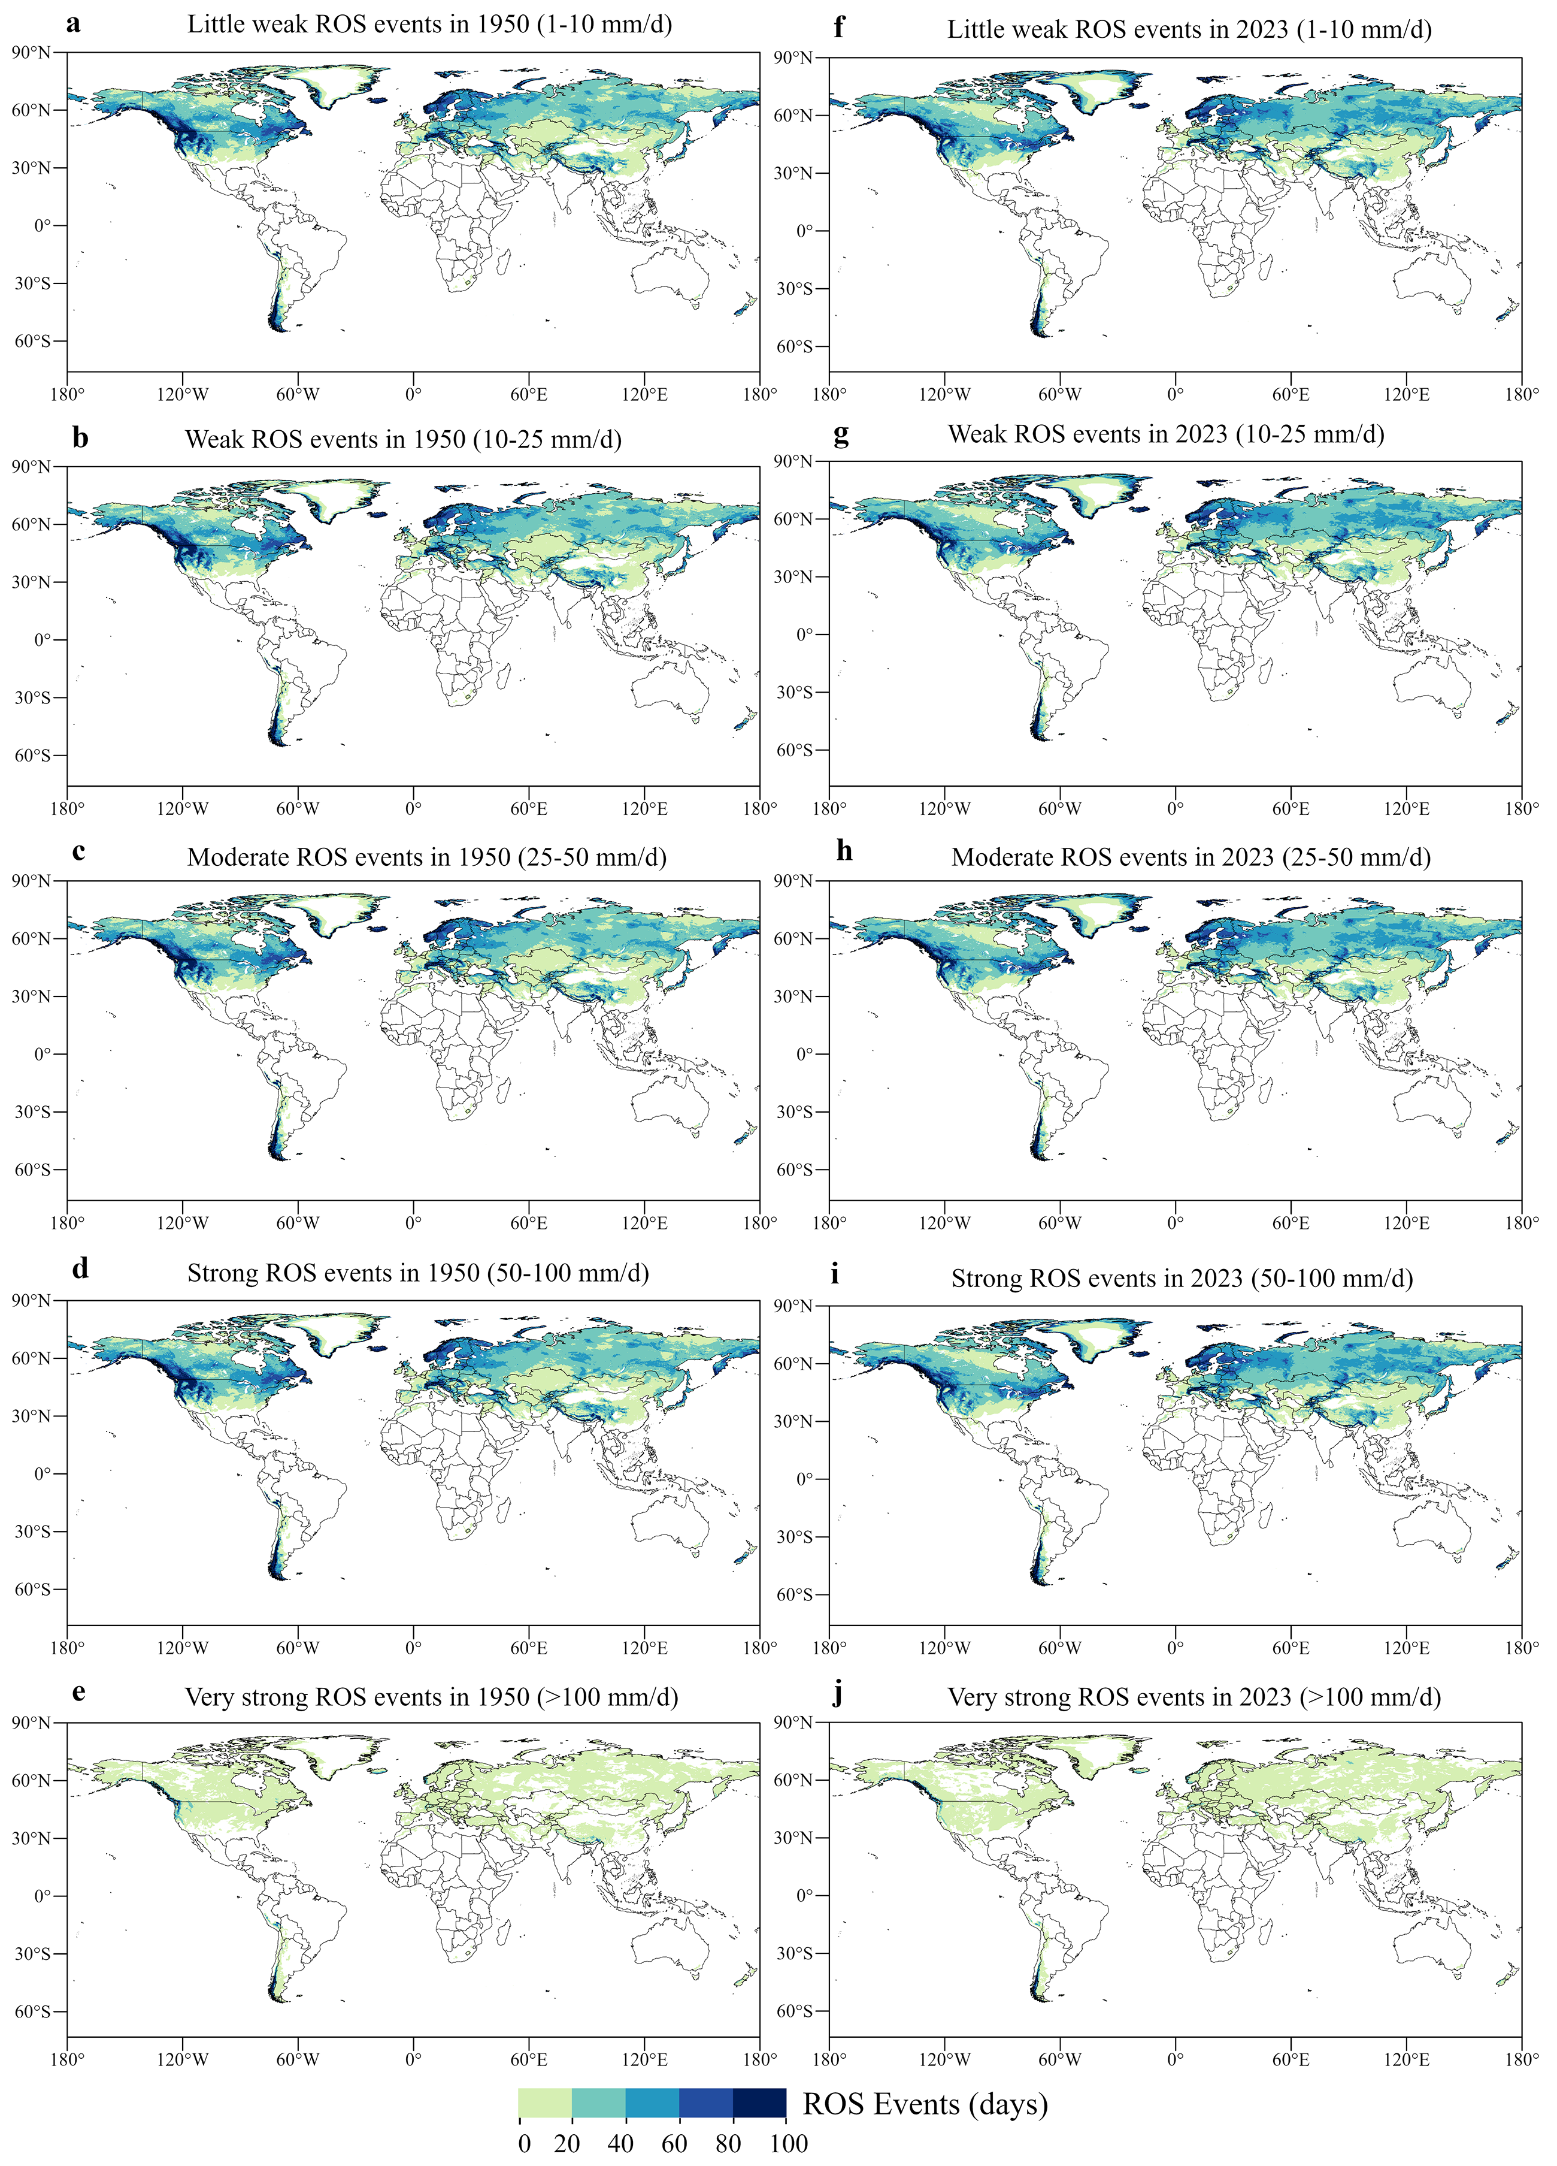

Supplementary Fig. 4 | Changes between ROS events of different intensities and main influencing factors. a. is the correlation matrix of temperature, precipitation, snow depth and five kinds of ROS events. b. is the scatter plot of temperature and little weak ROS events. c is the scatter plot of temperature and weak ROS events. d. is the scatter plot of temperature and moderate ROS events. e is the scatter plot of temperature and strong ROS events. f. is the scatter plot of temperature and very strong ROS events.
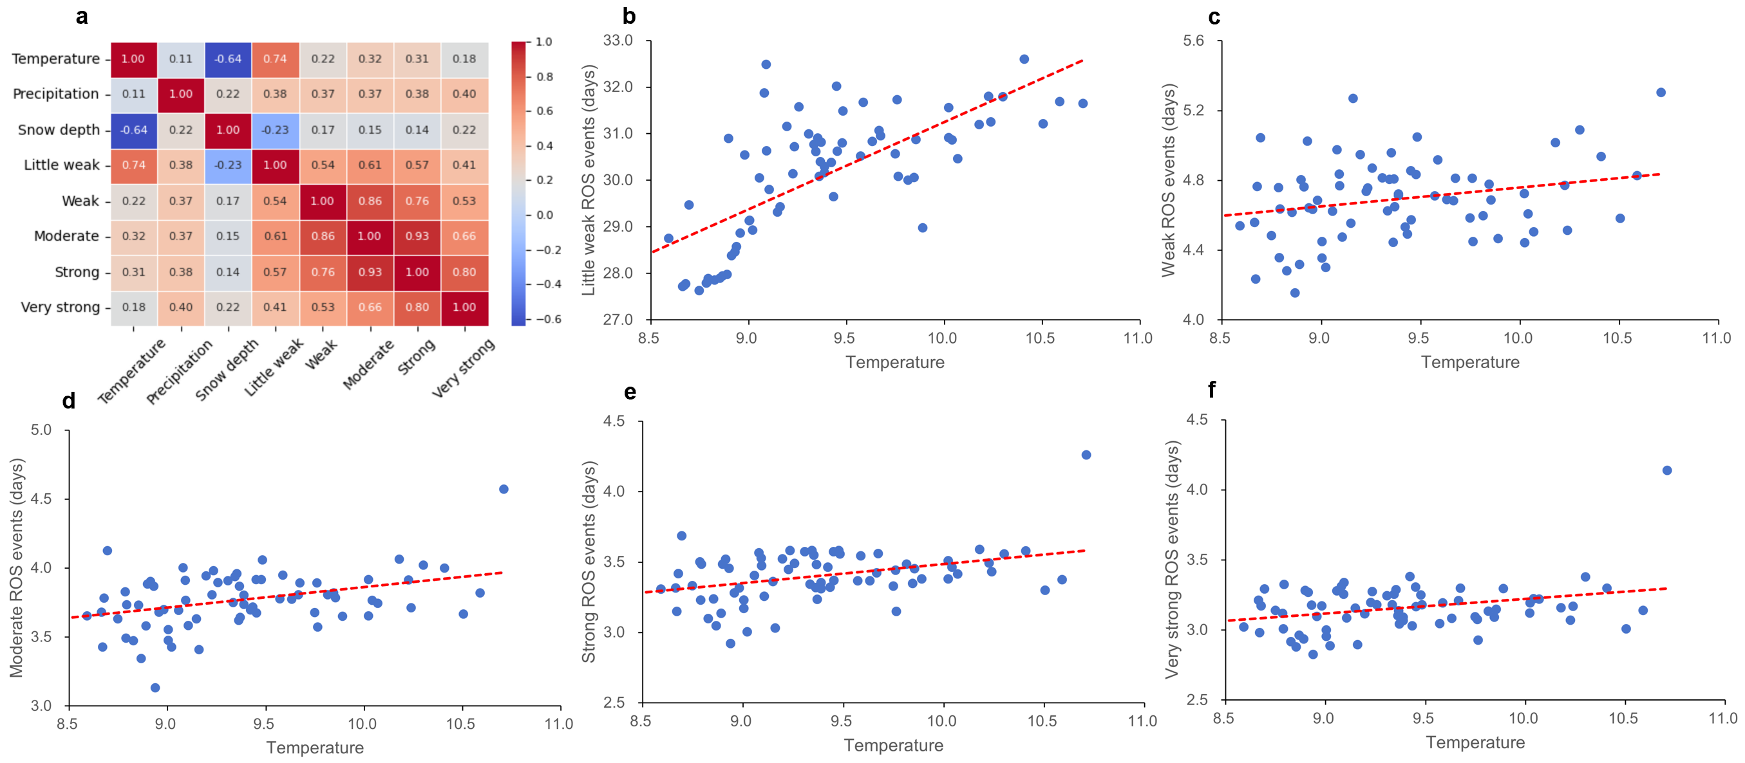

Supplementary Fig. 5 | Multi-year (1950–2023) average monthly spatial distribution of ROS events. (a-l). are the spatial distribution of global monthly average ROS events in various years, January, February, March, April, May, June, July, August, September, October, November and December, respectively.
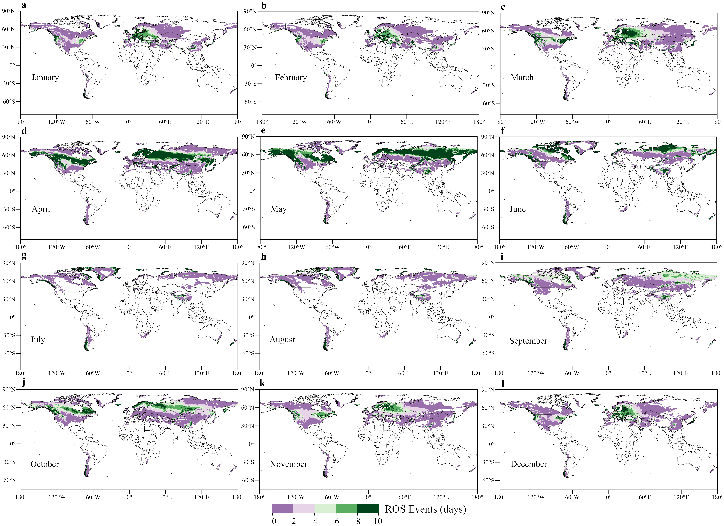

Supplementary Fig. 6 | Monthly ROS event trends from 1950 to 2023. (a-l). are the annual average spatial distribution trends of global monthly average ROS events in January, February, March, April, May, June, July, August, September, October, November and December from 1950 to 2023, respectively.
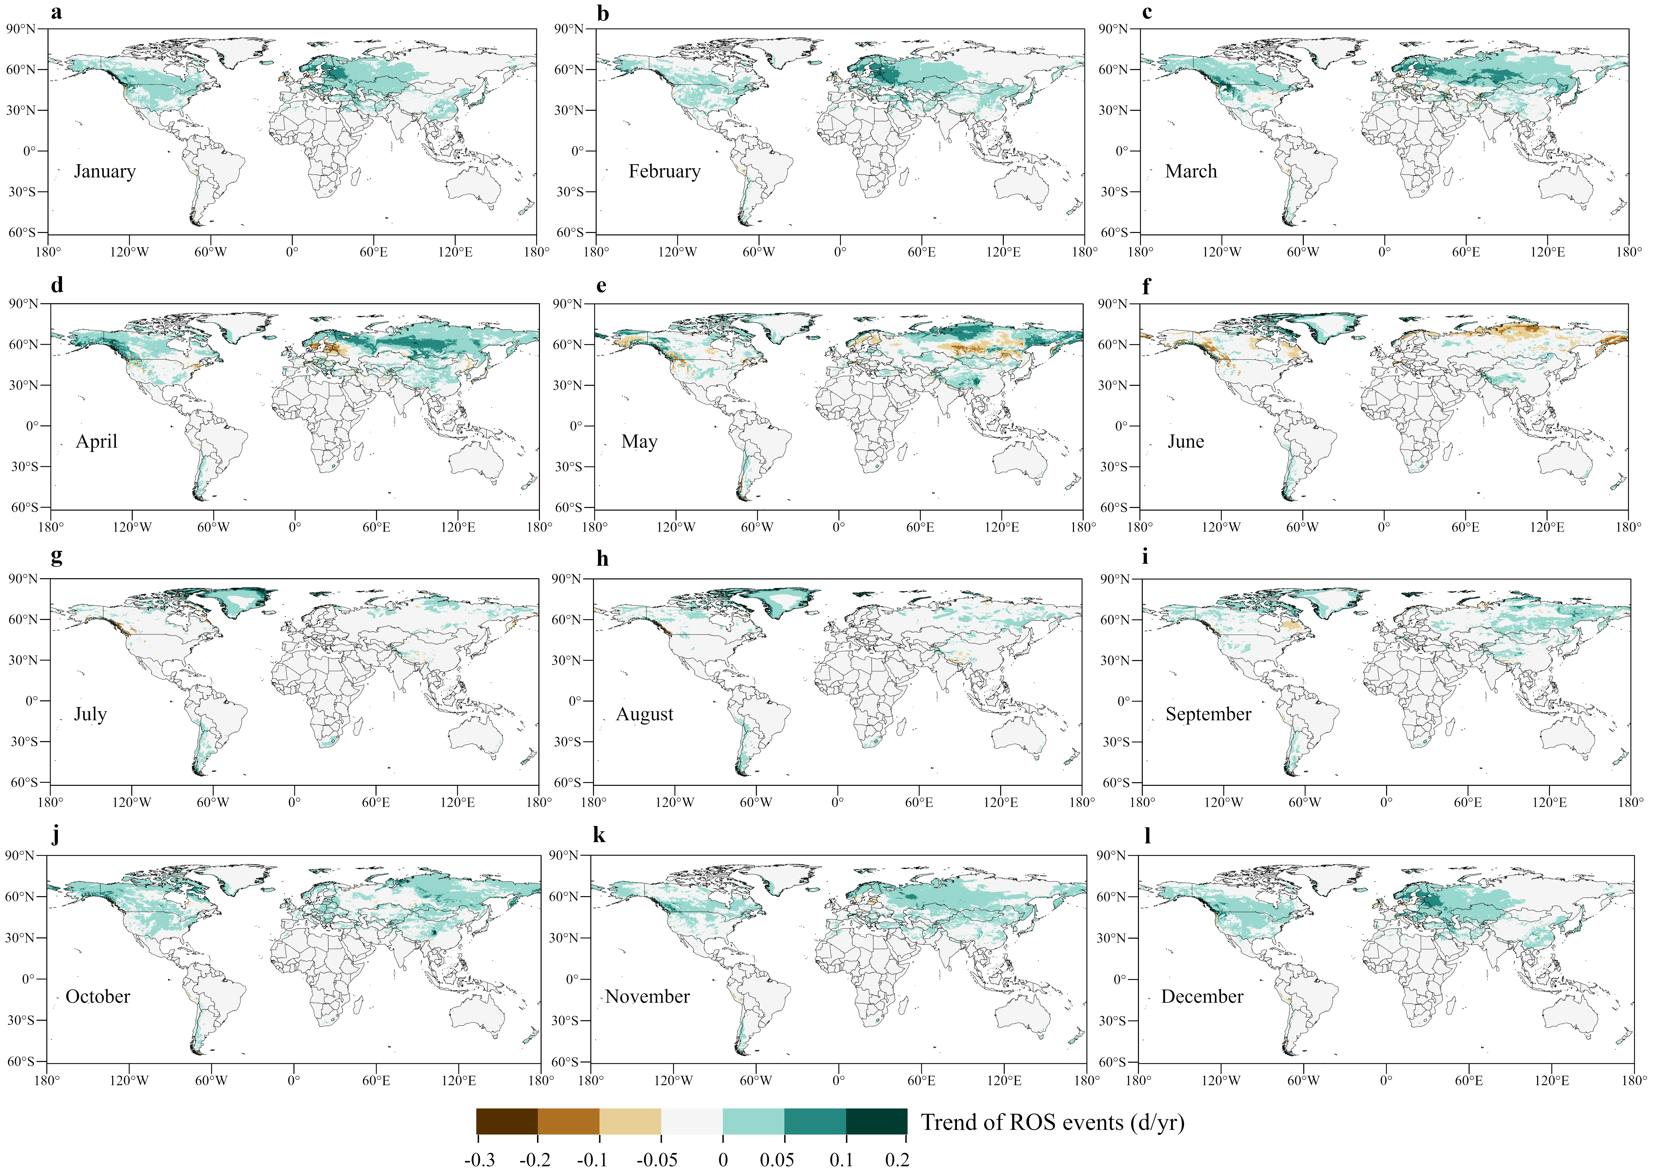

Supplementary Fig. 7 | Seasonal Distribution of ROS Events. (a-d). are the spatial distribution of ROS events in spring, summer, autumn and winter in 1950, respectively. (e-h). are the spatial distribution of ROS events in spring, summer, autumn and winter in 2023, respectively. (i-l). are the changes in ROS events in spring, summer, autumn and winter every decade, respectively.
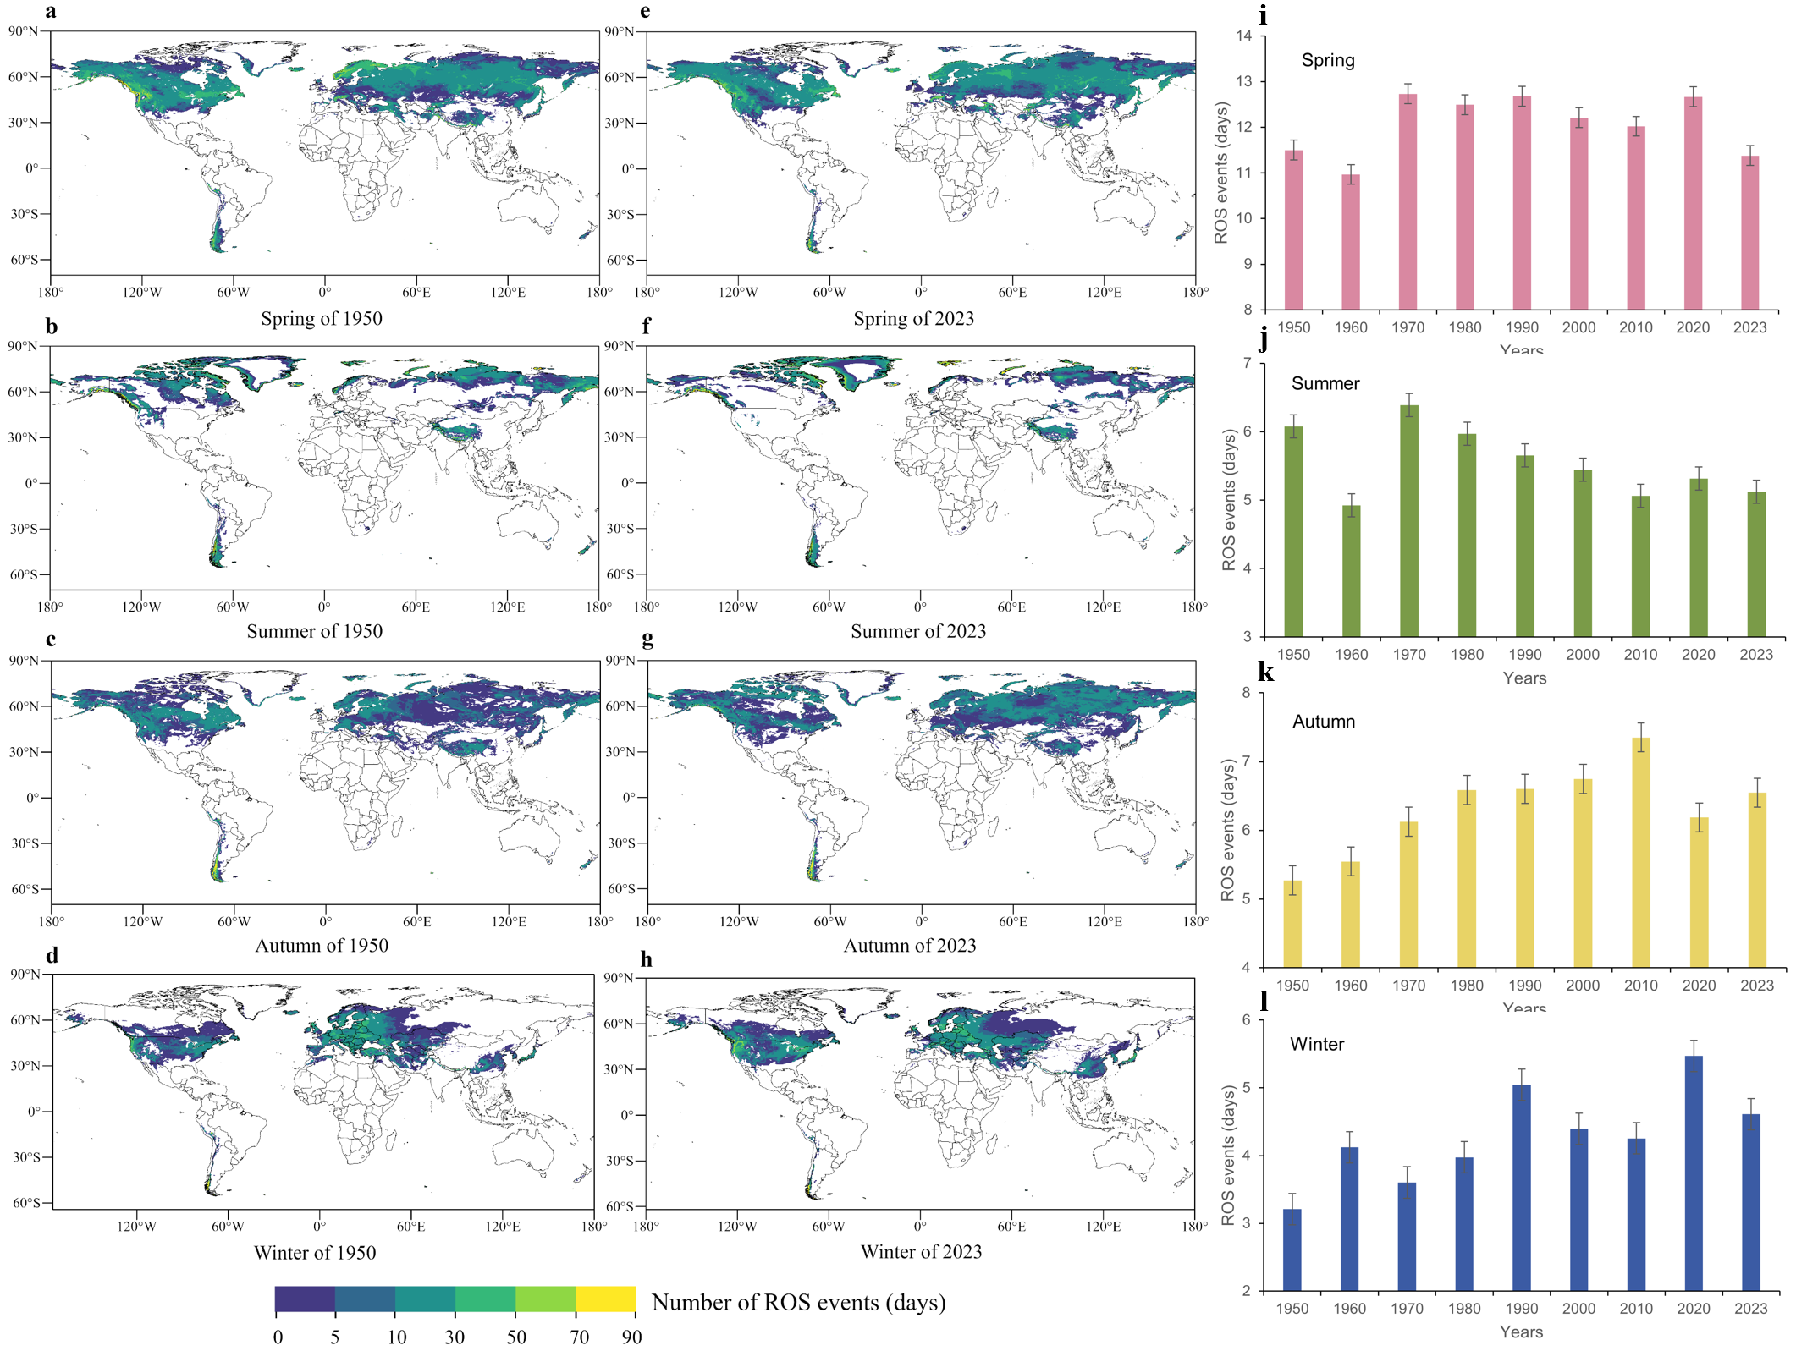

Supplementary Fig. 8 | Field experiment locations and distribution of observation stations. a. is the location of the ROS events basin and the distribution of observation sites that have been established in the Tianshan Mountains in this study. b. shows the schematic diagram of the fine grid (500 m×500 m) hydrological unit in the Hutubi River basin.
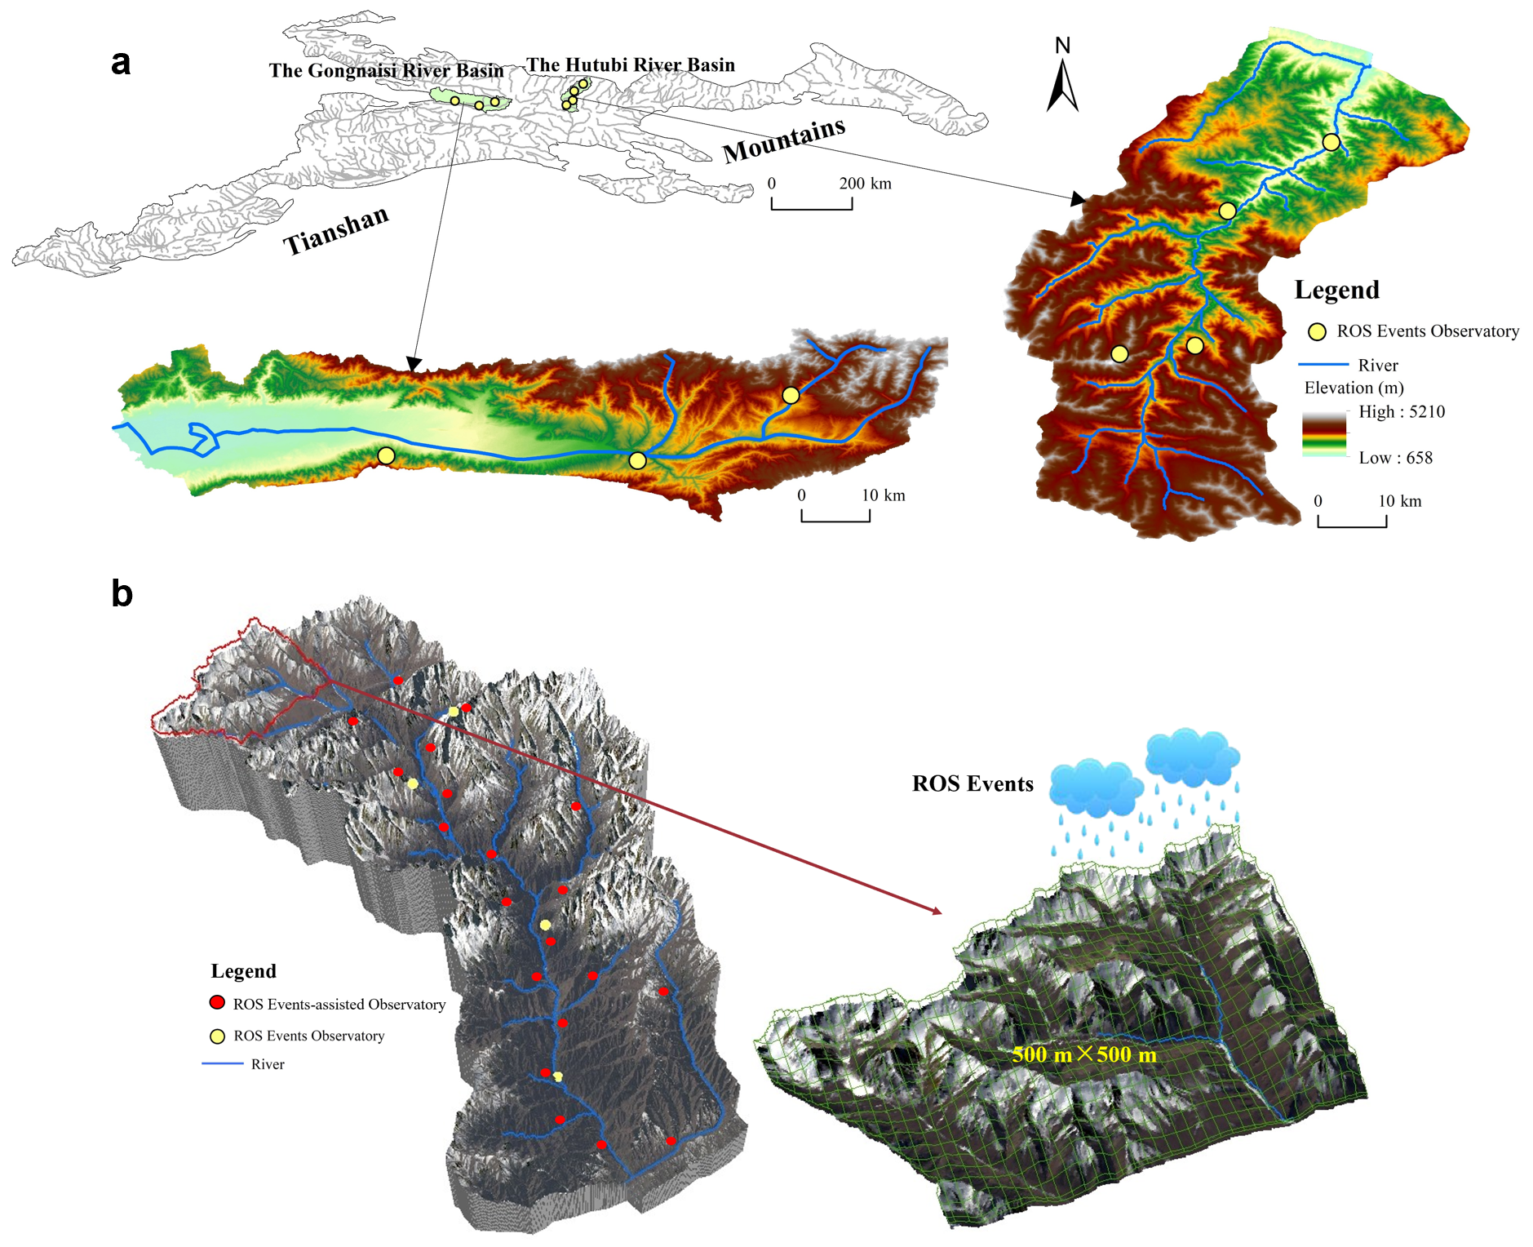

Supplementary Fig. 9 | Trends in the spatial distribution of rainfall, snow depth, temperature, and ROS event days. (a-d). are the annual average spatial distribution trends of rainfall, snow depth, temperature days and ROS event days that meet the definition of ROS events from 1950 to 2023, respectively. (e-h). are the corresponding significance distributions, respectively.
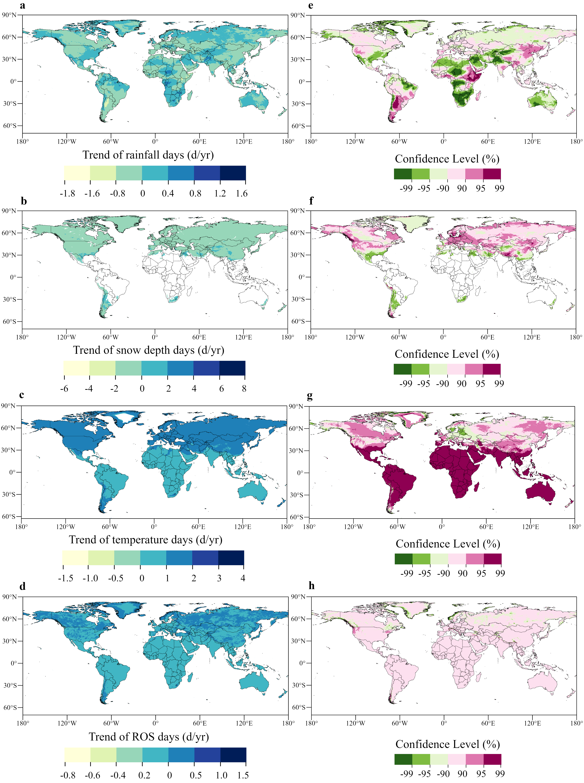

Supplementary Fig. 10 | Validation of results from the Copula. (a-d). are the QQ plots of temperature, precipitation, snow depth, and ROS events from 1950 to 2023, respectively. e. is the correlation matrix among the four.
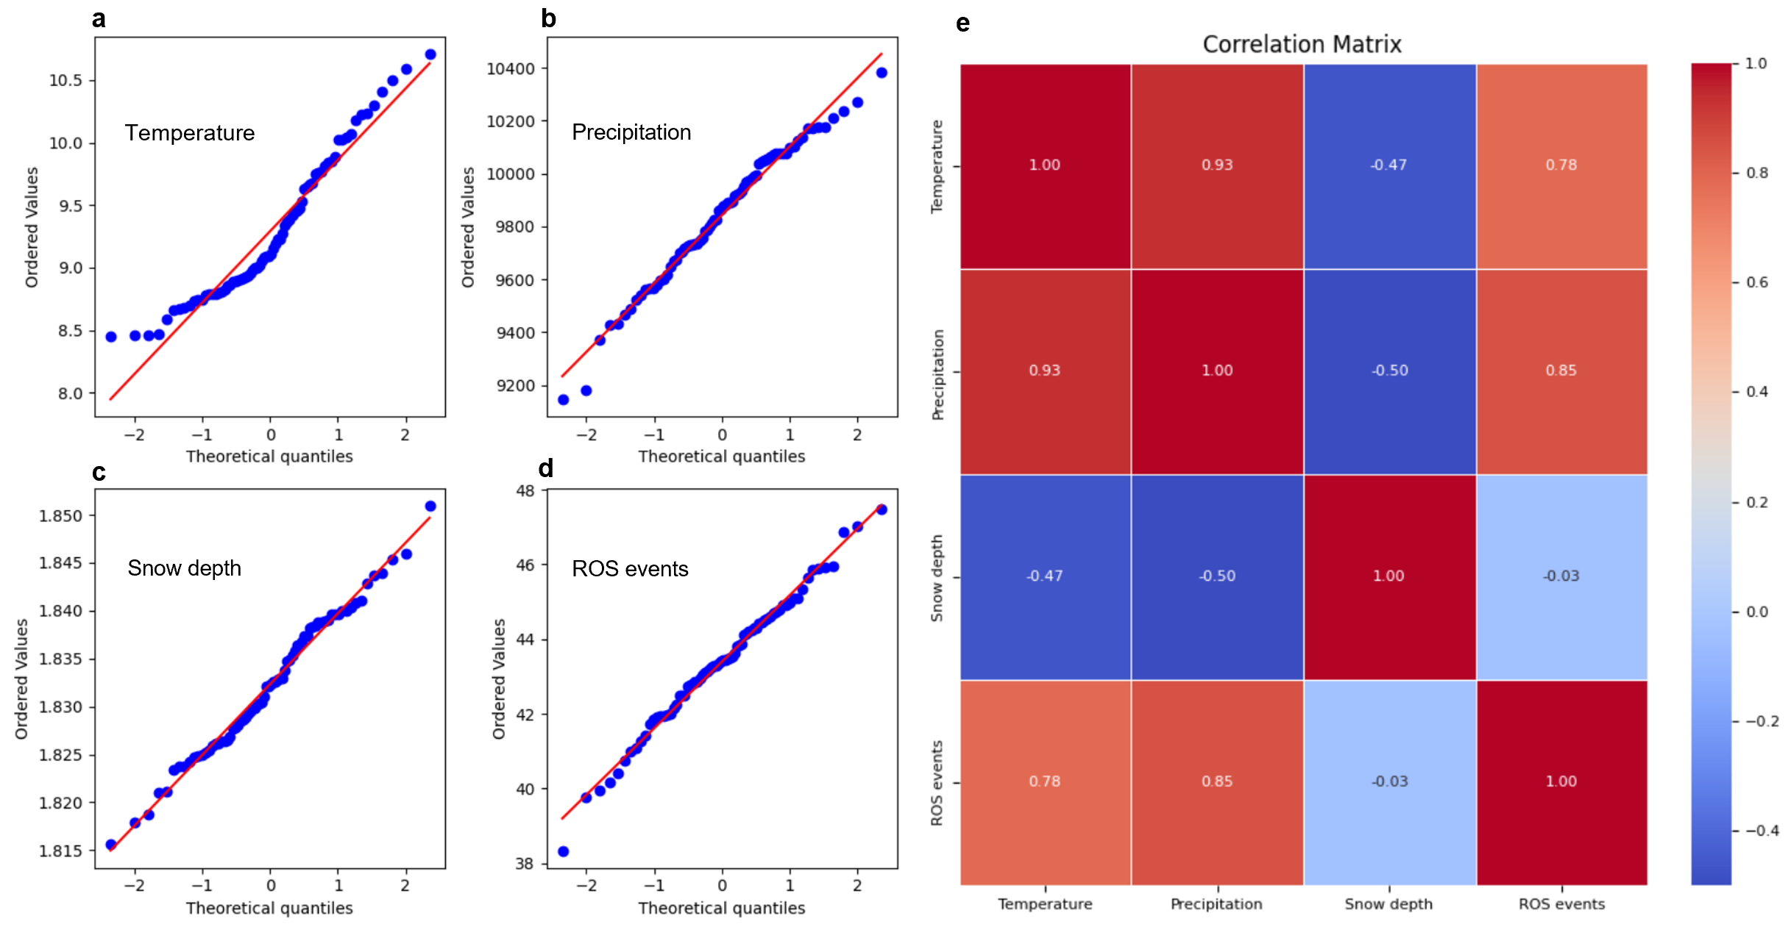

Supplementary Tables
Supplementary Table. 1 | ROS events intensity classification. According to the intensity of rainfall in ROS events and the practical significance they represent, ROS events are further divided into five intensities to determine the occurrence and distribution characteristics of ROS events of different intensities and identify ROS events that may cause floods.
ROS intensity | Precipitation (mm/d) | Significance
Very strong | > 100 | Forming snowmelt floods
Strong | 50 - 100 | Forming snowmelt runoff
Moderate | 25 - 50 | Accelerating snowmelt
Weak | 10 - 25 | Causing snowmelt
Little weak | 1 - 10 | Filling snow gaps

Supplementary Table. 2 | Statistics of ROS events with different intensities. According to the five levels of ROS event intensity defined in this study, the main distribution areas, occurrence times, frequency, trends, and key influencing factors of ROS events at different intensities were statistically analyzed, with $↓$ indicating a decrease and $↑$ indicating an increase.
ROS events intensity | Main distribution range | Primary season of occurrence | Average annual ROS event frequency | Trend
Little weak | 30 - 90 N° | Winter | 31.6 days | $$↓$$
Weak | 30 - 90 N°  30 - 60 S° | Autumn | 5.8 days | $$↑$$
Moderate | 30 - 60 N° | Spring | 4.9 days | $$↑$$
Strong | 35 - 70 N° | Summer | 3.7 days | $$↑$$
Very strong | 35 - 65 N° | Summer | 3.2 days | $$↓$$

Supplementary Table. 3 | Countries with ROS events mainly occur. According to administrative divisions, an analysis was conducted on the countries most affected by ROS events across the major continents, with statistics on the frequency, intensity, and trend of ROS events, with $↓$ indicating a decrease and $↑$ indicating an increase.
Continents | Country | Average annual ROS event frequency | ROS events intensity | Trend
North America | United States | 14.6 days | Very strong | $$↑$$
North America | Canada | 40.8 days | Strong | $$↑$$
North America | Mexico | 4.2 days | Moderate | $$↑$$
South America | Chile | 12.7 days | Moderate | $$↑$$
South America | Argentina | 36.9 days | Strong | $$↑$$
Europe | Norway | 86.5 days | Weak | $$↑$$
Europe | Sweden | 62.4 days | Weak | $$↑$$
Europe | Finland | 93.1 days | Weak | $$↑$$
Europe | Russia | 45.8 days | Moderate | $$↑$$
Europe | Ukraine | 37.6 days | Weak | $$↑$$
Europe | Poland | 28.9 days | Moderate | $$↑$$
Europe | Iceland | 95.7 days | Little weak | $$↑$$
Europe | Germany | 25.3 days | Moderate | $$↑$$
Europe | France | 16.2 days | Moderate | $$↑$$
Europe | Italy | 48.6 days | Weak | $$↑$$
Europe | Turkey | 38.4 days | Moderate | $$↑$$
Europe | United Kingdom | 19.8 days | Strong | $$↑$$
Oceania | New Zealand | 20.5 days | Weak | $$↑$$
Asia | China | 22.6 days | Moderate | $$↑$$
Asia | Japan | 41.7 days | Strong | $$↑$$
Asia | South Korea | 18.8 days | Strong | $$↑$$
Asia | Iran | 24.3 days | Weak | $$↑$$
Asia | Mongolia | 14.5 days | Weak | $$↑$$
Asia | Kazakhstan | 18.2 days | Moderate | $$↑$$
Africa | Morocco | 8.6 days | Weak | $$↑$$
Africa | South Africa | 5.4 days | Little weak | $$↑$$
Supplementary Table. 4 | Distribution of ROS events across different elevation ranges. The elevation range is divided into intervals of 500 meters: 0-1500 m as the low-elevation zone, 1500-3000 m as the mid-elevation zone, 3000-6000 m as the high-elevation zone, and above 6000 m as the ultra-high elevation zone. The frequency, intensity, and trend of ROS events are statistically analyzed for each elevation interval, with $↓$ indicating a decrease and $↑$ indicating an increase.
Elevation zone (m) | Elevation zone attributes | Average annual ROS events frequency | ROS events intensity | Trend
0-500 | Low elevation | 0 days | — | —
501-1000 | Low elevation | 2.7 days | Moderate | $$↓$$
1001-1500 | Low elevation | 12. 8 days | Weak | $$↓$$
1501-2000 | Medium elevation | 16.3 days | Moderate | $$↓$$
2001-2500 | Medium elevation | 19.5 days | Strong | $$↓$$
2501-3000 | Medium elevation | 22.9 days | Very strong | $$↓$$
3001-3500 | Medium elevation | 25.6 days | Very strong | $$↑$$
3501-4000 | High elevation | 27.2 days | Strong | $$↑$$
4001-4500 | High elevation | 29.4 days | Strong | $$↑$$
4501-5000 | High elevation | 30.1 days | Moderate | $$↑$$
5001-5500 | High elevation | 32.7 days | Moderate | $$↑$$
5501-6000 | High elevation | 31.4 days | Weak | $$↑$$
6001-6500 | Ultra-high-elevation | 30.6 days | Weak | $$↑$$
6501-7000 | Ultra-high-elevation | 59.8 days | Weak | $$↑$$
7001-7500 | Ultra-high-elevation | 80.3 days | Weak | $$↑$$
7501-8000 | Ultra-high-elevation | 108.1 days | Little weak | $$↑$$
8001-8500 | Ultra-high-elevation | 0 days | — | —
8501-8900 | Ultra-high-elevation | 0 days | — | —

Supplementary Table. 5 | Seasonal characteristics of ROS events. Based on a seasonal division of the year—spring (March–May), summer (June–August), autumn (September–November), and winter (December to February of the following year)—the frequency, intensity, and trend of ROS events are analyzed, with $↓$ indicating a decrease and $↑$ indicating an increase.
Season | Month | Average monthly ROS events frequency | ROS events intensity | Trend
Spring | March | 2.1 days | Weak | $$↑$$
Spring | April | 5.5 days | Moderate | $$↑$$
Spring | May | 6.4 days | Strong | $$↑$$
Summer | June | 4.2 days | Strong | $$↓$$
Summer | July | 2.1 days | Very strong | $$↑$$
Summer | August | 1.6 days | Very strong | $$↑$$
Autumn | September | 3.2 days | Strong | $$↑$$
Autumn | October | 3.7 days | Moderate | $$↑$$
Autumn | November | 2.5 days | Weak | $$↑$$
Winter | December | 2.8 days | Little weak | $$↑$$
Winter | January | 1.2 days | Little weak | $$↑$$
Winter | February | 1.9 days | Little weak | $$↑$$

Supplementary Table. 6 | Distribution of ROS events across different latitudinal ranges. The global latitude is divided into latitudinal bands every 30°, corresponding to low, middle, and high latitudes (excluding high latitudes in the Southern Hemisphere). The frequency, intensity, and trend of ROS events are statistically analyzed, with $↓$ indicating a decrease and $↑$ indicating an increase.
Latitude range | Latitude zone | Average annual ROS events frequency | ROS events intensity | Trend
0-30 N | Low latitude | 2.5 days | Weak | $$↓$$
30-60 N | Mid-latitude | 28.6 days | Moderate | $$↑$$
60-90 N | High Latitude | 37.4 days | Moderate | $$↑$$
0-30 S | Low latitude | 1.8 days | Little weak | $$↓$$
30-60 S | Mid-latitude | 16.3 days | Weak | $$↑$$

Supplementary Table. 7 | Field measured stations. We selected the areas that were both easy to monitor and representative of regions with a high incidence of mixed rain and snow floods — namely, the Manas River, Jingou River, Hutubi River, and Gongnaisi River on the northern slope of the Tianshan Mountains. In these areas, we installed field snow accumulation meteorological stations to observe and record ROS events, and further validated the ERA5-Land data using the field-measured observations.
Station name | Station category | Basin | Longitude | Latitude | Elevation (m)
Shimen station | Hydrology | Hutubi River | 86°34′ E | 43°45′ N | 1180
Bajiahu station | Hydrology | Jingou River | 85°25′ E | 43°57′ N | 1000
Kensiwate station | Hydrology | Manasi River | 85°57′ E | 43°58′ N | 900
Hutubi station | Meteorology | Hutubi River | 86°54′ E | 44°11′ N | 522
Fangcaohu station | Meteorology | Hutubi River | 86°39′ E | 44°36′ N | 383
Self-built snow station1 | Snow | Hutubi River | 86°28′ E | 43°37′ N | 1500
Self-built snow station2 | Snow | Hutubi River | 86°26′ E | 43°34′ N | 2000
Self-built snow station3 | Snow | Hutubi River | 86°31′ E | 43°39′ N | 2500
Self-built snow station4 | Snow | Hutubi River | 86°35′ E | 43°36′ N | 4000
Self-built snow station4 | Snow | Gongnaisi River | 83°45′ E | 43°22′ E | 1000
Self-built snow station5 | Snow | Gongnaisi River | 83°44′ E | 43°21′ E | 3000
Self-built snow station6 | Snow | Gongnaisi River | 83°46′ E | 43°23′ E | 3500

Supplementary Table. 8 | Introduction and sources of main datasets. The ERA5-Land dataset mainly provides snow depth, precipitation, and temperature related to ROS events, the SRTM90 dataset mainly provides elevation data, the Pathfinder SST and Nino3.4 SST datasets mainly provide ENSO data, and the remaining datasets are used to verify the ERA5-Land dataset.
ID | Dataset name | Time Range | Spatial resolution | Temporal resolution | Data source
1 | ERA5-Land | 1950 — | 5 km | Hourly | https://doi.org/10.24381/cds.e2161bac
2 | MODIS MOD10A1 | 2000 — | 500 m | Daily | https://nsidc.org/data/MOD10A1
3 | GHCN-Daily | 1950 — | — | Daily | https://www.ncei.noaa.gov/products/land-based-station/global-historical-climatology-network-daily
4 | SRTM90 | 2000 | 90 m | — | https://srtm.csi.cgiar.org
5 | Pathfinder SST | 1981 — | 4 km | Daily | https://doi.org/10.7289/V52J68XX
6 | Nino3.4 SST | 1950 — | — | Daily | http://climexp.knmi.nl

Supplementary Table. 9 | The key factors influencing ROS events. The influences of elevation, temperature, precipitation, snow depth, and ENSO on ROS events were systematically analyzed. For each factor, the spatial extent of influence, underlying mechanisms, consequent impacts, and temporal trends were evaluated, with $↓$ indicating a decrease and $↑$ indicating an increase.
Factor | Spatial extent | Mechanism | Result | Trend
Elevation | Mid-high latitudes | Affect local climatic conditions | An increase in ROS events at high elevations | —
Temperature | Global | Determine the form of precipitation | An increase in rainfall | $$↑$$
Precipitation | Global | Determine the intensity of ROS events | An increase in intensity of ROS events | $$↑$$
Snow depth | Global | Underlying surface conditions | A decrease in spatial extent of ROS events | $$↓$$
ENSO | Global | Influence atmospheric circulation | Fluctuations in ROS events | $$↑$$

Supplementary Table. 10 | The current experiments on ROS events around the world. At present, most of the experiments on ROS are conducted by American researchers, and they primarily use chemical tracers to investigate rainfall infiltration, solute transport, runoff generation, and runoff partitioning. However, there has been limited focus on the mechanisms of ROS events, particularly in relation to the corresponding thresholds of temperature, snow depth, and rainfall.
Purpose | Location | Elevation /m | Number of trials | Rainfall /mm | Duration /min | Tracer | Rainfall area /m² | Snow depth /cm | Test interval /min
Rainwater infiltration | Soda Springs in the Sierra Nevada, USA | 2100 | 3 | 2.5 | 5 | Dye | 1.0*1.0 | 50-100 | —
Rainwater infiltration | Snoqualmie Pass in the Cascade Range, USA | 915 | 2 | 19.0、100.0 | 600、2160 | None | 1.5*1.0 | 120、135 | None、660
Runoff generation | Glatabach catchment in the Großglockner Mountain, Austria | 2640 | 6 | 49.2-201.0 | 60-120 | None | 2.0*1.0、2.0*2.0 | 108 | 10-14
Solute transport | Soda Springs in the Sierra Nevada, USA | 2100 | 3 | 240.0（total） | 90-270 | Tm、Yb、Lu | 6.0*3.0 | 135 | 45-90
Solute transport | Soda Springs in the Sierra Nevada, USA | 2100 | 4 | 460.0（total） | 306-330 | F-(KF)、Br-（LiBr） | 6.0*3.0 | 210 | 110-130
Internal snowpack runoff | Boise National Forest, Idaho, USA | 850 | 8 | 9.5 | 30 | NaCI | 1.5*0.5 | 47-138 | 120-1290
Runoff partitioning | Elbe River basin in the Krkonoš Mountains, Czech Republic | 1300 | 1 | 72.7 | 61 | δ²H | 0.5*0.5 | 120 | 19

Supplementary References
- Juras, R. et al. Isotopic tracing of the outflow during artificial Rain-On-Snow event. J. Hydrol. 541, 1145-1154 (2016).
- Chen, R. S. et al. Progress and issues on key technologies in forecasting of snowmelt flood disaster in arid areas, Northwest China. Adv. Earth Sci. 36, 233-244 (2021).
- Lee, J., Jung, H. Separations of meltwater discharge in a snowpack by artificial rain-on-snow experiments. Appl. Water Sci. 14, 248 (2024).
- Lei, G. J. et al. Hydrological Frequency Analysis in Changing Environments Based on Empirical Mode Decomposition and Metropolis-Hastings Sampling Bayesian Models. J. Hydrol. Eng. 28, 04023027 (2023).
- Maruki, T. et al. What can we infer about mutation calling by using time-series mutation accumulation data and a Bayesian Mutation Finder? Ecol. Evol. 14, e70339 (2024).
- Menne, M. J. et al. An Overview of the Global Historical Climatology Network-Daily Database. J. Atmos. Oceanic Technol. 29, 897-910 (2012).
- Rajah, K. et al. Changes to the temporal distribution of daily precipitation. Geophys. Res. Lett. 41, 8887-8894 (2015).
- McNicholl, B. et al. Evaluating the Reliability of Air Temperature From ERA5 Reanalysis Data. IEEE Geosci. Remote Sens. Lett. 19, 1004505 (2022).
- Hall, D. K. et al. MODIS snow-cover products. Remote Sens. Environ. 83, 181-194 (2002).
- Remer, L. A. et al. The MODIS aerosol algorithm, products, and validation. J. Atmos. Sci. 62, 947-973 (2005).
- Notarnicola, C. Hotspots of snow cover changes in global mountain regions over 2000-2018. Remote Sens. Environ. 243,111781 (2020).
- Trenberth, K. E. The definition of El Nino. Bull. Am. Meteorol. Soc. 78, 2771-2777 (1997).
- McPhaden, M. J., Zebiak, S. E. & Glantz, M. H. ENSO as an integrating concept in Earth science. Science 314, 1740-1745 (2006).
- Yeh, S. W. et al. El Niño in a changing climate. Nature 461, 511–514 (2009).
- Jacob, P., Suquet, C. Regression and edge estimation. Stat. Probab. Lett. 17,11-15 (1996).
- Evin, G., Le Roux, E. & Kamir, E. Estimating changes in extreme snow load in Europe as a function of global warming levels. Cold Reg. Sci. Technol. 231, 104424 (2025).
- Takeuchi, T. T., Kono, K. T. Constructing a multivariate distribution function with a vine copula: towards multivariate luminosity and mass functions. Mon. Not. R. Astron. Soc. 498, 4365-4378 (2020).
- Wang, B. et al. Redshift-evolutionary X-Ray and UV Luminosity Relation of Quasars from Gaussian Copula. Astrophys. J. 940,174 (2022).
- Favre, A. C. et al. Multivariate hydrological frequency analysis using copulas. Water Resour. Res. 40, W01101 (2004).
- Genest, C., Favre, A. C. Everything you always wanted to know about copula modeling but were afraid to ask. J. Hydrol. Eng. 12, 347-368 (2007).
- Razmkhah, H., Fararouie, A. & Ravari, A. R. Multivariate Flood Frequency Analysis Using Bivariate Copula Functions. Water Resour. Res. 36, 729-743 (2022).
- Basistha, A., Arya, D. S. & Goel, N. K. Analysis of historical changes in rainfall in the Indian Himalayas. Int. J. Climatol. 29, 555-572 (2009).
- Schober, P., Boer, C. & Schwarte, L. A. Correlation Coefficients: Appropriate Use and Interpretation. Anesth. Analg. 126, 1763-1786 (2018).
- Tanaka, H., Watada, J. Possibilistic linear systems and their application to the linear regression model. Fuzzy Sets Syst. 27, 275-289 (1988).
- Knoben, W. J. M., Freer, J. E. & Woods, R. A. Technical note: Inherent benchmark or not? Comparing Nash-Sutcliffe and Kling-Gupta efficiency scores. Hydrol. Earth Syst. Sci. 23, 4323-4331 (2019).
- Hamed, M. M. et al. Inconsistency in historical simulations and future projections of temperature and rainfall: A comparison of CMIP5 and CMIP6 models over Southeast Asia. Atmos. Res. 265, 105927 (2022).

