Perovskite-Organic Tandem Solar Cells Via Mobile Defects Mitigation and Solution-Processed Interconnecting Layers
Yingjie Hu^{1,6}, Qianyi Li^{1,6}, Kaifeng Jing¹, Jiangsheng Yu¹, Fuyi Zhou⁴, Zhenhai Ai¹, You Chen^{3,5}, Yue Zhao¹, Yijia Zhang¹, Zhenyi Ni⁴, Yang Bai^{3,5*}, Gang Li^{1,2*}, Guang Yang^{1,2*}
¹Department of Electrical and Electronic Engineering, The Hong Kong Polytechnic University, Hung Hom, Kowloon, Hong Kong, China
²Photonic Research Institute (PRI), Research Institute of Smart Energy (RISE), Research Institute for Advanced Manufacturing (RIAM), The Hong Kong Polytechnic University, Hung Hom, Kowloon, Hong Kong, China
³Faculty of Materials Science and Energy Engineering, Shenzhen University of Advanced Technology, Shenzhen 518107, China
⁴State Key Laboratory of Silicon and Advanced Semiconductor Materials & School of Materials Science and Engineering, Zhejiang University, Hangzhou 310027, China
⁵Institute of Technology for Carbon Neutrality, Shenzhen Institutes of Advanced Technology (SIAT), Chinese Academy of Sciences, Shenzhen 518055, China.
⁶These authors contributed equally: Yingjie Hu, Qianyi Li
Email: y.bai@siat.ac.cn, gang.w.li@polyu.edu.hk, guang.yg.yang@polyu.edu.hk

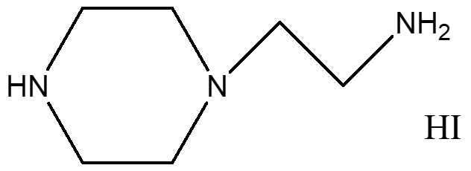
Supplementary Figure 1. The chemical structure of 2-(piperazine-1-yl) ethylamine hydroiodide (PipEAI).

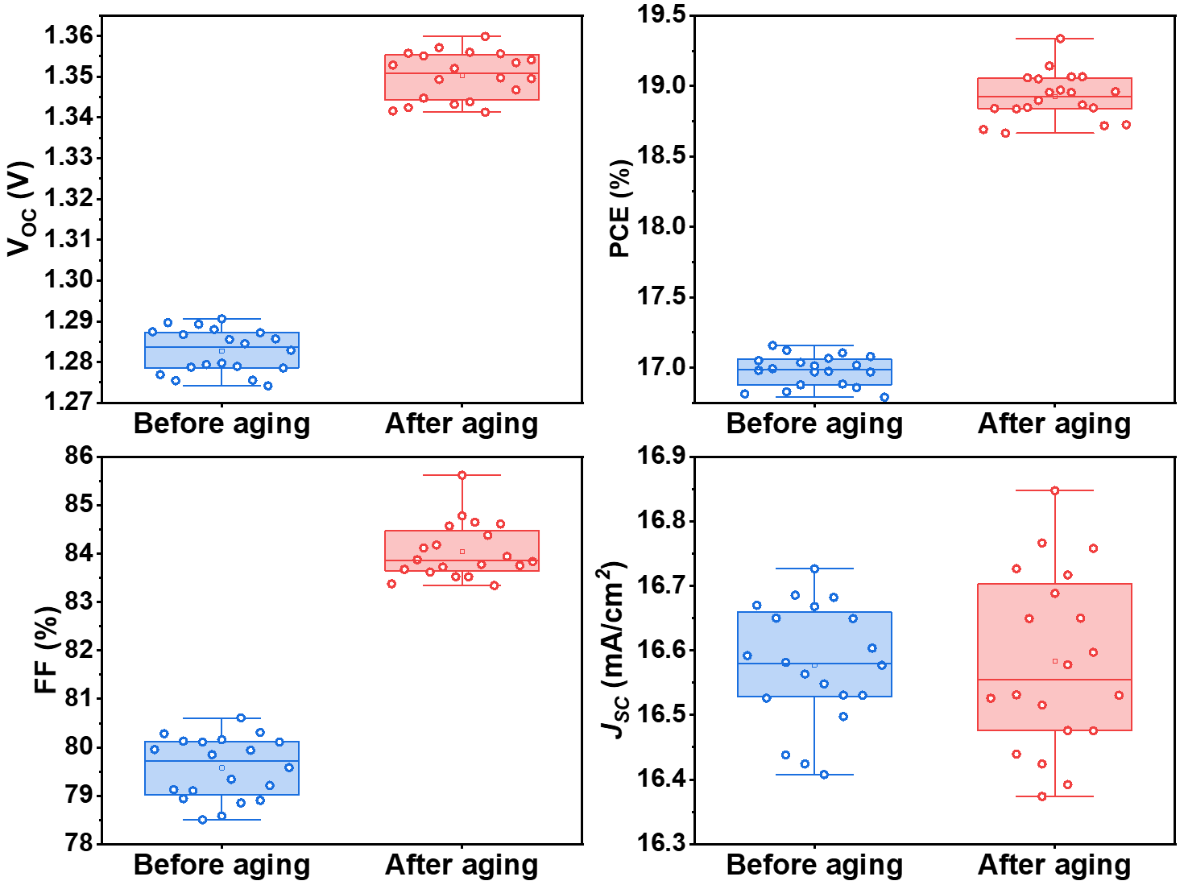
Supplementary Figure 2. Statistics of (a) V_{OC}, (b)FF (c) J_{SC} and (d) PCE for 20 WBG PSCs before and after 72h aging. Statistical parameters were analyzed for both before and after aging devices (aperture area = 0.1 cm²) across 20 devices from four independent batches. The boxplots display: whiskers (data minima and maxima), box boundaries (25th and 75th percentiles), and center line (mean value).

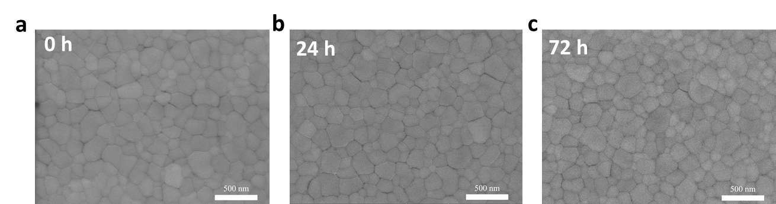
Supplementary Figure 3. Top-view SEM images of WBG perovskite films with different aging times.

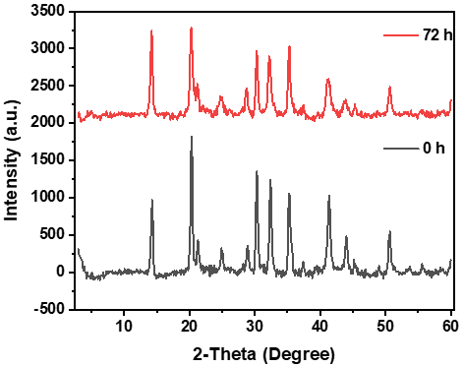
Supplementary Figure 4. XRD patterns of WBG perovskite films with different aging time

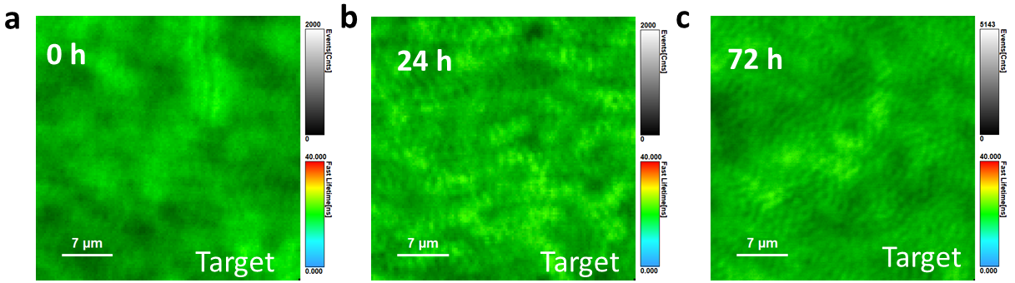
Supplementary Figure 5. PL mapping images of WBG perovskite films with different aging times. It should be noted that the color bar for counts in Figure c is distinct from that in Figure a and b.

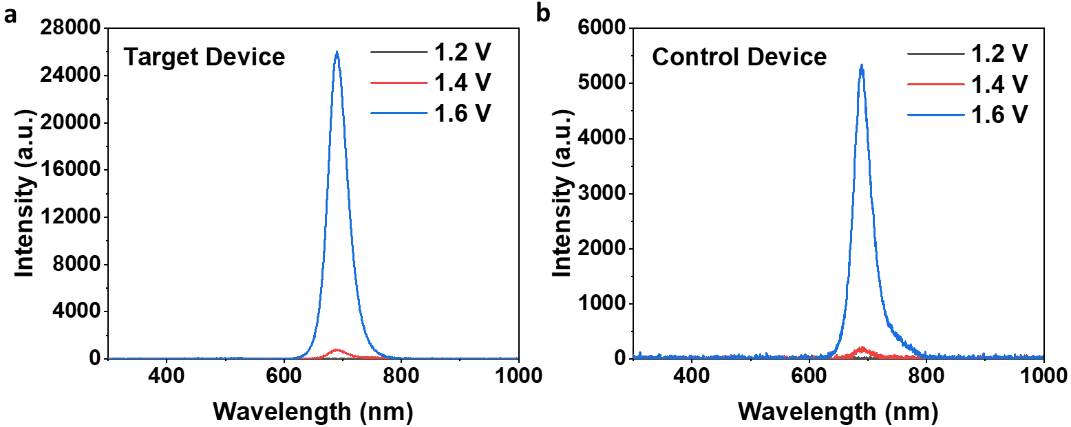
Supplementary Figure 6. EL intensity of WBG perovskite films with different injection voltage.

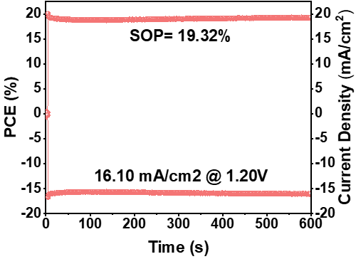
Supplementary Figure 7. Stabilized efficiency of target WBG PSC.

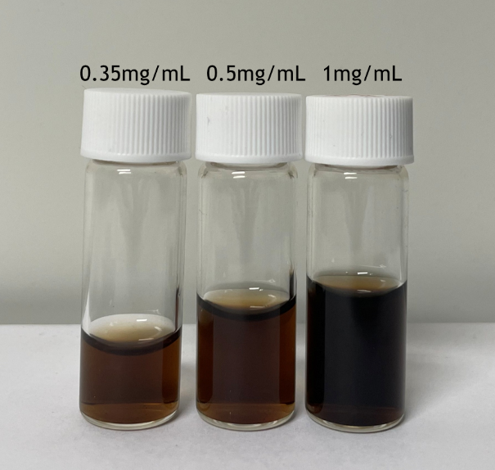
Supplementary Figure 8. Digital picture of GO dispersions in Water with various concentrations.

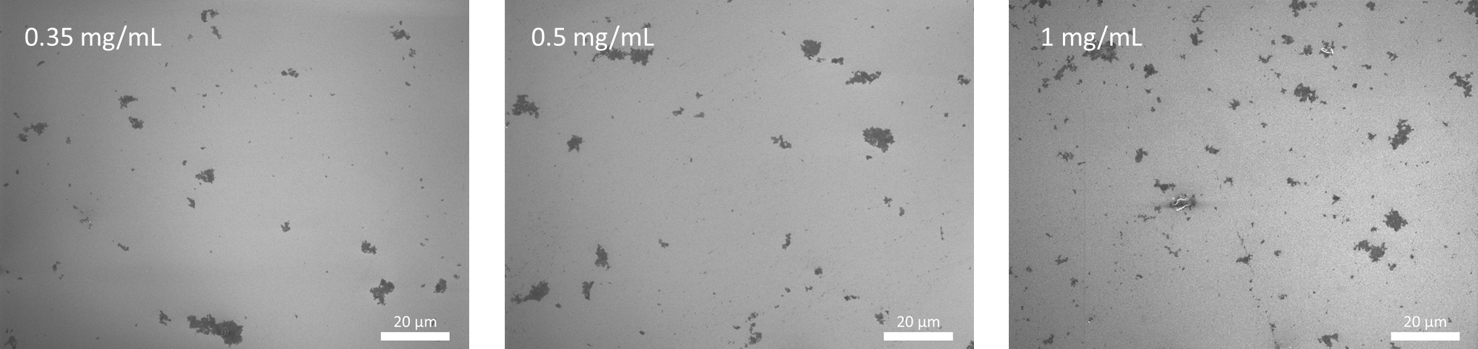
Supplementary Figure 9. Top-view SEM images of graphene oxide layers on silicon by spin coating graphene oxide dispersions with different concentrations

Supplementary Figure 10. Transmittance of spin-coated GO films and thermally evaporated Ag film on ITO substrate.

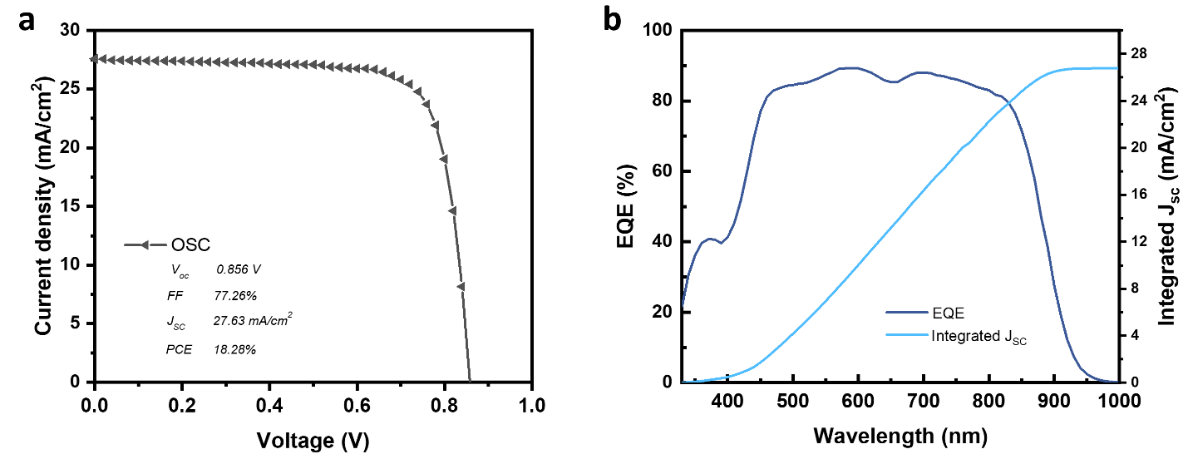
Supplementary Figure 11. The J-V curve (a) and EQE spectra (b) of single-junction OPV.

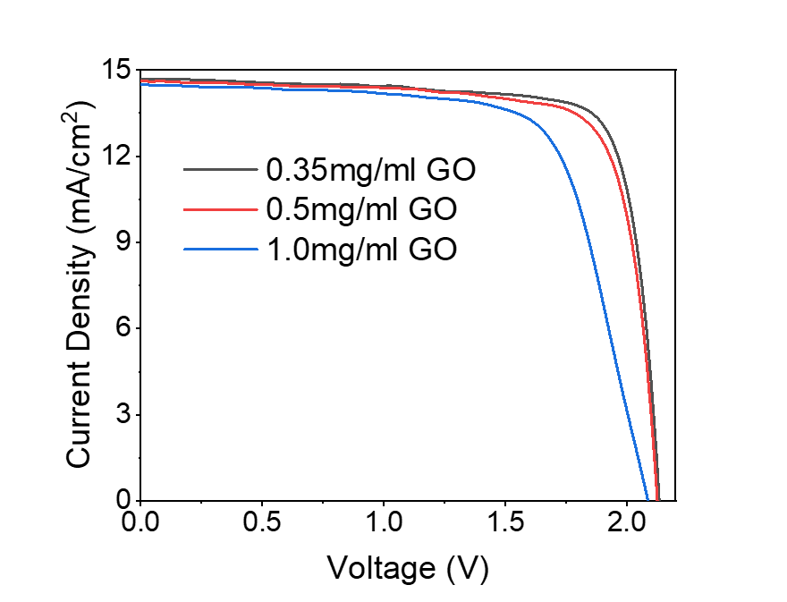
Supplementary Figure 12. J-V curves of the PO-TSCs with different GO concentrations.

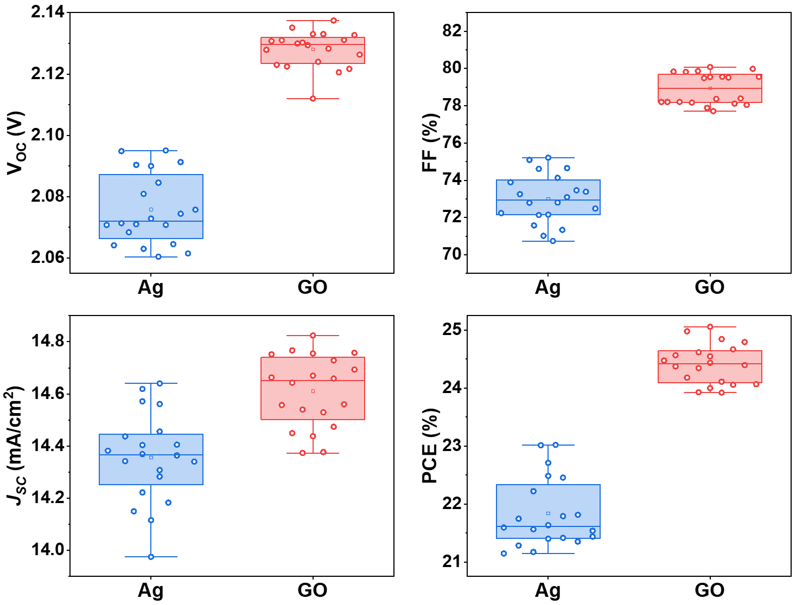
Supplementary Figure 13. Statistics of (a) V_{OC}, (b)FF (c) J_{SC} and (d) PCE for 20 POTSCs with Ag and GO as ICLs. Statistical parameters were analyzed for both Ag and GO devices (aperture area = 0.1 cm²) across 20 devices from four independent batches. The boxplots display: whiskers (data minima and maxima), box boundaries (25th and 75th percentiles), and center line (mean value).

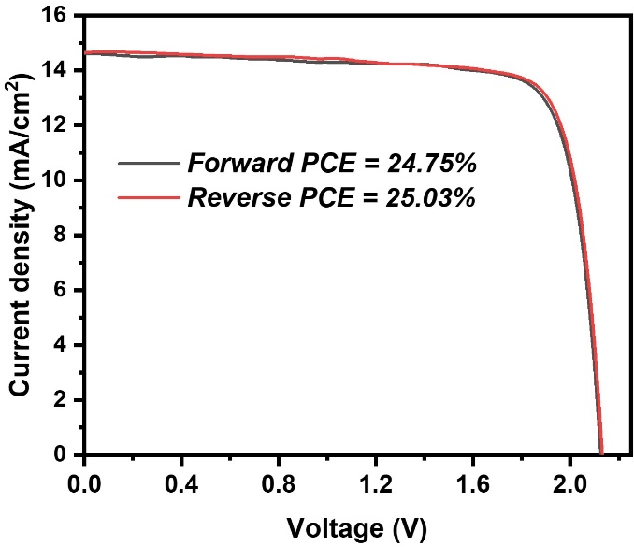
Supplementary Figure 14. Forward and Reverse scan J–V curves of GO-based POTSCs.

Supplementary Table 1. J-V results for control WBG PSCs with different aging times.
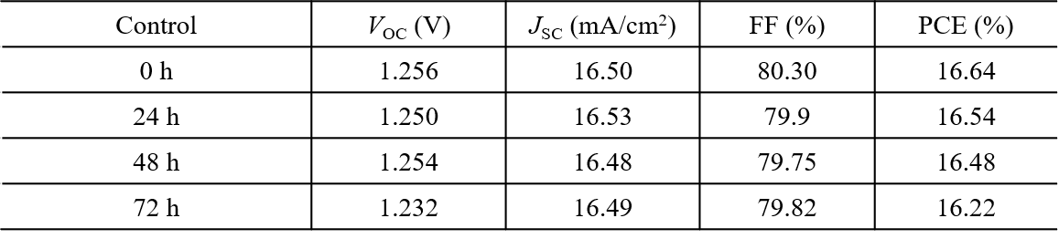

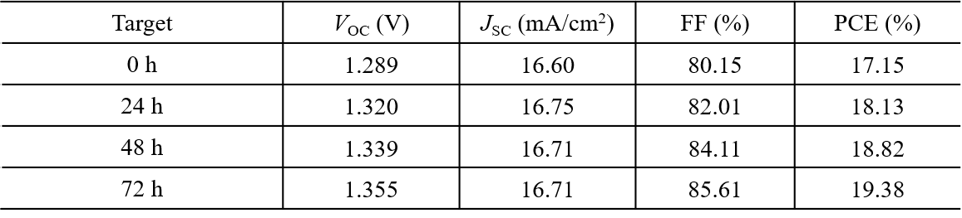
Supplementary Table 2. J-V results for target WBG PSCs with different aging times.

