Supporting information

A surface-imprinting lanthanide fluorescent hybrid probe on the SiO₂ microspheres for the detection of the enrofloxacin

Xiao-Qing Huang^{1,†}，Mao-Yu Wang^{1,†}, Xiao-Chen Wang^{2,†}, Xin Shi¹, Rui-Wen Li¹, Shuang Wu¹ and Ying Li^{1, *}
¹ School of Materials and Chemistry, University of Shanghai for Science and Technology, Shanghai 200093, P. R. China
² Shandong Center for Food and Drug Evaluation&Inspection, Shandong 250014, P. R. China

† These two authors contributed equally to this work
* Correspondence: liying@usst.edu.cn. (Y.L)
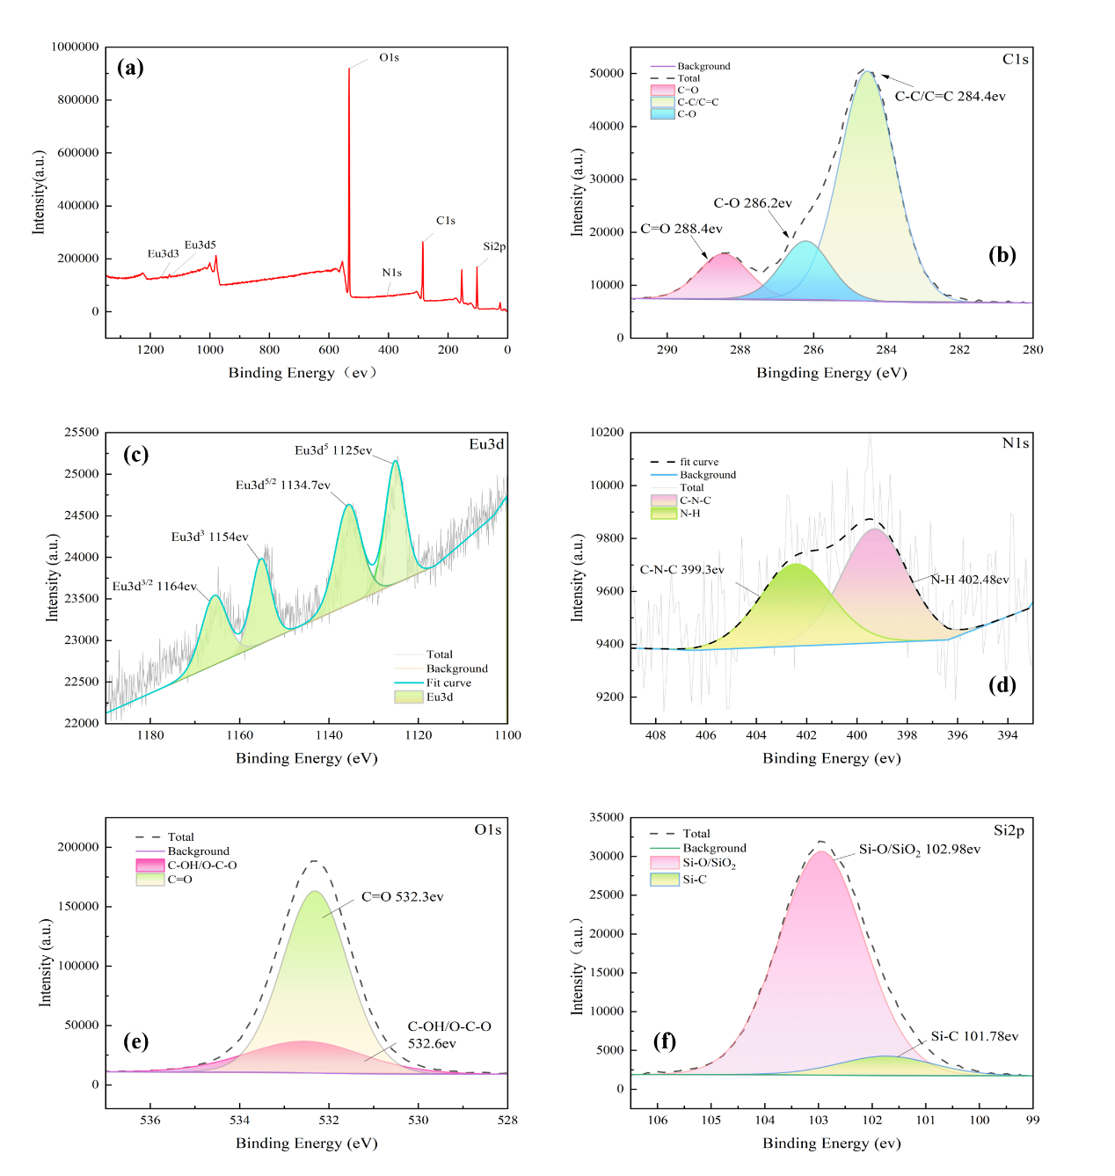
Fig S1. XPS wide-scan high-resolution full spectrum of SiO₂@Eu(DBM)₃Phen/SMIP (a); XPS narrow-scan maps of C1s (b), Eu3d (c), N1s (d), O1s (e) and Si2p (f)

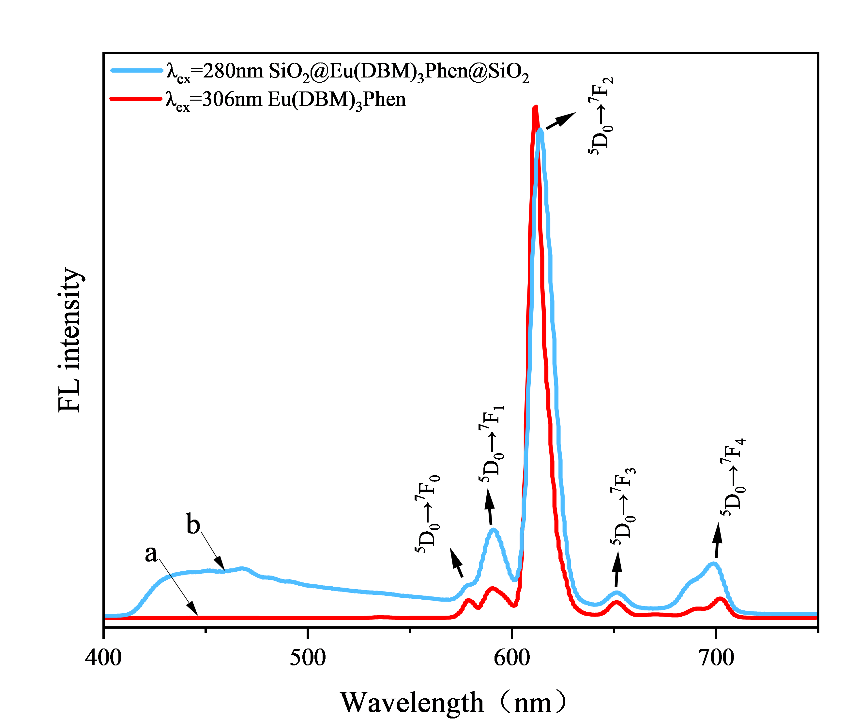

Fig S2. (a) Emission spectra of pure Eu(DBM)₃Phen complexes (a) and SiO₂@Eu(DBM)₃Phen(b)

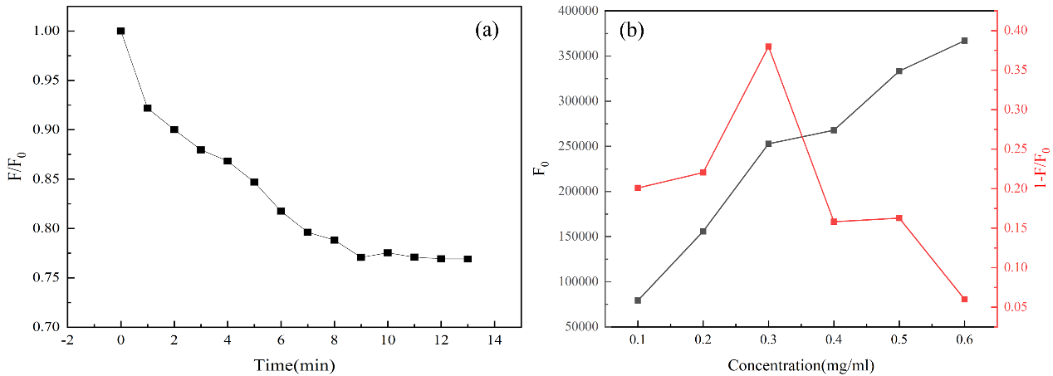

Fig S3. Effect of incubation time (a) and concentration (b) on the fluorescence burst value (F/F₀) of SiO₂@Eu(DBM)₃Phen/SMIP

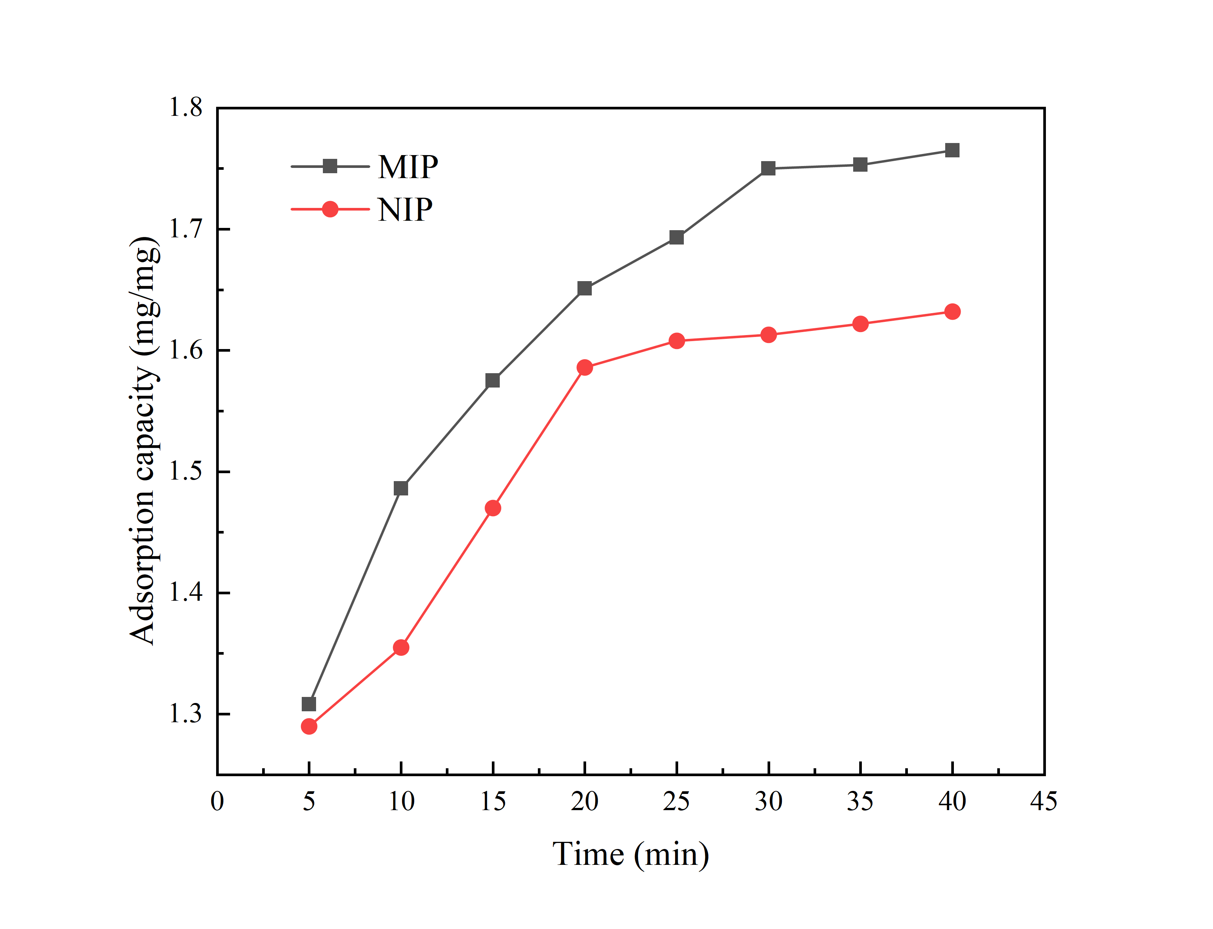
Fig S4. MIP and NIP dynamic adsorption curves of 0.3 mg/ml SiO₂@Eu(DBM)₃Phen/SNIP/SMIP incubated with an initial concentration of 100 mg/ml enrofloxacin at 500 rpm stirring speed for 30 min

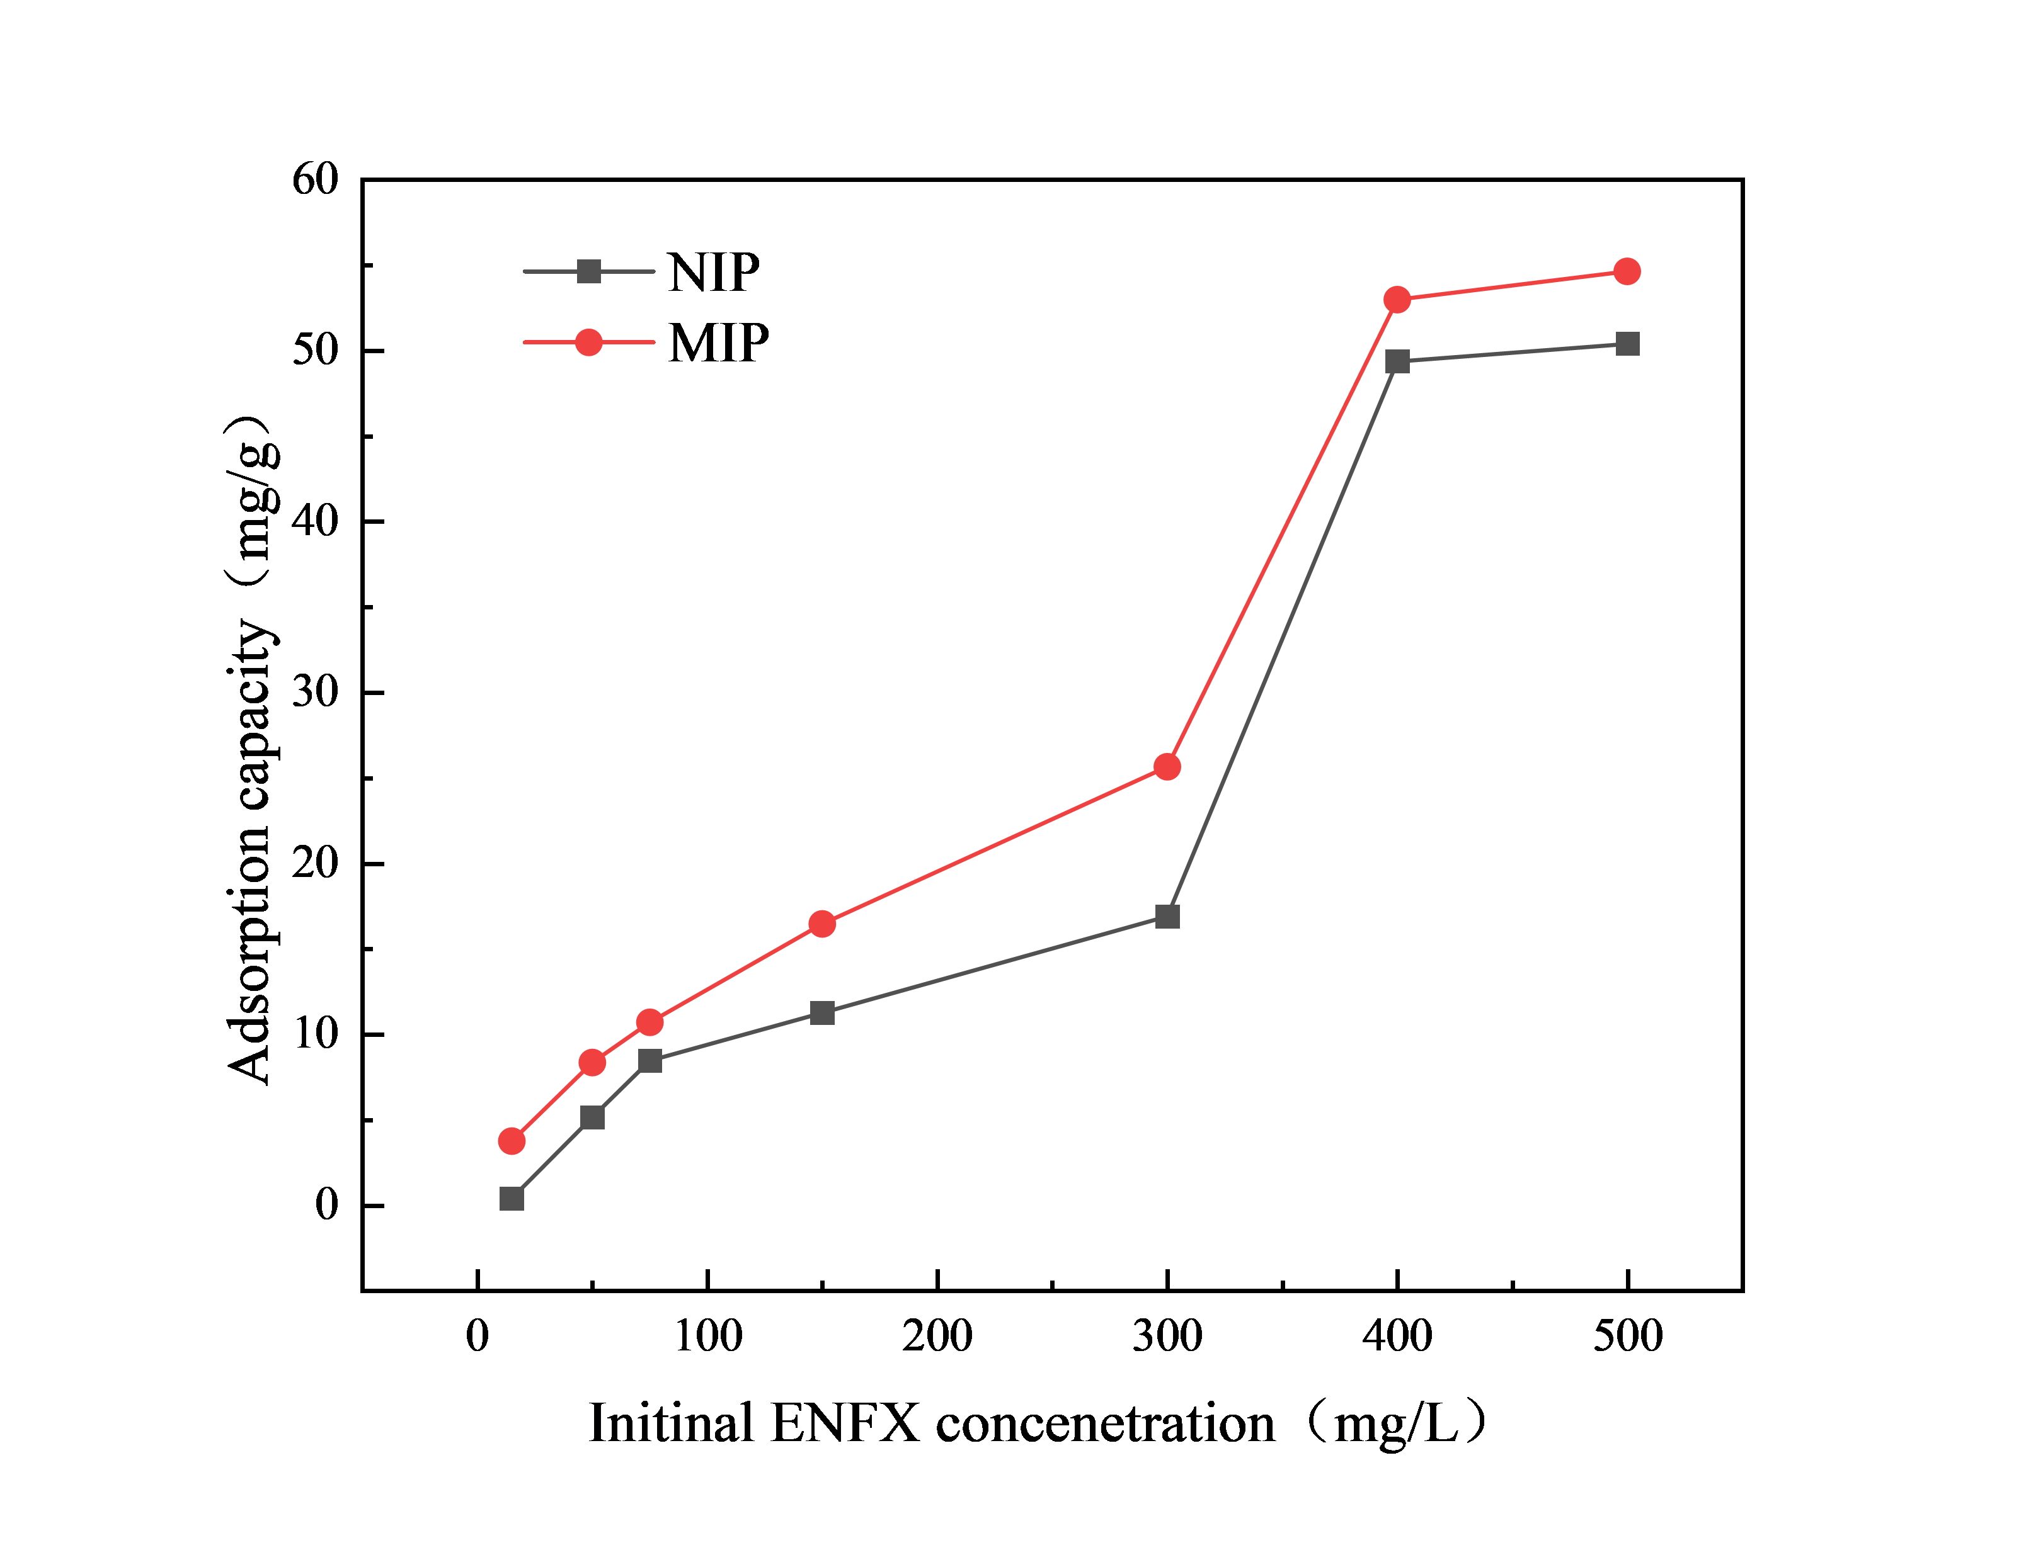
Fig S5. Static adsorption curves of MIP and NIP on different concentrations of ENFX (0, 50, 75, 150, 300, 400, 500 mg/L) in 1h

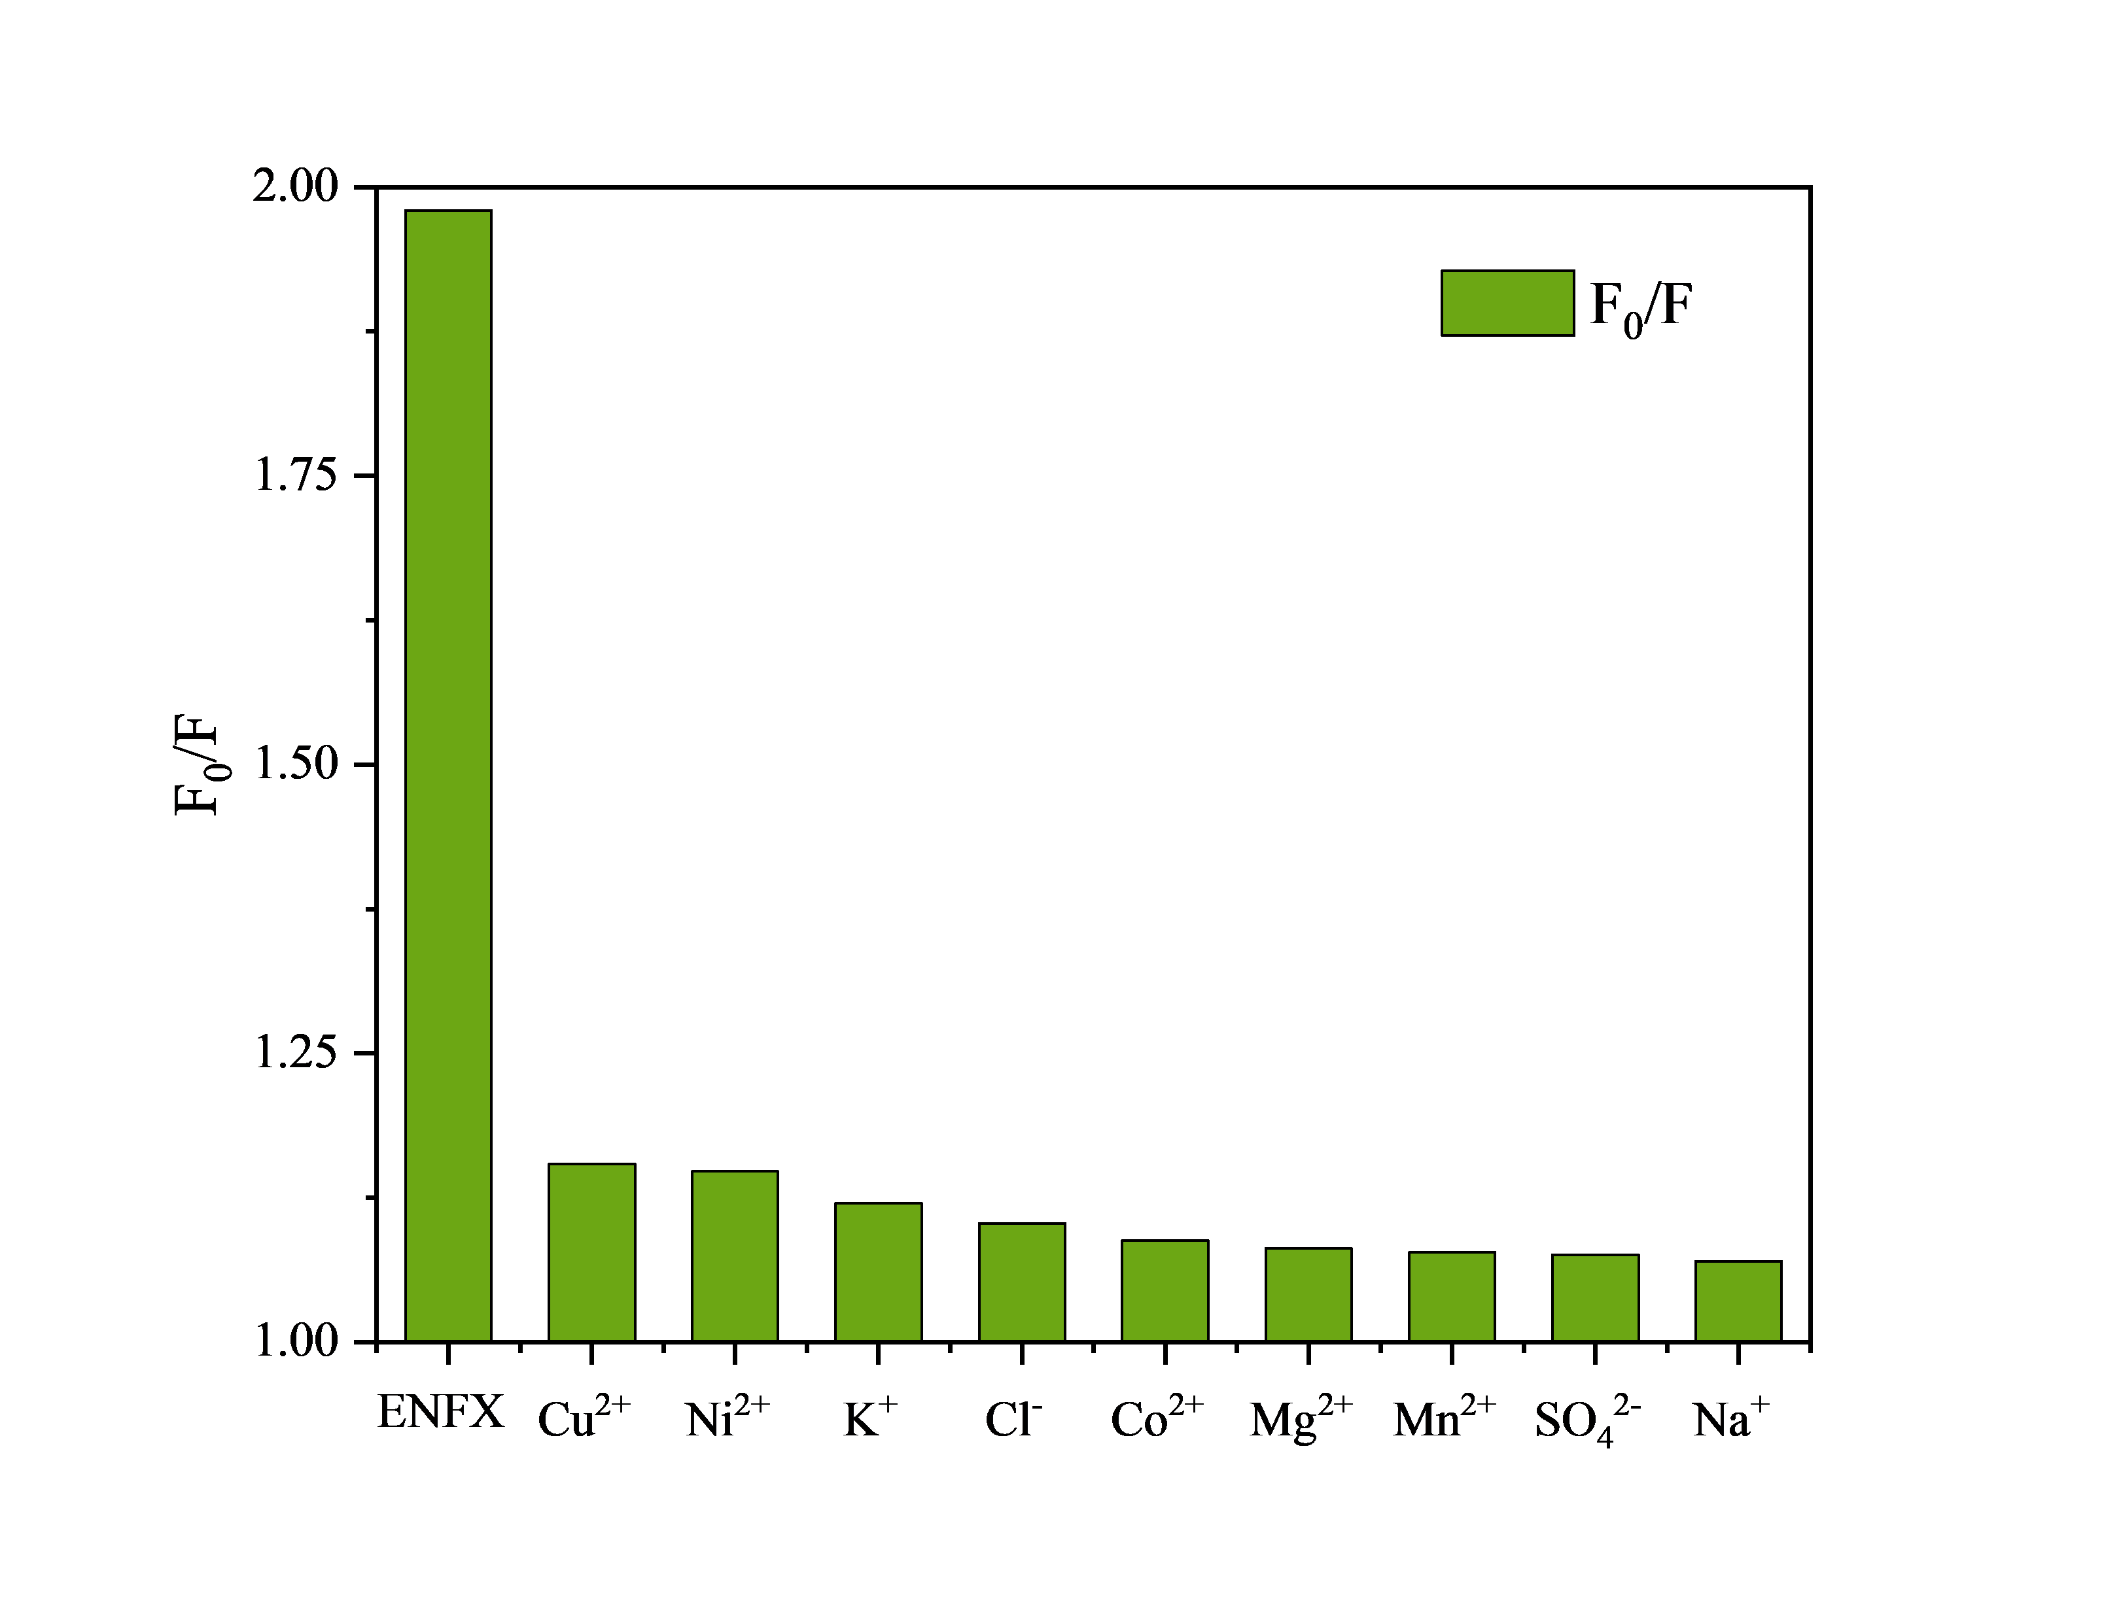
Fig S6. Ion immunity detection for MIP

Table S1 Detection of ENFX content in real samples using the probe.

Sample | Spiked concentration  (μmol/L) | Detectable limit  (μmol/L) | Recovery rate  (%) | RSD  (%)
Milk | 5 | 5.81 | 116.18% | 1.03%
Milk | 10 | 10.53 | 105.31% | 1.36%
Milk | 25 | 24.35 | 97.40% | 1.01%
Milk | 50 | 47.32 | 94.64% | 1.27%
Milk | 80 | 79.29 | 99.11% | 0.89%
Milk | 100 | 96.35 | 96.35% | 0.83%
Drinking water | 5 | 5.22 | 104.4% | 0.97%
Drinking water | 10 | 10.16 | 101.6% | 1.03%
Drinking water | 25 | 25.59 | 102.36% | 1.16%
Drinking water | 50 | 48.59 | 97.18% | 0.99%
Drinking water | 80 | 79.48 | 99.35% | 1.06%
Drinking water | 100 | 96.96 | 96.96% | 1.05%

