Supplementary Information

Mitogenomic Insights of notopterids (Actinopterygii: Osteoglossomorpha) from Sundaland biodiversity hotspot: Transcontinental diversification and colonization before Last Glacial Maximum
Flandrianto Sih Palimirmo^{a†}, Angkasa Putra^{b}, Arif Wibowo^{a†}, Sarifah Aini^{b}, Ah Ran Kim^{c,d}, Soo Rin Lee^{c,d}, Hye-Eun Kang^{e}, Jung Hwa Choi^{f}, Kurniawan Kurniawanª, Vitas Atmadi Prakosoª, Indah Lestari Surbani^{g}, Hyun-Woo Kim^{b,d,h*}, Shantanu Kundu^{f,i*}

- Research Center for Conservation of Marine and Inland Water Resources, National Research and Innovation Agency, BRIN KST Soekarno, Jl. Raya Jakarta − Bogor Km 46, Cibinong, West Java 16915, Republic of Indonesia.
- Department of Marine Biology, Pukyong National University, Busan 48513, Republic of Korea.
- Institute of Marine Living Modified Organisms, Pukyong National University, Busan 48513, Republic of Korea.
- Marine Integrated Biomedical Technology Center, National Key Research Institutes in Universities, Pukyong National University, Busan 48513, Republic of Korea.
- Institute of Marine Life Science, Pukyong National University, Busan 48513, Republic of Korea.
- Ocean and Fisheries Development International Cooperation Institute, College of Fisheries Science, Pukyong National University, Busan 48513, Republic of Korea.
- Diversitas Lestari Nusantara, Menara Bidakara 2, Annex Building Fl 4, Jl. Gatot Subroto, Jakarta Selatan, Republic of Indonesia.
- Research Center for Marine Integrated Bionics Technology, Pukyong National University, Busan 48513, Republic of Korea.
- International Graduate Program of Fisheries Science, Pukyong National University, Busan 48513, Republic of Korea.

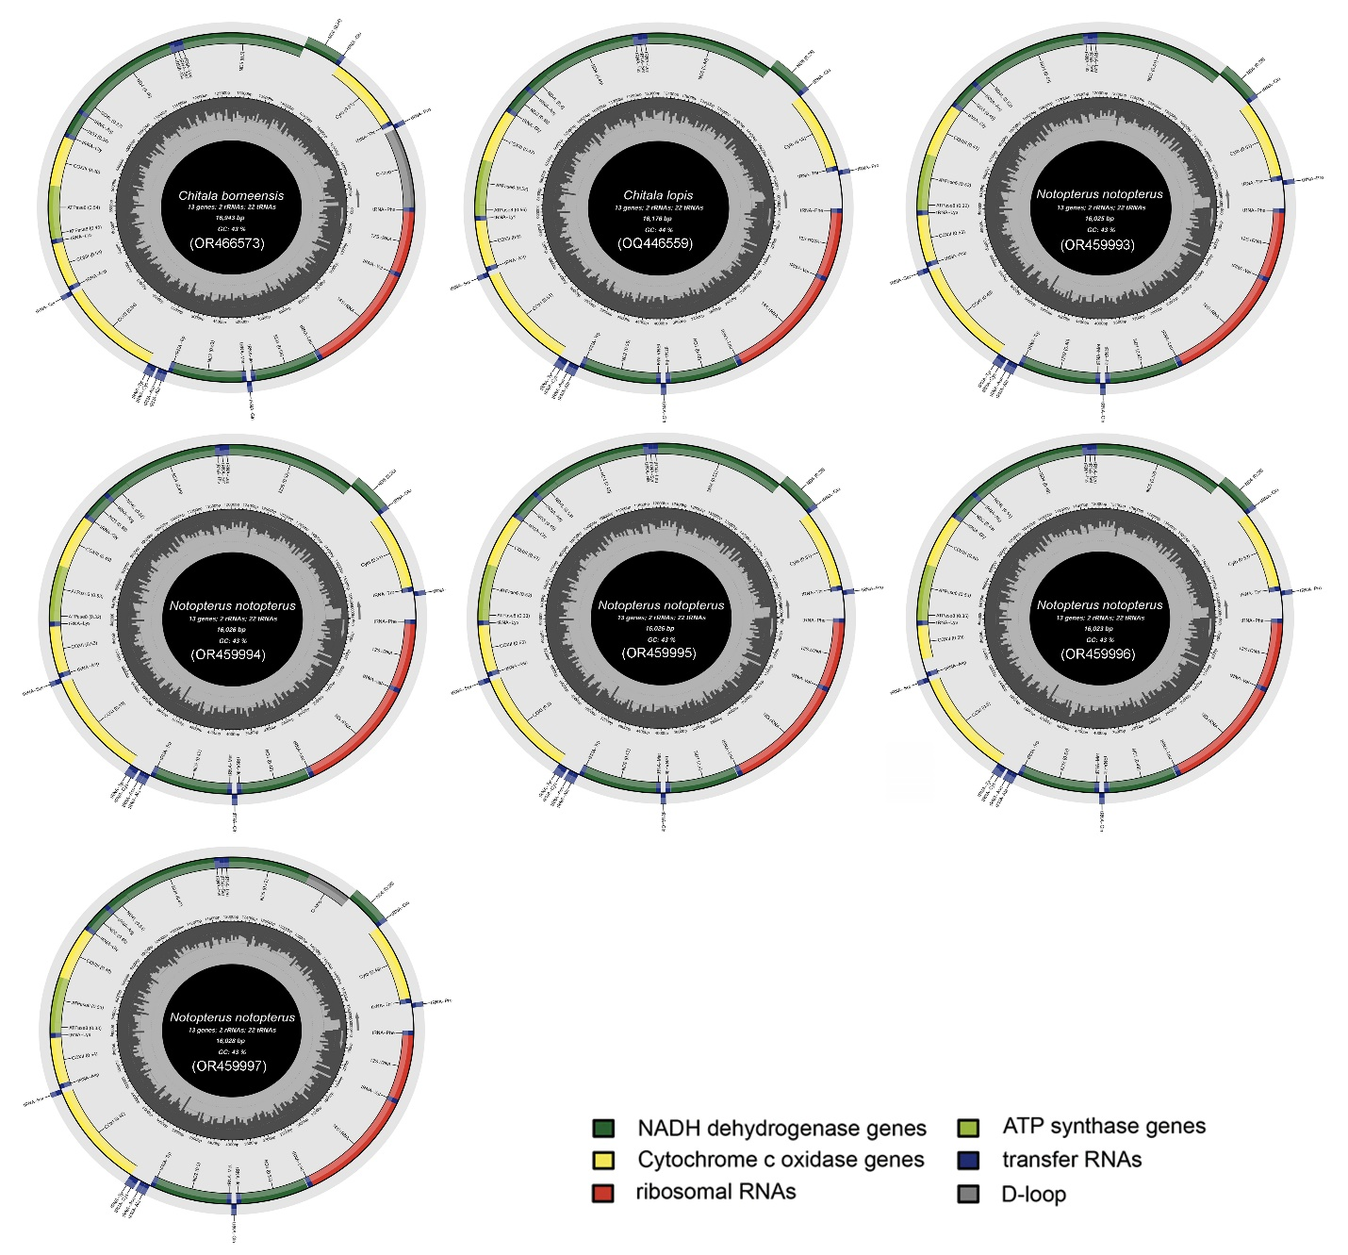

Supplementary Figure S1. The complete mitochondrial genomes of the notopterid species were visually represented and annotated using the MitoAnnotator online server. Different colour arcs highlight the presence of PCGs, rRNAs, tRNAs, and CR.

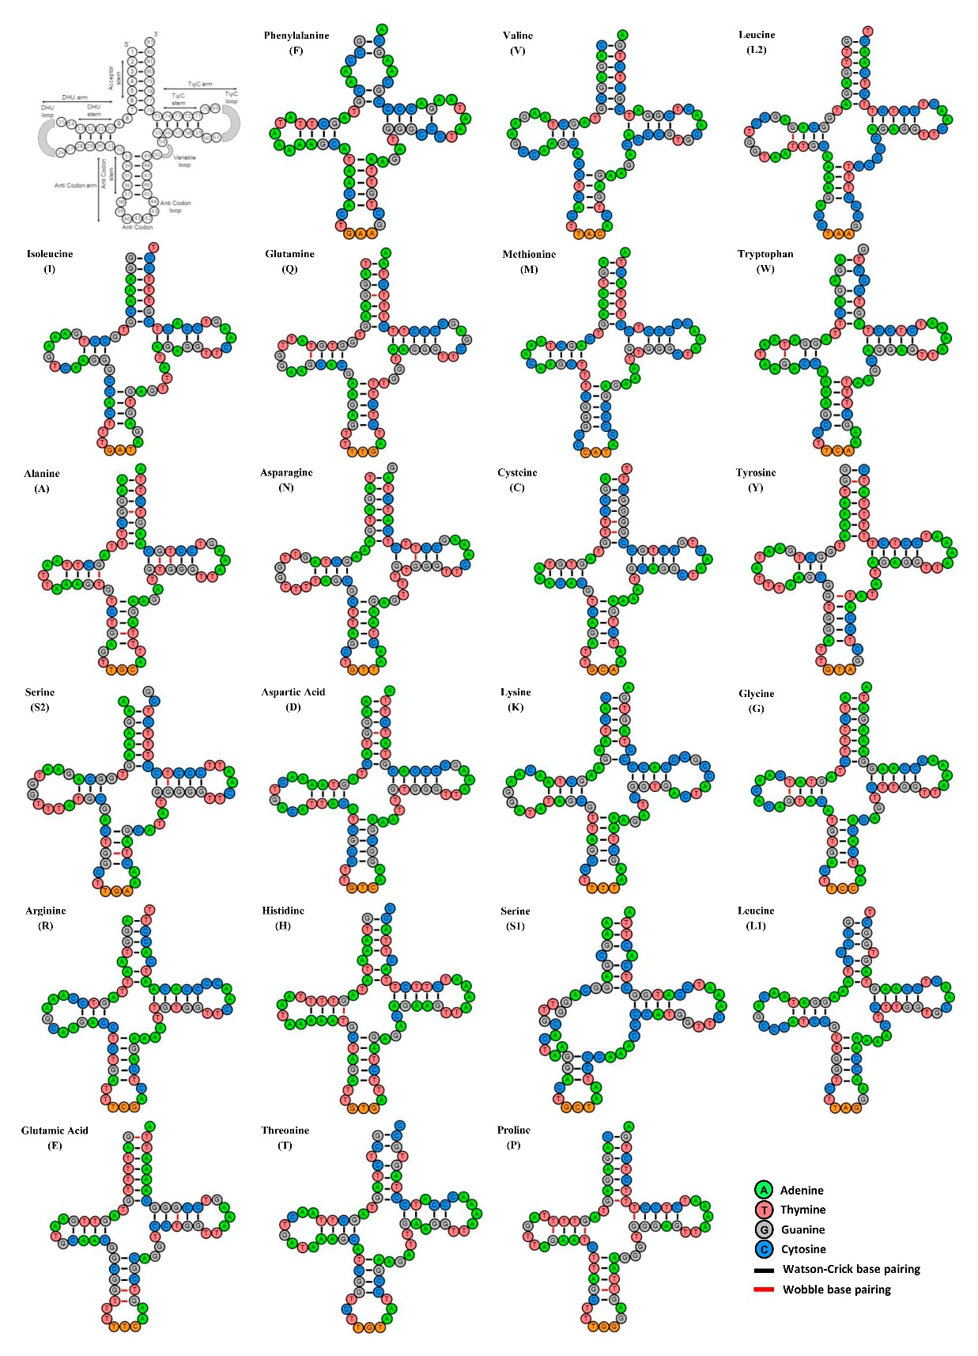
Supplementary Figure S2. Secondary structures of 22 tRNAs of Chitala borneensis display the structural variation. The tRNAs are denoted by full names and IUPAC-IUB single letter amino acid codes. The first structure shows the nucleotide positions and details of stem-loop of tRNAs. Watson-Crick and wobble base pairing are marked by black and red colour bars respectively.
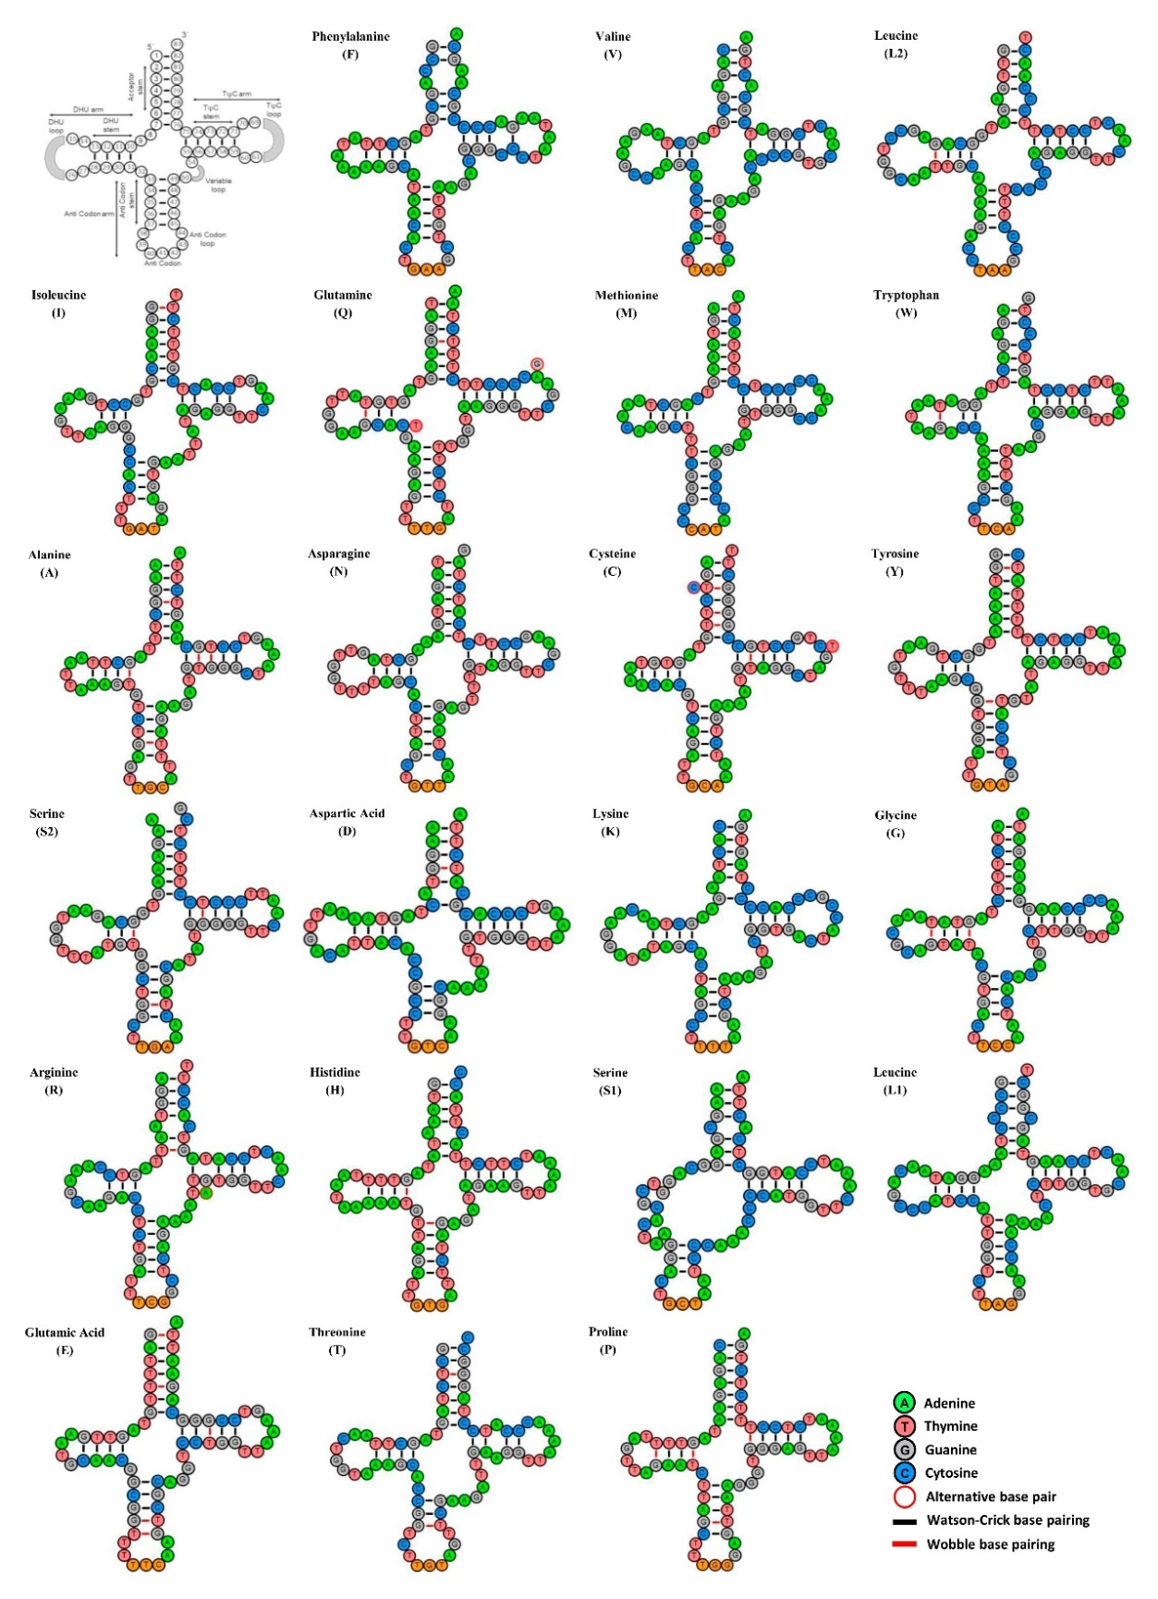
Supplementary Figure S3. Secondary structures of 22 tRNAs of Chitala lopis display the structural variation. The alternative base pairing with other mitogenome (AP008922) are marked by red circles. Watson-Crick and wobble base pairing are marked by black and red colour bars respectively.
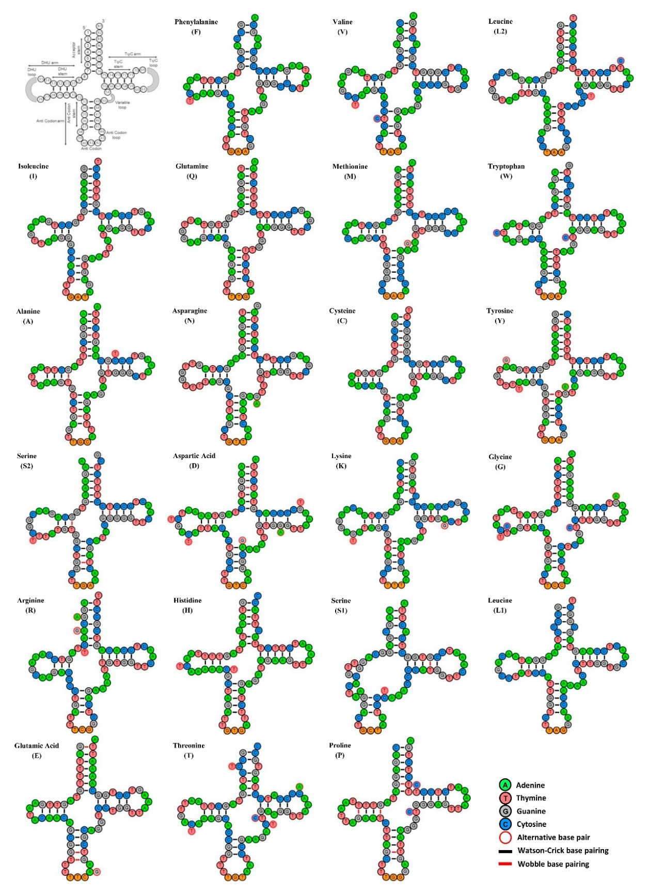
Supplementary Figure S4. Secondary structures of 22 tRNAs of Notopterus notopterus display the structural variation. The alternative base pairing with other mitogenome (AP008925) are marked by red circles. Watson-Crick and wobble base pairing are marked by black and red colour bars respectively.
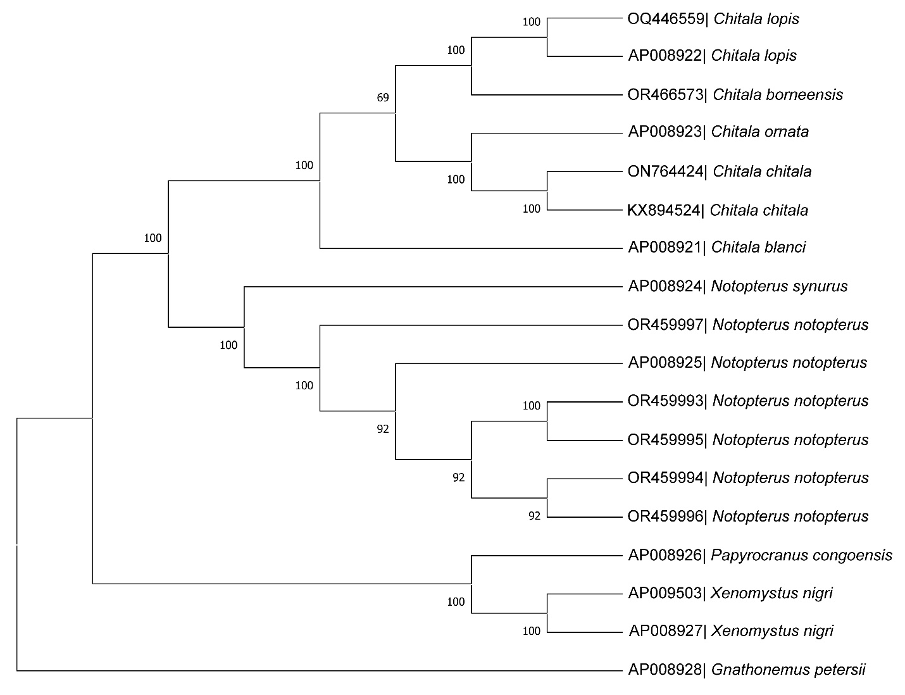
Supplementary Figure S5. The ML matrilineal phylogenetic tree, constructed by the concatenated sequences of the 13 PCGs, provides insights into the evolutionary relationships among Asian and African notopterid species. The ML posterior probability values (in black) are shown at each node, indicating the statistical support for the respective branching points. The mitogenome of Gnathonemus petersii (family Mormyridae) was used as an outgroup in the present cladistic analysis.
Supplementary Table S1. Generated and GenBank mitogenomes of the Notopteridae species.

S1. No. | Species name | Accession number | Size  (bp) | Collection  information | References
1. | Chitala borneensis | OR466573 | 16943 | 0.8306N 112.6003E | This study
2. | Chitala lopis | OQ446559 | 16176 | 6.2151S 106.6266E | This study
3. | Chitala lopis | AP008922 | 16177 | Southeast Asia | Inoue et al., 2009
4. | Chitala chitala | ON764424 | 16248 | Bangladesh | GenBank
5. | Chitala chitala | KX894524 | 16375 | Teesta river, India | Singh et al., 2019
6. | Chitala ornata | AP008923 | 16164 | Southeast Asia | Inoue et al., 2009
7. | Chitala blanci | AP008921 | 16272 | Southeast Asia | Inoue et al., 2009
8. | Notopterus notopterus | OR459993 | 16025 | 0.3586N 101.2058E | This study
9. | Notopterus notopterus | OR459994 | 16026 | 7.5175S 109.2072E | This study
10. | Notopterus notopterus | OR459995 | 16026 | 3.0563S 104.4877E | This study
11. | Notopterus notopterus | OR459996 | 16023 | 0.2453S 116.5661E | This study
12. | Notopterus notopterus | OR459997 | 16028 | 7.4566S 112.4838E | This study
13. | Notopterus notopterus | AP008925 | 15854 | Southeast Asia (Thailand) | Inoue et al., 2009
14. | Notopterus synurus | AP008924 | 16030 | South Asia (India) | Inoue et al., 2009
15. | Xenomystus nigri | AP009503 | 16635 | Ouémé river, Bénin | Lavoue et al., 2011
16. | Xenomystus nigri | AP008927 | 16635 | Tropical Africa | Inoue et al., 2009
17. | Papyrocranus congoensis | AP008926 | 16823 | Congo basin, Central Africa | Inoue et al., 2009
18. | Gnathonemus petersii | AP008928 | 16687 | Nigeria (outgroup) | Inoue et al., 2009

Supplementary Table S2. Intergenic nucleotide regions in various Chitala species.

Genes | C. borneensis (OR466573) | C. lopis (OQ446559) | C. lopis (AP008922) | C. chitala (ON764424) | C. chitala (KX894524) | C. ornata (AP008923) | C. blanci (AP008921)
tRNA-Phe (F) | 0 | 0 | 0 | 0 | 0 | 0 | 0
12S rRNA | 0 | 0 | 0 | 0 | 0 | 0 | 0
tRNA-Val (V) | 0 | 0 | 0 | 0 | 0 | 0 | 0
16S rRNA | 0 | 1 | 0 | 0 | 0 | 0 | 0
tRNA-Leu (L2) | 9 | 9 | 9 | 8 | 0 | 9 | 9
ND1 | 2 | 2 | 2 | 3 | 3 | 2 | 2
tRNA-Ile (I) | -1 | -1 | -1 | -1 | -1 | -1 | -1
tRNA-Gln (Q) | -1 | -1 | -1 | -2 | -1 | -1 | -1
tRNA-Met (M) | 0 | 0 | 0 | -1 | 0 | 0 | 0
ND2 | 0 | 0 | 0 | -2 | 0 | 0 | 0
tRNA-Trp (W) | 1 | 1 | 1 | -1 | 1 | 1 | 1
tRNA-Ala (A) | 1 | 1 | 1 | 0 | 1 | 1 | 1
tRNA-Asn (N) | 34 | 34 | 34 | 32 | 34 | 34 | 34
tRNA-Cys (C) | -1 | 0 | -1 | -1 | -1 | -1 | -1
tRNA-Tyr (Y) | 1 | 1 | 1 | 1 | 1 | 1 | 1
COI | -9 | 0 | 0 | -2 | 0 | 0 | 0
tRNA-Ser (S2) | 4 | 4 | 4 | 4 | 5 | 4 | 4
tRNA-Asp (D) | 5 | 5 | 5 | 0 | 0 | 5 | 5
COII | 0 | 0 | 0 | 0 | 0 | 0 | 0
tRNA-Lys (K) | 1 | 1 | 1 | 0 | 1 | 1 | 1
ATP8 | -10 | -10 | -10 | -10 | -10 | -10 | -10
ATP6 | 0 | -1 | 0 | -1 | -1 | 0 | 0
COIII | 0 | 0 | 0 | 0 | 0 | 0 | 0
tRNA-Gly (G) | 0 | 0 | 0 | 0 | 0 | 0 | 0
ND3 | 0 | 0 | 0 | 0 | 0 | 0 | 0
tRNA-Arg (R) | 0 | 0 | 0 | 0 | 0 | 0 | 0
ND4L | -7 | -7 | -7 | -7 | -7 | -7 | -7
ND4 | 0 | 0 | 0 | 0 | 0 | 0 | 0
tRNA-His (H) | 0 | 0 | 0 | 0 | 0 | 0 | 0
tRNA-Ser (S1) | 0 | 0 | 0 | -1 | 0 | 0 | 0
tRNA-Leu (L1) | 0 | 0 | 0 | -1 | 0 | 0 | 0
ND5 | -5 | -5 | -5 | 0 | 0 | -5 | -5
ND6 | 0 | 0 | -1 | 0 | 0 | 0 | 0
tRNA-Glu (E) | 5 | 5 | 5 | 5 | 0 | 5 | 5
Cytb | 0 | 0 | 0 | 0 | 0 | 0 | 0
tRNA-Thr (T) | 3 | 2 | 3 | 3 | 3 | 3 | 3
tRNA-Pro (P) | 0 | 0 | 0 | 0 | 0 | 0 | 0
Control region | - | - | - | - | - | - | -

Supplementary Table S3. Intergenic nucleotide regions in two Notopterus species.

Genes | N.  notopterus  (OR459993) | N.  notopterus  (OR459994) | N.  notopterus  (OR459995) | N.  notopterus  (OR459996) | N.  notopterus  (OR459997) | N.  notopterus  (AP008925) | N.  synurus (AP008924)
tRNA-Phe (F) | 0 | 0 | 0 | 0 | 0 | 0 | 0
12S rRNA | 0 | 0 | 0 | 0 | 0 | 0 | 0
tRNA-Val (V) | 0 | 0 | 0 | 0 | 0 | 0 | 0
16S rRNA | 0 | 0 | 0 | 0 | 0 | 0 | 0
tRNA-Leu (L2) | 9 | 9 | 9 | 9 | 9 | 9 | 3
ND1 | 2 | 2 | 2 | 2 | 2 | 2 | 2
tRNA-Ile (I) | -1 | -1 | -1 | -1 | -1 | -1 | -1
tRNA-Gln (Q) | -1 | -1 | -1 | -1 | -1 | -1 | -1
tRNA-Met (M) | 0 | 0 | 0 | 0 | 0 | 0 | 0
ND2 | 0 | 0 | 0 | 0 | 0 | 0 | 0
tRNA-Trp (W) | 1 | 2 | 1 | 2 | 2 | 1 | 1
tRNA-Ala (A) | 1 | 1 | 1 | 1 | 1 | 1 | 1
tRNA-Asn (N) | 34 | 33 | 33 | 34 | 34 | 34 | 34
tRNA-Cys (C) | -1 | -1 | -1 | -1 | -1 | -1 | -1
tRNA-Tyr (Y) | 1 | 1 | 1 | 1 | 1 | 1 | 1
COI | -5 | -5 | -5 | -5 | -5 | 0 | 0
tRNA-Ser (S2) | 4 | 4 | 4 | 4 | 4 | 4 | 4
tRNA-Asp (D) | 5 | 5 | 5 | 5 | 5 | 5 | 5
COII | 0 | 0 | 0 | 0 | 0 | 0 | 0
tRNA-Lys (K) | 1 | 1 | 1 | 1 | 1 | 1 | 1
ATP8 | -10 | -10 | -10 | -10 | -10 | -10 | -10
ATP6 | 0 | 0 | 0 | 0 | 0 | 0 | 0
COIII | 0 | 0 | 0 | 0 | 0 | 0 | 0
tRNA-Gly (G) | 0 | 0 | 0 | 0 | 0 | 0 | 0
ND3 | 0 | 0 | 0 | -1 | 0 | 0 | 0
tRNA-Arg (R) | 0 | 0 | 0 | 1 | 0 | 0 | 0
ND4L | -7 | -7 | -7 | -7 | -7 | -7 | -7
ND4 | 0 | 0 | 0 | 0 | 0 | 0 | 0
tRNA-His (H) | 0 | 0 | 0 | 0 | 0 | 0 | 0
tRNA-Ser (S1) | 0 | 0 | 0 | 0 | 0 | 0 | 0
tRNA-Leu (L1) | 0 | 0 | 0 | 0 | 0 | 0 | 0
ND5 | -5 | -5 | -5 | -5 | -5 | -5 | -5
ND6 | 0 | 0 | 0 | 0 | 0 | 0 | 0
tRNA-Glu (E) | 5 | 5 | 5 | 5 | 5 | 5 | 5
Cytb | 3 | 3 | 3 | 3 | 3 | 3 | 0
tRNA-Thr (T) | 3 | 4 | 3 | 3 | 4 | 3 | 3
tRNA-Pro (P) | 0 | 0 | 0 | 0 | 0 | 0 | 0
Control region | - | - | - | - | - | - | -

Supplementary Table S4. Comprehensive comparison of the start and stop codons of the PCGs across 14 notopterids mitogenomes.

Genes | C. borneensis (OR466573) |  | C. lopis (OQ446559) |  | C. lopis (AP008922) |  | C. chitala (ON764424) |  | C. chitala (KX894524) |  | C. ornata (AP008923) |  | C. blanci (AP008921)
Genes | Start | Stop | Start | Stop | Start | Stop | Start | Stop | Start | Stop | Start | Stop | Start | Stop
ND1 | ATG | TAA | ATG | TAA | ATG | TAA | ATG | TAA | ATG | TAA | ATG | TAA | ATG | TAA
ND2 | ATG | TAG | ATG | T-- | ATG | T-- | ATG | TAG | ATG | T-- | ATG | T-- | ATG | T--
COI | GTG | AGG | GTG | T-- | GTG | T-- | GTG | T-- | GTG | T-- | GTG | T-- | GTG | T--
COII | ATG | AGA | ATG | T-- | ATG | T-- | ATG | T-- | ATG | T-- | ATG | T-- | ATG | T--
ATP8 | ATG | TAA | ATG | TAA | ATG | TAA | ATG | TAA | ATG | TAA | ATG | TAA | ATG | TAA
ATP6 | ATG | TAA | ATG | TAA | ATG | TA- | ATG | TAA | ATG | TAA | ATG | TA- | ATG | TA-
COIII | ATG | TAA | ATG | TA- | ATG | TA- | ATG | TA- | ATG | A-- | ATG | TA- | ATG | TA-
ND3 | ATG | TAG | ATG | T-- | ATG | T-- | ATG | T-- | ATG | T-- | ATG | T-- | ATG | T--
ND4L | ATG | TAA | ATG | TAA | ATG | TAA | ATG | TAA | ATG | TAA | ATG | TAA | ATG | TAA
ND4 | ATG | T-- | ATG | T-- | ATG | T-- | ATG | T-- | ATG | T-- | ATG | T-- | ATG | T--
ND5 | ATG | TAA | ATG | TAA | ATG | TAA | ATG | TAA | ATG | TAA | ATG | TAA | ATG | TAA
ND6 | ATG | AGA | ATG | AGA | ATG | AGA | ATG | AGA | ATG | AGA | ATG | AGA | ATG | AGA
Cytb | ATG | T-- | ATG | T-- | ATG | T-- | ATG | T-- | ATG | - | ATG | T-- | ATG | T--
Genes | N.  notopterus  (OR459993) |  | N. notopterus  (OR459994) |  | N. notopterus  (OR459995) |  | N. notopterus  (OR459996) |  | N. notopterus  (OR459997) |  | N.  notopterus  (AP008925) |  | N.  synurus (AP008924)
Genes | Start | Stop | Start | Stop | Start | Stop | Start | Stop | Start | Stop | Start | Stop | Start | Stop
ND1 | ATG | TAA | ATG | TAA | ATG | TAA | ATG | TAA | ATG | TAA | ATG | TAA | ATA | TAA
ND2 | ATG | TAG | ATG | TAG | ATG | TAG | ATG | TAG | ATG | TAG | ATG | T-- | ATG | T--
COI | GTG | AGA | GTG | AGA | GTG | AGA | GTG | AGA | GTG | AGA | GTG | T-- | GTG | T--
COII | ATG | AGA | ATG | AGA | ATG | AGA | ATG | AGA | ATG | AGA | ATG | T-- | ATG | T--
ATP8 | ATG | TAA | ATG | TAA | ATG | TAA | ATG | TAA | ATG | TAA | ATG | TAA | ATG | TAA
ATP6 | ATG | TAA | ATG | TAA | ATG | TAA | ATG | TAA | ATG | TAA | ATG | TA- | ATG | TA-
COIII | ATG | TAA | ATG | TAA | ATG | TAA | ATG | TAA | ATG | TAA | ATG | TA- | ATG | TA-
ND3 | ATG | TAG | ATG | TAG | ATG | TAG | ATG | TAG | ATG | TAG | ATG | T-- | ATG | T--
ND4L | ATG | TAA | ATG | TAA | ATG | TAA | ATG | TAA | ATG | TAA | ATG | TAA | ATG | TAA
ND4 | ATG | T-- | ATG | T-- | ATG | T-- | ATG | T-- | ATG | T-- | ATG | T-- | ATG | T--
ND5 | ATG | TAA | ATG | TAA | ATG | TAA | ATG | TAA | ATG | TAA | ATG | TAA | ATG | TAA
ND6 | ATG | AGG | ATG | AGG | ATG | AGG | ATG | AGG | ATG | AGG | ATG | AGG | ATG | AGG
Cytb | ATG | TAA | ATG | TAA | ATG | TAA | ATG | TAA | ATG | TAA | ATG | TAA | ATG | T--

Supplementary Table S5. Ka/Ks ratios of 13 PCGs in Notopteridae mitogenomes.

Genes | ND1 | ND2 | COI | COII | ATP8 | ATP6 | COIII | ND3 | ND4L | ND4 | ND5 | ND6 | Cytb
1 | 0 | 0.120500189 | 0 | 0 | 0 | 0 | 0 | 0 | 0 | 0 | 0 | 0 | 0
2 | 0.099468489 | 0.115661737 | 0.0139165 | 0 | 0.256663801 | 0.057814 | 0.035217035 | 0 | 0 | 0.06548241 | 0.058258083 | 0.078205128 | 0.096327834
3 | 0.048494983 | 0.161891892 | 0.01154734 | 0.023651146 | 0.215836526 | 0.041487 | 0.005811966 | 0.098570724 | 0.032734952 | 0.031342267 | 0.069719043 | 0.101146497 | 0.042421354
4 | 0.039889324 | 0.084763124 | 0.00941873 | 0.009756098 | 0.21028971 | 0.054286 | 0.009563994 | 0.059550562 | 0.050278134 | 0.044039805 | 0.066096423 | 0.073184358 | 0.022775526
5 | 0.053989362 | 0.111339148 | 0.00648217 | 0.030107047 | 0.198896632 | 0.058994 | 0.028880866 | 0.050608584 | 0.041617122 | 0.052449965 | 0.057625738 | 0.04476709 | 0.035147152
6 | 0.03096256 | 0.062225183 | 0.00819414 | 0.008895131 | 0.182758621 | 0.030786 | 0.012474616 | 0.051828584 | 0.032087734 | 0.028397285 | 0.049064095 | 0.061072056 | 0.034615915
7 | 0.027892847 | 0.071760891 | 0.00844156 | 0.008895131 | 0.182758621 | 0.030786 | 0.012474616 | 0.051828584 | 0.032087734 | 0.028397285 | 0.049064095 | 0.061072056 | 0.034615915
8 | 0.03019432 | 0.0706285 | 0.00827235 | 0.007092199 | 0.231316726 | 0.026793 | 0.012474616 | 0.051828584 | 0.032087734 | 0.028397285 | 0.049064095 | 0.061072056 | 0.034615915
9 | 0.033051399 | 0.067813337 | 0.00819414 | 0.008895131 | 0.182758621 | 0.030786 | 0.012474616 | 0.051828584 | 0.032087734 | 0.028397285 | 0.049064095 | 0.061072056 | 0.034615915
10 | 0.03019432 | 0.0706285 | 0.00827235 | 0.007092199 | 0.231316726 | 0.026793 | 0.012474616 | 0.051828584 | 0.032087734 | 0.028397285 | 0.049064095 | 0.061072056 | 0.034615915
11 | 0.027209427 | 0.074881517 | 0.01020408 | 0.008691674 | 0.182758621 | 0.035511 | 0.013727055 | 0.050974513 | 0.027563074 | 0.025726603 | 0.045990394 | 0.068248773 | 0.037328628
12 | 0.026937957 | 0.063768116 | 0.00659105 | 0.009616585 | 0.186201958 | 0.017742 | 0.004870362 | 0.045684667 | 0.014229488 | 0.020739405 | 0.041391799 | 0.056451613 | 0.044061303
13 | 0.026937957 | 0.063768116 | 0.00659105 | 0.009616585 | 0.186201958 | 0.017742 | 0.004870362 | 0.045684667 | 0.014229488 | 0.020739405 | 0.041391799 | 0.056451613 | 0.044061303
14 | 0.094667807 | 0.174462011 | 0.01784219 | 0.038470174 | 0.177093059 | 0.090682 | 0.067072457 | 0.097643287 | 0.064073057 | 0.069968804 | 0.098725559 | 0.218436679 | 0.05071844
15 | 0.100393349 | 0.144865459 | 0.01825419 | 0.038868458 | 0.394701543 | 0.120267 | 0.051719156 | 0.102630556 | 0.087226548 | 0.076763166 | 0.082783538 | 0.244915528 | 0.06384925
Average | 0.044685607 | 0.097263848 | 0.00948146 | 0.013976504 | 0.201303541 | 0.042698 | 0.018940422 | 0.054032699 | 0.032826036 | 0.036615884 | 0.05382019 | 0.083144504 | 0.040651358
STDV | 0.030100616 | 0.03830728 | 0.00458451 | 0.012592614 | 0.078151828 | 0.030474 | 0.01890963 | 0.029642549 | 0.022669747 | 0.021031088 | 0.02183211 | 0.064025783 | 0.020635086

Supplementary Table S6. The abundance of amino acids and RSCU value of the complete PCGs of Notopteridae species.

Chitala borneensis (OR466573)
Codon | Count | RSCU | Codon | Count | RSCU | Codon | Count | RSCU | Codon | Count | RSCU
UUU(F) | 82 | 1.03 | UCU(S) | 75 | 1.25 | UAU(Y) | 88 | 1.04 | UGU(C) | 17 | 0.69
UUC(F) | 78 | 0.98 | UCC(S) | 64 | 1.07 | UAC(Y) | 82 | 0.96 | UGC(C) | 32 | 1.31
UUA(L) | 82 | 1.08 | UCA(S) | 95 | 1.58 | UAA(*) | 71 | 1.12 | UGA(*) | 55 | 0.86
UUG(L) | 45 | 0.59 | UCG(S) | 24 | 0.40 | UAG(*) | 65 | 1.02 | UGG(W) | 22 | 1.00
CUU(L) | 87 | 1.15 | CCU(P) | 111 | 1.31 | CAU(H) | 81 | 0.93 | CGU(R) | 17 | 0.61
CUC(L) | 69 | 0.91 | CCC(P) | 84 | 0.99 | CAC(H) | 93 | 1.07 | CGC(R) | 34 | 1.21
CUA(L) | 116 | 1.53 | CCA(P) | 115 | 1.35 | CAA(Q) | 82 | 1.28 | CGA(R) | 27 | 0.96
CUG(L) | 56 | 0.74 | CCG(P) | 30 | 0.35 | CAG(Q) | 46 | 0.72 | CGG(R) | 25 | 0.89
AUU(I) | 117 | 1.26 | ACU(T) | 100 | 1.11 | AAU(N) | 82 | 0.87 | AGU(S) | 35 | 0.58
AUC(I) | 83 | 0.89 | ACC(T) | 89 | 0.99 | AAC(N) | 106 | 1.13 | AGC(S) | 67 | 1.12
AUA(I) | 79 | 0.85 | ACA(T) | 139 | 1.55 | AAA(K) | 86 | 1.54 | AGA(R) | 26 | 0.93
AUG(M) | 57 | 1.00 | ACG(T) | 31 | 0.35 | AAG(K) | 26 | 0.46 | AGG(R) | 39 | 1.39
GUU(V) | 26 | 0.91 | GCU(A) | 35 | 0.74 | GAU(D) | 35 | 0.90 | GGU(G) | 27 | 0.84
GUC(V) | 14 | 0.49 | GCC(A) | 86 | 1.81 | GAC(D) | 43 | 1.10 | GGC(G) | 37 | 1.16
GUA(V) | 53 | 1.86 | GCA(A) | 61 | 1.28 | GAA(E) | 61 | 1.37 | GGA(G) | 45 | 1.41
GUG(V) | 21 | 0.74 | GCG(A) | 8 | 0.17 | GAG(E) | 28 | 0.63 | GGG(G) | 19 | 0.59
Chitala lopis (OQ446559)
UUU(F) | 83 | 1.08 | UCU(S) | 73 | 1.15 | UAU(Y) | 78 | 0.95 | UGU(C) | 25 | 0.88
UUC(F) | 71 | 0.92 | UCC(S) | 70 | 1.10 | UAC(Y) | 86 | 1.05 | UGC(C) | 32 | 1.12
UUA(L) | 76 | 1.02 | UCA(S) | 98 | 1.54 | UAA(*) | 66 | 1.05 | UGA(*) | 61 | 0.97
UUG(L) | 32 | 0.43 | UCG(S) | 34 | 0.54 | UAG(*) | 62 | 0.98 | UGG(W) | 23 | 1.00
CUU(L) | 79 | 1.06 | CCU(P) | 112 | 1.32 | CAU(H) | 86 | 0.95 | CGU(R) | 14 | 0.53
CUC(L) | 81 | 1.08 | CCC(P) | 85 | 1.00 | CAC(H) | 96 | 1.05 | CGC(R) | 31 | 1.17
CUA(L) | 125 | 1.67 | CCA(P) | 113 | 1.33 | CAA(Q) | 89 | 1.37 | CGA(R) | 28 | 1.06
CUG(L) | 55 | 0.74 | CCG(P) | 29 | 0.34 | CAG(Q) | 41 | 0.63 | CGG(R) | 21 | 0.79
AUU(I) | 113 | 1.21 | ACU(T) | 92 | 1.05 | AAU(N) | 90 | 0.96 | AGU(S) | 33 | 0.52
AUC(I) | 84 | 0.90 | ACC(T) | 87 | 0.99 | AAC(N) | 97 | 1.04 | AGC(S) | 73 | 1.15
AUA(I) | 84 | 0.90 | ACA(T) | 139 | 1.58 | AAA(K) | 89 | 1.53 | AGA(R) | 26 | 0.98
AUG(M) | 47 | 1.00 | ACG(T) | 34 | 0.39 | AAG(K) | 27 | 0.47 | AGG(R) | 39 | 1.47
GUU(V) | 25 | 0.84 | GCU(A) | 44 | 0.89 | GAU(D) | 35 | 0.92 | GGU(G) | 15 | 0.50
GUC(V) | 21 | 0.71 | GCC(A) | 83 | 1.69 | GAC(D) | 41 | 1.08 | GGC(G) | 44 | 1.47
GUA(V) | 54 | 1.82 | GCA(A) | 62 | 1.26 | GAA(E) | 64 | 1.52 | GGA(G) | 41 | 1.37
GUG(V) | 19 | 0.64 | GCG(A) | 8 | 0.16 | GAG(E) | 20 | 0.48 | GGG(G) | 20 | 0.67
Chitala lopis (AP008922)
Codon | Count | RSCU | Codon | Count | RSCU | Codon | Count | RSCU | Codon | Count | RSCU
UUU(F) | 84 | 1.09 | UCU(S) | 75 | 1.19 | UAU(Y) | 78 | 0.95 | UGU(C) | 25 | 0.88
UUC(F) | 70 | 0.91 | UCC(S) | 68 | 1.08 | UAC(Y) | 86 | 1.05 | UGC(C) | 32 | 1.12
UUA(L) | 75 | 1.00 | UCA(S) | 98 | 1.56 | UAA(*) | 67 | 1.05 | UGA(*) | 61 | 0.96
UUG(L) | 32 | 0.43 | UCG(S) | 33 | 0.52 | UAG(*) | 63 | 0.99 | UGG(W) | 23 | 1.00
CUU(L) | 78 | 1.04 | CCU(P) | 110 | 1.30 | CAU(H) | 87 | 0.95 | CGU(R) | 14 | 0.53
CUC(L) | 80 | 1.07 | CCC(P) | 86 | 1.01 | CAC(H) | 96 | 1.05 | CGC(R) | 31 | 1.17
CUA(L) | 128 | 1.71 | CCA(P) | 112 | 1.32 | CAA(Q) | 88 | 1.38 | CGA(R) | 28 | 1.06
CUG(L) | 56 | 0.75 | CCG(P) | 31 | 0.37 | CAG(Q) | 40 | 0.63 | CGG(R) | 21 | 0.79
AUU(I) | 113 | 1.20 | ACU(T) | 92 | 1.05 | AAU(N) | 89 | 0.95 | AGU(S) | 33 | 0.52
AUC(I) | 84 | 0.89 | ACC(T) | 87 | 0.99 | AAC(N) | 99 | 1.05 | AGC(S) | 71 | 1.13
AUA(I) | 86 | 0.91 | ACA(T) | 138 | 1.57 | AAA(K) | 90 | 1.55 | AGA(R) | 26 | 0.98
AUG(M) | 47 | 1.00 | ACG(T) | 34 | 0.39 | AAG(K) | 26 | 0.45 | AGG(R) | 39 | 1.47
GUU(V) | 25 | 0.85 | GCU(A) | 43 | 0.87 | GAU(D) | 35 | 0.92 | GGU(G) | 15 | 0.50
GUC(V) | 21 | 0.72 | GCC(A) | 84 | 1.71 | GAC(D) | 41 | 1.08 | GGC(G) | 44 | 1.47
GUA(V) | 52 | 1.78 | GCA(A) | 62 | 1.26 | GAA(E) | 65 | 1.55 | GGA(G) | 40 | 1.33
GUG(V) | 19 | 0.65 | GCG(A) | 8 | 0.16 | GAG(E) | 19 | 0.45 | GGG(G) | 21 | 0.70
Chitala chitala (ON764424)
Codon | Count | RSCU | Codon | Count | RSCU | Codon | Count | RSCU | Codon | Count | RSCU
UUU(F) | 84 | 1.08 | UCU(S) | 80 | 1.28 | UAU(Y) | 78 | 0.95 | UGU(C) | 20 | 0.69
UUC(F) | 72 | 0.92 | UCC(S) | 72 | 1.15 | UAC(Y) | 86 | 1.05 | UGC(C) | 38 | 1.31
UUA(L) | 75 | 0.99 | UCA(S) | 90 | 1.44 | UAA(*) | 68 | 1.09 | UGA(*) | 59 | 0.94
UUG(L) | 36 | 0.47 | UCG(S) | 34 | 0.54 | UAG(*) | 61 | 0.97 | UGG(W) | 29 | 1.00
CUU(L) | 92 | 1.21 | CCU(P) | 103 | 1.26 | CAU(H) | 82 | 0.95 | CGU(R) | 21 | 0.76
CUC(L) | 74 | 0.98 | CCC(P) | 78 | 0.95 | CAC(H) | 90 | 1.05 | CGC(R) | 31 | 1.13
CUA(L) | 123 | 1.62 | CCA(P) | 116 | 1.41 | CAA(Q) | 92 | 1.38 | CGA(R) | 24 | 0.87
CUG(L) | 55 | 0.73 | CCG(P) | 31 | 0.38 | CAG(Q) | 41 | 0.62 | CGG(R) | 21 | 0.76
AUU(I) | 116 | 1.20 | ACU(T) | 95 | 1.10 | AAU(N) | 86 | 0.90 | AGU(S) | 27 | 0.43
AUC(I) | 84 | 0.87 | ACC(T) | 88 | 1.01 | AAC(N) | 105 | 1.10 | AGC(S) | 72 | 1.15
AUA(I) | 89 | 0.92 | ACA(T) | 134 | 1.54 | AAA(K) | 87 | 1.60 | AGA(R) | 24 | 0.87
AUG(M) | 55 | 1.00 | ACG(T) | 30 | 0.35 | AAG(K) | 22 | 0.40 | AGG(R) | 44 | 1.60
GUU(V) | 29 | 1.02 | GCU(A) | 37 | 0.79 | GAU(D) | 30 | 0.76 | GGU(G) | 26 | 0.83
GUC(V) | 16 | 0.56 | GCC(A) | 79 | 1.68 | GAC(D) | 49 | 1.24 | GGC(G) | 39 | 1.24
GUA(V) | 55 | 1.93 | GCA(A) | 61 | 1.30 | GAA(E) | 59 | 1.39 | GGA(G) | 45 | 1.43
GUG(V) | 14 | 0.49 | GCG(A) | 11 | 0.23 | GAG(E) | 26 | 0.61 | GGG(G) | 16 | 0.51
Chitala ornata (AP008923)
Codon | Count | RSCU | Codon | Count | RSCU | Codon | Count | RSCU | Codon | Count | RSCU
UUU(F) | 84 | 1.08 | UCU(S) | 80 | 1.28 | UAU(Y) | 78 | 0.95 | UGU(C) | 20 | 0.69
UUC(F) | 72 | 0.92 | UCC(S) | 72 | 1.15 | UAC(Y) | 86 | 1.05 | UGC(C) | 38 | 1.31
UUA(L) | 75 | 0.99 | UCA(S) | 90 | 1.44 | UAA(*) | 68 | 1.09 | UGA(*) | 59 | 0.94
UUG(L) | 36 | 0.47 | UCG(S) | 34 | 0.54 | UAG(*) | 61 | 0.97 | UGG(W) | 29 | 1.00
CUU(L) | 92 | 1.21 | CCU(P) | 103 | 1.26 | CAU(H) | 82 | 0.95 | CGU(R) | 21 | 0.76
CUC(L) | 74 | 0.98 | CCC(P) | 78 | 0.95 | CAC(H) | 90 | 1.05 | CGC(R) | 31 | 1.13
CUA(L) | 123 | 1.62 | CCA(P) | 116 | 1.41 | CAA(Q) | 92 | 1.38 | CGA(R) | 24 | 0.87
CUG(L) | 55 | 0.73 | CCG(P) | 31 | 0.38 | CAG(Q) | 41 | 0.62 | CGG(R) | 21 | 0.76
AUU(I) | 116 | 1.20 | ACU(T) | 95 | 1.10 | AAU(N) | 86 | 0.90 | AGU(S) | 27 | 0.43
AUC(I) | 84 | 0.87 | ACC(T) | 88 | 1.01 | AAC(N) | 105 | 1.10 | AGC(S) | 72 | 1.15
AUA(I) | 89 | 0.92 | ACA(T) | 134 | 1.54 | AAA(K) | 87 | 1.60 | AGA(R) | 24 | 0.87
AUG(M) | 55 | 1.00 | ACG(T) | 30 | 0.35 | AAG(K) | 22 | 0.40 | AGG(R) | 44 | 1.60
GUU(V) | 29 | 1.02 | GCU(A) | 37 | 0.79 | GAU(D) | 30 | 0.76 | GGU(G) | 26 | 0.83
GUC(V) | 16 | 0.56 | GCC(A) | 79 | 1.68 | GAC(D) | 49 | 1.24 | GGC(G) | 39 | 1.24
GUA(V) | 55 | 1.93 | GCA(A) | 61 | 1.30 | GAA(E) | 59 | 1.39 | GGA(G) | 45 | 1.43
GUG(V) | 14 | 0.49 | GCG(A) | 11 | 0.23 | GAG(E) | 26 | 0.61 | GGG(G) | 16 | 0.51
Chitala blanci (AP008921)
Codon | Count | RSCU | Codon | Count | RSCU | Codon | Count | RSCU | Codon | Count | RSCU
UUU(F) | 88 | 1.14 | UCU(S) | 65 | 1.07 | UAU(Y) | 92 | 0.99 | UGU(C) | 20 | 0.68
UUC(F) | 67 | 0.86 | UCC(S) | 70 | 1.15 | UAC(Y) | 93 | 1.01 | UGC(C) | 39 | 1.32
UUA(L) | 76 | 1.02 | UCA(S) | 96 | 1.58 | UAA(*) | 62 | 1.01 | UGA(*) | 62 | 1.01
UUG(L) | 38 | 0.51 | UCG(S) | 30 | 0.49 | UAG(*) | 60 | 0.98 | UGG(W) | 26 | 1.00
CUU(L) | 82 | 1.11 | CCU(P) | 109 | 1.31 | CAU(H) | 76 | 0.94 | CGU(R) | 24 | 0.87
CUC(L) | 66 | 0.89 | CCC(P) | 82 | 0.98 | CAC(H) | 86 | 1.06 | CGC(R) | 29 | 1.05
CUA(L) | 126 | 1.70 | CCA(P) | 112 | 1.35 | CAA(Q) | 85 | 1.27 | CGA(R) | 27 | 0.98
CUG(L) | 57 | 0.77 | CCG(P) | 30 | 0.36 | CAG(Q) | 49 | 0.73 | CGG(R) | 18 | 0.65
AUU(I) | 119 | 1.21 | ACU(T) | 94 | 1.10 | AAU(N) | 88 | 0.96 | AGU(S) | 29 | 0.48
AUC(I) | 79 | 0.81 | ACC(T) | 86 | 1.01 | AAC(N) | 95 | 1.04 | AGC(S) | 75 | 1.23
AUA(I) | 96 | 0.98 | ACA(T) | 135 | 1.58 | AAA(K) | 88 | 1.54 | AGA(R) | 28 | 1.02
AUG(M) | 54 | 1.00 | ACG(T) | 27 | 0.32 | AAG(K) | 26 | 0.46 | AGG(R) | 39 | 1.42
GUU(V) | 32 | 1.06 | GCU(A) | 47 | 0.96 | GAU(D) | 33 | 0.89 | GGU(G) | 26 | 0.79
GUC(V) | 15 | 0.50 | GCC(A) | 80 | 1.63 | GAC(D) | 41 | 1.11 | GGC(G) | 42 | 1.27
GUA(V) | 55 | 1.82 | GCA(A) | 61 | 1.24 | GAA(E) | 57 | 1.41 | GGA(G) | 37 | 1.12
GUG(V) | 19 | 0.63 | GCG(A) | 8 | 0.16 | GAG(E) | 24 | 0.59 | GGG(G) | 27 | 0.82
Notopterus notopterus (OR459993)
Codon | Count | RSCU | Codon | Count | RSCU | Codon | Count | RSCU | Codon | Count | RSCU
UUU(F) | 86 | 1.08 | UCU(S) | 83 | 1.35 | UAU(Y) | 103 | 1.16 | UGU(C) | 28 | 0.90
UUC(F) | 74 | 0.93 | UCC(S) | 73 | 1.19 | UAC(Y) | 74 | 0.84 | UGC(C) | 34 | 1.10
UUA(L) | 97 | 1.23 | UCA(S) | 85 | 1.39 | UAA(*) | 62 | 1.01 | UGA(*) | 63 | 1.03
UUG(L) | 51 | 0.65 | UCG(S) | 23 | 0.38 | UAG(*) | 59 | 0.96 | UGG(W) | 26 | 1.00
CUU(L) | 84 | 1.07 | CCU(P) | 109 | 1.38 | CAU(H) | 70 | 0.86 | CGU(R) | 12 | 0.46
CUC(L) | 71 | 0.90 | CCC(P) | 71 | 0.90 | CAC(H) | 93 | 1.14 | CGC(R) | 31 | 1.19
CUA(L) | 117 | 1.49 | CCA(P) | 110 | 1.39 | CAA(Q) | 87 | 1.32 | CGA(R) | 22 | 0.85
CUG(L) | 52 | 0.66 | CCG(P) | 26 | 0.33 | CAG(Q) | 45 | 0.68 | CGG(R) | 23 | 0.88
AUU(I) | 125 | 1.39 | ACU(T) | 100 | 1.12 | AAU(N) | 91 | 0.94 | AGU(S) | 35 | 0.57
AUC(I) | 76 | 0.84 | ACC(T) | 91 | 1.02 | AAC(N) | 102 | 1.06 | AGC(S) | 69 | 1.13
AUA(I) | 69 | 0.77 | ACA(T) | 133 | 1.49 | AAA(K) | 85 | 1.55 | AGA(R) | 29 | 1.12
AUG(M) | 54 | 1.00 | ACG(T) | 34 | 0.38 | AAG(K) | 25 | 0.45 | AGG(R) | 39 | 1.50
GUU(V) | 27 | 0.86 | GCU(A) | 39 | 0.80 | GAU(D) | 36 | 0.94 | GGU(G) | 20 | 0.64
GUC(V) | 20 | 0.64 | GCC(A) | 82 | 1.69 | GAC(D) | 41 | 1.06 | GGC(G) | 34 | 1.09
GUA(V) | 63 | 2.02 | GCA(A) | 65 | 1.34 | GAA(E) | 55 | 1.36 | GGA(G) | 47 | 1.50
GUG(V) | 15 | 0.48 | GCG(A) | 8 | 0.16 | GAG(E) | 26 | 0.64 | GGG(G) | 24 | 0.77
Notopterus notopterus (OR459994)
Codon | Count | RSCU | Codon | Count | RSCU | Codon | Count | RSCU | Codon | Count | RSCU
UUU(F) | 83 | 1.04 | UCU(S) | 83 | 1.35 | UAU(Y) | 102 | 1.15 | UGU(C) | 28 | 0.90
UUC(F) | 76 | 0.96 | UCC(S) | 75 | 1.22 | UAC(Y) | 75 | 0.85 | UGC(C) | 34 | 1.10
UUA(L) | 97 | 1.23 | UCA(S) | 84 | 1.36 | UAA(*) | 62 | 1.01 | UGA(*) | 64 | 1.04
UUG(L) | 50 | 0.63 | UCG(S) | 23 | 0.37 | UAG(*) | 59 | 0.96 | UGG(W) | 25 | 1.00
CUU(L) | 89 | 1.13 | CCU(P) | 110 | 1.39 | CAU(H) | 69 | 0.85 | CGU(R) | 14 | 0.54
CUC(L) | 66 | 0.84 | CCC(P) | 73 | 0.92 | CAC(H) | 94 | 1.15 | CGC(R) | 29 | 1.12
CUA(L) | 116 | 1.47 | CCA(P) | 108 | 1.37 | CAA(Q) | 87 | 1.32 | CGA(R) | 23 | 0.88
CUG(L) | 55 | 0.70 | CCG(P) | 25 | 0.32 | CAG(Q) | 45 | 0.68 | CGG(R) | 22 | 0.85
AUU(I) | 128 | 1.40 | ACU(T) | 96 | 1.08 | AAU(N) | 94 | 0.98 | AGU(S) | 36 | 0.58
AUC(I) | 73 | 0.80 | ACC(T) | 95 | 1.06 | AAC(N) | 98 | 1.02 | AGC(S) | 69 | 1.12
AUA(I) | 74 | 0.81 | ACA(T) | 132 | 1.48 | AAA(K) | 85 | 1.55 | AGA(R) | 29 | 1.12
AUG(M) | 49 | 1.00 | ACG(T) | 34 | 0.38 | AAG(K) | 25 | 0.45 | AGG(R) | 39 | 1.50
GUU(V) | 27 | 0.86 | GCU(A) | 40 | 0.83 | GAU(D) | 35 | 0.91 | GGU(G) | 19 | 0.61
GUC(V) | 22 | 0.70 | GCC(A) | 80 | 1.66 | GAC(D) | 42 | 1.09 | GGC(G) | 34 | 1.09
GUA(V) | 63 | 2.00 | GCA(A) | 65 | 1.35 | GAA(E) | 57 | 1.41 | GGA(G) | 48 | 1.54
GUG(V) | 14 | 0.44 | GCG(A) | 8 | 0.17 | GAG(E) | 24 | 0.59 | GGG(G) | 24 | 0.77
Notopterus notopterus (OR459996)
Codon | Count | RSCU | Codon | Count | RSCU | Codon | Count | RSCU | Codon | Count | RSCU
UUU(F) | 79 | 1.00 | UCU(S) | 81 | 1.32 | UAU(Y) | 106 | 1.18 | UGU(C) | 28 | 0.90
UUC(F) | 79 | 1.00 | UCC(S) | 77 | 1.25 | UAC(Y) | 73 | 0.82 | UGC(C) | 34 | 1.10
UUA(L) | 98 | 1.24 | UCA(S) | 85 | 1.38 | UAA(*) | 65 | 1.04 | UGA(*) | 63 | 1.01
UUG(L) | 48 | 0.61 | UCG(S) | 23 | 0.37 | UAG(*) | 59 | 0.95 | UGG(W) | 26 | 1.00
CUU(L) | 90 | 1.14 | CCU(P) | 110 | 1.40 | CAU(H) | 67 | 0.83 | CGU(R) | 15 | 0.57
CUC(L) | 67 | 0.85 | CCC(P) | 69 | 0.88 | CAC(H) | 94 | 1.17 | CGC(R) | 29 | 1.11
CUA(L) | 116 | 1.47 | CCA(P) | 109 | 1.39 | CAA(Q) | 84 | 1.31 | CGA(R) | 23 | 0.88
CUG(L) | 54 | 0.68 | CCG(P) | 26 | 0.33 | CAG(Q) | 44 | 0.69 | CGG(R) | 22 | 0.84
AUU(I) | 136 | 1.44 | ACU(T) | 96 | 1.08 | AAU(N) | 98 | 1.03 | AGU(S) | 33 | 0.54
AUC(I) | 68 | 0.72 | ACC(T) | 93 | 1.04 | AAC(N) | 93 | 0.97 | AGC(S) | 70 | 1.14
AUA(I) | 79 | 0.84 | ACA(T) | 133 | 1.49 | AAA(K) | 85 | 1.55 | AGA(R) | 29 | 1.11
AUG(M) | 47 | 1.00 | ACG(T) | 34 | 0.38 | AAG(K) | 25 | 0.45 | AGG(R) | 39 | 1.49
GUU(V) | 26 | 0.85 | GCU(A) | 41 | 0.85 | GAU(D) | 35 | 0.91 | GGU(G) | 19 | 0.60
GUC(V) | 21 | 0.68 | GCC(A) | 82 | 1.69 | GAC(D) | 42 | 1.09 | GGC(G) | 38 | 1.20
GUA(V) | 61 | 1.98 | GCA(A) | 63 | 1.30 | GAA(E) | 57 | 1.41 | GGA(G) | 45 | 1.42
GUG(V) | 15 | 0.49 | GCG(A) | 8 | 0.16 | GAG(E) | 24 | 0.59 | GGG(G) | 25 | 0.79
Notopterus notopterus (OR459995)
Codon | Count | RSCU | Codon | Count | RSCU | Codon | Count | RSCU | Codon | Count | RSCU
UUU(F) | 83 | 1.04 | UCU(S) | 83 | 1.35 | UAU(Y) | 101 | 1.14 | UGU(C) | 28 | 0.90
UUC(F) | 77 | 0.96 | UCC(S) | 72 | 1.17 | UAC(Y) | 76 | 0.86 | UGC(C) | 34 | 1.10
UUA(L) | 95 | 1.21 | UCA(S) | 85 | 1.39 | UAA(*) | 62 | 1.01 | UGA(*) | 63 | 1.03
UUG(L) | 51 | 0.65 | UCG(S) | 24 | 0.39 | UAG(*) | 59 | 0.96 | UGG(W) | 26 | 1.00
CUU(L) | 86 | 1.09 | CCU(P) | 110 | 1.39 | CAU(H) | 70 | 0.86 | CGU(R) | 12 | 0.46
CUC(L) | 68 | 0.86 | CCC(P) | 69 | 0.87 | CAC(H) | 93 | 1.14 | CGC(R) | 31 | 1.19
CUA(L) | 118 | 1.50 | CCA(P) | 111 | 1.41 | CAA(Q) | 87 | 1.32 | CGA(R) | 21 | 0.81
CUG(L) | 54 | 0.69 | CCG(P) | 26 | 0.33 | CAG(Q) | 45 | 0.68 | CGG(R) | 24 | 0.92
AUU(I) | 124 | 1.38 | ACU(T) | 99 | 1.10 | AAU(N) | 92 | 0.95 | AGU(S) | 34 | 0.55
AUC(I) | 76 | 0.84 | ACC(T) | 91 | 1.01 | AAC(N) | 101 | 1.05 | AGC(S) | 70 | 1.14
AUA(I) | 70 | 0.78 | ACA(T) | 135 | 1.50 | AAA(K) | 85 | 1.55 | AGA(R) | 29 | 1.12
AUG(M) | 53 | 1.00 | ACG(T) | 34 | 0.38 | AAG(K) | 25 | 0.45 | AGG(R) | 39 | 1.50
GUU(V) | 28 | 0.90 | GCU(A) | 38 | 0.78 | GAU(D) | 36 | 0.94 | GGU(G) | 21 | 0.67
GUC(V) | 19 | 0.61 | GCC(A) | 83 | 1.71 | GAC(D) | 41 | 1.06 | GGC(G) | 33 | 1.06
GUA(V) | 63 | 2.02 | GCA(A) | 65 | 1.34 | GAA(E) | 55 | 1.36 | GGA(G) | 46 | 1.47
GUG(V) | 15 | 0.48 | GCG(A) | 8 | 0.16 | GAG(E) | 26 | 0.64 | GGG(G) | 25 | 0.80
Notopterus notopterus (OR459997)
Codon | Count | RSCU | Codon | Count | RSCU | Codon | Count | RSCU | Codon | Count | RSCU
UUU(F) | 79 | 1.00 | UCU(S) | 81 | 1.32 | UAU(Y) | 106 | 1.18 | UGU(C) | 28 | 0.90
UUC(F) | 79 | 1.00 | UCC(S) | 77 | 1.25 | UAC(Y) | 73 | 0.82 | UGC(C) | 34 | 1.10
UUA(L) | 98 | 1.24 | UCA(S) | 85 | 1.38 | UAA(*) | 65 | 1.04 | UGA(*) | 63 | 1.01
UUG(L) | 48 | 0.61 | UCG(S) | 23 | 0.37 | UAG(*) | 59 | 0.95 | UGG(W) | 26 | 1.00
CUU(L) | 90 | 1.14 | CCU(P) | 110 | 1.40 | CAU(H) | 67 | 0.83 | CGU(R) | 15 | 0.57
CUC(L) | 67 | 0.85 | CCC(P) | 69 | 0.88 | CAC(H) | 94 | 1.17 | CGC(R) | 29 | 1.11
CUA(L) | 116 | 1.47 | CCA(P) | 109 | 1.39 | CAA(Q) | 84 | 1.31 | CGA(R) | 23 | 0.88
CUG(L) | 54 | 0.68 | CCG(P) | 26 | 0.33 | CAG(Q) | 44 | 0.69 | CGG(R) | 22 | 0.84
AUU(I) | 136 | 1.44 | ACU(T) | 96 | 1.08 | AAU(N) | 98 | 1.03 | AGU(S) | 33 | 0.54
AUC(I) | 68 | 0.72 | ACC(T) | 93 | 1.04 | AAC(N) | 93 | 0.97 | AGC(S) | 70 | 1.14
AUA(I) | 79 | 0.84 | ACA(T) | 133 | 1.49 | AAA(K) | 85 | 1.55 | AGA(R) | 29 | 1.11
AUG(M) | 47 | 1.00 | ACG(T) | 34 | 0.38 | AAG(K) | 25 | 0.45 | AGG(R) | 39 | 1.49
GUU(V) | 26 | 0.85 | GCU(A) | 41 | 0.85 | GAU(D) | 35 | 0.91 | GGU(G) | 19 | 0.60
GUC(V) | 21 | 0.68 | GCC(A) | 82 | 1.69 | GAC(D) | 42 | 1.09 | GGC(G) | 38 | 1.20
GUA(V) | 61 | 1.98 | GCA(A) | 63 | 1.30 | GAA(E) | 57 | 1.41 | GGA(G) | 45 | 1.42
GUG(V) | 15 | 0.49 | GCG(A) | 8 | 0.16 | GAG(E) | 24 | 0.59 | GGG(G) | 25 | 0.79
Notopterus notopterus (AP008925)
Codon | Count | RSCU | Codon | Count | RSCU | Codon | Count | RSCU | Codon | Count | RSCU
UUU(F) | 82 | 1.06 | UCU(S) | 84 | 1.37 | UAU(Y) | 98 | 1.10 | UGU(C) | 27 | 0.93
UUC(F) | 72 | 0.94 | UCC(S) | 72 | 1.18 | UAC(Y) | 80 | 0.90 | UGC(C) | 31 | 1.07
UUA(L) | 94 | 1.20 | UCA(S) | 85 | 1.39 | UAA(*) | 61 | 0.99 | UGA(*) | 64 | 1.04
UUG(L) | 49 | 0.63 | UCG(S) | 25 | 0.41 | UAG(*) | 59 | 0.96 | UGG(W) | 25 | 1.00
CUU(L) | 88 | 1.12 | CCU(P) | 112 | 1.40 | CAU(H) | 68 | 0.84 | CGU(R) | 14 | 0.53
CUC(L) | 69 | 0.88 | CCC(P) | 68 | 0.85 | CAC(H) | 94 | 1.16 | CGC(R) | 33 | 1.25
CUA(L) | 113 | 1.44 | CCA(P) | 116 | 1.45 | CAA(Q) | 91 | 1.34 | CGA(R) | 21 | 0.80
CUG(L) | 57 | 0.73 | CCG(P) | 24 | 0.30 | CAG(Q) | 45 | 0.66 | CGG(R) | 21 | 0.80
AUU(I) | 123 | 1.33 | ACU(T) | 96 | 1.09 | AAU(N) | 91 | 0.96 | AGU(S) | 35 | 0.57
AUC(I) | 80 | 0.86 | ACC(T) | 89 | 1.01 | AAC(N) | 99 | 1.04 | AGC(S) | 66 | 1.08
AUA(I) | 75 | 0.81 | ACA(T) | 136 | 1.54 | AAA(K) | 84 | 1.51 | AGA(R) | 28 | 1.06
AUG(M) | 52 | 1.00 | ACG(T) | 32 | 0.36 | AAG(K) | 27 | 0.49 | AGG(R) | 41 | 1.56
GUU(V) | 25 | 0.84 | GCU(A) | 42 | 0.84 | GAU(D) | 34 | 0.89 | GGU(G) | 18 | 0.55
GUC(V) | 17 | 0.57 | GCC(A) | 86 | 1.72 | GAC(D) | 42 | 1.11 | GGC(G) | 43 | 1.31
GUA(V) | 61 | 2.05 | GCA(A) | 64 | 1.28 | GAA(E) | 55 | 1.39 | GGA(G) | 47 | 1.44
GUG(V) | 16 | 0.54 | GCG(A) | 8 | 0.16 | GAG(E) | 24 | 0.61 | GGG(G) | 23 | 0.70
Notopterus synurus (AP008924)
Codon | Count | RSCU | Codon | Count | RSCU | Codon | Count | RSCU | Codon | Count | RSCU
UUU(F) | 92 | 1.07 | UCU(S) | 85 | 1.44 | UAU(Y) | 114 | 1.24 | UGU(C) | 27 | 0.83
UUC(F) | 80 | 0.93 | UCC(S) | 66 | 1.12 | UAC(Y) | 70 | 0.76 | UGC(C) | 38 | 1.17
UUA(L) | 113 | 1.38 | UCA(S) | 84 | 1.43 | UAA(*) | 64 | 0.99 | UGA(*) | 61 | 0.94
UUG(L) | 50 | 0.61 | UCG(S) | 16 | 0.27 | UAG(*) | 69 | 1.07 | UGG(W) | 24 | 1.00
CUU(L) | 105 | 1.28 | CCU(P) | 98 | 1.30 | CAU(H) | 62 | 0.84 | CGU(R) | 19 | 0.78
CUC(L) | 57 | 0.70 | CCC(P) | 69 | 0.92 | CAC(H) | 85 | 1.16 | CGC(R) | 26 | 1.07
CUA(L) | 123 | 1.50 | CCA(P) | 106 | 1.41 | CAA(Q) | 87 | 1.31 | CGA(R) | 20 | 0.82
CUG(L) | 44 | 0.54 | CCG(P) | 28 | 0.37 | CAG(Q) | 46 | 0.69 | CGG(R) | 16 | 0.66
AUU(I) | 146 | 1.44 | ACU(T) | 94 | 1.09 | AAU(N) | 96 | 1.01 | AGU(S) | 33 | 0.56
AUC(I) | 63 | 0.62 | ACC(T) | 93 | 1.08 | AAC(N) | 94 | 0.99 | AGC(S) | 69 | 1.17
AUA(I) | 96 | 0.94 | ACA(T) | 125 | 1.45 | AAA(K) | 88 | 1.52 | AGA(R) | 26 | 1.07
AUG(M) | 50 | 1.00 | ACG(T) | 34 | 0.39 | AAG(K) | 28 | 0.48 | AGG(R) | 39 | 1.60
GUU(V) | 27 | 0.94 | GCU(A) | 48 | 1.03 | GAU(D) | 40 | 1.03 | GGU(G) | 25 | 0.79
GUC(V) | 18 | 0.63 | GCC(A) | 76 | 1.63 | GAC(D) | 38 | 0.97 | GGC(G) | 32 | 1.02
GUA(V) | 53 | 1.84 | GCA(A) | 56 | 1.20 | GAA(E) | 61 | 1.49 | GGA(G) | 49 | 1.56
GUG(V) | 17 | 0.59 | GCG(A) | 7 | 0.15 | GAG(E) | 21 | 0.51 | GGG(G) | 20 | 0.63

Supplementary Table S7. Genetic distances among the target Notopteridae species.

Species | Genetic distances
C. borneensis
C. lopis | 8.33
C. lopis | 8.37 | 0.22
C. chitala | 9.89 | 9.15 | 9.23
C. chitala | 10.33 | 9.42 | 9.50 | 0.79
C. ornata | 10.22 | 9.91 | 9.98 | 7.64 | 8.10
C. blanci | 10.98 | 10.50 | 10.56 | 10.59 | 11.06 | 10.93
N. notopterus | 15.30 | 15.32 | 15.34 | 14.82 | 15.23 | 14.80 | 15.85
N. notopterus | 15.18 | 15.21 | 15.28 | 14.66 | 15.07 | 14.79 | 15.70 | 1.20
N. notopterus | 15.28 | 15.30 | 15.32 | 14.79 | 15.20 | 14.76 | 15.76 | 0.39 | 1.40
N. notopterus | 15.15 | 15.07 | 15.15 | 14.57 | 14.98 | 14.57 | 15.53 | 2.29 | 1.53 | 2.48
N. notopterus | 15.33 | 15.40 | 15.43 | 14.87 | 15.28 | 14.77 | 15.76 | 2.68 | 3.30 | 2.38 | 4.32
N. notopterus | 15.07 | 15.10 | 15.13 | 14.47 | 14.92 | 14.60 | 15.46 | 3.10 | 3.52 | 2.86 | 4.10 | 3.99
N. synurus | 15.44 | 15.52 | 15.61 | 14.73 | 15.16 | 15.03 | 15.62 | 9.19 | 8.48 | 9.55 | 7.30 | 7.67 | 9.83
P. congoensis | 26.54 | 26.84 | 26.88 | 26.38 | 26.84 | 26.71 | 26.66 | 26.44 | 26.37 | 26.38 | 26.24 | 26.20 | 26.05 | 26.28
X. nigri | 27.48 | 27.76 | 27.83 | 27.65 | 28.17 | 27.46 | 27.44 | 27.96 | 27.69 | 27.85 | 27.63 | 27.72 | 27.43 | 27.97 | 23.69
X. nigri | 27.15 | 27.39 | 27.47 | 27.30 | 27.80 | 27.05 | 27.03 | 27.64 | 27.37 | 27.53 | 27.30 | 27.36 | 27.04 | 27.59 | 23.35 | 0.46

