Seasonal hotspots of leatherback turtle bycatch in the Atlantic Ocean: Insights from longline observer data.
Makoto Nishimoto^{1*}, Shintaro Ueno¹, Kei Okamoto¹, Hirotaka Ijima¹, Daisuke Ochi¹
*Corresponding author: Makoto Nishimoto.

Supplementary material

Table S1. Posterior distribution of hyper parameters for the negative binomial model in (a) Q1 and (b) Q4. In these tables, Range and Stdev are the range of spatial correlation and the standard deviation of the spatial random effect, respectively. GroupRho is the strength of the annual temporal autocorrelation for spatiotemporal random effect.
(a)
Parameters | mean | sd | 0.025quant | 0.5quant | 0.975quant
size for nbinomial zero-inflated observations | 29.081 | 30.995 | 4.806 | 19.897 | 110.168
zero-probability parameter for zero-inflated nbinomial | 0.663 | 0.042 | 0.570 | 0.667 | 0.734
Range for s | 4197.113 | 886.038 | 2848.414 | 4064.655 | 6315.289
Stdev for s | 1.372 | 0.349 | 0.856 | 1.315 | 2.221
Range for x | 2900.080 | 1750.301 | 698.344 | 2516.753 | 7339.838
Stdev for x | 0.232 | 0.079 | 0.116 | 0.219 | 0.425
GroupRho for x | 0.846 | 0.022 | 0.796 | 0.849 | 0.881

(b)
Parameters | mean | sd | 0.025quant | 0.5quant | 0.975quant
size for nbinomial zero-inflated observations | 21.791 | 10.742 | 8.343 | 19.377 | 49.394
zero-probability parameter for zero-inflated nbinomial | 0.322 | 0.051 | 0.229 | 0.319 | 0.431
Range for s | 4345.686 | 2008.903 | 1584.107 | 3969.078 | 9324.532
Stdev for s | 1.149 | 0.372 | 0.584 | 1.095 | 2.032
Range for x | 4675.234 | 1862.805 | 2041.932 | 4342.255 | 9252.114
Stdev for x | 0.718 | 0.216 | 0.380 | 0.690 | 1.222
GroupRho for x | 0.702 | 0.122 | 0.408 | 0.722 | 0.880

(a)
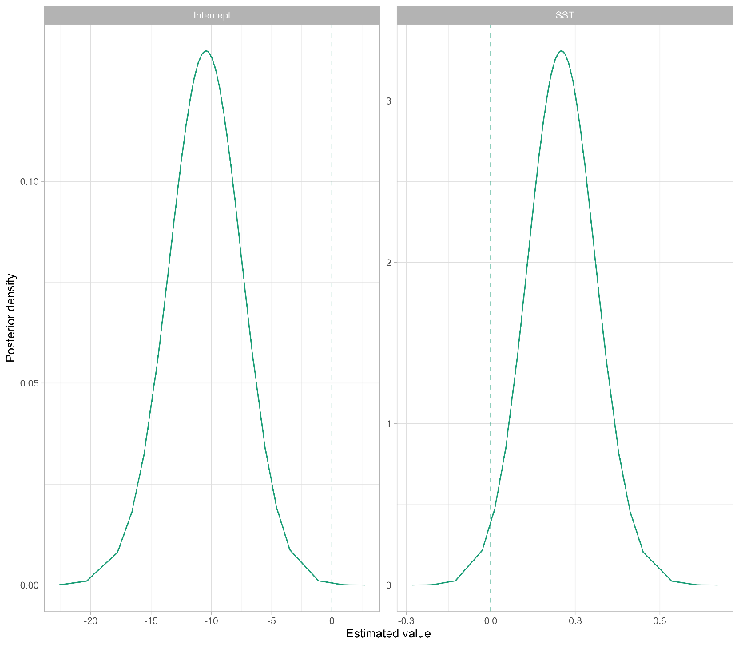
(b)
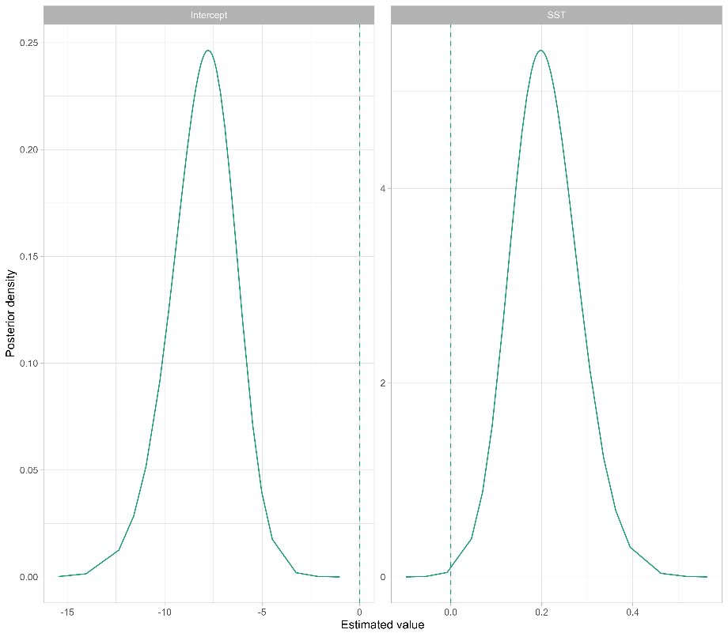
Figure S1. Posterior distribution of fixed effects parameters for each dataset in (a) Q1 and (b) Q4. In these figures, w is the parameter for SST, and intercept in the hurdle gamma model, respectively.

(a)
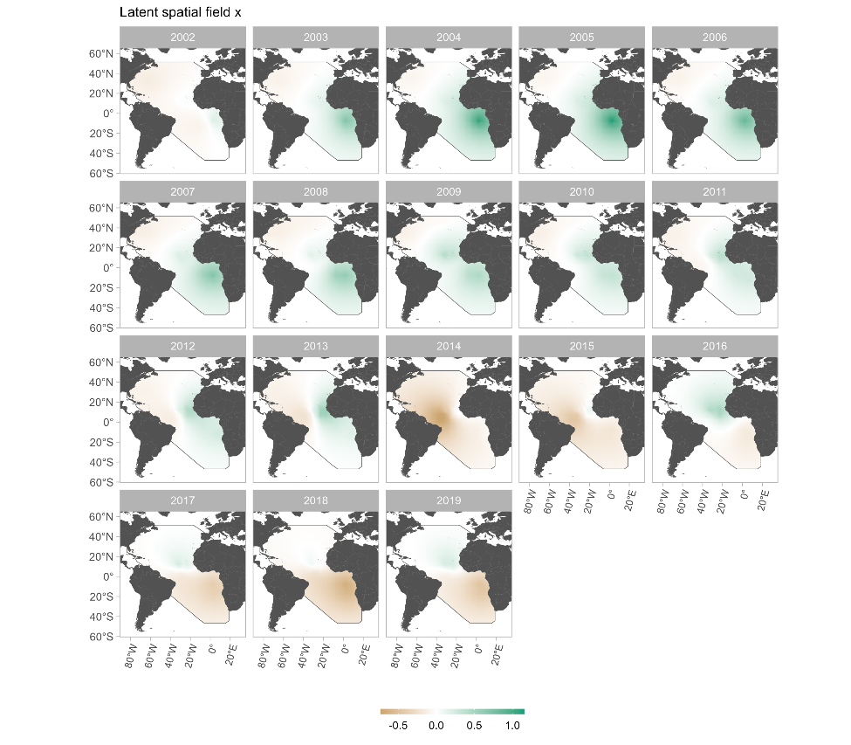
(b)
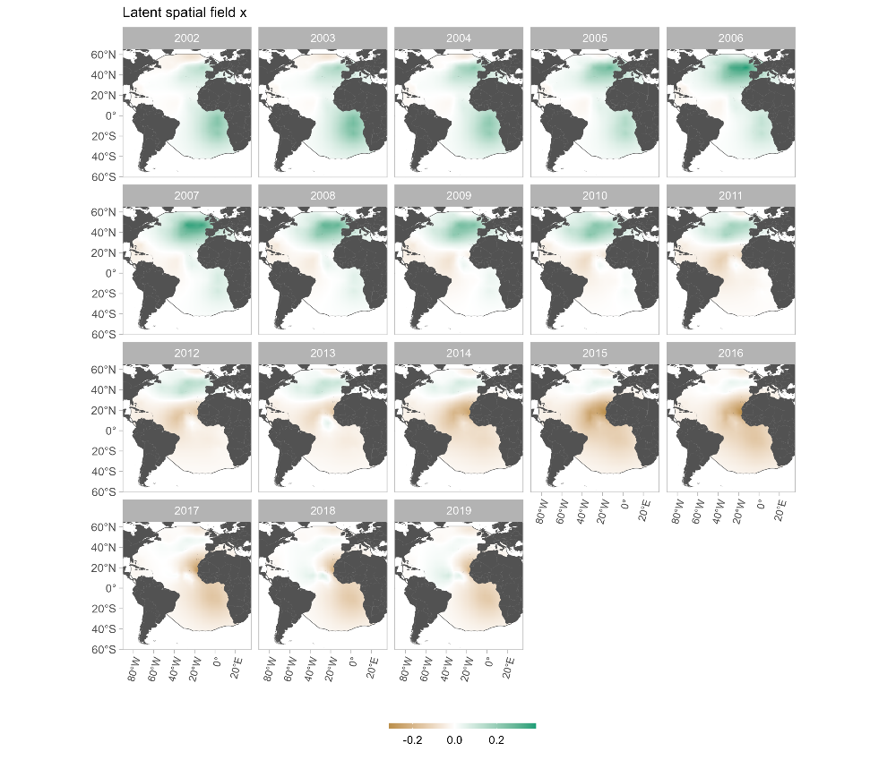
Figure S2. Changes over time in the spatial distribution of latent spatial fields x in (a) Q1 and (b) Q4.

(a)
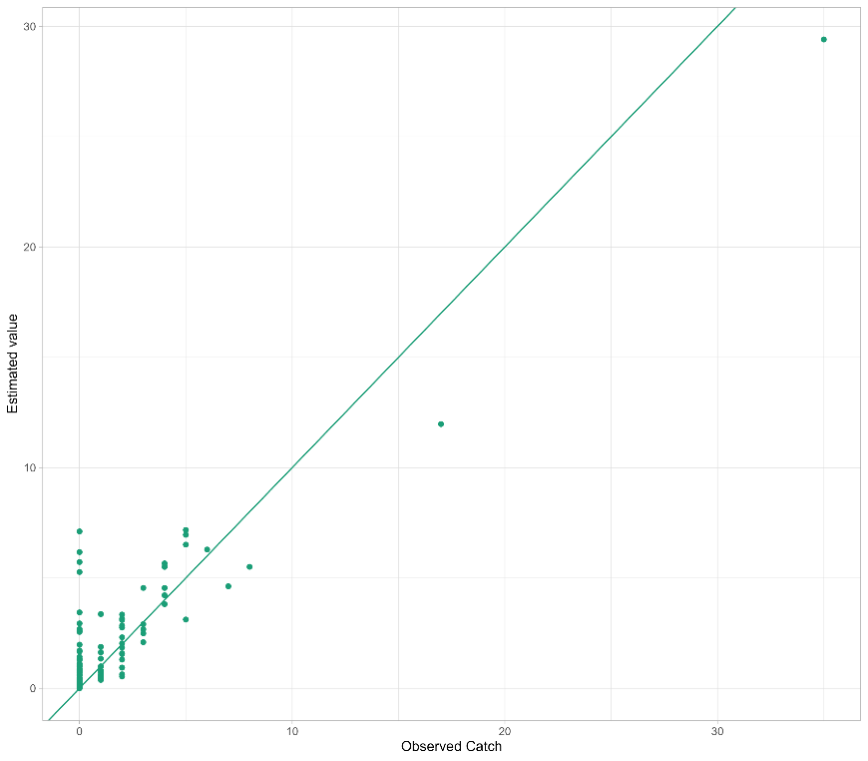
(b)
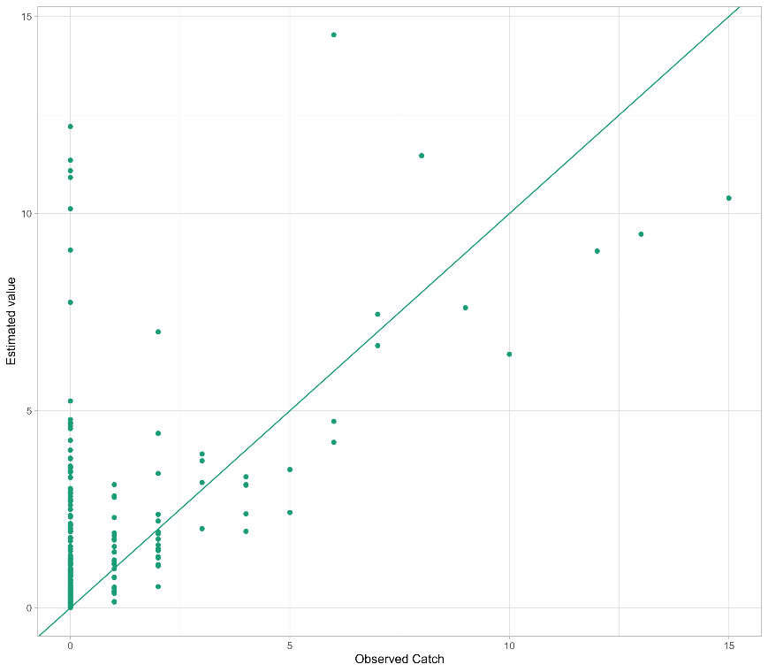
Figure S3. Relationship between observed and predicted CPUE in (a) Q1and (b) Q4. The solid line in the figure is y=x, which usually indicates that the model fits well when the observed and predicted values do not deviate greatly from this straight line. It should be noted, however, that since we are using a zero-inflated model and are estimating with a false-negative of 0, this is true for the non-zero observed values, and it is natural for the predictions to be larger than the observed values with respect to the zero places.

(a)
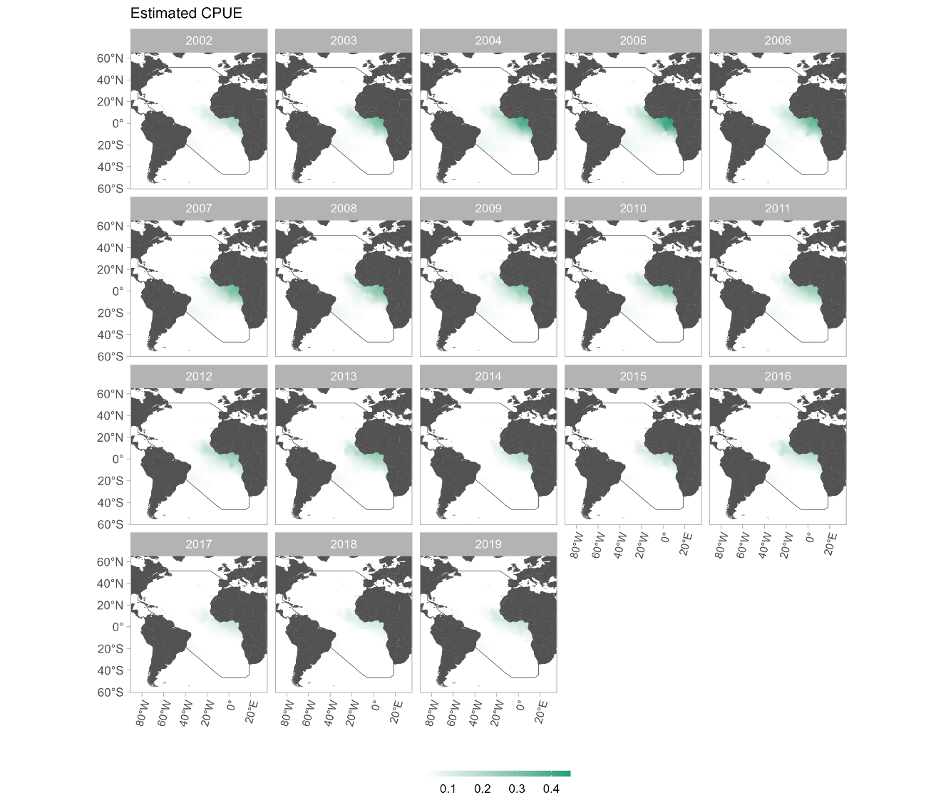
(b)
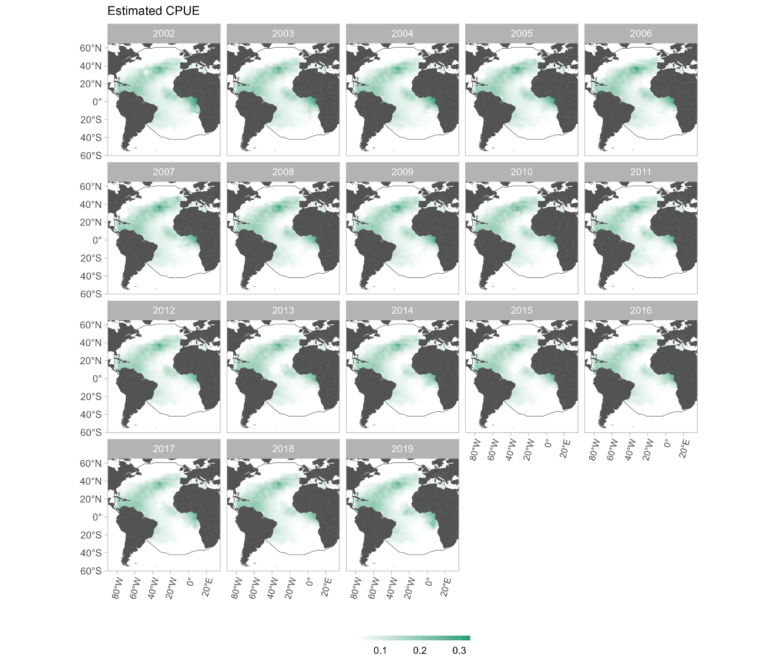
Figure S4. Spatiotemporal patterns of estimated relative abundance in (a) Q1 and (b) Q4. The extent of the inner mesh including the observation points in figure 1 is shown in the figure to match the distribution limits of leatherback turtles.

(a)
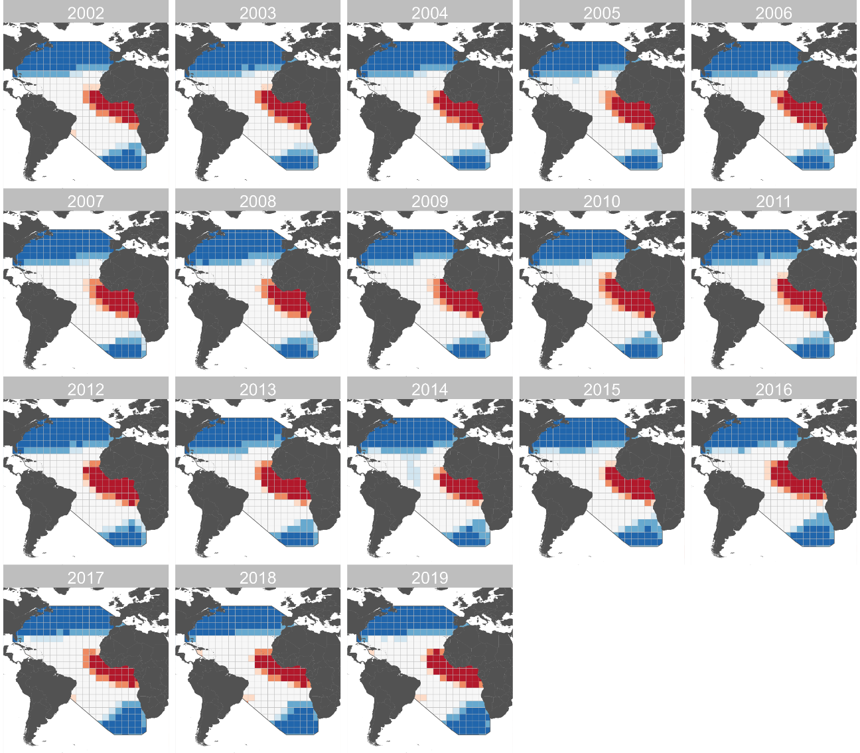

(b)
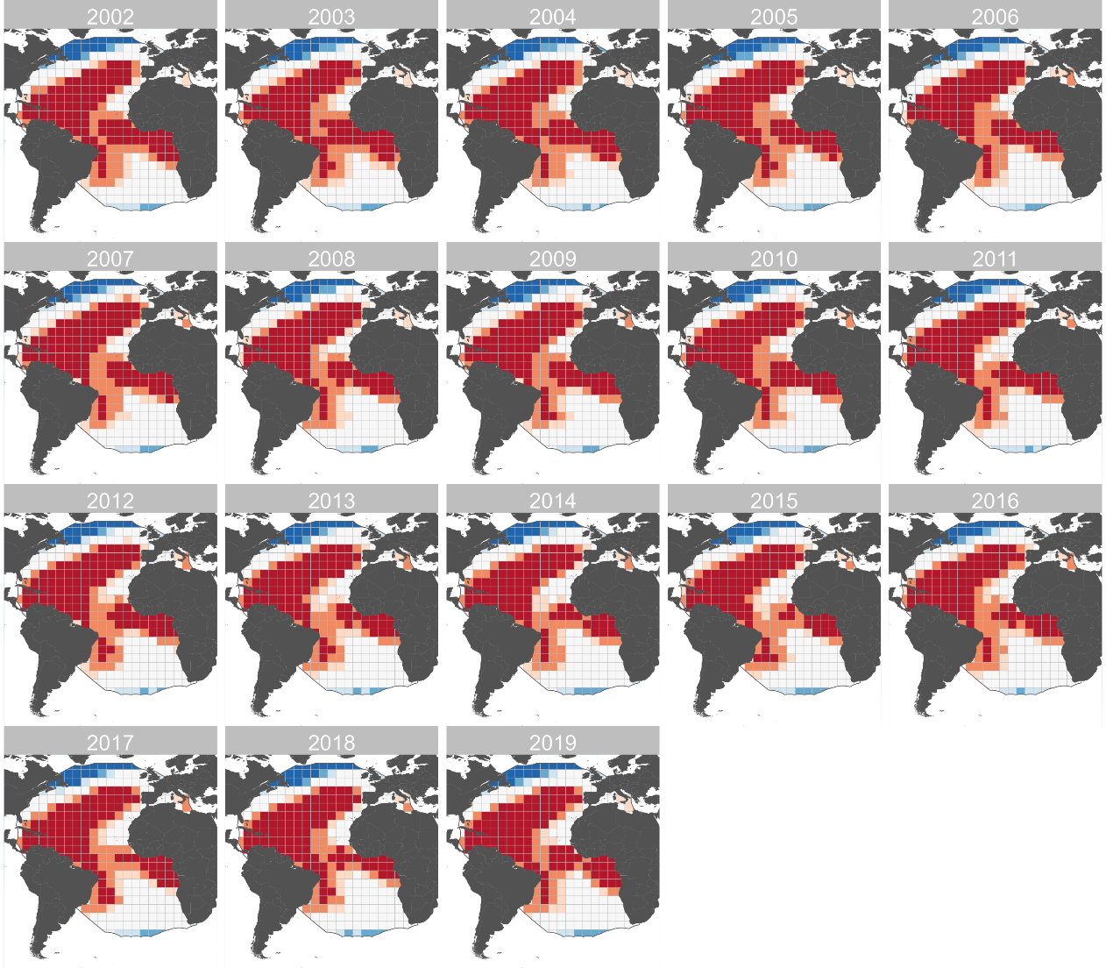
Figure S5 Spatiotemporal patterns of potential bycatch hot spots in (a) Q1 and (b) Q4. Red areas indicate hotspots at risk of bycatch and blue areas indicate cold spots where the risk is lower than elsewhere.

(a)
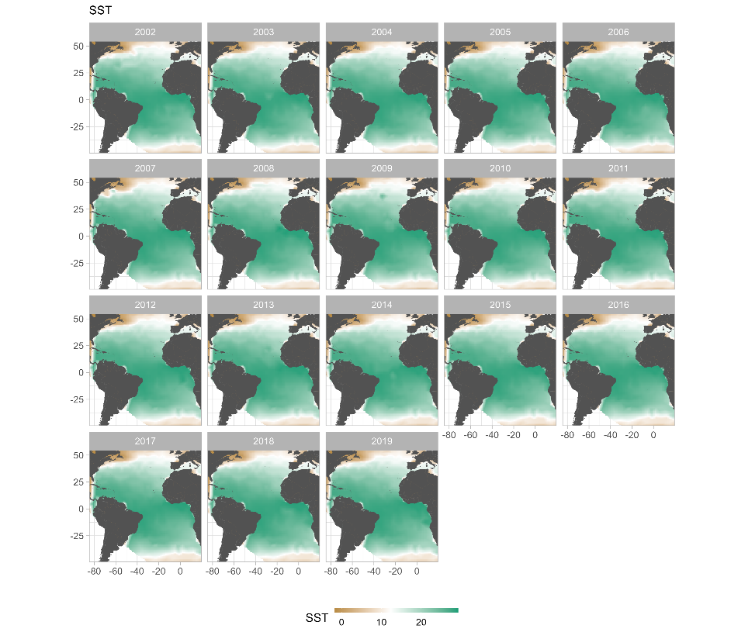
(b)
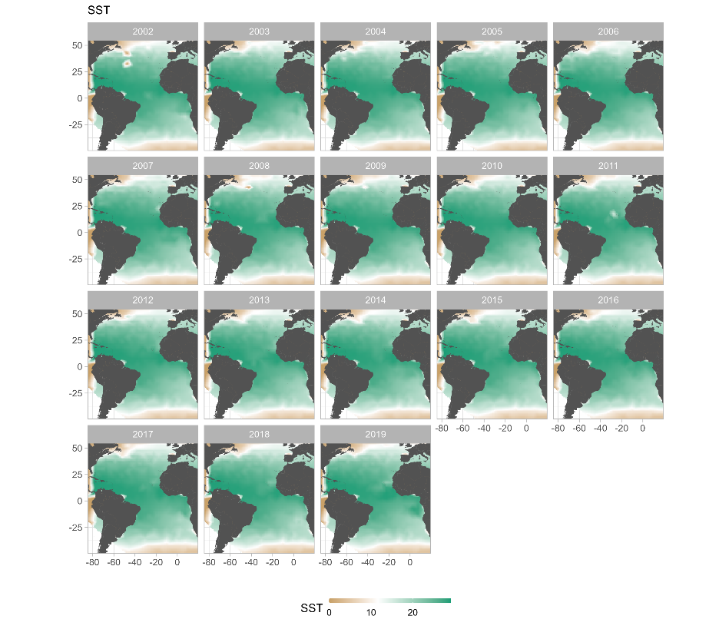
Figure S6. Spatial distribution of (a) Q1 and (b) Q4 for sea surface temperature data from 2002 to 2019.

