Table 1 : List of genes up-regulated by RA and down-regulated by BMS493 at 3-somites stage (with FDR<0,01).
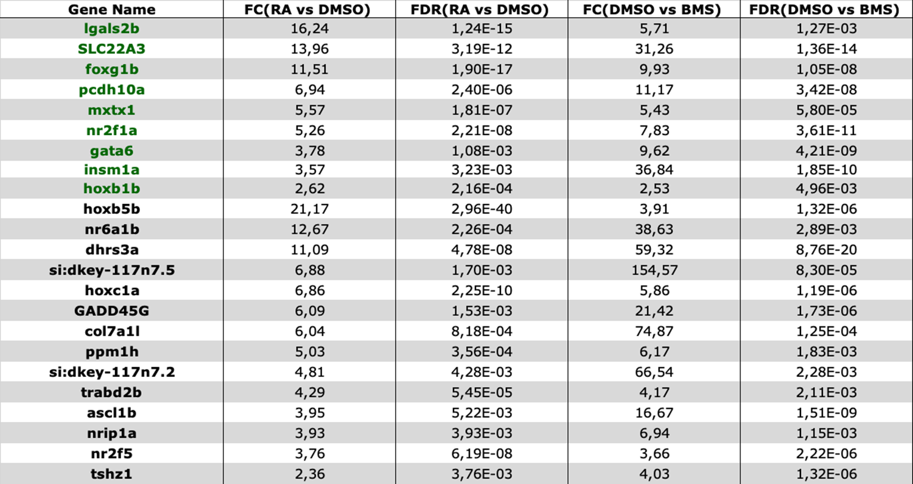
The regulation of each gene is shown by the Fold Change expression ratio (FC) and with the Fold Discovery Rate (FDR) for the RA treatment (column 2 and 3) and for the BMS493 treatment (columns 4 and 5). The genes highlighted in green are those showing enriched expression in endoderm (FC>4 and FDR<0,01)

Table 2 : List of genes up-regulated by RA and down-regulated by BMS493 at 8-somites stage (with FDR<0,01).
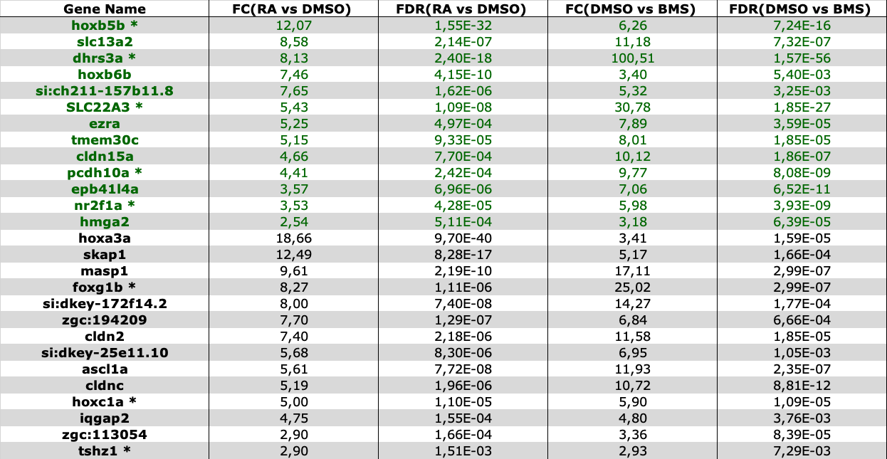
The regulation of each gene is shown by the Fold Change expression ratio (FC) and with the Fold Discovery Rate (FDR) for the RA treatment (column 2 and 3) and for the BMS493 treatment (columns 4 and 5). The genes highlighted in green are those showing enriched expression in endoderm (FC>4 and FDR<0,01). Genes displaying the same regulation at 3 somites (Table1) are shown by an asterisk.

