DEUBIQUITINASES AS PROGNOSTIC BIOMARKER AND POTENTIAL DRUG TARGET FOR GYNECOLOGICAL CANCERS
Kondapally Mavika¹, Anubha Dey¹, Golagana Velangani Harshitha², Shashi Kiran², Manjari Kiran^{1*}
¹ Department of Systems and Computational Biology, School of Life Sciences, University of Hyderabad, Hyderabad, India
² Department of Biochemistry, School of Life Sciences, University of Hyderabad, Hyderabad, India

Journal: International Journal of Clinical Oncology

Authors
- Kondapally Mavika
Department of Systems and Computational Biology,
School of Life Sciences,
University of Hyderabad, Gachibowli, Hyderabad,
500046, India.
E-mail: mavikakondapally@gmail.com
ORCID iD: https://orcid.org/0009-0004-4738-984X
- Anubha Dey
Department of Systems and Computational Biology,
School of Life Sciences,
University of Hyderabad, Gachibowli, Hyderabad,
500046, India.
E-mail: 19lsph01@uohyd.ac.in
ORCID iD: https://orcid.org/0000-0001-5934-2732
- Golagana Velangani Harshitha
Department of Biochemistry,
School of Life Sciences,
University of Hyderabad, Gachibowli, Hyderabad,
500046, India.
E-mail: 20lbph15@uohyd.ac.in
ORCID iD: https://orcid.org/0009-0004-0936-6460
- Shashi Kiran
Department of Biochemistry,
School of Life Sciences,
University of Hyderabad, Gachibowli, Hyderabad,
500046, India.
E-mail: shashi_sls@uohyd.ac.in
ORCID iD: https://orcid.org/0000-0003-2088-8273
- Manjari Kiran
Department of Systems and Computational Biology,
School of Life Sciences,
University of Hyderabad, Gachibowli, Hyderabad,
500046, India.
E-mail: manjari.hcu@uohyd.ac.in
ORCID iD - 0000-0003-0153-7072

SUPPLEMENTARY MATERIAL
Table S1
Table S1: Sample information of TCGA and GEO datasets of three cancer types.
Clinical features |  | Cervical Cancer |  | Ovarian Cancer |  | Uterine Cancer
 |  | TCGA-CESC | GSE44001 | TCGA-OV | GSE63885 | TCGA-UCEC | GSE119041
Sample Size |  | 306 | 300 | 429 | 101 | 577 | 50
Complete clinical information |  | 290 | 300 | 365 | 75 | 423 | 50
OS | 0 | 218 | 262 | 140 | 5 | 352 | 11
OS | 1 | 72 | 38 | 225 | 70 | 71 | 39
Grade | I | 18 | - | 1 | - | 98 | -
Grade | II | 135 | - | 42 | - | 120 | -
Grade | III | 118 | - | 320 | - | 318 | -
Grade | IV | 1 | - | 1 | - | 0 | -
MPS | Pre | 182 | - | 79 | - | 63 | -
MPS | Post | 106 | - | 283 | - | 463 | -

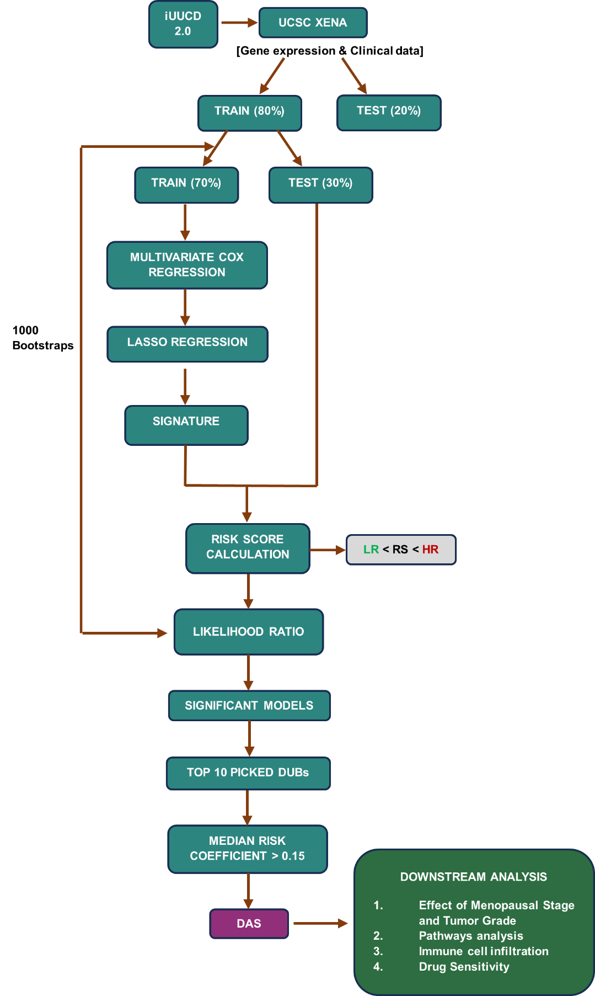
Figure S1

Figure S1: Flowchart of the study

Figure S2
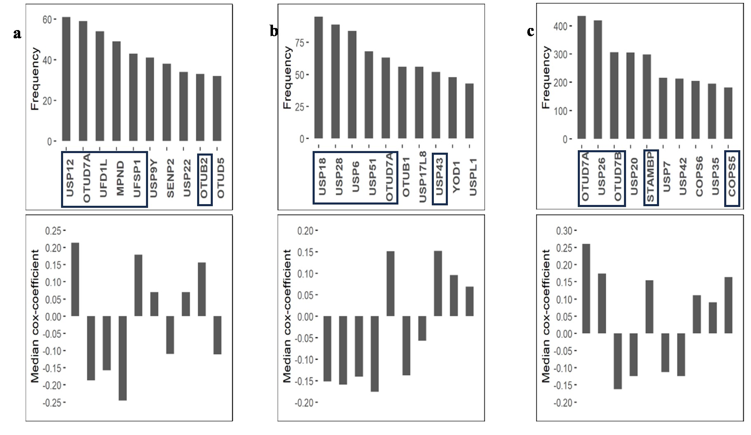
Figure S2: Top 10 most occurred DUBs in Cervical(a), Ovarian(b), and Uterine(c) cancers. Upper panel: Bar plots showing the number of times significant models picked up the DUB in 1000 trials.
Lower panel: Median cox-coefficient of top 10 DUBs. Selected prognostic DUBs for DAS are represented with a box.
DUB, Deubiquitinase; DAS, Deubiquitinase Associated Signature

Figure S3
Figure S3: Validation of DAS in GEO dataset in Uterine cancer
DAS, Deubiquitinase Associated Signature; GEO, Gene Expression Omnibus

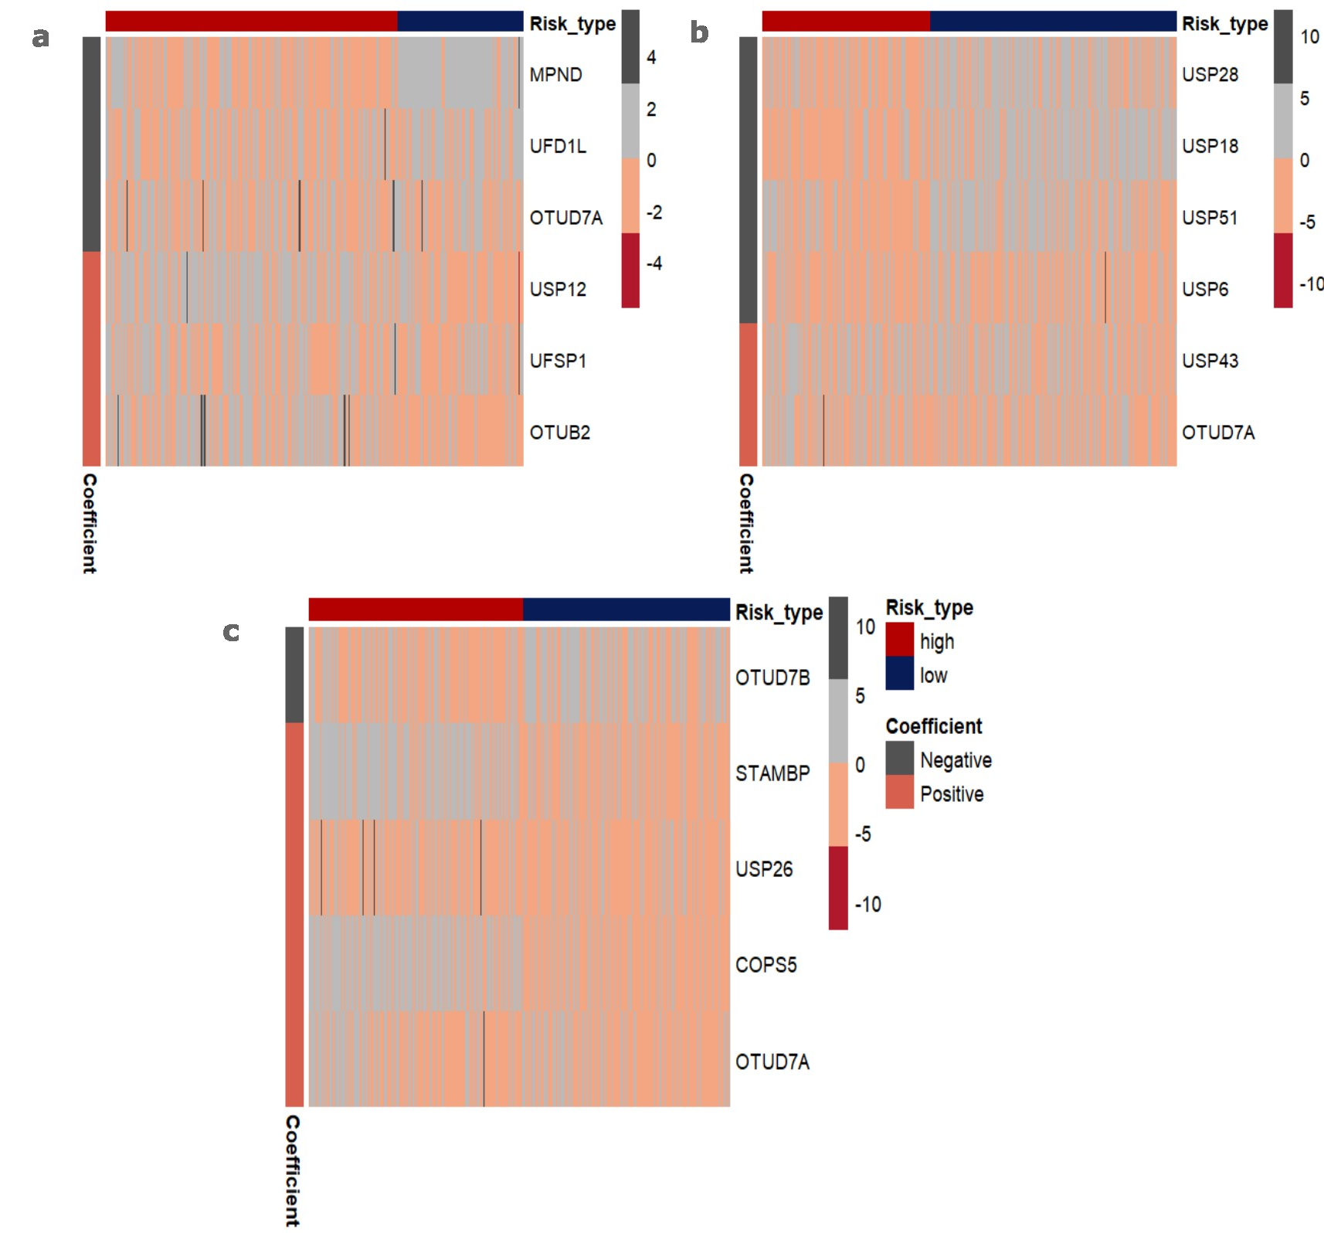
Figure S4

Figure S4: Heatmaps showing the expression of prognostic DUBs in Cervical(a), Ovarian(b) and Uterine(c) cancers. DUBs, Deubiquitinases

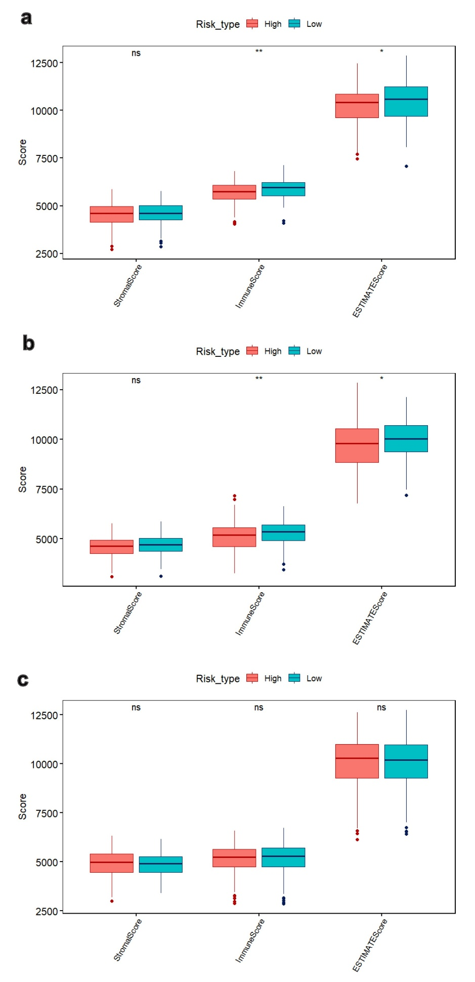
Figure S5

Figure S5: ESTIMATE scores of high-risk and low patients in Cervical(a), Uterine(b), and Ovarian cancers(c).
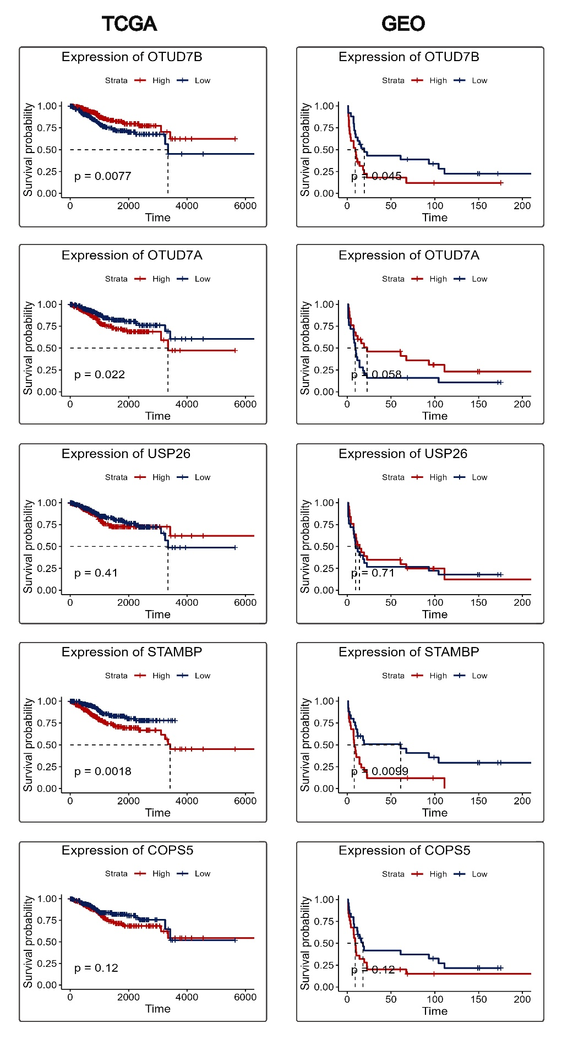
Figure S6
Figure S6: KM plots showing the relation between two risk groups and expression of prognostic DUBs in TCGA and GEO datasets of Uterine cancer.
KM, Kaplan Meier; DUBs, Deubiqutinases; GEO, Gene Expression Omnibus; TCGA, The Cancer Genome Atlas
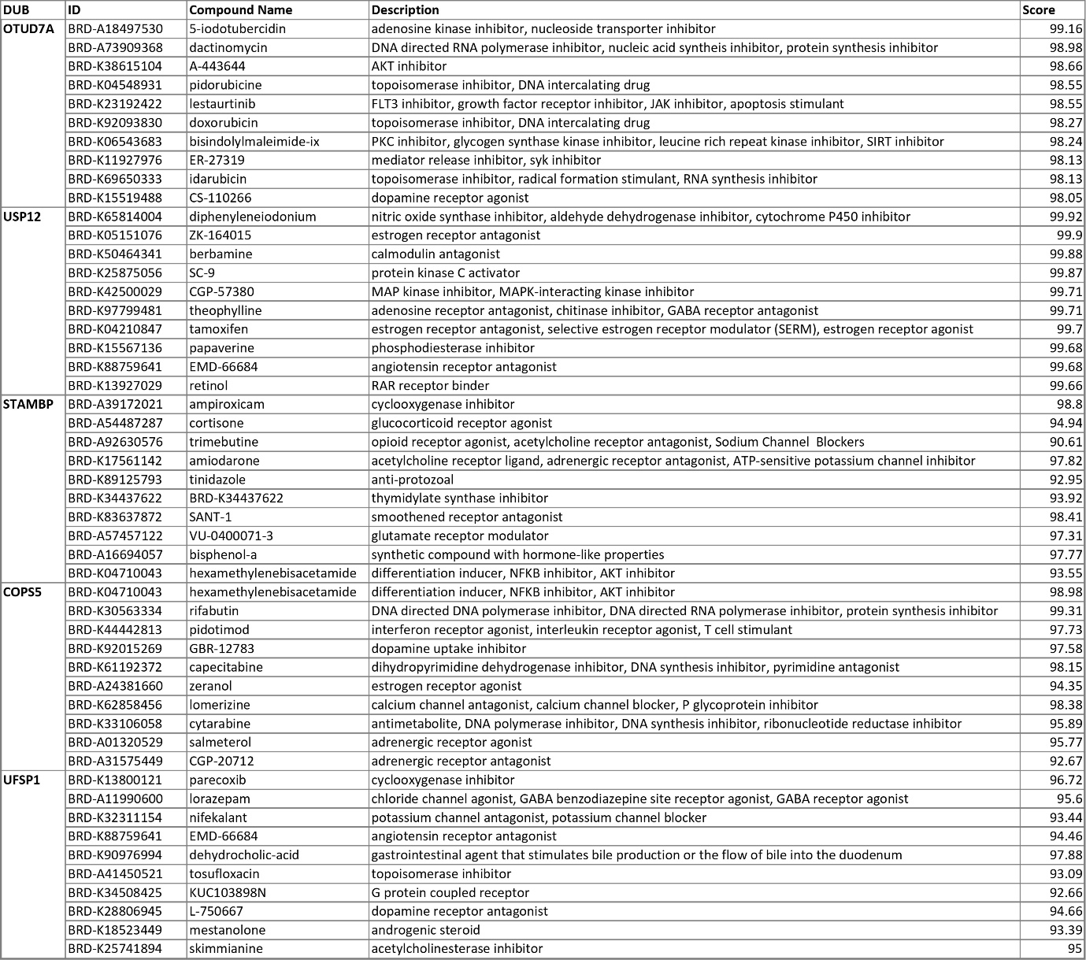
Figure S7

Figure S7: Result of CMap analysis for unfavorable DUBs
CMap, Connectivity Map; DUBs, Deubiquitinases

