Supplymentary materials 2
Sample Information
Sample type: Biopsy sample
Receipt day: November 8, 2022
Report day: November 10, 2022

Polymerase chain reaction (PCR) was carried out to amplify a partial sequence of Tropheryma whipplei, and first - generation sequencing technology was used for sequencing.

- Total DNA was extracted from the patient's paraffin-embedded tissues using the QIAamp DNA Blood Mini Kit (Qiagen) according to the manufacturer's instructions.

- The PCR was performed with TB Green Premix Ex Taq according to the manufacturer’s instructions (Takara, Dalian, Liaoning) on an ABI QuantStudio5 System (Applied Biosystems).

The sequences of primers were as follows:
Forward primer:5’-CGCCTGTGTGCCAATGTAGA-3’;
Reverse primer:5’-ACTGATATACACGAGCGGCAT-3.

c. The ITS region (the non-coding region between the 16S - 23S rRNA genes) has a higher mutation rate than the 16S rDNA and stronger specificity. It is the gold-standard target for the diagnosis of Whipple's disease.
Conclusion
The 16S-23S ribosomal RNA spacer region (partial sequence: 144 bases) measured from the sample
1 TCGCCTGTGTGCCAATGTAGAACGGGT
28 GATCCTTGCGGTCGAGCTCAATAAATT
55 CAATCAGGTCTTGCTCTGTATTCCGCC
82 CAGAGACTATAAGCCCACGCTCAACCA
109 GTCGCTGTGCATAGCCATTATTTACTT
136 AAAAGGGGT

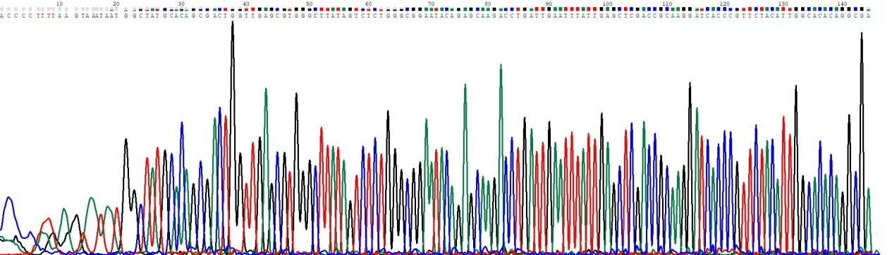
Fig.1 Nucleotide sequencing chromatogram

Fig.2 Phylogenetic tree of T.whipplei 16S -23S rRNA sequence.

Nucleotide sequence alignment and MEGA phylogenetic tree results indicate that the obtained partial sequence is derived from Tropheryma whipplei.
Report Information
Bacterium: Tropheryma whipplei

