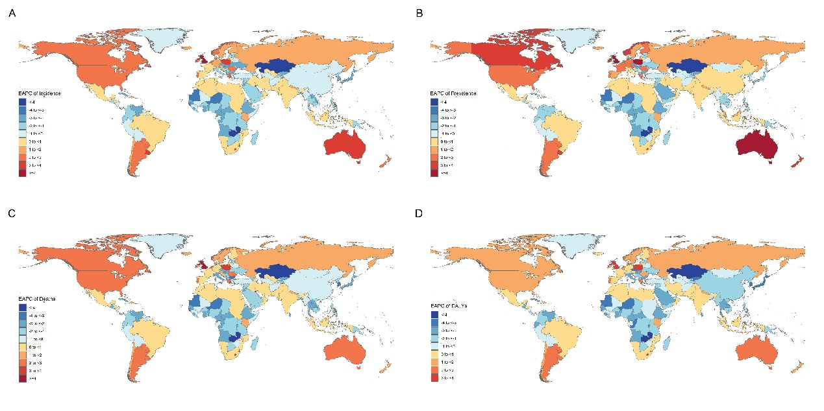
Figure S1. The EAPC distribution of liver cancer due to hepatitis B in 204 countries and regions from 1990 to 2021.
(A) ASIR; (B) ASPR; (C) ASDR; (D) ASR of DALYs.

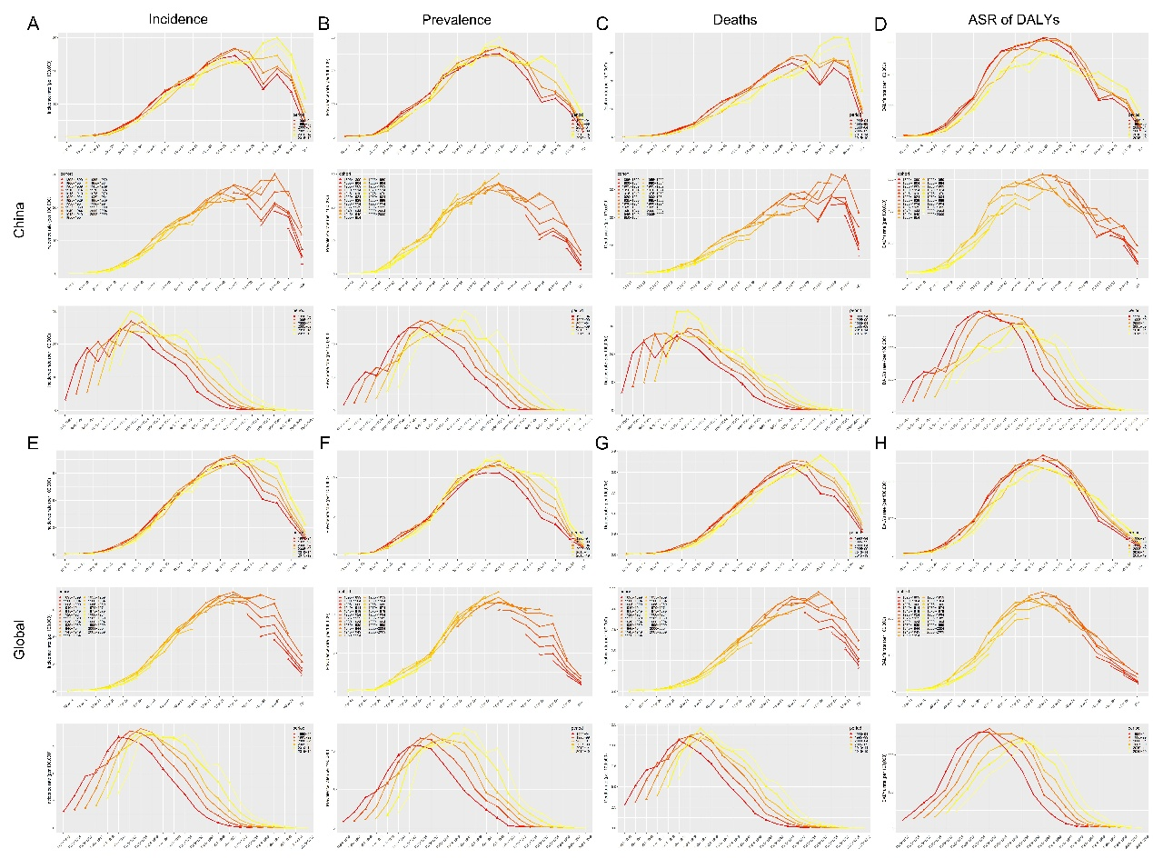
Figure S5. Age-period-cohort analysis of liver cancer due to hepatitis B in China and Globally from 1990 to 2021.
(A) ASIR in China; (B) ASIR Globally; (C) ASPR in China; (D) ASPR Globally. (E) ASDR in China; (F) ASDR Globally; (G) ASR of DALYs in China; (H) ASR of DALYs Globally.

