Appendix S1

Supplement to:

Environmental DNA metabarcoding accelerates integral conservation assessments and species rediscoveries in tropical biodiversity hotspots

Plewnia et al.

Basic code for processing of demultiplexed MiSeq sequences.

## merge all F and R files individually at once:
# 1. pear script:
ls | awk '{print "pear -q 20 -j 12 -v 50 -f "$0" -r "$0" -o "$0}' | grep -v _R2_ | sed 's/_R1_/_R2_/2' | sed -r 's/_S[0-9] {1,3}_L001_R1_001.fastq.gz//2' >pear.sh

# 2. make it executable:
chmod +x pear.sh

# 3. execute pear for all files:
./pear.sh

## quality filtering for all files at once:
# 1. fast script:
ls *assembled.fastq | awk '{print "fastq_quality_filter -Q33 -q 30 -p 90 -i "$0" | fastq_to_fasta -Q33 -o "$0}' | sed 's/assembled.fastq/fasta/2' >fast.sh

# 2. make it executable:
chmod +x fast.sh

# 3. execute FASTX Toolkit for all files:
./fast.sh

## cutting off primer sequences (replace all characters that are not A,T,G or C with a point) and (optionally) removing short sequences. Replace characters in italics with the specific primer sequence, primer length for trimming, filtering length and desired file name respectively. Further, all files are merged into a single .fas file:
grep -E "^FwdPRIMERSEQ.*REVERSECOMPLIMENTOFRevPRIMERSEQ$" *fasta | sed -r 's/:[A-Z]{FwdPRIMERLENGTH}/\t/' | sed -r 's/[A-Z]{RevPRIMERLENGTH}$//' | awk 'length ($2)>=100{print ">"$1"\n"$2}' > name.fas

## dereplicate and cluster sequences (../ redirects to the usearch executable file in the folder above the current working directory. If usearch bin is stored somewhere else, replace ../ with the appropriate path).
## dereplicate Sequences:
../usearch -fastx_uniques name.fas -fastaout name.derep -sizeout

## Cluster OTUs (here, all sequences that occur less than 5 times are discarded; the command -cluster_otus by default produces 97% radius OTUs):
../usearch -cluster_otus name.derep -otus name.OTU.fas -minsize 5 -relabel OTU

Replace – with _ in the .fas header:
sed -i 's/-/_/g' name.fas

## making OTU table:
../usearch -otutab name.fas -otus name.OTU.fas -otutabout name.Tab.txt
## run BLAST search:
blastn -db /path/nt -query name.OTU.fas -num_threads 24 -max_target_seqs 10 -out name_OTUs.out -outfmt "6 qseqid sseqid pident length mismatch gapopen qstart qend sstart send evalue bitscore staxids"

## assign taxon names to OTUs:
/path/blast2taxonomy_v1.4.2.py -i name_OTUs.out -o name_blast2tax.txt -t 6

Table S1. Details on sampling localities, time points and total water volume sampled. To protect sensitive populations of threatened species from poaching, coordinates appear in a cropped format and are available in detail upon request from authors only.

ID | locality name, province | coordinates | altitude | date | volume (l)
PA1 up F1 | Palanda 1, Zamora Chinchipe | -4.64, -79.18 | 2400 | 18 July 2023 | 0.6
PA1 up F2 | Palanda 1, Zamora Chinchipe | -4.64, -79.18 | 2400 | 18 July 2023 | 0.6
PA1 down F1 | Palanda 1, Zamora Chinchipe | -4.64, -79.18 | 2400 | 18 July 2023 | 1.0
PA1 down F2 | Palanda 1, Zamora Chinchipe | -4.64, -79.18 | 2400 | 18 July 2023 | 0.6
PA2 F1 | Palanda 2, Zamora Chinchipe | -4.64, -79.19 | 2580 | 18 July 2023 | 0.6
PA2 F2 | Palanda 2, Zamora Chinchipe | -4.64, -79.19 | 2580 | 18 July 2023 | 0.4
PA3 F1 | Valladolid, Zamora Chinchipe | -4.47, -79.14 | 2600 | 18 July 2023 | 0.8
PA3 F2 | Valladolid, Zamora Chinchipe | -4.47, -79.14 | 2600 | 18 July 2023 | 0.5
AZ1.1 | Abra de Zamora 1, Zamora Chinchipe | -3.97, -79.10 | 2050 | 26 July 2023 | 1.0
AZ1.2 | Abra de Zamora 1, Zamora Chinchipe | -3.97, -79.10 | 2050 | 26 July 2023 | 0.8
AZ2.1 | Abra de Zamora 2, Zamora Chinchipe | -3.97, -79.10 | 2050 | 26 July 2023 | 1.2
AZ2.2 | Abra de Zamora 2, Zamora Chinchipe | -3.97, -79.10 | 2050 | 26 July 2023 | 1.3
AZ2.3 | Abra de Zamora 2, Zamora Chinchipe | -3.97, -79.10 | 2050 | 26 July 2023 | 2.2
AZ3.1 | Abra de Zamora 3, Zamora Chinchipe | -3.97, -79.08 | 2020 | 26 July 2023 | 2.5
AZ3.2 | Abra de Zamora 3, Zamora Chinchipe | -3.97, -79.08 | 2020 | 26 July 2023 | 2.5
ZR1.1 | Abra de Zamora - old road - 1, Loja | -3.98, -79.13 | 2670 | 27 July 2023 | 0.3
ZR1.2 | Abra de Zamora - old road - 1, Loja | -3.98, -79.13 | 2670 | 27 July 2023 | 0.25
ZR2.1 | Abra de Zamora - old road - 2, Zamora Chinchipe | -3.96, -79.11 | 2210 | 27 July 2023 | 1.1
ZR2.2 | Abra de Zamora - old road - 2, Zamora Chinchipe | -3.96, -79.11 | 2210 | 27 July 2023 | 0.9
ZR3.1 | Abra de Zamora - old road - 3, Zamora Chinchipe | -3.96, -79.11 | 2210 | 27 July 2023 | 0.9
ZR3.2 | Abra de Zamora - old road - 3, Zamora Chinchipe | -3.96, -79.11 | 2210 | 27 July 2023 | 1.0
ZR4.1 | Abra de Zamora - old road - 4, Zamora Chinchipe | -3.96, -79.11 | 2210 | 27 July 2023 | 1.5
ZR4.2 | Abra de Zamora - old road - 4, Zamora Chinchipe | -3.96, -79.11 | 2210 | 27 July 2023 | 1.3
GL1.1 | Gualaceo - Limón road 1, Azuay | -2.95, -78.70 | 3140 | 29 July 2023 | 0.6
GL1.2 | Gualaceo - Limón road 1, Azuay | -2.95, -78.70 | 3140 | 29 July 2023 | 0.5
GL2.1 | Gualaceo - Limón road 2, Azuay | -2.97, -78.68 | 3220 | 29 July 2023 | 1.1
GL2.2 | Gualaceo - Limón road 2, Azuay | -2.97, -78.68 | 3220 | 29 July 2023 | 1.0
GL2.3 | Gualaceo - Limón road 2, Azuay | -2.97, -78.68 | 3220 | 29 July 2023 | 1.0
GL3.1 | Gualaceo - Limón road 3, Morona Santiago | -3.00, -78.65 | 3210 | 29 July 2023 | 1.0
GL3.2 | Gualaceo - Limón road 3, Morona Santiago | -3.00, -78.65 | 3210 | 29 July 2023 | 0.7
GL4.1 | Gualaceo - Limón road 4, Morona Santiago | -3.01, -78.61 | 2740 | 29 July 2023 | 0.8
GL4.2 | Gualaceo - Limón road 4, Morona Santiago | -3.01, -78.61 | 2740 | 29 July 2023 | 0.6
GL4.3 | Gualaceo - Limón road 4, Morona Santiago | -3.01, -78.61 | 2740 | 29 July 2023 | 0.6
GL5.1 | Gualaceo - Limón road 5, Azuay | -2.99, -78.67 | 3260 | 29 July 2023 | 1.1
GL5.2 | Gualaceo - Limón road 5, Azuay | -2.99, -78.67 | 3260 | 29 July 2023 | 0.9
GL6.1 | Gualaceo - Limón road 6, Azuay | -2.98, -78.68 | 3220 | 29 July 2023 | 0.7
CS1.1 | Chico Soldados 1, Azuay | -2.93, -79.23 | 3300 | 31 July 2023 | 1.0
CS1.2 | Chico Soldados 1, Azuay | -2.93, -79.23 | 3300 | 31 July 2023 | 0.6
CS1.3 | Chico Soldados 1, Azuay | -2.93, -79.23 | 3300 | 31 July 2023 | 0.8
CS2.1 | Chico Soldados 2, Azuay | -2.93, -79.18 | 3150 | 31 July 2023 | 3.7
PC1.1 | Parque Nacional Cajas 1, Azuay | -2.77, -79.23 | 4030 | 1 August 2023 | 0.6
PC1.2 | Parque Nacional Cajas 1, Azuay | -2.77, -79.23 | 4030 | 1 August 2023 | 0.5
PC1.3 | Parque Nacional Cajas 1, Azuay | -2.77, -79.23 | 4030 | 1 August 2023 | 0.4
PC1.4 | Parque Nacional Cajas 1, Azuay | -2.77, -79.23 | 4030 | 1 August 2023 | 0.4
PC2.1 | Parque Nacional Cajas 2, Azuay | -2.76, -79.22 | 3980 | 1 August 2023 | 0.6
PC2.2 | Parque Nacional Cajas 2, Azuay | -2.76, -79.22 | 3980 | 1 August 2023 | 0.4
PC2.3 | Parque Nacional Cajas 2, Azuay | -2.76, -79.22 | 3980 | 1 August 2023 | 1.15
PC3.1 | Parque Nacional Cajas 3, Azuay | -2.76, -79.21 | 3860 | 1 August 2023 | 0.9
PC3.2 | Parque Nacional Cajas 3, Azuay | -2.76, -79.21 | 3860 | 1 August 2023 | 0.7
PC3.3 | Parque Nacional Cajas 3, Azuay | -2.76, -79.21 | 3860 | 1 August 2023 | 0.5
PC3.4 | Parque Nacional Cajas 3, Azuay | -2.76, -79.21 | 3860 | 1 August 2023 | 0.6
CN1.1 | Cerro Negro 1, Azuay | -3.16, -78.84 | 3070 | 2 August 2023 | 0.7
CN1.2 | Cerro Negro 1, Azuay | -3.16, -78.84 | 3070 | 2 August 2023 | 0.5
CN1.3 | Cerro Negro 1, Azuay | -3.16, -78.84 | 3070 | 2 August 2023 | 0.6
CN2.1 | Cerro Negro 2, Azuay | -3.15, -78.84 | 3080 | 2 August 2023 | 0.5
CN2.2 | Cerro Negro 2, Azuay | -3.15, -78.84 | 3080 | 2 August 2023 | 0.5
CN2.3 | Cerro Negro 2, Azuay | -3.15, -78.84 | 3080 | 2 August 2023 | 0.6
CN3.1 | Cerro Negro 3, Azuay | -3.15, -78.84 | 3080 | 2 August 2023 | 0.4
CN3.2 | Cerro Negro 3, Azuay | -3.15, -78.84 | 3080 | 2 August 2023 | 0.3
CN3.3 | Cerro Negro 3, Azuay | -3.15, -78.84 | 3080 | 2 August 2023 | 0.4
CN3.4 | Cerro Negro 3, Azuay | -3.15, -78.84 | 3080 | 2 August 2023 | 0.4
GC1.1 | Gallo Cresta 1, Azuay | -3.19, -78.83 | 3170 | 3 August 2023 | 0.9
GC1.2 | Gallo Cresta 1, Azuay | -3.19, -78.83 | 3170 | 3 August 2023 | 0.7
GC1.3 | Gallo Cresta 1, Azuay | -3.19, -78.83 | 3170 | 3 August 2023 | 0.7
GC1.4 | Gallo Cresta 1, Azuay | -3.19, -78.83 | 3170 | 3 August 2023 | 0.7
GC2.1 | Gallo Cresta 2, Azuay | -3.19, -78.83 | 3170 | 3 August 2023 | 1.0
GC2.2 | Gallo Cresta 2, Azuay | -3.19, -78.83 | 3170 | 3 August 2023 | 0.7
GC2.3 | Gallo Cresta 2, Azuay | -3.19, -78.83 | 3170 | 3 August 2023 | 0.8
GC2.4 | Gallo Cresta 2, Azuay | -3.19, -78.83 | 3170 | 3 August 2023 | 0.8
GC3.1 | Gallo Cresta 3, Azuay | -3.19, -78.83 | 3170 | 3 August 2023 | 0.5
GC3.2 | Gallo Cresta 3, Azuay | -3.19, -78.83 | 3170 | 3 August 2023 | 0.4
GC4.1 | Gallo Cresta 4, Azuay | -3.20, -78.84 | 3130 | 3 August 2023 | 0.7
GC4.2 | Gallo Cresta 4, Azuay | -3.20, -78.84 | 3130 | 3 August 2023 | 0.8
GC5.1 | Gallo Cresta 5, Azuay | -3.19, -78.85 | 3260 | 3 August 2023 | 0.15
PZ1.1 | Puzhio 1, Azuay | -2.98, -78.73 | 3120 | 4 August 2023 | 1.6
PZ1.2 | Puzhio 1, Azuay | -2.98, -78.73 | 3120 | 4 August 2023 | 0.45
PZ2.1 | Puzhio 2, Azuay | -2.97, -78.72 | 3110 | 4 August 2023 | 0.6
PZ2.2 | Puzhio 2, Azuay | -2.97, -78.72 | 3110 | 4 August 2023 | 0.45
RP1.1 | Molleturo 1, Azuay | -2.74, -79.38 | 1670 | 6 August 2023 | 1.3
RP1.2 | Molleturo 1, Azuay | -2.74, -79.38 | 1670 | 6 August 2023 | 1.4
QC1.1 | Páramo de Quimsacocha 1, Azuay | -3.05, -79.22 | 3760 | 21 August 2023 | 0.3
QC1.2 | Páramo de Quimsacocha 1, Azuay | -3.05, -79.22 | 3760 | 21 August 2023 | 0.3
QC2.1 | Páramo de Quimsacocha 2, Azuay | -3.06, -79.23 | 3760 | 21 August 2023 | 0.25
QC2.2 | Páramo de Quimsacocha 2, Azuay | -3.06, -79.23 | 3760 | 21 August 2023 | 0.25
QC3.1 | Páramo de Quimsacocha 3, Azuay | -3.10, -79.21 | 3300 | 21 August 2023 | 0.6
TYa | undisclosed locality, Tandayapa, Pichincha | -0.00, -78.67 | 1760 | 11 August 2023 | 2.0
TYb | undisclosed locality, Tandayapa, Pichincha | -0.00, -78.67 | 1740 | 11 August 2023 | 2.0
TYc | undisclosed locality, Tandayapa, Pichincha | -0.00, -78.67 | 1710 | 11 August 2023 | 1.0
TYd | undisclosed locality, Tandayapa, Pichincha | -0.01, -78.68 | 2220 | 11 August 2023 | 2.0
TYe | undisclosed locality, Tandayapa, Pichincha | -0.01, -78.68 | 2240 | 11 August 2023 | 2.0
TYf | undisclosed locality, Tandayapa, Pichincha | -0.03, -78.71 | 2230 | 12 August 2023 | 2.0
TYg | undisclosed locality, Tandayapa, Pichincha | -0.01, -78.68 | 2290 | 12 August 2023 | 2.0
TYh | undisclosed locality, Tandayapa, Pichincha | -0.03, -78.64 | 2070 | 12 August 2023 | 1.0
TYi | undisclosed locality, Tandayapa, Pichincha | 0.01, -78.67 | 1600 | 12 August 2023 | 0.9
TYj | undisclosed locality, Tandayapa, Pichincha | 0.01, -78.67 | 1600 | 12 August 2023 | 0.9
TYk | undisclosed locality, Tandayapa, Pichincha | 0.01, -78.67 | 1600 | 12 August 2023 | 0.9
TYl | undisclosed locality, Tandayapa, Pichincha | 0.01, -78.67 | 1600 | 12 August 2023 | 0.9
TYm | undisclosed locality, Tandayapa, Pichincha | -0.01, -78.68 | 2260 | 13 August 2023 | 1.0
TYn | undisclosed locality, Tandayapa, Pichincha | -0.02, -78.71 | 2070 | 13 August 2023 | 1.0
TYo | undisclosed locality, Tandayapa, Pichincha | -0.02, -78.71 | 2050 | 13 August 2023 | 2.0
TYp | undisclosed locality, Tandayapa, Pichincha | -0.02, -78.71 | 2060 | 13 August 2023 | 1.0
TYq | undisclosed locality, Tandayapa, Pichincha | -0.02, -78.71 | 2060 | 13 August 2023 | 1.0
TYr | undisclosed locality, Tandayapa, Pichincha | -0.01, -78.68 | 2090 | 14 August 2023 | 3.0

Figure S1. Relative read composition for vertebrate classes for (A) 12S (12S-V5) and (B) 16S (MiAmphi_L). Note that both primer pairs did not yield any reptiles. Further, the amphibian-specific 16S primer pair barely amplified birds.

A
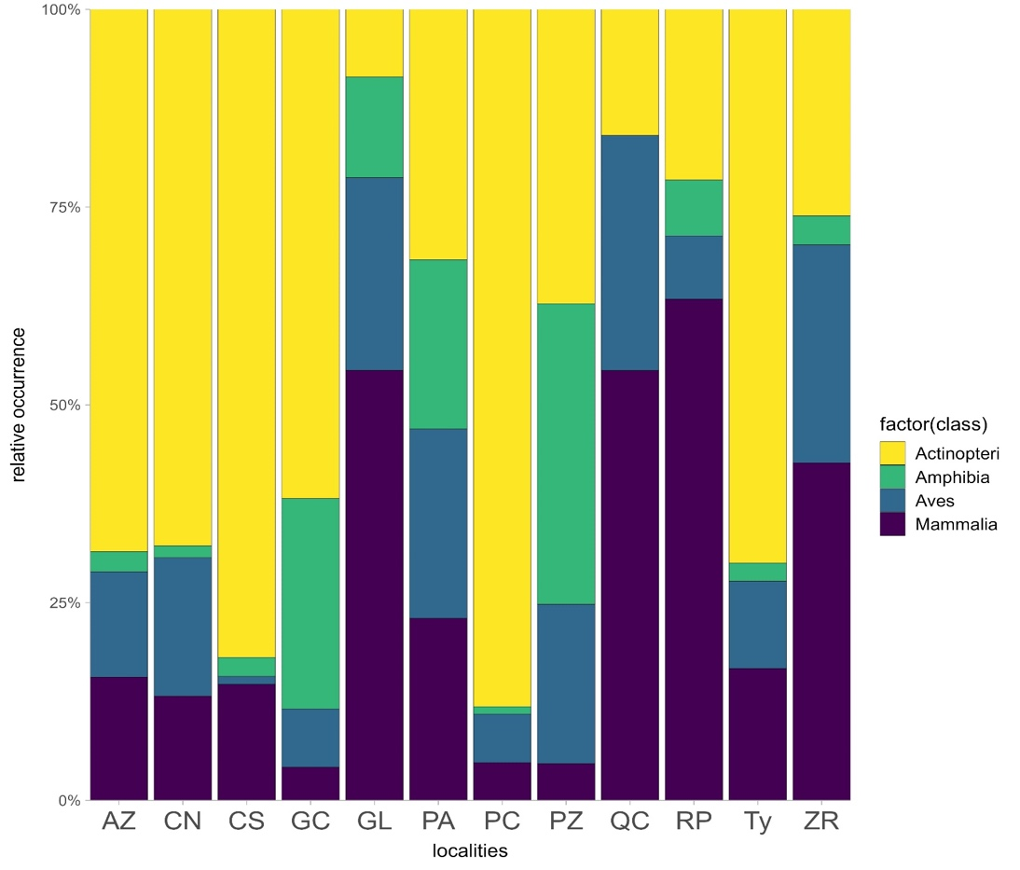
B
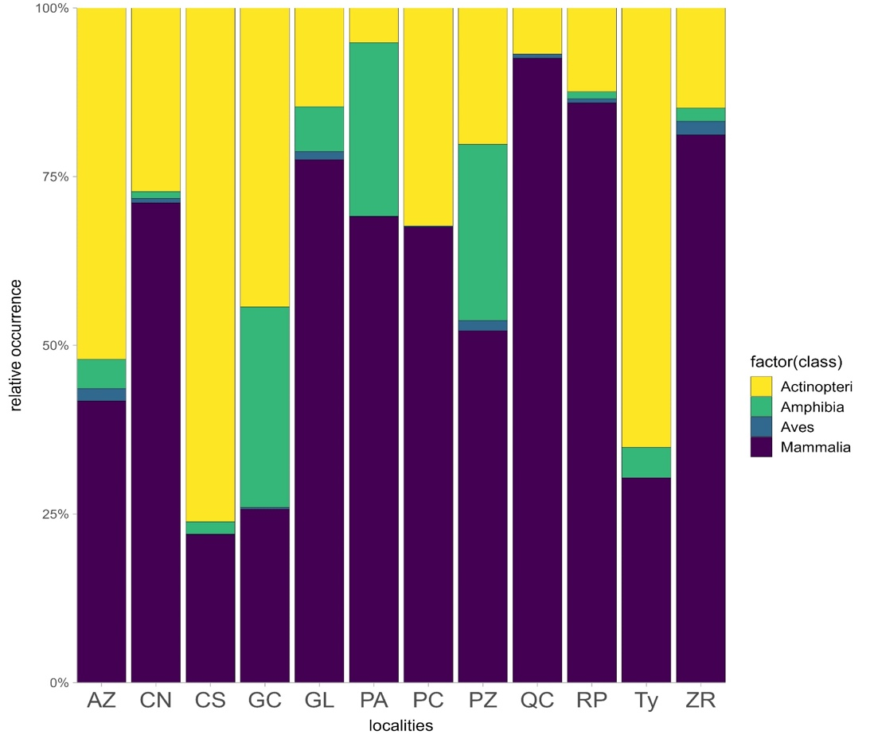
Figure S2. Supplemental figures highlighting (A) the endemism among Siluriformes OTUs versus non-native OTUs. (B) Species composition with high abundance of likely native Siluriformes among all fish. (C) Species composition when considering only OTUs with high taxonomic resolution (i.e. max. 3 % difference in Blastn percent identity). Figures are based on the general vertebrate (12S) dataset.

A
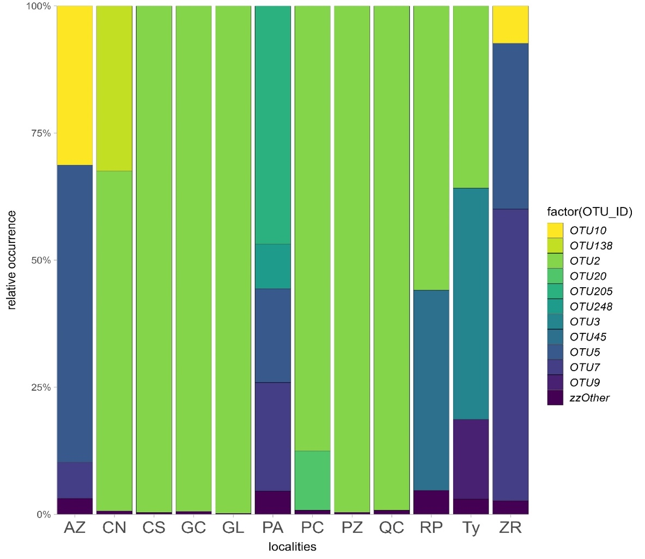
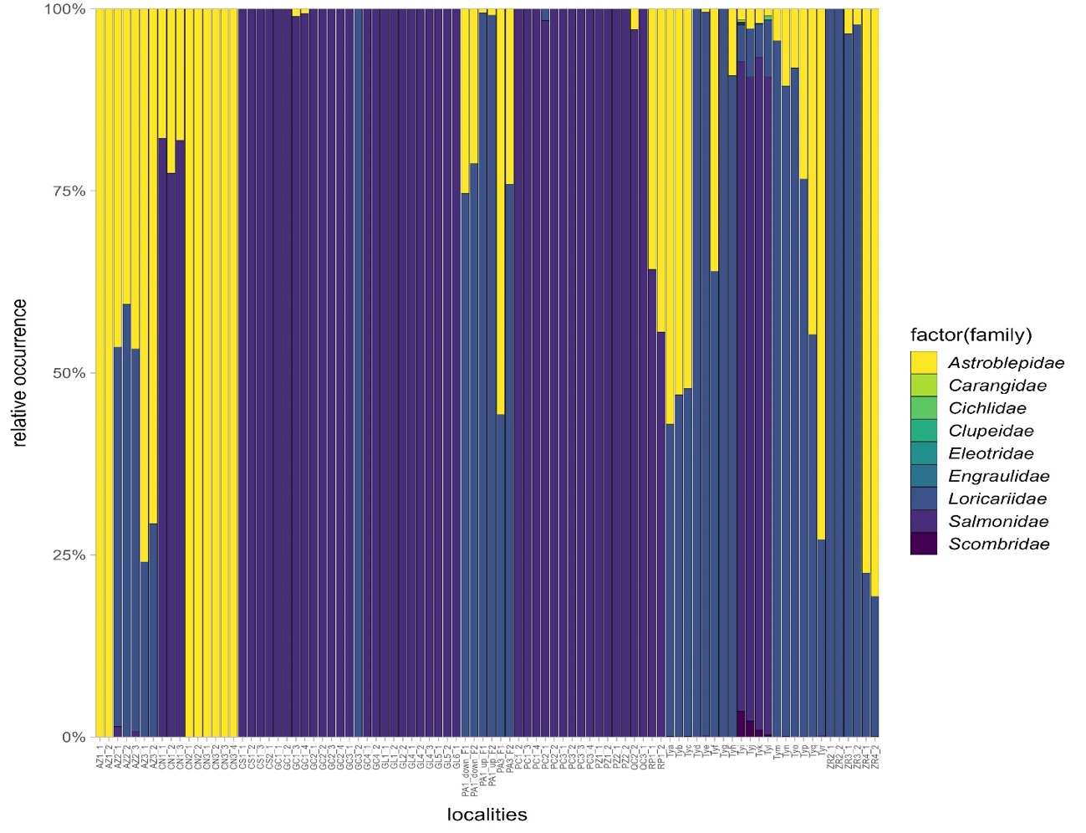.
C
B
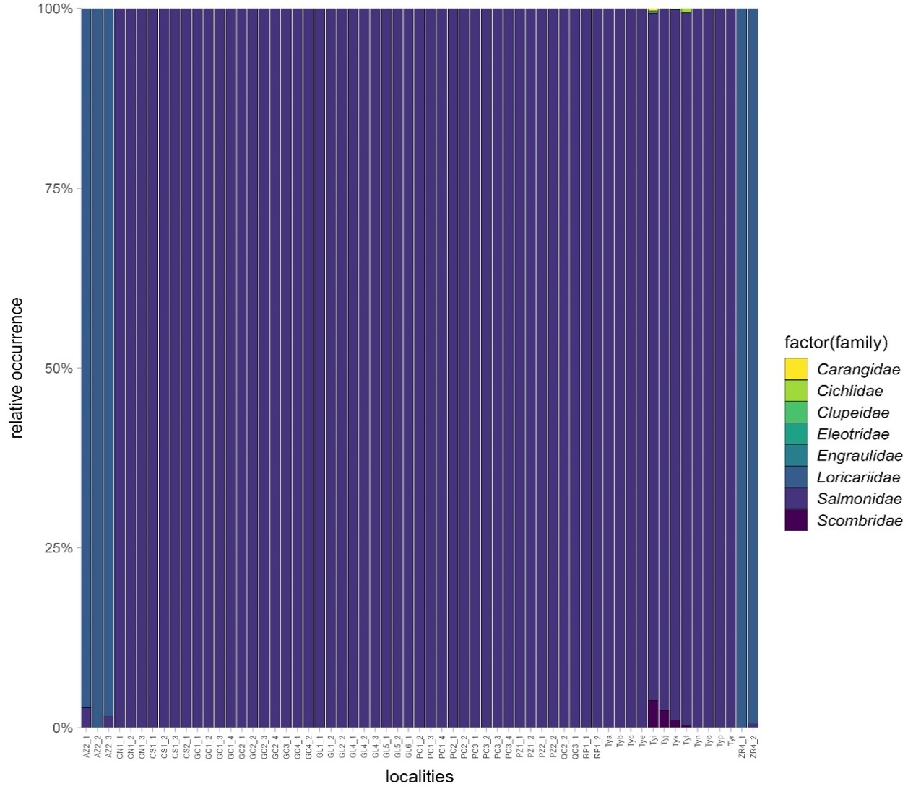
Figure S3. Saturation curves of MiSeq reads for (A) 12S (12S-V5) and (B) 16S (MiAmphi_L). The saturation shows sufficient sequence depth.

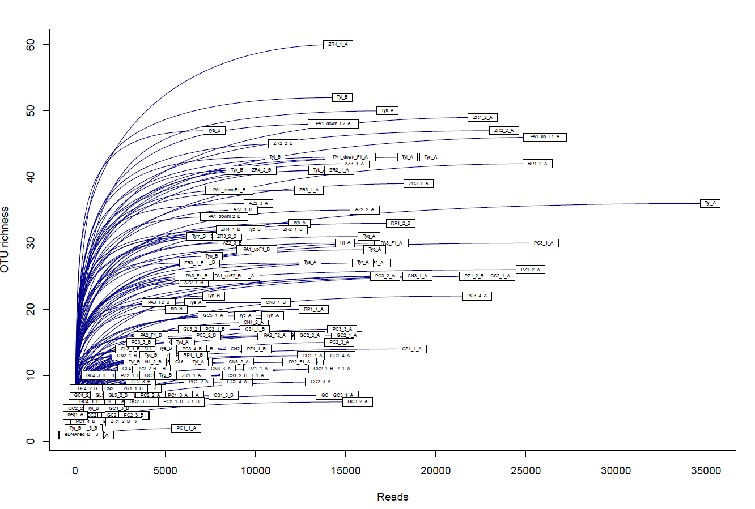
A
B
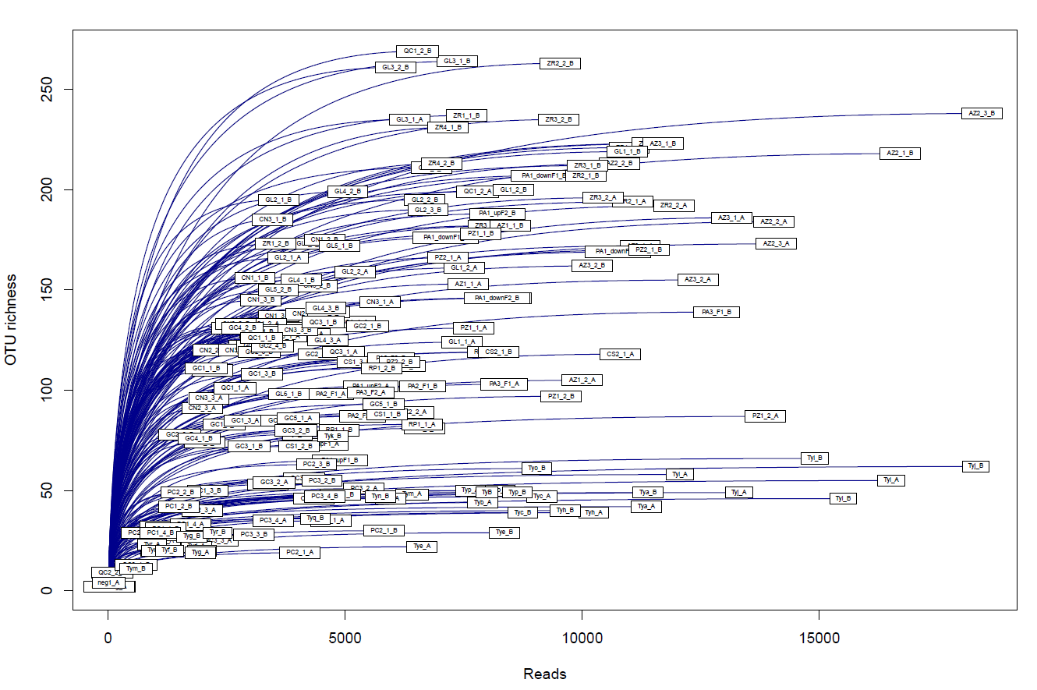

Table S2. Detection of Batrachochytrium dendrobatidis using quantitative PCR (see Methods section). For positive samples, the CT values and quantity in Genomic Equivalents is given.

locality | Cт value | Cт mean | Cт SD | quantity | quantity mean | quantity SD
AZ1.1 | Undetermined
AZ1.1 | Undetermined
AZ1.2 | Undetermined
AZ1.2 | Undetermined
AZ2.1 | Undetermined
AZ2.1 | Undetermined
AZ2.2 | 37.42240906 | 37.510498 | 0.12457664 | 20.2657547 | 19.15243721 | 1.57446873
AZ2.2 | 37.59858704 | 37.510498 | 0.12457664 | 18.0391197 | 19.15243721 | 1.57446873
AZ2.3 | 40.24267578 | 39.8181992 | 0.60030329 | 3.64863014 | 4.981184006 | 1.8845154
AZ2.3 | 39.39371872 | 39.8181992 | 0.60030329 | 6.31373739 | 4.981184006 | 1.8845154
AZ3.1 | 37.98734665 | 38.0333061 | 0.06499651 | 13.9532661 | 13.54221725 | 0.58131158
AZ3.1 | 38.07926559 | 38.0333061 | 0.06499651 | 13.1311674 | 13.54221725 | 0.58131158
AZ3.2 | 40.54317856 | 40.0807114 | 0.46246719 | 2.57857227 | 4.01996541 | 1.44139314
AZ3.2 | 39.61824417 | 40.0807114 | 0.46246719 | 5.46135855 | 4.01996541 | 1.44139314
CN1.1 | Undetermined
CN1.1 | Undetermined
CN1.2 | 37.14649582 | 38.776825 | 2.30563092 | 24.3178596 | 13.5694437 | 15.2005558
CN1.2 | 40.40715027 | 38.776825 | 2.30563092 | 2.82102752 | 13.5694437 | 15.2005558
CN1.3 | 36.02318954 | 36.7494736 | 1.02711797 | 51.0757065 | 35.31985092 | 22.2821445
CN1.3 | 37.47575378 | 36.7494736 | 1.02711797 | 19.5639954 | 35.31985092 | 22.2821445
CN2.1 | Undetermined
CN2.1 | Undetermined
CN2.2 | Undetermined
CN2.2 | Undetermined
CN2.3 | Undetermined
CN2.3 | Undetermined
CN3.1 | Undetermined
CN3.1 | Undetermined
CN3.2 | Undetermined
CN3.2 | Undetermined
CN3.3 | Undetermined
CN3.3 | Undetermined
CN3.4 | Undetermined
CN3.4 | Undetermined
CS1.1 | Undetermined
CS1.1 | Undetermined
CS1.2 | Undetermined
CS1.2 | Undetermined
CS1.3 | Undetermined
CS1.3 | Undetermined
CS2.1 | Undetermined
CS2.1 | Undetermined
field negative control | Undetermined
field negative control | Undetermined
GC1.1 | Undetermined
GC1.1 | Undetermined
GC1.2 | Undetermined
GC1.2 | Undetermined
GC1.3 | Undetermined
GC1.3 | Undetermined
GC1.4 | Undetermined
GC1.4 | Undetermined
GC2.1 | 37.72372437 | 38.0675011 | 0.48617369 | 18.5681038 | 15.23874283 | 4.70842791
GC2.1 | 38.41127777 | 38.0675011 | 0.48617369 | 11.9093809 | 15.23874283 | 4.70842791
GC2.2 | Undetermined
GC2.2 | Undetermined
GC2.3 | Undetermined
GC2.3 | Undetermined
GC2.4 | 40.47156525 | 40.2713318 | 0.28317016 | 2.70349741 | 3.112886429 | 0.57896334
GC2.4 | 40.07110214 | 40.2713318 | 0.28317016 | 3.52227521 | 3.112886429 | 0.57896334
GC3.1 | 37.29946136 | 37.5795212 | 0.3960644 | 21.9805126 | 18.58133125 | 4.80716848
GC3.1 | 37.85958099 | 37.5795212 | 0.3960644 | 15.1821499 | 18.58133125 | 4.80716848
GC3.2 | 36.474823 | 36.4123497 | 0.08835059 | 37.8996964 | 39.53027344 | 2.30598164
GC3.2 | 36.3498764 | 36.4123497 | 0.08835059 | 41.1608467 | 39.53027344 | 2.30598164
GC4.1 | Undetermined
GC4.1 | Undetermined
GC4.2 | Undetermined
GC4.2 | Undetermined
GL1.1 | Undetermined
GL1.1 | Undetermined
GL1.2 | Undetermined
GL1.2 | Undetermined
Gl2.1 | Undetermined
Gl2.1 | Undetermined
GL2.2 | Undetermined
GL2.2 | Undetermined
GL2.3 | Undetermined
GL2.3 | Undetermined
GL3.1 | Undetermined
GL3.1 | Undetermined
GL3.2 | Undetermined
GL3.2 | Undetermined
GL4.1 | Undetermined
GL4.1 | Undetermined
GL4.2 | Undetermined
GL4.2 | Undetermined
GL4.3 | 41.93375778 | 41.9749451 | 0.05824492 | 1.02897942 | 1.001730442 | 0.03853587
GL4.3 | 42.01612854 | 41.9749451 | 0.05824492 | 0.97448146 | 1.001730442 | 0.03853587
GL5.1 | Undetermined
GL5.1 | Undetermined
GL5.2 | Undetermined
GL5.2 | Undetermined
GL6.1 | Undetermined
GL6.1 | Undetermined
negative_control_1 | Undetermined
negative_control_1 | Undetermined
negative_control_2 | Undetermined
negative_control_2 | Undetermined
PA1down F1 | 33.27842712 | 33.1983185 | 0.11328803 | 313.124634 | 330.6044006 | 24.7201233
PA1down F1 | 33.11821365 | 33.1983185 | 0.11328803 | 348.084167 | 330.6044006 | 24.7201233
PA1down F2 | 30.83517647 | 30.7022018 | 0.18805587 | 1572.94312 | 1724.006348 | 213.63559
PA1down F2 | 30.56922531 | 30.7022018 | 0.18805587 | 1875.06946 | 1724.006348 | 213.63559
PA1up F1 | Undetermined
PA1up F1 | Undetermined
PA1up F2 | 34.74259186 | 34.5560684 | 0.26378667 | 119.023331 | 135.6554565 | 23.5213776
PA1up F2 | 34.36954117 | 34.5560684 | 0.26378667 | 152.287582 | 135.6554565 | 23.5213776
PA2 F1 | Undetermined
PA2 F1 | Undetermined
PA2 F2 | 38.49341202 | 38.6737671 | 0.99767923 | 9.98803616 | 10.11112976 | 4.81103086
PA2 F2 | 37.96985245 | 38.6737671 | 0.99767923 | 14.1154642 | 10.11112976 | 4.81103086
PA3 F1 | 38.39548111 | 38.8683643 | 0.47288322 | 12.0315228 | 8.868071079 | 3.16345167
PA3 F1 | 39.34124756 | 38.8683643 | 0.47288322 | 5.70461941 | 8.868071079 | 3.16345167
PA3 F2 | 38.81372452 | 38.2306747 | 0.8245542 | 8.08311749 | 12.77357864 | 6.63331461
PA3 F2 | 37.64762878 | 38.2306747 | 0.8245542 | 17.4640408 | 12.77357864 | 6.63331461
PC1.1 | Undetermined
PC1.1 | Undetermined
PC1.2 | Undetermined
PC1.2 | Undetermined
PC1.3 | Undetermined
PC1.3 | Undetermined
PC1.4 | Undetermined
PC1.4 | Undetermined
PC2.1 | Undetermined
PC2.1 | Undetermined
PC2.2 | Undetermined
PC2.2 | Undetermined
PC2.3 | Undetermined
PC2.3 | Undetermined
PC3.1 | Undetermined
PC3.1 | Undetermined
PC3.2 | Undetermined
PC3.2 | Undetermined
PC3.3 | Undetermined
PC3.3 | Undetermined
PC3.4 | Undetermined
PC3.4 | Undetermined
positive_control_1 | 31.92325401 | 32.0819054 | 0.22436824 | 766.534058 | 694.0543213 | 102.501823
positive_control_1 | 32.24055862 | 32.0819054 | 0.22436824 | 621.574585 | 694.0543213 | 102.501823
positive_control_2 | 28.36338043 | 28.0873871 | 0.39031354 | 7845.32471 | 9525.769531 | 2376.5083
positive_control_2 | 27.81139374 | 28.0873871 | 0.39031354 | 11206.2148 | 9525.769531 | 2376.5083
PZ1.1 | Undetermined
PZ1.1 | Undetermined
PZ1.2 | Undetermined
PZ1.2 | Undetermined
PZ2.1 | Undetermined
PZ2.1 | Undetermined
PZ2.2 | Undetermined
PZ2.2 | Undetermined
QC1.1 | Undetermined
QC1.1 | Undetermined
QC1.2 | Undetermined
QC1.2 | Undetermined
QC2.2 | Undetermined
QC2.2 | Undetermined
QC2.2 | Undetermined
QC2.2 | Undetermined
QC3.1 | Undetermined
QC3.1 | Undetermined
RP1.1 | Undetermined
RP1.1 | Undetermined
RP1.2 | Undetermined
RP1.2 | Undetermined
TYa | Undetermined
TYa | Undetermined
TYb | Undetermined
TYb | Undetermined
TYc | 36.12215424 | 36.5639343 | 0.62476867 | 47.8432121 | 37.26567078 | 14.9588995
TYc | 37.0057106 | 36.5639343 | 0.62476867 | 26.6881332 | 37.26567078 | 14.9588995
TYd | Undetermined
TYd | Undetermined
TYe | Undetermined
TYe | Undetermined
TYf | 38.13918304 | 37.9696426 | 0.23976365 | 12.6215401 | 14.20604515 | 2.24082923
TYf | 37.80010605 | 37.9696426 | 0.23976365 | 15.7905512 | 14.20604515 | 2.24082923
TYg | 40.59086227 | 40.153801 | 0.61809534 | 2.49860907 | 3.474984646 | 1.38080359
TYg | 39.71674347 | 40.153801 | 0.61809534 | 4.45136023 | 3.474984646 | 1.38080359
TYh | 39.51967621 | 39.4326153 | 0.08706093 | 5.07029819 | 5.791775703 | 0.72147751
TYh | 39.34555435 | 39.4326153 | 0.08706093 | 6.51325321 | 5.791775703 | 0.72147751
TYi | 37.59116364 | 37.5756683 | 0.02191366 | 20.2280769 | 20.43258095 | 0.28921235
TYi | 37.56017303 | 37.5756683 | 0.02191366 | 20.637085 | 20.43258095 | 0.28921235
TYj | Undetermined
TYj | Undetermined
TYk | 37.93104935 | 38.6536026 | 1.02184463 | 16.2407837 | 11.3132782 | 6.96854591
TYk | 39.37615585 | 38.6536026 | 1.02184463 | 6.38577175 | 11.3132782 | 6.96854591
TYl | Undetermined
TYl | Undetermined
TYm | Undetermined
TYm | Undetermined
TYn | Undetermined
TYn | Undetermined
TYo | 38.03572464 | 37.6322174 | 0.57064271 | 13.5143671 | 18.27330017 | 6.73014688
TYo | 37.22871399 | 37.6322174 | 0.57064271 | 23.0322323 | 18.27330017 | 6.73014688
TYp | 38.93077469 | 38.8178329 | 0.15972105 | 7.4816246 | 8.083646774 | 0.85138792
TYp | 38.70489502 | 38.8178329 | 0.15972105 | 8.68566895 | 8.083646774 | 0.85138792
TYq | 40.03094482 | 39.7297363 | 0.42597044 | 3.61696959 | 4.500973701 | 1.25017023
TYq | 39.42853165 | 39.7297363 | 0.42597044 | 5.38497734 | 4.500973701 | 1.25017023
TYr | Undetermined
TYr | Undetermined
ZR1.1 | Undetermined
ZR1.1 | Undetermined
ZR1.2 | Undetermined
ZR1.2 | Undetermined
ZR2.1 | 40.25336075 | 39.8544197 | 0.56418782 | 3.12270713 | 4.206334114 | 1.53248012
ZR2.1 | 39.45547867 | 39.8544197 | 0.56418782 | 5.28996134 | 4.206334114 | 1.53248012
ZR2.2 | Undetermined
ZR2.2 | Undetermined
ZR3.1 | 38.39191437 | 38.1915207 | 0.28339946 | 10.6807299 | 12.29959679 | 2.28942299
ZR3.1 | 37.99112701 | 38.1915207 | 0.28339946 | 13.9184628 | 12.29959679 | 2.28942299
ZR3.2 | Undetermined
ZR3.2 | Undetermined
ZR4.1 | Undetermined
ZR4.1 | Undetermined
ZR4.2 | Undetermined
ZR4.2 | Undetermined

