Electronic supplementary materials
Title:
Transcriptome analysis revealed stress responsive fusion transcripts in Chickpea (Cicer arietinum)
Journal name:
Journal of Plant Research
Authors:
Fiza Hamid¹, Shafaque Zahra², and Shailesh Kumar^{1,#}
¹Bioinformatics Lab, National Institute of Plant Genome Research, Aruna Asaf Ali Marg, New Delhi 110067, India.
²Department of Pathology, School of Medicine, University of Virginia, Charlottesville, VA 22908, USA.
#Corresponding author
Shailesh Kumar
Scientist, National Institute of Plant Genome Research (NIPGR), Aruna Asaf Ali Marg, New Delhi 110067, India. Tel: +91-11-26735217, Fax: +91-11-26741658
Email: shailesh@nipgr.ac.in
ORCID ID: https://orcid.org/0000-0002-1872-9903

Supplementary Information
Supplementary figures
Fig. S1. Chromatogram of validated fusion transcripts from chickpea, where black lines mark the junction sites between the two fusion genes.
Fig. S2. Box plot depicting the relation between the predicted length of fusion transcripts and their parental genes.
Fig. S3. Inter-specific conserved fusion events. a) Venn diagram showing orthologous fusion events shared between Cicer arietinum and Arabidopsis thaliana, b-d) Gene Ontology (GO) enrichment analysis of orthologous fusion gene pairs, highlighting enriched categories in b) Molecular Function, c) Biological Process, and d) Cellular Component.
Fig. S4. Relative expression of validated fusion transcripts in Cicer arietinum across different tissues.
Fig. S5. Benchmark analysis of fusion detection tools using in-house generated RNA-seq data and publicly available RNA-seq data from chickpea. (a) Sensitivity of fusion detection tools evaluated for both datasets, calculated as Sensitivity (%) = (TP/TF) * 100, where TP represents true positives and TF is the total number of fusions. (b) F-measure for each tool, calculated as F-measure = 2 * (Sensitivity * PPV) / (Sensitivity + PPV), where PPV (positive predictive value) = TP / (TP + FP). (c-d) Venn diagrams showing the overlapping fusion transcripts identified by different fusion detection tools in the in-house generated RNA-seq data (c) and the publicly available RNA-seq data (d), highlighting common fusions across the tools. The performance metrics (sensitivity, specificity, and F-measure) were calculated based on the identification of validated fusion transcripts (true fusions) across all tools.
Supplementary tables
Table S1. Summary of RNA-Seq reads and mapping statistics.
Table S2. Summary of the number of fusion transcripts detected in each sample by three fusion detection methods and the sequencing depth of each sample.
Table S3. List of fusion transcripts detected in RNA-Seq samples.
Table S4. Information regarding Short homologous sequences (SHSs) detected at the junction of the fusion transcript.
Table S5. List of fusion transcripts detected in Long-read RNA-Seq data.
Table S6. List of RNA-Seq samples used to study intra-specific diversity of fusion transcripts.
Table S7. List of primers used for validation of fusion transcripts.
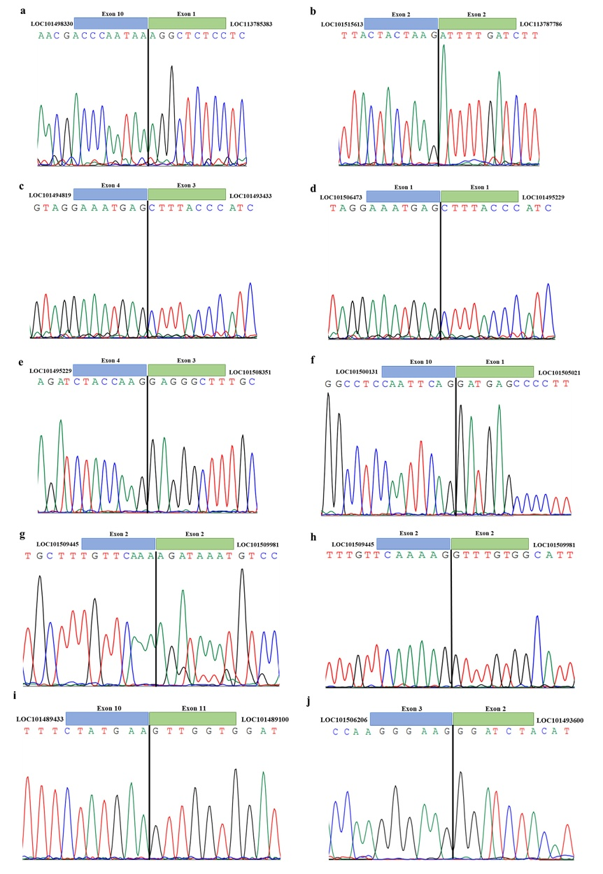
Fig. S1 Chromatogram of validated fusion transcripts from chickpea, where black lines mark the junction sites between the two fusion genes

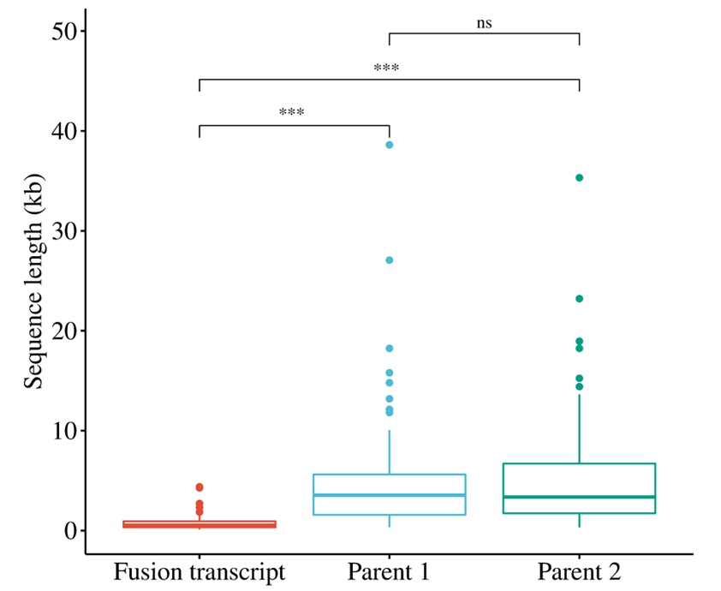
Fig. S2 Box plot depicting the relation between the predicted length of fusion transcripts and their parental genes
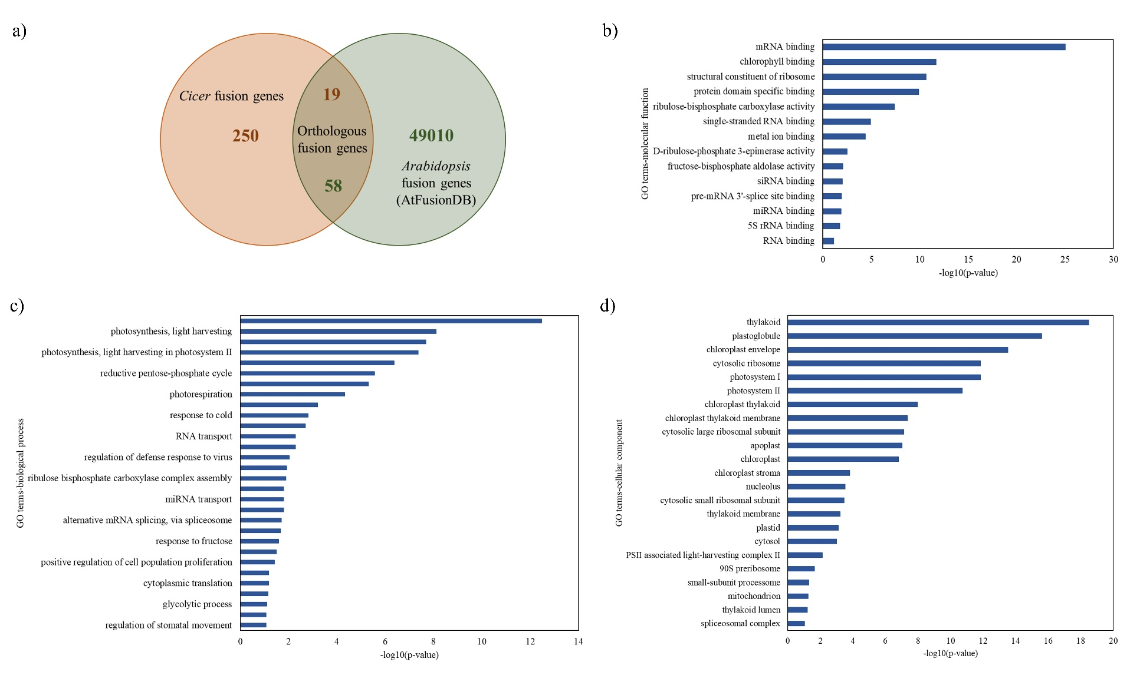
Fig. S3 Inter-specific conserved fusion events. a) Venn diagram showing orthologous fusion events shared between Cicer arietinum and Arabidopsis thaliana. b-d) Gene Ontology (GO) enrichment analysis of orthologous fusion gene pairs, highlighting enriched categories in b) Molecular Function, c) Biological Process, and d) Cellular Component
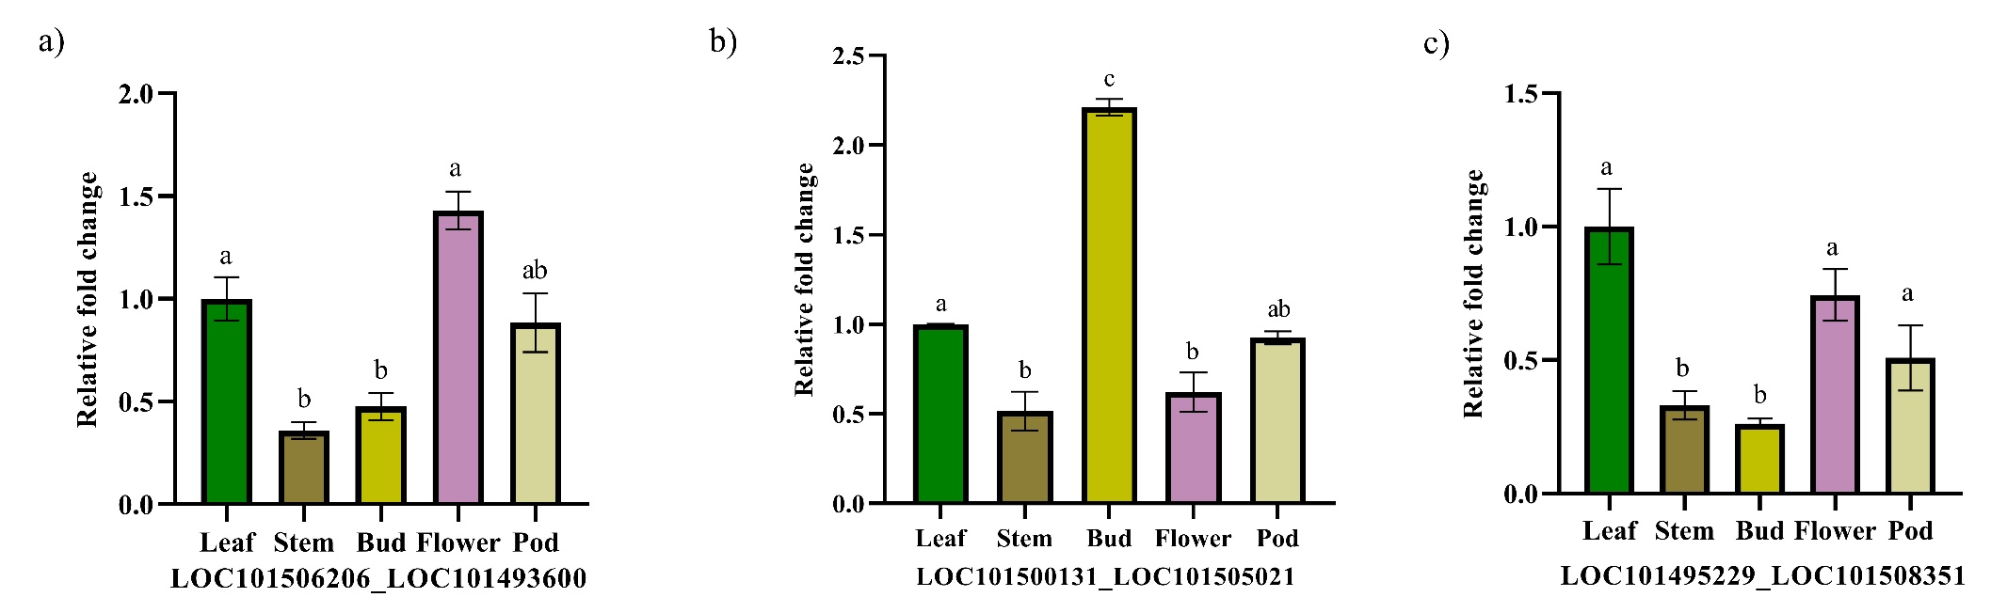
Fig. S4 Relative expression of validated fusion transcripts in Cicer arietinum across different tissues
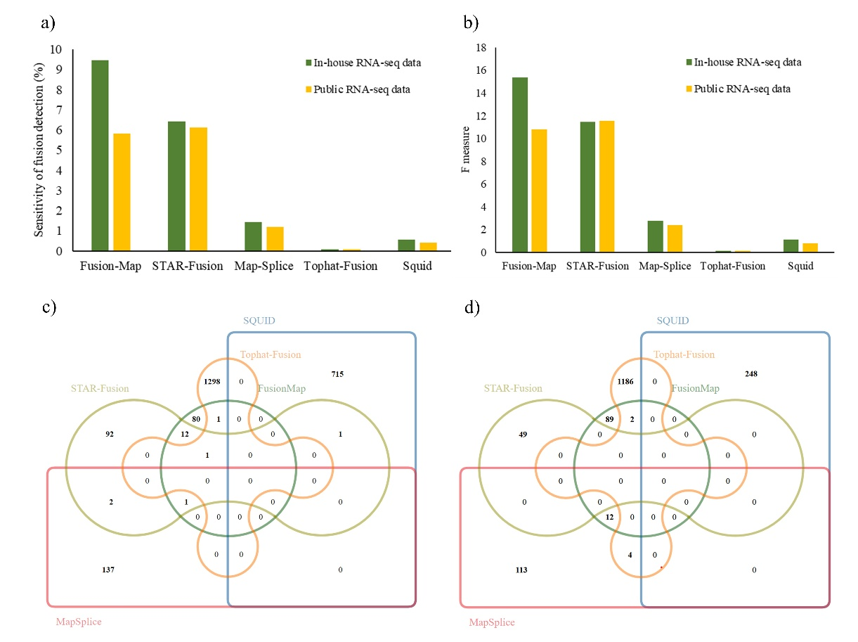
Fig. S5 Benchmark analysis of fusion detection tools using in-house generated RNA-seq data and publicly available RNA-seq data from chickpea. (a) Sensitivity of fusion detection tools evaluated for both datasets, calculated as Sensitivity (%) = (TP/TF) * 100, where TP represents true positives and TF is the total number of fusions. (b) F-measure for each tool, calculated as F measure = 2 * (Sensitivity * PPV) / (Sensitivity + PPV), where PPV (positive predictive value) = TP / (TP + FP). (c-d) Venn diagrams showing the overlapping fusion transcripts identified by different fusion detection tools in the in-house generated RNA-seq data (c) and the publicly available RNA-seq data, (d) highlighting common fusions across the tools. The performance metrics (sensitivity, specificity, and F-measure) were calculated based on the identification of validated fusion transcripts (true fusions) across all tools
Table S1. Summary of RNA-Seq reads and mapping statistics.
Sample ID | Description | Total reads before filtering | Total bases before filtering | Total reads after filtering | Total bases after filtering | Overall mapping rate
B1 | bud1 | 32.097466 M | 4.814620 G | 31.798002 M | 4.665035 G | 97.38%
B2 | bud2 | 39.589018 M | 5.938353 G | 39.274374 M | 5.783985 G | 97.75%
B3 | bud3 | 32.111594 M | 4.848851 G | 31.439312 M | 4.405996 G | 96.60%
CD1 | control drought1 | 35.675820 M | 5.387049 G | 35.379608 M | 5.106564 G | 96.89%
CD2 | control drought2 | 35.155350 M | 5.308458 G | 34.895670 M | 4.974223 G | 97.01%
CD3 | control drought3 | 35.272586 M | 5.290888 G | 35.040190 M | 5.186991 G | 95.31%
CS1 | control salt1 | 28.409916 M | 4.289897 G | 28.088466 M | 3.974790 G | 96.99%
CS2 | control salt2 | 23.759012 M | 3.587611 G | 23.537146 M | 3.350033 G | 96.77%
CS3 | control salt3 | 34.412248 M | 5.161837 G | 34.053352 M | 5.022196 G | 97.47%
D1 | drought1 | 29.990286 M | 4.498543 G | 29.663260 M | 4.377915 G | 97.52%
D2 | drought2 | 30.762700 M | 4.614405 G | 30.452014 M | 4.511143 G | 97.29%
D3 | drought3 | 32.090942 M | 4.813641 G | 31.633712 M | 4.665287 G | 97.05%
F1 | flower1 | 28.445162 M | 4.266774 G | 28.235434 M | 4.132264 G | 97.36%
F2 | flower2 | 35.872482 M | 5.380872 G | 35.545986 M | 5.204315 G | 95.22%
F3 | flower3 | 31.034542 M | 4.686216 G | 30.524134 M | 4.104437 G | 96.30%
L1 | leaf1 | 27.014486 M | 4.052173 G | 26.794922 M | 3.946489 G | 97.63%
L2 | leaf2 | 32.510794 M | 4.876619 G | 32.231424 M | 4.758872 G | 97.40%
P1 | pod1 | 34.432722 M | 5.199341 G | 34.013796 M | 4.835398 G | 96.94%
P2 | pod2 | 40.797534 M | 6.160428 G | 40.427928 M | 5.746738 G | 96.20%
P3 | pod3 | 38.289934 M | 5.781780 G | 37.990414 M | 5.443072 G | 97.04%
S1 | salt1 | 25.885696 M | 3.882854 G | 25.594944 M | 3.796070 G | 97.47%
S2 | salt2 | 37.785730 M | 5.705645 G | 37.232842 M | 5.148091 G | 96.98%
S3 | salt3 | 24.385190 M | 3.682164 G | 24.004768 M | 3.304218 G | 97.14%
ST1 | stem1 | 41.337854 M | 6.242016 G | 40.896440 M | 5.510618 G | 96.93%
ST2 | stem2 | 39.581018 M | 5.976734 G | 38.907446 M | 5.553084 G | 96.96%
ST3 | stem3 | 35.630652 M | 5.380228 G | 35.153606 M | 4.967206 G | 97.07%

Table S2. Summary of the number of fusion transcripts detected in each sample by three fusion detection methods and sequencing depth of each sample.
Sample | Description | Sequencing depth | FusionMap | STAR-Fusion | MapSplice
B1 | bud1 | 8.788686888 | 21 | 33 | 19
B2 | bud2 | 10.89673135 | 22 | 33 | 19
B3 | bud3 | 8.300670686 | 19 | 29 | 14
CD1 | control drought1 | 9.620504898 | 23 | 30 | 35
CD2 | control drought2 | 9.371181236 | 24 | 29 | 20
CD3 | control drought3 | 9.772025245 | 27 | 33 | 19
CS1 | control salt1 | 7.488300678 | 14 | 26 | 16
CS2 | control salt2 | 6.311290505 | 18 | 22 | 15
CS3 | control salt3 | 9.46155991 | 20 | 25 | 18
D1 | drought1 | 8.247767521 | 17 | 21 | 14
D2 | drought2 | 8.498762246 | 17 | 23 | 12
D3 | drought3 | 8.789161643 | 14 | 25 | 17
F1 | flower1 | 7.784973625 | 18 | 30 | 18
F2 | flower2 | 9.804662773 | 26 | 26 | 18
F3 | flower3 | 7.732548983 | 17 | 23 | 11
L1 | leaf1 | 7.434983044 | 20 | 28 | 22
L2 | leaf2 | 8.965470987 | 26 | 24 | 26
P1 | pod1 | 9.10964205 | 16 | 31 | 30
P2 | pod2 | 10.82655991 | 24 | 28 | 30
P3 | pod3 | 10.25446873 | 25 | 42 | 31
S1 | salt1 | 7.151601356 | 15 | 20 | 17
S2 | salt2 | 9.698739638 | 19 | 26 | 20
S3 | salt3 | 6.224977393 | 17 | 22 | 14
ST1 | stem1 | 10.38172193 | 21 | 32 | 21
ST2 | stem2 | 10.4617257 | 19 | 33 | 35
ST3 | stem3 | 9.357961567 | 20 | 27 | 22
Total fusion detected |  |  | 496 | 721 | 533
No. of unique FTs |  |  | 95 | 109 | 140

Table S3. List of fusion transcripts detected in RNA-Seq samples.
Chromosome 1 | Breakpoint 1 | Strand 1 | Chromosome 2 | Breakpoint 2 | Strand 2 | Gene 1 | Gene 2 | Splice site location
2 | 2062657 | - | 3 | 36308938 | + | LOC101494223 | LOC101504783 | None
2 | 23931340 | + | NW_004517187.1 | 5631 | + | LOC101512687 | LOC101503191 | Both
2 | 23933574 | + | NW_004517187.1 | 5631 | + | LOC101512687 | LOC101503191 | Both
2 | 23933994 | + | NW_004517187.1 | 5631 | + | LOC101512687 | LOC101503191 | None_Exon
2 | 247417 | + | 2 | 29700242 | + | LOC101499528 | LOC101494120 | None
2 | 247417 | + | 6 | 1116301 | - | LOC101499528 | LOC101512000 | None
2 | 247461 | - | 2 | 257539 | + | LOC101499528 | LOC105851539 | None
2 | 25534571 | - | 7 | 22344920 | - | LOC113785449 | LOC101494531 | None
2 | 257048 | + | 6 | 1116319 | - | LOC105851539 | LOC101512000 | None
2 | 257066 | + | 2 | 29700242 | + | LOC105851539 | LOC101494120 | None
2 | 257066 | + | 6 | 1116301 | - | LOC105851539 | LOC101512000 | None
2 | 30028516 | + | 4 | 11451527 | + | LOC101504009 | LOC101493413 | None
2 | 30144899 | - | 4 | 2023971 | + | LOC101511831 | LOC101502954 | None
2 | 30744589 | - | 7 | 13555156 | - | LOC101504980 | LOC101509554 | None
2 | 30965639 | - | 3 | 34452352 | - | LOC101514211 | LOC101508956 | None
2 | 31356943 | + | 3 | 39264029 | - | LOC101493912 | LOC101496628 | None_Exon
2 | 31358189 | + | 3 | 21635029 | - | LOC101493912 | LOC101509484 | None_Exon
2 | 31358189 | + | 3 | 21635586 | - | LOC101493912 | LOC101509484 | None_Exon
2 | 3343313 | - | 6 | 14022203 | + | LOC101514962 | LOC101496011 | None
2 | 3343375 | + | 6 | 14022305 | - | LOC101514962 | LOC101496011 | None
2 | 3343694 | - | 6 | 14021908 | + | LOC101514962 | LOC101496011 | None
2 | 3343711 | + | 6 | 14021889 | - | LOC101514962 | LOC101496011 | None
1 | 13497308 | + | 2 | 30479154 | + | LOC101510411 | LOC101495619 | None
2 | 34908711 | + | 2 | 34943519 | + | LOC113785512 | LOC101497027 | Both
2 | 35441273 | + | 4 | 40170427 | + | LOC101506059 | LOC101500851 | Both
2 | 36051172 | + | 2 | 3642870 | - | LOC101505628 | LOC101495178 | None
2 | 6229425 | - | 1 | 32602422 | - | LOC101498330 | LOC113785383 | None
2 | 6381127 | - | 5 | 45803311 | + | LOC101499938 | LOC101503085 | None
2 | 6381228 | + | 2 | 36191405 | - | LOC101499938 | LOC101514326 | None
2 | 6414031 | + | 7 | 13670917 | + | LOC101501330 | LOC101512251 | None
2 | 7569350 | + | 7 | 18818298 | - | LOC101501648 | LOC101499935 | Exon_None
2 | 7668307 | - | 6 | 1932646 | - | LOC101502810 | LOC101511778 | None
2 | 7668365 | - | 4 | 14069897 | - | LOC101502810 | LOC101507074 | None
2 | 7668383 | - | 4 | 11451540 | + | LOC101502810 | LOC101493413 | None
2 | 7668387 | - | 6 | 19726142 | - | LOC101502810 | LOC101494085 | None
2 | 7668504 | - | 1 | 6097477 | + | LOC101502810 | LOC101494711 | None
2 | 7668518 | - | 8 | 13248333 | - | LOC101502810 | LOC101495739 | None
2 | 8273513 | - | 6 | 9515613 | + | LOC101494112 | UBQ5 | None
2 | 8294351 | - | 6 | 23393185 | + | LOC101494736 | LOC101489111 | None
2 | 8295603 | - | 6 | 23393179 | + | LOC101494736 | LOC101489111 | Exon_None
3 | 16533516 | + | 1 | 2538836 | + | LOC101501345 | LOC101500252 | None_Exon
3 | 23900664 | - | 2 | 8516622 | - | LOC101506274 | LOC101501235 | None_Exon
3 | 26932908 | - | 5 | 33690951 | + | LOC101491644 | LOC101505889 | None
3 | 27404363 | + | 8 | 5439100 | + | LOC101508430 | LOC101515298 | None
3 | 27784879 | - | 3 | 34452357 | - | LOC101497592 | LOC101508956 | None
3 | 27845438 | - | 2 | 27608496 | + | LOC101498915 | LOC101509145 | Exon_None
3 | 27956976 | + | 3 | 31303423 | + | LOC101501673 | LOC101515202 | None
3 | 28523480 | + | 7 | 40734451 | - | LOC101501261 | LOC101510205 | None
3 | 2879883 | - | 1 | 6097564 | + | LOC101491737 | LOC101494711 | None
1 | 16466208 | + | 6 | 14021894 | - | LOC101499819 | LOC101496011 | None
3 | 28995363 | - | 3 | 29007310 | - | LOC101489274 | LOC101489596 | None
3 | 29226306 | + | 2 | 24651696 | + | LOC105851812 | LOC113785432 | Exon_None
1 | 16466254 | + | 6 | 14021848 | - | LOC101499819 | LOC101496011 | None
3 | 31623291 | + | 2 | 31359283 | + | LOC101501466 | LOC101493912 | Exon_None
3 | 32961388 | - | 6 | 19735634 | + | LOC101493176 | LOC101504207 | None
3 | 34502846 | + | NW_004522750.1 | 17073 | - | LOC101509269 | LOC101496647 | None
3 | 35829859 | + | 4 | 40170427 | + | LOC101507895 | LOC101500851 | Both
3 | 36712301 | + | 4 | 43532656 | + | LOC101497170 | LOC113786100 | Both
3 | 36712301 | + | 6 | 32237813 | + | LOC101497170 | LOC101514815 | Exon_None
3 | 37683093 | + | NW_004516029.1 | 234017 | - | LOC113785842 | LOC101490259 | Both
3 | 39340361 | + | 3 | 39300069 | + | LOC101501581 | LOC101498254 | Both
3 | 39751662 | - | 5 | 30675509 | - | LOC101499472 | LOC101512214 | None
3 | 39988535 | + | 1 | 958 | - | LOC101506836 | LOC101497325 | None
3 | 6965732 | + | 3 | 6838668 | - | LOC101501663 | LOC101500070 | None
3 | 974327 | + | 1 | 3266649 | + | LOC113785863 | LOC101504403 | None
4 | 11378175 | + | 4 | 45752819 | + | LOC101488621 | LOC101509617 | Both
4 | 11724007 | + | 6 | 58255084 | + | LOC101500209 | LOC101506557 | None
4 | 11724046 | + | 3 | 26933074 | - | LOC101500209 | LOC101491644 | None
4 | 11724046 | + | 7 | 1701609 | - | LOC101500209 | LOC101501730 | None
4 | 11724079 | + | 5 | 32966992 | + | LOC101500209 | LOC101494179 | None
4 | 11724100 | + | 7 | 1701549 | - | LOC101500209 | LOC101501730 | None
4 | 11724100 | + | 7 | 19767875 | - | LOC101500209 | LOC101508402 | None
4 | 11724136 | + | 6 | 58265166 | + | LOC101500209 | LOC101506890 | None
4 | 12293362 | + | 7 | 9049790 | - | LOC101492195 | LOC101502286 | None
4 | 13765589 | + | 8 | 617853 | - | LOC101493738 | LOC101511091 | Exon_None
4 | 14069724 | + | 4 | 14083803 | - | LOC101507074 | LOC101506406 | None
4 | 14069750 | - | 4 | 14088744 | - | LOC101507074 | LOC113786294 | None
4 | 15076791 | + | 4 | 15070272 | + | LOC101515546 | LOC101515223 | None
4 | 15076792 | + | 4 | 15070273 | + | LOC101515546 | LOC101515223 | None
4 | 15076793 | + | 4 | 15070274 | + | LOC101515546 | LOC101515223 | None
4 | 15076794 | + | 4 | 15070275 | + | LOC101515546 | LOC101515223 | None
4 | 15076796 | + | 4 | 15070277 | + | LOC101515546 | LOC101515223 | None
4 | 1561884 | - | 6 | 58273105 | + | LOC101513777 | LOC101507444 | None
1 | 186719 | + | 1 | 46532096 | - | LOC101494203 | LOC101497567 | Both
4 | 16278431 | - | 3 | 34452360 | - | LOC101499877 | LOC101508956 | None
4 | 19020149 | + | 3 | 26295288 | - | LOC105851910 | LOC101493610 | None
4 | 19020392 | + | 4 | 43479567 | - | LOC105851910 | LOC101507919 | None
4 | 22375531 | - | 2 | 36191301 | - | LOC101489622 | LOC101514326 | None
4 | 25254569 | - | 4 | 25286975 | - | LOC101508452 | LOC101508756 | Both
4 | 2556967 | - | 1 | 10690149 | + | LOC101494047 | LOC101500372 | None
4 | 2734712 | + | 4 | 2703638 | + | LOC101514244 | LOC101513258 | Exon_None
4 | 30334555 | + | 3 | 5554464 | - | LOC101509942 | LOC101511513 | None
4 | 30334557 | + | 3 | 5554462 | - | LOC101509942 | LOC101511513 | None
4 | 31553202 | + | 6 | 10453276 | + | LOC101493097 | LOC101515132 | None
1 | 22131631 | - | NW_004516527.1 | 525194 | + | LOC105852588 | LOC101501045 | Both
4 | 37722642 | + | 3 | 35294187 | - | LOC101496964 | LOC101515087 | None
4 | 3793903 | + | 4 | 3765761 | + | LOC101501044 | LOC101500197 | None
4 | 38611709 | - | 8 | 61086 | + | LOC101495550 | LOC101512264 | Both
4 | 38830108 | + | 2 | 9727681 | - | LOC101499888 | LOC101494958 | Both
4 | 40168610 | - | 4 | 40204933 | - | LOC101501181 | LOC101499889 | Exon_None
4 | 43441474 | - | 3 | 27878275 | - | LOC113786305 | LOC101499238 | None
4 | 43891185 | + | 2 | 34245685 | + | LOC101494477 | LOC101506259 | None
4 | 46430084 | + | 5 | 36666746 | + | LOC101502456 | LOC101512740 | Both
4 | 4705896 | - | 3 | 2926665 | + | LOC101513360 | LOC101493155 | Exon_None
1 | 24450273 | + | 6 | 7679368 | - | LOC101490106 | LOC101489323 | Both
1 | 24450273 | + | 6 | 7679791 | - | LOC101490106 | LOC101489323 | Exon_None
4 | 8666491 | + | 4 | 8648457 | + | LOC101496750 | LOC101494893 | None_Exon
4 | 8807367 | - | 4 | 33619832 | + | LOC101501591 | LOC113786381 | Both
4 | 8807367 | - | 4 | 33620013 | + | LOC101501591 | LOC113786381 | Both
4 | 887192 | + | 3 | 12123321 | + | LOC101491017 | LOC105851751 | None
5 | 11997177 | + | 6 | 15450781 | - | LOC101504067 | LOC113787067 | None_Exon
5 | 17855071 | - | 6 | 24426206 | - | LOC101508763 | LOC101501416 | None
1 | 2538887 | + | 3 | 16534249 | + | LOC101500252 | LOC101501345 | None
5 | 20844865 | - | 3 | 33764259 | + | LOC113786767 | LOC101490255 | None_Exon
5 | 28200368 | - | 3 | 34452352 | - | LOC105852166 | LOC101508956 | None
5 | 29232366 | - | 3 | 27403339 | - | LOC101510276 | LOC101508430 | Exon_None
5 | 29989618 | - | 7 | 42739035 | - | LOC101510056 | LOC101489247 | None
5 | 30675522 | - | 4 | 11452274 | + | LOC101512214 | LOC101493413 | None
5 | 30675525 | - | 3 | 34452357 | - | LOC101512214 | LOC101508956 | None
5 | 30675525 | - | 4 | 11452269 | + | LOC101512214 | LOC101493413 | None
5 | 30675525 | - | 4 | 14427147 | - | LOC101512214 | LOC101513370 | None
5 | 30675535 | - | 4 | 11452259 | + | LOC101512214 | LOC101493413 | None
5 | 30675550 | - | 3 | 34452355 | - | LOC101512214 | LOC101508956 | None
5 | 30675569 | - | 2 | 6381354 | + | LOC101512214 | LOC101499938 | None
5 | 30778772 | + | 7 | 7379193 | + | LOC101491250 | LOC101501855 | None
5 | 31137965 | + | 3 | 26294024 | - | LOC101505130 | LOC101493610 | Both
5 | 31763840 | - | NW_004516357.1 | 62137 | + | LOC101503743 | LOC101505762 | None
5 | 31763840 | - | NW_004516357.1 | 62269 | + | LOC101503743 | LOC101505762 | None
1 | 29166793 | - | 4 | 40170427 | + | LOC101500471 | LOC101500851 | None_Exon
1 | 29166793 | - | 4 | 40171855 | + | LOC101500471 | LOC101500851 | None_Exon
5 | 34494770 | - | NW_004522673.1 | 5200 | - | LOC101500660 | LOC101496430 | None
1 | 30270824 | - | 5 | 47196140 | + | LOC101508275 | LOC101507935 | None_Exon
5 | 35496439 | + | 1 | 13567904 | - | LOC101494182 | LOC101497453 | None_Exon
5 | 37640967 | - | 6 | 41564486 | + | LOC101515776 | LOC101509332 | None
5 | 38267287 | - | 5 | 38249972 | + | LOC101489433 | LOC101489100 | Both
5 | 38642983 | - | 5 | 24597010 | - | LOC101497628 | LOC101510928 | Both
5 | 38944371 | + | 6 | 58255059 | + | LOC101509740 | LOC101506557 | None
5 | 38944371 | + | 6 | 58265166 | + | LOC101509740 | LOC101506890 | None
5 | 38944374 | + | 6 | 58265166 | + | LOC101509740 | LOC101506890 | None
5 | 38944377 | + | 7 | 6839572 | - | LOC101509740 | LOC101506791 | None
5 | 38944380 | + | 6 | 24256373 | + | LOC101509740 | LOC101490833 | None
5 | 38944380 | + | 7 | 3226883 | - | LOC101509740 | LOC101510518 | None
5 | 3945958 | + | 3 | 5093174 | - | LOC101509949 | LOC101503913 | Exon_None
5 | 3946715 | + | 3 | 5093174 | - | LOC101509949 | LOC101503913 | None
1 | 329868 | + | 6 | 2636734 | + | LOC101503647 | LOC101512325 | None
5 | 41103222 | - | 2 | 258241 | - | LOC101492998 | LOC105851539 | None
5 | 41103801 | - | 6 | 58265166 | + | LOC101492998 | LOC101506890 | None
5 | 41701939 | + | 5 | 41677974 | + | LOC101502569 | LOC101496222 | Exon_None
5 | 42648080 | + | 5 | 37837157 | - | LOC101504279 | LOC101501389 | None_Exon
5 | 43132228 | - | 8 | 10728746 | - | LOC101506206 | LOC101493600 | None
5 | 43570492 | - | 1 | 3009297 | + | LOC101496223 | LOC101493117 | Both
5 | 43950938 | + | 5 | 43955194 | - | NAC5 | LOC101510394 | Both
5 | 46794716 | + | 6 | 28581336 | - | LOC101500980 | LOC101497772 | Exon_None
5 | 47146708 | + | 5 | 36427842 | - | LOC101506760 | LOC105852198 | Both
5 | 47370173 | + | 7 | 8435144 | + | LOC101515446 | LOC101508805 | None
5 | 47370174 | + | 7 | 8435145 | + | LOC101515446 | LOC101508805 | None
5 | 48062932 | - | NW_004516931.1 | 11085 | - | LOC101514374 | LOC113784864 | Exon_None
5 | 48112776 | + | 8 | 14436328 | + | LOC101488993 | LOC101494865 | Both
6 | 10054855 | + | 3 | 39298057 | + | LOC101502371 | LOC101498254 | None
6 | 10748835 | + | 3 | 38914715 | - | LOC101499602 | LOC113785749 | None_Exon
6 | 1116231 | - | 2 | 29700202 | + | LOC101512000 | LOC101494120 | None
6 | 1116240 | - | 2 | 29700202 | + | LOC101512000 | LOC101494120 | None
6 | 13838946 | - | 5 | 48156966 | - | LOC113787216 | LOC105852223 | None
6 | 14021890 | - | 2 | 36037990 | + | LOC101496011 | LOC101504983 | None
6 | 14021988 | - | 8 | 10698267 | + | LOC101496011 | LOC101504019 | None
6 | 14022019 | - | 2 | 36037861 | + | LOC101496011 | LOC101504983 | None
6 | 14022099 | - | 8 | 10698267 | + | LOC101496011 | LOC101504019 | None
6 | 14022212 | - | 2 | 3343305 | + | LOC101496011 | LOC101514962 | None
6 | 14022288 | + | 8 | 10698275 | - | LOC101496011 | LOC101504019 | None
6 | 14943853 | + | 5 | 43392474 | - | LOC101504391 | LOC101491259 | Exon_None
6 | 15450536 | + | 5 | 11997177 | - | LOC113787067 | LOC101504067 | Exon_None
6 | 15847340 | + | 1 | 1828762 | + | LOC101500129 | LOC113788097 | None_Exon
6 | 15847345 | + | 1 | 1828767 | + | LOC101500129 | LOC113788097 | None
6 | 15847371 | + | 1 | 1829056 | + | LOC101500129 | LOC113788097 | Both
6 | 17031746 | + | 3 | 16534246 | + | LOC101511786 | LOC101501345 | None
6 | 17738439 | + | 6 | 17714024 | + | LOC101506987 | LOC101505574 | None_Exon
6 | 17738537 | + | 6 | 17714024 | + | LOC101506987 | LOC101505574 | None_Exon
6 | 1933217 | + | 7 | 21874916 | + | LOC101511778 | LOC101501434 | None
6 | 1933220 | + | 6 | 58265166 | + | LOC101511778 | LOC101506890 | None
6 | 20505694 | + | NW_004522704.1 | 673 | + | LOC101500131 | LOC101505021 | None
1 | 10206701 | - | 6 | 23492668 | + | LOC101502588 | PPI | None
6 | 21322921 | + | 1 | 12639212 | + | LOC101510288 | LOC101500264 | None
6 | 27103908 | + | 1 | 4378552 | - | LOC101491592 | LOC101494088 | None
6 | 28685347 | - | NW_004516576.1 | 364000 | - | LOC101502579 | LOC101497514 | Both
6 | 28685347 | - | NW_004517338.1 | 141098 | - | LOC101502579 | LOC113784935 | Both
6 | 2879111 | - | 3 | 39298055 | + | LOC101496982 | LOC101498254 | None
6 | 3194275 | + | 8 | 14437125 | + | LOC101512652 | LOC101494865 | None
6 | 32293512 | - | 6 | 16703214 | + | LOC101488214 | LOC101502894 | Exon_None
6 | 32411643 | + | 4 | 555463 | + | LOC101499190 | LOC105851854 | None
6 | 3396106 | + | 6 | 3346993 | + | LOC101494819 | LOC101493433 | Both
6 | 3396106 | + | 6 | 3347657 | + | LOC101494819 | LOC101493433 | Both
6 | 34235216 | - | 6 | 34394896 | - | LOC101496683 | LOC105852351 | Exon_None
6 | 35799076 | - | 1 | 12404685 | + | LOC101510832 | LOC101495045 | None
6 | 40269370 | + | 3 | 21802632 | - | LOC101507625 | LOC101514108 | None_Exon
6 | 41576320 | + | 6 | 55393820 | + | LOC101509648 | LOC101512439 | Exon_None
6 | 41576482 | + | 6 | 55393820 | + | LOC101509648 | LOC101512439 | None
6 | 41576635 | + | 6 | 55393513 | + | LOC101509648 | LOC101512439 | None
6 | 41830675 | - | 5 | 16122360 | + | MT-1 | LOC101506526 | None
6 | 41836517 | + | 5 | 28326709 | - | LOC101513828 | LOC101507300 | None
6 | 41836517 | + | 6 | 18383064 | - | LOC101513828 | LOC105851113 | None
6 | 47809225 | - | NW_004516470.1 | 127108 | + | LOC101515266 | LOC101498260 | Exon_None
6 | 47857942 | - | 4 | 15371376 | - | LOC101489223 | LOC101500213 | None
6 | 47938263 | + | 4 | 16278277 | - | LOC101490096 | LOC101499877 | None
1 | 424988 | + | 8 | 10001662 | - | LOC101508579 | LOC101494343 | None
6 | 5065900 | - | 6 | 26669649 | - | LOC101511451 | LOC101503313 | None
6 | 52501653 | + | 6 | 52450784 | + | LOC101500680 | LOC101500032 | Both
6 | 53304323 | + | 5 | 17861724 | - | LOC101515041 | LOC101508763 | Exon_None
6 | 53654943 | + | 1 | 10973532 | - | LOC101497651 | LOC101490323 | None
6 | 53857641 | + | 5 | 48063594 | - | LOC101501310 | LOC101514374 | None_Exon
6 | 55393372 | - | 6 | 55496422 | + | LOC101512439 | LOC101514064 | None
6 | 55412531 | + | 6 | 55393820 | + | LOC101513088 | LOC101512439 | None
6 | 55412531 | + | 6 | 55393975 | + | LOC101513088 | LOC101512439 | None_Exon
6 | 55451491 | - | 6 | 41575554 | + | LOC101503109 | LOC101509648 | None_Exon
6 | 55508253 | - | 6 | 55393820 | + | LOC101514064 | LOC101512439 | Exon_None
6 | 55528752 | - | 6 | 41575554 | + | LOC101514064 | LOC101509648 | None_Exon
6 | 56568473 | - | 1 | 6226171 | + | LOC101496571 | LOC101510510 | None
6 | 57508662 | + | 5 | 41585015 | + | LOC101497225 | LOC101494184 | Both
6 | 579413 | - | 2 | 257454 | - | LOC101494386 | LOC105851539 | None
6 | 58264602 | + | 6 | 58254689 | + | LOC101506890 | LOC101506557 | Both
6 | 58832150 | - | 6 | 58844011 | + | LOC101497227 | LOC101496901 | None
6 | 58832317 | - | 6 | 58844011 | + | LOC101497227 | LOC101496901 | None
6 | 58844100 | - | 6 | 58832228 | + | LOC101496901 | LOC101497227 | None
1 | 43851669 | - | 5 | 28200381 | - | LOC105851505 | LOC105852166 | Both
6 | 7429102 | + | 5 | 35187921 | + | LOC101505566 | LOC101511040 | Exon_None
6 | 7603273 | + | NW_004516678.1 | 50285 | + | LOC101512656 | LOC105851297 | Exon_None
6 | 7667437 | - | 5 | 46767758 | + | LOC101515781 | LOC101493226 | Both
6 | 9262608 | + | 3 | 38015939 | - | LOC101499182 | LOC101494664 | Exon_None
6 | 9405674 | + | 1 | 6919972 | + | LOC101504938 | LOC101512978 | None
6 | 9405675 | + | 1 | 6919973 | + | LOC101504938 | LOC101512978 | None
6 | 9405675 | + | 6 | 5623050 | + | LOC101504938 | LOC101515578 | None
6 | 9405680 | + | 6 | 5623055 | + | LOC101504938 | LOC101515578 | None
7 | 11772930 | - | 7 | 8721619 | - | LOC101488682 | LOC101489466 | Both
7 | 1245565 | - | 7 | 1246950 | + | LOC101509445 | LOC101509981 | Both
7 | 1245565 | - | 7 | 1247011 | + | LOC101509445 | LOC101509981 | Exon_None
1 | 45244313 | - | 2 | 4797206 | - | LOC101500028 | LOC105851688 | None
1 | 46720294 | - | NW_004522260.1 | 732 | + | LOC101506473 | LOC101495229 | None
7 | 16268441 | + | 2 | 32140253 | - | LOC101501743 | LOC101489157 | Both
7 | 17037466 | - | 3 | 27989127 | - | LOC101500904 | LOC101502944 | Exon_None
7 | 17037467 | - | 3 | 27989128 | - | LOC101500904 | LOC101502944 | Exon_None
7 | 17759738 | + | NW_004518291.1 | 4602 | + | LOC101495277 | LOC101498938 | None
7 | 17781661 | + | 7 | 8174506 | - | LOC101496917 | LOC101507543 | None
7 | 17781663 | + | 7 | 8174504 | - | LOC101496917 | LOC101507543 | None
7 | 17922471 | + | 7 | 17885841 | + | LOC105852505 | LOC101498120 | None_Exon
7 | 23589400 | - | 1 | 14725718 | + | LOC101489239 | LOC101506669 | None_Exon
7 | 23592181 | - | 1 | 14725718 | + | LOC101489239 | LOC101506669 | Both
7 | 23896324 | - | 3 | 3361909 | - | LOC101494954 | LOC101498567 | Both
7 | 27323257 | + | 4 | 40096167 | + | LOC113787737 | LOC101502451 | None_Exon
7 | 27633096 | - | 7 | 47988425 | + | LOC101515613 | LOC113787786 | Exon_None
7 | 28703435 | + | NW_004516357.1 | 596140 | - | LOC101509032 | LOC101495642 | Exon_None
7 | 28718346 | + | 7 | 28705696 | + | LOC101509032 | LOC101509032 | None
7 | 35870747 | + | 5 | 30287198 | + | LOC101512901 | LOC101493645 | Both
7 | 42837004 | + | 2 | 30757226 | + | LOC101511501 | LOC105851662 | None_Exon
7 | 44543760 | + | 6 | 31823532 | + | LOC101511606 | LOC101494302 | None
7 | 47696106 | - | 7 | 48100876 | + | LOC113787790 | LOC101499448 | None
7 | 6057982 | + | 1 | 9779031 | + | LOC101493571 | LOC101511796 | None
7 | 6469505 | + | 1 | 597182 | - | LOC101494942 | LOC101499917 | Both
7 | 8327542 | - | 7 | 8343458 | - | LOC101497235 | LOC101498113 | Exon_None
1 | 5442950 | - | 1 | 5199218 | + | LOC101501306 | LOC101494709 | None_Exon
7 | 9050005 | - | NW_004515657.1 | 598234 | + | LOC101502286 | LOC101500824 | Exon_None
7 | 9050007 | - | NW_004515657.1 | 598232 | + | LOC101502286 | LOC101500824 | None
7 | 9050011 | - | 4 | 16583380 | - | LOC101502286 | LOC101508129 | None
8 | 10727989 | - | 6 | 1325083 | - | LOC101493600 | LOC101490946 | Exon_None
8 | 10728637 | - | 6 | 1325083 | - | LOC101493600 | LOC101490946 | Exon_None
8 | 10887373 | + | NW_004516575.1 | 1168 | - | LOC113783912 | LOC113784679 | None
8 | 14152990 | + | 7 | 44465346 | + | LOC101514104 | ARF23 | Both
8 | 1433611 | + | 4 | 42774451 | - | LOC101506698 | LOC101492090 | None
8 | 14437054 | + | 8 | 14760891 | + | LOC101494865 | LOC101506927 | None
8 | 14693307 | + | 1 | 1944443 | - | LOC101503700 | LOC101499913 | None
8 | 14984074 | - | 8 | 15002360 | + | LOC101513875 | LOC101514219 | Exon_None
8 | 14984075 | - | 8 | 15002359 | + | LOC101513875 | LOC101514219 | Exon_None
8 | 14984076 | - | 8 | 15002358 | + | LOC101513875 | LOC101514219 | None
8 | 14986340 | - | 8 | 15000223 | + | LOC101513875 | LOC101514219 | None
8 | 15000223 | - | 8 | 14986340 | + | LOC101514219 | LOC101513875 | None
8 | 15002386 | + | 8 | 14984057 | - | LOC101514219 | LOC101513875 | None
8 | 2588 | - | 1 | 958 | - | LOC113788070 | LOC101497325 | None
8 | 618156 | - | 4 | 13765525 | + | LOC101511091 | LOC101493738 | Both
8 | 6990029 | - | 8 | 2539703 | - | LOC101509048 | LOC101509472 | None
8 | 7665123 | - | 6 | 23492616 | + | LOC101506265 | PPI | Exon_None
8 | 7760446 | + | 3 | 34452348 | - | LOC101514329 | LOC101508956 | None
8 | 8011232 | - | 2 | 1705884 | - | LOC101503032 | LOC101503341 | None
8 | 957294 | + | 8 | 938147 | + | LOC105852659 | CHS | None_Exon
NW_004515686.1 | 321646 | - | 4 | 40170427 | + | LOC101504675 | LOC101500851 | Both
NW_004515716.1 | 19253 | - | 8 | 14296154 | - | LOC113783989 | LOC101489263 | Both
NW_004515735.1 | 195451 | + | NW_004517768.1 | 10168 | + | LOC101491642 | LOC101500529 | None_Exon
1 | 6125834 | - | 3 | 14473738 | + | LOC101495690 | LOC101499232 | None
NW_004515837.1 | 203634 | - | 5 | 44002598 | - | LOC101488602 | LOC101510937 | Both
NW_004515843.1 | 20075 | - | NW_004522746.1 | 13860 | - | LOC101503481 | LOC101494793 | None
NW_004515920.1 | 43341 | - | 2 | 32140253 | - | LOC101490575 | LOC101489157 | Both
NW_004515953.1 | 37475 | + | 1 | 29617784 | + | LOC101505196 | LOC105852820 | Both
NW_004515983.1 | 21959 | + | 6 | 49219136 | - | LOC101511004 | LOC101504406 | Both
NW_004516029.1 | 234571 | - | 3 | 37683057 | + | LOC101490259 | LOC113785842 | Both
NW_004516029.1 | 234597 | - | 3 | 37682777 | + | LOC101490259 | LOC113785842 | None
NW_004516230.1 | 128700 | + | 1 | 5843228 | - | LOC101507060 | LOC101514175 | None
NW_004516230.1 | 128701 | + | 1 | 5843227 | - | LOC101507060 | LOC101514175 | None
NW_004516243.1 | 14103 | + | 3 | 452967 | - | LOC101505203 | LOC101491197 | Both
NW_004516243.1 | 14103 | + | 3 | 453768 | - | LOC101505203 | LOC101491197 | Exon_None
NW_004516264.1 | 262580 | - | 6 | 55393820 | + | LOC113784532 | LOC101512439 | None
NW_004516329.1 | 553399 | + | 6 | 13839022 | - | LOC101514245 | LOC113787216 | None_Exon
NW_004516410.1 | 3136 | + | NW_004516678.1 | 50285 | + | LOC101490268 | LOC105851297 | None
NW_004516410.1 | 34838 | + | NW_004516313.1 | 80977 | + | LOC113784622 | LOC101492297 | Exon_None
1 | 6781654 | - | 6 | 58255086 | + | LOC101506661 | LOC101506557 | None
NW_004516627.1 | 74668 | - | 6 | 41575554 | + | LOC101491443 | LOC101509648 | Both
NW_004516695.1 | 34624 | + | NW_004516047.1 | 253087 | - | LOC101506617 | LOC101502632 | None_Exon
NW_004516723.1 | 109569 | + | 1 | 47888433 | + | LOC101514127 | LOC101497901 | None
NW_004516753.1 | 210242 | + | 7 | 13482044 | - | LOC101497726 | LOC101508599 | Both
NW_004516931.1 | 10722 | - | 7 | 2361041 | + | LOC113784864 | LOC101498781 | Both
NW_004517596.1 | 1457 | - | 5 | 20745107 | - | LOC101506738 | LOC101510273 | None_Exon
NW_004517817.1 | 17538 | - | NW_004516931.1 | 11085 | - | LOC101505873 | LOC113784864 | None
NW_004517817.1 | 17538 | - | NW_004516931.1 | 9191 | - | LOC101505873 | LOC113784864 | None_Exon
NW_004517947.1 | 469 | - | NW_004516545.1 | 96922 | - | LOC101489294 | LOC101494367 | None
NW_004517947.1 | 469 | - | NW_004516545.1 | 96926 | - | LOC101489294 | LOC101494367 | None
NW_004522059.1 | 377 | - | NW_004517335.1 | 55733 | - | LOC105851490 | LOC101500331 | Exon_None
NW_004522111.1 | 182 | - | 1 | 2855394 | - | LOC101514580 | LOC101512435 | None
NW_004522260.1 | 1173 | + | NW_004521997.1 | 108 | + | LOC101495229 | LOC101508351 | None_Exon
NW_004522260.1 | 1226 | + | NW_004521997.1 | 108 | + | LOC101495229 | LOC101508351 | None_Exon
NW_004522636.1 | 1764 | - | 7 | 241412 | - | LOC101491565 | LOC101505476 | Both
NW_004522673.1 | 467 | - | 5 | 34488433 | - | LOC101496101 | LOC101510715 | None
NW_004522673.1 | 471 | - | 5 | 34488437 | - | LOC101496101 | LOC101510715 | None_Exon
NW_004522681.1 | 340 | - | 6 | 6273742 | + | LOC101498403 | LOC101515780 | None
NW_004522681.1 | 340 | - | 6 | 6552461 | - | LOC101498403 | LOC101495245 | None
NW_004522716.1 | 5841 | + | 2 | 10219184 | - | LOC101509074 | LOC101508407 | Exon_None
NW_004522716.1 | 5841 | + | 2 | 10219188 | - | LOC101509074 | LOC101508407 | Exon_None
NW_004522716.1 | 6046 | + | 2 | 10219184 | - | LOC101509074 | LOC101508407 | Exon_None
NW_004522716.1 | 6046 | + | 2 | 10219188 | - | LOC101509074 | LOC101508407 | Exon_None
NW_004522742.1 | 426 | - | NW_004520126.1 | 9840 | - | LOC101492545 | LOC101510150 | None
1 | 8839590 | - | 3 | 26933074 | - | LOC101496895 | LOC101491644 | None
4 | 141545 | - | 2 | 1494384 | - | LOC101496413 | LOC101497135 | Both
4 | 141545 | - | 2 | 1494384 | - | LOC101492414 | LOC101497135 | Both

Table S4. Information regarding Short homologous sequences (SHSs) detected at the junction of fusion transcript.
Coordinate 1 | Coordinate 2 | Splice pattern | SHSs | Length of SHS
2:247415-247419(+) | 2:29700239-29700243(+) | GCCU | GCCT | 4
2:257064-257068(+) | 2:29700239-29700243(+) | GCCU | TTGAACAGCCT | 11
2:30028514-30028518(+) | 4:11451524-11451528(+) | AUGU | CATGT | 5
2:30144896-30144900(-) | 4:2023968-2023972(+) | GAAG | GGAAGAG | 7
3:28995360-28995364(-) | 3:29007308-29007312(-) | ACAU | ACAT | 4
1:16466252-16466256(+) | 6:14021846-14021850(-) | AUGU | CTATGTTT | 6
4:15076794-15076798(+) | 4:15070274-15070278(+) | AUAU | TATATTCA | 8
6:15847343-15847347(+) | 1:1828764-1828768(+) | AUGU | GGATGTCCATACCAGAT | 17
6:3194273-3194277(+) | 8:14437122-14437126(+) | AUGU | GATGT | 5
6:41576633-41576637(+) | 6:55393510-55393514(+) | AUGU | AAATGTTA | 6
6:55393369-55393373(-) | 6:55496419-55496423(+) | ACAU | ACAT | 4
8:14437052-14437056(+) | 8:14760888-14760892(+) | AGGC | AGGCC | 5
8:14984071-14984075(-) | 8:15002357-15002361(+) | AACA | AATACAAA | 8
8:14986337-14986341(-) | 8:15000220-15000224(+) | ACCU | ACCT | 4
2:247456-247464(-) | 2:257534-257542(+) | GUAG | GAAGGTA | 7
2:25534566-25534574(-) | 7:22344916-22344924(-) | GUAG | ATAGGTGC | 8
2:7668378-7668386(-) | 4:11451535-11451543(+) | GUAG | TAGGTG | 6
4:11724042-11724050(+) | 3:26933070-26933078(-) | GUAG | TGGAGGTGAG | 10
4:11724075-11724083(+) | 5:32966987-32966995 | GUAG | GAAGGTGA | 8
4:11724096-11724104(+) | 7:1701545-1701553(-) | GUAG | GAAGGTGG | 8
4:11724096-11724104(+) | 7:19767871-19767879(-) | GUAG | GGAGGT | 6
4:14069745-14069753(-) | 4:14088740-14088748(-) | GUAG | AGGTTG | 6
4:19020145-19020153(+) | 3:26295284-26295292(-) | GUAG | GGAGGTG | 7
4:43441469-43441477(-) | 3:27878271-27878279(-) | GUAG | GAGGTG | 6
4:43891181-43891189(+) | 2:34245680-34245688(+) | GUAG | GAAGGTT | 7
5:29989613-29989621(-) | 7:42739031-42739039(-) | GUAG | AAAGGT | 6
6:14021885-14021893(-) | 2:36037985-36037993(+) | GUAG | GAAGGTGA | 8
6:14022207-14022215(-) | 2:3343300-3343308(+) | GUAG | CAGGTG | 6
6:41836513-41836521(+) | 5:28326705-28326713(-) | GUAG | AGAGGTC | 7
6:47938259-47938267(+) | 4:16278273-16278281(-) | GUAG | GAAGGT | 6
1:424984-424992(+) | 8:10001658-10001666 | GUAG | GGAGGTGC | 8
7:44543756-44543764(+) | 6:31823527-31823535(+) | GUAG | CAGAGGTGTA | 10
8:15000218-15000226(-) | 8:14986335-14986343(+) | GUAG | AGAGGTGT | 8

Table S5. List of fusion transcripts detected in Long-read RNA-Seq data.
Gene1 | Gene2 | Breakpoint 1 | Breakpoint 2 | Start 1 | End 1 | Start 2 | End 2 | Predicted length of fusion transcript
LOC101512687 | LOC101503191 | 23933994 | 5631 | 23933789 | 23933999 | 5635 | 7225 | 1800
LOC101504980 | LOC101509554 | 30744589 | 13555156 | 30744586 | 30744657 | 13554936 | 13555149 | 284
LOC101493912 | LOC101496628 | 31356943 | 39264029 | 31356717 | 31356943 | 39263978 | 39264032 | 280
LOC101493912 | LOC101509484 | 31358189 | 21635029 | 31357711 | 31358189 | 21634854 | 21635030 | 654
LOC101493912 | LOC101509484 | 31358189 | 21635586 | 31357711 | 31358189 | 21635404 | 21635583 | 657
LOC101514962 | LOC101496011 | 3343313 | 14022203 | 3343304 | 3343879 | 14021571 | 14022203 | 1207
LOC101501345 | LOC101500252 | 16533516 | 2538836 | 16533243 | 16533517 | 2538835 | 2539225 | 664
LOC101501466 | LOC101493912 | 31623291 | 31359283 | 31623174 | 31623292 | 31359282 | 31359798 | 634
LOC101506836 | LOC101497325 | 39988535 | 958 | 39988426 | 39988532 | 736 | 949 | 319
LOC101501663 | LOC101500070 | 6965732 | 6838668 | 6965676 | 6965732 | 6836937 | 6838669 | 1788
LOC101488621 | LOC101509617 | 11378175 | 45752819 | 11377984 | 11378175 | 45752822 | 45752927 | 296
LOC105851910 | LOC101493610 | 19020149 | 26295288 | 19020159 | 19020896 | 26295095 | 26295285 | 927
LOC105851910 | LOC101507919 | 19020392 | 43479567 | 19020402 | 19021328 | 43478842 | 43479574 | 1658
LOC101501044 | LOC101500197 | 3793903 | 3765761 | 3793617 | 3793904 | 3765758 | 3765905 | 434
LOC101502456 | LOC101512740 | 46430084 | 36666746 | 46429965 | 46430084 | 36666744 | 36667405 | 780
LOC101490106 | LOC101489323 | 24450273 | 7679368 | 24448689 | 24450276 | 7679109 | 7679370 | 1848
LOC101490106 | LOC101489323 | 24450273 | 7679791 | 24448689 | 24450276 | 7679748 | 7679793 | 1632
LOC101491017 | LOC105851751 | 887192 | 12123321 | 886826 | 887193 | 12123316 | 12123386 | 437
LOC101504067 | LOC113787067 | 11997177 | 15450781 | 11997032 | 11997173 | 15450730 | 15450781 | 192
LOC101508763 | LOC101501416 | 17855071 | 24426206 | 17855071 | 17855235 | 24426095 | 24426209 | 278
LOC113786767 | LOC101490255 | 20844865 | 33764259 | 20844865 | 20845325 | 33764257 | 33764306 | 509
LOC101491250 | LOC101501855 | 30778772 | 7379193 | 30778480 | 30778772 | 7379192 | 7379427 | 527
LOC101503743 | LOC101505762 | 31763840 | 62137 | 31763840 | 31764007 | 61970 | 62131 | 328
LOC101503743 | LOC101505762 | 31763840 | 62269 | 31763840 | 31764007 | 62270 | 62678 | 575
LOC101500660 | LOC101496430 | 34494770 | 5200 | 34494770 | 34495186 | 5071 | 5206 | 551
LOC101515776 | LOC101509332 | 37640967 | 41564486 | 37640967 | 37641118 | 41564486 | 41564634 | 299
LOC101489433 | LOC101489100 | 38267287 | 38249972 | 38267292 | 38267417 | 38249972 | 38250398 | 551
LOC101502569 | LOC101496222 | 41701939 | 41677974 | 41701734 | 41701939 | 41677975 | 41678176 | 406
LOC101504279 | LOC101501389 | 42648080 | 37837157 | 42647912 | 42648080 | 37836239 | 37837157 | 1086
LOC101514374 | LOC113784864 | 48062932 | 11085 | 48062932 | 48063174 | 11094 | 11387 | 535
LOC113787216 | LOC105852223 | 13838946 | 48156966 | 13838946 | 13839022 | 48156689 | 48156962 | 349
LOC101496011 | LOC101504019 | 14021988 | 10698267 | 14021569 | 14021987 | 10698275 | 10698352 | 495
LOC101496011 | LOC101504019 | 14022099 | 10698267 | 14021615 | 14022100 | 10698275 | 10698352 | 562
LOC101496011 | LOC101514962 | 14022212 | 3343305 | 14021571 | 14022203 | 3343304 | 3343879 | 1207
LOC101496011 | LOC101504019 | 14022288 | 10698275 | 14021731 | 14022278 | 10698275 | 10698352 | 624
LOC113787067 | LOC101504067 | 15450536 | 11997177 | 15450257 | 15450536 | 11997032 | 11997173 | 420
LOC101500131 | LOC101505021 | 20505694 | 673 | 20505612 | 20505695 | 602 | 683 | 549
LOC101502579 | LOC101497514 | 28685347 | 364000 | 28685352 | 28685406 | 363623 | 364002 | 433
LOC101502579 | LOC113784935 | 28685347 | 141098 | 28685352 | 28685406 | 140877 | 141100 | 277
LOC101496683 | LOC105852351 | 34235216 | 34394896 | 34235221 | 34235630 | 34392600 | 34394895 | 2704
LOC101509648 | LOC101512439 | 41576320 | 55393820 | 41576239 | 41576315 | 55393818 | 55393871 | 129
LOC101509648 | LOC101512439 | 41576482 | 55393820 | 41576419 | 41576482 | 55393818 | 55393871 | 116
LOC101509648 | LOC101512439 | 41576635 | 55393513 | 41576100 | 41576633 | 55393507 | 55393893 | 919
LOC101515041 | LOC101508763 | 53304323 | 17861724 | 53304094 | 53304325 | 17861534 | 17861724 | 421
LOC101501310 | LOC101514374 | 53857641 | 48063594 | 53857352 | 53857641 | 48063295 | 48063595 | 589
LOC101513088 | LOC101512439 | 55412531 | 55393820 | 55412458 | 55412533 | 55393818 | 55393871 | 128
LOC101513088 | LOC101512439 | 55412531 | 55393975 | 55412458 | 55412533 | 55393975 | 55394208 | 308
LOC101506890 | LOC101506557 | 58264602 | 58254689 | 58264434 | 58264600 | 58254687 | 58254838 | 317
LOC101505566 | LOC101511040 | 7429102 | 35187921 | 7428393 | 7429103 | 35187921 | 35188155 | 944
LOC101512656 | LOC105851297 | 7603273 | 50285 | 7602928 | 7603273 | 50284 | 50457 | 518
LOC101504938 | LOC101515578 | 9405675 | 5623050 | 9405500 | 9405683 | 5622860 | 5623044 | 367
LOC101509445 | LOC101509981 | 1245565 | 1246950 | 1245567 | 1245643 | 1246946 | 1248204 | 1334
LOC101509445 | LOC101509981 | 1245565 | 1247011 | 1245567 | 1245643 | 1247011 | 1247377 | 442
LOC101500028 | LOC105851688 | 45244313 | 4797206 | 45244307 | 45244575 | 4796914 | 4797202 | 556
LOC101506473 | LOC101495229 | 46720294 | 732 | 46720296 | 46720568 | 733 | 1131 | 670
LOC105852505 | LOC101498120 | 17922471 | 17885841 | 17922290 | 17922469 | 17885841 | 17886071 | 409
LOC101494954 | LOC101498567 | 23896324 | 3361909 | 23896327 | 23898316 | 3361583 | 3361911 | 2317
LOC113787737 | LOC101502451 | 27323257 | 40096167 | 27322398 | 27323256 | 40096165 | 40096739 | 1432
LOC101509032 | LOC101495642 | 28703435 | 596140 | 28703343 | 28703433 | 595481 | 596147 | 756
LOC101501306 | LOC101494709 | 5442950 | 5199218 | 5442942 | 5443011 | 5199224 | 5199624 | 469
LOC101493600 | LOC101490946 | 10728637 | 1325083 | 10728635 | 10728944 | 1325031 | 1325081 | 359
LOC113783912 | LOC113784679 | 10887373 | 1168 | 10886531 | 10887375 | 893 | 1171 | 1122
LOC113788070 | LOC101497325 | 2588 | 958 | 2591 | 2696 | 736 | 949 | 318
LOC105852659 | CHS | 957294 | 938147 | 957102 | 957296 | 938147 | 938277 | 324
LOC101488602 | LOC101510937 | 203634 | 44002598 | 203634 | 203786 | 44002402 | 44002598 | 348
LOC101503481 | LOC101494793 | 20075 | 13860 | 20071 | 20248 | 13851 | 13953 | 279
LOC101490575 | LOC101489157 | 43341 | 32140253 | 43349 | 43902 | 32139508 | 32140255 | 1300
LOC101507060 | LOC101514175 | 128700 | 5843228 | 128707 | 128906 | 5843219 | 5844286 | 1266
LOC101507060 | LOC101514175 | 128701 | 5843227 | 128707 | 128906 | 5843219 | 5844286 | 1266
LOC113784532 | LOC101512439 | 262580 | 55393820 | 262582 | 262672 | 55393818 | 55393871 | 143
LOC101514245 | LOC113787216 | 553399 | 13839022 | 553294 | 553405 | 13838946 | 13839022 | 187
LOC101490268 | LOC105851297 | 3136 | 50285 | 2903 | 3132 | 49049 | 50282 | 1462
LOC113784622 | LOC101492297 | 34838 | 80977 | 34635 | 34846 | 80978 | 81252 | 485
LOC101491443 | LOC101509648 | 74668 | 41575554 | 74663 | 74773 | 41575557 | 41576106 | 659
LOC101506617 | LOC101502632 | 34624 | 253087 | 34560 | 34624 | 252883 | 253087 | 268
LOC113784864 | LOC101498781 | 10722 | 2361041 | 9619 | 10731 | 2360463 | 2361051 | 1700
LOC101506738 | LOC101510273 | 1457 | 20745107 | 1256 | 1464 | 20745030 | 20745104 | 282
LOC101505873 | LOC113784864 | 17538 | 11085 | 17065 | 17542 | 11094 | 11387 | 770
LOC101505873 | LOC113784864 | 17538 | 9191 | 17065 | 17542 | 9195 | 9442 | 724
LOC101489294 | LOC101494367 | 469 | 96922 | 181 | 473 | 96868 | 96931 | 355
LOC101489294 | LOC101494367 | 469 | 96926 | 181 | 473 | 96868 | 96931 | 355
LOC105851490 | LOC101500331 | 377 | 55733 | 373 | 1007 | 55393 | 55742 | 983
LOC101514580 | LOC101512435 | 182 | 2855394 | 181 | 508 | 2854902 | 2855396 | 821
LOC101495229 | LOC101508351 | 1173 | 108 | 1168 | 1376 | 99 | 179 | 288
LOC101495229 | LOC101508351 | 1226 | 108 | 1233 | 1441 | 99 | 179 | 288
LOC101496101 | LOC101510715 | 467 | 34488433 | 181 | 473 | 34488265 | 34488437 | 464
LOC101496101 | LOC101510715 | 471 | 34488437 | 181 | 473 | 34488265 | 34488437 | 464
LOC101498403 | LOC101515780 | 340 | 6273742 | 342 | 507 | 6273752 | 6273818 | 231
LOC101498403 | LOC101495245 | 340 | 6552461 | 342 | 507 | 6552385 | 6552451 | 231
LOC101509074 | LOC101508407 | 5841 | 10219184 | 5656 | 5849 | 10215007 | 10219189 | 4375
LOC101509074 | LOC101508407 | 5841 | 10219188 | 5656 | 5849 | 10215007 | 10219189 | 4375
LOC101509074 | LOC101508407 | 6046 | 10219184 | 5955 | 6046 | 10215007 | 10219189 | 4273
LOC101509074 | LOC101508407 | 6046 | 10219188 | 5955 | 6046 | 10215007 | 10219189 | 4273
LOC101492545 | LOC101510150 | 426 | 9840 | 435 | 552 | 9832 | 10590 | 875
LOC101496413 | LOC101497135 | 141545 | 1494384 | 141545 | 142080 | 1493866 | 1494384 | 1053

Table S6. List of RNA-Seq samples used to study intra-specific diversity of fusion transcripts.
SRR ID | Chickpea genotype
SRR12081280 | JG11
SRR12081281 | JG11
SRR12081282 | KAK2
SRR12081283 | KAK2
SRR12081284 | JG11
SRR12081287 | KAK2
SRR12081288 | KAK2
SRR12081289 | KAK2
SRR12081290 | JG11
SRR12081291 | JG11
SRR1298983 | JG62
SRR1298984 | JG62
SRR1298985 | WR315
SRR1298986 | WR315
SRR2079844 | ICC1882
SRR2079847 | ICC1882
SRR2079852 | ICC1882
SRR2079853 | ICC1882
SRR2079854 | ICC1882
SRR2079855 | ICC1882
SRR2183533 | WR315
SRR2183534 | K850
SRR2183535 | JG62
SRR3313137 | JGK3
SRR3313138 | JGK3
SRR3313139 | JGK3
SRR3313140 | JGK3
SRR3313141 | JGK3
SRR3313142 | JGK3
SRR3313143 | JGK3
SRR3313144 | JGK3
SRR3313145 | JGK3
SRR3313146 | JGK3
SRR3313150 | JGK3
SRR3313151 | JGK3
SRR3313152 | JGK3
SRR3313153 | JGK3
SRR3313154 | JGK3
SRR3313155 | JGK3
SRR3313156 | JGK3
SRR3313157 | JGK3
SRR3313158 | JGK3
SRR3313159 | JGK3
SRR3313160 | JGK3
SRR3313161 | Himchana 1
SRR3313162 | Himchana 1
SRR3313163 | Himchana 1
SRR3313164 | Himchana 1
SRR3313165 | Himchana 1
SRR3313166 | Himchana 1
SRR3313167 | Himchana 1
SRR3313168 | Himchana 1
SRR3313169 | Himchana 1
SRR3313170 | Himchana 1
SRR3313171 | Himchana 1
SRR3313172 | Himchana 1
SRR3313173 | Himchana 1
SRR3313174 | Himchana 1
SRR3313176 | Himchana 1
SRR3313177 | Himchana 1
SRR3313178 | Himchana 1
SRR3313179 | Himchana 1
SRR3313180 | Himchana 1
SRR3313181 | Himchana 1
SRR3313182 | Himchana 1
SRR3313183 | Himchana 1
SRR3313184 | Himchana 1
SRR3990783 | BG362
SRR3990784 | P256
SRR3990786 | P256
SRR3990788 | BG362
SRR5435262 | JG62
SRR5435263 | JG62
SRR5435264 | JG62
SRR5435265 | JG62
SRR5435266 | JG62
SRR5435267 | JG62
SRR5927129 | Hashem
SRR5927130 | Hashem
SRR5927131 | Hashem
SRR5927132 | Hashem
SRR5927133 | Bivanij
SRR5927134 | Bivanij
SRR5927135 | Bivanij
SRR5927136 | Bivanij
SRR7686346 | Pb7
SRR7686347 | C214
SRR7686348 | ICCV 05530
SRR7686349 | BC3F6
SRR7686351 | C214
SRR7686352 | C214
SRR7686353 | ICCV 05530
SRR7686354 | Pb7
SRR7686355 | C214
SRR7686356 | ILC 3279
SRR7686357 | Pb7
SRR7686359 | BC3F6
SRR7686360 | ILC 3279
SRR7686361 | Pb7
SRR7686362 | ICCV 05530
SRR7686363 | ICCV 05530
SRR7686364 | ILC 3279
SRR7686365 | ILC 3279

Table S7. List of primers used for qRT-PCR of fusion transcripts and their parental genes.
Fusion ID | Forward primer | Reverse primer
LOC101498330_LOC113785383 | CTGGAGAGAATTGGACCTGC | AGGCTTCACGTGGTTAGA
LOC101489433_LOC101489100 | GATGTTGATTCTGACGGG | GACTGTTGCGAATGAGAGC
LOC101506206_LOC101493600 | GCTTGAATTGGAGGAGGCG | GAAGTGAAAAGCCCGGTGC
LOC101515613_LOC113787786 | CGGGTTATCAGAATCAGC | CAATGCCTTCACATCCC
LOC101494819_LOC101493433 | TGGTGGCAAACAAGGCTGAT | CAATTCGAGGTCTTCTTGTC
LOC101506473_LOC101495229 | CCTGAAATCCCCCCTTTCT | AGGAGTTTCATTGGCACAGC
LOC101495229_LOC101508351 | GCCTTGATCTTGGAGGAGAA | GTTTTGGGACATTTGCTCG
LOC101500131_LOC101505021 | AGCTACCATAAGCCAGCC | GCATAATCGGAGAGAAGTTG
LOC101509445_LOC101509981 | TCTCTCCCTCCTCCAGAT | CTGTGGCTCTTCTGCAATTA
Fusion Parental gene | Forward primer | Reverse primer
LOC101500131 | CGGAGAGAGCAGCCTACA | GCAGACCTGAATTGGAGGC
LOC101505021 | GGGCCTTCTCTGTTCTATG | GACTGAAGCTTGCGGGGTGT
LOC101495229 | ATGGAGATCAACCACAATGCC | GGATAAGGACCATCAAGAAGG
LOC101508351 | GAGGGCTTTGCTTTTTCTCAC | CTCCCAAGAAAGCAACAACC
LOC101506206 | GCTTGAATTGGAGGAGGCGAT | GCACGAACTTTCAACATGGC
LOC101493600 | GAGTGGAAGGGAGTGGGATA | GAGGAGAAGTGAAAAGCCCG

