SUPPLEMENTARY MATERIALS
Prevalence of overweight and obesity, and associated complications in a tertiary hospital in Beijing

Authors:
Yuxi Wang†, Ruofei He†, Yuanyuan Fang*, Fang He*

† Equal contributors
Department of Comprehensive Clinic, the eighth medical center of Chinese People of liberation of Army (PLA), No. 17 Heishanhu Road, Haidian District, Beijing 100091, China
*Corresponding author: wangyuxi0720@sina.com; Tel: +86-18801027670
Contents
Our checkup center database population 4
Diagnostic criteria for overweight/obesity-related complications 5
Standardization process 8
FIGURE S1 Distribution of BMI in the male, female and overall study population (N=8691) 9
TABLE S1 Participant demographics and characteristics 11
TABLE S2 Prevalence of overweight and obesity in the overall study population and by age and sex, using Chinese criteria and WHO criteria 12
TABLE S3 Prevalence of overweight and obesity by District, using Chinese criteria and WHO criteria 15
TABLE S4 Prevalence of overweight and obesity by regional GDP per capita 17
TABLE S5 Prevalence of complications among the overall study population and participants with BMI classified as normal, overweight or obesity using Chinese criteria or WHO criteria 18
TABLE S6 Number of complications among the overall study population and participants with BMI classified as normal, overweight or obesity using Chinese criteria or WHO criteria 21
TABLE S7 Prevalence of chronic diseases in the normal BMI, overweight and obesity population and by age and sex, using WHO criteria 24
TABLE S8 Prevalence of chronic diseases in the normal BMI, overweight and obesity population and by age and sex, using Chinese criteria 29
TABLE S9 Completeness of data on complications among the overall study population 34
FIGURE S2 Prevalence of overweight (A) and obesity (B) in the overall study population and by age and sex, using Chinese BMI classification criteria† 35
FIGURE S3 Prevalence of complications among the overall study population and participants with body mass index (BMI) classified as normal, overweight or obesity using Chinese criteria† 36
FIGURE S4 Number of complications among the overall study population and participants with BMI classified as normal, overweight or obesity using Chinese criteria† 37
FIGURE S5 The distribution of the working unit of the check-up participants 39
FIGURE S6 Prevalence of obesity by district in Beijing for the Chinese BMI classification 40
FIGURE S7 Prevalence of overweight by district in Beijing for the Chinese BMI classification 42
Reference 44

Our checkup center database population
The check-up center of the eighth medical center of the People's Liberation Army (PLA) general hospital is situated in the northwest Beijing, China. It is in proximity to notable attractions, including the "Three Mountains and Five Gardens," such as Jade Fountain Hill and Summer Palace to the south, while to the west lies Fragrant Hill and the Beijing Botanical Garden, among other national parks. Established in 2016, the center has since been renamed the health medicine department of the eighth medical center of the PLA General Hospital. In 2023, it was recognized as an advanced unit in medical service. This center primarily provides physical examination and health management services to residents in the northwest region of Beijing, specifically in Haidian District, Changping District, Fengtai District, and Yanqing District.
This physical examination center primarily provides physical examination and health management services to residents of the northwest region of Beijing, specifically targeting Haidian District, Changping District, Fengtai District, and Yanqing District. From 2016 to 2019, approximately 4,000 individuals from the surrounding areas received physical examinations annually. However, in 2020, the annual physical examination program was suspended due to the impact of the COVID-19 pandemic. In 2021, the number of physical examinations increased to approximately 8,000. Since 2022, the annual number of physical examinations has consistently exceeded 12,000 to 13,000.
The physical examination center encompasses an area of 50 square meters and currently houses clinics for ophthalmology, otolaryngology, general medicine and surgery, gynecology, dentistry, B-ultrasound, as well as rooms for C13 breath testing, electrocardiograms for both men and women, lounges, a tube patching office, a blood sampling room, a main examination room, and a reporting room. Additionally, the center is equipped with a variety of advanced eye examination equipment, including an ultrasound triage reporting system, an ear, nose, and throat operation work platform, slit lamps, various mobile ultrasound diagnostic comprehensive operation platforms, fully automatic blood pressure monitors, height and weight detectors, and testing platforms for medical, surgical, and gynecological assessments.
All physical examination data utilized in this study have been processed through decryption and de-identification technology, and are incorporated within the annual physical examination system (version 3.0) database. Furthermore, these data have previously undergone cross-sectional statistical analysis. Consequently, this study is free from selection bias related to health data.

Diagnostic criteria for overweight/obesity-related complications
Diagnosis of overweight/obesity-related complications was based on the following criteria.
- Diabetes (American Diabetes Association [ADA] criteria):
  - No missing values on fasting blood glucose (FBG) and haemoglobin A1C (HbA1c) and
  - Having self-reported history of diabetes or
  - Having self-reported history of diabetes medication or
  - FBG ≥7 mmol/L or
  - HbA1c ≥6.5%.
- Diabetes (World Health Organization [WHO] criteria):
  - No missing value on FBG and
  - Having self-reported history of diabetes or
  - Having self-reported history of diabetes medication or
  - FBG ≥7 mmol/L.
- Prediabetes (ADA criteria):
  - No missing values on FBG and HbA1c and
  - No self-reported history of diabetes and diabetes medication and
  - 5.6 mmol/L ≤ FBG <7 mmol/L or
  - 5.7% ≤ HbA1c <6.5%.
- Prediabetes (WHO criteria):
  - No missing value on FBG and
  - No self-reported history of diabetes and diabetes medication and
  - 6.1 mmol/L ≤ FBG <7 mmol/L.
- Hypertension:
  - No missing values on systolic blood pressure (SBP) and diastolic blood pressure (DBP) and
  - Having self-reported history of hypertension or
  - Having self-reported history of hypertension medication or
  - SBP ≥140 mmHg or
  - DBP ≥90 mmHg.
- Cholelithiasis:
  - Colour Doppler ultrasound diagnosis results (liver).
- Fatty liver disease:
  - Colour Doppler ultrasound diagnosis results (liver).
- Carotid plaque:
  - Cervical vascular ultrasound diagnosis results.
- Hyperuricaemia:
  - No missing value on uric acid and
  - Uric acid ≥420 μmol/L.
- Dyslipidaemia:
  - No missing value on at least one of total cholesterol (TC)/triglycerides (TG)/high-density lipid cholesterol (HDL-C)/low-density lipid cholesterol (LDL-C)/history of dyslipidaemia;
  - TC ≥6.22 mmol/L or
  - HDL-C <1.04 mmol/L or
  - LDL-C ≥4.14 mmol/L or
  - TG ≥2.26 mmol/L.

Standardization process
Prevalence of obesity and overweight for the whole population were standardized by age groups (5-year) and sex according to China Census 2020¹. Five-year age groups and sex-specific prevalence of obesity and overweight in the study population were identified, following which the age groups (5-year) and sex distribution were calculated based on the China Census 2020. Finally, the distributions were applied as weights to age- and sex- specific prevalence data to obtain the standardized prevalence for the whole population.

FIGURE S1 Distribution of BMI in the male, female and overall study population (N=8691)
Male:

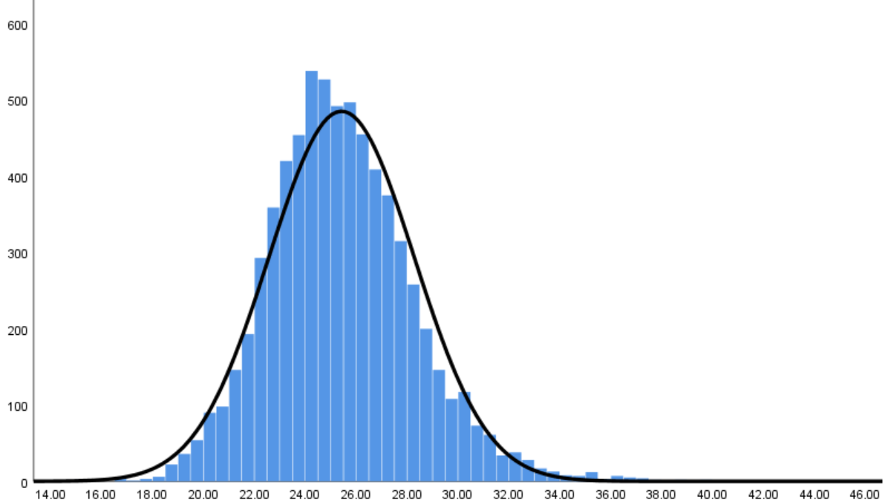
BMI (kg/m²)
Number of individuals

Female:
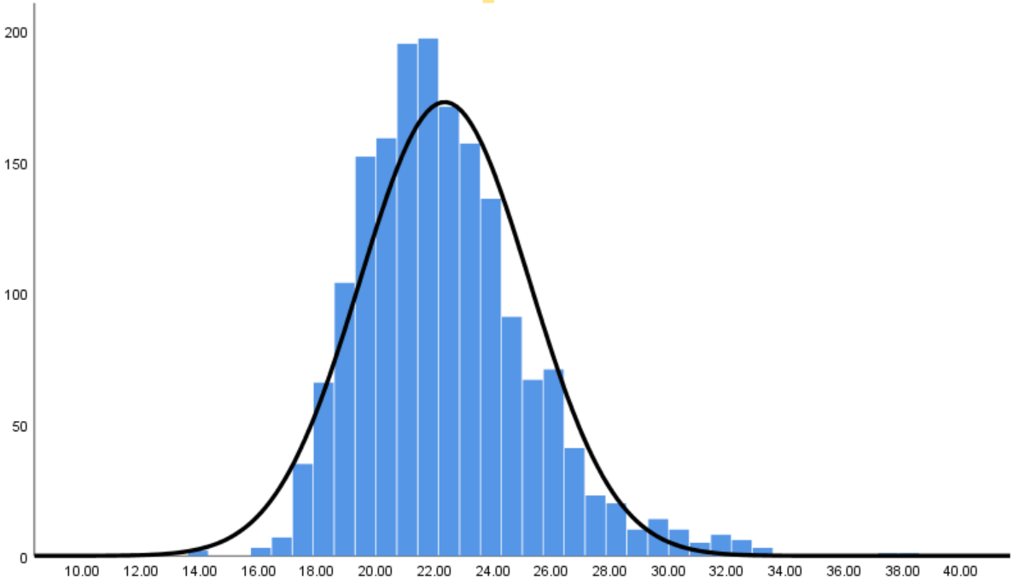
BMI (kg/m²)
Number of individuals

ALL:
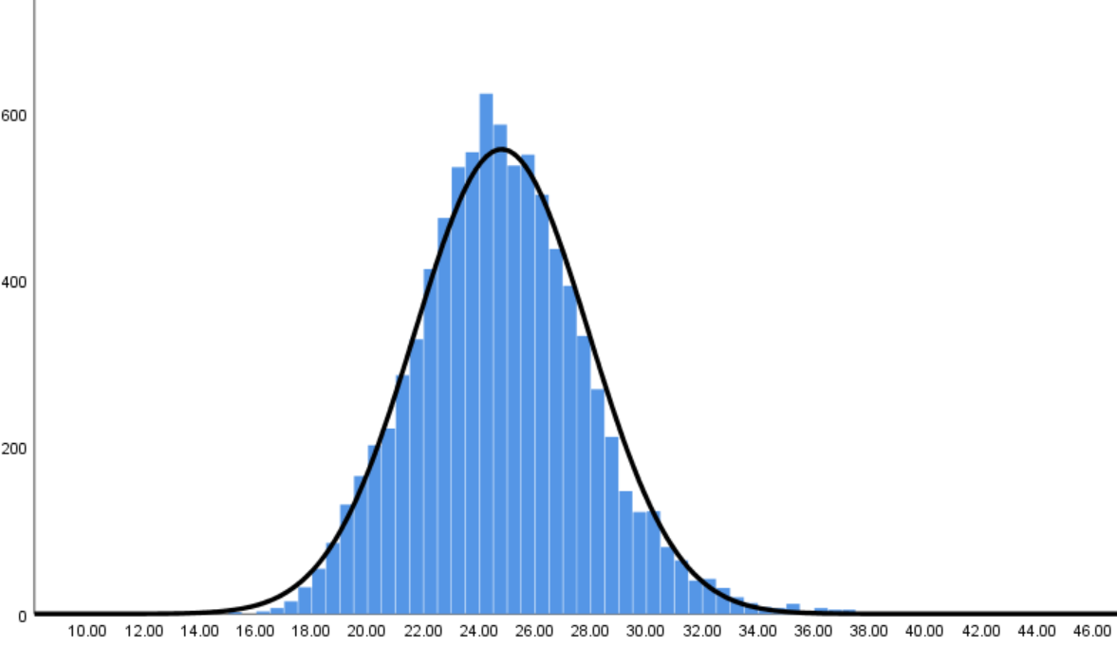
BMI (kg/m²)
Number of individuals
Note: BMI distribution is grouped by participants with a BMI of 1 kg/m² above or below the stated value (e.g. the 26 kg/m² bar represents participants with BMI ranging from ≥27 kg/m² to <25 kg/m²).
BMI, Body mass index

TABLE S1 Participant demographics and characteristics
Participants/Characteristics | Overall (N=8691) | Male  (n=6935) | Female (n=1756)
Age, median (IQR), years | 35(32-40) | 35(32-39) | 37(33-41)
Age, n(%)
30-34 | 3736(42.99) | 3100(44.70) | 636(36.22)
35-39 | 2692(30.97) | 2207(31.82) | 485(27.62)
40-44 | 1461(16.81) | 1120(16.15) | 341(19.42)
45-49 | 245(2.82) | 175(2.52) | 70(3.99)
50-54 | 88(1.01) | 39(0.56) | 49(2.79)
55-59 | 200(2.30) | 112(1.61) | 88(5.01)
60-64 | 172(1.98) | 123(1.77) | 49(2.79)
≧65 | 97(1.11) | 59(0.84) | 38(2.17)
BMI, mean (SD), kg/m² | 24.80(3.11) | 25.43(2.85) | 22.35(8.38)
GDP per capita regionª, n(%)
1st tertile | 7506(86.37%) | 5906(85.16%) | 1600(91.12%)
2nd tertile | 346(3.98%) | 318(4.59%) | 28(1.59%)
3rd tertile | 839(9.65%) | 711(10.25%) | 128(7.29%)
Geographical region, n(%)
Yanqing District | 24(0.28%) | 23(0.33%) | 1(0.06%)
Fengtai District | 346(3.98%) | 318(4.59%) | 28(1.59%)
Changping District | 815(9.38%) | 688(9.92%) | 127(7.23%)
Haidian District | 7506(86.37%) | 5906(85.16%) | 1600(91.12%)
Abbreviations: BMI, body mass index; GDP, gross domestic product; IQR, interquartile range; SD, standard deviation; USD, united states dollar
ª Districts in Beijing were divided into tertiles according to the district’s GDP per capita level in 2022¹ as follows: first tertile: CNY 177,656-518,185; second tertile: CNY 102,472-173,601; third tertile: CNY 59,143-89,410.

TABLE S2 Prevalence of overweight and obesity in the overall study population and by age and sex, using Chinese criteria and WHO criteria
 | Overweight |  |  | Obesity
 | Overall | Male | Female | Overall | Male | Female
Prevalence by Chinese BMI classification for overweight and obesity†
Overall crude prevalence | 45.59 | 52.03 | 20.10 | 14.03 | 16.52 | 4.16
Overall standardized prevalence | 46.35 | 52.50 | 28.19 | 17.01 | 20.77 | 8.82
Adjusted prevalence by age
30 to 34 years | 44.12  （42.53,45.72） | 50.27  (48.51,52.04) | 14.15  (11.43,16.87) | 12.48  (11.42,13.54) | 14.65  (13.40,15.90) | 1.89  (0.83,2.95)
35 to 39 years | 46.17  （44.29,48.06） | 52.61  (50.52,54.69) | 16.91  (13.56,20.25) | 13.97  (12.66,15.28) | 16.45  (14.90,18.00) | 2.68  (1.24,4.12)
40 to 44 years | 47.40  （44.83,49.96） | 55.27  (52.35,58.18) | 21.41  （17.08,25.86） | 14.66  (12.84,16.47) | 18.21  （15.95,20.48） | 2.94  (1.14,4.75)
45 to 49 years | 51.02  (44.72,57.32) | 58.29  （50.91,65.66） | 32.86  （21.58,44.14） | 15.10  (10.59,19.62) | 19.43  （13.51,25.35） | 4.29  （-0.58,9.15）
50 to 54 years | 47.73  (37.08,58.37) | 51.28  (34.87,67.70) | 44.90  (30.46,59.33) | 19.32  (10.91,27.73) | 28.21  (13.43,42.98) | 12.24  (2.73-21.76)
55 to 59 years | 46.50  (39.53,53.47) | 50.00  (40.60,59.40) | 42.05  (31.53,52.56) | 24.00  (18.03,29.97) | 33.04  (24.19,41.88) | 12.50  (5.45,19.55)
60 to 64 years | 43.02  (35.55,50.50) | 49.59  (40.63,58.55) | 26.53  (13.72,39.34) | 25.58  (19.00,32.17) | 26.83  (18.89,34.77) | 22.45  (10.34,34.56)
≥65 years | 45.36  (35.27,55.45) | 52.54  (39.42,65.67) | 34.21  (18.41,50.01) | 16.49  (8.98,24.01) | 16.95  (7.09,26.81) | 15.79  （3.64,27.94）
Prevalence by WHO BMI classification for overweight and obesity‡
Overall crude prevalence | 40.30 | 46.94 | 14.07 | 5.39 | 6.26 | 1.94
Overall standardized prevalence | 40.35 | 47.77 | 21.72 | 6.79 | 8.15 | 3.89
Adjusted prevalence by age
30 to 34 years | 37.19  (35.64,38.74) | 43.08  (41.33,44.82) | 8.49  (6.32, 10.66) | 5.09  (4.38,5.79) | 5.91  (5.07,6.74) | 1.10  (0.29, 1.91)
35 to 39 years | 41.75  (39.89,43.62) | 48.44  (46.35,50.52) | 11.34  (8.51,14.17) | 5.20  (4.36,6.04) | 6.07  (5.07, 7.07) | 1.24  (0.25,2.22)
40 to 44 years | 43.97  (41.42,46.52) | 52.86  (49.93,55.79) | 14.71  (10.92,18.49) | 4.45  (3.39,5.51) | 5.54  (4.19,6.88) | 0.88  (-0.12,1.88)
45 to 49 years | 42.45  (36.22,48.68) | 50.29  (42.80,57.77) | 22.86  (12.77,32.94) | 6.53  (3.42,9.65) | 8.57  (4.38,12.76) | 1.43  (-1.42,4.28)
50 to 54 years | 43.18  (32.63,53.74) | 56.41  (40.13,72.69) | 32.65  (19.04,46.26) | 6.82  (1.45,12.19) | 7.69  (-1.06,16.44) | 6.12  (-0.84, 13.08)
55 to 59 years | 43.00  (36.08,49.92) | 52.68  (43.29,62.07) | 30.68  (20.85,40.51) | 13.00  (8.30,17.70) | 17.86  (10.65, 25.06) | 6.82  (1.45,12.19)
60 to 64 years | 48.26  (40.71,55.80) | 53.66  (44.72, 62.60) | 34.69  (20.88,48.51) | 11.05  (6.31,15.78) | 10.57  （5.06,16.08） | 12.24  (2.73,21.76)
≥65 years | 37.11  (27.33,46.90) | 40.68  （27.77,53.59） | 31.58  (16.10,47.06) | 6.19  (1.31,11.07) | 6.78  (0.17,13.39) | 5.26  (-2.17,12.70)
Notes: Data are % or % (95% confidence interval). Data presented for the ‘overall’ rows are crude unadjusted prevalence of overweight or obesity and prevalence standardized according to the 2020 China census by age groups and sex. The prevalence by age groups is crude.
Abbreviations: BMI, body mass index；WHO, World Health Organization.
†Chinese classification criteria^{2,3} define overweight as BMI 24 to <28 kg/m² and obesity as BMI ≥28 kg/m².
‡WHO classification criteria⁴ define overweight as BMI 25 to <30 kg/m² and obesity as BMI ≥30 kg/m².

TABLE S3 Prevalence of overweight and obesity by District, using Chinese criteria and WHO criteria
 | Overweight |  |  | Obesity
 | Overall | Male | Female | Overall | Male | Female
By Chinese BMI classification for overweight and obesity†
Haidian District | 45.90 | 52.55 | 27.63 | 17.32 | 21.40 | 9.02
Fengtai District | 47.92 | 49.95 | 11.64 | 18.29 | 19.50 | 12.50
Changping District | 48.83 | 50.27 | 26.9 | 14.79 | 18.03 | 13.98
Yanqing District* | 42.15 | 44.98 | NA | 26.44 | NA | NA
By WHO BMI classification for overweight and obesity‡
Haidian District | 40.67 | 48.36 | 21.81 | 7.11 | 8.58 | 4.19
Fengtai District | 44.51 | 46.76 | NA | 8.60 | 9.04 | NA
Changping District | 50.81 | 50.84 | 34.72 | 5.75 | 6.70 | 3.65
Yanqing District* | 46.64 | 49.11 | NA | 10.73 | NA | NA
Notes: The prevalence of overweight and obesity presented was standardized according to China Census 2020¹ by age groups (5 years) and sex. Data for other districts were unavailable due to no participants coming from the working units in those regions.
Abbreviations: BMI, body mass index; NA, Non-applicable; WHO, World Health Organization.
*The data in the columns were missing due to there were limited number of participants in this region that could not calculate a compelling percentage.
†Chinese classification criteria^{2,3} define overweight as BMI 24 to <28 kg/m² and obesity as BMI ≥28 kg/m².
‡WHO classification criteria⁴ define overweight as BMI 25 to <30 kg/m² and obesity as BMI ≥30 kg/m².
ª Districts in Beijing were divided into tertiles according to the district’s GDP per capita level in 2022⁵ as follows: first tertile: CNY 177,656-518,185; second tertile: CNY 102,472-173,601; third tertile: CNY 59,143-89,410.

TABLE S4 Prevalence of overweight and obesity by regional GDP per capita
 | Overweight |  |  | Obesity
 | Overall | Male | Female | Overall | Male | Female
By Chinese BMI classification for overweight and obesity†
By regional GDP per capita
1st tertile‡ | 45.27  (44.14, 46.40) | 52.12  (50.84, 53.39) | 20.0  (18.04, 21.96) | 13.88  (13.10, 14.66) | 16.54  (15.59, 17.49) | 4.06  (3.09, 5.03)
2nd tertile‡ | 47.11  (41.82, 52.40) | 50.00  (44.47,55.53) | 14.29  (0.47, 28.10) | 17.05  (13.07, 21.03) | 18.24  （13.97,22.51） | 3.57  (-.3.76,10.90)
3rd tertile‡ | 47.68  (44.29, 51.06) | 52.18  (48.50,55.86) | 22.66  (15.31,30.01) | 14.06  (11.71, 16.42) | 15.61  (12.94,18.29) | 5.47  (1.48,9.46)
By WHO BMI classification for overweight and obesity†
By regional GDP per capita
1st tertile‡ | 40.03  (38.93,41.14) | 47.14  (45.87,48.41) | 13.81  (12.12,15.50) | 5.21  (4.71,5.71) | 6.10  (5.49,6.71) | 1.94  (1.26,2.61)
2nd tertile‡ | 41.33  (36.12,46.54) | 44.34  (38.85,49.83) | 7.14  (-3.03,17.31) | 8.67  (5.69,11.65) | 9.12  (5.94,12.30) | 3.57  (-3.76,10.90)
3rd tertile‡ | 42.19  (38.84,45.54) | 46.41  (42.74,50.09) | 18.75  (11.90,25.60) | 5.72  (4.15,7.30) | 6.33  (4.54,8.12) | 2.34  (-0.31,5.00)
Notes: Unless stated otherwise, all data are estimated proportions of participants in percentage (95% confidence interval). Logistic regression was used to estimate the adjusted prevalence of overweight and obesity, adjusted by sex (when applicable) as covariates.
Abbreviations: BMI, body mass index; GDP, gross domestic product; WHO, World Health Organization.
†Chinese classification criteria^{2,3} define overweight as BMI 24 to <28 kg/m² and obesity as BMI ≥28 kg/m².
‡WHO classification criteria⁴ define overweight as BMI 25 to <30 kg/m² and obesity as BMI ≥30 kg/m².
ª Districts in Beijing were divided into tertiles according to the district’s GDP per capita level in 2022⁵ as follows: first tertile: CNY 177,656-518,185; second tertile: CNY 102,472-173,601; third tertile: CNY 59,143-89,410.

TABLE S5 Prevalence of complications among the overall study population and participants with BMI classified as normal, overweight or obesity using Chinese criteria or WHO criteria
 | Overall | Normal BMI | Overweight | Obesity
Prevalence by Chinese BMI classification for overweight and obesity†
Prevalence of complication
Diabetes (ADA criteria) | 12.69  (11.31, 14.06) | 4.68  (3.20, 6.15) | 12.95  (10.93, 14.96) | 29.60  (24.96, 34.24)
Diabetes (WHO criteria) | 1.70  (1.42, 1.97) | 1.03  (0.69, 1.38) | 1.67  (1.27, 2.07) | 3.78  (2.71, 4.86)
Prediabetes (ADA criteria) | 38.73  (36.72, 40.74) | 31.61  (28.36, 34.85) | 39.02  (36.09, 41.96) | 53.87  (48.80, 58.94)
Prediabetes (WHO criteria) | 2.78  (2.43, 3.13) | 1.45  (1.05, 1.85) | 2.83  (2.31, 3.35) | 6.50  (5.11,7.88)
Hypertension | 9.28  (8.67, 9.89) | 4.08  (3.41, 4.74) | 9.76  (8.83, 10.68) | 22.86  (20.50, 25.23)
Cholelithiasis | 1.51  (1.25, 1.77) | 1.18  (0.82, 1.55) | 1.57  (1.18, 1.95) | 2.30  (1.46, 3.15)
Fatty liver disease | 28.45  (27.50, 29.40) | 8.10  (7.18, 9.02) | 34.28  (32.80, 35.76) | 68.67  (66.06, 71.28)
Carotid plaque (age≧50 years) | 39.67  (35.58, 43.77) | 31.21  (24.24, 38.19) | 42.63  (36.47, 48.79) | 44.35  (35.49, 53.22)
Hyperuricaemia | 34.44  (33.44, 35.44) | 18.56  (17.25, 19.87) | 42.11  (40.57, 43.65) | 56.41  (53.62, 59.21)
Dyslipidaemia | 19.74  (18.90, 20.58) | 9.66  (8.67, 10.66) | 23.79  (22.46, 25.11) | 36.10  (33.40, 38.81)
Prevalence by WHO BMI classification for overweight and obesity†
Prevalence of complication
Diabetes (ADA criteria) | 12.69  (11.31,14.06) | 5.32  (4.00, 6.65) | 18.26  (15.84,20.67) | 34.06  (26.05,42.06)
Diabetes (WHO criteria) | 1.70  (1.42, 1.97) | 1.26  (0.94,1.59) | 1.80  (1.36,2.24) | 5.56  (3.47,7.64)
Prediabetes (ADA criteria) | 38.73  (36.72, 40.74) | 32.67  (29.91, 35.44) | 43.71  (40.61, 46.81) | 54.35  (45.93, 62.76)
Prediabetes (WHO criteria) | 2.78  (2.43, 3.13) | 1.87  (1.48, 2.27) | 3.43  (2.83, 4.04) | 7.26  (4.90, 9.63)
Hypertension | 9.28  (8.67, 9.89) | 5.14  (4.50, 5.78) | 12.01  (10.93, 13.09) | 31.20  (26.98, 35.41)
Cholelithiasis | 1.51  (1.25, 1.77) | 1.22  (0.90, 1.54) | 1.74  (1.31, 2.18) | 2.78  (1.28, 4.27)
Fatty liver disease | 28.45  (27.50, 29.40) | 11.72  (10.79,12.65) | 44.47  (42.82, 46.11) | 79.49  (75.82,83.16)
Carotid plaque (age≧50 years) | 39.67  (35.58, 43.77) | 35.20  (29.24, 41.16) | 42.98  (36.69, 49.26) | 42.86  (29.48, 56.23)
Hyperuricaemia | 34.44  (33.44, 35.44) | 23.07  (21.85, 24.29) | 46.67  (45.01, 48.32) | 61.75  (57.33, 66.17)
Dyslipidaemia | 19.74  (18.90, 20.58) | 11.94  (11.00, 12.87) | 27.85  (26.37, 29.34) | 39.53  （35.08, 43.98）
Notes: Data are % (95% confidence interval). The prevalence of each complication was estimated using a logistic regression model. Diagnostic criteria for obesity-related complications are provided in the supplementary materials (p 4-5).
Abbreviations: ADA, American Diabetes Association; BMI, body mass index; WHO, World Health Organization.
†Chinese classification criteria^{2,3} define normal BMI as 18.5 to <24 kg/m², overweight as BMI 24 to <28 kg/m² and obesity as BMI ≥28 kg/m²
‡WHO classification criteria⁴ define normal BMI as 18.5 to <25 kg/m², overweight as BMI 25 to <30 kg/m² and obesity as BMI ≥30 kg/m².

TABLE S6 Number of complications among the overall study population and participants with BMI classified as normal, overweight or obesity using Chinese criteria or WHO criteria
 | Overall | Normal BMI | Overweight | Obesity
Prevalence by Chinese BMI classification for overweight and obesity†(age≧30)
Number of complications (%)
0 | 43.84  （42.80, 44.89） | 67.67  （66.09, 69.25） | 32.33  (30.87, 33.79) | 10.86  (9.10, 12.61)
1 | 28.22  （27.27, 29.16） | 23.43  (22.01, 24.86) | 34.13  (32.65, 35.60) | 23.93  (21.53, 26.33)
2 | 16.80  (16.01, 17.59) | 6.44  (5.61, 7.27) | 21.11  (19.84, 22.38) | 33.22  (30.57, 35.87)
3 | 8.73  (8.14, 9.32) | 2.10  (1.61, 2.58) | 10.34  (9.39, 11.29) | 22.62  (20.26, 24.97)
4 | 2.16  (1.85, 2.46) | 0.33  (0.13, 0.52) | 1.85  (1.43, 2.26) | 8.47  (6.90, 10.04)
5 | 0.25  (0.15, 0.36) | 0.03  (-0.03, 0.09) | 0.25  (0.10, 0.41) | 0.90  (0.37, 1.44)
Prevalence by Chinese BMI classification for overweight and obesity‡(age≧50)
Number of complications (%)
0 | 14.67  (11.71, 17.63) | 25.43  (18.88, 31.99) | 13.15  (8.94,17.36) | 2.42  (-0.32, 5.16)
1 | 23.55  (20.00, 27.10) | 30.06  (23.16, 36.96) | 25.10  (19.70, 30.50) | 12.10  (6.28, 17.92)
2 | 26.81  (23.10, 30.52) | 23.70  (17.30, 30.10) | 26.69  (21.18, 32.20) | 30.65  (22.42, 38.87)
3 | 19.02  (15.74, 22.31) | 12.72  (7.70, 17.73) | 17.13  (12.44, 21.82) | 32.26  (23.91, 40.60)
4 | 10.14  (7.62, 12.67) | 6.94  (3.11, 10.76) | 11.16  (7.23, 15.08) | 12.10  (6.28, 17.92)
5 | 5.07  (3.24, 6.91) | 1.16  (-0.45, 2.76) | 6.37  (3.33, 9.42) | 8.06  (3.20, 12.92)
6 | 0.72  (0.01. 1.43) | 0  (0,0) | 0.4  (-0.39, 1.18) | 2.42  (-0.32, 5.16)
Prevalence by WHO BMI classification for overweight and obesity†(age≧30)
Number of complications (%)
0 | 43.84  （42.80, 44.89） | 60.88  (59.47, 62.29) | 24.96  (23.53,26.40) | 7.05  (4.72, 9.38)
1 | 28.22  （27.27, 29.16） | 26.42  (25.15, 27.70) | 32.77  (31.21, 34.33) | 16.03  (12.69, 19.36)
2 | 16.80  (16.01, 17.59) | 8.97  (8.15, 9.80) | 25.31  (23.87, 26.75) | 34.19  (29.87, 38.50)
3 | 8.73  (8.14, 9.32) | 3.09  (2.59, 3.59) | 13.67  (12.53, 14.81) | 28.85  (24.73, 32.97)
4 | 2.16  (1.85, 2.46) | 0.59  (0.37, 0.81) | 2.86  （2.31, 3.41） | 12.82  (9.78, 15.86)
5 | 0.25  (0.15, 0.36) | 0.04  (-0.02, 0.10) | 0.43  (0.21, 0.65) | 1.07  (0.13, 2.00)
Prevalence by WHO BMI classification for overweight and obesity‡(age≧50)
Number of complications (%)
0 | 14.67  (11.71, 17.63) | 21.20  (16.10, 26.30) | 10.74  (6.81, 14.67) | 1.79  (-1.79, 5.36)
1 | 23.55  (20.00, 27.10) | 29.20  (23.52, 34.88) | 20.25  (15.15, 25.35) | 14.29  (4.83, 23.74)
2 | 26.81  (23.10, 30.52) | 24.80  (19.41, 30.19) | 28.51  (22.78, 34.24) | 26.79  (14.82, 38.75)
3 | 19.02  (15.74, 22.31) | 13.60  (9.32, 17.88) | 22.73  (17.41, 28.04) | 28.57  (16.36, 40.78)
4 | 10.14  (7.62, 12.67) | 9.20  (5.59, 12.81) | 9.50  (5.78, 13.23) | 16.07  (6.15, 26.00)
5 | 5.07  (3.24, 6.91) | 2.00  (0.25, 3.75) | 7.02  (3.78, 10.27) | 10.71  (2.36, 19.07)
6 | 0.72  (0.01. 1.43) | 0  (0,0) | 1.24  (-0.16, 2.64) | 1.79  (-1.79, 5.36)
Notes: Data are % (95% confidence interval). Number of complications was based on the presence of diabetes (assessed using WHO definitions), hypertension, hyperuricaemia, dyslipidaemia, fatty liver disease, cholelithiasis or carotid plaque (age≧50) . Diagnostic criteria for complications are provided in the supplementary materials (p 4-5). P for trend was testing the null hypothesis of no trend in prevalence of complications in numbers over BMI classes, performed by analysing BMI class as a continuous variable, with the median BMI value assigned to each BMI class. P for trend < .05 for number 0 and 1 of complications in the obesity group and 0 of complication in the overweight group (A. age≥30) and 6 of complication in the overweight group (B. age≥50). Otherwise, P for trend >.05. The prevalence of complications was estimated using a logistic regression model.
Abbreviations: ADA, American Diabetes Association; BMI, body mass index; WHO, World Health Organization.
†Chinese classification criteria^{2,3} define normal BMI as 18.5 to <24 kg/m², overweight as BMI 24 to <28 kg/m² and obesity as BMI ≥28 kg/m².
‡WHO classification criteria⁴ define normal BMI as 18.5 to <25 kg/m2, overweight as BMI 25 to <30 kg/m² and obesity as BMI ≥30 kg/m².

TABLE S7 Prevalence of chronic diseases in the normal BMI, overweight and obesity population and by age and sex, using WHO criteria
 |  | Normal BMI |  |  | Overweight |  |  | Obesity
 | Age | Overall | Male | Female | Overall | Male | Female | Overall | Male | Female
Diabetes  (ADA criteria) | 40-44 | 1.23  (0.43,2.03) | 1.73  (0.54,2.92) | 0.37  (-0.36,1.10) | 11.72  (9.22,14.22) | 11.69  (9.09,14.30) | 12.00  (2.67,21.33) | 25.76  (14.93,36.59) | 24.19  (13.23,35.16) | 50.00  (-41.87,141.87)
Diabetes  (ADA criteria) | 45-49 | 3.20  (0.07,6.33) | 5.56  (0.14,10.98) | 0  (0,0) | 13.46  (6.79,20.13) | 14.77  (7.21,22.33) | 6.25  (-7.07,19.57) | 25.00  (1.17,48.83) | 26.67  (1.32,52.02) | 0  (0,0)
Diabetes  (ADA criteria) | 50-54 | 11.90  (1.69,22.12) | 21.43  (-3.16,46.01) | 7.14  (-3.03,17.31) | 36.84  (20.77,52.91) | 36.36  (14.53,58.19) | 37.50  (10.86,64.14) | 33.33  (-20.86,87.53) | 66.67  (-76.76,210.09) | 0  (0,0)
Diabetes  (ADA criteria) | 55-59 | 19.54  (11.04,28.04) | 24.24  (8.81,39.67) | 16.67  (6.40,26.93) | 31.40  (21.39,41.40) | 33.90  (21.46,46.34) | 25.93  (8.26,43.59) | 40.00  (19.36,60.64) | 36.84  (12.96,60.73) | 50.00  (-7.48,107.48)
Diabetes  (ADA criteria) | 60-64 | 17.39  (8.22,26.56) | 16.28  (4.78,27.78) | 19.23  (3.00,35.46) | 43.90  (32.93,54.87) | 44.62  (32.20,57.03) | 41.18  (15.09,67.26) | 57.89  (33.45,82.34) | 76.92  (50.42,103.42) | 16.67  (-26.18,59.51)
Diabetes  (ADA criteria) | ≧65 | 23.08  (11.23,34.92) | 27.59  (10.28,44.89) | 17.39  (0.63,34.15) | 38.89  (22.16,55.62) | 37.50  (16.62,58.38) | 41.67  (8.95,74.38) | 50.00  (-7.48,107.48) | 75.00  (-4.56,154.56) | 0  (0,0)
Diabetes  (WHO criteria) | 30-34 | 0.10  (-0.04,0.23) | 0.13  (-0.05, 0.30) | 0  (0,0) | 0.22  (-0.03,0.46) | 0.22  (-0.03,0.48) | 0  (0,0) | 1.58  (-0.21.3.37) | 1.64  (-0.22,3.50) | 0  (0,0)
Diabetes  (WHO criteria) | 35-39 | 0.14  (-0.06,0.34) | 0.20  (-0.08,0.48) | 0  (0,0) | 0.53  (0.11,0.96) | 0.56  (0.11,1.01) | 0  (0,0) | 5.00  (1.35,8.65) | 4.48  (0.93,8.02) | 16.67  (-26.18,59.51)
Diabetes  (WHO criteria) | 40-44 | 1.09  (0.34,1.85) | 1.51  (0.40,2.63) | 0.37  (-0.36,1.10) | 1.72  (0.71,2.73) | 1.69  (0.65,2.74) | 2.00  (-2.02,6.02) | 7.58  (1.02,14.13) | 6.45  (0.16,12.74) | 25.00  (-54.56,104.56)
Diabetes  (WHO criteria) | 45-49 | 2.40  (-0.32,5.12) | 4.17  (-0.56,8.90) | 0  (0,0) | 4.81  (0.63,8.99) | 5.68  (0.75,10.61) | 0  (0,0) | 0  (0,0) | 0  (0,0) | 0  (0,0)
Diabetes  (WHO criteria) | 50-54 | 14.29  (3.25,25.32) | 28.57  (1.50,55.64) | 7.14  (-3.03,17.31) | 15.79  (3.64,27.94) | 13.64  (-1.94,29.21) | 18.75  (-2.73,40.23) | 16.67  (-26.18,59.51) | 33.3  (-110.09,176.76) | 0  (0,0)
Diabetes  (WHO criteria) | 55-59 | 13.79  (6.40,21.18) | 15.15  (2.24,28.06) | 12.96  (3.71,22.22) | 18.60  (10.21,27.00) | 22.03  (11.14,32.93) | 11.11  (-1.56,23.78) | 20.00  (3.15,36.85) | 26.32  (4.51,48.12) | 0  (0,0)
Diabetes  (WHO criteria) | 60-64 | 18.84  (9.38,28.30) | 20.93  (8.26,33.60) | 15.38  (0.52,30.25) | 14.63  (6.82,22.45) | 15.38  (6.37,24.39) | 11.76  (-5.31,28.84) | 21.05  (0.86,41.24) | 30.77  (1.74,59.80) | 0  (0,0)
Diabetes  (WHO criteria) | ≧65 | 23.08  (11.23,34.92) | 31.03  (13.13,48.94) | 13.04  (-1.85,27.93) | 11.11  (0.33,21.90) | 8.33  (-3.59,20.26) | 16.67  (-8.07,41.40) | 16.67  (-26.18,59.51) | 25.00  (-54.56,104.56) | 0  (0,0)
Prediabetes  (ADA criteria) | 40-44 | 24.56  (21.43,27.68) | 27.21  (23.14,31.28) | 20.00  (15.20,24.80) | 36.56  (32.82,40.30) | 36.27  (32.38,40.16) | 40.00  (25.94,54.06) | 43.94  (31.64,56.23) | 43.55  (30.85,56.24) | 50.00  (-41.87,141.87)
Prediabetes  (ADA criteria) | 45-49 | 30.40  (22.22,38.58) | 34.72  (23.46,45.99) | 24.53  (12.56,36.50) | 40.38  (30.80,49.97) | 40.91  (30.43,51.39) | 37.50  (10.86,64.14) | 43.75  (16.45,71.05) | 46.67  (18.07,75.26) | 0  (0,0)
Prediabetes  (ADA criteria) | 50-54 | 59.52  (44.04,75.01) | 35.71  (7.00,64.42) | 71.43  (53.59,89.27) | 47.37  (30.74,64.00) | 59.09  (36.78,81.40) | 31.25  (5.74,56.76) | 66.67  (12.47,120.86) | 66.67  (-76.76,210.09) | 66.67  (-76.76,210.09)
Prediabetes  (ADA criteria) | 55-59 | 57.47  (46.87,68.07) | 51.52  (33.52,69.51) | 61.11  (47.68,74.54) | 63.95  (53.60,74.31) | 59.32  (46.41,72.23) | 74.07  (56.41,91.74) | 72.00  (53.08,90.92) | 68.42  (45.40,91.44) | 83.33  (40.49,126.18)
Prediabetes  (ADA criteria) | 60-64 | 60.87  (49.06,72.68) | 58.14  (42.78,73.50) | 65.38  (45.79,84.98) | 69.51  (59.33,79.69) | 67.69  (56.01,79.37) | 76.47  (53.99,98.95) | 63.16  (39.27,87.04) | 69.23  (40.20,98.26) | 50.00  (-7.48,107.48)
Prediabetes  (ADA criteria) | ≧65 | 51.92  (37.88,65.97) | 44.83  (25.58,64.08) | 60.87  (39.29,82.45) | 69.44  (53.64,85.25) | 70.83  (51.23,90.44) | 66.67  (35.38,97.95) | 83.33  (40.49,126.18) | 75.00  (-4.56,154.56) | 100  (100,100)
Prediabetes  (WHO criteria) | 30-34 | 0.43  (0.15,0.71) | 0.45  (0.12,0.77) | 0.38  (-0.15,0.91) | 1.30  (0.70,1.89) | 1.27  (0.67,1.88) | 1.85  (-1.86,5.57) | 1.58  (-0,21,3.37) | 1.64  (-0.22,3.50) | 0  (0,0)
Prediabetes  (WHO criteria) | 35-39 | 1.23  (0.65,1.81) | 1.10  (0.45,1.75) | 1.56  (0.32,2.81) | 2.14  (1.29,2.98) | 2.15  (1.28,3.03) | 1.82  (-1.83,5.46) | 9.29  (4.42,14.15) | 9.70  (4.63,14.78) | 0  (0,0)
Prediabetes  (WHO criteria) | 40-44 | 2.32  (1.23,3.41) | 3.02  (1.46,4.59) | 1.11  (-0.15,2.37) | 4.84  (3.18,6.51) | 4.41  (2.75,6.07) | 10.00  (1.39,18.61) | 7.58  (1.02,14.13) | 8.06  (1.09,15.04) | 0  (0,0)
Prediabetes  (WHO criteria) | 45-49 | 2.40  (-0.32,5.12) | 4.17  (-0.56,8.90) | 0  (0,0) | 2.88  (-0.39,6.16) | 2.27  (-0.90,5.45) | 6.25  (-7.07,19.57) | 6.25  (-7.07,19.57) | 6.67  (-7.63,20.97) | 0  (0,0)
Prediabetes  (WHO criteria) | 50-54 | 9.52  (0.27,18.78) | 0  (0,0) | 14.29  (0.47,28.10) | 7.89  (-1.09,16.88) | 9.09  (-3.96,22.14) | 6.25  (-7.07,19.57) | 16.67  (-26.18,59.51) | 33.33  (-110.09,176.76) | 0  (0,0)
Prediabetes  (WHO criteria) | 55-59 | 20.69  (12.01,29.37) | 15.15  (2.24,28.06) | 24.07  (12.30,35.85) | 15.12  (7.39,22.84) | 18.64  (8.41,28.88) | 7.41  (-3.15,17.96) | 28.00  (9.08,46.92) | 21.05  (0.86,41.24) | 50.00  (-7.48,107.48)
Prediabetes  (WHO criteria) | 60-64 | 18.84  (9.38,28.30) | 20.93  (8.26,33.60) | 15.38  (0.52,30.25) | 25.61  (15.96,35.26) | 26.15  (15.18,37.13) | 23.53  (1.05,46.01) | 15.79  (-2.27,33.85) | 23.08  (-3.42,49.58) | 0  (0,0)
Prediabetes  (WHO criteria) | ≧65 | 9.62  (1.33,17.90) | 6.90  (-2.91,16.71) | 13.04  (-1.85,27.93) | 19.44  (5.86,33.03) | 16.67  (0.59,32.74) | 25.00  (-3.74,53.74) | 16.67  (-26.18,59.51) | 0  (0,0) | 50.00  (-585.31,685.31)
Hypertension | 30-34 | 3.33  (2.57,4.10) | 3.94  (2.98,4.91) | 1.52  (0.47,2.57) | 9.37  (7.83,10.90) | 9.67  (8.08,11.26) | 1.85  (-1.86,5.57) | 30.53  (23.92,37.13) | 31.15  (24.37,37.92) | 14.29  (-20.67,49.24)
Hypertension | 35-39 | 3.18  (2.25,4.10) | 4.10  (2.87,5.33) | 0.78  (-0.10,1.67) | 9.97  (8.22,11.73) | 10.21  (8.39,12.02) | 5.45  (-0.74,11.65) | 26.43  (19.03,33.82) | 27.61  (19.94,35.28) | 0  (0,0)
Hypertension | 40-44 | 4.37  (2.88,5.85) | 5.18  (3.16,7.21) | 2.96  (0.93,5.00) | 11.88  (9.36,14.39) | 12.37  (9.71,15.04) | 6.00  (-0.82,12.82) | 21.21  (11.09,31.34) | 20.97  (10.55,31.39) | 25.00  (-54.56,104.56)
Hypertension | 45-49 | 12.00  (6.22,17.78) | 11.11  (3.67,18.55) | 13.21  (3.79,22.63) | 10.58  (4.57,16.59) | 11.36  (4.60,18.13) | 6.25  (-7.07,19.57) | 43.75  (16.45,71.05) | 46.67  (18.07,75.26) | 0  (0,0)
Hypertension | 50-54 | 26.19  (12.32,40.06) | 14.29  (-6.68,35.25) | 32.14  (13.70,50.58) | 34.21  (18.41,50.01) | 45.45  (22.86,68.05) | 18.75  (-2.73,40.23) | 33.33  (-20.86,87.53) | 66.67  (-76.76,210.09) | 0  (0,0)
Hypertension | 55-59 | 27.59  (18.01,37.17) | 42.42  (24.63,60.22) | 18.52  (7.82,29.22) | 27.91  (18.23,37.58) | 23.73  (12.55,34.91) | 37.04  (17.57,56.50) | 40.00  (19.36,60.64) | 31.58  (8.56,54.60) | 66.67  (12.47,120.86)
Hypertension | 60-64 | 30.43  (19.30,41.57) | 27.91  (13.94,41.87) | 34.62  (15.02,54.21) | 42.68  (31.75,53.62) | 43.08  (30.71,55.44) | 41.18  (15.09,67.26) | 68.42  (45.40,91.44) | 84.62  (61.92,107.31) | 33.33  (-20.86,87.53)
Hypertension | ≧65 | 36.54  (23.00,50.08) | 41.38  (22.31,60.45) | 30.43  (10.09,50.78) | 52.78  (35.65,69.91) | 50.00  (28.43,71.57) | 58.33  (25.62,91.05) | 83.33  (40.49,126.18) | 100.00  (100.00,100.00) | 50.00  (-585.31,685.31)
Cholelithiasis | 30-34 | 0.48  (0.18,0.77) | 0.45  (0.12,0.77) | 0.57  (-0.08,1.21) | 0.65  (0.23,1.07) | 0.52  (0.14,0.91) | 3.70  (-1.50,8.91) | 2.11  (0.05,4.17) | 2.19  (0.05,4.32) | 0  (0,0)
Cholelithiasis | 35-39 | 1.66  (0.99,2.34) | 1.60  (0.82,2.38) | 1.82  (0.48,3.17) | 1.60  (0.87,2.34) | 1.59  (0.84,2.34) | 1.82  (-1.83,5.46) | 0.71  (-0.70,2.13) | 0.75  (-0.73,2.22) | 0  (0,0)
Cholelithiasis | 40-44 | 0.82  (0.16,1.47) | 0.65  (-0.09,1.38) | 1.11  (-0.15,2.37) | 1.88  (0.82,2.93) | 1.86  (0.77,2.96) | 2.00  (-2.02,6.02) | 1.52  (-1.51,4.54) | 1.61  (-1.61,4.84) | 0  (0,0)
Cholelithiasis | 45-49 | 4.80  (1.00,8.60) | 4.17  (-0.56,8.90) | 5.66  (-0.77,12.09) | 2.88  (-0.39,6.16) | 3.41  (-0.46,7.28) | 0  (0,0) | 12.50  (-5.70,30.70) | 13.33  (-6.15,32.82) | 0  (0,0)
Cholelithiasis | 50-54 | 0  (0,0) | 0  (0,0) | 0  (0,0) | 7.89  (-1.09,16.88) | 4.55  (-4.91,14.00) | 12.50  (-5.70,30.70) | 16.67  (-26.18,59.51) | 0  (0,0) | 33.33  (-110.09,176.76)
Cholelithiasis | 55-59 | 6.90  (1.46,12.33) | 9.09  (-1.26,19.44) | 5.56  (-0.76,11.87) | 9.30  (3.04,15.57) | 3.39  (-1.37,8.15) | 22.22  (5.46,38.98) | 8.00  (-3.43,19.43) | 5.26  (-5.79,16.32) | 16.67  (-26.18,59.51)
Cholelithiasis | 60-64 | 4.35  (-0.59,9.28) | 4.65  (-1.91,11.21) | 3.85  (-4.08,11.77) | 7.32  (1.56,13.07) | 6.15  (0.15,12.15) | 11.76  (-5.31,28.84) | 10.53  (-4.67,25.72) | 7.69  (-9.07,24.45) | 16.67  (-26.18,59.51)
Cholelithiasis | ≧65 | 3.85  (-1.56,9.25) | 6.90  (-2.91,16.71) | 0  (0,0) | 5.56  (-2.30,13.42) | 8.33  (-3.59,20.26) | 0  (0,0) | 0  (0,0) | 0  (0,0) | 0  (0,0)
Fatty liver disease | 30-34 | 8.67  (7.47,9.88) | 10.81  (9.28,12.35) | 2.28  (1.00,3.55) | 40.49  (37.90,43.08) | 41.30  (38.66,43.95) | 20.37  (9.27,31.47) | 76.84  (70.79,82.89) | 78.14  (72.10,84.19) | 42.86  (-6.58,92.29)
Fatty liver disease | 35-39 | 11.63  (9.94,13.32) | 14.90  (12.69,17.11) | 3.13  (1.38,4.87) | 42.12  (39.23,45.01) | 42.42  (39.45,45.38) | 36.36  (23.24,49.49) | 82.86  (76.54,89.18) | 82.09  (75.51,88.67) | 100  (100,100)
Fatty liver disease | 40-44 | 14.87  (12.29,17.45) | 21.38  (17.63,25.13) | 3.70  (1.44,5.97) | 54.22  (50.35,58.09) | 55.59  (51.57,59.61) | 38.00  (24.07,51.93) | 81.82  (72.26,91.37) | 82.26  (72.48,92.04) | 75.00  (-4.56,154.56)
Fatty liver disease | 45-49 | 15.20  (8.82,21.58) | 19.44  (10.08,28.81) | 9.43  (1.30,17.57) | 44.23  (34.53,53.94) | 48.86  (38.21,59.52) | 18.75  (-2.73,40.23) | 68.75  (43.24,94.26) | 66.67  (39.64,93.69) | 100  (100,100)
Fatty liver disease | 50-54 | 33.33  (18.47,48.20) | 28.57  (1.50,55.64) | 35.71  (16.79,54.64) | 50.00  (33.34,66.66) | 45.45  (22.86,68.05) | 56.25  (28.95,83.55) | 66.67  (12.47,120.86) | 66.67  (-76.76,210.09) | 66.67  (-76.76,210.09)
Fatty liver disease | 55-59 | 26.44  (16.98,35.89) | 21.21  (6.49,35.93) | 29.63  (17.05,42.21) | 56.98  (46.30,67.65) | 55.93  (42.88,68.98) | 59.26  (39.45,79.07) | 88.00  (74.31,101.69) | 89.47  (74.28,104.67) | 83.33  (40.49,126.18)
Fatty liver disease | 60-64 | 31.88  (20.61,43.16) | 23.26  (10.10,36.41) | 46.15  (25.62,66.69) | 53.66  (42.63,64.68) | 60.00  (47.77,72.23) | 29.41  (5.26,53.56) | 84.21  (66.15,102,27) | 84.62  (61.92,107.31) | 83.33  (40.49,126.18)
Fatty liver disease | ≧65 | 15.38  (5.24,25.53) | 24.14  (7.57,40.70) | 4.35  (-4.67,13.36) | 41.67  (24.75,58.58) | 37.50  (16.62,58.38) | 50.00  (16.82,83.18) | 50.00  (-7.48,107.48) | 50.00  (-41.87,141.87) | 50.00  (-585.31,685.31)
Carotid plaque  (age≧50 years) | 50-54 | 11.90  (1.69,22.12) | 21.43  (-3.16,46.01) | 7.14  (-3.03,17.31) | 26.32  (11.65,40.98) | 31.82  (10.68,52.96) | 18.75  (-2.73,40.23) | 50.00  (-7.48,107.48) | 66.67  (-76.76,210.09) | 33.33  (-110.09,176.76)
Carotid plaque  (age≧50 years) | 55-59 | 33.33  (23.23,43.44) | 42.42  (24.63,60.22) | 27.78  (15.44,40.12) | 34.88  (24.61,45.16) | 40.68  (27.77,53.59) | 22.22  (5.46,38.98) | 40.00  (19.36,60.64) | 42.11  (17.66,66.55) | 33.33  (-20.86,87.53)
Carotid plaque  (age≧50 years) | 60-64 | 40.58  (28.70,52.46) | 48.84  (33.27,64.40) | 26.92  (8.65,45.19) | 48.78  (37.73,59.83) | 49.23  (36.75,61.72) | 47.06  (20.61,73.51) | 47.37  (22.64,72.09) | 38.46  (7.86,69.06) | 66.67  (12.47,120.86)
Carotid plaque  (age≧50 years) | ≧65 | 50.00  (35.94,64.06) | 68.97  (51.06,86.87) | 26.09  (6.67,45.50) | 66.67  (50.49,82.84) | 70.83  (51.23,90.44) | 58.33  (25.62,91.05) | 33.33  (-20.86,87.53) | 50.00  (-41.87,141.87) | 0  (0,0)
Hyperuricaemia | 30-34 | 25.68  (23.81,27.55) | 33.46  (31.13,35.80) | 2.47  (1.14,3.80) | 49.64  (47.01,52.27) | 51.42  (48.74,54.11) | 5.56  (-0.76,11.87) | 69.47  (62.87,76.08) | 71.58  (64.99,78.18) | 14.29  (-20.67,49.24)
Hyperuricaemia | 35-39 | 23.27  (21.04,25.49) | 31.80  (28.91,34.69) | 1.04  (0.02,2.06) | 51.38  (48.45,54.31) | 53.56  (50.56,56.55) | 9.09  (1.25,16.93) | 67.86  (60.03,75.69) | 70.90  (63.10,78.69) | 0  (0,0)
Hyperuricaemia | 40-44 | 19.51  (16.63,22.38) | 30.02  (25.83,34.21) | 1.48  (0.03,2.93) | 41.09  (37.27,44.92) | 44.41  (40.39,48.43) | 2.00  (-2.02,6.02) | 60.61  (48.50,72.71) | 62.90  (50.54,75.27) | 25.00  (-54.56,104.56)
Hyperuricaemia | 45-49 | 18.40  (11.51,25.29) | 31.94  (20.91,42.98) | 0  (0,0) | 38.46  (28.95,47.97) | 44.32  (33.73,54.90) | 6.25  (-7.07,19.57) | 37.50  (10.86,64.14) | 40.00  (11.92,68.08) | 0  (0,0)
Hyperuricaemia | 50-54 | 7.14  (-0.98,15.27) | 21.43  (-3.16,46.01) | 0  (0,0) | 31.58  (16.10,47.06) | 45.45  (22.86,68.05) | 12.50  (-5.70,30.70) | 16.67  (-26.18,59.51) | 33.33  (-110.09,176.76) | 0  (0,0)
Hyperuricaemia | 55-59 | 10.34  (3.82,16.87) | 12.12  (0.37,23.87) | 9.26  (1.27,17.25) | 24.42  (15.15,33.68) | 30.51  (18.41,42.61) | 11.11  (-1.56,23.78) | 36.00  (15.78,56.22) | 36.84  (12.96,60.73) | 33.33  (-20.86,87.53)
Hyperuricaemia | 60-64 | 24.64  (14.21,35.06) | 37.21  (22.16,52.26) | 3.85  (-4.08,11.77) | 26.83  (17.03,36.62) | 32.31  (20.63,43.99) | 5.88  (-6.59,18.35) | 31.58  (8.56,54.60) | 38.46  (7.86,69.06) | 16.67  (-26.18,59.51)
Hyperuricaemia | ≧65 | 5.77  (-0.79,12.32) | 10.34  (-1.44,22.13) | 0  (0,0) | 22.22  (7.96,36.49) | 29.17  (9.56,48.77) | 8.33  (-10.01,26.67) | 0  (0,0) | 0  (0,0) | 0  (0,0)
Dyslipidaemia | 30-34 | 9.96  (8.68,11.24) | 11.64  (10.05,13.23) | 4.93  (3.08,6.79) | 25.43  (23.14,27.73) | 26.24  (23.87,28.60) | 5.56  (-0.76,11.87) | 38.95  (31.95,45.94) | 40.44  (33.26,47.61) | 0  (0,0)
Dyslipidaemia | 35-39 | 11.49  (9.81,13.17) | 12.70  (10.63,14.77) | 8.33  (5.56,11.11) | 29.12  (26.46,31.78) | 29.96  (27.21,32.71) | 12.73  (3.63,21.82) | 47.86  (39.48,56.23) | 48.51  (39.94,57.08) | 33.33  (-20.86,87.53)
Dyslipidaemia | 40-44 | 14.19  (11.66,16.72) | 18.14  (14.62,21.67) | 7.41  (4.26,10.55) | 31.72  (28.10,35.33) | 33.22  (29.41,37.03) | 14.00  (4.04,23.96) | 37.88  (25.86,49.90) | 38.71  (26.24,51.18) | 25.00  (-54.56,104.56)
Dyslipidaemia | 45-49 | 12.80  (6.86,18.74) | 16.67  (7.85,25.49) | 7.55  (0.20,14.90) | 28.85  (19.99,37.70) | 28.41  (18.80,38.02) | 31.25  (5.74,56.76) | 25.00  (1.17,48.83) | 26.67  (1.32,52.02) | 0  (0,0)
Dyslipidaemia | 50-54 | 30.95  (16.37,45.53) | 28.57  (1.50,55.64) | 32.14  (13.70,50.58) | 31.58  (16.10,47.06) | 27.27  (7.06,47.48) | 37.50  (10.86,64.14) | 0  (0,0) | 0  (0,0) | 0  (0,0)
Dyslipidaemia | 55-59 | 25.29  (15.97,34.60) | 24.24  (8.81,39.67) | 25.93  (13.85,38.00) | 33.72  (23.53,43.92) | 33.90  (21.46,46.34) | 33.33  (14.33,52.34) | 32.00  (12.35,51.65) | 36.84  (12.96,60.73) | 16.67  (-26.18,59.51)
Dyslipidaemia | 60-64 | 26.09  (15.46,36.71) | 25.58  (11.99,39.17) | 26.92  (8.65,45.19) | 18.29  (9.75,26.84) | 20.00  (10.01,29.99) | 11.76  (-5.31,28.84) | 36.84  (12.96,60.73) | 23.08  (-3.42,49.58) | 66.67  (12.47,120.86)
Dyslipidaemia | ≧65 | 13.46  (3.87,23.06) | 13.79  (0.44,27.14) | 13.04  (-1.85,27.93) | 13.89  (2.02,25.76) | 16.67  (0.59,32.74) | 8.33  (-10.01,26.67) | 0  (0,0) | 0  (0,0) | 0  (0,0)
Notes: Data are % (95% confidence interval). The chronic diseases included the presence of diabetes (assessed using WHO definitions), hypertension, hyperuricaemia, dyslipidaemia, fatty liver disease, cholelithiasis or carotid plaque (age≧50) . Diagnostic criteria for complications are provided in the supplementary materials (p 4-5). The prevalence of complications was estimated using a logistic regression model.
Abbreviations: ADA, American Diabetes Association; BMI, body mass index; WHO, World Health Organization.
†Chinese classification criteria^{2,3} define normal BMI as 18.5 to <24 kg/m², overweight as BMI 24 to <28 kg/m² and obesity as BMI ≥28 kg/m².
‡WHO classification criteria⁴ define normal BMI as 18.5 to <25 kg/m2, overweight as BMI 25 to <30 kg/m² and obesity as BMI ≥30 kg/m².

TABLE S8 Prevalence of chronic diseases in the normal BMI, overweight and obesity population and by age and sex, using Chinese criteria
 |  | Normal BMI |  |  | Overweight |  |  | Obesity
 |  | Overall | Male | Female | Overall | Male | Female | Overall | Male | Female
Diabetes  (ADA criteria) | 40-44 | 1.12  (0.23,2.02) | 1.69  (0.21,3.18) | 0.42  (-0.40,1.24) | 6.81  (4.93,8.70) | 6.81  (4.81,8.80) | 6.85  (0.92,12.78) | 22.43  (16.80,28.06) | 22.17  (16.40,27.93) | 27.27  (-4.11,58.65)
Diabetes  (ADA criteria) | 45-49 | 2.41  (-0.96,5.78) | 5.13  (-2.12,12.37) | 0  (0, 0) | 12.80  (6.86,18.74) | 14.71  (7.72, 21.70) | 4.35  (-4.67,13.36) | 10.81  (0.31,21.31) | 11.76  (0.35,23.18) | 0  (0, 0)
Diabetes  (ADA criteria) | 50-54 | 7.14  (-3.03,17.31) | 12.50  (-17.06,42.06) | 5.00  (-5.47,15.47) | 29.27  (14.73,43.81) | 35.00  (12.10,57.90) | 23.81  (3.94,43.68) | 41.18  (15.09,67.26) | 45.45  (10.37, 80.54) | 33.33  (-20.86,87.53)
Diabetes  (ADA criteria) | 55-59 | 18.97  (8.57,29.36) | 21.05  (0.86, 41.24) | 17.95  (5.35,30.55) | 25.81  (16.75,34.87) | 28.57  (16.36,40.78) | 21.62  (7.71,35.54) | 40.43  (25.86,54.99) | 41.67  (24.75,58.58) | 36.36  (2.47,70.26)
Diabetes  (ADA criteria) | 60-64 | 16.98  (6.53,27.43) | 17.86  (2.73,32.98) | 16.00  (0.56,31.44) | 32.88  (21.84,43.91) | 31.67  (19.55,43.78) | 38.46  (7.86,69.06) | 59.09  (43.97,74.21) | 66.67  (49.69,83.64) | 36.36  (2.47,70.26)
Diabetes  (ADA criteria) | ≧65 | 20.59  (6.27,34.91) | 25.00  (1.17,48.83) | 16.67  (-2.40,35.74) | 34.09  (19.51,48.67) | 38.71  (20.55,56.87) | 23.08  (-3.42,49.58) | 43.75  (16.45,71.05) | 40.00  (3.06,76.94) | 50.00  (-7.48,107.48)
Diabetes  (WHO criteria) | 30-34 | 0.06  (-0.06,0.19) | 0.09  (-0.09,0.27) | 0  (0, 0) | 0.12  (-0.05,0.29) | 0.13  (-0.05,0.31) | 0  (0, 0) | 1.08  (0.13,2.02) | 1.10  (0.14,2.07) | 0  (0, 0)
Diabetes  (WHO criteria) | 35-39 | 0  (0, 0) | 0  (0, 0) | 0  (0, 0) | 0.56  (0.15,0.98) | 0.60  (0.16, 1.05) | 0  (0, 0) | 2.13  (0.66,3.59) | 1.93  (0.51, 3.35) | 7.69  (-9.07, 24.45)
Diabetes  (WHO criteria) | 40-44 | 0.93  (0.12,1.75) | 1.36  (0.03, 2.68) | 0.42  (-0.40, 1.24) | 1.45  (0.56,2.34) | 1.46  (0.51, 2.41) | 1.37  (-1.36, 4.10) | 4.21  (1.49,6.92) | 3.94  (1.24, 6.64) | 9.09  (-11.16, 29.35)
Diabetes  (WHO criteria) | 45-49 | 2.41  (-0.96,5.78) | 5.13  (-2.12, 12.37) | 0  (0, 0) | 4.00  (0.52,7.48) | 4.90  (0.64, 9.16) | 0  (0, 0) | 2.70  (-2.78,8.18) | 2.94  (-3.04,8.93) | 0  (0, 0)
Diabetes  (WHO criteria) | 50-54 | 10.71  (-1.50,22.93) | 25.00  (-13.70, 63.70) | 5.00  (-5.47, 15.47) | 14.63  (3.34,25.93) | 20.00  (0.79, 39.21) | 9.52  (-4.17, 23.22) | 23.53  (1.05,46.01) | 18.18  (-8.99, 45.36) | 33.33  (-20.86,87.53)
Diabetes  (WHO criteria) | 55-59 | 15.52  (5.91,25.12) | 15.79  (-2.27, 33.85) | 15.38  (3.54, 27.23) | 15.05  (7.65,22.46) | 17.86  (7.51, 28.21) | 10.81  (0.31,21.31) | 21.28  (9.13,33.42) | 27.78  (12.41, 43.15) | 0  (0, 0)
Diabetes  (WHO criteria) | 60-64 | 15.09  (5.13,25.06) | 17.86  (2.73, 32.98) | 12.00  (-1.69,25.69) | 17.81  (8.82,26.80) | 16.67  (6.96, 26.38) | 23.08  (-3.42,49.58) | 18.18  (6.32,30.04) | 24.24  (8.81,39.67) | 0  (0, 0)
Diabetes  (WHO criteria) | ≧65 | 20.59  (6.27,34.91) | 31.25  (5.74, 56.76) | 11.11  (-4.97, 27.19) | 20.45  (8.05,32.86) | 19.35  (4.62, 34.09) | 23.08  (-3.42,49.58) | 6.25  (-7.07,19.57) | 10.00  (-12.62,32.62) | 0  (0, 0)
Prediabetes  (ADA criteria) | 40-44 | 24.49  (20.83,28.14) | 29.15  (23.94,34.37) | 18.75  (13.78,23.72) | 31.59  (28.12,35.07) | 31.28  (27.61,34.95) | 34.25  (23.10,45.39) | 43.93  (37.22,50.63) | 43.35  (36.47,50.22) | 54.55  (19.46,89.63)
Prediabetes  (ADA criteria) | 45-49 | 22.89  (13.66,32.12) | 25.64  (11.30,39.98) | 20.45  (8.05,32.86) | 38.40  (29.76,47.04) | 38.24  (28.64,47.83) | 39.13  (17.55,60.71) | 54.05  (37.21,70.90) | 55.88  (38.30,73.47) | 33.33  (-110.09,176.76)
Prediabetes  (ADA criteria) | 50-54 | 57.14  (37.60,76.68) | 37.50  (-5.77,80.77) | 65.00  (42.10,87.90) | 51.22  (35.25,67.19) | 45.00  (21.11,68.89) | 57.14  (34.06,80.23) | 58.82  (32.74,84.91) | 72.73  (41.35,104.11) | 33.33  (-20.86,87.53)
Prediabetes  (ADA criteria) | 55-59 | 56.90  (43.76,70.03) | 52.63  (27.91,77.36) | 58.97  (42.82,75.13) | 63.44  (53.47,73.41) | 58.93  (45.63,72.22) | 70.27  (54.82,85.72) | 65.96  (51.89,80.02) | 61.11  (44.38,77.84) | 81.82  (54.64,108.99)
Prediabetes  (ADA criteria) | 60-64 | 60.38  (46.77,73.99) | 53.57  (33.88,73.26) | 68.00  (48.35,87.65) | 63.01  (51.67,74.36) | 63.33  (50.78,75.89) | 61.54  (30.94,92.14) | 75.00  (61.68,88.32) | 75.76  (60.33,91.19) | 72.73  (41.35,104.11)
Prediabetes  (ADA criteria) | ≧65 | 55.88  (38.30,73.47) | 43.75  (16.45,71.05) | 66.67  (42.54,90.79) | 54.55  (39.23,69.86) | 54.84  (36.28,73.39) | 53.85  (22.49,85.20) | 87.50  (69.30,105.70) | 90.00  (67.38,112.62) | 83.33  (40.49,126.18)
Prediabetes  (WHO criteria) | 30-34 | 0.45  (0.12,0.78) | 0.46  (0.06,0.87) | 0.41  (-0.16,0.98) | 0.91  (0.45,1.37) | 0.96  (0.48,1.45) | 0  (0, 0) | 1.72  (0.53,2.91) | 1.55  (0.41,2.69) | 8.33  (-10.01,26.67)
Prediabetes  (WHO criteria) | 35-39 | 0.97  (0.37,1.57) | 1.03  (0.27,1.79) | 0.86  (-0.11,1.83) | 1.93  (1.17,2.70) | 1.81  (1.04,2.58) | 3.66  (-0.49,7.81) | 5.32  (3.04,7.60) | 5.23  (2.93,7.54) | 7.69  (-9.07,24.45)
Prediabetes  (WHO criteria) | 40-44 | 1.31  (0.34,2.27) | 2.37  (0.63,4.12) | 0  (0, 0) | 3.91  (2.46,5.36) | 3.08  (1.71,4.45) | 10.96  (3.62,18.30) | 8.88  (5.04,12.72) | 9.36  (5.32,13.40) | 0  (0, 0)
Prediabetes  (WHO criteria) | 45-49 | 1.20  (-1.19,3.60) | 2.56  (-2.63,7.75) | 0  (0, 0) | 3.20  (0.07,6.33) | 2.94  (-0.39,6.28) | 4.35  (-4.67,13.36) | 5.41  (-2.24,13.05) | 5.88  (-2.45,14.22) | 0  (0, 0)
Prediabetes  (WHO criteria) | 50-54 | 7.14  (-3.03,17.31) | 0  (0, 0) | 10.00  (-4.41,24.41) | 9.76  (0.27,19.24) | 5.00  (-5.47,15.47) | 14.29  (-2.04,30.61) | 11.76  (-5.31,28.84) | 18.18  (-8.99,45.36) | 0  (0, 0)
Prediabetes  (WHO criteria) | 55-59 | 17.24  (7.22,27.26) | 21.05  (0.86,41.24) | 15.38  (3.54,27.23) | 17.20  (9.39,25.02) | 14.29  (4.83,23.74) | 21.62  (7.71,35.54) | 25.53  (12.59,38.47) | 22.22  (7.96,36.49) | 36.36  (2.47,70.26)
Prediabetes  (WHO criteria) | 60-64 | 15.09  (5.13,25.06) | 14.29  (0.47,28.10) | 16.00  (0.56,31.44) | 21.92  (12.20,31.64) | 25.00  (13.72,36.28) | 7.69  (-9.07,24.45) | 29.55  (15.51,43.58) | 30.30  (13.75,46.85) | 27.27  (-4.11,58.65)
Prediabetes  (WHO criteria) | ≧65 | 11.76  (0.35,23.18) | 6.25  (-7.07,19.57) | 16.67  (-2.40,35.74) | 13.64  (3.08,24.19) | 16.13  (2.42,29.84) | 7.69  (-9.07,24.45) | 18.75  (-2.73,40.23) | 0  (0, 0) | 50.00  (-7.48,107.48)
Hypertension | 30-34 | 3.13  (2.27,4.00) | 3.80  (2.66,4.95) | 1.65  (0.51,2.78) | 7.16  (5.91,8.41) | 7.57  (6.26,8.89) | 0  (0, 0) | 19.57  (15.95,23.19) | 19.65  (15.97,23.32) | 16.67  (-8.07,41.40)
Hypertension | 35-39 | 2.04  (1.18,2.91) | 2.95  (1.67,4.22) | 0.29  (-0.28,0.85) | 8.13  (6.61,9.65) | 8.36  (6.77,9.96) | 4.88  (0.12,9.64) | 18.88  (14.91,22.86) | 19.28  (15.21,23.36) | 7.69  (-9.07,24.45)
Hypertension | 40-44 | 2.43  (1.12,3.74) | 2.37  (0.63,4.12) | 2.50  (0.51,4.49) | 8.99  (6.85,11.12) | 9.56  (7.24,11.89) | 4.11  (-0.55,8.77) | 21.96  (16.37,27.55) | 21.67  (15.96,27.39) | 27.27  (-4.11,58.65)
Hypertension | 45-49 | 8.43  (2.33,14.54) | 7.69  (-1.06,16.44) | 9.09  (0.25,17.93) | 14.40  (8.16,20.64) | 13.73  (6.93,20.52) | 17.39  (0.63,34.15) | 21.62  (7.71,35.54) | 23.53  (8.51,38.55) | 0  (0, 0)
Hypertension | 50-54 | 25.00  (7.90,42.10) | 0  (0, 0) | 35.00  (12.10,57.90) | 34.15  (18.99,49.30) | 50.00  (25.99,74.01) | 19.05  (0.73,37.36) | 29.41  (5.26,53.56) | 36.36  (2.47,70.26) | 16.67  (-26.18,59.51)
Hypertension | 55-59 | 24.14  (12.79,35.49) | 36.84  (12.96,60.73) | 17.95  (5.35,30.55) | 25.81  (16.75,34.87) | 23.21  (11.81,34.62) | 29.73  (14.28,45.18) | 42.55  (27.88,57.23) | 38.89  (22.16,55.62) | 54.55  (19.46,89.63)
Hypertension | 60-64 | 28.30  (15.77,40.84) | 25.00  (7.90,42.10) | 32.00  (12.35,51.65) | 38.36  (26.93,49.78) | 38.33  (25.67,51.00) | 38.46  (7.86,69.06) | 59.09  (43.97,74.21) | 63.64  (46.31,80.96) | 45.45  (10.37,80.54)
Hypertension | ≧65 | 35.29  (18.37,52.22) | 43.75  (16.45,71.05) | 27.78  (4.86,50.70) | 47.73  (32.37,63.09) | 51.61  (32.98,70.25) | 38.46  (7.86,69.06) | 62.50  (35.86,89.14) | 50.00  (12.30,87.70) | 83.33  (40.49,126.18)
Cholelithiasis | 30-34 | 0.45  (0.12,0.78) | 0.37  (0.01,0.73) | 0.62  (-0.08,1.32) | 0.61  (0.23,0,98) | 0.51  (0.16,0.87) | 2.22  (-0.88,5.33) | 1.29  (0.26,2.32) | 1.32  (0.27,2.38) | 0  (0, 0)
Cholelithiasis | 35-39 | 2.04  (1.18,2.91) | 2.06  (0.99,3.13) | 2.00  (0.53,3.47) | 1.29  (0.66,1.92) | 1.29  (0.64,1.94) | 1.22  (-1.21,3.65) | 1.33  (0.17,2.49) | 1.38  (0.17,2.58) | 0  (0, 0)
Cholelithiasis | 40-44 | 0.75  (0.02,1.48) | 0.34  (-0.33,1.01) | 1.25  (-0.17,2.67) | 1.59  (0.66,2.53) | 1.62  (0.62,2.62) | 1.37  (-1.36,4.10) | 1.87  (0.04,3.70) | 1.97  (0.04,3.90) | 0  (0, 0)
Cholelithiasis | 45-49 | 2.41  (-0.96,5.78) | 0  (0, 0) | 4.55  (-1.86,10.95) | 5.60  (1.51,9.69) | 5.88  (1.24,10.53) | 4.35  (-4.67,13.36) | 5.41  (-2.24,13.05) | 5.88  (-2.45,14.22) | 0  (0, 0)
Cholelithiasis | 50-54 | 0  (0, 0) | 0  (0, 0) | 0  (0, 0) | 4.88  (-2.01,11.76) | 5.00  (-5.47,15.47) | 4.76  (-5.17,14.70) | 11.76  (-5.31,28.84) | 0  (0, 0) | 33.33  (-20.86,87.53)
Cholelithiasis | 55-59 | 6.90  (0.18,13.62) | 10.53  (-4.67,25.72) | 5.13  (-2.12,12.37) | 8.60  (2.80,14.41) | 5.36  (-0.73,11.44) | 13.51  (1.96,25.07) | 8.51  (0.23,16.79) | 2.78  (-2.86,8.42) | 27.27  (-4.11,58.65)
Cholelithiasis | 60-64 | 3.77  (-1.53,9.08) | 3.57  (-3.76,10.90) | 4.00  (-4.26,12.26) | 6.85  (0.92,12.78) | 6.67  (0.17,13.16) | 7.69  (-9.07,24.45) | 9.09  (0.25,17.93) | 6.06  (-2.53,14.65) | 18.18  (-8.99,45.36)
Cholelithiasis | ≧65 | 0  (0, 0) | 0  (0, 0) | 0  (0, 0) | 6.82  (-0.93,14.57) | 9.68  (-1.35,20.70) | 0  (0, 0) | 6.25  (-7.07,19.57) | 10.00  (-12.62,32.62) | 0  (0, 0)
Fatty liver disease | 30-34 | 5.69  (4.54,6.84) | 7.51  (5.94,9.09) | 1.65  (0.51,2.78) | 29.85  (27.64,32.07) | 30.62  (28.33,32.91) | 16.67  (8.82,24.52) | 66.45  (62.14,70.76) | 67.55  (63.22,71.88) | 25.00  (-3.74,53.74)
Fatty liver disease | 35-39 | 7.68  (6.05,9.31) | 10.75  (8.42,13.09) | 1.71  (0.35,3.08) | 33.66  (31.02,36.29) | 34.14  (31.41,36.87) | 26.83  (17.03,36.62) | 67.29  (62.52,72.05) | 66.94  (62.08,71.80) | 76.92  (50.42,103.42)
Fatty liver disease | 40-44 | 11.03  (8.37,13.69) | 17.97  (13.56,22.37) | 2.50  (0.51,4.49) | 42.17  (38.48,45.87) | 43.92  (40.00,47.85) | 27.40  (16.92,37.88) | 74.77  (68.90,80.63) | 75.86  (69.93,81.80) | 54.55  (19.46,89.63)
Fatty liver disease | 45-49 | 8.43  (2.33,14.54) | 10.26  (0.29,20.22) | 6.82  (-0.93,14.57) | 36.80  (28.23,45.37) | 41.18  (31.46,50.89) | 17.39  (0.63,34.15) | 62.16  (45.77,78.56) | 61.76  (44.55,78.98) | 66.67  (-76.76,210.09)
Fatty liver disease | 50-54 | 25.00  (7.90,42.10) | 12.50  (-17.06,42.06) | 30.00  (8.00,52.00) | 48.78  (32.81,64.75) | 45.00  (21.11,68.89) | 52.38  (29.09,75.68) | 58.82  (32.74,84.91) | 54.55  (19.46,89.63) | 66.67  (12.47,120.86)
Fatty liver disease | 55-59 | 24.14  (12.79,35.49) | 15.79  (-2.27,33.85) | 28.21  (13.43,42.98) | 46.24  (35.91,56.56) | 46.43  (32.95,59.91) | 45.95  (29.10,62.79) | 78.72  (66.58,90.87) | 77.78  (63.51,92.04) | 81.82  (54.64,108.99)
Fatty liver disease | 60-64 | 30.19  (17.41,42.96) | 17.86  (2.73,32.98) | 44.00  (23.09,64.91) | 42.47  (30.85,54.08) | 46.67  (33.67,59.66) | 23.08  (-3.42,49.58) | 79.55  (67.14,91.95) | 81.82  (67.93,95.71) | 72.73  (41.35,104.11)
Fatty liver disease | ≧65 | 8.82  (-1.22,18.87) | 18.75  (-2.73,40.23) | 0  (0, 0) | 34.09  (19.51,48.67) | 29.03  (12.11,45.96) | 46.15  (14.80,77.51) | 50.00  (22.48,77.52) | 60.00  (23.06,96.94) | 33.33  (-20.86,87.53)
Carotid plaque  (age≧50 years) | 50-54 | 3.57  (-3.76,10.90) | 12.50  (-17.06,42.06) | 0  (0, 0) | 24.39  (10.67,38.11) | 30.00  (8.00,52.00) | 19.05  (0.73,37.36) | 41.18  (15.09,67.26) | 45.45  (10.37,80.54) | 33.33  (-20.86,87.53)
Carotid plaque  (age≧50 years) | 55-59 | 32.76  (20.31,45.21) | 42.11  (17.66,66.55) | 28.21  (13.43,42.98) | 33.33  (23.57,43.09) | 37.50  (24.42,50.58) | 27.03  (12.02,42.04) | 40.43  (25.86,54.99) | 47.22  (30.09,64.35) | 18.18  (-8.99,45.36)
Carotid plaque  (age≧50 years) | 60-64 | 33.96  (20.78,47.14) | 39.29  (20.00,58.57) | 28.00  (9.08,46.92) | 53.42  (41.71,65.14) | 55.00  (42.04,67.96) | 46.15  (14.80,77.51) | 45.45  (30.14,60.77) | 42.42  (24.63,60.22) | 54.55  (19.46,89.63)
Carotid plaque  (age≧50 years) | ≧65 | 47.06  (29.38,64.74) | 68.75  (43.24,94.26) | 27.78  (4.86,50.70) | 61.36  (46.39,76.34) | 67.74  (50.31,85.17) | 46.15  (14.80,77.51) | 56.25  (28.95,83.55) | 70.00  (35.44,104.56) | 33.33  (-20.86,87.53)
Hyperuricaemia | 30-34 | 21.16  (19.14,23.19) | 29.68  (26.95,32.42) | 2.26  (0.94,3.59) | 45.02  (42.62,47.43) | 47.30  (44.82,49.79) | 5.56  (0.73,10.38) | 61.72  (57.29,66.15) | 63.13  (58.68,67.59) | 8.33  (-10.01,26.67)
Hyperuricaemia | 35-39 | 18.85  (16.46,21.25) | 28.42  (25.02,31.83) | 0.29  (-0.28,0.85) | 45.25  (42.48,48.02) | 47.84  (44.97,50.72) | 8.54  (2.36,14.71) | 63.30  (58.40,68.19) | 65.29  (60.37,70.21) | 7.69  (-9.07,24.45)
Hyperuricaemia | 40-44 | 13.83  (10.90,16.77) | 24.07  (19.16,28.97) | 1.25  (-0.17,2.67) | 37.83  (34.20,41.45) | 41.98  (38.07,45.88) | 2.74  (-1.10,6.57) | 51.87  (45.12,58.62) | 54.19  (47.27,61.10) | 9.09  (-11.16,29.35)
Hyperuricaemia | 45-49 | 8.43  (2.33,14.54) | 17.95  (5.35,30.55) | 0  (0, 0) | 37.60  (28.99,46.21) | 45.10  (35.28,54.92) | 4.35  (-4.67,13.36) | 40.54  (23.94,57.14) | 44.12  (26.53,61.70) | 0  (0, 0)
Hyperuricaemia | 50-54 | 7.14  (-3.03,17.31) | 25.00  (-13.70,63.70) | 0  (0, 0) | 21.95  (8.72,35.18) | 35.00  (12.10,57.90) | 9.52  (-4.17,23.22) | 29.41  (5.26,53.56) | 45.45  (10.37,80.54) | 0  (0, 0)
Hyperuricaemia | 55-59 | 8.62  (1.18,16.06) | 10.53  (-4.67,25.72) | 7.69  (-1.06,16.44) | 21.51  (13.00,30.01) | 28.57  (16.36,40.78） | 10.81  (0.31,21.31) | 29.79  (16.21,43.36) | 30.56  (14.75,46.36) | 27.27  (-4.11,58.65)
Hyperuricaemia | 60-64 | 26.42  (14.15,38.68) | 46.43  (26.74,66.12) | 4.00  (-4.26,12.26) | 23.29  (13.36,33.22) | 26.67  (15.15,38.19) | 7.69  (-9.07,24.45) | 31.82  (17.49,46.14) | 39.39  (21.80,56.99) | 9.09  (-11.16,29.35)
Hyperuricaemia | ≧65 | 2.94  (-3.04,8.93) | 6.25  (-7.07,19.57) | 0  (0, 0) | 18.18  (6.32,30.04) | 22.58  (6.99,38.17) | 7.69  (-9.07,24.45) | 12.50  (-5.70,30.70) | 20.00  (-10.16,50.16) | 0  (0, 0)
Dyslipidaemia | 30-34 | 7.99  (6.65,9.34) | 9.65  (7.88,11.41) | 4.32  (2.51,6.14) | 21.12  (19.14,23.09) | 21.82  (19.77,23.88) | 8.89  (2.90,14.88) | 35.05  (30.70,39.41) | 35.98  (31.55,40.42) | 0  (0, 0)
Dyslipidaemia | 35-39 | 9.14  (7.37,10.90) | 10.31  (8.02,12.60) | 6.86  (4.20,9.52) | 25.04  (22.63,27.45) | 25.60  (23.09,28.12) | 17.07  (8.75,25.39) | 39.36  (34.40,44.32) | 39.94  (34.88,45.01) | 23.08  (-3.42,49.58)
Dyslipidaemia | 40-44 | 11.96  (9.20,14.72) | 15.93  (11.73,20.13) | 7.08  (3.81,10.35) | 26.38  (23.08,29.67) | 28.20  (24.64,31.76) | 10.96  (3.62,18.30) | 40.19  (33.57,46.81) | 40.89  (34.07,47.71) | 27.27  (-4.11,58.65)
Dyslipidaemia | 45-49 | 8.43  (2.33,14.54) | 7.69  (-1.06,16.44) | 9.09  (0.25,17.93) | 28.00  (20.02,35.98) | 30.39  (21.31,39.47) | 17.39  (0.63,34.15) | 21.62  (7.71,35.54) | 20.59  (6.27,34.91) | 33.33  (-110.09,176.76)
Dyslipidaemia | 50-54 | 21.43  (5.23,37.63) | 12.50  (-17.06,42.06) | 25.00  (4.21,45.79) | 36.59  (21.19,51.98) | 35.00  (12.10,57.90) | 38.10  (15.44,60.75) | 23.53  (1.05,46.01) | 18.18  (-8.99,45.36) | 33.33  (-20.86,87.53)
Dyslipidaemia | 55-59 | 22.41  (11.35,33.47) | 21.05  (0.86,41.24) | 23.08  (9.24,36.91) | 31.18  (21.59,40.77) | 30.36  (17.93,42.78) | 32.43  (16.61,48.26) | 36.17  (21.91,50.43) | 38.89  (22.16,55.62) | 27.27  (-4.11,58.65)
Dyslipidaemia | 60-64 | 28.30  (15.77,40.84) | 32.14  (13.70,50.58) | 24.00  (6.01,41.99) | 17.81  (8.82,26.80) | 18.33  (8.25,28.41) | 15.38  (-7.31,38.08) | 27.27  (13.58,40.97) | 21.21  (6.49,35.93) | 45.45  (10.37,80.54)
Dyslipidaemia | ≧65 | 8.82  (-1.22,18.87) | 6.25  (-7.07,19.57) | 11.11  (-4.97,27.19) | 18.18  (6.32,30.04) | 22.58  (6.99,38.17) | 7.69  (-9.07,24.45) | 6.25  (-7.07,19.57) | 0  (0, 0) | 16.67  (-26.18,59.51)
Notes: Data are % (95% confidence interval). The chronic diseases included the presence of diabetes (assessed using WHO definitions), hypertension, hyperuricaemia, dyslipidaemia, fatty liver disease, cholelithiasis or carotid plaque (age≧50) . Diagnostic criteria for complications are provided in the supplementary materials (p 4-5). The prevalence of complications was estimated using a logistic regression model.
Abbreviations: ADA, American Diabetes Association; BMI, body mass index; WHO, World Health Organization.
†Chinese classification criteria^{2,3} define normal BMI as 18.5 to <24 kg/m², overweight as BMI 24 to <28 kg/m² and obesity as BMI ≥28 kg/m².
‡WHO classification criteria⁴ define normal BMI as 18.5 to <25 kg/m2, overweight as BMI 25 to <30 kg/m² and obesity as BMI ≥30 kg/m².

TABLE S9 Completeness of data on complications among the overall study population
 | Number of non-missing assessments of complications, N | Proportion of study population with non-missing assessments of complications, %
Diabetes (ADA criteria) | 9233 | 93.38
Diabetes (WHO criteria) | 9233 | 93.38
Hypertension | 8949 | 96.35
Cholelithiasis | 9902 | 87.07
Fatty liver disease | 9902 | 87.07
Carotid plaque | 676 | 91.57
Hyperuricaemia | 9234 | 93.37
Dyslipidaemia | 9232 | 93.39
Note: Abbreviations: ADA, American Diabetes Association; WHO, World Health Organization.

FIGURE S2 Prevalence of overweight (A) and obesity (B) in the overall study population and by age and sex, using Chinese BMI classification criteria†
- Overweight | - Obesity  Overall  Overall
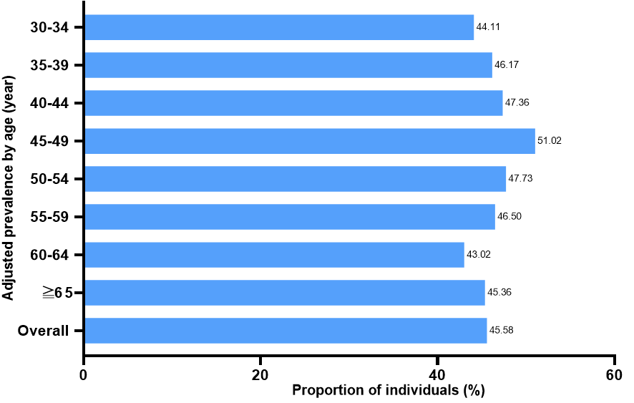  Male | 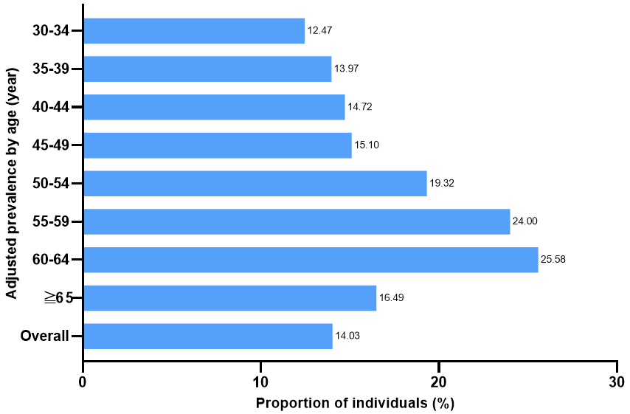  Male
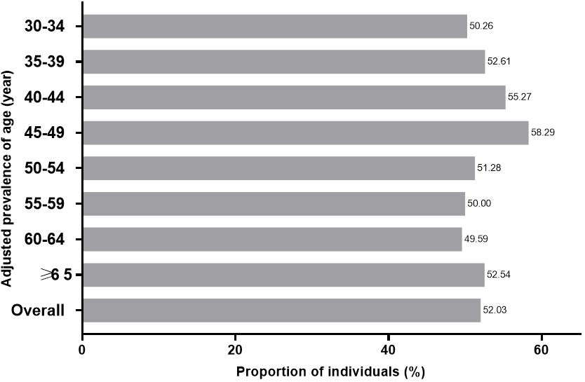 | 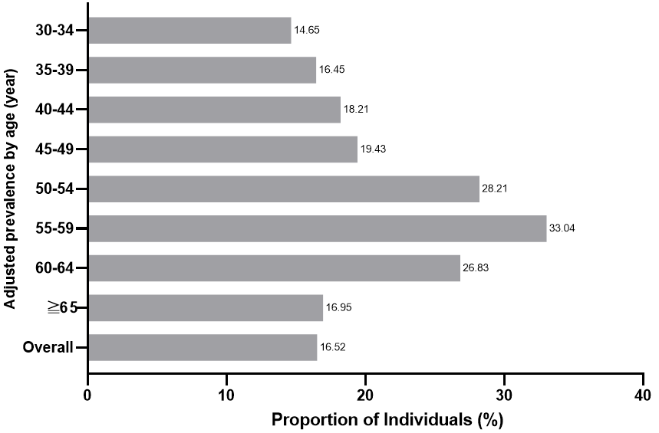
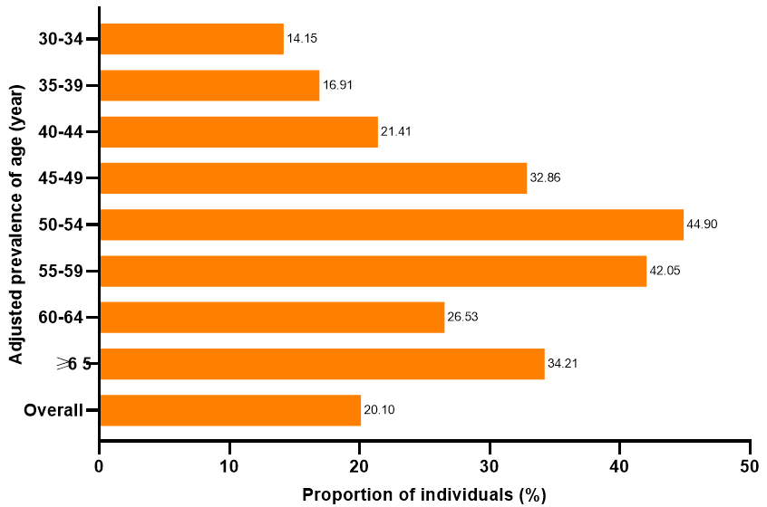  Female | 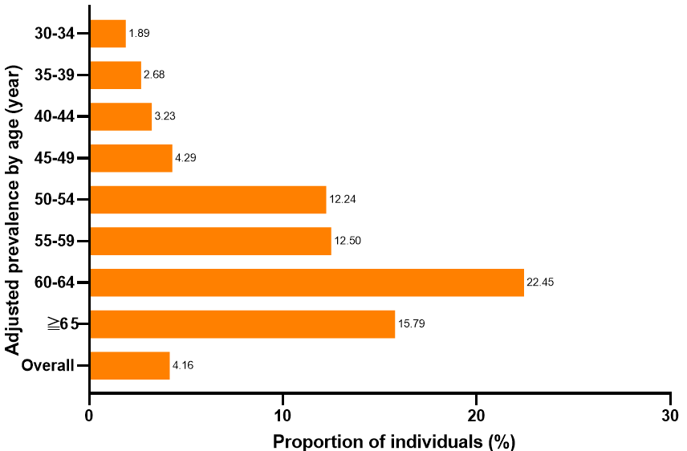  Female
Note: Data for the ‘overall’ bars in the figure are crude unadjusted prevalence of overweight or obesity. The prevalence by age groups is crude.
BMI, body mass index.
†Chinese classification criteria^{2,3} define overweight as BMI 24 to <28 kg/m² and obesity as BMI ≥28 kg/m².

FIGURE S3 Prevalence of complications among the overall study population and participants with body mass index (BMI) classified as normal, overweight or obesity using Chinese criteria†

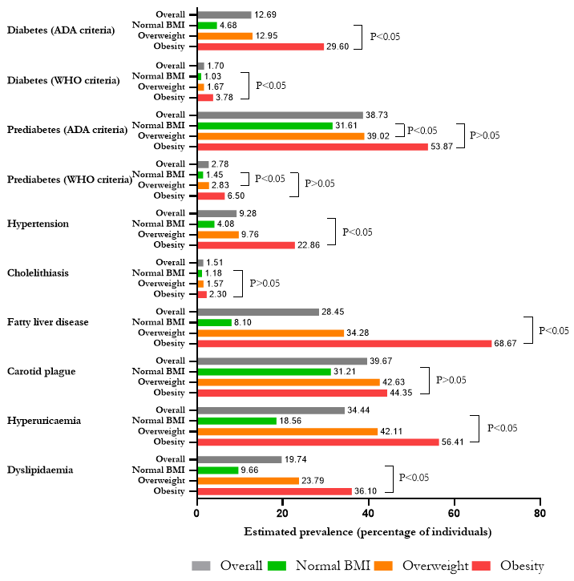
Note: †Chinese classification criteria^{2,3} define normal BMI as 18.5 to <24 kg/m², overweight as BMI 24 to <28 kg/m² and obesity as BMI ≥28 kg/m².

FIGURE S4 Number of complications among the overall study population and participants with BMI classified as normal, overweight or obesity using Chinese criteria†
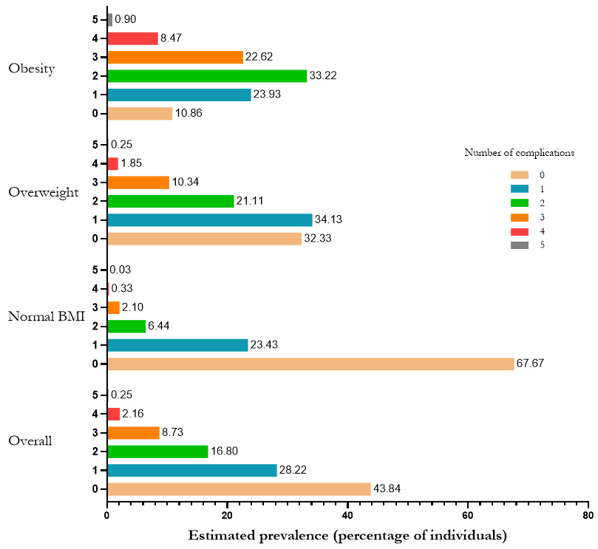
A (age≧30)
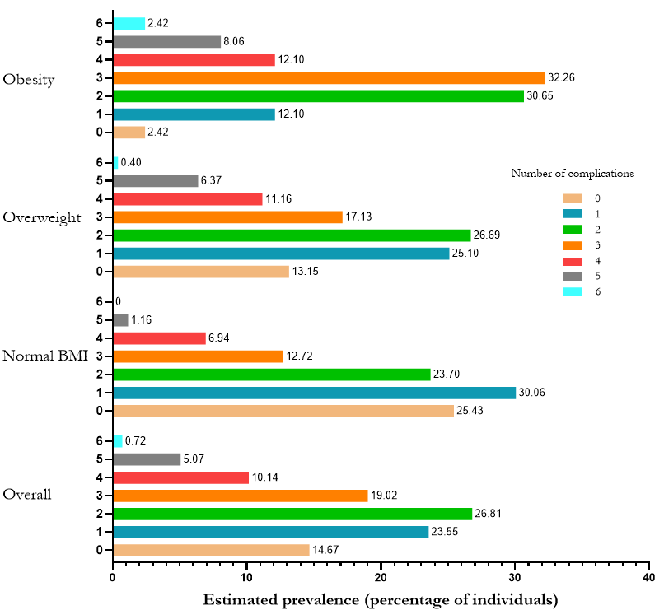
B (age≧50)
Note: Number of complications (A. age≥30; B. age≥50) was based on the presence of diabetes or prediabetes (assessed using WHO definitions), hypertension, hyperuricaemia, dyslipidaemia, fatty liver disease, cholelithiasis, and carotid plague (B. age≥50). Diagnostic criteria for complications are provided in the supplementary materials (p 4-5). The prevalence of complications was estimated using a logistic regression model, adjusting for age, sex and region (Haidian district, Changping district, Fengtai district, Yanqing district). P for trend was testing the null hypothesis of no trend in prevalence of complications in numbers over BMI classes, performed by analyzing BMI class as a continuous variable, with the median BMI value assigned to each BMI class. P for trend < .05 for number 0 and 1 of complications in the obesity group and 0 of complication in the overweight group (A. age≥30) and 6 of complication in the overweight group (B. age≥50). Otherwise, P for trend >.05.
ADA, American Diabetes Association; BMI, body mass index; WHO, World Health Organization.
†Chinese classification criteria^{2,3} define normal BMI as 18.5 to <24 kg/m², overweight as BMI 24 to <28 kg/m² and obesity as BMI ≥28 kg/m².

FIGURE S5 The distribution of the working unit of the check-up participants
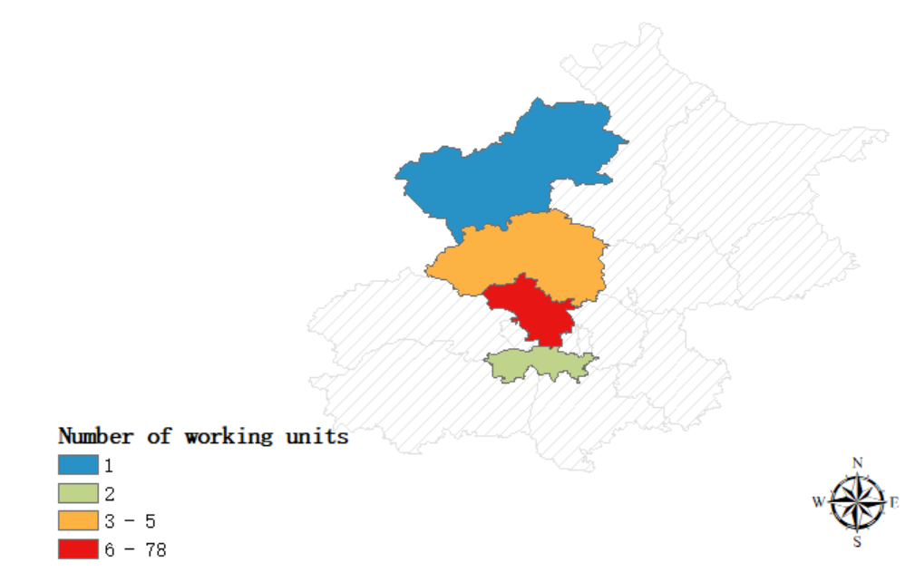

FIGURE S6 Prevalence of obesity by district in Beijing for the Chinese BMI classification
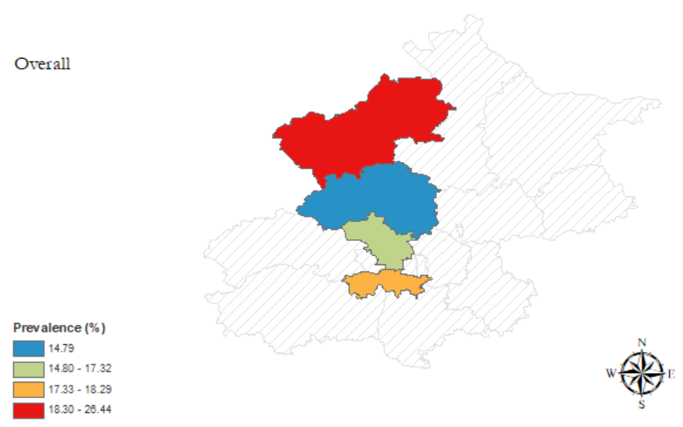
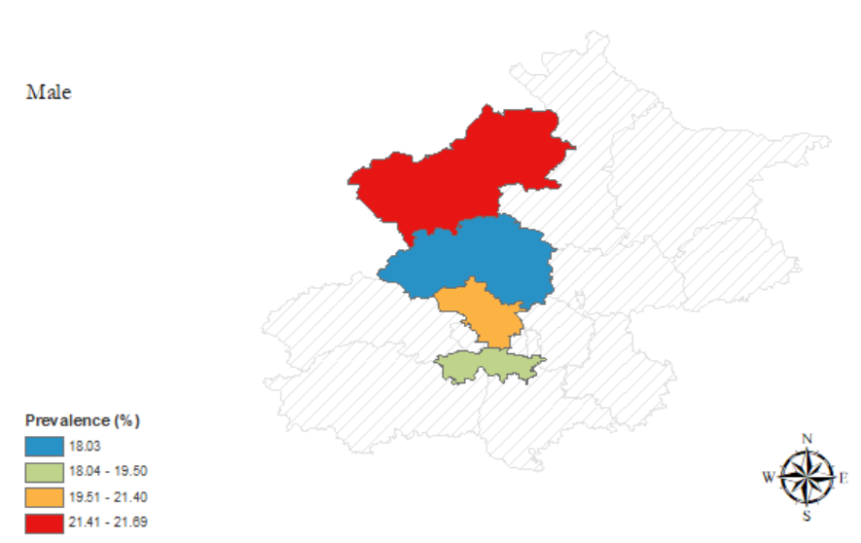

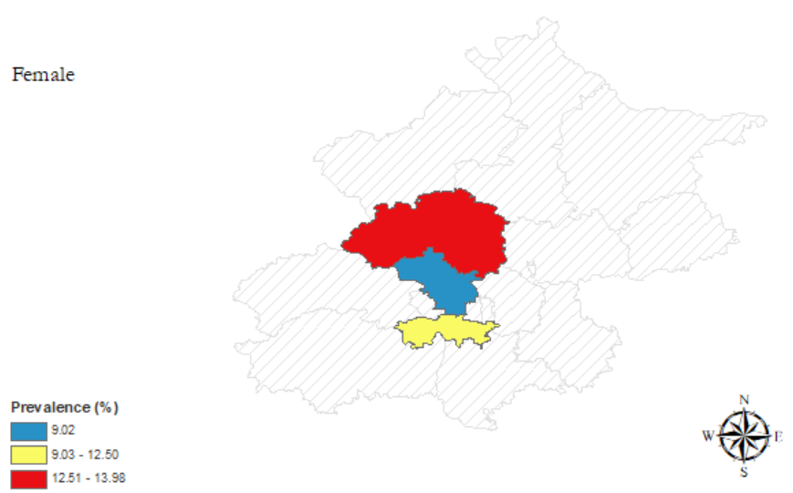

FIGURE S7 Prevalence of overweight by district in Beijing for the Chinese BMI classification
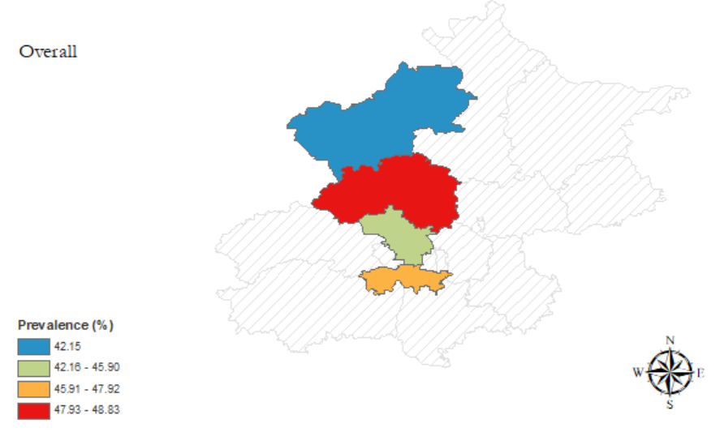
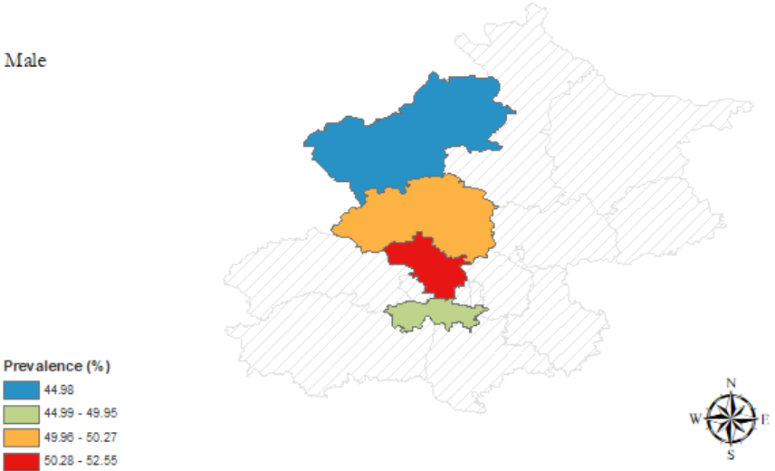

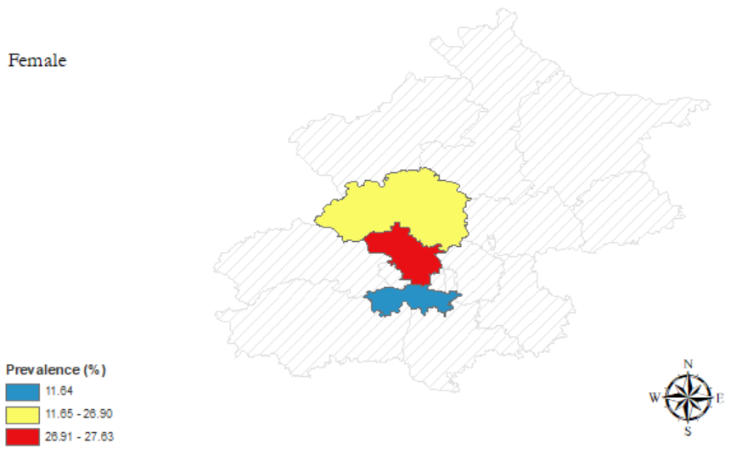

Reference
1. National Bureau of Statistics of China. China Population and Employment Statistics Yearbook 2020: China Statistics Press. Accessed December 1, 2023. https://www.chinayearbooks.com/tags/china-population-and-employment-statistics-yearbook
2. Zhou BF, Cooperative Meta-Analysis Group of the Working Group on Obesity in China. Predictive values of body mass index and waist circumference for risk factors of certain related diseases in Chinese adults--study on optimal cut-off points of body mass index and waist circumference in Chinese adults. Biomed Environ Sci. 2002;15(1):83-96.
3. Pan XF, Wang L, Pan A. Epidemiology and determinants of obesity in China. Lancet Diabetes Endocrinol. 2021;9(6):373-392.
4. World Health Organization. obesity: preventing and managing the global epidemic. Report of a WHO consultation. Accessed December 1, 2023. https://apps.who.int/iris/handle/10665/42330
5. National Bureau of Statistics of China. China Statistical Yearbook 2022: China Statistics Press . Accessed November 26, 2024. http://www.stats.gov.cn/english

