Supplemental material

Figures
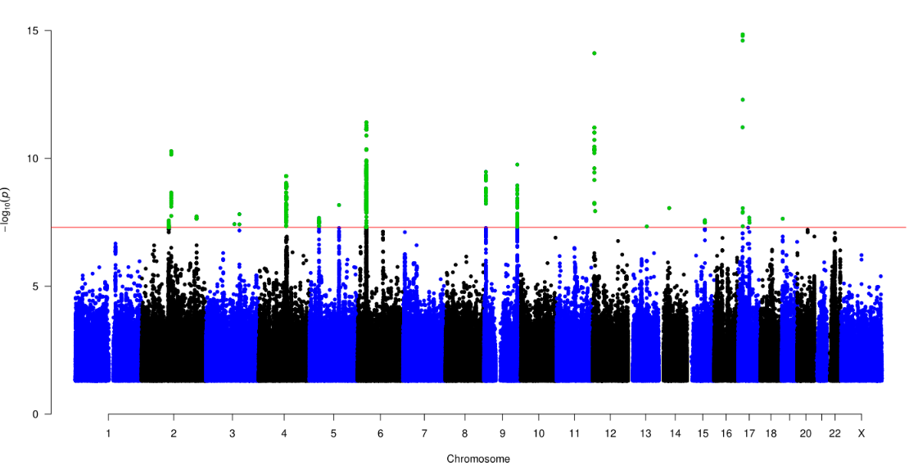
Supplementary Figure 1: Genome-wide association of inflammatory and infectious upper respiratory diseases (IURDs). Manhattan plot of p-values from GWAS of 16,355,289 variants with 61,197 cases of IURDs in the FinnGen study, detecting 20 genome-wide significant loci.

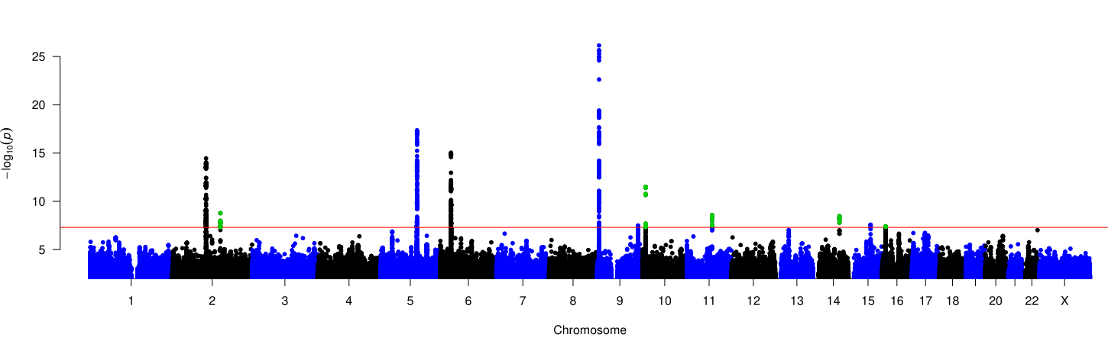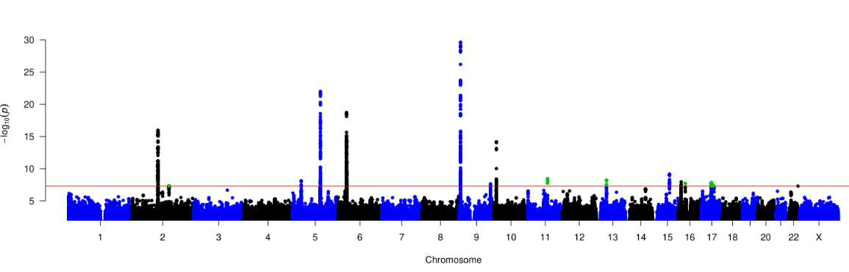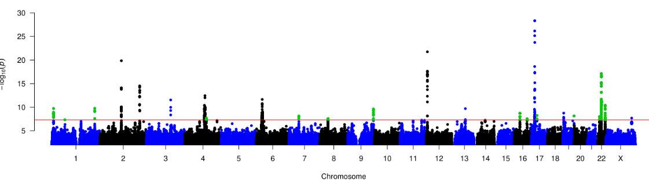
Supplementary Figure 2: Genome-wide association of IURD subgroups. A (top): GWAS of sinonasal diseases (n = 25,235) detected 13 GWS loci, replicating six loci identified by IURD analysis and additionally implicating genomic regions. B (middle): GWAS of CISD (n = 19,901), a subgroup of sinonasal diseases, associated 15 GWS loci, replicating nine loci and newly implicating six genomic regions. C (bottom): GWAS of pharyngeal diseases (n = 33,157) detected 25 GWS loci, replicating ten loci associated with IURDs and distinguishing 15 additional genomic regions. Loci not identified in the parent GWAS are highlighted with green.

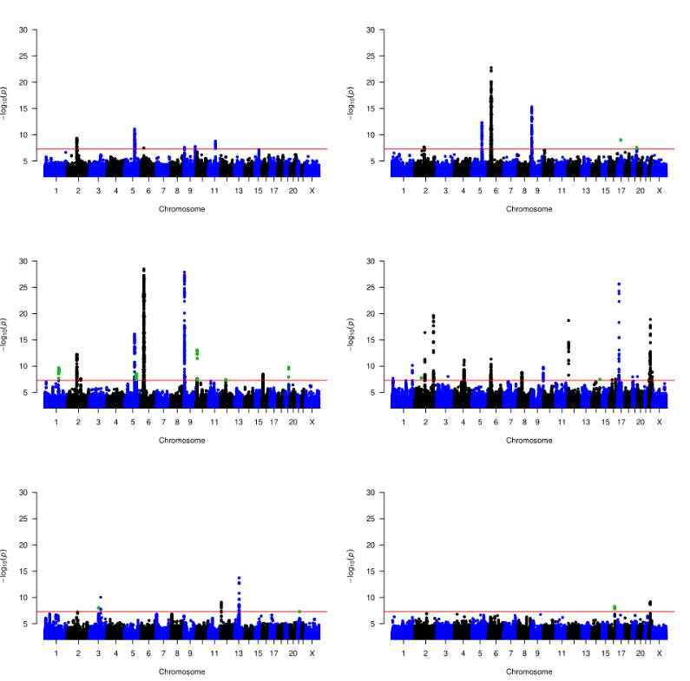
Supplementary Figure 3: Genome-wide association of IURD phenotypes. Manhattan plots of GWAS of IURD phenotypes against 199,208 controls. A (top left): 8975 cases of VAR link to six GWS loci; B (top right): 10,435 cases of CRS distinguish 7 GWS loci; C (middle left): 3919 cases of NP associate with 13 GWS loci; D (middle right): 29,135 cases of CDTA associate 21 GWS loci; E (bottom left): 4863 cases of PA associate with five GWS loci; F (bottom right): 48,687 cases of DPPT associate with two GWS loci.

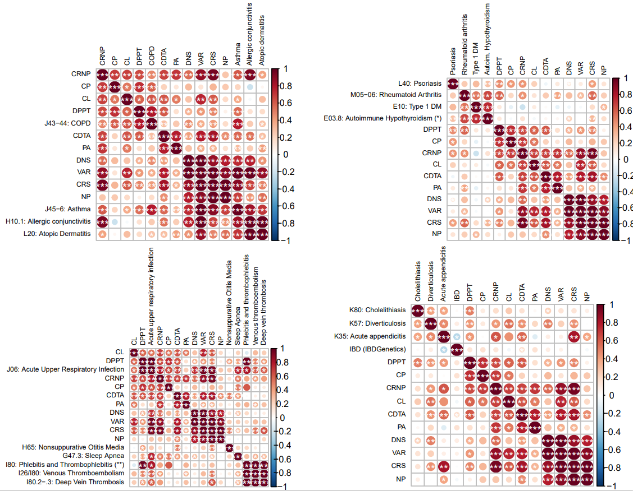
Supplementary Figure 4: Genetic correlation between IURD phenotypes and PheWAS-linked phenotypes. Genetic correlation was measured using LD Score regression. Each plot employs unsupervised hierarchical clustering. A (top left): Genetic correlation with allergic diseases and asthma, showing strong clustering with VAR, CRS, and NP. B (top right): Genetic correlation with autoimmune disorders, showing wide correlation with rheumatoid arthritis in particular. *Autoimmune hypothyroidism included all hypothyroidism cases, with non-autoimmune causes excluded post hoc. C (bottom left): Genetic correlation with other diseases of the upper respiratory tract, and thrombotic disorders, showing distinct clustering of sinus disorders from other chronic IURD infections. **Phlebitis and thrombophlebitis included all I80 cases except I80.2-.3. D (bottom right): Genetic correlation with inflammatory intestinal disorders. IBD (IBDGenetics) = Inflammatory bowel disease, summary statistics from Liu et al (ref 52). All other endpoints are from the FinnGen database. Inside the matrices: *p < 0.05, **p < 0.005, ***p < 1.9e-4. VAR = Vasomotor and allergic rhinitis; CRNP = Chronic rhinitis, nasopharyngitis and pharyngitis; CRS = Chronic rhinosinusitis; NP = Nasal polyps; NSD = Nasal septal deviation; CDTA = Chronic diseases of tonsils and adenoids; PA = Peritonsillar abscess; CLT = Chronic laryngitis and laryngotracheitis; DPPT = Diseases of pulp and periapical tissues; CP = Chronic periodontitis

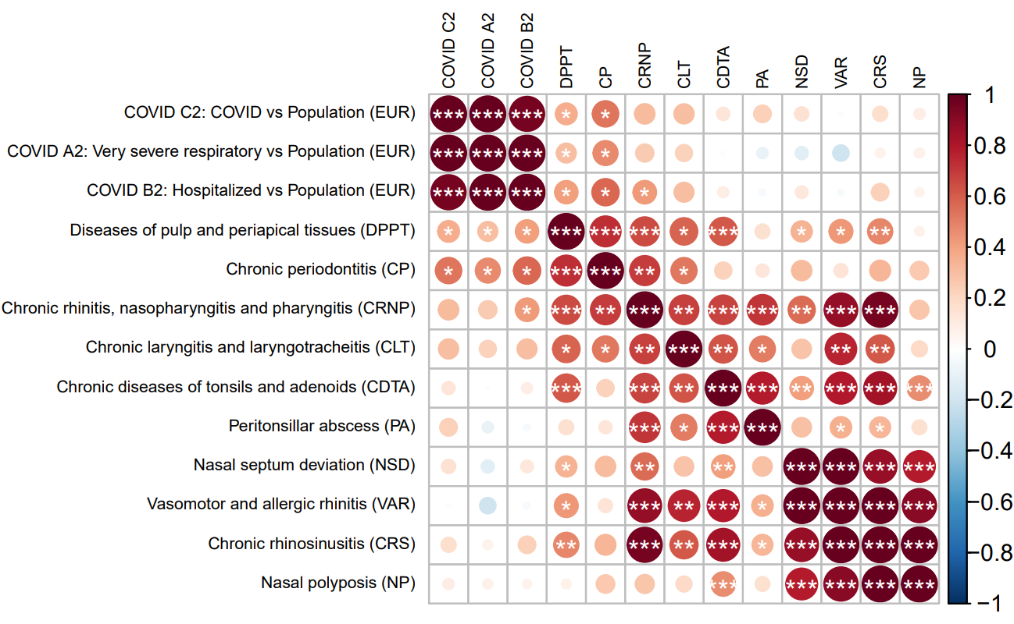
Supplementary Figure 5: IURD genetic correlation with COVID-19 phenotypes. Genetic correlation was measured using LD Score regression. The COVID-19 GWAS summary statistics are from the Host Genetics Initiative (ref. 6). Genetic correlation was observed between COVID-19 endpoints and DPPT, CP, and CRNP. *p < 0.05, **p < 0.005, ***p < 1.9e-4.

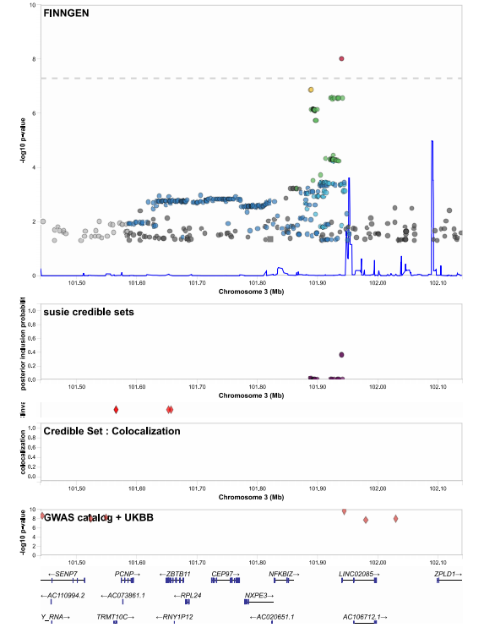
Supplementary Figure 7: Locus zoom plot of NFKBIZ locus in GWAS of peritonsillar abscess. Top: p-values of SNPs in the genome-wide association analysis, with lead SNP denoted in purple and color scaling from red to yellow to green to blue in decreasing LD. Blue line is the population recombination rate at different genomic locations. 2nd graph: SNPs in credible set, with posterior probability on the vertical axis. 3rd graph: colocalized credible sets of other FinnGen endpoints in the locus. 4th graph: GWAS Catalog reported lead SNPs and UKBB associated SNPs (Neale lab analyses). Bottom: genes denoted in this location (including non-coding).

