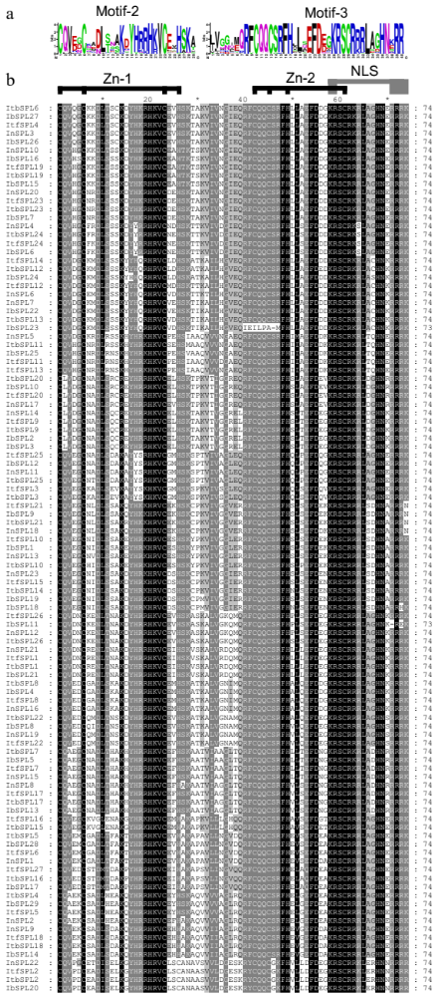
Supplementary Figure S1. Conserved SBP domain and motifs in Ipomoea SPL proteins
(a) Sequence logo of the conserved motifs in SBP domain. The motifs were identified by the MEME software. The height of each stack indicates the degree of conservation at each position, and the height of the letters within each stack represents the relative frequency of the corresponding amino acid. (b) Multiple alignment of the conserved SBP domain. The two non-interleaved zinc finger-like structures (Zn-1/2) and one nuclear localization signal (NLS) were indicated on the top. Multiple sequence alignment of the SBP domain were shown on the below.

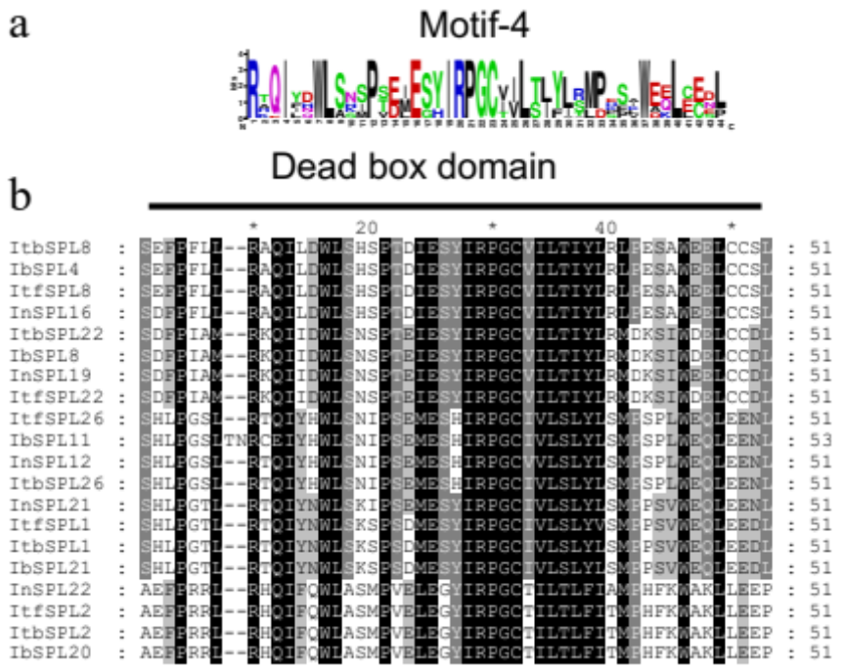
Supplementary Figure S2. Conserved DEXDc domain and motifs in Ipomoea SPL proteins
(a) Sequence logo of the conserved motifs in DEXDc domain. The motifs were identified by the MEME software. The height of each stack indicates the degree of conservation at each position, and the height of the letters within each stack represents the relative frequency of the corresponding amino acid. (b) Multiple alignment of the conserved DEXDc domain.

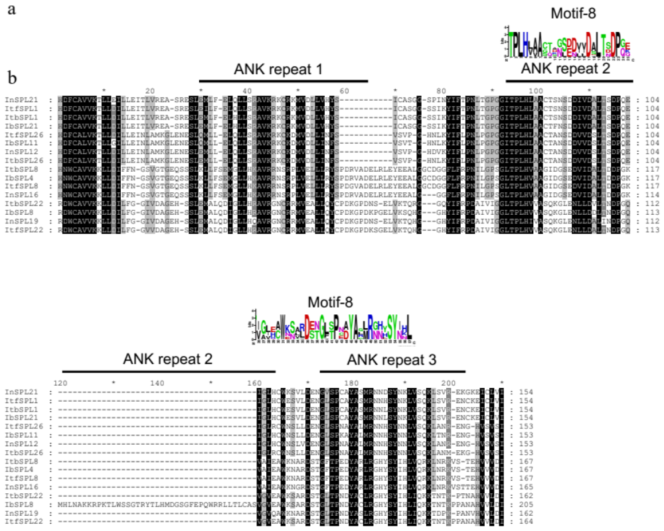
Supplementary Figure S3. Conserved ANK repeats and motifs in Ipomoea SPL proteins
(a) Sequence logo of the conserved motifs in ANK repeats. The motifs were identified by the MEME software. The height of each stack indicates the degree of conservation at each position, and the height of the letters within each stack represents the relative frequency of the corresponding amino acid. (b) Multiple alignment of the conserved ANK repeats.

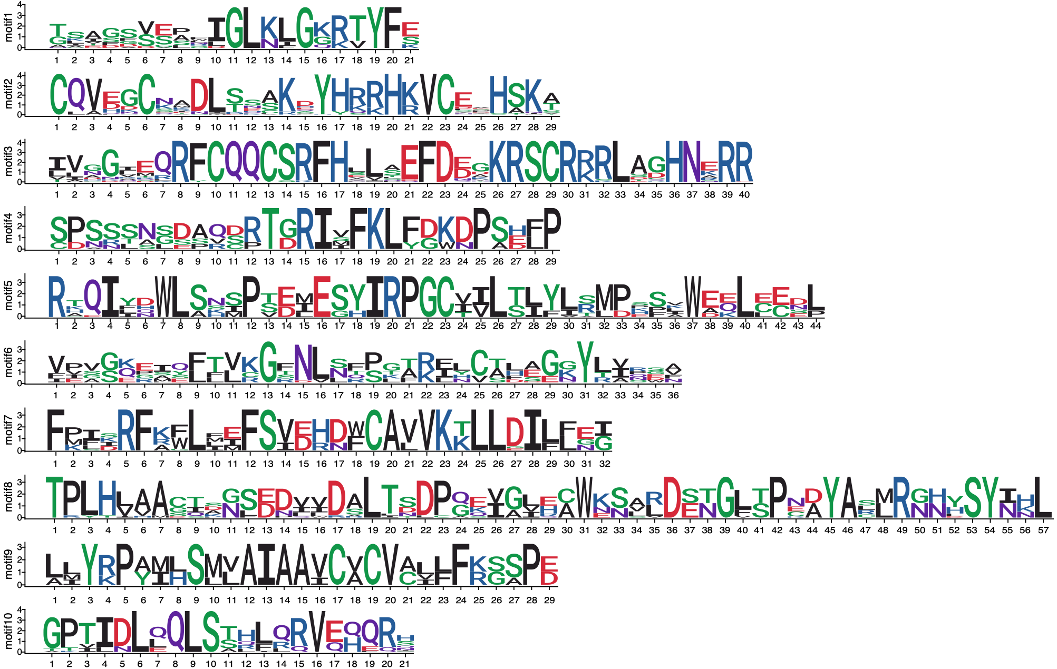
Supplementary Figure S4. Sequence logo of the ten conserved motifs
The height of each stack indicates the degree of conservation at each position, and the height of the letters within each stack represents the relative frequency of the corresponding amino acid.

Supplementary Figure S5. Syntenic relationships of Ipomoea SPLs
(a) The colinear relationship among SPL genes in I. trifida. (b) The colinear relationship among SPL genes in I. triloba. (c) The colinear relationship among SPL genes in I. nil. Colored lines indicate syntenic regions. Ipomoea SPL genes can be classified into four duplicated types, and marked as different colors.

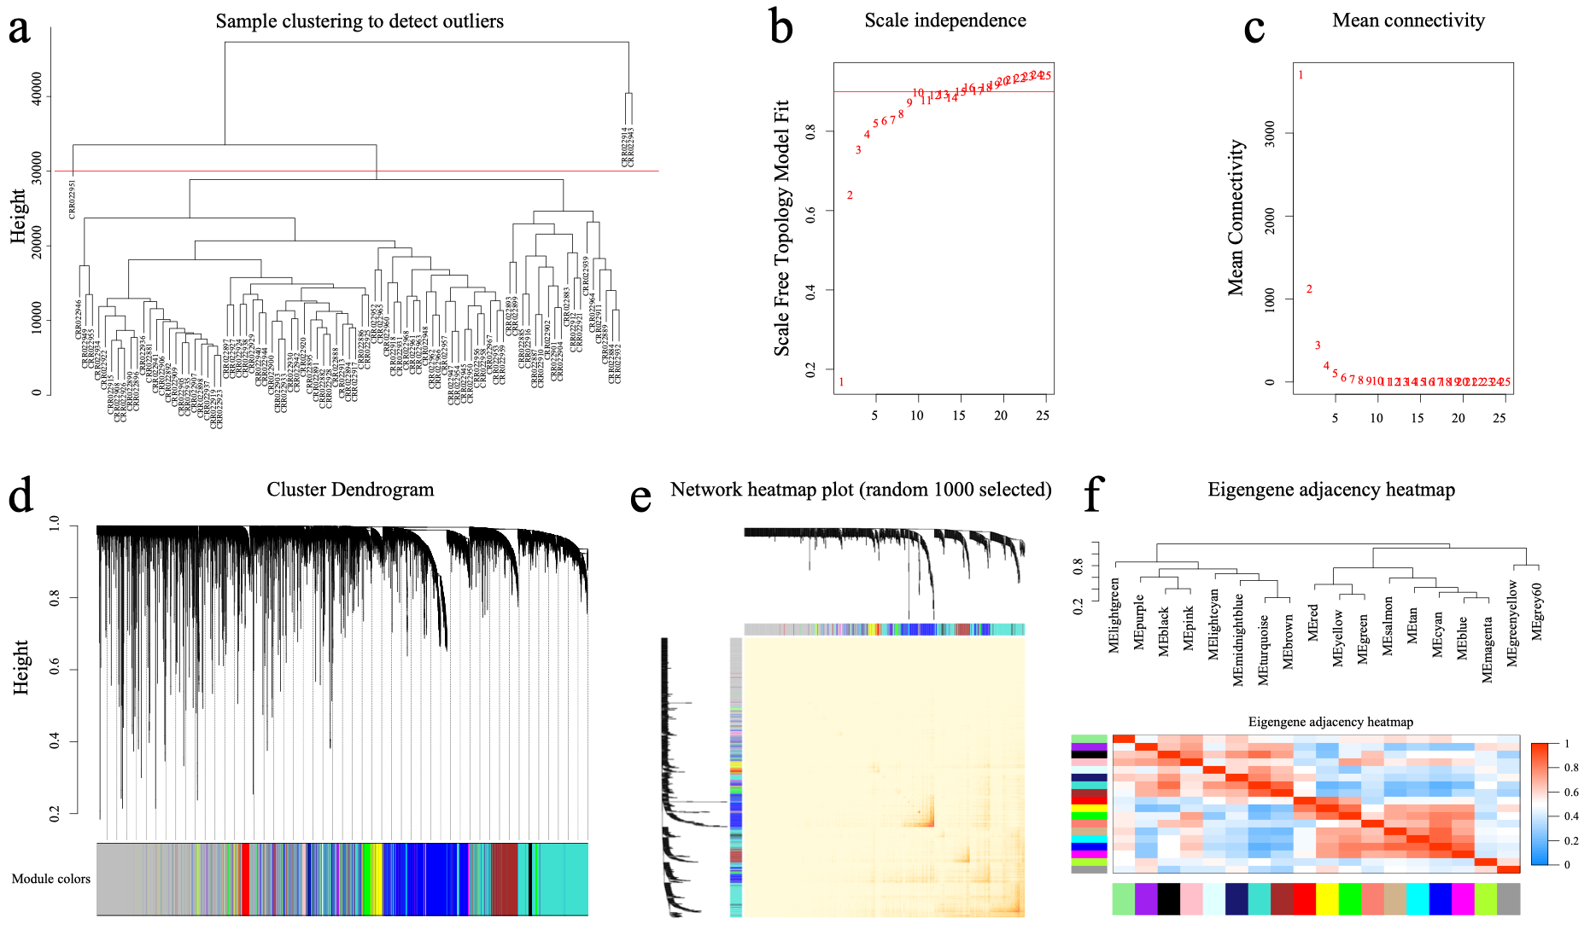
Supplementary Figure S6. WGCNA network and module detection
(a) Sample clustering was performed to detect outliers. CRR022914, CRR022943, and CRR022951 were considered as outlier samples, and were removed from the further analysis. (b, c) Selection of the soft-thresholding powers. Power 9 was selected, for which the fit index curve flattens out upon reaching a high value. (d) Cluster dendrogram and module assignment. Each color indicates one assigned module, and branches represent genes. 19 modules with 19431 genes were detected. (e) Heatmap shows the Topological Overlap Matrix (TOM) of 1000 genes selected randomly for WGCNA. (f) The cluster dendrogram constructed based on the eigengenes of the modules (excluding grey module) (above) and the heatmap for the correlation coefficient between the modules (below).

