Visual representation of Research Paper
“Optimizing MOOCs for Student Engagement: Insights from Conjoint Analysis”

Abstract
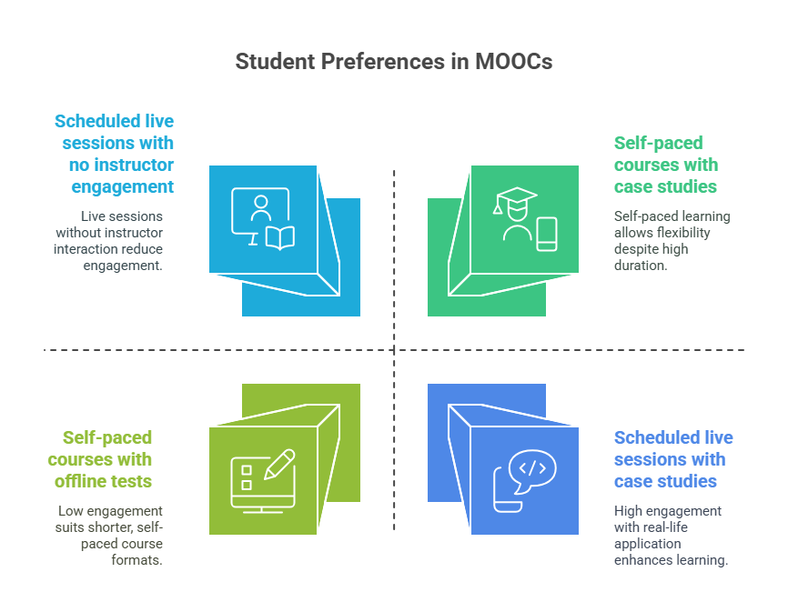
Introduction
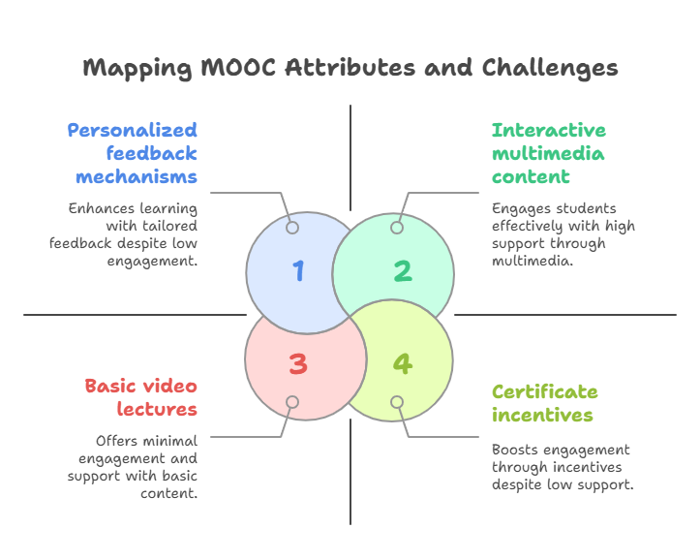
Statistical Analysis & Results
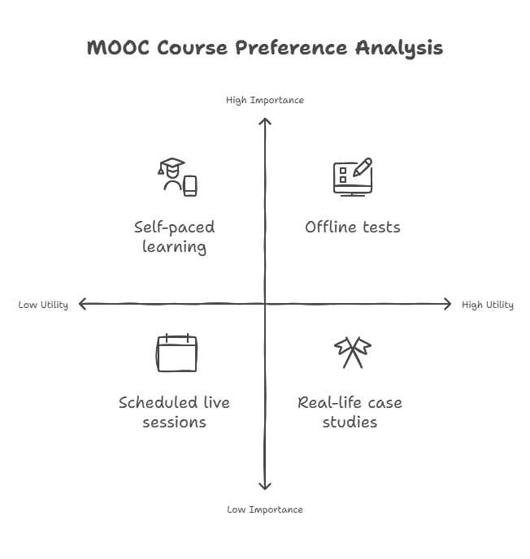
Discussion
