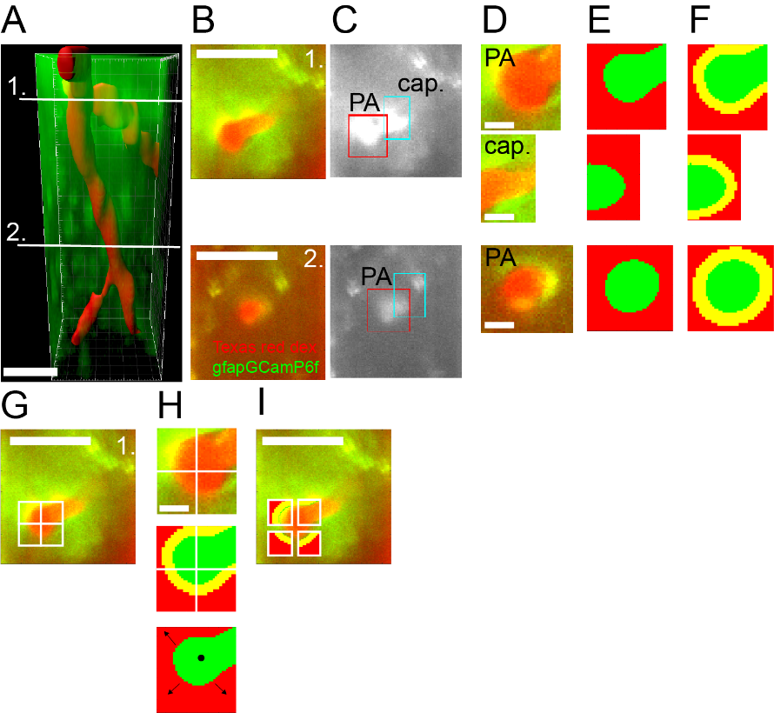
Supplemental Figures:
Sup. Figure S1. Method to detect vessel position and astrocyte end-feet ROIs within manually defined vessel segments in a 3D-FOV.
- 3D reconstruction of a PA with two 1st order capillary branches taken 40-240 µm below the cortical surface. The image represents the cumulative average of a 3D-FOV (x= 75.5 µm, y= 75.5 µm, z=200 µm) timeseries (104 s) taken from the auditory cortex of a Texas red-dextran injected GFAPCreERT2:GCaMP6f mouse. Red: Masked vessel lumen. Green: cumulative GCaMP6f signal in astrocyte structures. White lines indicate the position of the two z-levels shown in B-F. Scalebar: 30 µm.
- Two 2D x-y images from the cumulative averaged x-y-z stack in A representing individual scanned focal planes at z-levels 1 and 2 respectively. Red: Texas red-dextran in the vessel lumen. Green: GCaMP6f signal in astrocyte structures. Scalebar: 30 µm.
- Rectangular regions framing relevant vessel segments were manually defined at the two z-levels shown in A-B. In each experiment, such rectangular regions were defined at each z-level for each 3D-t scan performed. Their manual definition was done consistently from one z-level to the other to follow the same vessel between layers. Red rectangle: PA segment; blue rectangle: capillary segment.
- Average fluorescence signals in the two cropped rectangular regions defined in C. The regions contain both the Texas red-dextran signal, outlining the specific vessel segments shown in C, and the GCaMP6f signal coming from the astrocyte structures surrounding the vessel segments. Scalebar: 5 µm.
- The area of each vessel segment (here depicted in green) in the cropped rectangles was automatically determined by masking the normalized, gaussian filtered images using a custom-written software (see Methods).
- End-feet structures (here depicted in yellow) were automatically defined for each cropped rectangle as 2 um-thick annular ROIs around the vessel structures in continuity with the vessel’s edges.
- Same rectangular crop from z-level 1 shown in C-F presenting the average red and green fluorescence from a Texas red-dextran injected GFAPCreERT2:GCaMP6f mouse. The cropped image captures the PA before dilation and was divided into four quarters to allow repositioning relative to changes in vessel diameter. Scalebar: 30 µm.
- Following dilation, the quarters in the rectangular crop shown in G were moved relative to the positions of the PA centromere (black point) and of the borders of the vessel lumen (arrows) to adapt to the increased vessel volume, as described in Methods “3D imaging data analysis”. Scalebar: 5 µm.
- The end-feet ROIs in the quarters of the cropped rectangle are repositioned following dilation relative to the new vessel position and diameter change. Only after this operation, measurements of astrocytic end-feet Ca2+ activity were made. Scalebar: 30 µm.

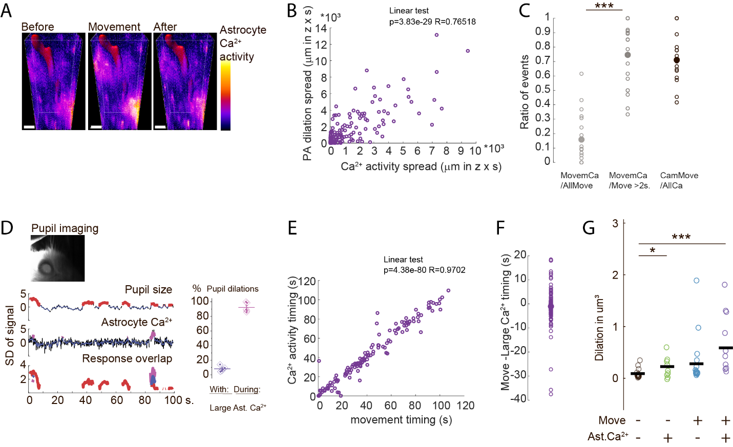
Sup. Figure S2. Correlation between movements, large astrocytic Ca2+ events, and dilations.
- Astrocyte Ca2+ levels measured as cumulative average of the GFAP-GCaMP6f signal (pseudocolor) in a large-volume 3D-FOV along the PA during 5 s periods when the animal was at rest before moving (left), when it moved (middle) and when it was at rest again after movement (right). Red: Masked vessel lumen. Cortical depth 40-240 µm. Scalebar: 20 µm.
- Linear correlation between the spatial spread (µm in z x s) of astrocyte Ca2+ activities and of PA dilations during movements (N= 145 dilations events, 8 PAs, in 6 mice), measured using 10-20 µm steps in z-stacks covering 100-280 µm of the depth of the cortex beginning from 50-100 µm below the surface (Pearson linear correlation p=3.9x10⁻²⁹, R=0.76).
- Proportion of cases in which large astrocyte Ca2+ activity and movement of the mouse overlap during each experiment, relative to the total number of: movements (left), long movements (>2s, middle), or large Ca2+ activities (right). Considering all movements, they were accompanied by astrocytic Ca2+ activity in only some cases (left); however, considering just long-duration movements, the astrocytic Ca2+ activity was present in more cases (middle: Mann-Whitney test, p=0.0007, 11.1±4.6 Ca2+ events and 54.0±24.5 movement events in N=20 FOV in 6 mice). Considering the cases of large astrocytic Ca2+ activities, they appeared in association with a movement (of any duration) in 71.1±7.5% of cases.
- Top: Mouse pupil diameter changes recorded during two-photon imaging sessions. Bottom, left: example of simultaneous traces of pupil size (top), average astrocytic Ca2+ activities (middle) and their overlay (bottom). Pupil dilations periods (>2SD) are shown in red. Astrocyte Ca2+ activities periods (>2SD) are shown in purple. The overlay shows in blue the overlapping periods. Bottom, right: percentage of pupil dilations accompanied by a large astrocyte Ca2+ activity (left) and, vice versa, percentage of large astrocytic Ca2+ activities occurring in overlap with a pupil dilation (right). (N=95 astrocyte Ca2+ activities and N=450 pupil dilations in 5 mice).
- Linear correlation between the onset time of the astrocyte Ca2+ activity and the onset time of the animal movements considering all those movements associated with a large Ca2+ activity. N = 129 events from 20 FOVs. (Pearson linear correlation, p=4.37x10⁻⁸ R=0.97).
- Onset time of movements relative to onset time of Ca2+ activity in the same event population as in E (129 events from 20 FOVs). Movements initiated on average 1.03±1.25s before the astrocytic Ca2+ activity.
- Average vessel lumen expansion (µm³) during dilation events per FOV in different conditions: at rest (black: 162±31.2 dilations/FOV); at rest in the presence of a large astrocyte Ca2+ activity (green: 4.2±2.0 dilations/FOV); during animal movement without large astrocyte Ca2+ activity (azure: 47.6±22.1 dilations/FOV); during animal movement with large astrocyte Ca2+ activity (violet: 6.5±2.5 dilations/FOV). All conditions in N = 20 FOV in 6 mice. Compared to dilations during rest, dilations accompanied by large astrocytic Ca2+ activities, alone or simultaneously with movements, were significantly larger (Paired t-test, with Holm correction: Rest vs. Ca2+: p=0.033 and vs Ca2+ during movements: 0.00039. Rest vs movement: p= 0.12. Movement without vs with Ca2+ p=0.062. All values were compared with ANOVA before t-test p=0.0011).

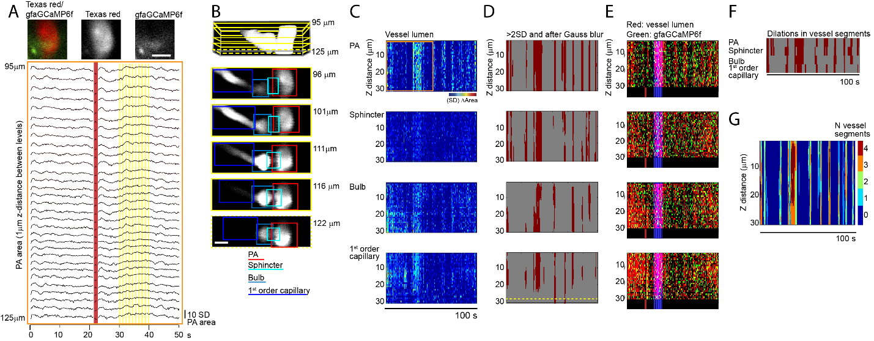
Sup. Figure S3. Method to detect dilation patterns in a 3D-FOV
- Top: cumulative average two-photon image of a PA at the capillary branch point and surrounding astrocyte end-feet in a single z-level focal plane in auditory cortex during a tone stimulation experiment. Red: Texas red-dextran shows vessel lumen. Green: GFAPGCaMP6f highlights astrocyte structures via the cumulative Ca2+ signal during the acquisition. Left: color overlay of red and green channels; middle: red channel (represented in black and white); right: green channel (in black and white). Scalebar: 10 µm. Bottom: changes in the PA vessel area shown for all the focal planes recorded in z between 95-125 µm below the surface at 1 µm interdistance. Red line: identifies the timing of a dilation throughout the FOV related to a short animal movement; yellow highlight: identifies the period of a longer dilation evoked by a tone stimulation.
- Top: cumulative average of the entire 3D stack of Texas red-dextran vessel lumen images (white) used in panel A and in the rest of this figure. Yellow rectangles outline the position in the stack of the 5 z-levels used as examples below. One of the levels is stippled as it represents the example also shown in panel D. Bottom: rectangular crops of the images at each of the 5 selected z-levels are manually defined as explained in Suppl. Fig. 1C and color-coded to mark the various vessel segments (red: PA; cyan: sphincter; light blue: bulb; blue: 1st order capillary). Imaging depths below cortical surface are indicated next to the pictures. Scalebar: 10 µm.
- Representative z-t depiction of the changes in vessel area during a 100 s 3D imaging session for (top to bottom) PA, sphincter, bulb and 1st order capillary. The normalized values of changed vessel area measured in the rectangular x-y image crops at each z level are shown in a map of pixel intensity (jet colormap) over time. The orange box in the PA depiction marks the same period and z-levels presented as traces in panel A.
- Binarization of the data shown in C: periods of dilations (red) correspond to periods in which the z-t pixels have >2SD values after Gaussian filter blurring. Notice that the capillary in this example is only present in the top and bottom z-levels during the largest expansions as illustrated by the yellow dotted line at the bottom of the panel.
- Representative z-t depiction of the changes in vessel area during the 100 s 3D imaging session overlaying the normalized vessel area detected with Texas red for each z-level (red) and the average GFAP-GCaMP6f Ca2+ signal from astrocyte end-feet surrounding the vessel at the corresponding z-level (green). In overlay is also shown in blue the period with tone stimulation, giving an overall pinkish appearance. For better visual clarity, the blue period is also shown in a black bar below the z-t depiction, together with a red line indicating the time of a mouse movement.
- Summary of the dilation periods (red) for each of the four vessel compartments shown in D, here presented in a binary form that just displays dilation or non-dilation of the whole compartment. This representation visualizes the timing of all the dilations and highlights that different dilations initiate at different vessel segments. However, it disregards the individual event’s characteristics that are instead presented in D (x-y area of dilation, shown as pixels’ intensity) and in E (z-levels involved in the dilation).
- Overlay of the dilation patterns of the different vessel segments summarized in F. In this case, a color code is used to show the number of vessel segments participating in each dilation at any specific time during the 100 s acquisition period. The graphical representation helps visualizing that not all vessel segments participate in each dilation.

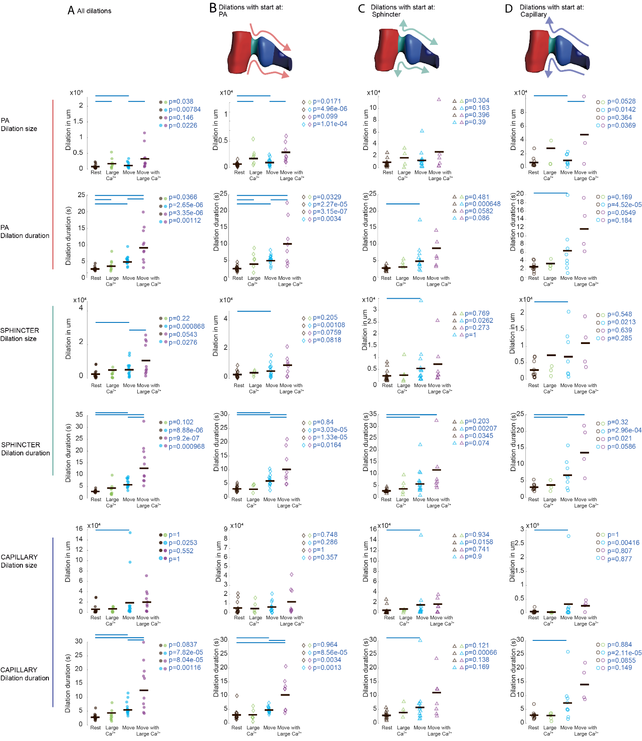
Sup. Figure S4. Size and duration of dilations in different vessel segments do not depend on the initiation site but are differently affected by the mouse movements and by large astrocytic Ca2+ activity.
- Column presenting quantitative analysis of the size and duration of all the dilations seen in the different vessel segments (from top to bottom: PA, sphincter, and capillary) independent of the initiation site but according to the condition in which they occurred, namely during: resting periods of the mouse (black circles); resting periods showing large astrocytic Ca2+ activities (green circles); periods of movement of the mouse (azure circles); periods of movement showing large astrocyte Ca2+ activities (violet circles). The main observations are: in the resting mouse, when astrocyte Ca2+ activity was present, size and duration of the dilations increased at the level of the PA, but not of the sphincter and 1st order capillary. When the mouse moved, but no large astrocyte Ca2+ activity was seen, duration and size of the dilations increased in all three segments. The co-occurrence of movement and large astrocyte Ca2+ activity led to an increase in duration of dilations in all vessel segments, but only increased size of dilations in PA and sphincter. Number of dilations/FOV were: during rest: 162±31.2; during rest + large astrocyte Ca2+: 4.2±2.0; during movement without astro Ca2+: 47.6±22.1; during movement + large astrocyte Ca2+: 6.5±2.5. Statistical comparisons were performed with the t-test, modified with Holm correction for multiple comparisons. All comparisons (colored circles) and corresponding p-values are shown in the figure; if p>0.05, a blue line is shown above the two compared datasets. Data from: N=20 FOV in 6 mice.
- Column presenting the same type of analysis as in A but restricted to dilations with a perceived initiation at the PA, i.e. arriving from the PA compartment (symbols: diamonds). The results are largely similar to those obtained in A, where we considered all dilations independent of their initiation site. Number of dilations/FOV were: during rest: 50.9±12.8; during rest + large astrocyte Ca2+: 1.92±0.8; during movement without astro Ca2+: 15.0±7.1; during movement + large astrocyte Ca2+: 2.1±0.9. Statistical comparisons were performed and are presented as in A.
- Column presenting the same type of analysis as in A and B but here restricted to dilations starting at the sphincter (symbols: triangles). These dilations do not apparently show sensitivity to large astrocytic Ca2+ activities but are affected by movements similarly to what seen in A. Number of dilations/FOV were: during rest: 40.3±8.5; during rest + large astrocyte Ca2+: 1.6±0.5; during movement without astro Ca2+: 12.4±6.9; during movement + large astrocyte Ca2+: 2.3±1.0. Statistical comparisons were performed and are presented as in A.
- Column presenting the same type of analysis as in A, B and C, but here considering just dilations with a perceived initiation at the capillary level, i.e. arriving from the capillary compartment (symbols: circles). These dilations, like those starting at the sphincter, do not appear to be strongly affected by large astrocytic Ca2+ activity, but are affected by movements similarly to what seen in A. Number of dilations/FOV were: during rest: 56.4±13.0; during rest + large astrocyte Ca2+: 2.1±0.8; during movement without astro Ca2+: 14.7±7.9; during movement + large astrocyte Ca2+: 2.4±0.7. Statistical comparisons were performed and are presented as in A.

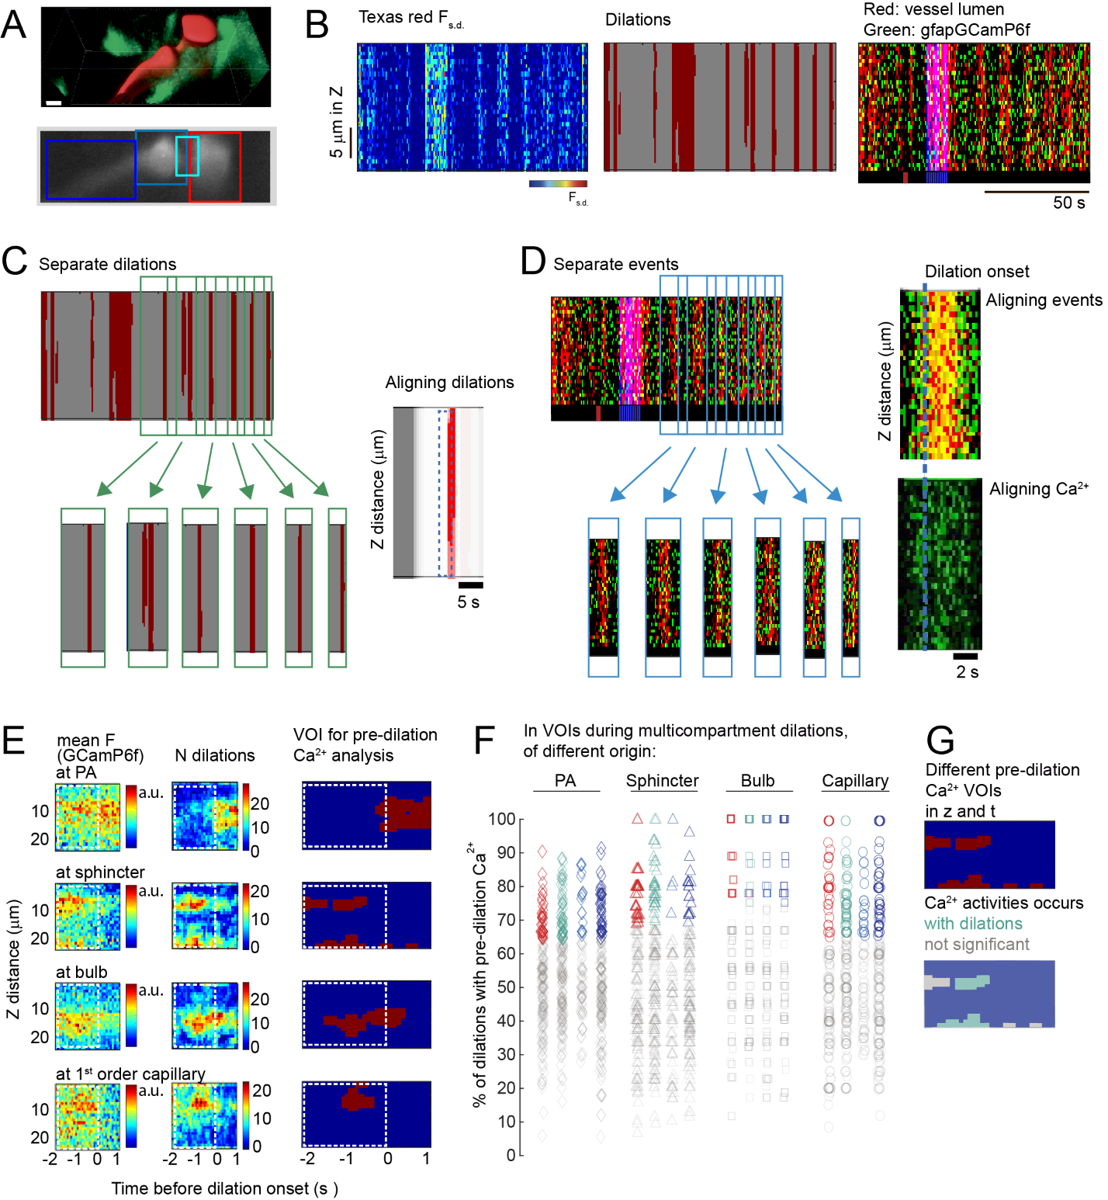
Sup. Figure S5. Method to detect regions with pre-dilation astrocytic Ca2+ activity.
- Cumulative average of a 3D timeseries from the auditory cortex of a Texas red-dextran-injected GFAPCreERT2:GCaMP6f mouse, revealing a 1st order capillary branch from a PA and neighboring astrocyte structures. Top: entire 3D stack taken 64-86 µm below the cortical surface. Red: masked vessel lumen. Green: GFAPGCaMP6f signal outlining the surrounding astrocyte structures. Bottom: an individual focal plane from the same stack, taken 72 µm below the surface. The average Texas red-dextran signal from the vessel lumen in black and white and four manually drawn color-coded rectangles identify the different vessel segments: red: PA; cyan: sphincter; light blue: bulb; blue: capillary. Scalebar: 5µm.
- Representative z-t depiction of the dilation events of the PA during the 100 s 3D imaging session across the different z-levels. Data are presented as in Fig S3C-E (see there for more details). Left: normalized values of changed vessel area measured in the rectangular x-y image crops at each z level are shown in a map of pixels intensity (jet colormap) over time. Middle: the data on the left are binarized to depict the periods of dilation (red) and the level of expansion of the dilations along the z-axis. Right: normalized signal from Texas red (red) and GFAPGCaMP6f (green). Blue: period indicates tone stimulation. Red in the black bar below the z-t depiction identifies a movement of the mouse.
- Left: Periods with dilation events detected in the z-t rendering were considered separate events (see criteria in Methods, section “Detection of dilation events and patterns”) and cropped (green arrows and boxes). Right: as in the example, all the crops where temporally aligned based on the onset time of each dilation to allow for detection of recurrent “pre-dilation” astrocyte Ca2+ activity in a 3-sec period including the 2-sec preceding dilation onset (blue dashed line box) and the first second after dilation start, the latter to avoid abrupt cutting Ca2+ dynamics initiated within the 2-sec pre-dilation period.
- Same data as in B, showing on the left the normalized vascular signal from Texas red (red) and astrocyte end-foot Ca2+ from GFAPGCaMP6f (green). Data related to separate dilations are cropped and temporally aligned as in C. Right: expanded example of the average Texas red and GFAP-GCaMP6 signals (top), or only the latter (bottom), showing that astrocytic Ca²⁺ activity rises before start of dilation (dotted blue line) and lasts through the dilation.
- Defining the z-t position of astrocytic pre-dilation Ca²⁺ activity in different end-feet ROIs on the vessel segments. The 2-sec period before dilation onset is marked with a white dashed box. Left: mean GFAP-GCaMP6f signal (pseudocolor scale) in astrocyte end-feet during the relevant 3-sec period in relation to vessel segments. Middle: the pseudocolor scale indicates in this case the number of dilations (N) during all imaging sessions showing an astrocyte Ca2+ elevation at this time and depth in z. The number of Ca2+ elevations was defined by summing up all the individual masks created from the mean GFAPGCaMP6f signals. Right: Binarization of the Ca2+ signals after Gaussian filtering; the resulting mask (red in blue background) defines the putative recurrent “pre-dilation Ca²⁺ signals” as voxels of interest (VOI) in relation to cortical depth and time relative to dilation onset. This mask was then used to evaluate for each individual dilation the presence or not of these specific VOIs of pre-dilation Ca2+ activity, as described in methods section” Detection and analysis of pre-dilation astrocytic 3D Ca2+ activity”.
- Percentage of dilations preceded by pre-dilation end-foot Ca2+ activity in VOIs located at the level of different vessel segments, according to the segment of origination of the dilation. The colors of the data points indicate the vessel segment at which the astrocytic end-feet VOI is located (red: PA; cyan: sphincter; light blue: bulb; blue: capillary). The symbols indicate the vessel segment of origin of the dilation (diamond: PA; triangle: sphincter; square: bulb; circle: capillary). The level of prevalence was used to define whether pre-dilation Ca2+ activities could be considered concurrently present in relation to a given dilation pattern. They were considered present if they occurred with 100 % of dilations subtracted of the 0.1 confidence limit, which depended on the number of dilations of a given dilation pattern (see Methods). The colored data points mark the pre-dilation Ca2+ activities that were considered statistically present before dilations of a specific pattern. The grey data points mark the activities that were not counted.
- Illustration of the statistical attribution of a group of astrocyte Ca2+ events to the specific sub-group of pre-dilations Ca²⁺ events. Top: binarized astrocyte Ca2+ elevation VOIs at the sphincter shown in E. Bottom: the Ca2+ events occurring consistently before all dilations (cyan because around sphincter) were assigned to the “pre-dilation” sub-group (see F), the others appearing randomly before only some of the dilations were not included in the “pre-dilation” events (grey).

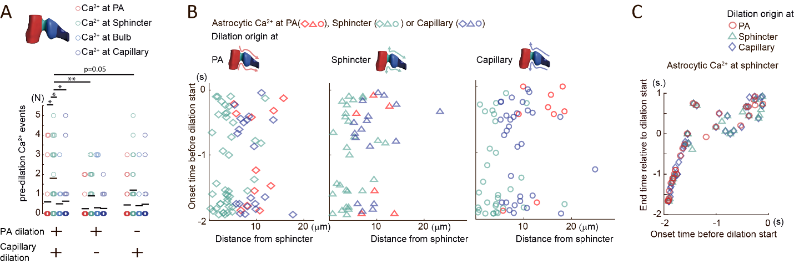
Sup. Figure S6. Pre-dilation astrocytic end-foot Ca²⁺ activity consisting of small local, not-spreading events occurs earlier and more frequently at the sphincter during multicompartmental dilations.
- Pre-dilation astrocytic end-foot Ca2+ activity during different types of dilations, either multi-compartmental, or mono-compartmental involving just the PA, or the 1st order capillary branch. The number of pre-dilation Ca2+ events occurring at the sphincter is significantly higher than those occurring at all the other compartments during multicompartmental dilations (left) but not significantly so during dilations of just the PA (middle) or the capillary branch (right). The number of events at the sphincter is also higher in case of multicompartmental dilations vs monocompartment dilations, independent if the latter involve the PA or the 1st order capillary branch. Statistical analysis: Kruskal Wallis ANOVA followed by Wilcoxon test with Holm-correction for multiple comparisons: (a) Multicompartmental dilations: number of end-foot Ca2+ events at sphincter (cyan circles) vs. at PA (red): p=0.012; at sphincter vs. at bulb (light blue): p=0.017; at sphincter vs. at capillary (blue): p=0.0178. After Kruskal Wallis test, the number of Ca2+ events at sphincter in multicompartmental dilations is significantly different from the number in monocompartment dilations involving just the PA (p=0.0096), or in monocompartment dilations involving just the 1st order capillary branch (p=0.05). Data are from 82.7±20.1 multicompartmental dilations/FOV, 15.3±4.5 monocompartment dilations involving just the PA/FOV; and 61.4±14.7 mono-compartment dilations involving just the capillary branch/FOV; N=20 FOV in 6 mice.
- Onset time of pre-dilation astrocytic Ca2+ activity according to distance from the sphincter. Localization of the astrocyte end-foot Ca2+ activity: at PA (red); at sphincter (cyan); at capillary (blue). Origin of the dilation: at PA (diamonds); at sphincter (triangles); at capillaries (circles). The distribution shows that the astrocyte Ca2+ activity preceding these multicompartment dilations does not spread from the sphincter like a wave. Experimental points are from 116.1±24.7, 82.4±19.7 and 67.2±16.2 dilations/FOV for dilations starting at PA, sphincter and capillary, respectively. From N=20 FOVs in 6 mice.
- Correlation between onset-time and end-time of pre-dilation Ca2+ activities at the sphincter before multicompartmental dilations arriving from either the PA (red circles) or the capillary (blue diamonds) or initiated at the sphincter (cyan triangles). The graph shows two groups of time-correlated activities, fully preceding or persisting after dilation onset.

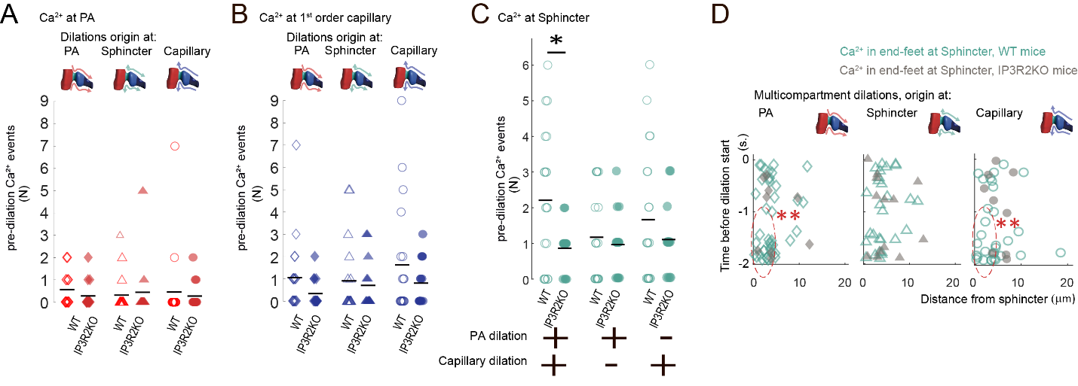

Sup. Figure S7. IP3R2-dependent and IP3R2-independent pre-dilation astrocytic end-foot Ca²⁺ activity depending on type of dilation and location of the active end-feet.
- Number of pre-dilation astrocytic end-foot Ca2+ events seen at the PA in WT (red, open symbols) vs. IP3R2KO (red, solid symbols) mice in multicompartmental dilations arriving from the PA (diamonds), or the capillaries (circles), or initiated at the sphincter (triangles). No statistical difference was found in the number of Ca2+ events in WT vs. IP3R2KO mice in all three the dilation patterns (Mann-Whitney test). Specifically: dilations originating at PA: p=0.11; WT: 116.1±24.7 dilations/FOV; IP3R2KO: 130.3±35.4 dilations/FOV. Dilations originating at the sphincter: p=0.89; WT: 82.4±19.7 dilations/FOV; IP3R2KO: 76.9±21.9 dilations/FOV. Dilations originating at capillary: p=0.55; WT: 67.2±16.2 dilations/FOV; IP3R2KO: 50.9±14.3 dilations/FOV. Data in WT: N=20 FOVs in 6 mice; in IP3R2KO: N=14 FOV in 4 mice.
- Number of pre-dilation astrocytic end-foot Ca2+ events seen at the capillaries in WT (blue, open symbols) vs. IP3R2KO (blue, solid symbols) mice in multicompartment dilations arriving from the PA (diamonds) or the capillaries (triangles) or initiated at the sphincter (circles). No statistical difference was found in the number of Ca2+ events in WT vs IP3R2KO mice in all three the dilation patterns (Mann-Whitney test). Specifically: dilations originating at PA: p=0.055; WT: 116.1±24.7 dilations/FOV; IP3R2KO: 130.3±35.4 dilations/FOV. Dilations originating at the sphincter: p=0.44; WT: 82.4±19.7 dilations/FOV; IP3R2KO: 76.9±21.9 dilations/FOV. Dilations originating at capillary: p=0.35; WT: 67.2±16.2 dilations/FOV; IP3R2KO: 50.9±14.3 dilations/FOV. Data in WT: N=20 FOVs in 6 mice; in IP3R2KO: N=14 FOV in 4 mice.
- Number of pre-dilation astrocytic end-foot Ca2+ events at the sphincter in WT (cyan, open circles) vs. IP3R2KO (cyan, solid circles) mice in multicompartmental dilations, and in monocompartment dilations either involving just the PA or the capillary. This type of information concerning the monocompartmental dilations was not presented in Figure 4C and is added here for comparison with the IP3R2KO effects on multicompartmental dilations. During the latter, the number of pre-dilation Ca2+ events in end-feet around the sphincter was significantly lower in IP3R2KO vs. WT mice (Mann-Whitney test: p=0.028; WT: 82.7±20.1 dilations/FOV; IP3R2KO: 75.3±16.7/FOV). In contrast, in dilations that did not spread across the sphincter, the number of pre-dilation Ca2+ events was not significantly different in IP3R2KO and WT mice (Mann-Whitney test). Specifically: dilations involving just the 1st order capillary branch: p=0.36. WT: 61.4±14.7 dilations/FOV; IP3R2KO: 83.3±25.6 dilations/FOV. Dilations involving just the PA : p=0.8. WT: 15.3±4.5 dilations/FOV; IP3R2KO: 10.3±2.5 dilations/FOV. Data in WT: N=20 FOVs in 6 mice; in IP3R2KO: N=14 FOV in 4 mice.
- Comparison of the onset time and distance from the sphincter of the astrocyte pre-dilation Ca2+ events for multicompartmental dilations in IP3R2KO (grey, solid symbols) vs WT (cyan, open symbols) mice. The two parameters are compared according to the origin of the dilations to which they are associated: at either the PA (diamonds), the capillary (circles), or the sphincter (triangles). The pre-dilation Ca2+ signals suppressed in IP3R2KO mice were mostly those occurring early and closest to the sphincter. As reported in the legend to Figure 4, for both dilations starting at PA and capillary, the Ca2+ events occurring at short distance from the sphincter (SD, <5 µm) were significantly more reduced in IP3R2KO vs WT (dashed red circles) than those occurring at long distance (LD, 5-20 µm). Statistics: Mann-Whitney test: WT vs KO: for dilations starting: (a) at PA: SD: p=0.0038; LD: p=0.18; (b) at sphincter: SD: p=0.52; LD: p=0.18; (c) at capillary: SD: p=0.023, LD: p=0.15. The number of dilations with origin at PA, sphincter and capillary were, respectively: in WT: 116.1±24.7, 82.4±19.7 and 67.2±16.2 in 20 FOVs in 6 mice; in IP3R2KO: 130.3±35.4, 76.9±21.9 and 50.9±14.3 in 14 FOVs in 4 mice.
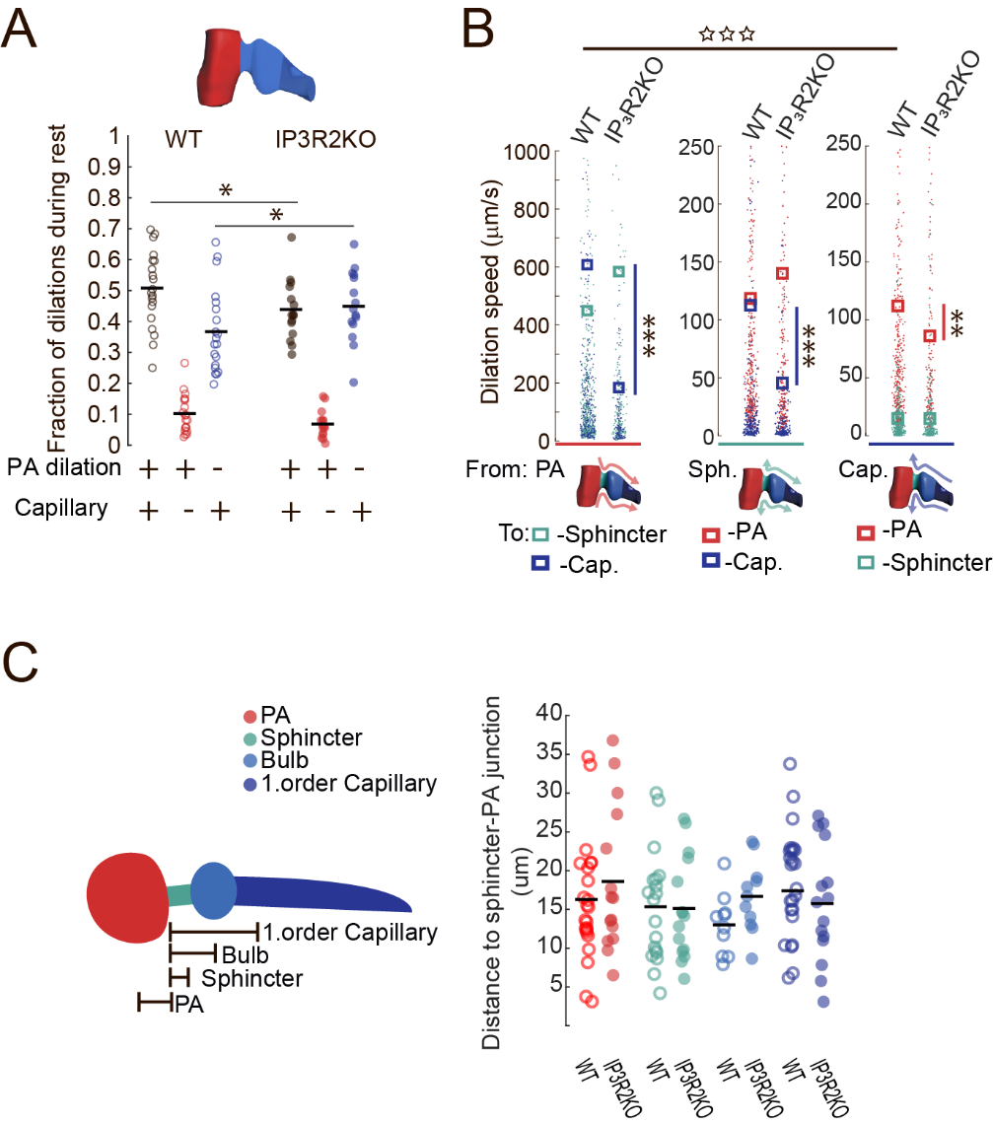
Sup. Figure S8. Dilation patterns and speed of dilation spread in IP3R2KO vs WT mice.
- Fraction of multicompartmental (black) and monocompartmental (either of PA, red, or capillary, blue) dilations in WT (open circles) vs IP3R2KO (solid circles) mice at rest. In IP3R2KO mice, multicompartmental dilations significantly decreased compared to WT mice, whereas dilations involving just the capillaries increased. Statistical analysis: Friedman ANOVA for each group followed by X² test comparing WT against IP3R2KO and Mann-Whitney test: multicompartmental dilations: WT vs IP3R2KO: p=0.037; monocompartmental dilations involving the 1st capillary branch: WT vs IP3R2KO: p=0.02; WT: 236±45 dilations/FOV; N=20 FOV, 6 mice; IP3R2KO: 235±53 dilations/FOV; N=14 FOV; 4 mice.
- Speed by which dilations spread between vessel compartments in WT and IP3R2KO mice according to the site of origination of the dilation (left: PA, red; middle: sphincter, cyan; right: capillary, blue). Color-coded dots along the y-axis mark the dilation spread time of a given vessel compartment, measured as the distance from the initiating compartment in µm/the delay from the start time. The color-coded rectangles are the corresponding mean values (red: at PA; cyan: at sphincter; light blue: at bulb; blue: at capillary). Rectangles indicate the mean speed value for spread in a given compartment, color-coded as above. In WT mice, dilations spread at much faster speed between PA and capillary compartments than vice versa (open stars on the top): Mann-Whitney test: PA to capillary (blue points in plot to the left) vs capillary to PA (red points in plot to the right): p=1.9x10⁻⁵; PA to capillary: N=366 dilations; capillary to PA: N=323 dilations; 20 FOVs; 6 mice). In IP3R2KO mice, dilations between PA and capillary spread at significantly reduced speed than in WT mice, regardless of whether: (a, left) the dilation arrived from the PA (Mann-Whitney test, WT vs IP3R2KO: dilation from PA to sphincter: p=0.15; or to capillary: p=1.5x10⁻⁷; WT: N=366 dilations, IP3R2KO: N=142 dilations); (b, middle) the dilation was initiated at the sphincter (Mann-Whitney test: WT vs IP3R2KO: dilation from sphincter to PA p=0.79 or to capillary p=6.02 x 10⁻⁷; WT: N=329 dilations; IP3R2KO: N=239 dilations); or (c, right) the dilation arrived from the capillary bed (Mann-Whitney test: WT vs IP3R2KO: dilation from capillary to sphincter p=0.96; and to PA p=0.0076; WT: N=323 dilations; IP3R2KO: N=145 dilations). Data for WT from N=20 FOV in 6 WT mice, and for IP3R2KO form N=14 FOV in 4 mice.
- Comparison of the average distance between vessel compartments in WT and IP3R2KO mice. Left: schematic representation of how the distance between each vessel compartment and the connection point between PA and sphincter was calculated for each FOV included in the study. The distances were relative to the point in which the sphincter met the PA circumference using as reference positions the center of the circular PA and bulb structures, and the middle point of the rectangular sphincter and capillary structures. Red: PA; cyan: sphincter; light blue: bulb; blue: capillary. Right: comparison of the distance between each vessel compartment and the connection point between PA and sphincter in WT (open circles) and IP3R2KO (solid circles) mice. Compartments identified by same colors as in left. No difference was found in WT vs IP3R2KO mice, though a large diversity was observed in the measures in each group. Paired t-test WT vs IP3R2KO: distance from the junction between PA and sphincter to the center of the PA: p=0.42; to the middle of the sphincter segment: p=0.92; to the center of the bulb: p=0.068; to the middle of the capillary segment: p=0.52 Data from N=20 FOV, 6 WT mice, N=14 FOV, 4 IP3R2KO mice.

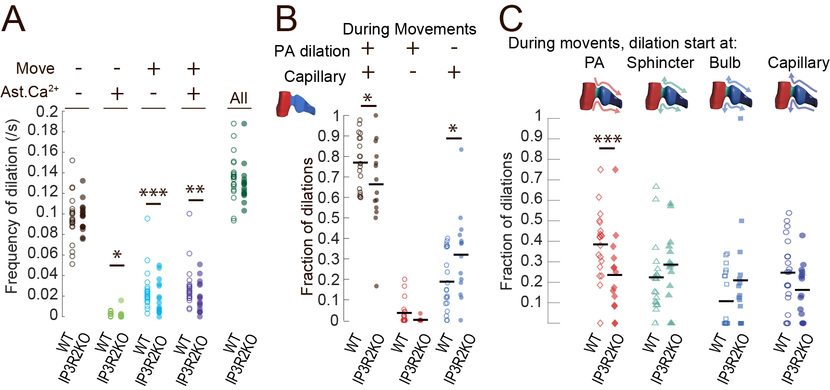
Sup. Figure S9. Comparative analysis of dilation features in different conditions in IP3R2KO vs WT mice.
- Frequency of all dilations independent of origin, direction and pattern, analyzed in different conditions in WT (open circles) and IP3R2KO (solid circles) mice. Conditions are: mouse at rest (black); mouse at rest displaying large astrocyte Ca2+ activity (green); mouse showing movements (azure); mouse showing movements and large astrocyte Ca2+ activity (violet). Moreover, to the far right, are the frequency values summing up all the dilation events in all conditions (dark green). Across all conditions, a X²-test did not indicate difference in dilation frequencies (p=0.39). Moreover, no frequency difference appeared between WT and IP3R2KO mice with the Mann-Whitney test when all the dilation events were compared independently of whether the mouse was moving, resting etc: WT vs IP3R2KO: p=0.16. In contrast, comparison of the dilations taking into account the specific condition, revealed that frequency of dilation was reduced in IP3R2KO for dilations that occurred during animal movements or were accompanied by large astrocyte Ca2+ activities or by both, but not for dilations in the resting animal. Mann-Whitney test: WT vs IP3R2KO: at rest: p=0.85; at rest + large Ca2+ activity: p=0.036; moving mouse: p=6.2x10-7: moving mouse + large Ca2+ activity: p=0.0059. In WT mice, the dilations/FOV/condition were: at rest: 162±31.2; at rest + large Ca2+ activity: 4.2±2.0; moving mouse: 47.6±22.1; moving mouse + large Ca2+ activity: 6.5±2.5; N = 20 FOV in 6 mice. In IP3R2KO mice the dilations/FOV/condition were: at rest: 176±39.8; at rest + large Ca2+ activity: 2.27±1.61; moving mouse: 34.1±15.2; moving mouse + large Ca2+ activity: 1.73±1.28; N = 14 FOV in 4 mice.
- Fraction of dilations involving different vessel compartments in WT (open circles) vs IP3R2KO (solid circles) mice during mouse movements. Multicompartmental dilations (black circles) were reduced, while monocompartmental ones including just capillaries (blue circles) were increased in IP3R2KO vs WT mice during movements (Friedman ANOVA followed by X² test comparing WT vs IP3R2KO and Mann-Whitney test: multicompartmental: WT vs IP3R2KO: p=0.045; just capillary: WT vs IP3R2KO: p=0.017). The fraction of monocompartment dilations involving just the PA (red circles) did not significantly change in IP3R2KO vs WT. In WT mice during movement: 47.6± 22.1 dilations/FOV; N=20 FOV, 6 mice; In IP3R2KO mice during movement: 34.1± 15.2 dilations/FOV N=14 FOV, 4 mice.
- Fraction of multicompartmental dilations according to origination site seen during mouse movements in WT (open symbols) and IP3R2KO (solid symbols) mice. Red diamonds: dilations originating at PA; cyan triangles: at sphincter; light blue squares: at bulb; blue circles: at capillary. Changes in dilation patterns mirror those found in the resting mouse (Figure 5A), but here only the fraction of multicompartmental dilations beginning at the PA was significantly reduced in the IP3R2KO mice. (Friedmans ANOVA, followed by Mann-Whitney test: WT vs IP3R2KO: start at PA: p=0.0041; at sphincter: p=0.059; at bulb: p=0.13; at capillary: p=0.070; In WT mice during movement: 35.7± 14.08 dilations/FOV N=20 FOV in 6 mice; In IP3R2KO mice during movement: 23.14± 8.86 dilations/FOV N=14 FOV in 4 mice.

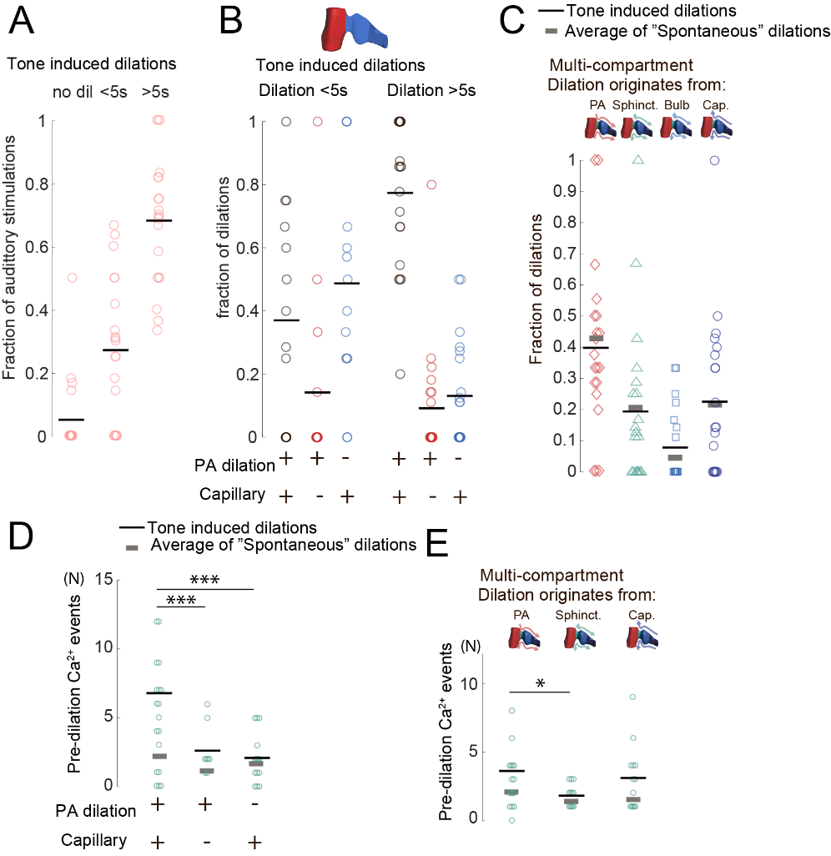
Sup. Figure S10. Dilation patterns in auditory cortex were similar for tone-evoked and spontaneous dilations.
- Temporal distribution of dilation responses to our protocol of auditory stimulations expressed as a fraction of all the auditory stimulations. Only a few stimulations did not trigger any dilation response (no dil). On average, ~ 30% of the stimulations triggered dilations <5s, and >65% triggered dilations >5s. Data are: 7.55±1.79 dilations/FOV; N=20 FOV; 6 mice.
- Fraction of tone-evoked dilations that are multicompartmental (black circles), or monocompartmental, the latter sub-divided in those involving the PA (red circles) or the 1st order capillary (blue circles). The fractions are presented in two groups, separated based on their duration, either <5s or >5s and compared between these groups. As seen also with spontaneous dilations, the proportion of multicompartment dilations induced by tone stimulations was higher among longer-lasting dilations: <5s dilations were more often restricted to just the capillary bed, whereas >5s dilations most often included all vessel compartments. Friedmans ANOVA for each response duration followed by comparison using the X² test. Dilations <5s: p=0.062, X²=5.6; dilations >5s: p=4.7x10⁻⁶, X²=24.5. ANOVA shows unequal distribution of dilations only in the >5s dilations group. The X² values support this difference between shorter and longer dilations. Data are: 2.15±0.92 <5s dilations/FOV and 5.4±1.33 >5s dilations/FOV; N=20 FOV in 6 mice.
- Fraction of tone-evoked multicompartmental dilations according to their origination site: at the PA (red diamonds), at the sphincter (cyan triangles), at the bulb (light blue squares), or at the capillary (dark blue circles). The average values of tone-induced dilations in each group (black lines) are plotted for comparison together with the corresponding average values (grey lines) of spontaneous dilations taken from the ad hoc set of experiments. Tone-evoked and spontaneous multicompartmental dilations displayed similar proportions of dilations with the same origination. Friedmans ANOVA. followed by Wilcoxon test: spontaneous vs tone-evoke: originating at PA: p=0.49; at sphincter: p=0.25; at bulb: p=0.68; at capillary: p=0.67. The number of spontaneous dilations/FOV analyzed was 82.65±20.13 and 4.15±1.13 tone induced dilations/FOV was in N=20 FOVs in 6 mice.
- Number of FOVs showing pre-dilation astrocytic end-foot Ca2+ activity at the sphincter in relation to tone-evoked dilation patterns, either multi-compartmental or involving just the PA or the capillary branch. The average values for tone-evoked dilations (black lines) are plotted for comparison together with the corresponding average values from spontaneous dilations taken from the ad hoc set of experiments (grey lines, see also supplemental Figure S6A). Tested with Kruskal Wallis ANOVA (p=0.00013) followed by Wilcoxon test. For tone-evoked dilations, we found a significantly higher number of pre-dilation Ca2+ activity at sphincter in multicompartmental dilations vs monocompartmental ones, both vs those involving just the PA (p=0.00069) and vs those involving just the 1st order capillary branch (p=0.00047). When we compared the distributions of pre-dilation Ca2+ activities in spontaneous vs tone-evoked dilations with Kruskal Wallis ANOVA and X² test, we did not find a difference between the two groups. Data are: tone-evoked dilations/FOV: multicompartmental: 0.6±0.46; monocompartmental involving just PA: 0.65±0.36; or just capillary branch: 4.15±1.13. Spontaneous dilations/FOV: multicompartmental: 82.7±20.1; monocompartmental involving just PA: 61.4±14.7; or just capillary branch: 15.3±4.5. N=20 FOV, 6 WT mice.
- Number of FOVs showing pre-dilation astrocytic end-foot Ca2+ activity at the sphincter associated to multicompartmental dilations, according to their site of origination. The average values for tone-evoked dilations (black lines) are plotted for comparison together with the corresponding average values from spontaneous dilations taken from the ad hoc set of experiments (grey lines). Pre-dilation astrocytic Ca2+ activity was numerous for both tone-evoked and spontaneous dilations, and their proportions according to the site of origination of the dilation was similar for tone-evoked and spontaneous dilations (see also supplemental Figure 3B). Tested with Kruskal Wallis ANOVA (p=0.07) followed by Wilcoxon test. Ca2+ at sphincter in multicompartment dilations starting at sphincter vs starting at PA: p=0.015; or vs starting at capillary: p=0.18. Comparison of the distributions of pre-dilation Ca2+ activities in spontaneous and tone-evoked dilations with Kruskal Wallis ANOVA and X² test did not indicate differences between the two groups as the X² values were of comparable size. Specifically: (a) dilations starting at the PA: spontaneous: p=0.019, X²=9.99; tone-evoked: p=0.056, X²=7.48. (b) dilations starting at the sphincter: spontaneous: p=0.031, X²=8.85; tone-evoked: p=0.11, X²=6.13; (c) dilations starting at the capillary: spontaneous: p=0.0032, X²=13.75; tone-evoked: p=0.027, X²=9.15. Data are: tone-evoked dilations/FOV: starting at PA: 1.98±0.62; at sphincter: 0.85±0.38; at bulb: 0.45±0.30, and at capillary: 1.25±0.58. Spontaneous dilations/FOV: starting at PA: 116.1±24.7; at sphincter: 82.4±19.7; at bulb: 70.4±18.9: at capillary: 67.2±16.2. N=20 FOVs in 6 mice.

