Supplementary

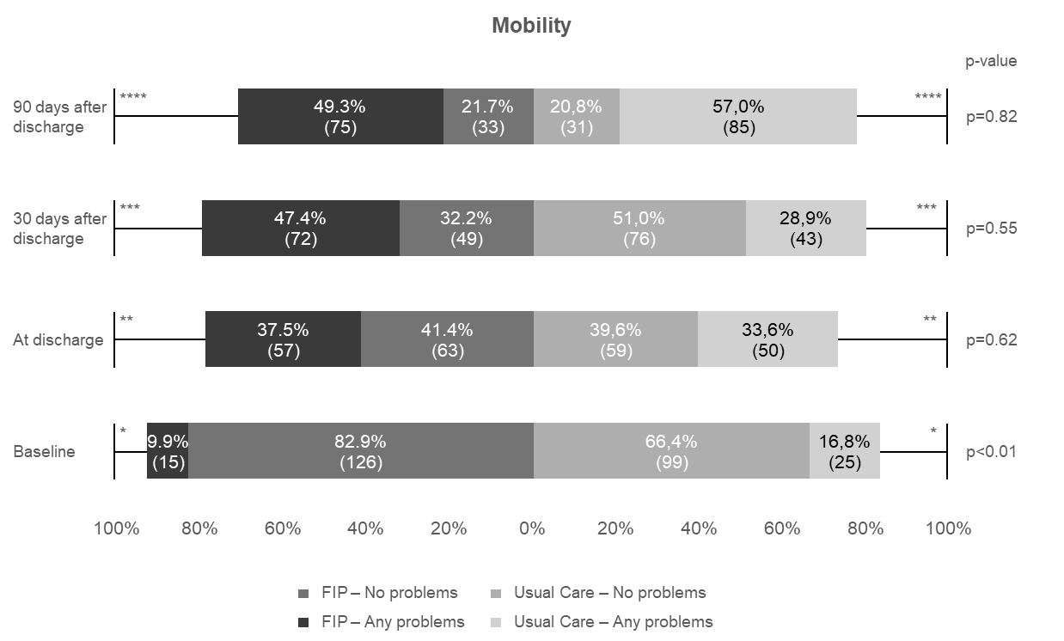Figure 1A: The mobility dimension scores as one of the five dimension of the health related quality of life questionnaire (EQ5D5L), measured at aimed follow up points during the study. Numbers are presented as percentages, with the exact number of patients presented in parentheses.
*Missing at baseline, N=numbers of patients: FIP N=31, usual care N=30.
**Missing at discharge, N=numbers of patients: FIP N=32, usual care N=40.
***Missing at 30days after discharge, N=numbers of patients: FIP N=31, usual care N=30.
****Missing at 90 days after discharge, N= numbers of patients: FIP N=44, usual care N=33.

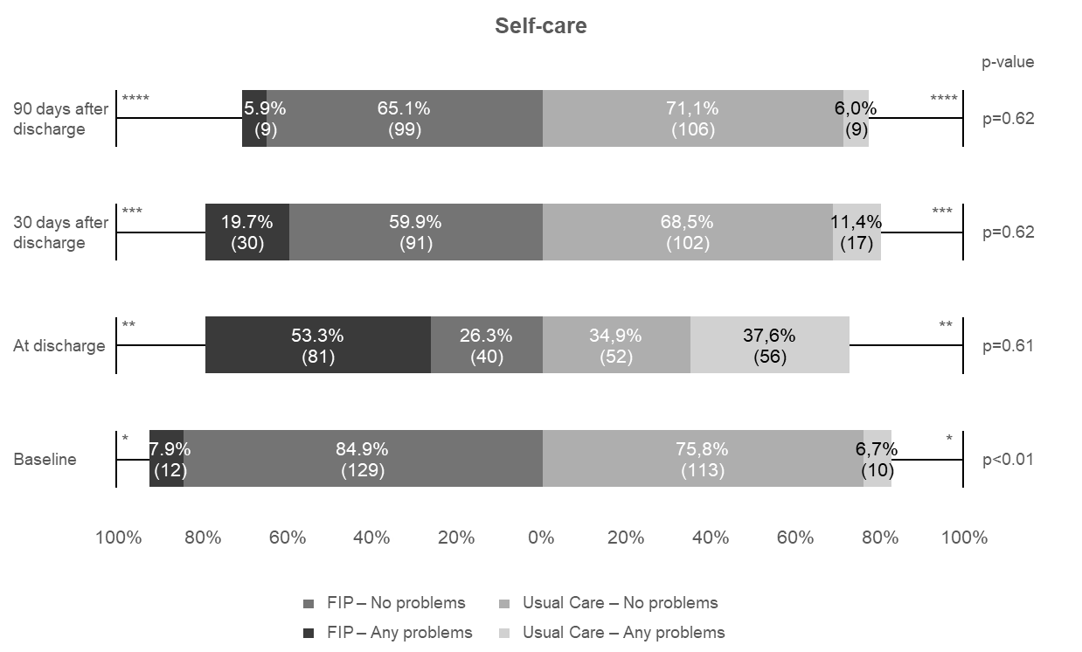
Figure 1B: The self-care dimension scores as one of the five dimension of the health related quality of life questionnaire (EQ5D5L), measured at aimed follow up points during the study. Numbers are presented as percentages, with the exact number of patients presented between parentheses.
*Missing at baseline, N=numbers of patients: FIP N=11, usual care N=26.
**Missing at discharge, N=numbers of patients: FIP N=31, usual care N=41.
***Missing at 30days after discharge, N=numbers of patients: FIP N=31, usual care N=30.
****Missing at 90 days after discharge, N= numbers of patients: FIP N=44, usual care N=34.

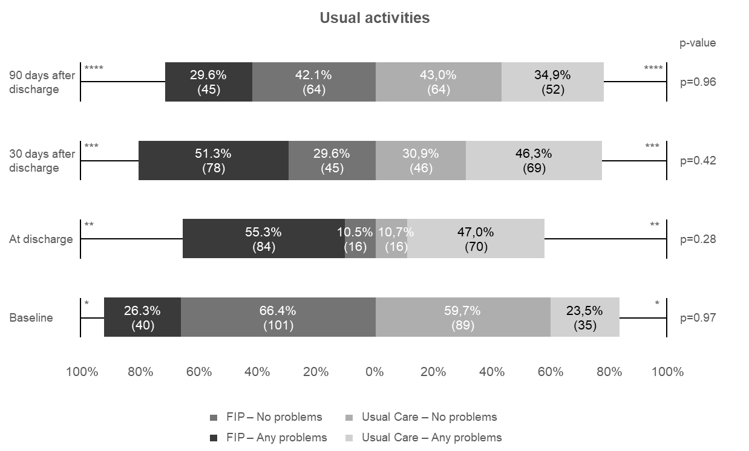
Figure 1C: The usual activities dimension scores as one of the five dimension of the health related quality of life questionnaire (EQ5D5L), measured at aimed follow up points during the study. Numbers are presented as percentages, with the exact number of patients presented in parentheses.
*Missing at baseline, N=numbers of patients: FIP N=11, usual care N=25.
**Missing at discharge, N=numbers of patients: FIP N=52 , usual care N=63.
***Missing at 30days after discharge, N=numbers of patients: FIP N=29, usual care N=34.
****Missing at 90 days after discharge, N= numbers of patients: FIP N=43, usual care N=33.

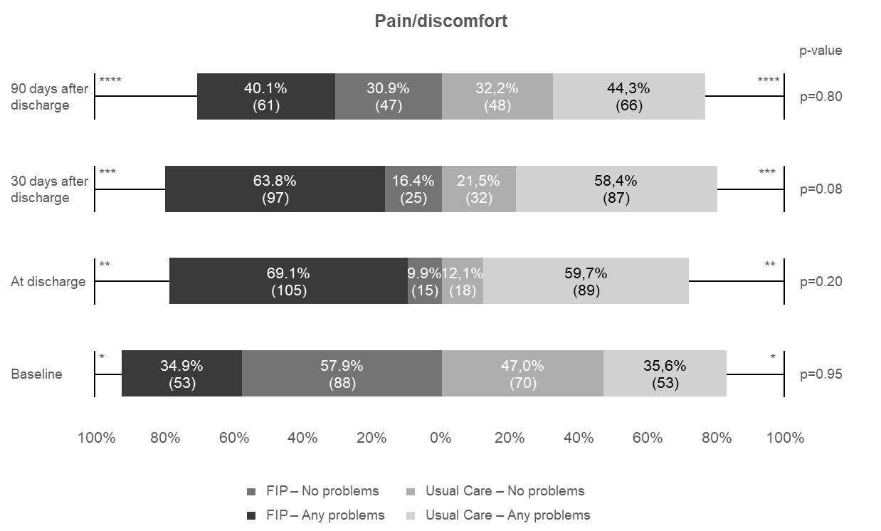
Figure 1D: The pain/discomfort dimension scores as one of the five dimension of the health related quality of life questionnaire (EQ5D5L), measured at aimed follow up points during the study. Numbers are presented as percentages, with the exact number of patients presented in parentheses.
*Missing at baseline, N=numbers of patients: FIP N=11, usual care N=26.
**Missing at discharge, N=numbers of patients: FIP N=32, usual care N=42.
***Missing at 30days after discharge, N=numbers of patients: FIP N=30, usual care N=30.
****Missing at 90 days after discharge, N= numbers of patients: FIP N=44, usual care N=35.

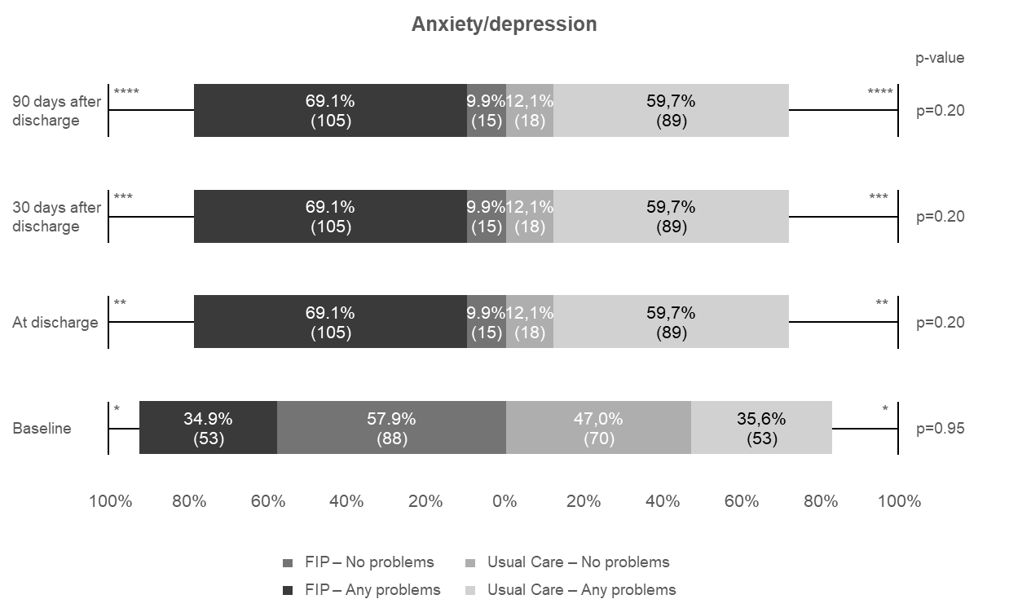
Figure 1E: The anxiety/depression dimension scores as one of the five dimension of the health related quality of life questionnaire (EQ5D5L), measured at aimed follow up points during the study. Numbers are presented as percentages, with the exact number of patients presented in parentheses.
*Missing at baseline, N=numbers of patients: FIP N=11, usual care N=26.
**Missing at discharge, N=numbers of patients: FIP N=32, usual care N=42.
***Missing at 30days after discharge, N=numbers of patients: FIP N=32, usual care N=42.
****Missing at 90 days after discharge, N= numbers of patients: FIP N=32, usual care N=42.

