Table 1.A Processing conditions
Composition |  | Barrel temperature (°C)
PA66/PPO  75/20 | GF | 1 | 2 | 3 | 4 | 5 | 6 | 7 | 8 | Export
PA66/PPO  75/20 | 0 | 245 | 255 | 260 | 260 | 265 | 265 | 270 | 270 | 265
PA66/PPO  75/20 | 30% | 275 | 275 | 270 | 270 | 265 | 265 | 265 | 265 | 265
Table 1.B Injection conditions
Composition |  | Barrel temperature (°C)
PA66/PPO  75/20 | GF | 1 | 2 | 3 | 4 | 5
PA66/PPO  75/20 | 0 | 257 | 262 | 265 | 260 | 255
PA66/PPO  75/20 | 30% | 267 | 272 | 275 | 270 | 265

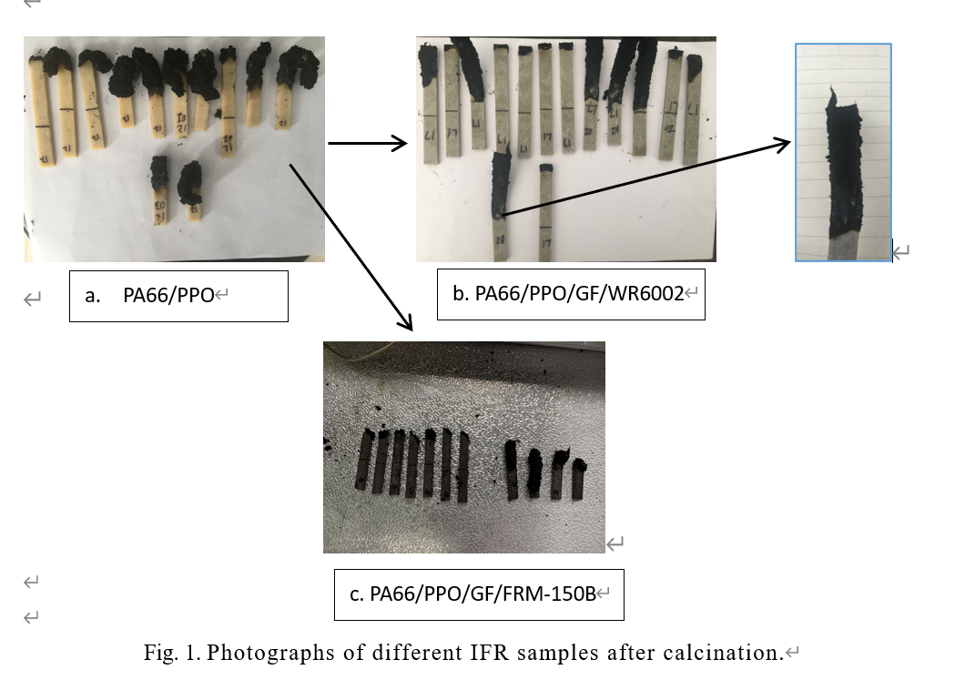
TABLE 2. LOI and UL-94 test results of the PA66/PPO/FRM-150B blends

Sample | LOI (%) | UL-94
PA66/PPO/30%GF | 25 | No
PA66/PPO/30%GF/8%FRM | 40.29 | V-1
PA66/PPO/30%GF/10%FRM | 39.488 | V-0
PA66/PPO/30%GF/12%FRM | 38.272 | V-0
PA66/PPO/30%GF/14%FRM | 36.65 | V-0

TABLE 3. LOI and UL-94 test results of the PA66/PPO/WR6002 blends

Sample | LOI (%) | UL-94
PA66/PPO/30%GF | 25 | No
PA66/PPO/30%GF/4%P-Si | 31 | V-2
PA66/PPO/30%GF/8% P-Si | 33 | V-1
PA66/PPO/30%GF/12% P-Si | 33.6 | V-1
PA66/PPO/30%GF/16% P-Si | 34.6 | V-0
PA66/PPO/30%GF/20% P-Si | 35.7 | V-0

Fig. 2. The influence of glass fiber content on the mechanical properties of PA66/PPO
Fig. 3. The influence of glass fiber content on the thermal deformation temperature of PA66/PPO

Fig. 4 The effect of glass fiber content on the friction and wear properties of PA66/PPO

Fig. 5. Tensile properties (left picture) and impact properties (right picture) of composites with different red phosphorus (FRM-150B) content

Fig. 6. Tensile properties (left picture) and impact properties (right picture) of composites with different phosphorus-silicon (WR6002) flame retardant content.

Fig. 7. A, TGA and B, DTG curves of different samples.

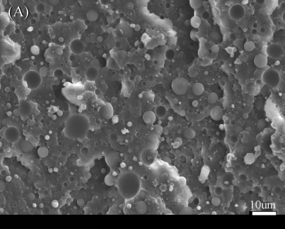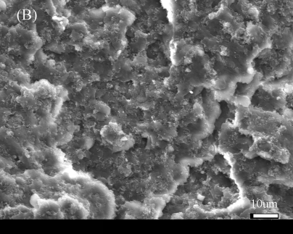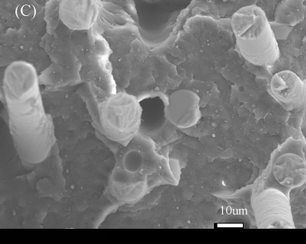
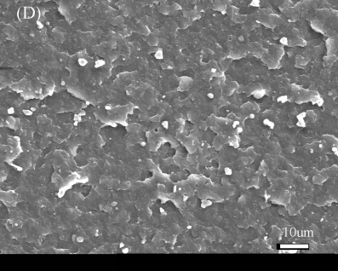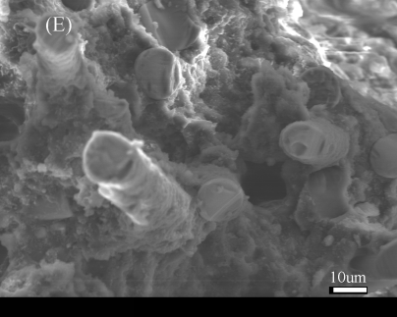
Fig. 8. SEM images of Notch impact surface（A）PA66/PPO、（B）PA66/PPO/HIPS-g-MAH、（C）PA66/PPO/HIPS-g-MAH/GF、（D）PA66/PPO/HIPS-g-MAH/WR6002、（E）PA66/PPO/HIPS-g-MAH/WR6002/GF

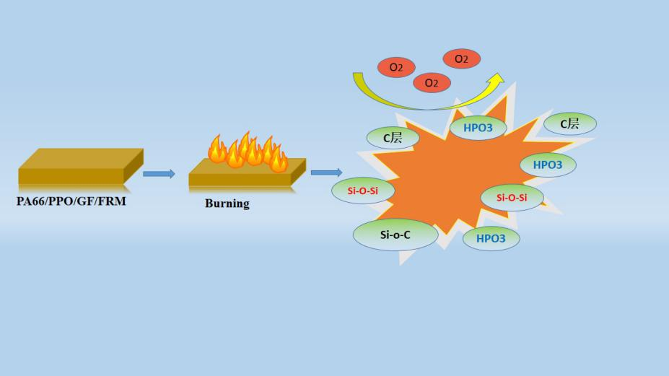
Fig. 9. The flame-retardant mechanism of PA66/PPO/FR composites

