Supplementary Figures
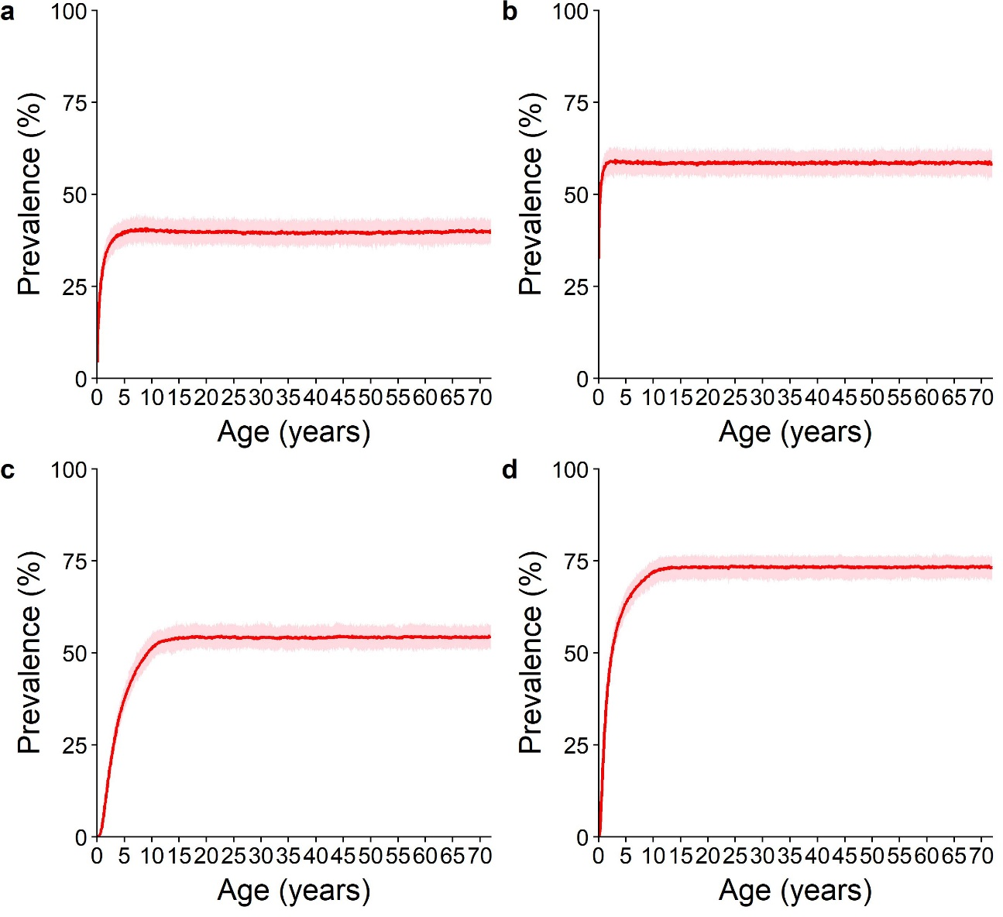
Supplementary Figure 1: Prevalence of any infection in girls/women as they age in the absence of any treatment for STH. Red line: mean; pale red area: 95% credible interval. a, c: Moderate baseline prevalence (20-50%). b, d: High baseline prevalence (>50%). a, b: Imperial College London (ICL) results. c, d: Erasmus MC (EMC) results.

