Integrated Analysis of Genetic Diversity in Costus pictus through Phenotypic Characterization, Molecular Markers and UHPLC-MS-Based Diosgenin Profiling
Ragul P¹, Chitra Rajagopal^{2*}, Kesiar Loudursamy³, Thanga Hemavathy A⁴, Vellaikumar S⁵, Rajagopal B⁵, Karthikeyan P ⁶
¹ Department of Spices, Plantation, Medicinal & Aromatic crops, Horticultural college and Research Institute
Tamil Nadu Agricultural University, Coimbatore, Tamil Nadu, India.
²Department of Floriculture and Landscape, Horticultural college and Research Institute, Tamil Nadu Agricultural University, Coimbatore, Tamil Nadu, India.
³Horticultural college and Research Institute, Tamil Nadu Agricultural University, Coimbatore, Tamil Nadu, India
⁴Department of Pulses, Centre for Plant breeding and Genetics, Tamil Nadu Agricultural University, Coimbatore, Tamil Nadu, India.
⁵Department of Plant Biotechnology, Centre for Plant Molecular Biology & Biotechnology,Tamil Nadu Agricultural University, Coimbatore, Tamil Nadu, India.
⁶Field Application Specialist, Spinco, Chennai, Tamil Nadu, India
Chitra.varadharaj@gmail.com
Supplementary fig 2: PCR amplification of Twenty genotypes with primer – UBC 841
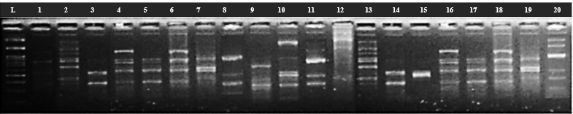
3000bp
1500bp
1000bp
900bp
200bp
100bp

