Integrated Analysis of Genetic Diversity in Costus pictus through Phenotypic Characterization, Molecular Markers and UHPLC-MS-Based Diosgenin Profiling
Ragul P¹, Chitra Rajagopal^{2*}, Kesiar Loudursamy³, Thanga Hemavathy A⁴, Vellaikumar S⁵, Rajagopal B⁵, Karthikeyan P ⁶
¹ Department of Spices, Plantation, Medicinal & Aromatic crops, Horticultural college and Research Institute
Tamil Nadu Agricultural University, Coimbatore, Tamil Nadu, India.
²Department of Floriculture and Landscape, Horticultural college and Research Institute, Tamil Nadu Agricultural University, Coimbatore, Tamil Nadu, India.
³Horticultural college and Research Institute, Tamil Nadu Agricultural University, Coimbatore, Tamil Nadu, India
⁴Department of Pulses, Centre for Plant breeding and Genetics, Tamil Nadu Agricultural University, Coimbatore, Tamil Nadu, India.
⁵Department of Plant Biotechnology, Centre for Plant Molecular Biology & Biotechnology,Tamil Nadu Agricultural University, Coimbatore, Tamil Nadu, India.
⁶Field Application Specialist, Spinco, Chennai, Tamil Nadu, India
Chitra.varadhraj@gmail.com
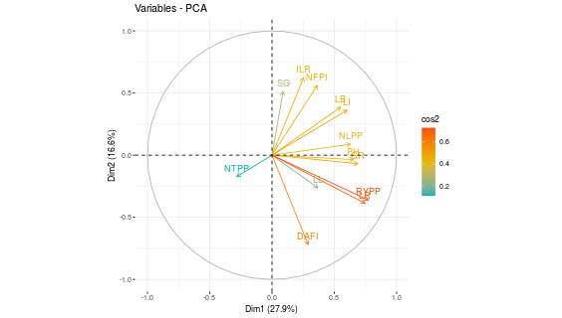
Supplementary Fig 5: Contribution of different traits to the total divergence. The traits are showed by color red include traits include RYPP (Rhizome yield per plant), LR (Length Rhizome) and blue colour traits include NTPP (Number of tillers per plant), and grey color indicates LL (Length length), light greenish colour appear SG (Stem Girth) and yellow colour traits include (ILR) Internodal length of rhizome, LB (Leaf breadth), NFPI (Number of flower per inflorescence ), NLPP (Number of leaves per plant), LB (leaf breadth), PH (plant height), DAFI (Days after flowers initiation) and GR (Girth of Rhizome).

