Supporting information of
Preparation of Fast Degradable Bio-based Polyester/thermoplastic starch Blends based on epoxidized soybean oil

Yezhong Chen^{1,2,3#}, Xuan Fei ^{2#}, Xuejun Fu², Yuhan Li⁴, Yi Zhang^{1※}, Lijun Zhou^{3※},Yansheng Yin¹

1 Guangdong Provincial Key Laboratory of Nanhai Microbial Mineralization Technology and Application，Guangzhou Maritime University, Guangzhou 510725, P. R. China
2 National-certified Enterprise Technology Center, Kingfa Science and Technology Co., Ltd.,, Zhuhai,510663, P. R. China
3 Qingdao Univ Sci & Technol, Key Lab Rubber Plast, Minist Educ, Shandong Prov Key Lab Rubber Plast, Qingdao 266042, P. R. China
4 College of Chemistry and Pingyuan Laboratory, Zhengzhou Key Laboratory of Elastic Sealing Materials, Zhengzhou University, Zhengzhou 450001, P. R. China.

* Corresponding Author:
Yi Zhang, zhangyizzdx@163.com
Lijuan Zhou, 03280@qust.edu.cn

Guangzhou “Yangcheng Scholar” Leading Talent Training Project (2024312143)
National Natural Science Foundation (52371059, 52001081).

- The intrinsic viscosity of PBSSeSa-c-M composites
Fig. S1 The intrinsic viscosity of PBSSeSa-c-M composites

- The photos of blown film bubbles of PBSSeSa-c-M/TPS-ESOs composite films
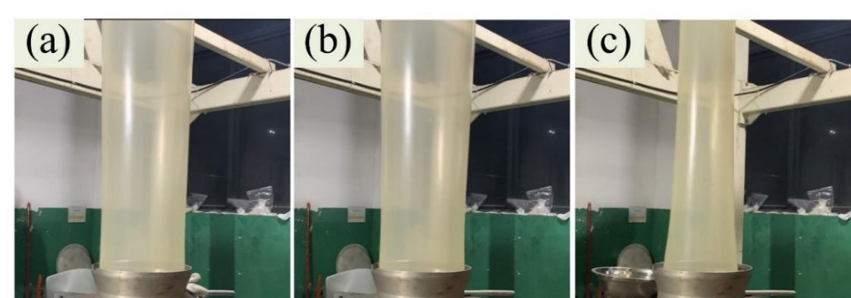
Fig. S2 The photos of blown film bubbles of PBSSeSa-c-M/TPS-ESOs composite films: (a) PBSSeSa-c-M/TPS-ESO1; (b) PBSSeSa-c-M/TPS-ESO2; (c) PBSSeSa-c-M/TPS-ESO3.

- The load bearing test data of films.
Table S1 The load bearing test data of films.
Samples | Load (3kg) | Load (3.5kg) | Load (4kg)
PBSSeSa-c-M | OK | Break | Break
PBSSeSa-c-M | OK | Break | Break
PBSSeSa-c-M | OK | Break | Break
PBSSeSa-c-M/TPS-MG1 | OK | Break | Break
PBSSeSa-c-M/TPS-MG1 | OK | OK | Break
PBSSeSa-c-M/TPS-MG1 | OK | Break | Break
PBSSeSa-c-M/TPS-ESO1 | OK | OK | Break
PBSSeSa-c-M/TPS-ESO1 | OK | OK | Break
PBSSeSa-c-M/TPS-ESO1 | OK | OK | Break
PBSSeSa-c-M/TPS-ESO2 | OK | OK | Break
PBSSeSa-c-M/TPS-ESO2 | OK | OK | Break
PBSSeSa-c-M/TPS-ESO2 | OK | OK | Break
PBSSeSa-c-M/TPS-ESO3 | OK | OK | Break
PBSSeSa-c-M/TPS-ESO3 | OK | OK | Break
PBSSeSa-c-M/TPS-ESO3 | OK | OK | Break

