Molecular subtyping of endometrial carcinoma cell lines uncovers subtype-specific targetable vulnerabilities

Eunice S. Li^{1,2*}, Rebecca Ho^{1,2,*}, Ran Tao^{1,2}, Yannes W. Choi^{1,2}, Chae Young Shin^{1,3}, Shary Y. Chen^{1,2,3}, Bengul Gokbayrak^{1,2,3}, Janine Senz^{1,3}, Betty Yao^{1,4}, Liam Johnston^{1,4}, Spencer D. Martin¹, Eric Yang¹, Mark Carey⁵, Bryan T. Hennessy⁶, David G. Huntsman^{1,2,3,5}, Ramon I. Klein Geltink^{1,3,4,7}, Lynn Hoang^{1,2}, Yemin Wang^{1,2,3,#}

Supplementary Figures
Figure S1. Expression of p53, ARID1A and ARID1B in MMRd EC cell lines and their derived mouse xenografted tumors. (A) H&E staining and immunostaining of VOA12371, HOUA-I and VOA14590H cell line xenografted tumors. (B) Immunoblotting of p53 expression in MMRd EC cell lines. (C) H&E staining of TEN cell line xenografted tumors.

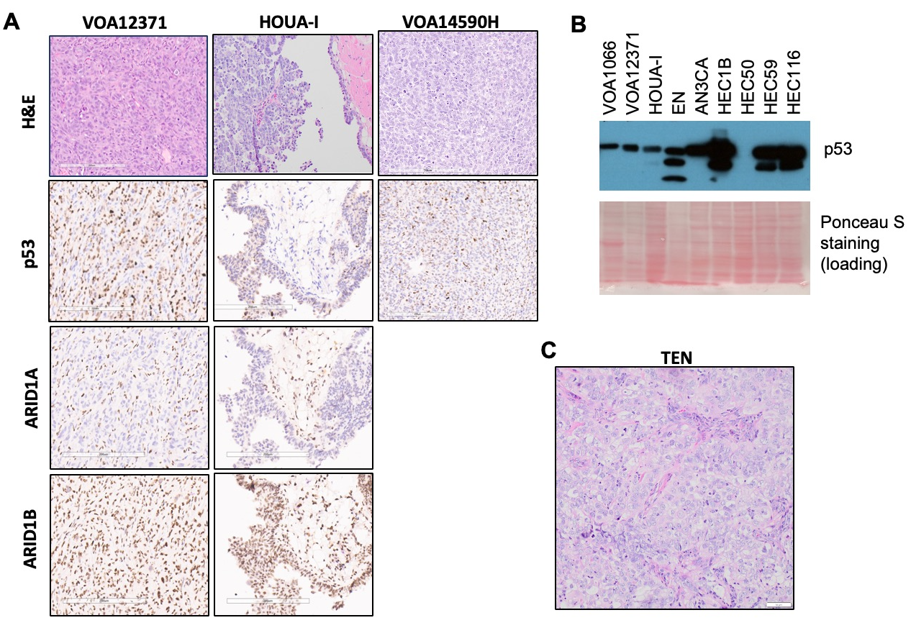
Fig. S2 Histology of the primary tumors from which p53abn EC cell lines derived.

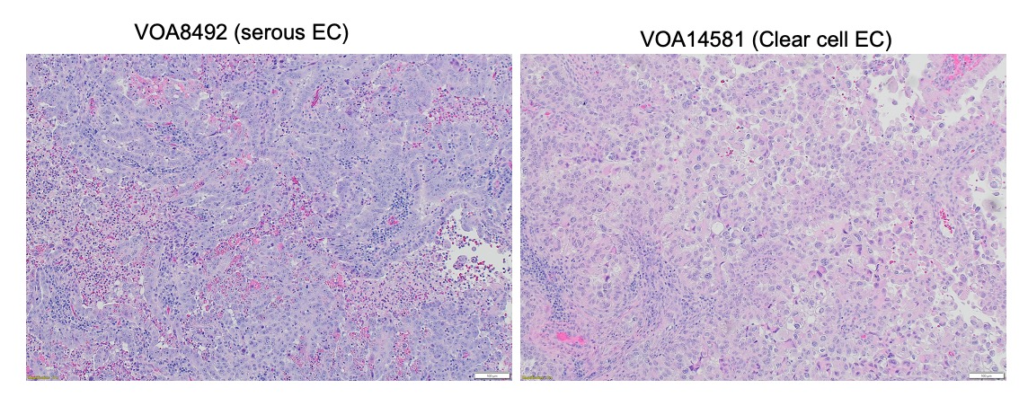
Fig. S3 Immunoblotting confirmed the dual loss of ARID1A/B in EFO-27 cells.

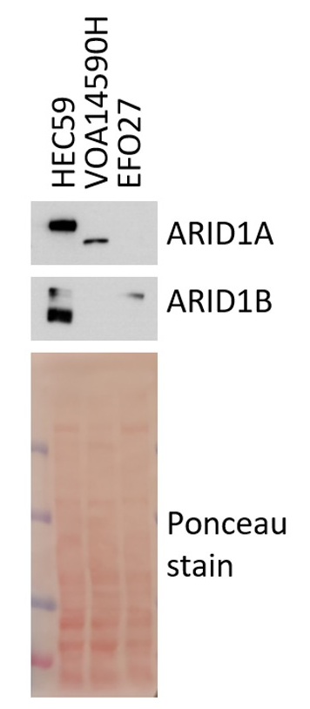
Fig. S4 Seahorse assay analyzing the oxygen consumption rate in VOA1066 cells. (A) Oxygen consumption rates (OCR) measured with the Seahorse Mito Stress test for VOA1066 cells treated with and without IACS-010759 (2 nM for 1 hour). (B) Bar graphs show relative basal respiration in (A).
